ReadabilityPro
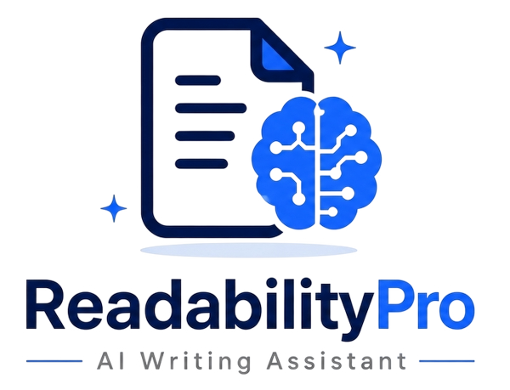

AI Writing Assistant | Semester Project Report
1. INTRODUCTION
Clear and effective writing is one of the most critical skills in today's academic and professional world. Whether it is a research paper, a business email, or an online article, poorly written content can confuse readers, damage credibility, and fail to communicate the intended message. Studies consistently show that readers abandon content within seconds if it is difficult to understand. This creates a strong demand for tools that help writers improve their work quickly and efficiently.
ReadabilityPro is an AI-powered writing assistant designed to address this challenge. The system analyzes written text in real time and provides actionable feedback on clarity, grammar, sentence structure, and overall readability. By combining modern web technologies with AI language processing, ReadabilityPro makes professional-level writing support accessible to everyone.
2. PROJECT OVERVIEW
ReadabilityPro is a web-based application that uses artificial intelligence to help users write clearer, more polished content. A user pastes or types text into the platform, and the system instantly evaluates it across multiple dimensions — readability score, grammar correctness, sentence complexity, tone, and vocabulary level. Based on this analysis, the tool generates specific, easy-to-follow suggestions to improve the writing.
Key Functionalities
- Real-time text analysis with readability scores (Flesch-Kincaid scale)
- Grammar and spelling correction with inline highlights
- Sentence simplification suggestions for complex or lengthy sentences
- Tone detection — formal, casual, persuasive, or academic
- AI-powered rewriting of selected paragraphs on user request
- Export of improved content in multiple formats (PDF, DOCX, plain text)
- User history and saved documents via personal dashboard
3. OBJECTIVES
- Develop a fully functional web application that evaluates and scores the readability of user-submitted text.
- Integrate an AI language model to provide meaningful, context-aware writing suggestions and rewrites.
- Implement user account management so individuals can save, track, and compare their writing over time.
- Design an intuitive and responsive user interface that requires no technical knowledge to operate.
- Build a scalable back-end architecture capable of handling multiple concurrent users without performance issues.
4. METHODOLOGY / APPROACH
The system follows a straightforward pipeline from text input to actionable feedback. Each step is designed to be lightweight and easy to understand, keeping the user experience smooth and fast.
Step-by-Step Working
- The user types or pastes text into the ReadabilityPro editor on the website. – User Input
- The front end sends the text to the Node.js back-end server via a REST API call. – Text Processing
- The server passes the text to an AI language model (OpenAI API or similar). The model evaluates grammar, tone, complexity, and clarity, then returns a structured result. – AI Analysis
- A built-in algorithm calculates a readability score using standard formulas such as Flesch-Kincaid. This score tells the user how easy or difficult the text is to read. – Scoring Engine
- Results are sent back to the React front end, where suggestions appear as color-coded highlights and pop-up tips directly on the text. – Feedback Display
- The user can accept, reject, or modify each suggestion. They can also ask the AI to rewrite a specific paragraph with one click. – User Action
- The final improved text can be saved to the user's account in MongoDB or exported as a PDF or Word document. – Save & Export
5. FEATURES
- Real-Time Readability Scoring: Real-Time Readability Scoring
Instantly calculates a readability grade based on sentence length, word frequency, and syllable count. Scores are displayed on a visual gauge so users can see their progress.
- AI Writing Suggestions: AI Writing Suggestions
Powered by a large language model, the tool offers context-aware suggestions — not just grammar fixes, but structural improvements and word choice alternatives.
- Tone & Style Detector: Tone & Style Detector
Identifies whether the text reads as formal, casual, academic, or persuasive, and flags sections where the tone is inconsistent with the user's goal.
- One-Click Rewrite: One-Click Rewrite
Users can select any paragraph and request an AI-generated rewrite that maintains the original meaning while improving clarity and flow.
- Personal Dashboard: Personal Dashboard
Each registered user has a private dashboard where they can view saved documents, track readability improvements over time, and manage their writing projects.
- Multi-Format Export: Multi-Format Export
Completed documents can be downloaded as PDF, DOCX, or plain text, making it easy to use the improved content directly in assignments, reports, or professional work.
6. TECHNOLOGIES USED
- React.js: React.js
A JavaScript library for building the user interface. React allows the application to update the screen in real time as users type or receive suggestions, without reloading the page.
- Node.js: Node.js
A server-side JavaScript runtime that handles API requests, manages communication between the front end and the database, and interacts with the AI model API.
- MongoDB: MongoDB
A NoSQL database used to store user accounts, saved documents, and writing history. MongoDB's flexible document structure makes it easy to store varied types of writing content.
- Firebase: Firebase
Used for user authentication (sign-up and login via email or Google). Firebase provides a secure and easy-to-integrate authentication system, removing the need to build one from scratch.
7. TARGET AUDIENCE
ReadabilityPro is designed for anyone who writes regularly and wants to communicate more clearly. The primary users include:
- University students preparing assignments, reports, and thesis drafts
- Content writers and bloggers who need to engage a broad online audience
- Professionals drafting emails, proposals, and business reports
- Non-native English speakers looking to improve the clarity of their writing
- Educators who want to assess the reading level of materials they prepare
The platform is especially valuable in academic settings, where clear writing directly impacts grades and evaluations.
8. SALES PERSPECTIVE
Why Users Will Buy It
Writing tools like Grammarly have proven that millions of users are willing to pay for writing assistance. ReadabilityPro differentiates itself by focusing specifically on readability and clarity — not just grammar — which is an underserved need, particularly among academic and professional users. The platform's AI rewriting feature provides genuine value that free tools cannot match, creating a strong reason for users to subscribe.
How the Product Will Be Sold
- Direct-to-consumer via the ReadabilityPro website with self-serve subscription sign-up
- University licensing: institutions can purchase team accounts for students and faculty
- Freemium model: free tier with limited daily analyses to build user trust before converting to paid plans
- Affiliate partnerships with academic tutoring platforms and content creation communities
Pricing Model (SaaS)
Plan | Price | Key Limits
Free | $0 / month | Score Check , basic grammar
Pro | $29 / month | Unlimited analyses, AI rewrite, export

9. CONCLUSION
ReadabilityPro addresses a real and growing need: the ability to write clearly in an information-saturated world. By combining a clean, easy-to-use interface with AI-driven analysis and suggestions, the platform empowers students, professionals, and content creators to produce higher-quality written work — without needing to be an expert writer.
Built on a reliable MERN stack enhanced with Firebase authentication, the system is both technically sound and practically viable. The freemium SaaS model provides a clear path to revenue while keeping the tool accessible to those who need it most. As a semester project, ReadabilityPro demonstrates how modern web technologies and AI integration can be combined to solve everyday problems in a meaningful and scalable way.

