|  |  |  |  |  |
| --- | --- | --- | --- | --- |
| |  | | --- | | Recipient NameMoeez Mustafa|01-134212-088AbuBakar Siddique |01-134212-011Jamshed Bashir | 01-134212-072 | | Hey , Welcome to our Little application !!!!  This program might look ordinary at first glance as  It only creates some files and then fetches the data from them .  But the working and the functionality of our app  Lies behind the scenes .  Using this very app the users , yes multiple users  Can chats in-between two devices . Over the  Internet . How that works you might think ?  Let me take you on the journey of the creation of tthis app and its working and logics .  Sincerely,  Team of  Fake whatsapp | | |  | | --- | | ContactAddressCity, ST ZIPEmailTelephone | |

The Home Screen

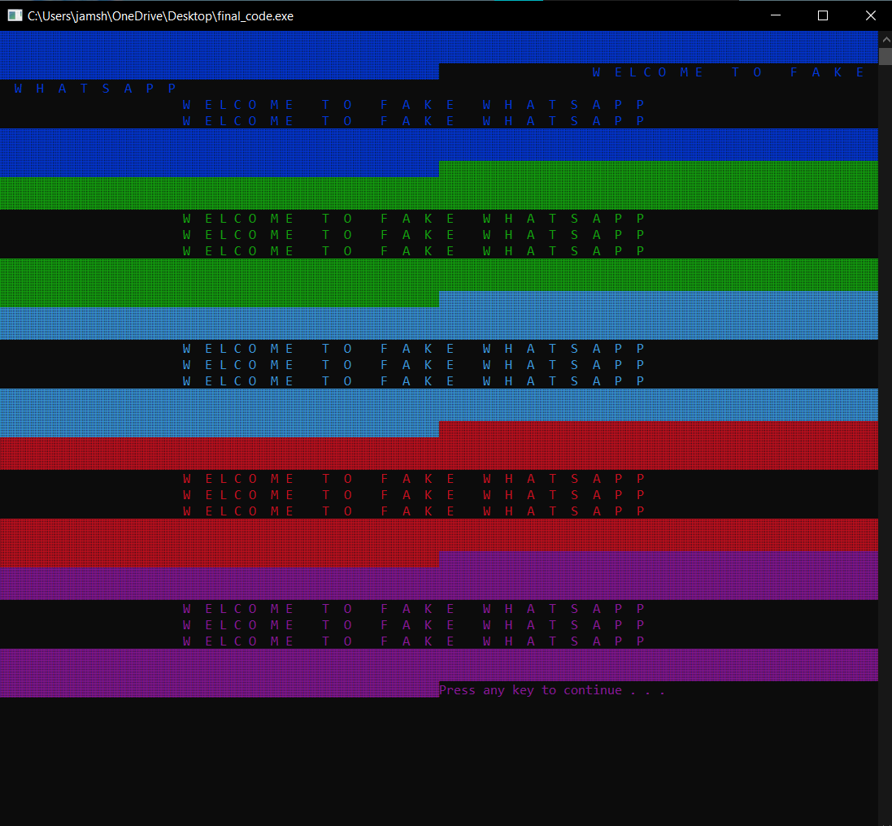

Upon clicking the .exe file of this application you are greated with an amazing enriched with colors animation pane . Which is done via the

Function :

**greetings( )**

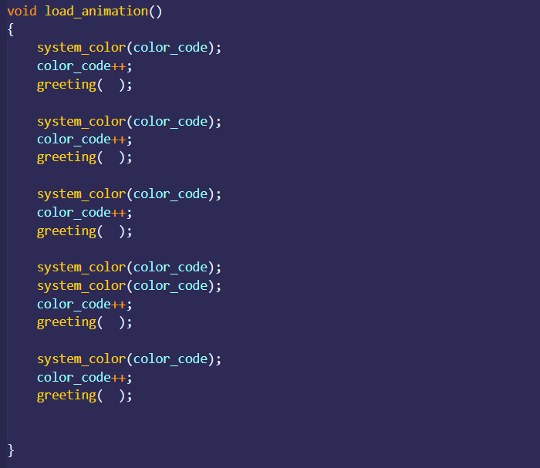**loading( )**

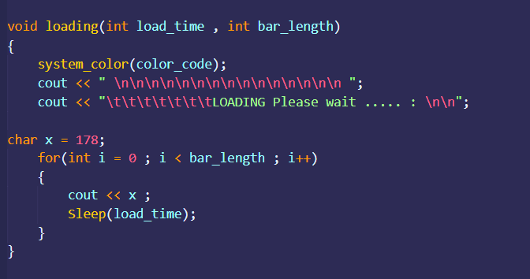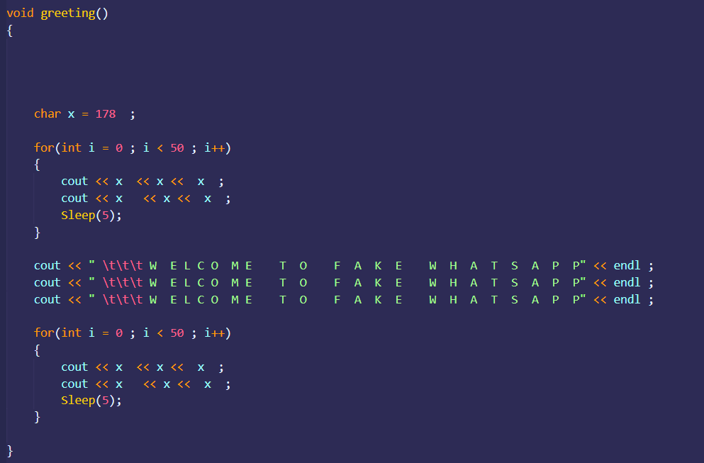**Loading_animation(** )

**The Sudden Loading Bar**

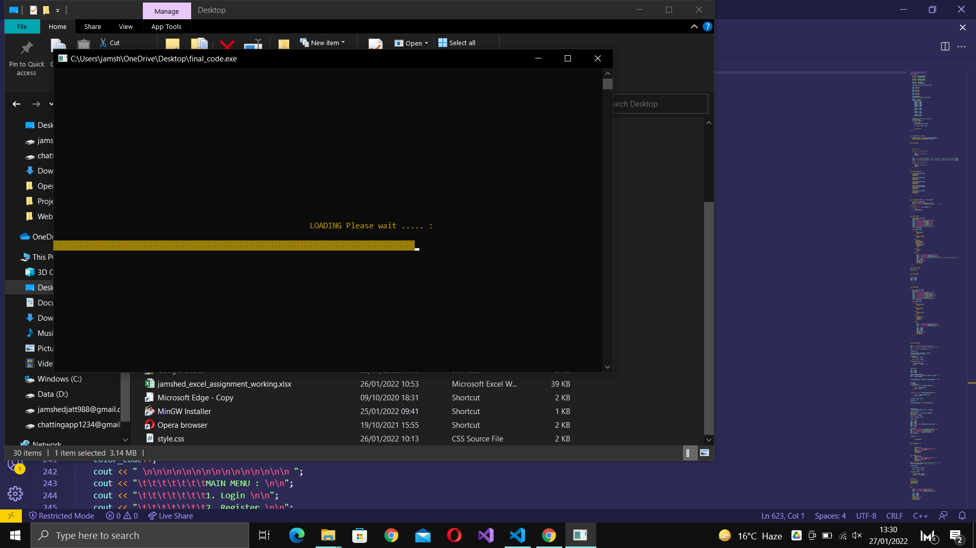

This Is happening due to the function ,

**Loading(int , int )**

This function takes two

Parameters .

The first one controls the

Loading speed of the bar

And the second one controls the

Length of the loading bar .

To achieve this effect we are using :

#include<windows.h>

**We are using the predefined function Sleep(n) ; which pauses n-mili seconds after printing . a unit/char of our loading bar .**

**In the extended ASCII table we have a set of unique**

**Characters at values 176 , 177 , 178 and 219 .**

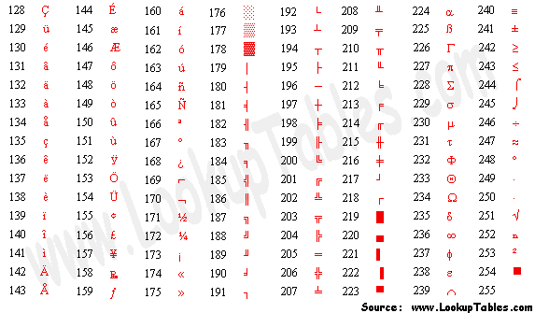





These special characters are being printed using a for loop , in the same line which creates the effect of animated loading bar .

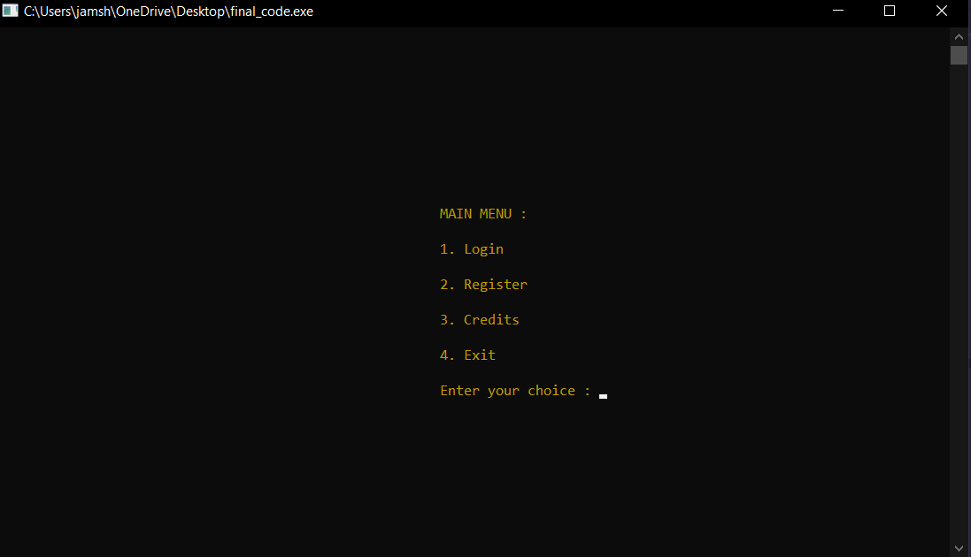**The Main Menu**

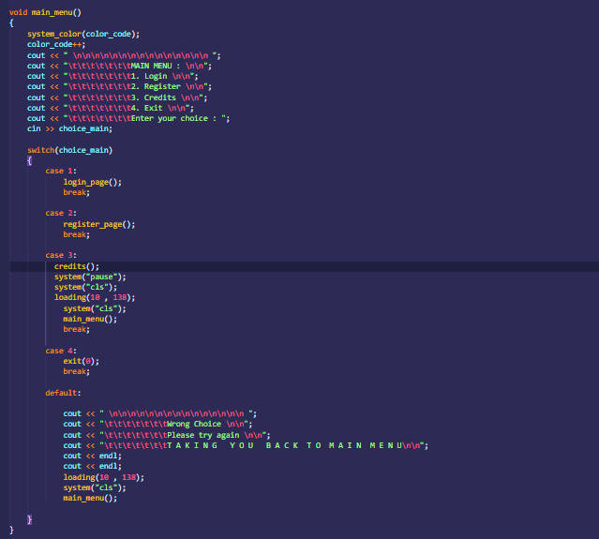

A simple switch

Function that is

Calling awesome

Funcitons that are #

Doing all the magic .

**Main Menu -> 4.Exit**

Just stops the code and exits the terminal

**Main Menu -> 4.Credits**

Using a very nice blend of file handeling and structures we are doing following .

1 . Creating a global structures that has 3 fields , in the string data type .

2 . Created 3 objects(variables) of type credit structure , assign them the id and names of the team members .

3 . then we are using file handeling to create a file by the name of

**Credits.txt , this file is created at the run time .**

in which we are plugging in the values saved via the structure .

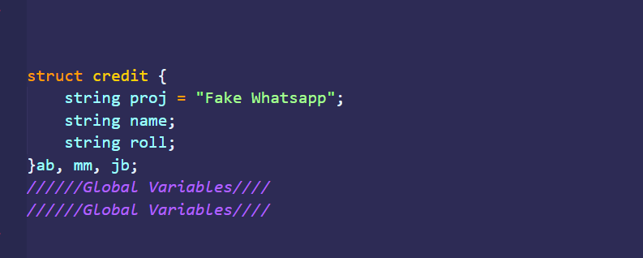4. Fetching the data from the credits.txt file and printing .

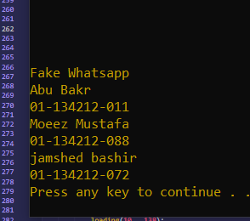

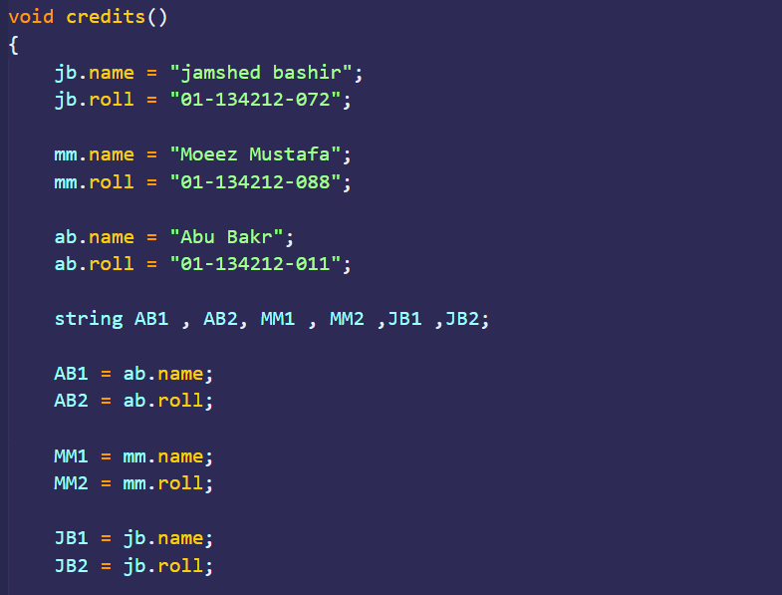

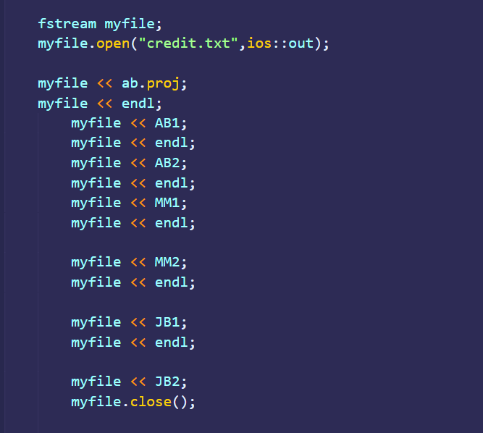

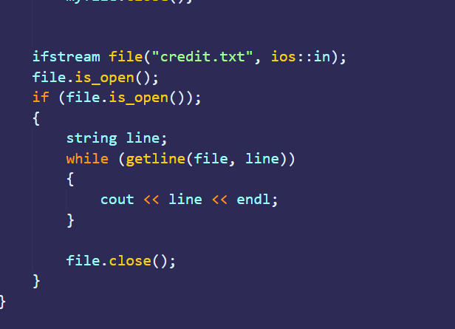

**Main Menu -> 4.Register**

Ahhh !!! The magic begins here !

The register menu takes in the input of Username and password in

The global variable .

The this function is creating ,

A file using a cool trick , it takes the username variable string and adds “.txt” to it . and also makes a database of registered users.

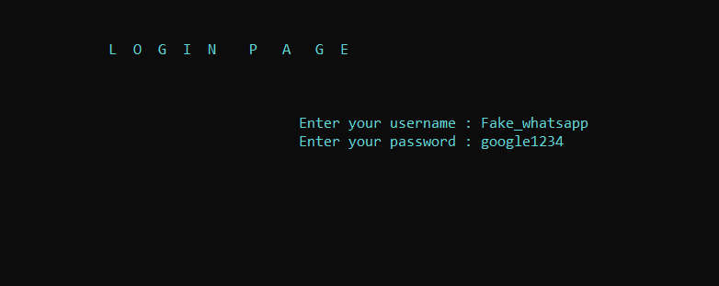

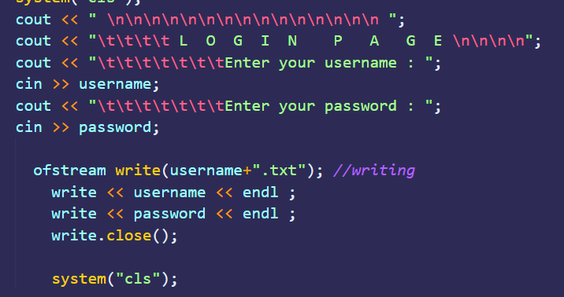

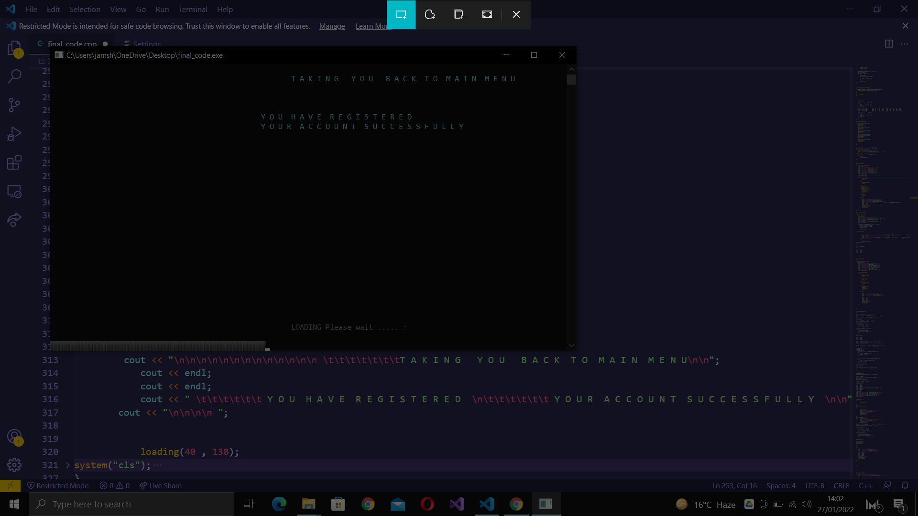

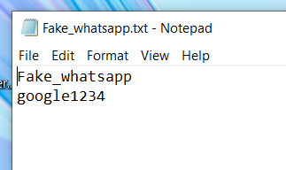

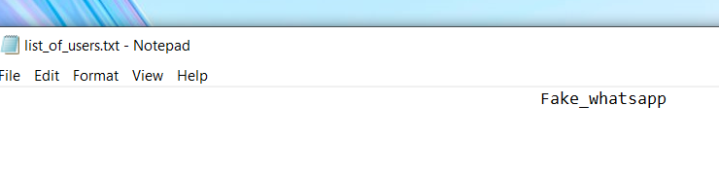

**Main Menu -> 4.Login**

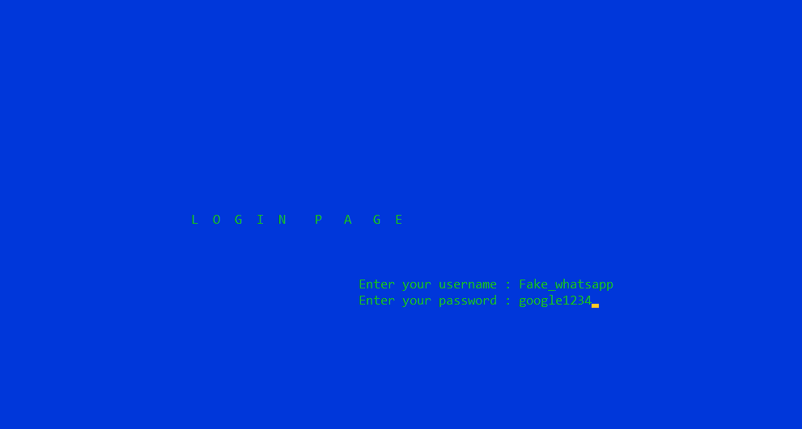

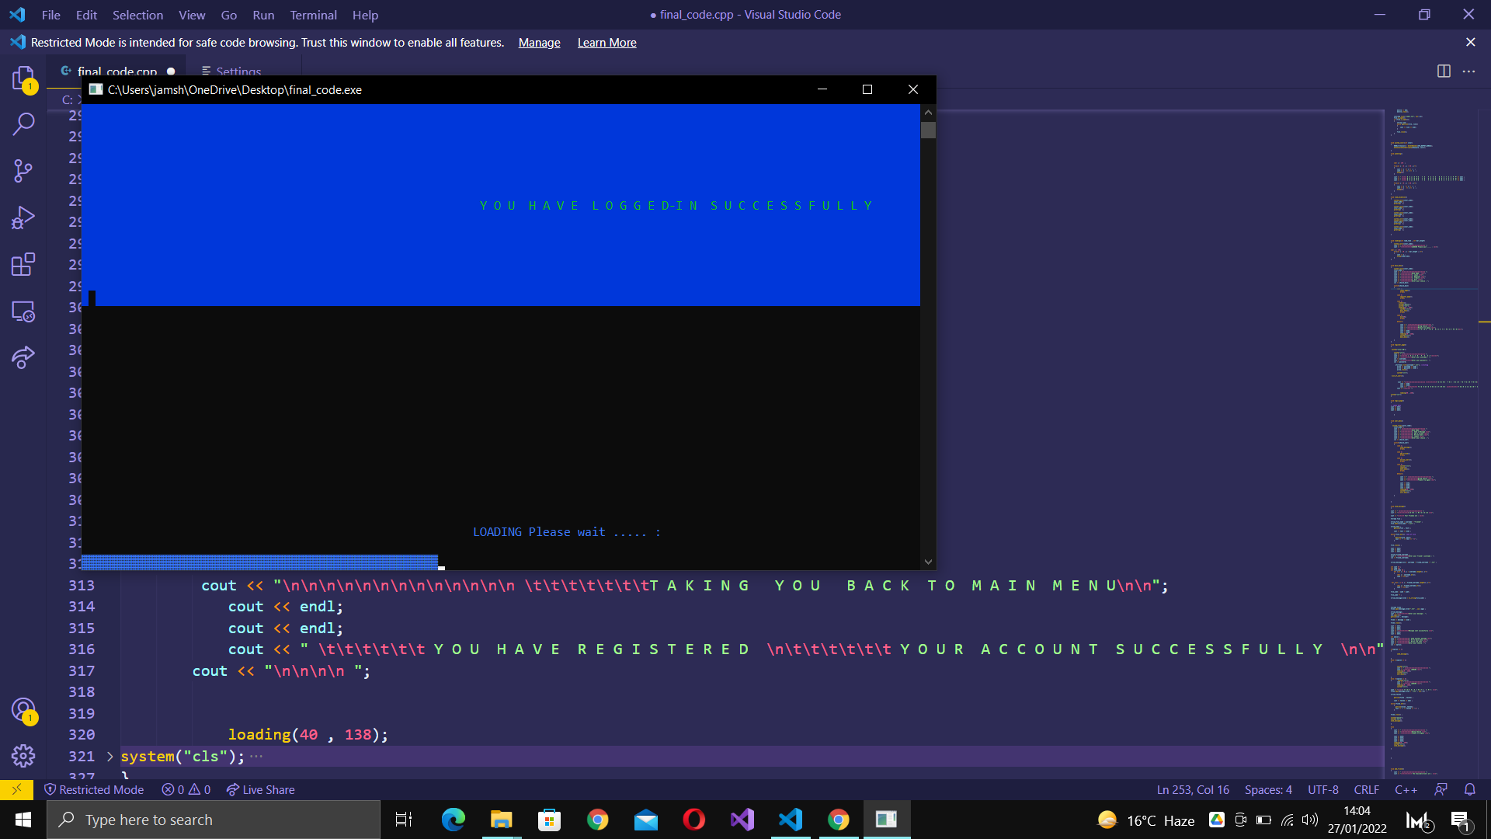

The login takes in the username and password

Opens the file

And fetches the data from the file created during the registration phase

User Login Menu

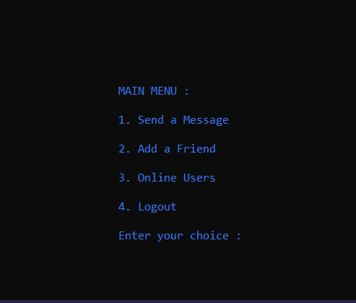

3 . Online users

Remember that database we created during the run time

That is being printed here .

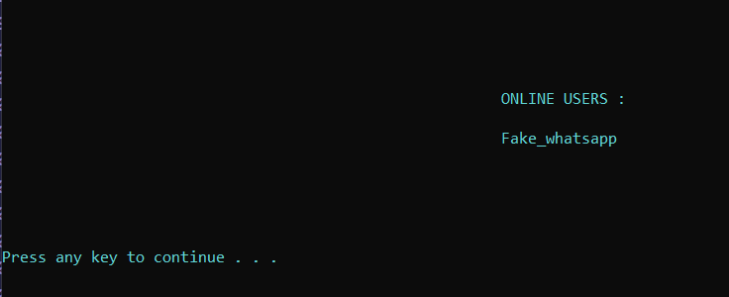

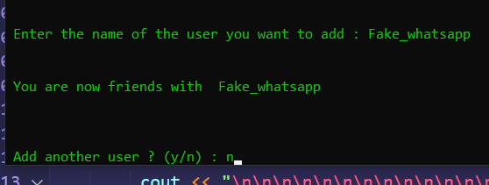2 . Add a Friend

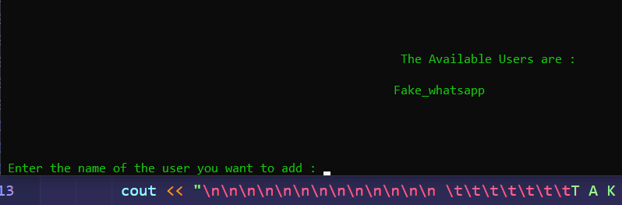

Lists the users active , you will type there username to add them

Now here is one of the cool parts .

The username we entered at login

And this username of a friend

Gets converted into ASCII value and added .

Why are we doing this ?

Well believe or not this is an two way chatting app that works

So what if I add abubakar my friend .

Then my name moeez + abubakar will make a file **abubakarmoeez.txt**

And on doing the opposite we will get a file

**Moeezabubakar.txt**

**In order to always open the same file when 2 same users are chatting over the network we , convert the string into numbers to get a unique but consistent file name .**

1 . Send Message

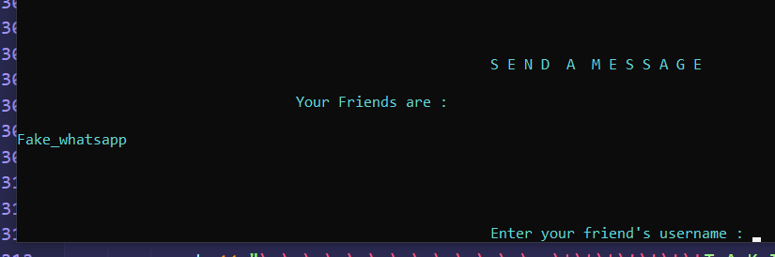

A file saved the list of friends each user has .

Then only prints those users form the network .

Using the same numeric file logic defined above that unique files is being used .

And to store messages from both sides .

Then we are simply printing that numeric named text file to get the chat

Which is being active , instantly in between devices.

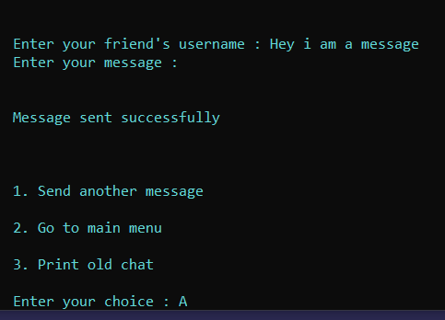

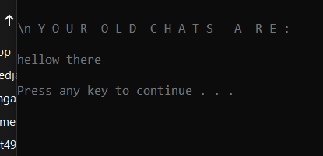

Now how are we chatting in between the devices ?

We are using a magical software , called the

**Google Drive Desktop**

**Which is acting as our server.**

**Extra things used :**

Git / Github for version control

Graphics Library for colors

Windows lib for animation

Google Drive Desktop as server