**Hadoop Stock Exchange Case study**

**Mapreduce Hands-on**

1] Write a map reduce program to split the NYSE_daily.txt into 4 files based on Ticker

*hadoop jar nyse.jar casestudy1.SplitData /user/training/stock/input/NYSE_daily.txt /case1*

*hadoop dfs –get /case1 output/*

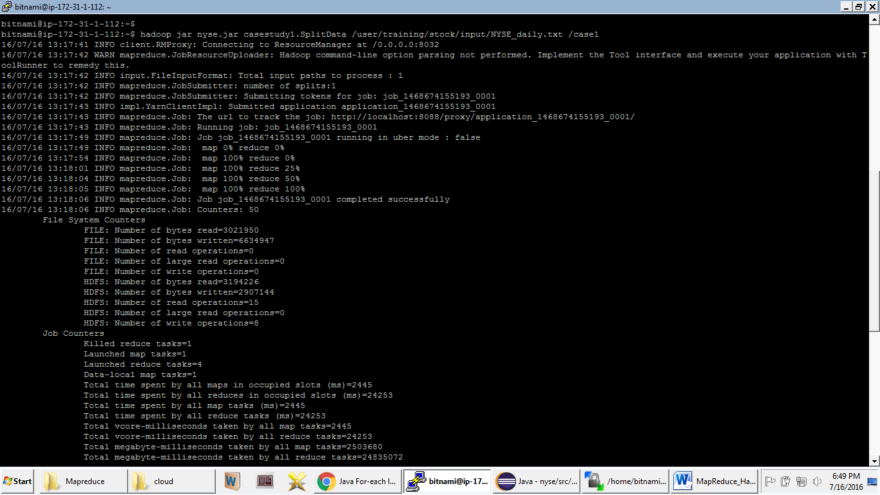

2] Write a Map Reduce Program to find the maximum Variation for each stock ticker

*hadoop jar nyse.jar casestudy2.MaxVariation /case1/p* /case2*

*hadoop dfs –get /case2 output/*

