JavaScript

**What is JavaScript?**

JavaScript is a very powerful **client-side scripting language**. JavaScript is used mainly for enhancing the interaction of a user with the webpage. In other words, you can make your webpage more lively and interactive, with the help of JavaScript. JavaScript is also being used widely in game development and[Mobile](https://www.guru99.com/mobile-testing.html)application development.

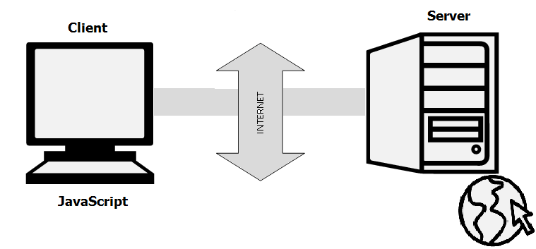

Hello world Example

<script>

alert("Hello world");

</script>

# Variable

Syntax:

var variable_Name=value:

Eg:

var name = "John";

Eg:

<script>

var str = "Calculator";

document.writeln(str + "<br/>");

var n1 = 30, n2 = 20;

var sum = n1 + n2;

var sub = n1 - n2;

document.writeln("Sum:" + sum + "<br/>");

document.writeln("Sub:" + sub + "<br/>");

</script>

Getting input from user

var one = prompt("Enter the first number");

var two = prompt("Enter the second number");

one = parseInt(one);

two = parseInt(two);

## **Data Types**

Primitive datatype

Number,string,Boolean,undefined

Complex datatype

Objects,function

JavaScript variables can hold many **data types**: numbers, strings, objects ,boolen

var length = 16;                               // Number  
var lastName = "Johnson";                      // String  
var x = {firstName:"John", lastName:"Doe"};    // Object

Eg:

<body>

<p id="len"> </p>

<p id="str"> </p>

<p id="obj"> </p>

<script>

var length = 16;

var lastName = "Johnson";

var x = { firstName: "John", lastName: "Doe" };

document.getElementById("len").innerHTML = length;

document.getElementById("str").innerHTML = lastName;

document.getElementById("obj").innerHTML = x.firstName + "" + x.lastName;

</script>

</body>

## **typeof Operator**

The **typeof** operator returns the type of a variable or an expression:

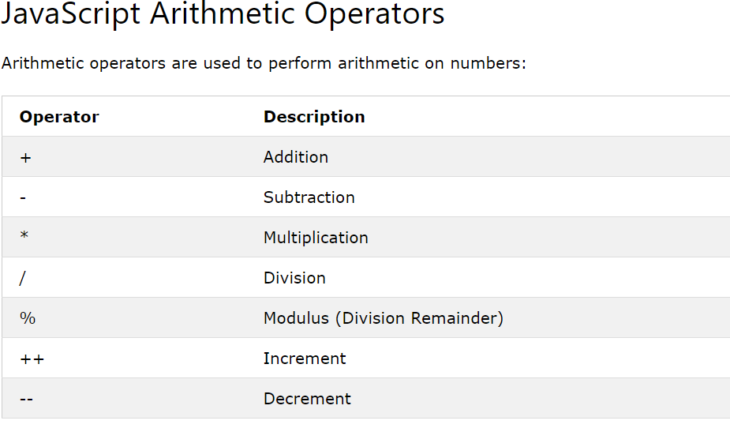

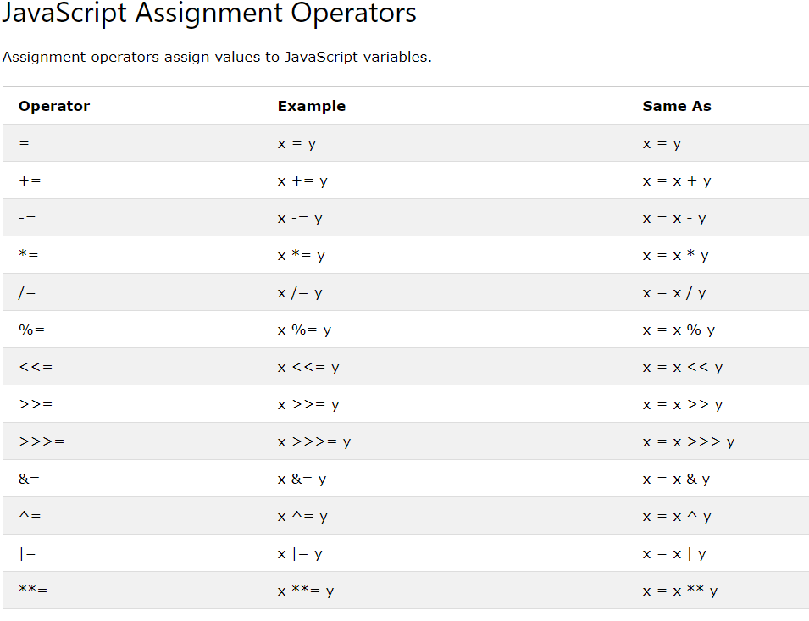

**Different Types of Loops**

There are mainly four types of loops in JavaScript.

1. for loop
2. for/in a loop (explained later)
3. while loop
4. do…while loop

# <https://www.guru99.com/how-to-use-loops-in-javascript.html>

< script type="text/javascript">

document.write("<b>Using while loops </b><br />");

var i = 0, j = 1, k;

document.write("Fibonacci series less than 40<br />");

while(i<40)

{

document.write(i + "<br />");

k = i+j;

i = j;

j = k;

}

</script>

**Different Types of Conditional Statements**

There are mainly three types of conditional statements in JavaScript.

1. If statement
2. If…Else statement
3. If…Else If…Else statement

<script type="text/javascript">

var one = prompt("Enter the first number");

var two = prompt("Enter the second number");

one = parseInt(one);

two = parseInt(two);

if (one == two)

document.write(one + " is equal to " + two + ".");

else if (one<two)

document.write(one + " is less than " + two + ".");

else

document.write(one + " is greater than " + two + ".");

</script>

Function

Syntax:

function name(parameter1, parameter2, parameter3) {  
    code to be executed  
}

<body>

<p id="demo"></p>

<script>

function Addition(a, b) {

return a + b;

}

document.getElementById("demo").innerHTML = Addition(4, 5);

</script>

</body>

Array:

**length property** --> If you want to know the number of elements in an array, you can use the length property.

**prototype property** --> If you want to add new properties and methods, you can use the prototype property.

**reverse method** --> You can reverse the order of items in an array using a reverse method.

**sort method -->** You can sort the items in an array using sort method.

**pop method** --> You can remove the last item of an array using a pop method.

**shift method** --> You can remove the first item of an array using shift method.

**push method** --> You can add a value as the last item of the array.

var color = new Array("Red", "blue", "Green", "Yellow");

Array.prototype.displayItems = function () {

for (i = 0; i < this.length; i++) {

document.write(this[i] + "<br />");

}

}

document.write("color array<br />");

color.displayItems();

document.write("<br />The number of items in students array is " + color.length + "<br />");

document.write("<br />The SORTED students array<br />");

color.sort();

color.displayItems();

document.write("<br />The REVERSED students array<br />");

color.reverse();

## color.displayItems();

## **HTML Events**

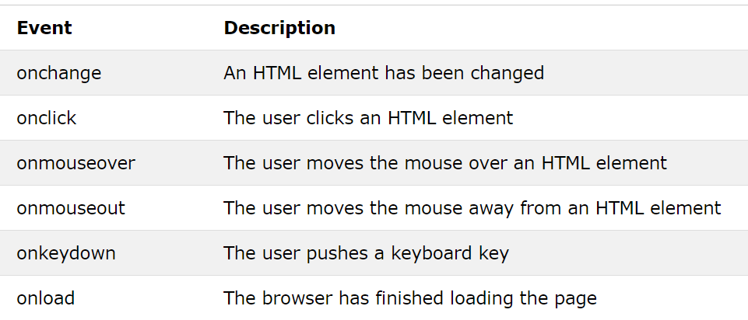

Eg 1:

<!DOCTYPE html>

<html>

<head>

<meta charset="utf-8" />

<title></title>

<script>

var y = 0;

function Addition(a, b) {

return a + b;

}

function myOverFunction() {

document.getElementById("demo3").innerHTML = y += 1;

}

</script>

</head>

<body>

<button onclick="this.innerHTML = Date()">The time is?</button>

<button onclick="document.getElementById('demo').innerHTML=Date()">The time is?</button>

<button onclick="document.getElementById('demo1').innerHTML=Addition(4, 5)">Addition</button>

<p id="demo"></p>

<p id="demo1">Addition Result will be displayed here!!</p>

<div onmouseover="myOverFunction()">

<p>onmouseover: <br> <span id="demo3">Mouse over me!</span></p>

</div>

</body>

</html>

# Cookies

Cookies are saved as key/value pairs.

**What is DOM in JavaScript?**

JavaScript can access all the elements in a webpage making use of Document Object Model (DOM). In fact, the web browser creates a DOM of the webpage when the page is loaded. The DOM model is created as a tree of objects like this:

**[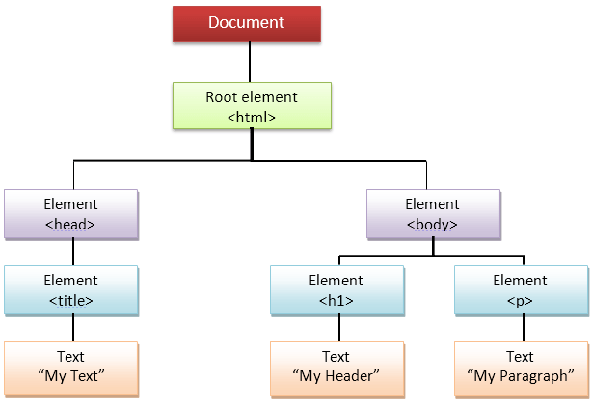](https://www.guru99.com/images/JavaScript/javascript8_1.png)**

**How to use DOM and Events**

Using DOM, JavaScript can perform multiple tasks. It can create new elements and attributes, change the existing elements and attributes and even remove existing elements and attributes. JavaScript can also react to existing events and create new events in the page.

**getElementById, innerHTML Example**

1. getElementById:  To access elements and attributes whose id is set.
2. innerHTML: To access the content of an element.

Example:

<!DOCTYPE html>

<html>

<head>

<meta charset="utf-8" />

<title></title>

<script type="text/javascript">

function change(){

var paragraphs = document.getElementsByTagName("p");

alert("Content in the second paragraph is " + paragraphs[1].innerHTML);

document.getElementById("second").innerHTML = "The orginal message is changed.";

}

</script>

</head>

<body>

<h1>Welcome</h1>

<p>This is the welcome message.</p>

<h2>Technology</h2>

<p id="second">This is the technology section.</p>

<button onclick=" change()">Click to change value</button>

</body>

</html>

Form Validation

<script>

function validateForm() {

var x = document.forms["Register"]["UserName"].value;

var y = document.forms["Register"]["pwd"].value;

var z = document.forms["Register"]["mobileno"].value;

var phoneno = /\d{10}$/

if (x == "") {

alert("Name must be filled out");

return false;

}

else if (y.length < 6) {

alert("Password must more than 6 digits");

return false;

}

else if (!z.match(phoneno)) {

alert("MobileNo should be in 10 digit ");

return false;

}

}

</script>

<form name="Register" onsubmit="return validateForm()" action="Page1.html">

Enter your Name

<input type="text" name="UserName" value="UserName" /><br /><br />

Enter your Password

<input type="password" name="pwd" /><br /><br />

Enter Your Age

<input type="number" name="UserAge" min="20" max="30" required /><br /><br />

Enter Your Mobile No

<input type="text" name="mobileno" /><br /><br />

Enter Email

<input type="text" name="UserEmail" /><br /><br />

Gender<br />

<input type="radio" name="gender" value="male" checked> Male<br>

<input type="checkbox" name="gender" value="female">Female <br>

<input type="checkbox" name="gender" value="VoterId">other<br>

<br />

List of Proof

<br />

<input type="checkbox" name="Proof" value="Pancard" checked> PanCard<br>

<input type="checkbox" name="Proof" value="Aadharcard">AadharCard <br>

<input type="checkbox" name="Proof" value="VoterId">VoterId<br>

<br />

<input type="submit" />

<input type="reset" />

</form>