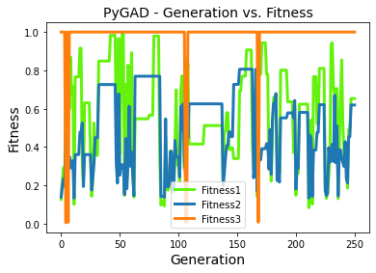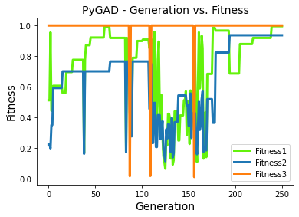
2.6_50 2.7_50
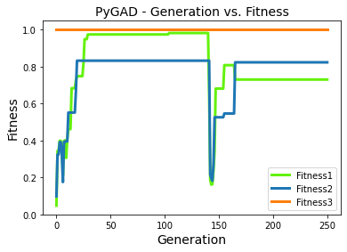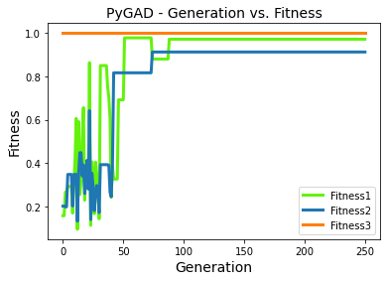
2.8_50 2.9_50
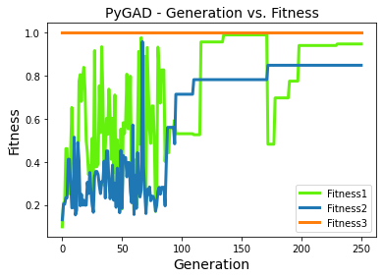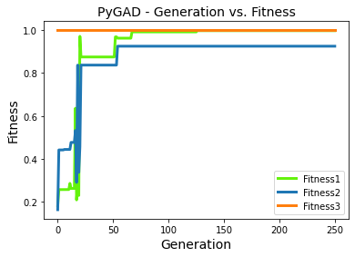
3.0_50 3.1_50
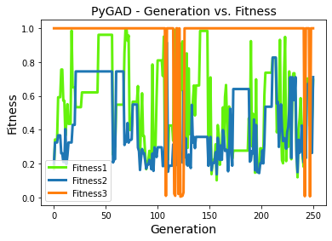
3.2_50
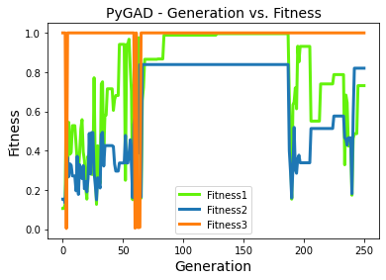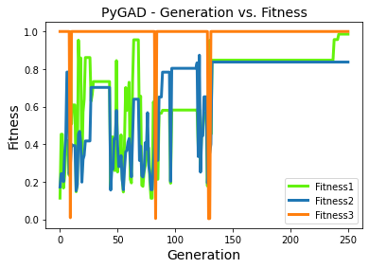
2.6_55 2.7_55
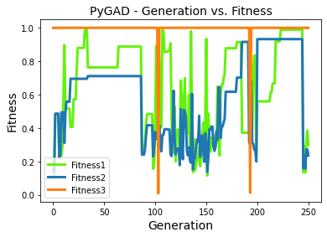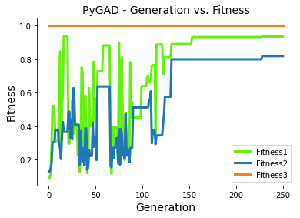
2.8_55 2.9_55
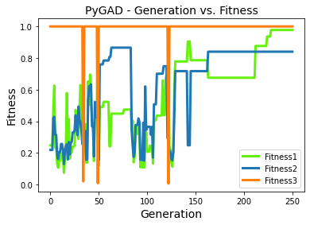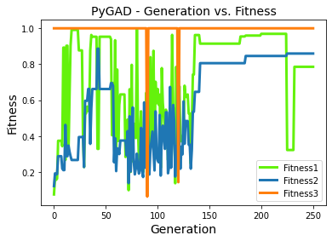
3.0_55 3.1_55
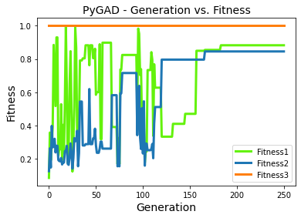
3.2_55
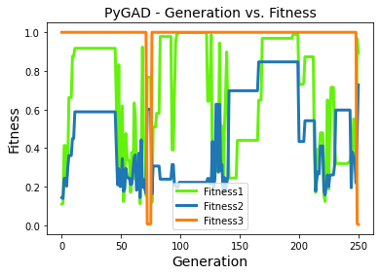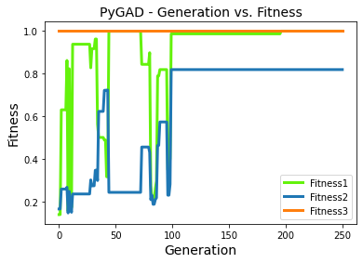
2.86_55.85 2.86_55.85

Cr
Best solution: [ 8.62625003 -0.12612385 -0.85900739 -0.15433855 -1.8264094 ]
Fitness of the best solution: [1. 0.9970641 0.45243519]
Time is 14847.205430984497
Best solution: [ 8.56850643e+00 -9.90138585e-01 -6.45370348e-01 -3.17528649e-01
-2.42332625e-03]
[ 8.56850643 -0.99013859 -0.64537035 -0.31752865 -0.00242333 ]
Fitness of the best solution: [1. 0.99735984 0.80590485]
Vanadium:
Best solution: [ 8.12859988 -0.36072256 0.31910873 -0.17289057 -1.22416082]
Fitness of the best solution: [1. 0.99960515 0.43691907]

[ 8.33366357e+00 -6.52600934e-01 -2.00141617e-01 -1.26518029e-03
-7.77795122e-01]
[ 8.33366357, -0.65260093, -0.20014162, -0.00126518, -0.77779512 ]
Fitness of the best solution: [1. 0.99914598 0.91771593]

Best solution: [ 9.34676187 -0.29971432 -0.14923777 -0.54564174 -1.46450099]
Fitness of the best solution: [1. 0.99975993 0.30414296]

