**Department of Electrical Engineering**

|  |  |
| --- | --- |
| **Faculty Member:** | **Dated:** |
|  |  |
| **Course/Section:** | **Semester:** |
|  |  |

**Computer Organization and Assembly Language (CS235)**

**Lab #**

**Operating the board (Introduction part 2)**

**Grp no.**

|  |  |  |  |  |
| --- | --- | --- | --- | --- |
| **Name** | **Reg. no.** | **Report Marks / 10** | **Viva Marks / 5** | **Total/15** |
| **Arifullah Jan** | **186943** |  |  |  |
| **Bilal Khalid** | **128608** |  |  |  |
| **Waqas Yaseen** | **196819** |  |  |  |
|  |  |  |  |  |

Objective

Upon completion of this lab, you will be able to locate and describe the various components on your circuit board, and demonstrate basic trainer functions.

**Answer the following questions.**

## Q 1. Which keys can you use to enter data into memory?

WRT key can be used to edit the contents of memory once the screen shows some memory content.

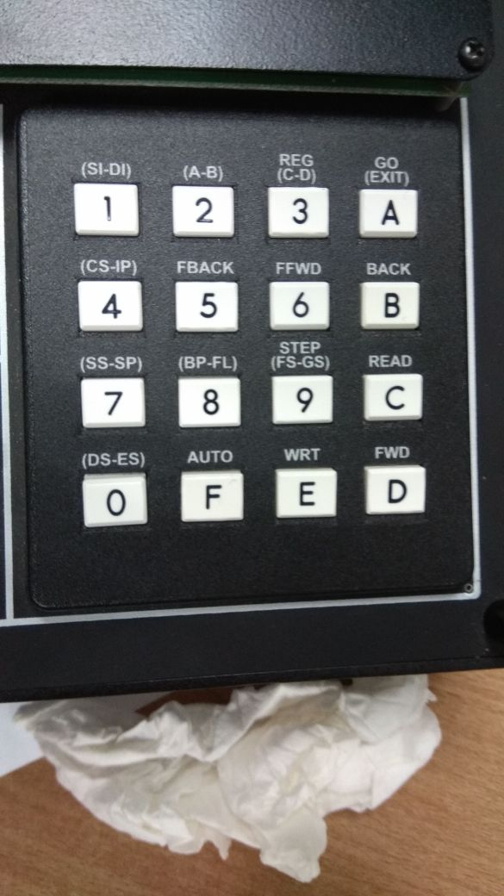

## Q 2. Which register pair always contains the address of the next instruction that the CPU will fetch?

CS IP . CS stands for Code segment while IP stands for Instruction pointer. Linear address is needed to calculate using these.



## Q 3. Press <REG> and select <(A-B)>. What number EAX contain?

It will contain a 32 bit number

A sample would be like XXXX XXXX in hex

The format is

EAX: XXXX XXXX

EBX: XXXX XXXX

## Q 4. Each time you press the FFWD key. What does the first byte in the display (after the address) represent?

FFWD mean fast forward. It is used to move forward quickly. (8 bytes at a time)

## Q 5. Which key would not be used to change the contents of CPU register?

STEP key cannot be used.