# Online : <https://js-nrbe2w.stackblitz.io>

# Task 1 & TASK 2

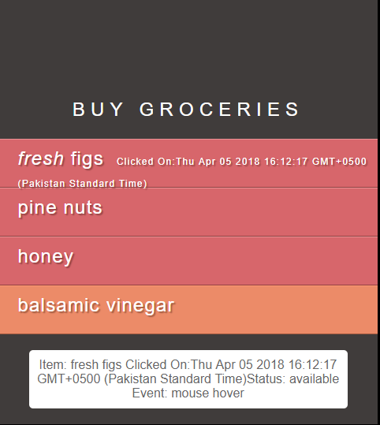

# HTML;

<!DOCTYPE html>

<html>

<head>

<title>JavaScript &amp; jQuery - Chapter 7: Introducing jQuery - Event Object</title>

<script src="js/jquery-1.11.0.js"></script>

<script src="js/date.js"></script>

</head>

<body>

<div id="page">

<h1 id="header">List</h1>

<h2>Buy groceries</h2>

<ul>

<li id="one" class="hot "><em>fresh</em> figs <span class="date"></span></li>

<li id="two" class="hot important">pine nuts <span class="date"></span></li>

<li id="three" class="hot important">honey <span class="date"></span></li>

<li id="four">balsamic vinegar <span class="date"></span></li>

<li id ="five" >linguine</li>

<li id ="six" >cream</li>

<li id ="seven">coconut milk</li>

<li id ="eight">mushrooms</li>

<li id ="nine">apples</li>

<li id ="ten">strawberries</li>

<li id ="eleven">rice crackers</li>

<li id ="twelve">brie</li>

<li id ="thirteen">rice </li>

<li id ="fourteen">green tea</li>

<li id ="fifteen">vine-ripened tomatoes</li>

<li id ="sixteen">bananas</li>

<li id ="seventeen">red kidney beans</li>

<li id ="eighteen">haricot beans</li>

<li id ="nineteen">lettuce</li>

<li id ="twenty">organic brown rice vineger</li>

<li id ="twentyone">sushi nori</li>

<li id ="twentytwo">garlic</li>

<li id ="twentythree">ginger</li>

<li id ="twentyfour">red onions</li>

<li id ="twentyfive">goat's cheese</li>

<li id ="twentysix">baby leaf spinach</li>

<li id ="twentyseven">coconut</li>

<li id ="twentyeight">avocado</li>

<li id ="twentynine">leeks</li>

<li id ="thirty">carrots</li>

<li id ="thirtyone">pears</li>

<li id ="thirtytwo">apples</li>

<li id ="thirtythree">organic free-range eggs</li>

<li id ="thirtyfour">cashew nut butter</li>

<li id ="thirtyfive">lemons</li>

<li id ="thirtysix">coconut oil</li>

<li id ="thirtyseven">sourdough bread</li>

<li id ="thirtyeight">alomond milk</li>

<li id ="thirtynine">kale</li>

<li id ="forty">gluttin-free soy sauce</li>

<li id ="fortyone">quinoa</li>

</ul>

<p id="info"></p>

</div>

</body>

</html>

js$('li').on('click', function() {

var d = new Date();

$(this).find('.date').text('Clicked On:'+d);

});

$('li').on('click', function () {

var item = $(this).text();

var status;

if ($(this).hasClass('important')) {

status = 'important';

}

else {

status = 'available';

}

$('#info').text('Item: ' + item + 'Status: ' + status + ' Event: click');

});

$('li').on('mouseover', function () {

var item = $(this).text();

var status;

if ($(this).hasClass('important')) {

status = 'important';

}

else {

status = 'available';

}

$('#info').text('Item: ' + item + 'Status: ' + status + ' Event: mouse hover');

});

# Task 4

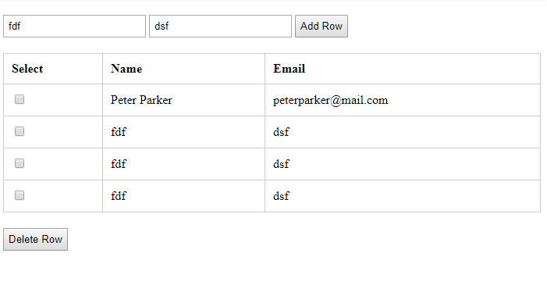

## HTML