WEBLAB09

# Task 2

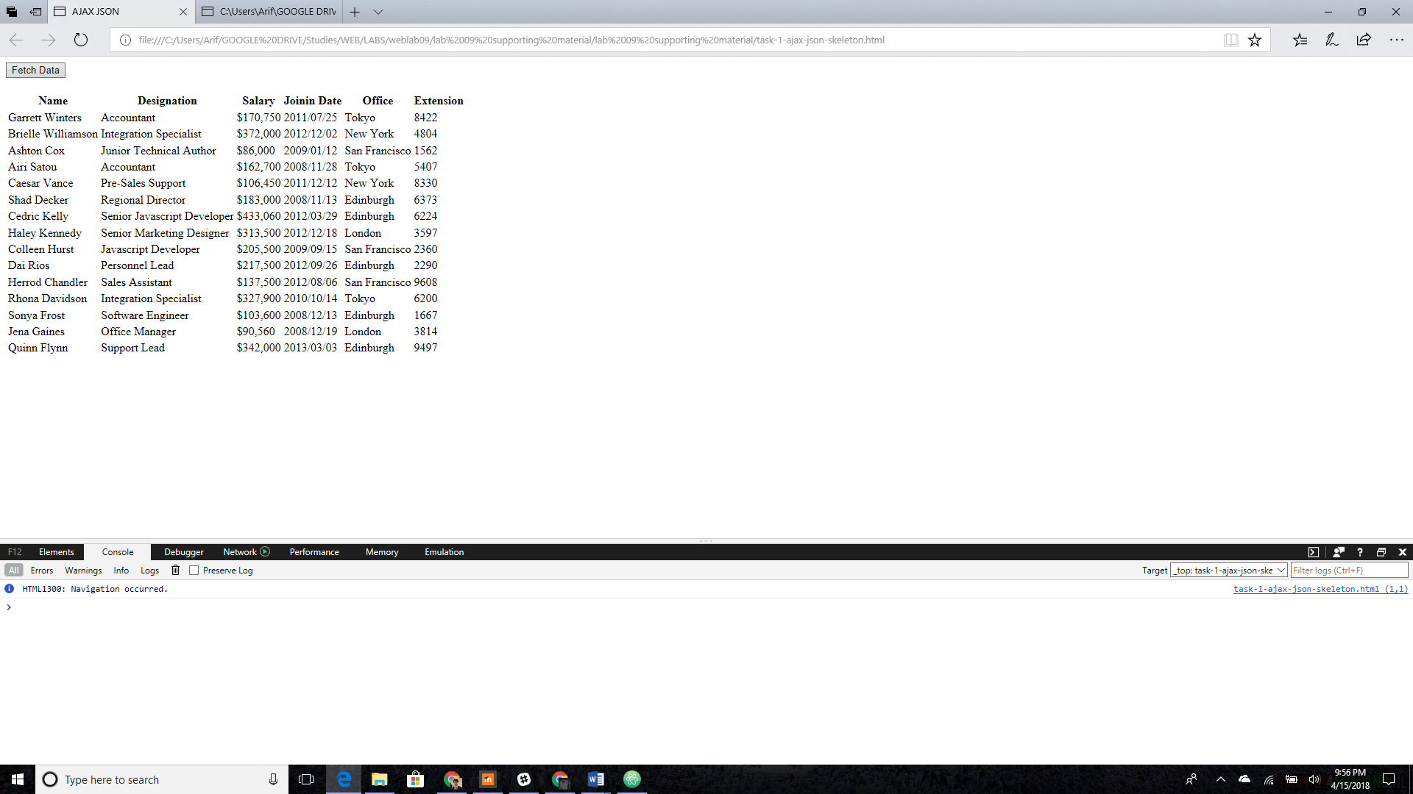

<!DOCTYPE HTML>

<html>

<head>

<meta charset="utf-8">

<title>AJAX JSON</title>

<script src="jquery-3.2.1.js"></script>

</head>

<body>

<button type="button" id='submitButton'>Fetch Data</button>

<br><br>

<div id="location"></div>

<script>

$(document).ready(function(){

alert('jQuery is working!')

$('#submitButton').on('click', function(){

$.ajax({

url: 'emp_data.json',

dataType: 'json',

success: function (result){

var table = "<table><thead><tr><th>Name</th><th>Designation</th><th>Salary</th><th>Joinin Date</th><th>Office</th><th>Extension</th></tr></thead>";

$(result.empolyees).each(function(){

table += '<tr><td>' + this.name + '</td>' +

'<td>' + this.designation + '</td>' +

'<td>' + this.salary + '</td>' +

'<td>' + this.joining_date + '</td>' +

'<td>' + this.office + '</td>' +

'<td>' + this.extension + '</td>' +

'</tr>';

});

table += '</table>';

$("#location").append(table);

},

// error:function(res, status){

// alert(status + res);

// }

});

});

})

</script>

</body>

</html>

# Task 2

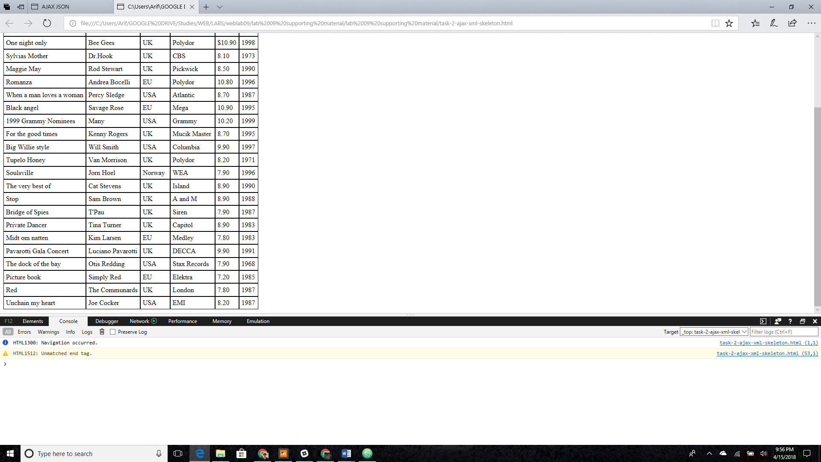

<!DOCTYPE html>

<html>

<style>

table,th,td {

border : 1px solid black;

border-collapse: collapse;

}

th,td {

padding: 5px;

}

</style>

<body>

<button type="button" id='submitButton'>Get my CD collection</button>

<br><br>

<table id="demo"></table>

<div id="error"></div>

<script src="jquery-3.2.1.js"></script>

<script type="text/javascript">

$(document).ready(function(){

alert('jQuery is working');

$('#submitButton').on('click', function(){

alert('click is working');

// your ajax call here e.g. $.ajax({ url: 'cd_catalog.xml', ...})

$.ajax({

url: 'cd_catalog.xml',

type: 'GET',

dataType: 'xml',

success: function (data) {

var table="<tr><th>Title</th><th>Artist</th><th>Country</th><th>Company</th><th>Price</th><th>Year</th></tr>";

$.each(data.getElementsByTagName('CD'), function(){

//alert('"each" call');

table += "<tr><td>" + this.getElementsByTagName("TITLE")[0].childNodes[0].nodeValue + "</td><td>" + this.getElementsByTagName("ARTIST")[0].childNodes[0].nodeValue + "</td>";

table += "<td>" + this.getElementsByTagName("COUNTRY")[0].childNodes[0].nodeValue + "</td><td>" + this.getElementsByTagName("COMPANY")[0].childNodes[0].nodeValue + "</td>";

if ($(this).find("PRICE").attr("currency")=="$"){

add = "$"+this.getElementsByTagName("PRICE")[0].childNodes[0].nodeValue;

}

else{

add = this.getElementsByTagName("PRICE")[0].childNodes[0].nodeValue;

}

table += "<td>" + add + "</td><td>" + this.getElementsByTagName("YEAR")[0].childNodes[0].nodeValue + "</td></tr>";

});

$('body').append(table);

}

});

});

});

</script>

</script>

</body>

</html>