Republic of the Philippines

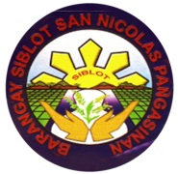Province of Pangasinan

Municipality of San Nicolas

**BARANGAY SIBLOT**

Office of the Punong Barangay

**CERTIFICATE OF INDIGENCY**

TO WHOM IT MAY CONCERN

This is to certify that **{NAME}** resident of Barangay Siblot, San Nicolas, Pangasinan**.**

This is to certify further that the family of the person stated above is one of the indigent families in this barangay and their income is not sufficient to sustain their daily needs.

This certification is being issued upon the request of the aforementioned name for **{PURPOSE}**

Issued on this {DATE} in Barangay Siblot, San Nicolas, Pangasinan.

**HON. NOEL A. LADIA**

Punong Barangay

My Home My Pride