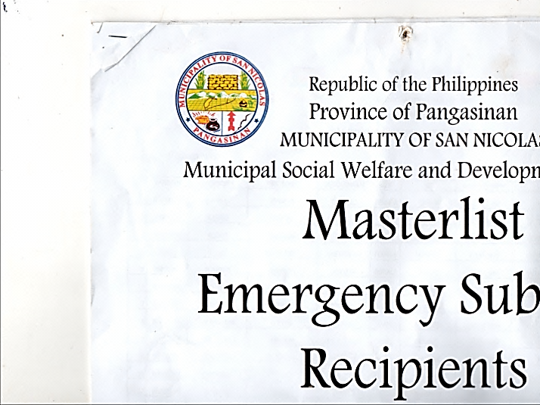

***REPUBLIC OF THE PHILIPPINES***



***PROVINCE OF PANGASINAN***

***MUNCIPALITY OF SAN NICOLAS***

***BARANGAY SIBLOT***

OFFICE OF THE PUNONG BARANGAY

**CERTIFICATE OF RESIDENCY**

TO WHOM IT MAY CONCERN:

This is to certify that {NAME}**,**  of legal age**,** is a resident in Barangay Siblot, San Nicolas, Pangasinan.

This certification is being issued upon the request of the aforementioned name for {PURPOSE}**.**

Issued this {DATE} in Barangay Siblot, San Nicolas, Pangasinan.

**HON. NOEL A. LADIA**

Punong Barangay