Grant overview · PWN DAO Foundation · October 2026

Private Lending
for Aleo
Universal lending infrastructure for Aleo, built in Leo by the team behind OWN and inspired by PWN’s bilateral, oracle-free lending mechanics.
Applicant  PWN DAO Foundation  Team behind OWN · PWN protocol lineage | Timeline  ~4 months  four milestones | Grant request  $85,000  mainnet launch | Deliverable  Protocol on mainnet  programs · SDK · reference app

The applicant is the PWN DAO Foundation. The team previously developed PWN, a peer-to-peer lending protocol deployed on 13 EVM chains. The team now operates as OWN, building crypto-backed mortgages on top of PWN’s lending infrastructure. Lenders and borrowers agree on fixed loan terms directly, without price oracles or price-based liquidations. This bilateral model fits a privacy-first ZK chain particularly well, because individual loans stay isolated instead of depending on global liquidity, utilisation and liquidation state.
This grant funds universal lending infrastructure for Aleo, designed around PWN v1.5’s lending mechanics: funded Elastic Proposals as the first offer type, private bilateral lending, a modular Hub and Config layer, a TypeScript SDK and a reference application, with a mainnet launch as the final milestone. A feasibility PoC of the core programs is already deployed and exercised on the Aleo testnet (see Current status).

Team
Josef Jelacic — Founder of PWN DAO and OWN. LinkedIn
Šimon Kozák — Founding Engineer & CTO at PWN DAO and OWN. LinkedIn · GitHub
Jan Mikšík — Engineer, 4 years of building PWN’s DeFi lending application. LinkedIn · GitHub

Protocol model
Each loan fixes the credit asset and amount, the collateral asset and amount, the repayment amount and the maturity. If the borrower repays, collateral is returned. If the loan is unpaid at maturity, the lender can claim the collateral; until the lender does so, the borrower can still repay. There is no price feed, no health factor and no price-based liquidation, which makes the model a natural fit for minimising public disclosure on Aleo.
The protocol is written in Leo around Aleo's record and execution model, drawing on PWN's lending mechanics and modular architecture.
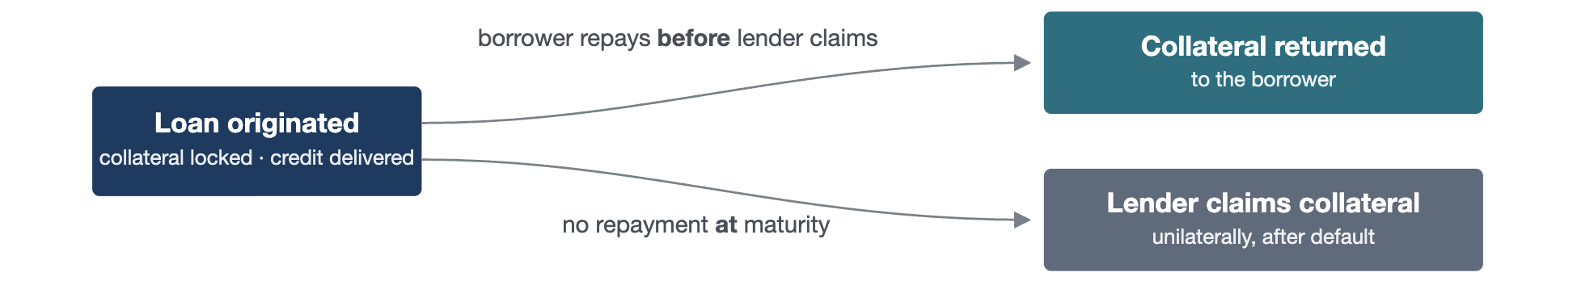
Two outcomes, decided only by the borrower's action and the clock. No third party, no price feed, no liquidation.

Current status
The feasibility work is done. The four core programs are deployed on the public Aleo testnet and the complete lifecycle (funded commitment, borrower draw, repayment, default claim, refund and repayment withdrawal) has been executed there with real proofs, collateral on the live token_registry.aleo, and privately paid fees.
Custody & funded commitments  Demonstrated on testnet. Lender commits once; borrower draws without any lender transaction; every exit settles into a private record. | Privacy  Measured on real transactions. No lender or borrower address in any lending transaction paid with a private fee, which the SDK will enforce; amounts, terms and IDs public by design. | Costs & timings  Within limits. 0.005–0.019 ALEO per call; proving 25–41 s on a laptop; confirmation in 1–4 blocks.

Not yet done: direct offers, USDCx execution against the live stablecoin, a complete test suite and external review. These are the subject of the milestones below.

Feasibility questions, answered by the PoC
01 Can lender credit be committed once and drawn asynchronously without lender participation? Yes. Draws are signed by the borrower only.
02 Can custody safely support private → controlled state → private asset flows? Yes, for native credits and token-registry assets; a premature default claim was rejected by network finalization. Escrow is protected against users, not against a collateral token’s issuer powers; see Open questions.
03 What is public, private, inferable or linkable in each transition? Measured; see the privacy page.
04 Does the model work within USDCx compliance and token-registry constraints? Token registry: yes, live. USDCx: interfaces compile against the real bytecode; execution with freeze-list proofs is part of Milestone 1.
05 Can Proposal, Loan and token programs compose within proving and transaction limits? Yes. A draw is four transitions across three programs in one transaction, at about 6% of the constraint limit.
06 Measured proving and execution times? 25–41 s per call on a laptop; 0.005–0.019 ALEO per call; confirmation in 1–4 blocks.

Elastic Proposal: the default offer type
In PWN's EVM implementation, an elastic proposal lets one lender publish a single reusable offer with a credit limit, a minimum draw and a fixed credit-to-collateral ratio. Borrowers draw from it independently; each draw is its own bilateral loan with its own collateral and maturity. It is not a pool: no shared position, no mutualised risk.
Proposal versus loan. A proposal is an offer and its available funding; each accepted draw creates a separate loan with its own collateral, repayment obligation and maturity. Proposal expiry stops new draws, not existing loans. Cancelling a proposal returns unused funding without cancelling active loans.
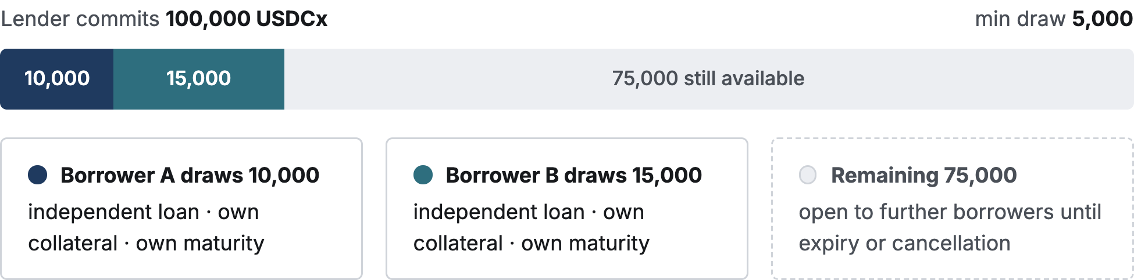

Why this is the default on Aleo
An Aleo transaction has a single signer and a program cannot spend a private record on a counterparty’s behalf, so our asynchronous acceptance flow commits capital in advance. Elastic proposals make every offer backed by real capital and allow discovery from public state without a proprietary backend. Multiple draws reuse one funded offer. The lender’s address stays private in the lending calls, while each loan publicly references the commitment it draws from. Direct offers use the same mechanism, with acceptance restricted to a designated borrower through a private proof of authorisation.

Discovery and indexing
Public Elastic Proposals remain canonical in Aleo public state. The SDK queries that state directly; an optional indexer or cache improves filtering and UX but is never a trusted source of truth. The wallet and SDK must discover private token records and securely retain the authorisation data needed to recover and manage loan positions.
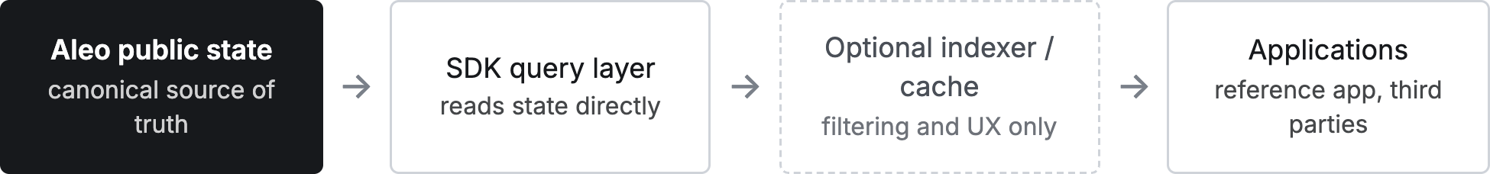

Architecture
Target production architecture. The grant completes and audits these module boundaries before the core is deployed without upgradeability.
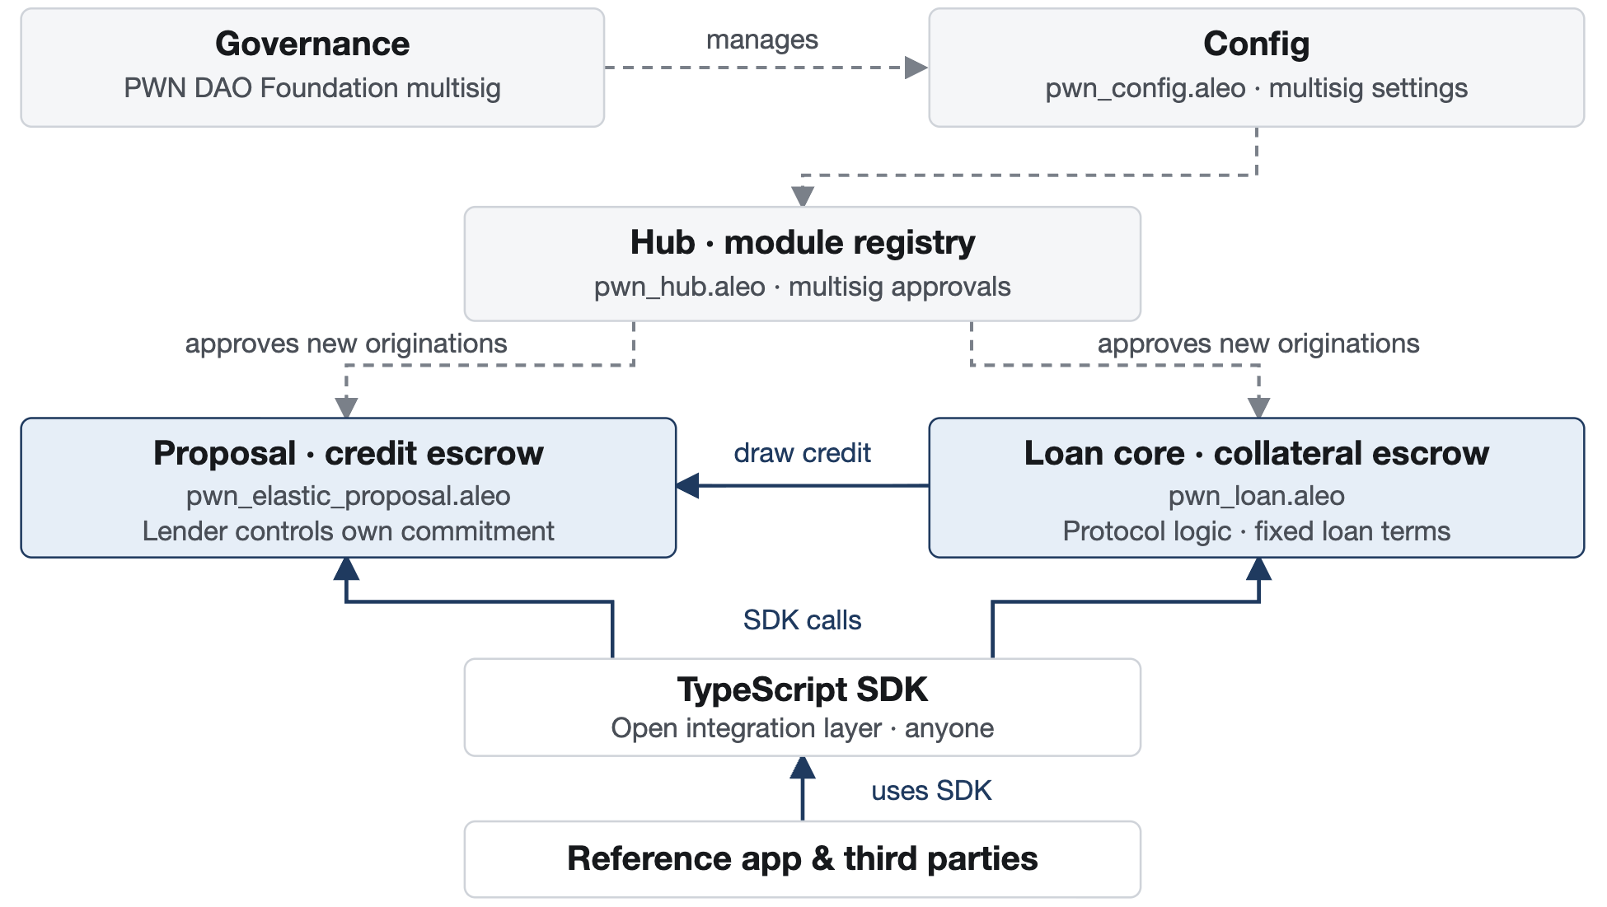
Dashed arrows: governance and module approval. Solid arrows: calls between layers. Asset transfers follow the loan lifecycle.
Layer | Program | Controlled by | Can affect existing loans
Governance | – | PWN DAO Foundation multisig | No
Registry & config | pwn_hub.aleo  pwn_config.aleo | multisig | No: approves modules for new originations only
Proposal | pwn_elastic_proposal.aleo | lender | Own commitment only
Loan core | pwn_loan.aleo | protocol logic | Terms fixed at origination
Integration | TypeScript SDK | anyone | –
Application | Reference app, third parties | anyone | –

Governance can decide what may be created next. It can never alter, seize or redirect a loan that already exists.
Hub. Registers approved modules for new loan originations: pwn_loan.aleo → ACTIVE_LOAN, pwn_elastic_proposal.aleo → PROPOSAL_MODULE. Future installments, crowdfunding and refinancing arrive as new versioned modules.
Config. Minimal protocol-wide settings: protocol fee (zero in V1), fee recipient, multisig authority, and an emergency stop for new originations. Loan-specific economic terms are fixed at creation and cannot be changed later through Config.
After audit. The production core will be deployed without upgradeability after the external audit and resolution of material findings. New functionality is introduced through new modules; existing loans remain in the immutable programs holding their funds. Third-party token programs may retain their own issuer and upgrade powers.

Universal and extensible lending
Elastic Proposal is the first offer type, not the limit of the framework. Following PWN v1.5, the target architecture separates proposal validation and product rules from shared custody and settlement. Additional proposal types that fit the agreed interfaces can be introduced as new modules without changing the deployed core.
Installment products, crowdfunding and refinancing can build on these extension points.
PWN v1.5 also provides borrower and lender hooks around loan creation and repayment, enabling integrations such as refinancing and external lender vaults. Equivalent Aleo integration points are a future extension, subject to privacy, authorisation and proving limits; hooks are not part of the demonstrated PoC.

Privacy model, measured on testnet
V1 behaviour as measured on the public Aleo testnet with the PoC programs, from confirmed transactions re-fetched from the network. What remains linkable is listed, not hidden.
Public by design  Required for the protocol to function, not a compromise.  existence of an offer · asset pair · available liquidity · minimum draw · duration · expiry · loan maturity · settlement and default events | Private in V1  Identities are not written to protocol public state; loan activity remains visible under public identifiers.  identity of the lender · identity of the borrower · the relationship between them · repayment history linked to a wallet identity · link between an offer and a particular borrower

Direct offers can keep more terms private.

Where the boundary sits
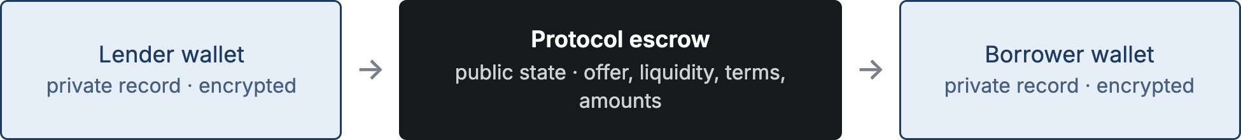
Value passes through program-controlled public state; ownership on both ends stays in encrypted records. Amounts are visible in the middle; that is the leakage measured below.

Known leakage, measured
Leak | Measured on testnet | Mitigation
Collateral amount | Public in the loan witness and in the token escrow delta | Normalised denominations; commitment-based private accounting in a later version
Draw amount | Public in the loan witness; delta in available liquidity per draw | Normalised draw steps
Lender / borrower address | Not present in any of the six lending flows when fees are paid from a private record; only program addresses appear. A public fee would name the payer. | Private fees, validated; the earlier public shielding transaction remains visible
Commitment → loan link | Public by construction (commitment ID inside the loan witness) | The link is public; it does not by itself reveal the lender’s address
Temporal correlation | 88 blocks between the borrower's shielding and the draw in the test run | Documented rather than concealed

Milestones
The feasibility gate has already been passed with the testnet PoC. The grant funds the path from PoC to a reviewed mainnet launch: hardening and completing the core programs, an SDK, a usable application, and a security review.
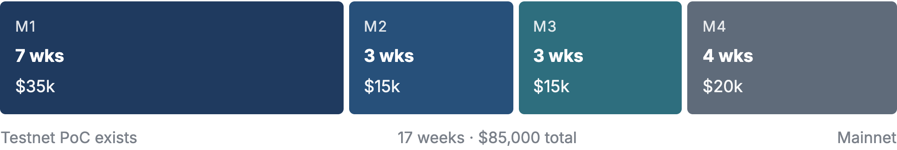

1 Core protocol completion & interface freeze
$35k · 7 weeks
Scope The core of the project: direct offers, an emergency stop for new offers and draws in Config, USDCx execution against the live stablecoin (freeze-list proofs, pause behaviour), a test suite covering the defined state transitions, critical failure cases and boundary conditions, supplemented by property-based testing and fuzzing, adversarial tests, documented invariants, threat model, freeze of custody and settlement logic, and agreement of the data model, proposal and product extension interfaces, and privacy boundary.
Validation On the public testnet: funded proposal with at least two independent borrowers; direct offer works; expiry, cancellation, overdraw, claims before maturity, double-settlement and replay protections pass; Hub and Config changes provably do not affect existing loans; one USDCx loan opened, drawn and repaid, or the blocker documented; test suite, invariants and threat model published; custody and settlement logic frozen for external review.

2 SDK & discovery
$15k · 3 weeks
Scope TypeScript SDK, public proposal discovery from Aleo state, private record handling, fee strategy (private fees by default), USDCx integration.
Validation SDK supports discover, open, accept, repay, claim, cancel and withdraw; discovery works without a proprietary PWN backend; an integration test suite runs against the testnet deployment.

3 Reference application
$15k · 3 weeks
Scope Lender and borrower application on top of the SDK: wallet connection, offer publishing and browsing, draw, repayment, default claim, position overview from private records, selective disclosure of a loan to a chosen party.
Validation External testers complete the full lender and borrower journeys on testnet without help from the team; usability findings addressed; the application is published with usage documentation.

4 Security review & mainnet launch
$20k · 4 weeks
Scope External audit of the core programs, resolution of material findings, non-upgradeable mainnet deployment, SDK published as a package.
Validation All critical invariants covered by tests; external audit completed and material findings resolved before mainnet deposits; at least one real loan originated, repaid and settled on mainnet end to end by an external user; deployment addresses and immutable constructor rules published.
If Milestone 1 finds a blocker that cannot be resolved, for example in USDCx compliance behaviour, we publish the findings and the privacy analysis as an open report for the ecosystem, and the remaining milestones are not claimed.

Open questions
• Licensing Does the Developer Grants Program require a specific open-source licence such as Apache-2.0, or is GPL-3.0 acceptable?
• Collateral policy Token issuers with public-burn, freeze or pause powers can affect a loan escrow. The current multi-token implementation checks a Hub asset allowlist when opening offers and accepting draws. Which issuer powers should V1 accept, and how should an escrow deficit affect positions in that token?

Out of scope
V1 is deliberately narrow: bilateral loans with terms fixed at origination. No oracles, no price-based liquidation, no pooled lending, no bridging to PWN's EVM deployments, no KYC or credit scoring. Installments, crowdfunded funding and refinancing are planned extensions. Protocol fees are zero. V1 targets a mainnet launch; the extensions follow later.

After the grant
The protocol becomes part of the PWN DAO Foundation’s maintained infrastructure, with the team behind OWN maintaining the SDK, reference application and integrations. The deployed core remains immutable. The SDK is published as an open-source package for third-party integrators.

Possible extensions
Installment loans
Crowdfunded funding: several lenders fund one loan, each holding a private position
Refinancing
Private collateral amounts
Borrower and lender integration hooks

Existing references
OWN
ownlabs.co
Current team and product reference: longer-term crypto-backed lending and onchain mortgage infrastructure, building on PWN’s lending primitives.
PWN Protocol v1.5
v1.5-withdraw-restriction
Architecture reference: Hub, Config, modular products and proposals, installments, crowdfunding and borrower/lender hooks.
PWN Elastic Proposal
dev-docs.pwn.xyz/smart-contracts/core/smart-contract-reference/proposals/simple-loan-proposal/elastic-proposal
Reference semantics of the elastic proposal: credit limit, minimum draw, credit-to-collateral ratio, expiry and per-draw loan creation, as implemented on EVM.
ProvableHQ compliant stablecoin / USDCx
github.com/ProvableHQ/compliant-stablecoin
Public and private token flows, freeze-list compliance, role administration, multisig upgrades, USDCx integration.
These are design references; the Aleo programs are written from scratch in Leo. Licensing is checked separately.

