ANDRES SORIANO COLLEGES OF BISLIG

GE10 – Issues in Philippine Popular Culture
Final Task: Digital Poster Campaign / Infographic Series

Title: #OneIslandsOneVoice: Promoting Unity Among Luzon, Visayas, and Mindanao

Date: Oct. 20 2025

Student: Ricky B. Salada
Instructor: Darioz B. Lucero, MAELT
Tagalog vs. Bisaya?
This poster highlights the issue of language and accent discrimination between Filipinos from Luzon and the Visayas. Many people from Visayas and Mindanao face ridicule for their accent or pronunciation. The dialogue in the poster — ‘Mas magaling kasi taga-Manila!’ vs. ‘Iisa lang tayo, iba lang ang tono’ — symbolizes how Taglish and Visayan dialects should be seen as equally Filipino, not superior or inferior.
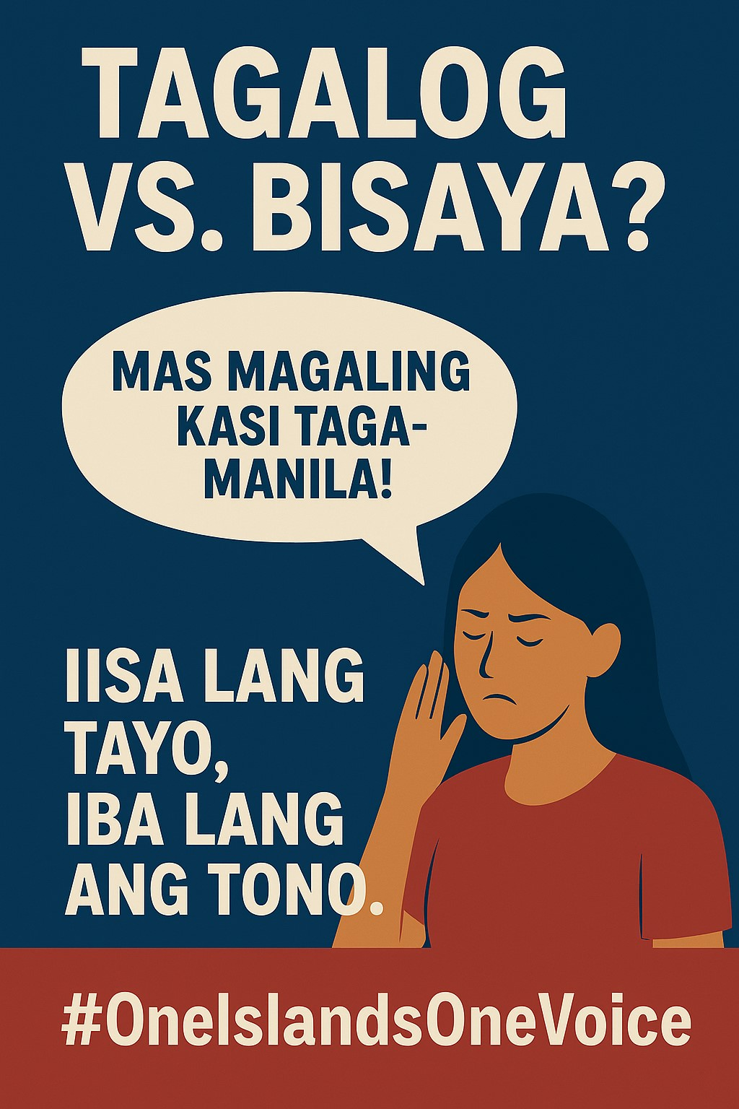
Luzon o Visayas?
This design promotes national solidarity among Luzon, Visayas, and Mindanao. It features young Filipinos forming a heart with their hands over a map of the Philippines. The tagline ‘Walang taga-ibaba o taga-itaas — lahat Pilipino’ conveys the message that all Filipinos are equal regardless of region or dialect. The use of blue and red emphasizes patriotism and harmony.

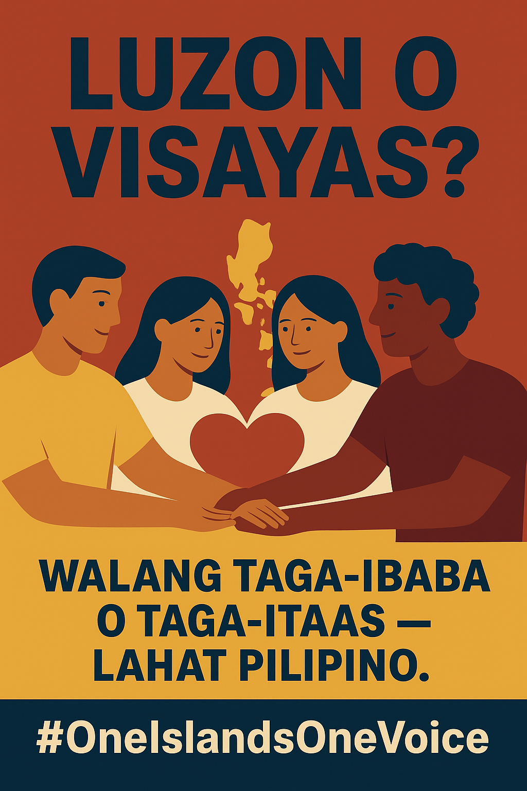
Imperial Manila?
This poster addresses the issue of centralization and inequality caused by ‘Imperial Manila’. It shows Metro Manila buildings elevated on a pedestal, symbolizing how resources and opportunities are often concentrated in the capital. The bridges represent efforts to connect and uplift other regions through unity and equal treatment. The quote ‘Pantay na trato, pantay na respeto’ reinforces the advocacy for fairness and representation across the country.

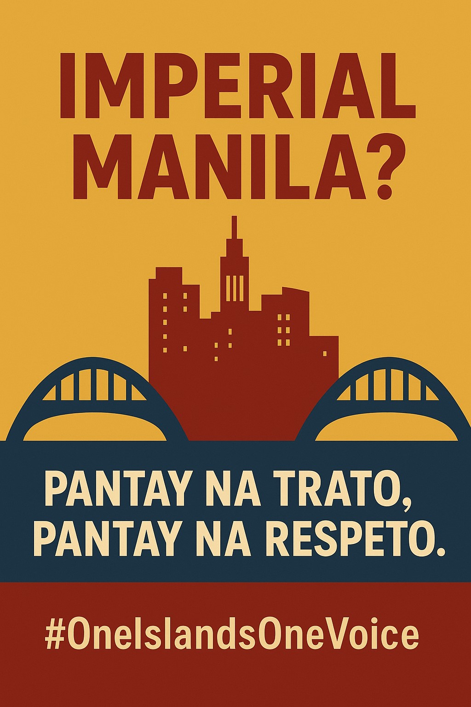
Cultural Impact
The #OneIslandsOneVoice campaign invites viewers to reflect on regional biases that divide the nation. It promotes empathy, inclusion, and the belief that Filipino identity transcends geography. By using Taglish and familiar imagery, the campaign connects deeply with youth, especially BSIT students, who can use digital media responsibly to promote equality.
References
Mendoza, R. U., & Ocampo, J. B. (2017). *Caught Between Imperial Manila and the Provincial Dynasties: Towards a New Fiscal Federalism.* Ateneo Policy Center.
Quimpo, N. G. (2000). *Colonial Name, Colonial Mentality and Ethnocentrism.* University of the Philippines Press.

