# Aufgabe 1

#include <stdio.h>

int main**(**int argc**,** char**\*** argv**[])** **{**

int number1 **=** 20**;**

int number2 **=** 10**;**

int memory **=** 0**;**

int result **=** 0**;**

**if** **(**number1 **>** number2**)** **{**

memory **=** number1**;**

number1 **=** number2**;**

number2 **=** memory**;**

**}**

memory **=** number2**;**

**while** **(**number1 **!=** 0**)** **{**

**if** **(**number1 **%** 2 **!=** 0**)** **{**

result **=** result **+** memory**;**

**}**

number1 **=** number1**/**2**;**

number2 **=** number2 **\*** 2**;**

memory **=** number2**;**

**}**

printf**(**"%d\n"**,**result**);**

**return** 0**;**

**}**

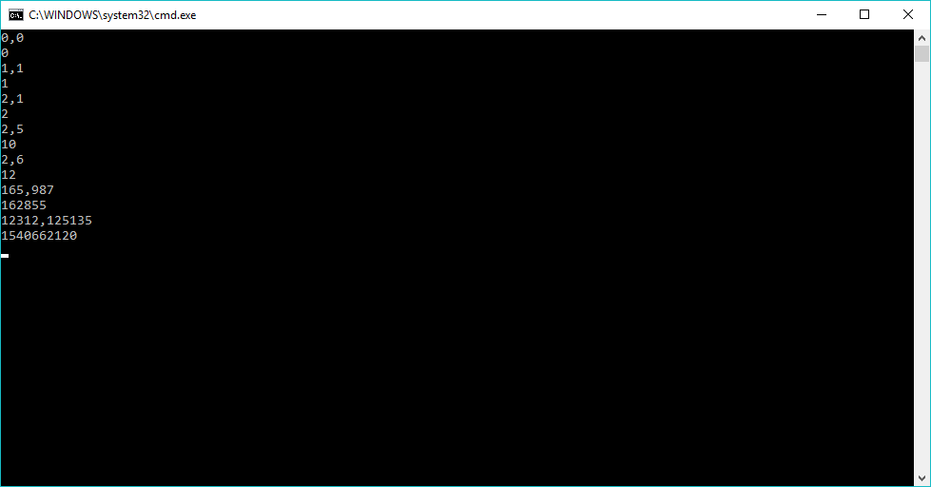

# Aufgabe 2

#include <stdio.h>

int main**(**int argc**,** const char**\*** argv**[])** **{**

int input **=** 1**;**

printBi**(**input**);**

//USER INPUT

int userIn **=** 1**;**

**while** **(**userIn **>=** 0**)** **{**

printf**(**"\nPlease input an integer value: ,to end enter a value x<0\n"**);**

scanf**(**"%d"**,** **&**userIn**);**

printBi**(**userIn**);**

**}**

//END USER INPUT

**return** 0**;**

**}**

int printBi**(**int number**)** **{**

**if** **(**number **>** 0**)** **{**

printBi**(**number **/** 2**);**

printf**(**"%d"**,** number **%** 2**);**

**}**

**else** **{** printf**(**"0"**);** **}**

**return** 0**;**

**}**

# 

# Aufgabe 3

#include <stdio.h>

int main(int argc, const char* argv[]) {

printf("n | n^2\n-----------\n");

for (int n = 1; n < 26;n+=1) {

if (n < 10) {

printf("%d | %d\n", n, n*n);

} else {

printf("%d | %d\n", n, n*n);

}

}

return 0;

}

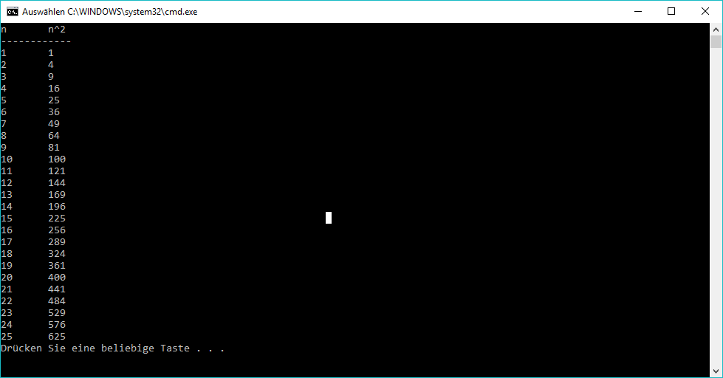

# Aufgabe 4

Gedanke: Syntaxdiagramm umsetzen

SimpleCalc**(**String str**):**Real

Real number1 **=** 0**;**

Real number2 **=** 0**;**

Integer position **=** 0**;**

Character operation**;**

**if** **((**str**[**0**]==**'c'**)**AND**(**str**[**1**]==**'a'**)**AND**(**str**[**2**]==**'l'**)**AND**(**str**[**3**]==**'c'**)**AND**(**str**[**4**]==**' '**)** then

Integer i**=**5

**while** **((**i**<**str**[].**length **)**AND**(**str**[**i**]!=**' '**))** **do**

number1 **=** 10**^**position**\***number1**+(**str**[**i**]-**48**)**

position**+=**1

i**+=**1**;**

end **while**

i**+=**1**;**

**for(**i**;**i**<**str**[].**length**;**i**+=**1**)**

**if** **(**str**[**i**]!=**' '**)** then

operation **=** str**[**i**]**

i**=**i**+**2

position**=**0

**while** **((**i**<**str**[].**length **)**AND**(**str**[**i**]!=**' '**))** **do**

number2 **=** 10**^**position**\***number2**+(**str**[**i**]-**48**)**

position**+=**1

i**+=**1**;**

end **while**

**switch(**operation**)**

**case** '+'**:** number1 **=** number1 **+** number2 **break**

**case** '-'**:** number1 **=** number1 **-** number2 **break**

**case** 'x'**:** number1 **=** number1 **\*** number2 **break**

**case** '/'**:** number1 **=** number1 **/** number2 **break**

**default:** //Fehler

end **switch**

i**-=**1

end **if**

end **for**

end **if**

number1 = ((int)number1*100)/100.0

**return** number1

end SimpleCalc