Report generated: 2025-04-11 22:48:56

Company Valuation Report

# Company Overview

**Company: VÍTKOVICE CYLINDERS a.s.**Industry: Manufacturing  
Location: Vítkovice 3041, 70300 Ostrava  
Established: None  
Employees: N/A

VÍTKOVICE CYLINDERS a.s., based in Ostrava, is a leader in the manufacturing industry primarily focused on assembling, repairing, revising, and testing of pressure equipment, gas containers and gas and electric equipment. The company further diversifies its services to include blacksmithing, locksmithing, toolmaking, and even construction, providing adjustments and removals as needed.

# Financial Analysis

|  |  |
| --- | --- |
| Key Metrics (thousands Kč) | 2023 |
| Revenue | 1,681,074 |
| EBIT | 5,524 |

## Financial Health Assessment

From the provided metrics, it appears that the company is significantly profitable with a total revenue of 1,681,074Kč. However, the EBIT (Earnings Before Interest and Taxes) value of 5,524Kč is considerably low in comparison to the total revenue, suggesting that operational efficiency may be suboptimal and the margin is relatively low. The data does not provide information regarding the company's financial obligations, assets, or overhead costs, so further analysis would be necessary for a comprehensive evaluation of its financial health.

# Valuation Analysis

**Enterprise Value Based on Multiples:**• EV/EBIT Multiple (25.16x): 151,333 thousands Kč  
• EV/EBITDA Multiple (18.53x): 1,752,264 thousands Kč

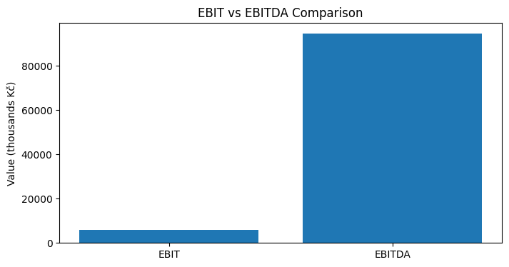

# Conclusion

The company under analysis shows significant profitability with substantial total revenue. However, the relatively low EBIT value in comparison to the total revenue indicates potential operational inefficiencies or low margins. A more thorough evaluation of financial obligations, assets, and overhead costs is advised to give a full overview of its financial health.