Report generated: 2025-03-21 21:15:05

Company Valuation Report

# Company Overview

**Company: ISOTRA a.s.**Industry: Building Materials  
Location: Opava, Czech Republic  
Established: 1992  
Employees: 534

ISOTRA a.s., established in 1992, is a leading building materials company based in Opava, Czech Republic. The company specializes in the production of shading technology, blinds, and various components. It is recognized for its expertise and innovative solutions in its industry.

# Financial Analysis

|  |  |
| --- | --- |
| Key Metrics (thousands Kč) | 2023 |
| Revenue | 1,433,673 |
| EBIT | 82,764 |
| Operating Profit | 82,764 |

## Financial Health Assessment

Based on the given metrics, the company appears to be profitable with an EBIT and operating profit of 82,764Kč. The identical EBIT and operating profit suggest that the company's operations are efficient and effective, as they generate equal amounts of profit before interest and taxes. Furthermore, its quite high revenue of 1,433,673Kč indicates a robust business with significant income generation capacity.

# Valuation Analysis

**Enterprise Value Based on Multiples:**• EV/EBIT Multiple (17.29x): 1,558,138 thousands Kč  
• EV/EBITDA Multiple (14.08x): 2,117,403 thousands Kč

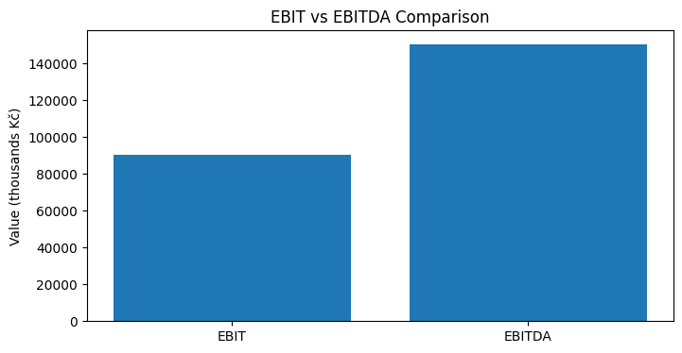

# Conclusion

The company valuation analysis suggests a sound financial health, with profitable operations demonstrated by equal EBIT and operating profit of 82,764Kč. The considerable high revenue of 1,433,673Kč denotes strong income potential, substantiated by high EV/EBIT valuation of 1,558,138 thousands Kč and EV/EBITDA valuation of 2,117,403 thousands Kč. This indicates that the company is highly valued with efficient functions and robust income generation capacity.