Report generated: 2025-03-22 12:51:41

Company Valuation Report

# Company Overview

**Company: ISOTRA a.s.**Industry: Machinery  
Location: Bllovecká 2411/1, 74601 Opava  
Established: 14. zárí 1992  
Employees: None

ISOTRA a.s., established in 1992 and located in Opava, is a diversified company operating within the machinery industry. The company specializes in the production of electricity, insulation, road motor transport using vehicles exceeding 3.5 tonnes with a purpose to transport goods or animals, carpentry, among other services not listed in Annexes 1 to 3 of the Trade Licensing Act. It also provides locksmith and toolmaking services.

# Financial Analysis

|  |  |
| --- | --- |
| Key Metrics (thousands Kč) | 2023 |
| Revenue | 1,433,673 |
| EBIT | 82,764 |
| Operating Profit | 82,764 |

## Financial Health Assessment

This company appears to be in good financial health. With the EBIT and Operating Profit being the same, it suggests that the company does not have non-operating income or costs, meaning its earnings are primarily from its main operations which reflects operational efficiency. The company is also profitable as indicated by the EBIT figure, though exact profit margin ratios or comparisons to the industry can provide more detailed insight.

# Valuation Analysis

**Enterprise Value Based on Multiples:**• EV/EBIT Multiple (20.2x): 1,820,381 thousands Kč  
• EV/EBITDA Multiple (17.29x): 2,600,134 thousands Kč

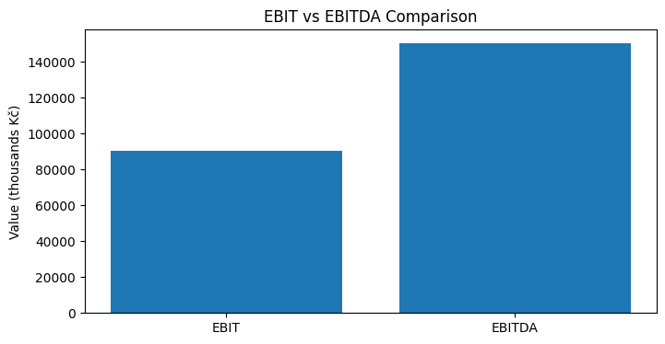

# Conclusion

The company demonstrates strong financial health and operational efficiency, its earnings mainly derived from its primary operations. Despite its robust profitability indicated by the EBIT figure, a further detailed analysis through profit margin ratios or industry comparisons could provide more comprehensive insights into the company's financial position.