10. Vježba

Dinamičko usmjeravanje s OSPF-om
Cilj vježbe
Izraditi konfiguraciju u mrežnom simulatoru i provjeriti međusobnu povezivost računala naredbom ping.
Zadatak obrađuje isključivo dinamičko usmjeravanje protokolom OSPF.
Uređaji
3 rutera: Router0, Router1 i Router2
3 switcha: Switch0, Switch1 i Switch2
6 računala: PC0, PC1, PC2, PC3, PC4 i PC5
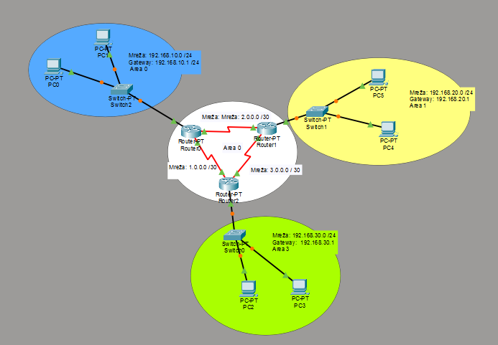

Tablica adresiranja
Uređaj | Sučelje | IP adresa | Maska | Gateway
PC0 | NIC | 192.168.10.2 | 255.255.255.0 | 192.168.10.1
PC1 | NIC | 192.168.10.3 | 255.255.255.0 | 192.168.10.1
PC2 | NIC | 192.168.30.2 | 255.255.255.0 | 192.168.30.1
PC3 | NIC | 192.168.30.3 | 255.255.255.0 | 192.168.30.1
PC4 | NIC | 192.168.20.2 | 255.255.255.0 | 192.168.20.1
PC5 | NIC | 192.168.20.3 | 255.255.255.0 | 192.168.20.1
Router0 | G0/0 | 192.168.10.1 | 255.255.255.0 | -
Router0 | S0/0/0 | 2.0.0.1 | 255.255.255.252 | -
Router0 | S0/0/1 | 1.0.0.1 | 255.255.255.252 | -
Router1 | G0/0 | 192.168.20.1 | 255.255.255.0 | -
Router1 | S0/0/0 | 2.0.0.2 | 255.255.255.252 | -
Router1 | S0/0/1 | 3.0.0.1 | 255.255.255.252 | -
Router2 | G0/0 | 192.168.30.1 | 255.255.255.0 | -
Router2 | S0/0/0 | 1.0.0.2 | 255.255.255.252 | -
Router2 | S0/0/1 | 3.0.0.2 | 255.255.255.252 | -

