Technical Documentation
Date: July 24, 2026, Version: 1.0
Project: AI Service Desk Platform (ai-service-desk)

Revision History
Version | Date | Author | Description
1.0 | 24-Jul-2026 | Janavarshini PA | Final complete technical documentation draft for AI Service Desk Platform

Table of Contents
Technical Documentation 1
Table of Contents 1
1. Introduction 1
1.1 Purpose 1
1.2 Scope 1
1.3 Intended Audience 1
1.4 Acronyms and Definitions 1
2. System Overview 1
2.1 High-Level Architecture 1
2.2 System Flow - Key Components 1
2.3 User Roles and Access Levels 1
3. Functional Requirements 1
3.1 Ticket Lifecycle & Incident Management Module 1
3.2 AI Ticket Summarization & Assistant Module 1
3.3 System Health & Diagnostics Module 1
3.4 Notifications Module (Future Scope) 1
3.5 Activity Logging Module (Future Scope) 1
3.6 Audit Logging Module (Future Scope) 1
3.7 Analytics Module (Future Scope) 1
4. Non-Functional Requirements 1
4.1 Performance 1
4.2 Security 1
4.3 Availability 1
4.4 Maintainability 1
5. Data Model / Database Design 1
5.1 Entity-Relationship Diagram 1
5.2 Indexes and Keys 1
6. Integration Points 1
6.1 External Systems 1
6.2 APIs Used 1
6.3 Data Flow Diagram 1

7. Test Strategy 1
7.1 Test Scenarios 1
7.2 Expected Results 1
7.3 Traceability to Requirements 1
8. Deployment & Configuration 1
8.1 Environments 1
8.2 Setup Steps 1
8.3 Configuration Files and Parameters 1
9. Appendix 1
Glossary 1
Screenshots 1
Code Snippets 1
References 1

1. Introduction

1.1 Purpose
IT Support teams and enterprise helpdesks frequently handle high volumes of support tickets ranging from hardware failures to software configuration requests. Manually categorizing issues, prioritizing tickets, and summarizing lengthy issue histories consumes significant engineering time, leading to delayed resolution SLA metrics.
AI Service Desk addresses this by providing an asynchronous, high-performance API backend built on FastAPI and SQLAlchemy 2.0. It integrates seamlessly with Amazon Bedrock Large Language Models (LLMs) to automatically generate structured incident summaries and suggested agent responses, enabling support teams to resolve tickets faster while maintaining complete operational control.

1.2 Scope
This document covers the core technical architecture of the AI Service Desk platform:
- Ticket Lifecycle Management (creation, filtering, detail retrieval, state updates, and deletion).
- AI Ticket Summarization via AWS Bedrock Runtime Converse API.
- Relational data persistence using PostgreSQL with SQLAlchemy 2.0 Async Session (asyncpg).
- Database schema migrations managed by Alembic.
- System health monitoring, middleware instrumentation, profiling, and load testing.
- Automated testing strategy (Unit, Integration) and Docker containerization.
The following items are out of scope for the current phase and are captured under Future Enhancements: multi-tenant organization isolation, automated email notification dispatchers, audit/activity logging streams, and ML-based SLA breach forecasting analytics.

1.3 Intended Audience
- Backend Engineers & Developers: Building, maintaining, and extending platform features.
- QA & Automation Engineers: Validating API behavior, edge cases, and test suites.
- DevOps & Infrastructure Team: Managing environment configurations, Docker builds, and deployment pipelines.
- Product Managers & Stakeholders: Reviewing technical scope, features, and future roadmaps.

1.4 Acronyms and Definitions
- API - Application Programming Interface
- ASGI - Asynchronous Server Gateway Interface
- ORM - Object-Relational Mapping
- LLM - Large Language Model
- DTO - Data Transfer Object (Pydantic Schemas)
- SLA - Service Level Agreement
- CORS - Cross-Origin Resource Sharing
- UUID - Universally Unique Identifier

2. System Overview

2.1 High-Level Architecture
The AI Service Desk platform follows a Modular Monolith architecture. Client applications communicate with a FastAPI backend, which is internally organized into domain modules (api, services, repositories, models, schemas, middleware, core). Data persistence is handled asynchronously via PostgreSQL, while generative AI workflows leverage AWS Bedrock Runtime.
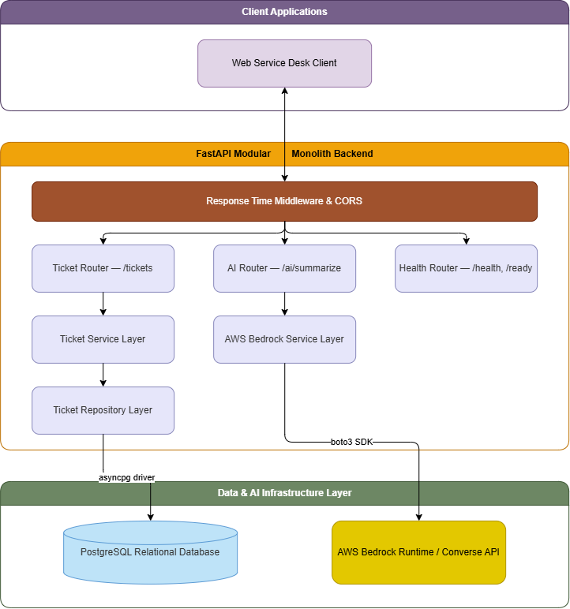

2.2 System Flow - Key Components
- HTTP Routing & Validation Layer (app/api/): Entry point for REST requests. Performs strict schema validation using Pydantic v2.
- Service Layer (app/services/): Enforces business rules (e.g., ticket state transition rules, default status assignments).
- Repository Layer (app/repositories/): Encapsulates DB queries using SQLAlchemy 2.0 Async Session (AsyncSession).
- AI Processing Layer (app/services/aws/bedrock_service.py): Renders Jinja2 prompt templates (TICKET_SUMMARY_V1), formats LLM payload requests, invokes AWS Bedrock, and parses JSON output responses (with fallback to FakeBedrockService when offline).
- Middleware Layer (app/middleware/): Logs response execution times (X-Process-Time) and configures cross-origin rules.

2.3 User Roles and Access Levels
System Admin / Desk Lead:
- Full administrative access to manage all tickets.
- Assign tickets to agents (assignee_email).
- Update ticket priority (low, medium, high) and status (open, in_progress, resolved, closed).
- Hard delete tickets (DELETE /tickets/{id}).
Support Agent:
- View open and assigned tickets with priority filtering.
- Request AI summaries (POST /ai/summarize) for fast issue context comprehension.
- Progress ticket status from open to in_progress or resolved.
Client / End User:
- Submit new tickets (POST /tickets/).
- View ticket status and details (GET /tickets/{id}).

3. Functional Requirements

3.1 Ticket Lifecycle & Incident Management Module
Purpose:
Handles complete CRUD operations for IT support tickets, maintaining state integrity and agent assignment.
Features:
- Ticket Creation: Automatically initializes tickets with status "open".
- Filtered Listing: Filter tickets by status (open, in_progress, resolved, closed) and priority (low, medium, high).
- Detail View: Retrieve ticket details by unique identifier (id).
- Partial Update: Update individual ticket attributes (title, priority, status, assignee_email).
- State Transition Guard: Block reopening of closed tickets.
- Deletion: Remove resolved/obsolete tickets from the system.
Exposed Endpoints:
- POST /tickets/ - Create a new support ticket
- GET /tickets/ - List all tickets (supports status and priority filters)
- GET /tickets/{ticket_id} - Retrieve detailed ticket info by ID
- PUT /tickets/{ticket_id} - Update ticket attributes
- DELETE /tickets/{ticket_id} - Delete ticket by ID
Business Rules:
- Default Status: New tickets receive status = "open".
- Priority Values: Must strictly match "low", "medium", or "high".
- Closed Ticket Constraint: Tickets with status == "closed" cannot be reopened or updated to any non-closed status. Attempting to reopen a closed ticket raises HTTP 400 Bad Request.
Error Handling:
Scenario | HTTP Status | Response
Invalid payload structure | 422 Unprocessable Entity | Validation error returned for invalid request payload.
Querying or updating a non-existent ticket ID | 404 Not Found | json { "error": "ticket_not_found", "id": "t-missing-101" }
Attempting to reopen a closed ticket | 400 Bad Request | json { "detail": "Closed tickets cannot be reopened" }

3.2 AI Ticket Summarization & Assistant Module
Purpose:
Leverages Amazon Bedrock Foundation Models to convert verbose ticket descriptions into actionable summaries and suggested responses for agents.
Features:
- Jinja2 prompt template rendering (TICKET_SUMMARY_V1).
- JSON payload extraction and response validation.
- Graceful error handling for AWS API timeouts or quota limits.
- Offline fallback via FakeBedrockService.
Exposed Endpoints:
- POST /ai/summarize - Summarize issue description and generate response suggestion
Inputs/Outputs:
- Input (SummarizeRequest): ticket_description: string (min length: 10, max length: 5,000)
- Output (SummarizeResponse): summary (concise issue overview), suggested_response (recommended response text for the support agent)
Error Handling:
- Descriptions shorter than 10 characters return HTTP 422 Unprocessable Entity.
- AWS Bedrock runtime failures raise BedrockServiceError which maps to HTTP 502 Bad Gateway:
{
"detail": "The AI service is temporarily unavailable"
}

3.3 System Health & Diagnostics Module
Purpose:
Provides operational probes for container orchestrators (e.g., Kubernetes, Docker Swarm) and load balancers.
Features:
- Readiness check endpoint (/ready).
- Database health check endpoint (/health) executing SELECT 1.
Exposed Endpoints:
- GET /ready - Returns {"status": "ready"}
- GET /health - Returns {"status": "healthy"} or HTTP 503 Service Unavailable if database is down.

3.4 Notifications Module (Future Scope)
- Purpose: Dispatches automated email notifications to clients and assigned agents upon ticket status changes or SLA alerts.
- Planned Endpoints: POST /notifications/email, GET /notifications

3.5 Activity Logging Module (Future Scope)
- Purpose: Records day-to-day user activity for auditability (e.g., ticket creation, agent assignment, status changes).
- Planned Endpoints: GET /activity-logs

3.6 Audit Logging Module (Future Scope)
- Purpose: Tracks security-sensitive events such as deletion of tickets, administrative setting updates, and system configuration changes.
- Planned Endpoints: GET /audit-logs

3.7 Analytics Module (Future Scope)
- Purpose: Aggregates ticket volume, resolution times, agent performance, and SLA compliance metrics.
- Planned Endpoints: GET /analytics/tickets, GET /analytics/sla

4. Non-Functional Requirements

4.1 Performance
- Response Times: Standard CRUD API endpoints target sub-50ms response times.
- AI Processing: LLM summarization completes within 1.5 - 2.5 seconds depending on Bedrock inference latency.
- Asynchronous Execution: Fully async database interactions via asyncpg prevent thread-blocking during heavy concurrent loads.
- Profiling & Load Testing: Verified using profiletest.py (cProfile) and Locust load testing scripts (locustfile.py).

4.2 Security
- Credential Protection: AWS Access Keys, Secret Keys, and Database URLs are loaded strictly from environment variables (.env).
- Data Validation: Strict Pydantic v2 schemas prevent SQL injection and payload malformation.
- CORS Policies: Explicit CORSMiddleware configuration controls allowed origins, methods, and headers.
- Error Shielding: Database exceptions are caught and sanitized before returning responses to clients.

4.3 Availability
- Resilience: The backend is containerized via Docker and can be horizontally scaled behind Nginx or AWS ALB.
- Health Monitoring: Probes /health and /ready enable active zero-downtime rolling deployment restarts.
- Graceful Fallback: Support for FakeBedrockService allows offline execution when cloud resources are unreachable.

4.4 Maintainability
- Clean Architecture: Clear decoupling between routers, services, repositories, ORM models, and schemas.
- Database Migrations: Alembic manages version-controlled database schema changes.
- Automated Test Coverage: 100% mocked offline Pytest suite executing 50+ test cases across Unit, Integration, and E2E layers in under 0.5 seconds.

5. Data Model / Database Design

5.1 Entity-Relationship Diagram
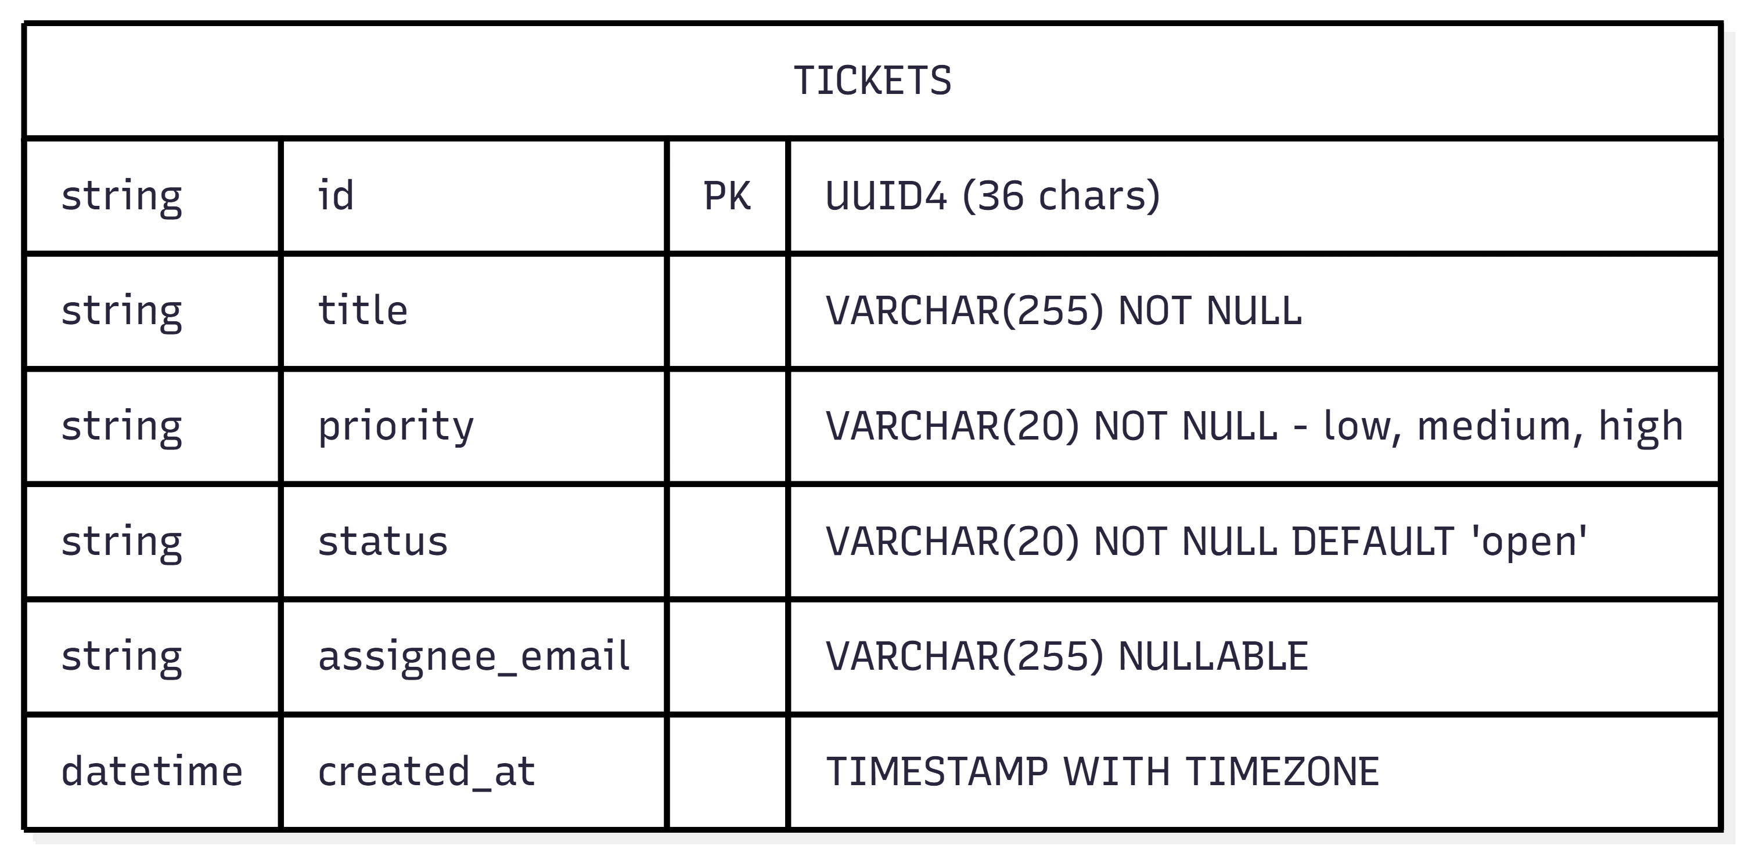

5.2 Tables and Fields
Field Name | Data Type | Constraints | Description
id | VARCHAR(50) | Primary Key | Unique identifier for each support ticket.
title | VARCHAR(255) | NOT NULL | Short description or title of the issue.
priority | VARCHAR(20) | NOT NULL | Priority level (low, medium, high).
status | VARCHAR(20) | NOT NULL | Current ticket status (open, in_progress, resolved).
assignee_email | VARCHAR(255) | NULL | Email address of the assigned support engineer.
created_at | TIMESTAMP | NOT NULL | Date and time when the ticket was created (UTC).

5.3 Indexes and Keys
Key / Index | Column | Description
Primary Key | id | Uniquely identifies each ticket in the database.
Migration Tracker | version_num | Tracks the active Alembic migration revision applied to the database.

5.4 Sample Data
ID | Title | Priority | Status | Assignee Email | Created At
71df887d-db95-4a77-b431-2173b7e76e | Assessment | High | Open | NULL | 2026-07-24 12:10:54
4d590de5-f42a-4160-a198-f273a9d729 | Login Break | High | Open | jana@gmail.com | 2026-07-24 12:10:54

6. Integration Points

6.1 External Systems
- AWS Bedrock Runtime Engine: Cloud-hosted LLM inference service. Communicates via official AWS SDK boto3 over HTTPS.

6.2 APIs Used
Exposed REST Endpoints:
HTTP Method | Endpoint | Description
POST | /tickets/ | Create a new ticket.
GET | /tickets/ | Retrieve all tickets with optional status and priority filters.
GET | /tickets/{ticket_id} | Retrieve details of a specific ticket by its ID.
PUT | /tickets/{ticket_id} | Update an existing ticket.
DELETE | /tickets/{ticket_id} | Delete a ticket by its ID.
POST | /ai/summarize | Generate an AI-powered summary and suggested response for a ticket description.
GET | /health | Check database connectivity (Health Check).
GET | /ready | Verify service readiness and application availability (Readiness Check).

6.3 Data Flow Diagram
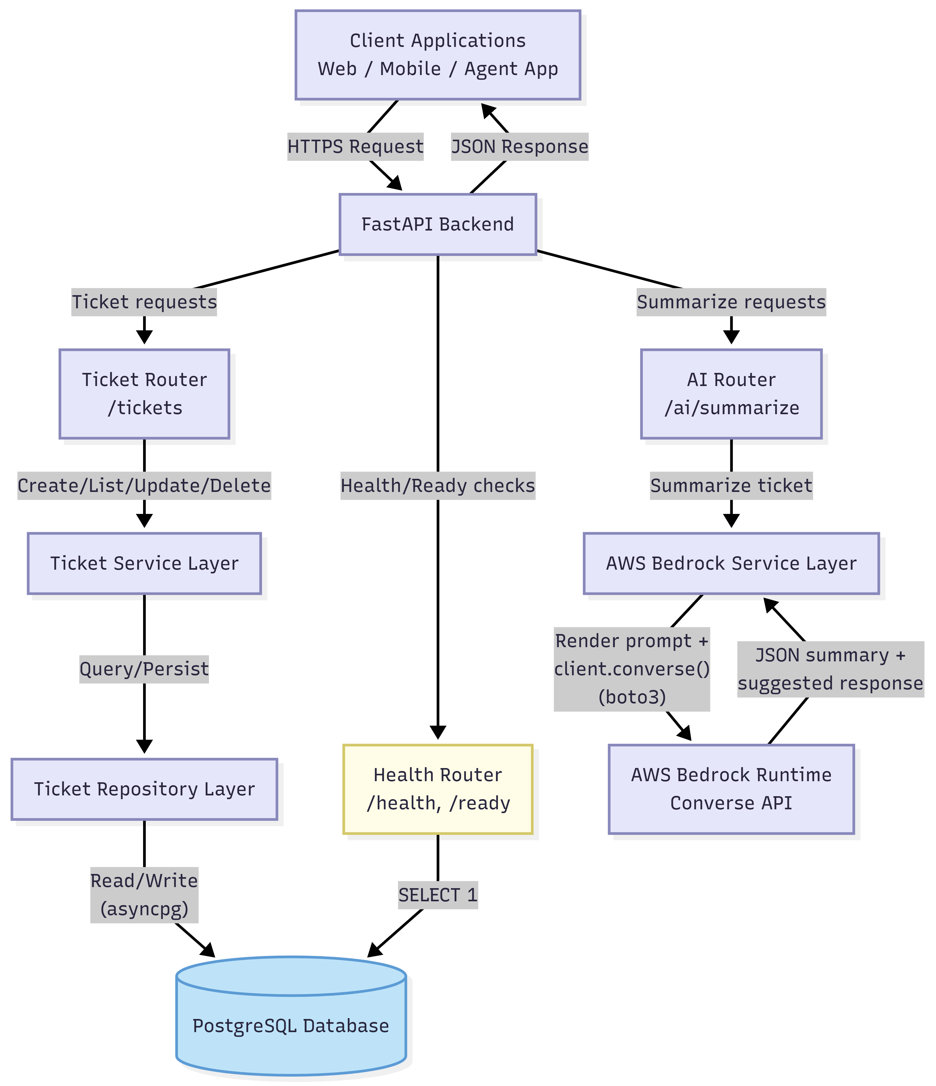

7. Test Strategy

7.1 Test Scenarios
- Unit Testing: Service and repository logic validated in tests/unit/ (ticket creation defaults, status-transition guard, priority validation, deletion).
- Integration Testing: API endpoint behavior validated in tests/integration/ (create/list/get/update/delete ticket flows, AI summarize request/response contract).
- Load Testing: Concurrent request throughput and latency measured with Locust (locustfile.py) against ticket CRUD and summarization endpoints.
- Profiling: CPU and call-time hotspots identified using profiletest.py (cProfile) for the AI summarization pipeline.

7.2 Expected Results

Requirement / Test Group | Expected Result
Ticket Schema Validation | Valid ticket requests are accepted and validated successfully.
Priority Validation | Only low, medium, and high priorities are accepted. Invalid values return validation errors.
Required Field Validation | Requests with missing mandatory fields are rejected.
Default Ticket Status | Newly created tickets are assigned the default status open.
Closed Ticket Reopen Protection | Closed tickets cannot be reopened and return HTTP 400 Bad Request.
Ticket Creation API | Valid ticket creation requests return HTTP 201 Created.
Invalid Request  Handling | Invalid request payloads return HTTP 422 Unprocessable Entity.
Ticket Retrieval API | Ticket listing and filtering return HTTP 200 OK with matching results.
Ticket Not Found Handling | Accessing a non-existent ticket returns HTTP 404 Not Found.
Ticket Update API | Valid ticket updates return HTTP 200 OK with updated details.
Ticket Deletion API | Successful deletion returns HTTP 204 No Content.

7.3 Traceability to Requirements

Module | Requirement ID(s) | Test Files | Result
Ticket Creation | FR-01 | test_create_ticket.py, test_ticket_service.py | Verified
Ticket Retrieval | FR-02 | test_get_tickets.py, test_get_ticket_by_id.py | Verified
Ticket Update | FR-03 | test_update_ticket.py, test_ticket_service.py | Verified
Ticket Deletion | FR-04 | test_delete_ticket.py, test_ticket_service.py | Verified
AI Integration | FR-05 | test_ticket_workflow.py | Verified
Health Checks | NFR-01 | test_health.py | Verified
Performance | NFR-02 | profile_test.py, profile_locust.py | Verified

8. Deployment & Configuration

8.1 Environments
- Local Development: Python 3.12 virtual environment (.venv) running Uvicorn with auto-reload, backed by a local or containerized PostgreSQL instance.
- Containerized / Staging: Docker Compose brings up the FastAPI service alongside PostgreSQL for integration testing prior to release.
- Production: Docker image (python:3.12-slim base) deployed behind a reverse proxy / load balancer, horizontally scalable, with /health and /ready wired into orchestrator liveness and readiness probes.

8.2 Setup Steps
Clone repository & prepare virtual environment:
python -m venv .venv
source .venv/bin/activate
pip install -r requirements.txt
Run Database Migrations:
alembic upgrade head
Start Application:
uvicorn app.main:app --host 0.0.0.0 --port 8000 --reload
Run Container with Docker:
docker build -t ai-service-desk .
docker run -p 8000:8000 --env-file .env ai-service-desk
Run Load / Profiling Tests:
locust -f locustfile.py
python profiletest.py

8.3 Configuration Files and Parameters

Configuration File | Purpose
.env | Stores environment-specific variables such as database URL, AWS credentials, API keys, and application configuration.
requirements.txt | Lists all Python dependencies required to install and run the application.
pytest.ini | Configures the pytest framework, including test discovery paths, asyncio mode, and test settings.
alembic.ini | Contains configuration for Alembic database migrations, including migration script location and database connection settings.
Dockerfile | Defines the Docker image build process, including the Python runtime, dependency installation, and application startup command.
app/core/config.py | Loads and validates application settings from environment variables using Pydantic Settings.
app/core/database.py | Configures the SQLAlchemy asynchronous database engine, session factory, and database connection.
.gitignore | Specifies files and directories (e.g., .env, __pycache__, virtual environments) that should not be tracked by Git.

9. Appendix

Glossary
- Ticket: Core data entity representing an incoming IT support request or incident.
- Bedrock Service: Application service wrapper that renders prompts and communicates with the AWS Bedrock LLM inference endpoint.
- FakeBedrockService: Offline mock implementation of the Bedrock service used for local development and automated testing without AWS connectivity.

Screenshots

Swagger UI
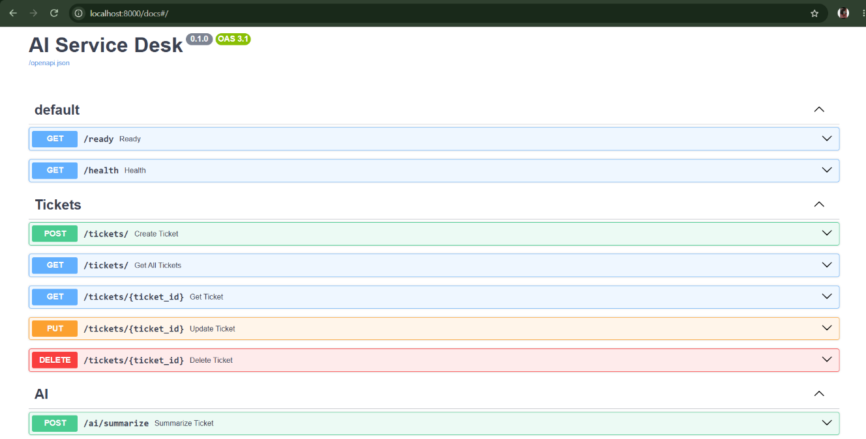

tickets/post/
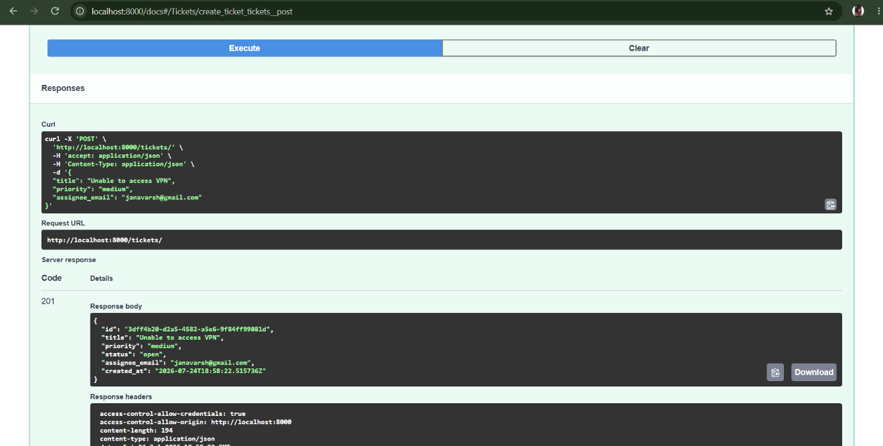

tickets/get/{ticket_id}

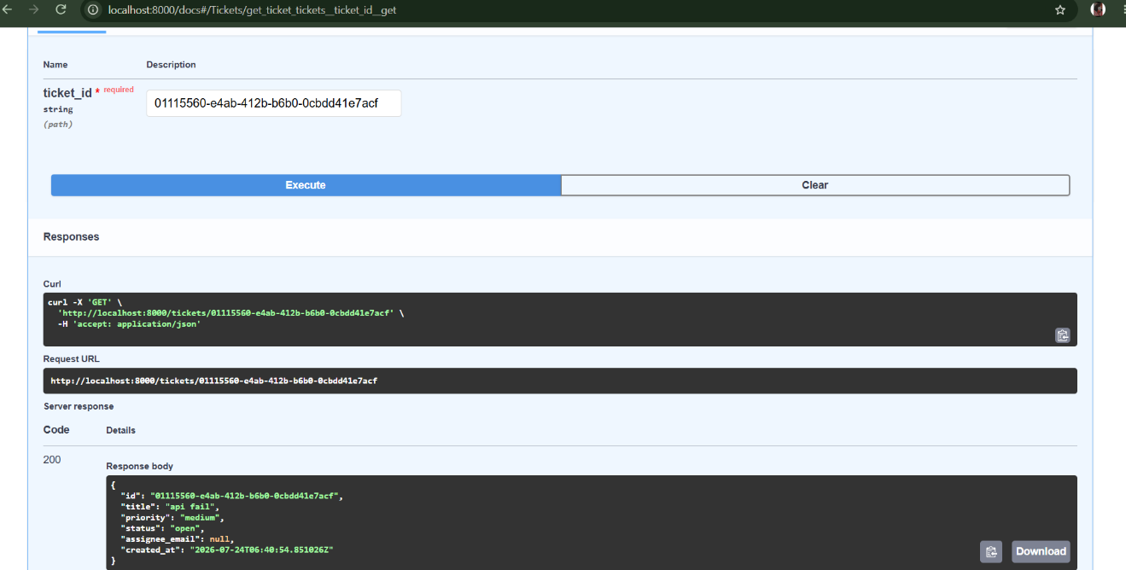

Code Snippets
ticket_routes.py
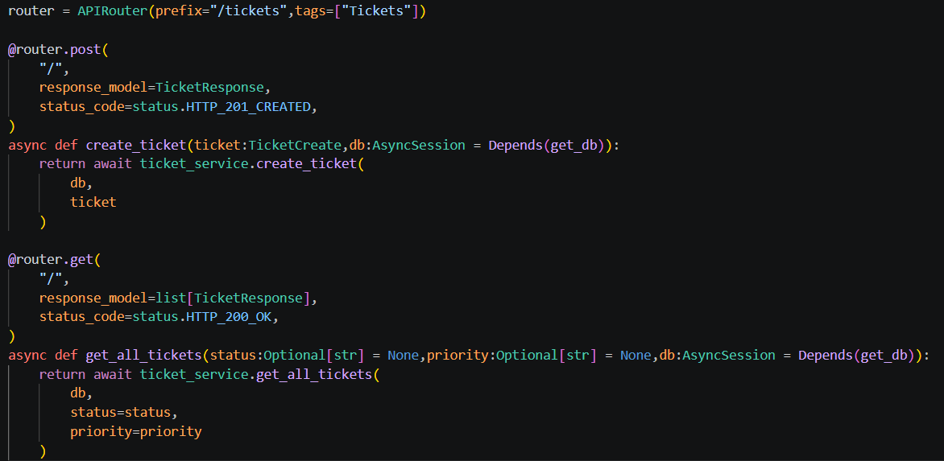

ticket_service.py
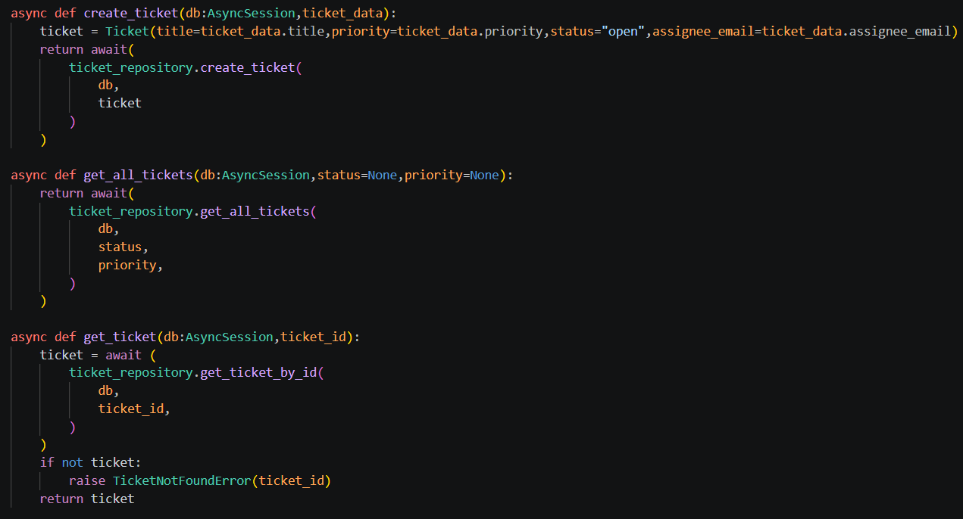

ticket_repo.py

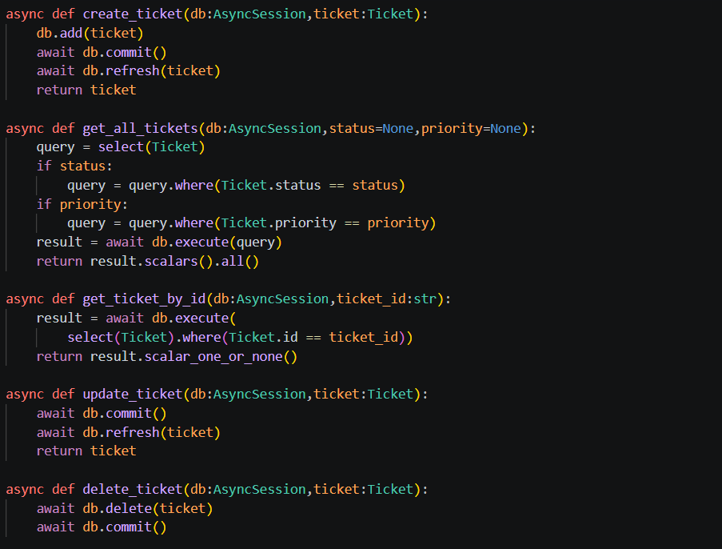

ticket_schema.py

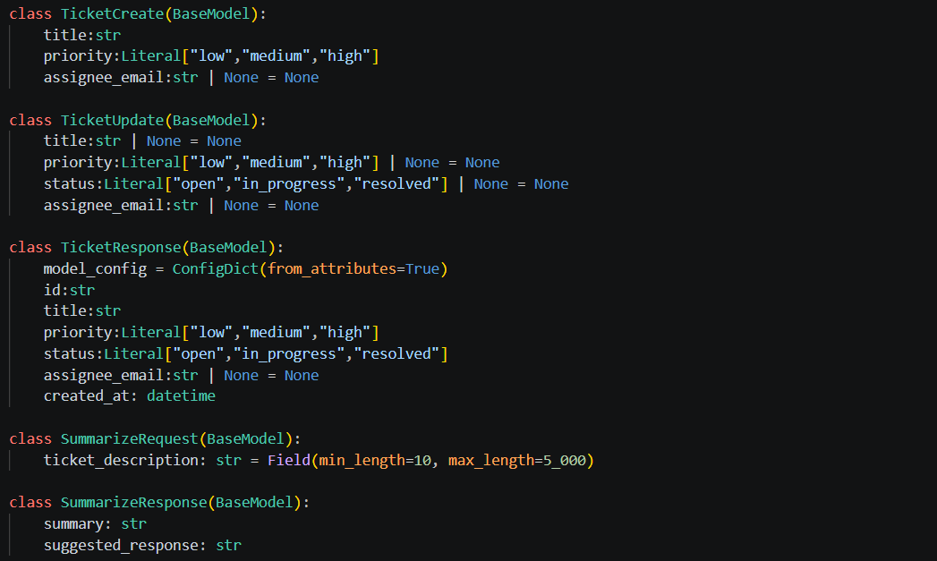

ticket_model.py

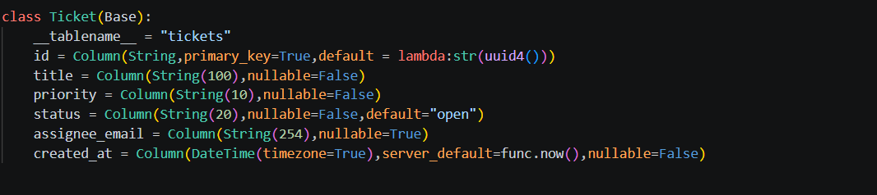

References

Github Link : https://github.com/jana-goml/Python-AI-Service-Desk.git

