Homepage > Get Ready > Screenshot Comparison

# Page title (H1): Screenshot Comparison

Pictures say a thousand words, and our Canvas comparison gallery is no different! Canvas will present a more functional and visually-pleasing way to access and provide course materials, although there's no need to take our word for it. Please feel free to view the images below for further details.

Note: Each image will expand to a full-view when selected

## Section heading (H2): Home Page

Before:

[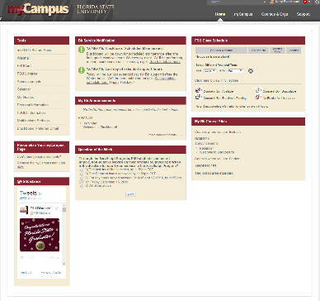](https://hf-files-oregon.s3.amazonaws.com/hdpbbsupport_kb_attachments/2016/12-21/dd6d121d-91d7-46a4-afa6-b483e8a65409/BlackboardHomeTab.png)

After:

[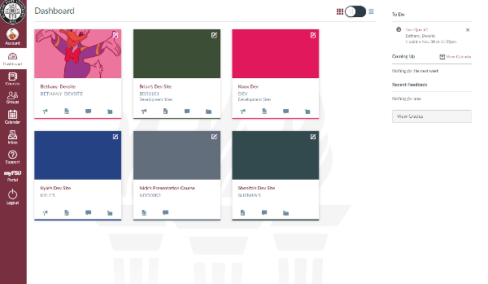](https://hf-files-oregon.s3.amazonaws.com/hdpbbsupport_kb_attachments/2016/12-21/19c136b9-ef76-4d14-9ab7-375a882c49fc/Dashboard%20Canvas.PNG)

## Section heading (H2): Notifications Panel

Before:

[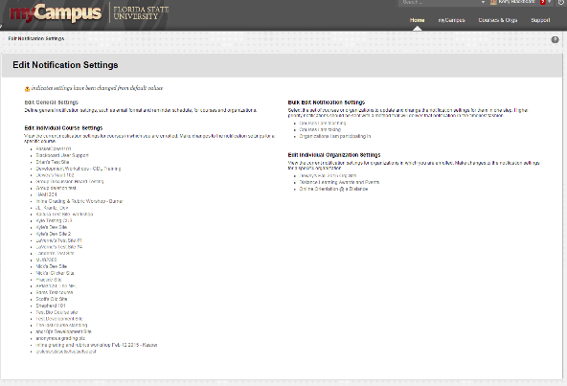](https://hf-files-oregon.s3.amazonaws.com/hdpbbsupport_kb_attachments/2016/12-21/a00a71f0-9d26-476d-9dc0-6eebd299e703/Notifications%20Bb.PNG)

After:

[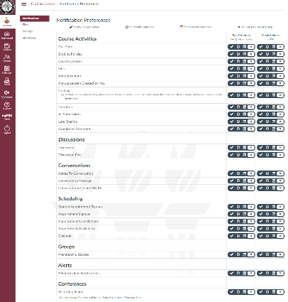](https://hf-files-oregon.s3.amazonaws.com/hdpbbsupport_kb_attachments/2016/12-21/17a265aa-4271-47c2-a859-1b58a69f367a/Notifications%20Canvas.PNG)

## Section heading (H2): Course Announcements Page

Before:

[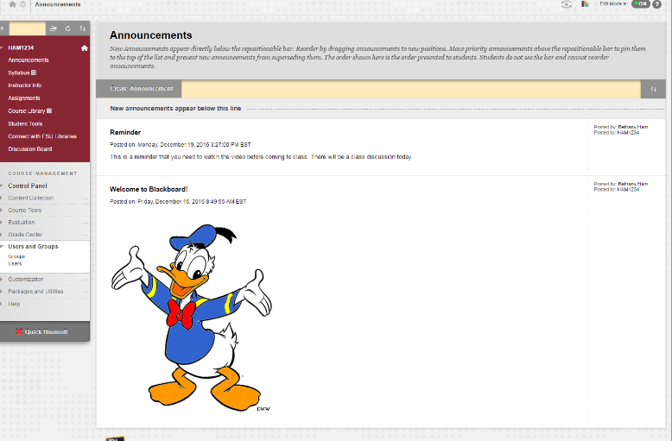](https://hf-files-oregon.s3.amazonaws.com/hdpbbsupport_kb_attachments/2016/12-21/dfad4b73-136a-4f54-b226-0de8fe460965/Home%20Bb.PNG)

After:

[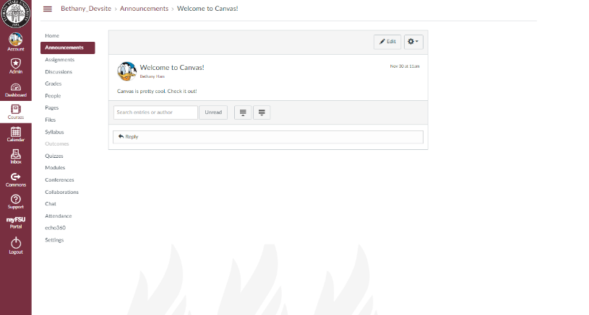](https://hf-files-oregon.s3.amazonaws.com/hdpbbsupport_kb_attachments/2016/12-21/839de00f-92ad-4655-a527-f3fc612e15aa/CanvasCourseAnnouncements.png)

## Section heading (H2): Course Assignment Submission Page

Before:

[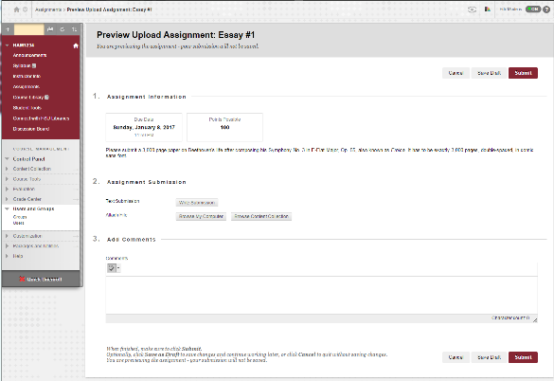](https://hf-files-oregon.s3.amazonaws.com/hdpbbsupport_kb_attachments/2016/12-21/e7b56a8b-aef9-4203-9344-cc7b7935ce07/Assignment%20Bb.PNG)

After:

[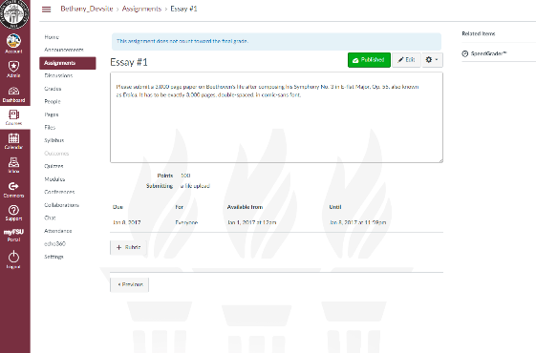](https://hf-files-oregon.s3.amazonaws.com/hdpbbsupport_kb_attachments/2016/12-21/e042cf3d-4ae5-475b-99a7-9217071c1880/Canvas%20Assignment.PNG)

## Section heading (H2): Course Discussion Board

Before:

[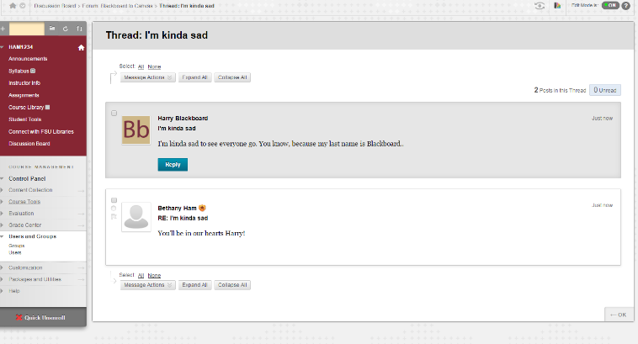](https://hf-files-oregon.s3.amazonaws.com/hdpbbsupport_kb_attachments/2016/12-21/5b5365a0-1a82-4d60-9df9-7396bb4d04f1/Discussions%20Bb.PNG)

After:

[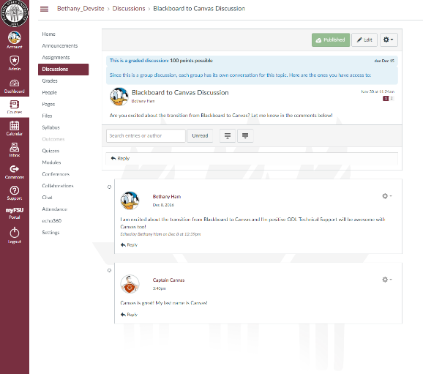](https://hf-files-oregon.s3.amazonaws.com/hdpbbsupport_kb_attachments/2016/12-21/1d1e3c2e-c4d6-4132-853c-06cb57699383/Canvas%20Discussion.PNG)