CS4074

Big Data Analytics

Lab 1: Hadoop Installation
& HDFS Operations
$ hdfs dfs -ls /user/naila
Found 3 items
drwxr-xr-x - naila hadoop 0 2026-01-15 input
drwxr-xr-x - naila hadoop 0 2026-01-15 output
-
rw-r–r– 3 naila hadoop 1.2G 2026-01-15 data.csv
$_
Department of Computer Science
Effat University
Jeddah, Saudi Arabia
Dr. Naila Marir
Spring 2026
Contents

- Lab Overview 2
- Prerequisites 2
- Part 1: Installing Java 4
- Part 2: Configuring SSH 4
- Part 3: Installing Hadoop 6
- Part 4: Configuring Hadoop 8
- Part 5: Starting HDFS 10
- Part 6: HDFS Operations 12
  - Basic Directory Operations . . . . . . . . . . . . . . . . . . . . . . . . . . . . . . 12
  - File Operations . . . . . . . . . . . . . . . . . . . . . . . . . . . . . . . . . . . . . 12
  - Working with Larger Files . . . . . . . . . . . . . . . . . . . . . . . . . . . . . . . 14
  - Analyzing Block Distribution . . . . . . . . . . . . . . . . . . . . . . . . . . . . . 14
  - File Management Commands . . . . . . . . . . . . . . . . . . . . . . . . . . . . . 15
  - HDFS Command Reference . . . . . . . . . . . . . . . . . . . . . . . . . . . . . . 16 8.7 Administrative Commands . . . . . . . . . . . . . . . . . . . . . . . . . . . . . . . 16
- Part 7: Stopping and Restarting Hadoop 17
- Lab Deliverables 18
- Challenge Exercises (Bonus) 19
- Summary 20
- Lab Overview
Lab Objectives:
1.
Install and configure Apache Hadoop on your local machine
2.
Set up a single-node (pseudo-distributed) HDFS cluster
3.
Execute basic HDFS shell commands
4.
Upload, download, and manage files in HDFS
5.
Explore the Hadoop Web UI
6.
Analyze file block distribution
Duration:
2-3
hours
Prerequisites:
Basic Linux command line knowledge
Deliverables:
Screenshots and short report (see Section 8)
What You Will Build:
NameNode
:9870
DataNode
:9864
Secondary
NameNode
Your Machine (Single-Node Cluster)
- Prerequisites
§
System Requirements
Before starting, ensure your system meets these requirements:
•
Operating System
:
–
Ubuntu 20.04/22.04 LTS (recommended)
–
macOS (with Homebrew)
–
Windows 10/11 with WSL2 (Ubuntu)
•
RAM
:
Minimum 4GB (8GB recommended
)
•
Disk Space
:
At least 20GB free
•
Internet
:
Required for downloading packages

For Windows Users
Install WSL2 (Windows Subsystem for Linux) first:
1
# In PowerShell (as Administrator)
2
wsl --install -d Ubuntu-22.04
Then follow the Ubuntu instructions inside WSL2.
- Part 1: Installing Java
Hadoop requires Java to run. We’ll install OpenJDK 11.
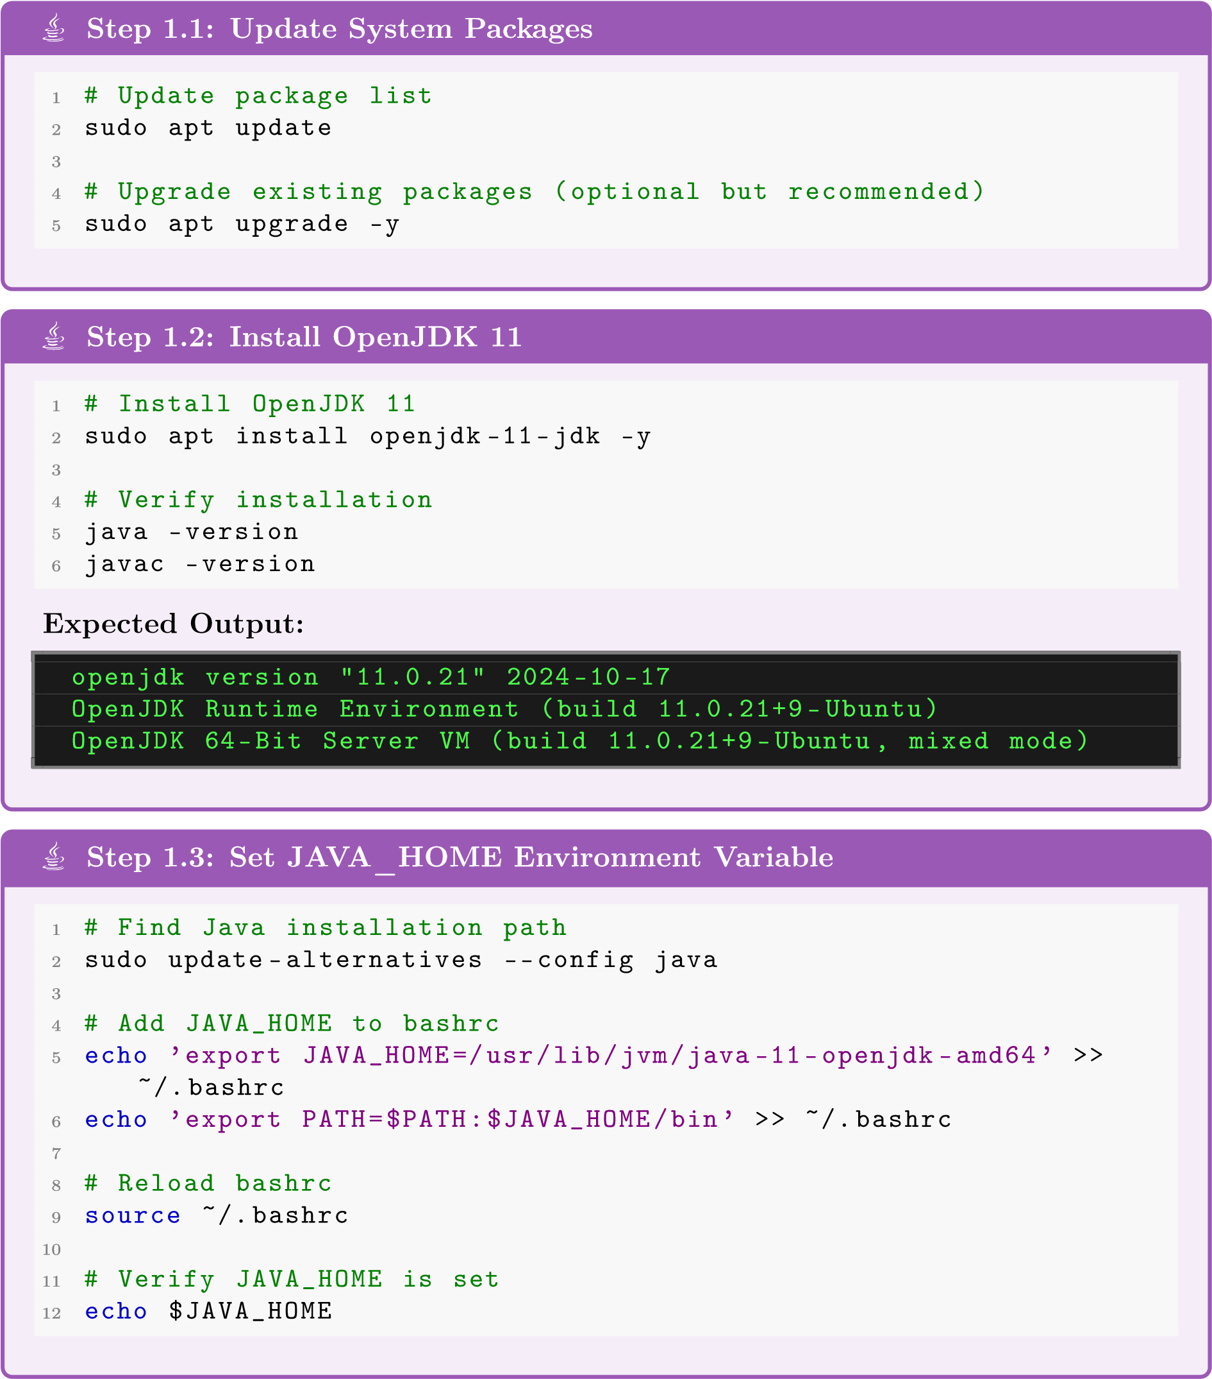
- Part 2: Configuring SSH

Hadoop uses SSH to manage nodes, even in single-node mode.
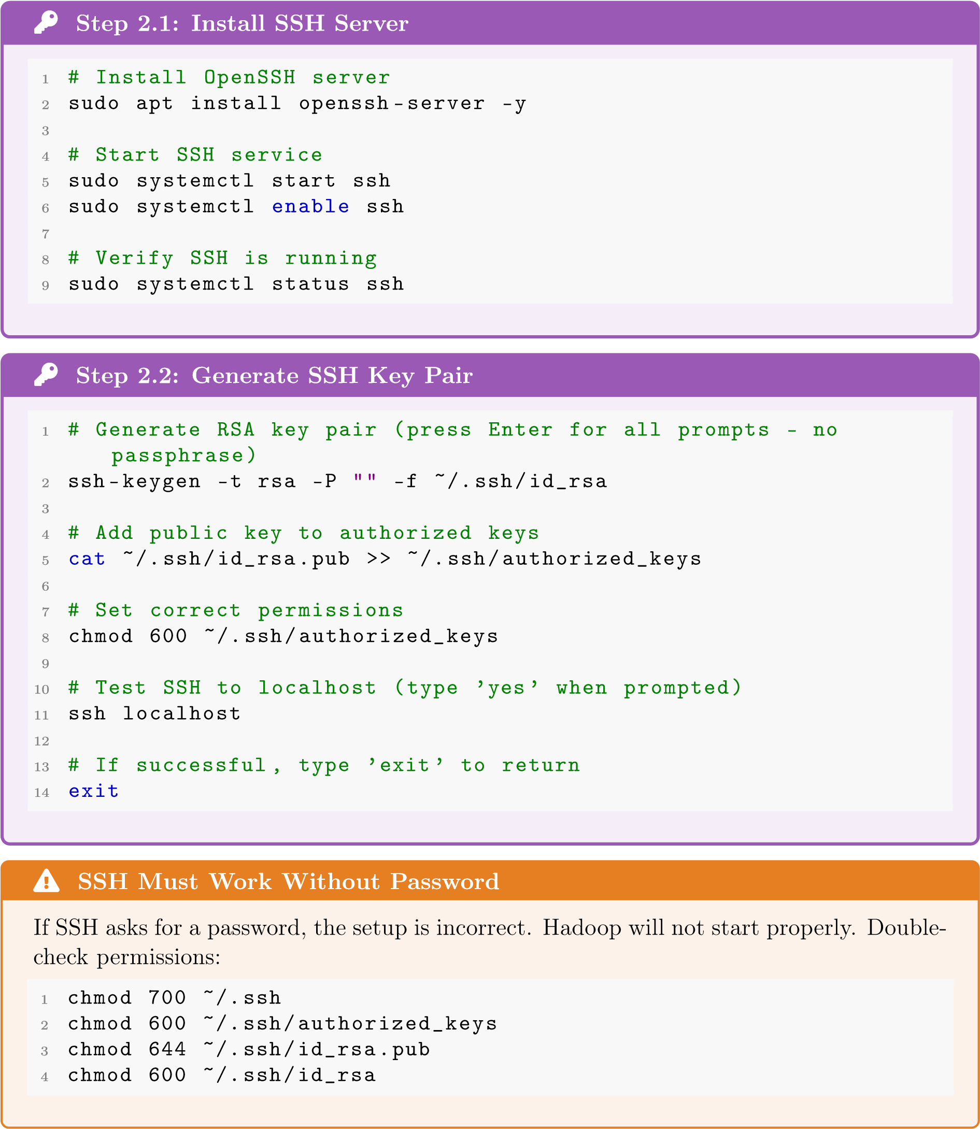
- Part 3: Installing Hadoop

Step 3.1: Download Hadoop
1
#
Navigate
to
home
directory
2
cd
~
3
4
#
Download
Hadoop
3.3.6
latest
(
stable
version)
5
wget https://dlcdn.apache.org/hadoop/common/hadoop-3.3.6/hadoop
.tar.gz
-3.3.6
6
7
#
Verify
download
check
(
file
size
~700MB)
8
ls -lh hadoop-3.3.6.tar.gz
i
Step 3.2: Extract and Install
1
#
Extract
the
archive
2
tar -xzf hadoop-3.3.6.tar.gz
3
4
#
Move
to
/opt
directory
5
sudo mv hadoop-3.3.6 /opt/hadoop
6
7
#
Set
ownership
to
your
user
8
sudo chown -R $USER:$USER /opt/hadoop
9
10
#
Verify
installation
11
ls /opt/hadoop
You should see directories like:
bin, etc, include, lib, sbin, share
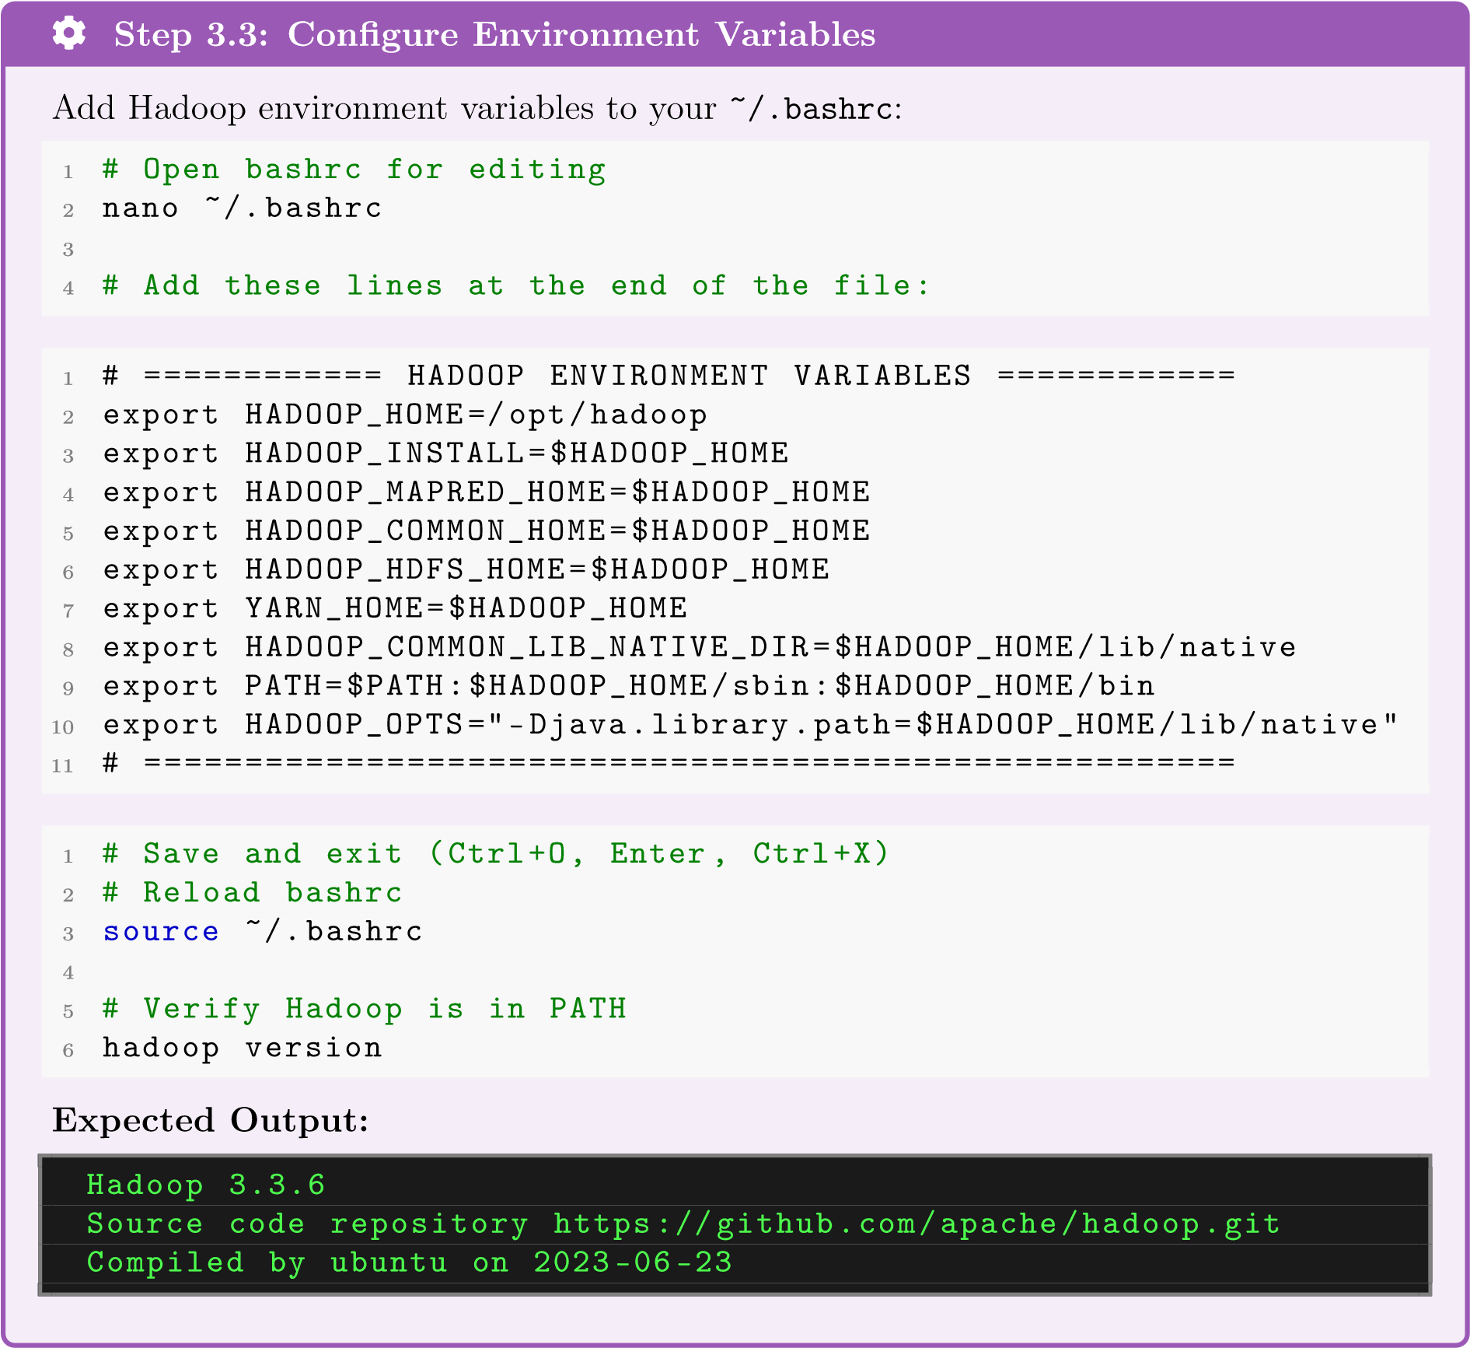
- Part 4: Configuring Hadoop
Now we configure Hadoop for pseudo-distributed mode (single-node cluster).
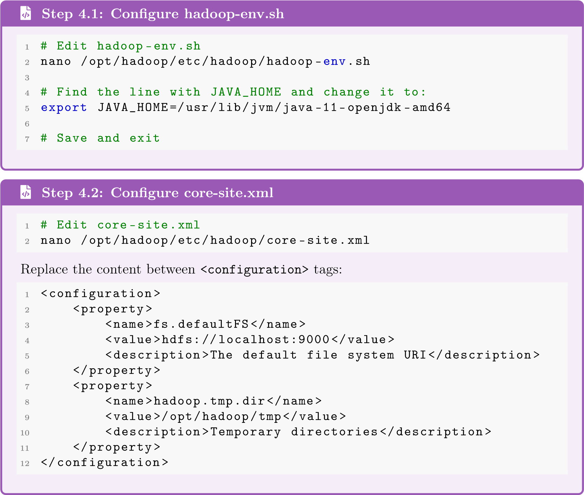
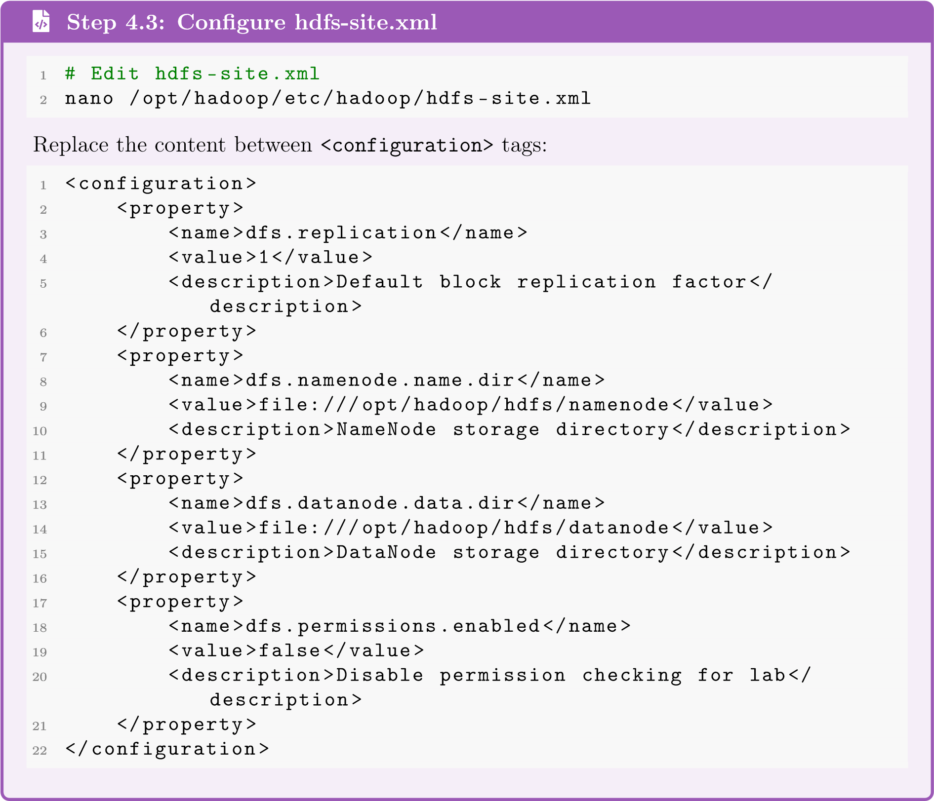

j
Step 4.4: Create Required Directories
1
#
Create
HDFS
directories
2
mkdir -p /opt/hadoop/hdfs/namenode
3
mkdir -p /opt/hadoop/hdfs/datanode
4
mkdir -p /opt/hadoop/tmp
5
6
#
Verify
directories
exist
7
ls -la /opt/hadoop/hdfs/
õ
Step 4.5: Format the NameNode
1
#
Format
the
NameNode
(
ONLY
DO
THIS
ONCE!)
2
hdfs namenode -format
Expected Output (look for this line):
Storage directory /opt/hadoop/hdfs/namenode has been successfully
formatted.
.
Warning: Never Reformat!
Only format the NameNode
once
during initial setup. Reformatting will
delete all data
in HDFS!
- Part 5: Starting HDFS
’
Step 5.1: Start HDFS Services
1
#
Start
HDFS
NameNode
(
,
DataNode
,
SecondaryNameNode)
2
start-dfs.sh
3
4
#
You
may
see
warnings
about
HDFS_NAMENODE_USER
-
these
are
safe
to
ignore
¥
Step 5.2: Verify Services Are Running
1
#
Check
running
Java
processes
2
jps
Expected Output:
12345
NameNode
12346
DataNode
12347
SecondaryNameNode
12348
Jps
If you see all three Hadoop processes, HDFS is running successfully!

Step 5.3: Access Web UI
Open your web browser and navigate to:
•
NameNode UI
:
http://localhost:987
0
•
DataNode UI
:
http://localhost:986
4
¥
Congratulations! Hadoop HDFS is Running!
- Part 6: HDFS Operations

Now let’s practice HDFS commands!
  - Basic Directory Operations

Exercise 6.1: Create Directory Structure
1
#
Create
user
directory
2
hdfs dfs -mkdir /user
3
4
#
Create
your
personal
directory
5
hdfs dfs -mkdir /user/naila
6
7
#
Create
subdirectories
8
hdfs dfs -mkdir /user/naila/input
9
hdfs dfs -mkdir /user/naila/output
10
11
#
List
root
directory
12
hdfs dfs -ls /
13
14
#
List
your
directory
15
hdfs dfs -ls /user/naila
  - File Operations

Exercise 6.2: Upload Files to HDFS
1
#
Create
a
sample
file
locally
2
echo
"Hello
HDFS!"
>
hello.txt
3
echo
"Welcome
to
Big
Data
Analytics
at
Effat
University."
>>
hello.txt
4
echo
"This
is
Lab
1:
Hadoop
Installation."
hello.txt
>>
5
6
#
Upload
file
to
HDFS
7
hdfs dfs -put hello.txt /user/naila/input/
8
9
#
Verify
upload
10
hdfs dfs -ls /user/naila/input/
11
12
#
View
file
contents
in
HDFS
13
hdfs dfs -
cat
/user/naila/input/hello.txt

Exercise 6.3: Download Files from HDFS
1
#
Download
file
from
HDFS
to
local
2
hdfs dfs -get /user/naila/input/hello.txt downloaded_hello.txt
3
4
#
Verify
download
5
cat
downloaded_hello.txt
6
7
#
Compare
files
(
should
be
identical)
8
diff hello.txt downloaded_hello.txt
  - Working with Larger Files

Exercise 6.4: Upload and Analyze a Larger Dataset
1
#
Download
Shakespeare
’s
complete
works
)
~5.5MB
(
2
curl -o shakespeare.txt https://www.gutenberg.org/files
/100/100-0.txt
3
4
#
Check
local
file
size
5
ls -lh shakespeare.txt
6
7
#
Upload
to
HDFS
8
hdfs dfs -put shakespeare.txt /user/naila/input/
9
10
#
Verify
upload
and
check
file
size
in
HDFS
11
hdfs dfs -ls -h /user/naila/input/
12
13
#
View
first
few
lines
14
hdfs dfs -head /user/naila/input/shakespeare.txt
15
16
#
View
last
few
lines
17
hdfs dfs -tail /user/naila/input/shakespeare.txt
  - Analyzing Block Distribution

Exercise 6.5: Check Block Information
1
#
Check
file
system
health
and
block
info
2
hdfs fsck /user/naila/input/shakespeare.txt -files -blocks
3
4
#
More
detailed
block
locations
5
hdfs fsck /user/naila/input/shakespeare.txt -files -blocks -
locations
6
7
#
Check
overall
HDFS
health
8
hdfs dfsadmin -report
Questions to Answer:
1.
How many blocks does shakespeare.txt have?
2.
What is the replication factor?
3.
What is the block size?
  - File Management Commands

Exercise 6.6: Copy, Move, and Delete
1
#
Copy
file
within
HDFS
2
hdfs dfs -cp /user/naila/input/hello.txt /user/naila/hello_backup
.txt
3
4
#
Move/rename
file
5
hdfs dfs -mv /user/naila/hello_backup.txt /user/naila/input/
hello_copy.txt
6
7
#
List
to
verify
8
hdfs dfs -ls /user/naila/input/
9
10
#
Delete
a
file
11
hdfs dfs -rm /user/naila/input/hello_copy.txt
12
13
#
Delete
a
directory
(
recursive
)
14
hdfs dfs -mkdir /user/naila/temp
15
hdfs dfs -rm -r /user/naila/temp
  - HDFS Command Reference
Command | Description | Example
-ls | List directory contents | hdfs dfs -ls /user
-ls -h | List with human-readable sizes | hdfs dfs -ls -h /
-mkdir | Create directory | hdfs dfs -mkdir /data
-mkdir -p | Create parent directories | hdfs dfs -mkdir -p /a/b/c
-put | Upload local file to HDFS | hdfs dfs -put file.txt /data/
-get | Download from HDFS | hdfs dfs -get /data/file.txt .
-cat | Display file contents | hdfs dfs -cat /data/file.txt
-head | Display first 1KB | hdfs dfs -head /data/file.txt
-tail | Display last 1KB | hdfs dfs -tail /data/file.txt
-rm | Delete file | hdfs dfs -rm /data/file.txt
-rm -r | Delete directory recursively | hdfs dfs -rm -r /data/
-cp | Copy within HDFS | hdfs dfs -cp /src /dest
-mv | Move/rename | hdfs dfs -mv /old /new
-du -h | Disk usage (human-readable) | hdfs dfs -du -h /user
-df -h | Free space | hdfs dfs -df -h /
-chmod | Change permissions | hdfs dfs -chmod 755 /data
-chown | Change ownership | hdfs dfs -chown user /data
-count | Count files/directories | hdfs dfs -count /user
-setrep | Set replication factor | hdfs dfs -setrep 2 /file.txt
-touchz | Create empty file | hdfs dfs -touchz /empty.txt
Table 1: HDFS Shell Commands Quick Reference
  - Administrative Commands
5
Stopping HDFS
1
#
Stop
all
HDFS
services
2
stop-dfs.sh
3
4
#
Verify
services
stopped
5
jps
6
#
Should
only
show
’Jps
’
º
Restarting HDFS
1
#
Start
HDFS
services
2
start-dfs.sh
3
4
#
Verify
services
running
5
jps

Troubleshooting Tips
If Hadoop doesn’t start properly:
1.
Check logs:
cat /opt/hadoop/logs/*.log
2.
Verify Java:
java -version
3.
Check SSH:
ssh localhost
4.
Verify JAVA_HOME in hadoop-env.sh
5.
Check if ports are in use:
netstat -tlnp | grep 9000

Exercise 6.7: Admin Operations
1
#
Check
cluster
status
2
hdfs dfsadmin -report
3
4
#
Check
safe
mode
status
5
hdfs dfsadmin -safemode get
6
7
#
Check
file
system
health
8
hdfs fsck /
9
10
#
Get
configuration
value
11
hdfs getconf -confKey dfs.replication
12
hdfs getconf -confKey dfs.blocksize
- Part 7: Stopping and Restarting Hadoop

- Lab Deliverables
T
Required Submissions
Submit the following via the course portal:
1
. Screenshots (4 images
):
a)
jps
command output showing NameNode, DataNode, SecondaryNameNode
b)
NameNode Web UI (
localhost:9870
)
overview page
c)
Output of
hdfs dfs -ls /user/[yourname]/input/
showing your files
d)
Output of
hdfs fsck
command for shakespeare.txt
2
. Short Report (1-2 pages
):
a)
Your name and student ID
b)
Brief description of any issues encountered and how you resolved them
c)
Answers to these questions:
•
How many blocks was shakespeare.txt split into?
•
What is the replication factor of your files?
•
What is the default block size in your configuration?
•
Why is the replication factor set to 1 in single-node mode?
Due Date:
Before next lab session
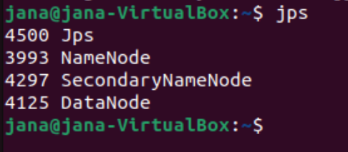
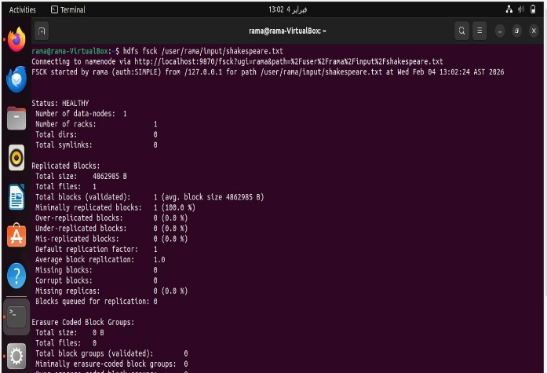

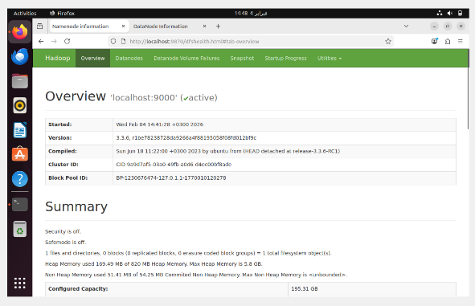
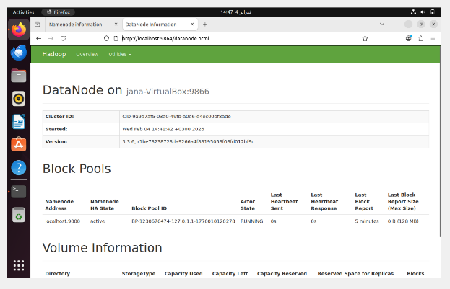

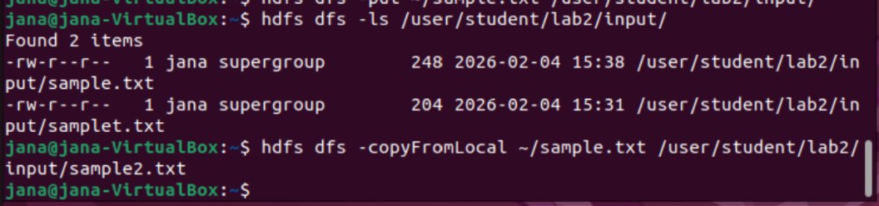

  - CS4074 – Big Data Analytics
  - Lab 1: Hadoop Installation & HDFS Operations
Instructor: Dr. Naila Marir
Semester: Spring 2026
  - Student Name: [Jana Mufti]
  - Student ID: [S21106991]

  - Introduction
  - This lab focused on installing and configuring Apache Hadoop in a single-node (pseudo-distributed) mode and performing basic HDFS operations. The objective was to understand how Hadoop Distributed File System (HDFS) works, how files are stored as blocks, and how replication is handled in a Hadoop environment.

  - Issues Encountered and Solutions
  - During the lab, a few minor issues were encountered:
  - SSH Connection Issue:
Initially, Hadoop services did not start because passwordless SSH was not properly configured. This issue was resolved by generating an SSH key and adding it to the authorized_keys file, which allowed Hadoop to communicate with the local node.
  - JAVA_HOME Configuration:
Hadoop failed to start at first due to an incorrect JAVA_HOME path. This was fixed by correctly setting the Java path in the hadoop-env.sh file.
  - After resolving these issues, HDFS services (NameNode, DataNode, and SecondaryNameNode) started successfully, and all required commands executed correctly.

  - Q1. How many blocks was shakespeare.txt split into?
  - The file shakespeare.txt is approximately 5.5 MB in size. Since the default HDFS block size is 128 MB, the file was stored in 1 block.
  - ✅: shakespeare.txt was split into 1 block.

  - Q2. What is the replication factor of your files?
  - The replication factor for the files in this lab is 1, as confirmed using the hdfs fsck and hdfs getconf -confKey dfs.replication commands.
  - ✅: The replication factor is 1.

  - Q3. What is the default block size in your configuration?
  - The default HDFS block size in Hadoop 3.x is 128 MB, which was verified using the command:
  - hdfs getconf -confKey dfs.blocksize
  - ✅: The default block size is 128 MB.

  - Q4. Why is the replication factor set to 1 in single-node mode?
  - In single-node (pseudo-distributed) mode, Hadoop runs all services on one machine with only one DataNode. Since there are no additional nodes available to store replicas, the replication factor is set to 1 to avoid unnecessary replication errors and resource waste.
  - ✅: The replication factor is set to 1 because there is only one DataNode in single-node mode, so additional replicas cannot be stored.

  - Conclusion
  - This lab provided hands-on experience with Hadoop and HDFS, including installing Hadoop, starting HDFS services, uploading files, and analyzing block distribution. The lab helped in understanding how HDFS manages data storage and replication in a distributed system, even when running on a single-node setup.

Questions?
Contact the instructor or teaching assistant
# namarir@effatuniversity.edu.sa

