

Smart Parking System Using IoT and Artificial Intelligence
CSCI410: Introduction to IoT-2025FALL

Jana Ali 221001050
Malak Faramawy 221000744
Arwa Salah 211001892
Hana Nasser Mostafa 231000620

Abstract
This IoT course project presents a Smart Parking System that integrates Internet of Things (IoT) technologies with Artificial Intelligence (AI) to automate parking management and vehicle authorization. The system aims to reduce traffic congestion, optimize parking space utilization, and enhance security by using sensors, cameras, and intelligent decision-making mechanisms.

Introduction
Parking congestion is one of the major challenges in modern urban environments. Traditional parking systems lack automation, real-time monitoring, and security. This project introduces an IoT-based Smart Parking System that provides automated vehicle detection, authorization, and gate control using sensors, Raspberry Pi, and AI-based recognition techniques.

System Overview
The Smart Parking System is controlled by a Raspberry Pi, which acts as the central processing unit. Sensors are used to detect vehicle presence, cameras are used for AI-based recognition, and cloud services provide real-time monitoring through web and mobile applications.

Hardware Requirements
- Raspberry Pi 4
- IR Sensors
- Ultrasonic Sensor
- Pi Camera
- RFID Reader and Tags
- Servo Motor (Barrier Gate)
- LEDs and Buzzer
- Breadboard, Jumper Wires
- Power Supply and SD Card

Software Requirements
- Python Programming Language
- OpenCV
- Tesseract / EasyOCR
- IoT Cloud Platform (HTTP / MQTT)
- Mobile Application (Blynk)

System Architecture
The system architecture consists of sensors connected to the Raspberry Pi, which processes data locally and communicates with a cloud server. The architecture supports real-time monitoring and automated decision-making.
The following block diagram presents the high-level architecture of the Smart Parking System and illustrates the interaction between sensing, processing, actuation, and cloud communication components.
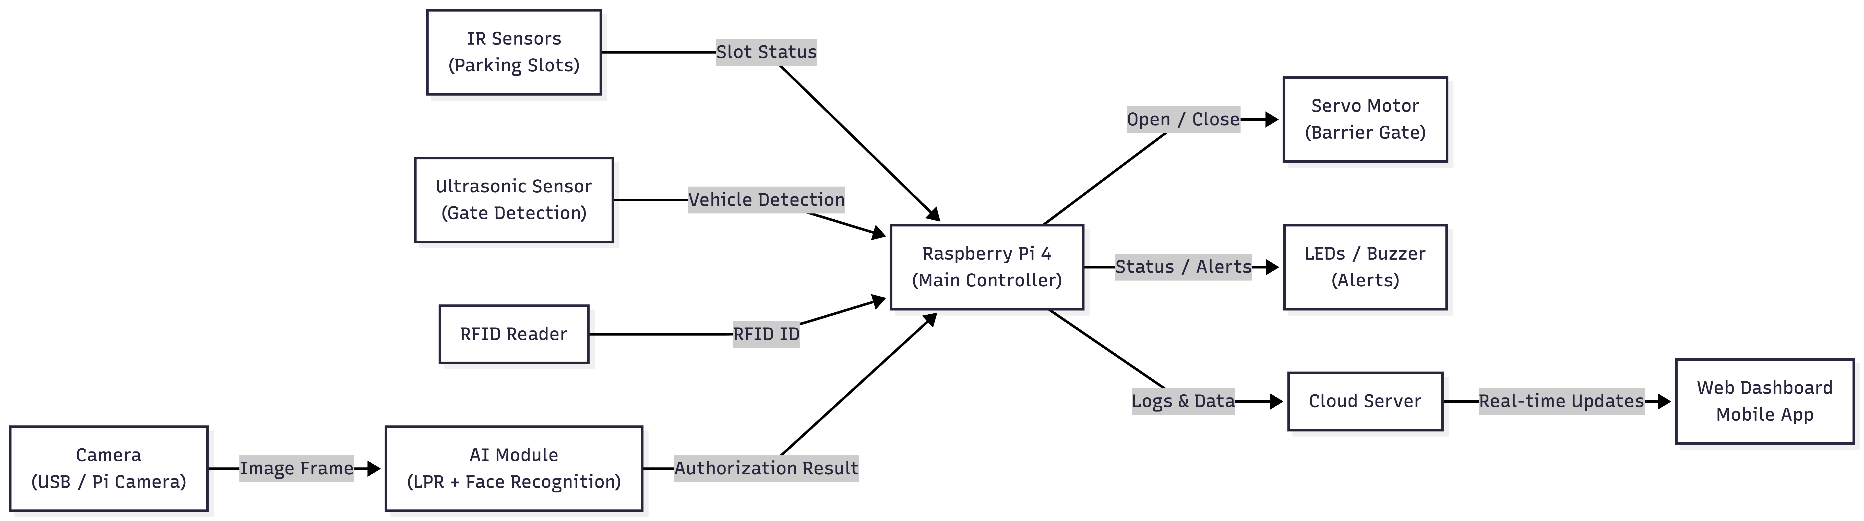
System block diagram
Multithreading Design
To ensure real-time performance, the Raspberry Pi uses a multithreading approach. Each thread is responsible for a specific subsystem such as parking slot detection, vehicle entry detection, authorization, AI processing, and cloud communication.

AI Integration
The AI module includes License Plate Recognition and Face Recognition to authorize vehicles and users. Images are captured at the gate, processed by AI models, and verified against a database.
System Workflow
1. Vehicle approaches the gate.
2. Ultrasonic sensor detects the vehicle.
3. Camera captures an image.
4. AI processes license plate and face.
5. Authorization decision is made.
6. Gate opens or access is denied.
7. Data is sent to the cloud.
Sequence diagram

The sequence diagram illustrates the time-ordered interaction between system components involved in vehicle detection, authorization, gate control, and cloud communication within the Smart Parking System
System sequence diagram
Code Implementation
IR Sensor Thread
# =========================
# IR Sensor Thread (Parking Slot Detection)
# =========================
# Reads IR sensors and updates LEDs + slot status.
# (In the final version, this logic can run in a dedicated thread.)
def update_slots():
global last_slot1_state, last_slot2_state
# Check Slot 1
s1 = GPIO.input(IR_SLOT1)
if s1 != last_slot1_state:
if s1 == 0:
GPIO.output(LED_S1_RED, GPIO.HIGH)
GPIO.output(LED_S1_GREEN, GPIO.LOW)
log("FEEDBACK: Slot 1 OCCUPIED")
else:
GPIO.output(LED_S1_RED, GPIO.LOW)
GPIO.output(LED_S1_GREEN, GPIO.HIGH)
log("FEEDBACK: Slot 1 FREE")
last_slot1_state = s1
# Check Slot 2
s2 = GPIO.input(IR_SLOT2)
if s2 != last_slot2_state:
if s2 == 0:
GPIO.output(LED_S2_RED, GPIO.HIGH)
GPIO.output(LED_S2_GREEN, GPIO.LOW)
log("FEEDBACK: Slot 2 OCCUPIED")
else:
GPIO.output(LED_S2_RED, GPIO.LOW)
GPIO.output(LED_S2_GREEN, GPIO.HIGH)
log("FEEDBACK: Slot 2 FREE")
last_slot2_state = s2
Ultrasonic Sensor Thread
# =========================
# Ultrasonic Sensor Thread (Entry/Exit Detection)
# =========================
# Measures distance and triggers exit gate opening when a car is detected.
def get_distance():
GPIO.output(US_EXIT_TRIG, True)
time.sleep(0.00001)
GPIO.output(US_EXIT_TRIG, False)
start_time = time.time()
stop_time = time.time()
timeout = time.time()
# Wait for echo to go HIGH
while GPIO.input(US_EXIT_ECHO) == 0:
start_time = time.time()
if time.time() - timeout > 0.1:
return 100 # timeout / no object
# Wait for echo to go LOW
while GPIO.input(US_EXIT_ECHO) == 1:
stop_time = time.time()
if time.time() - timeout > 0.1:
return 100 # timeout / no object
return ((stop_time - start_time) * 34300) / 2
# Example usage inside the main loop:
dist = get_distance()
if dist < 15:
log(f"FEEDBACK: Car Exiting ({dist:.1f}cm)")
control_gate("Exit Sensor")
time.sleep(2)
RFID / Camera Authorization
# =========================
# RFID / Camera Authorization
# =========================
# Non-blocking RFID read. If valid, grant access.
def check_rfid():
id, text = reader.read_no_block()
if id:
log(f"RFID SCANNED: {id}")
if id == VALID_RFID_ID:
log("ACCESS GRANTED: RFID Valid")
return True
else:
log("ACCESS DENIED: Invalid RFID")
return False
# Example usage inside the main loop:
if check_rfid():
control_gate("RFID Access")
AI License Plate Recognition
# =========================
# AI License Plate Recognition (LPR) using OCR
# =========================
# Captures a frame from USB camera, preprocesses it, and runs Tesseract OCR.
def check_usb_lpr():
cap = cv2.VideoCapture(CAMERA_INDEX)
cap.set(cv2.CAP_PROP_FOURCC, cv2.VideoWriter_fourcc('M', 'J', 'P', 'G'))
if not cap.isOpened():
log("CAM ERROR: Could not open USB Camera.")
return False
ret, frame = cap.read()
cap.release()
if not ret:
log("CAM ERROR: Camera opened but returned empty frame.")
return False
gray = cv2.cvtColor(frame, cv2.COLOR_BGR2GRAY)
gray = cv2.threshold(gray, 0, 255, cv2.THRESH_BINARY | cv2.THRESH_OTSU)[1]
text = pytesseract.image_to_string(gray, config='--oem 3 --psm 8')
clean_text = "".join(e for e in text if e.isalnum()).upper()
if len(clean_text) > 1:
log(f"CAM SEES: '{clean_text}'")
if TARGET_PLATE in clean_text:
log(f"MATCH FOUND: '{TARGET_PLATE}'")
return True
return False
# Example usage inside the main loop (rate-limited):
if (time.time() - last_cam_check_time) > CAMERA_CHECK_INTERVAL:
if check_usb_lpr():
control_gate("License Plate Match")
last_cam_check_time = time.time()
Cloud Communication
# =========================
# Cloud Communication (HTTP / MQTT)
# =========================
(To be implemented)
# Planned responsibilities:
# - Upload slot status changes (occupied/free)
# - Upload entry/exit events (timestamps, RFID/LPR result)
# - Push real-time updates to Web Dashboard / Mobile App (e.g., Blynk)

Conclusion and Future Work
The Smart Parking System demonstrates how IoT and AI can be combined to create an efficient and secure parking solution. Future work includes completing code implementation, improving AI accuracy, and integrating online payment features.

