CBIO313: Data Mining and Machine Learning
Heart Disease Prediction Using Machine Learning
Final Report
By:
Jana Mahmoud Abdalla
ID: 231001245
Under Supervision of:
Dr. Mohamed EL-Sayeh
Summer 2026

Abstract
In this project, a machine learning model was developed to predict heart disease using demographic, cardiovascular, ECG, and exercise-related patient information. The dataset includes age, sex, chest pain type, resting blood pressure, cholesterol, fasting blood sugar, resting ECG, maximum heart rate, exercise-induced angina, ST depression (Oldpeak), ST slope, and heart disease status. The project followed a complete machine learning workflow, including data understanding, data cleaning, feature engineering, exploratory data analysis, model training, model comparison, hyperparameter tuning, model evaluation, and deployment using Streamlit.
Six classification algorithms were trained and compared: Logistic Regression, Decision Tree, Random Forest, Support Vector Machine, K-Nearest Neighbors, and Gradient Boosting. Models were evaluated using accuracy, precision, recall, F1-score, ROC AUC, confusion matrix, and classification report. Random Forest was then tuned using GridSearchCV, saved as a reusable model, and connected to an interactive Streamlit application.
The tuned Random Forest achieved an accuracy of approximately 0.897, precision of 0.888, recall of 0.931, F1-score of 0.909, and ROC AUC of 0.927. These results indicate strong overall discrimination on the held-out test set. The model is intended for educational screening-support demonstration only and should not replace professional medical diagnosis.

Introduction
Heart disease is a major health problem in which early risk recognition can support timely medical evaluation and prevention. Clinical information such as age, blood pressure, cholesterol, ECG patterns, exercise response, and symptoms can contain useful predictive patterns. Machine learning can analyze these variables together and estimate the probability that a patient belongs to the heart-disease class.
The main objective of this project is to answer the question: Can machine learning predict heart disease status based on demographic, cardiovascular, ECG, and exercise-related features? The project demonstrates how a complete data-mining workflow can be applied to a healthcare classification problem while emphasizing that predictions are supportive rather than diagnostic.

Dataset Description
The dataset used in this project is the Heart Failure Prediction Dataset published on Kaggle by fedesoriano. The file used was heart.csv. It contains 918 patient records and 12 columns: 11 predictor variables and one binary target variable named HeartDisease. The target is coded as 1 for heart disease and 0 for normal.
The raw dataset contained no missing values and no duplicated rows. However, 1 resting blood pressure value and 172 cholesterol values were recorded as zero. Because these are not meaningful clinical measurements in this context, they were treated as unavailable values and replaced with the median of the corresponding variable before modeling. The target contained 508 positive cases and 410 negative cases.

Methodology
The project followed a complete machine learning lifecycle. First, pandas was used to load and inspect the dataset using functions such as head(), info(), isnull().sum(), duplicated().sum(), and value_counts(). Data cleaning standardized the column names, removed duplicates if any, checked the target, treated invalid zero RestingBP and Cholesterol values as missing, and filled numerical missing values using the median and categorical missing values using the mode.
Feature engineering created age groups, resting blood pressure categories, cholesterol categories, the percentage of age-predicted maximum heart rate reached, and an exercise-capacity category. These features were added to the original variables to improve interpretability and allow the models to use both continuous measurements and grouped clinical summaries.
The target HeartDisease was separated from the predictors, and the data were split into 80% training and 20% testing sets using stratification. A preprocessing pipeline applied StandardScaler to numerical variables and OneHotEncoder to categorical variables. SelectKBest with ANOVA F-statistics was used for feature selection. Six algorithms were trained and compared using accuracy, precision, recall, F1-score, and ROC AUC. Random Forest was then tuned using GridSearchCV with five-fold cross-validation and F1-score as the optimization metric.

Results
Model Comparison
Model | Accuracy | Precision | Recall | F1 Score | ROC AUC
Logistic Regression | 0.853 | 0.912 | 0.814 | 0.860 | 0.910
Decision Tree | 0.750 | 0.775 | 0.775 | 0.775 | 0.747
Random Forest | 0.777 | 0.785 | 0.824 | 0.804 | 0.867
SVM | 0.815 | 0.840 | 0.824 | 0.832 | 0.881
KNN | 0.788 | 0.806 | 0.814 | 0.810 | 0.869
Gradient Boosting | 0.810 | 0.825 | 0.833 | 0.829 | 0.884
Before tuning, Logistic Regression produced the highest accuracy (0.853) among the six baseline pipelines, while other models showed different trade-offs between precision and recall. After GridSearchCV, the tuned Random Forest achieved accuracy 0.897, precision 0.888, recall 0.931, F1-score 0.909, and ROC AUC 0.927. The final confusion matrix contained 70 true negatives, 12 false positives, 7 false negatives, and 95 true positives.

Visualization and Plot Interpretation
Figure 1: Target Distribution
The target distribution shows 508 patients in the heart-disease class and 410 in the normal class. The classes are not perfectly equal, but both are sufficiently represented. Multiple evaluation metrics were therefore used instead of relying on accuracy alone.
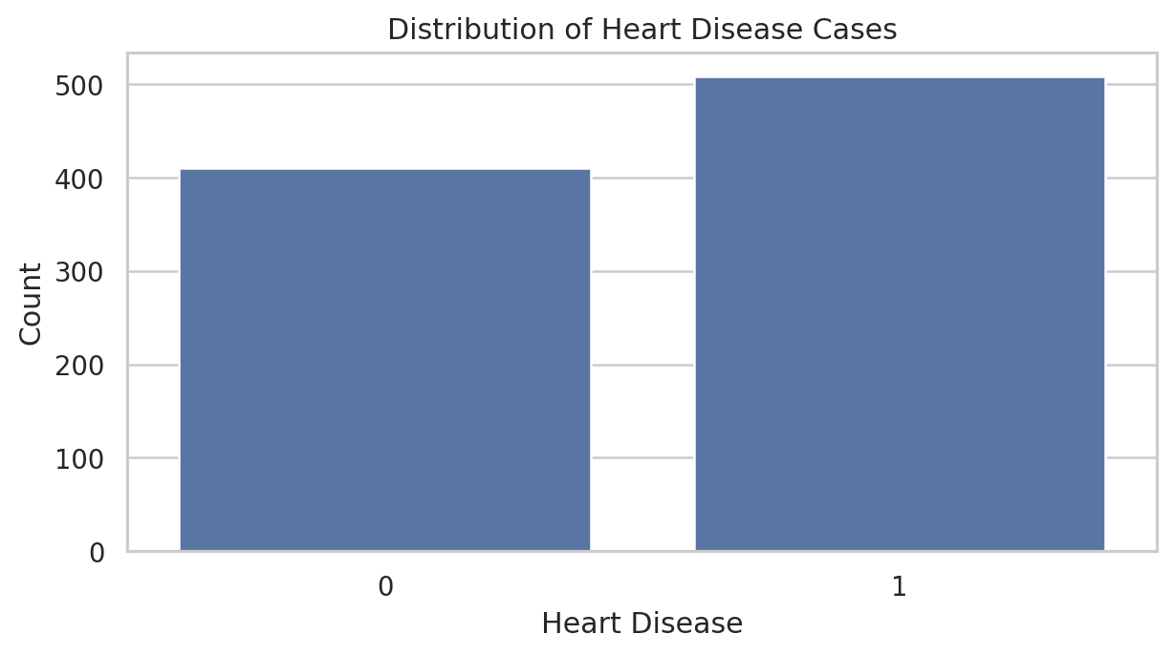
Figure 2: Age Distribution
The age distribution covers adults from the late twenties to the seventies, with many observations concentrated in middle and older adulthood. This range is useful for evaluating how age contributes to cardiovascular prediction.
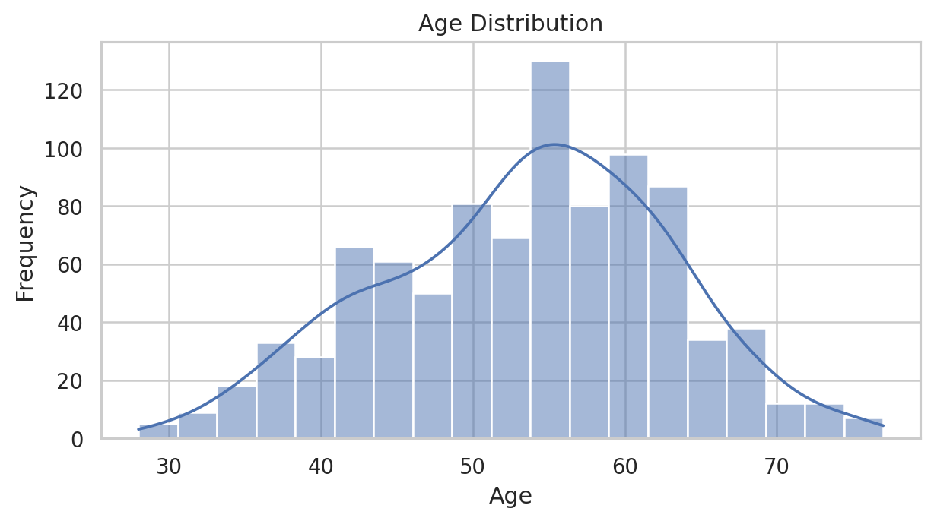

Figure 3: Cholesterol Distribution
The cholesterol plot shows a broad distribution after invalid zero measurements were replaced with the median. Most values fall in common clinical ranges, with a smaller number of high observations that may influence cardiovascular risk patterns.
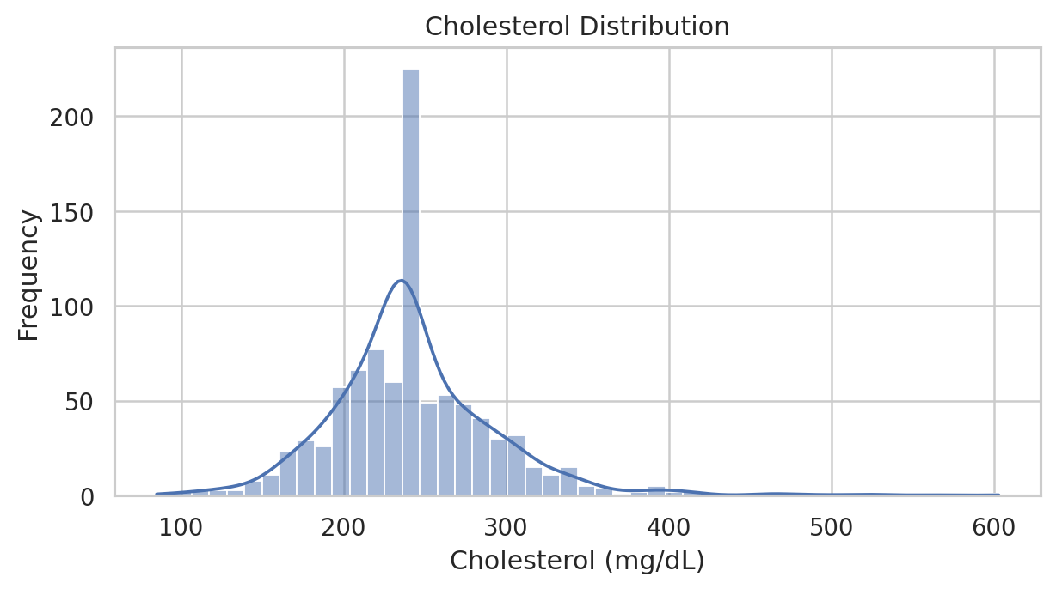
Figure 4: Resting Blood Pressure Distribution
Resting blood pressure is concentrated around typical adult values but includes elevated and high measurements. This variable can contribute useful information when combined with the remaining clinical features.
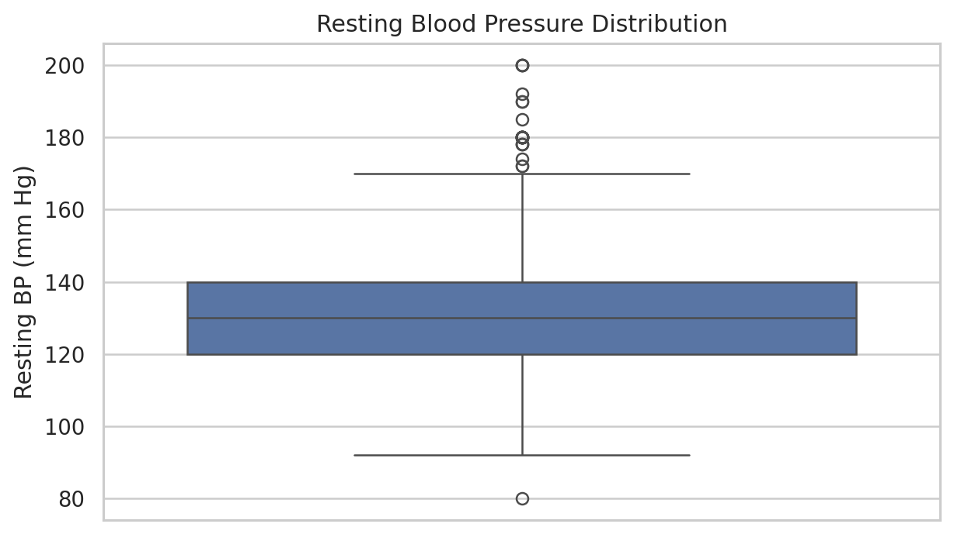

Figure 5: Maximum Heart Rate Distribution
Maximum heart rate achieved during exercise varies widely across the patients. Lower achieved heart rate may reflect different exercise responses and can contribute to model separation together with age and exercise-induced angina.
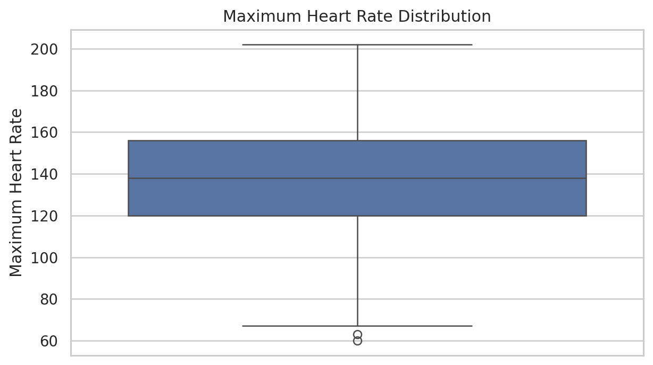
Figure 6: Age vs Heart Disease
Patients with heart disease were older on average (55.9 years) than patients without heart disease (50.6 years). This supports age as a useful predictor in the model.
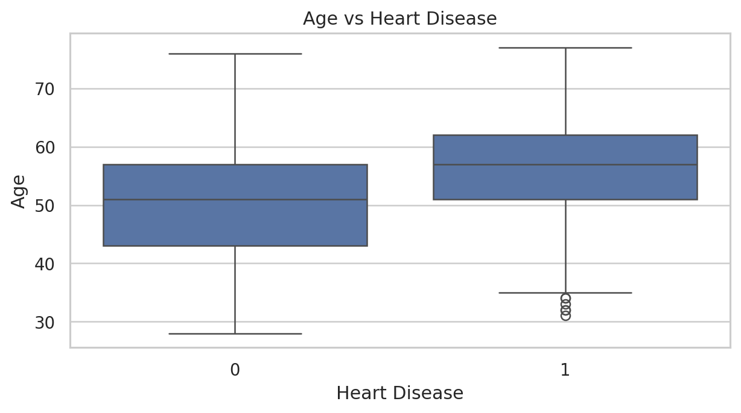

Figure 7: Cholesterol vs Heart Disease
The cholesterol distributions overlap substantially between the two classes. This indicates that cholesterol alone does not completely separate heart-disease status and should be interpreted together with symptoms, ECG, exercise response, and other variables.
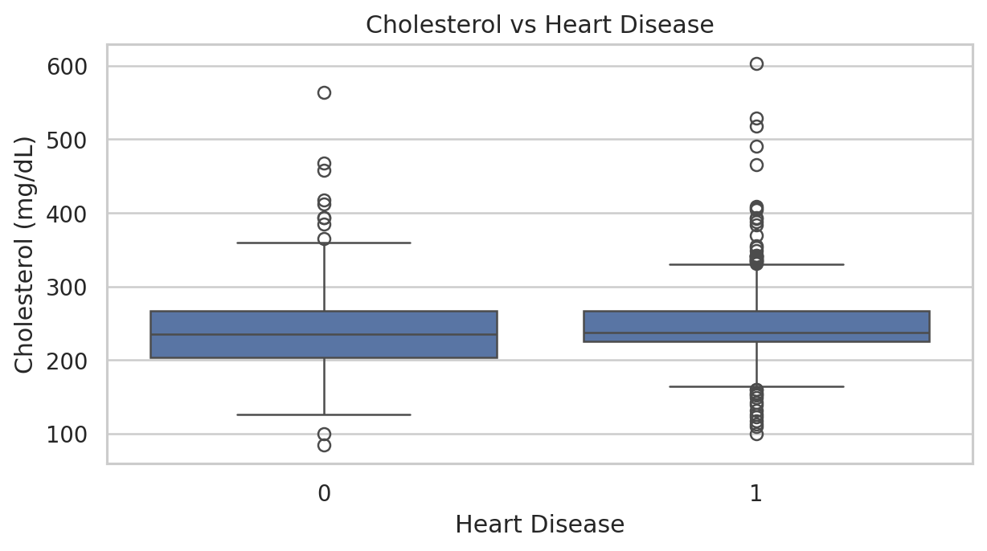
Figure 8: Chest Pain Type vs Heart Disease
Chest pain type shows a clear class pattern. The ASY category contains a high proportion of positive heart-disease cases, while ATA contains a larger proportion of normal cases. This makes chest pain type a useful categorical predictor.
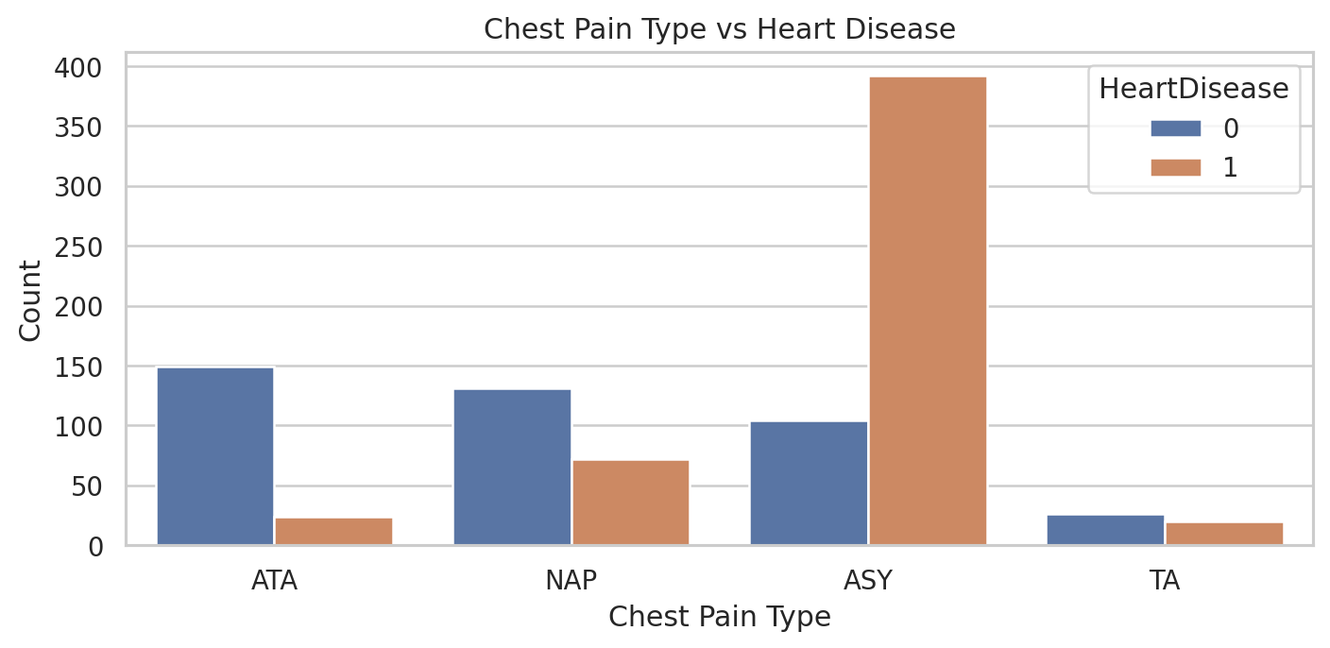

Figure 9: Exercise Angina vs Heart Disease
Exercise-induced angina shows a strong relationship with the target. Most patients with exercise angina belong to the heart-disease class, while patients without exercise angina contain a larger proportion of normal observations.
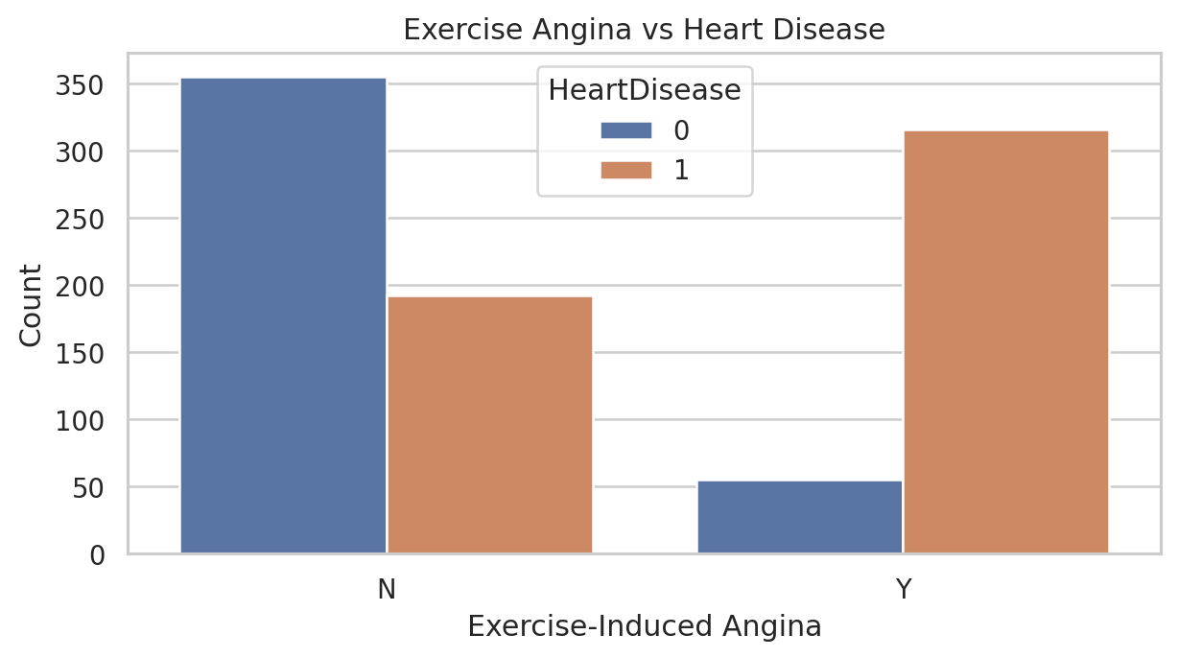
Figure 10: Sex vs Heart Disease
The sex plot shows different target proportions across the two categories in this dataset. This variable can contribute to prediction, although it should be interpreted as one feature among many rather than as an independent diagnostic factor.
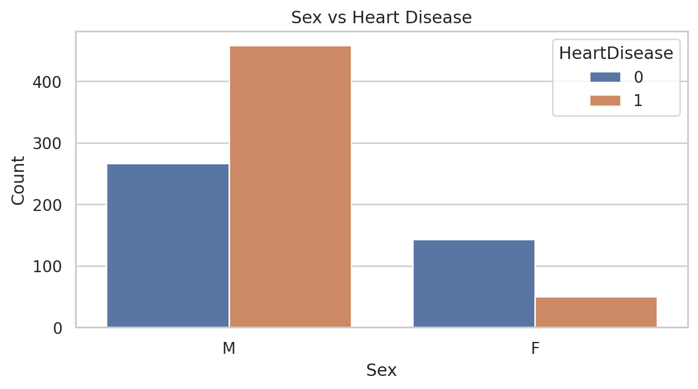

Figure 11: Correlation Heatmap
The correlation heatmap summarizes linear relationships among numerical variables. HeartDisease shows a positive association with Age and Oldpeak and a negative association with MaxHR. Because categorical variables are not fully represented in this heatmap, model-based evaluation remains necessary.
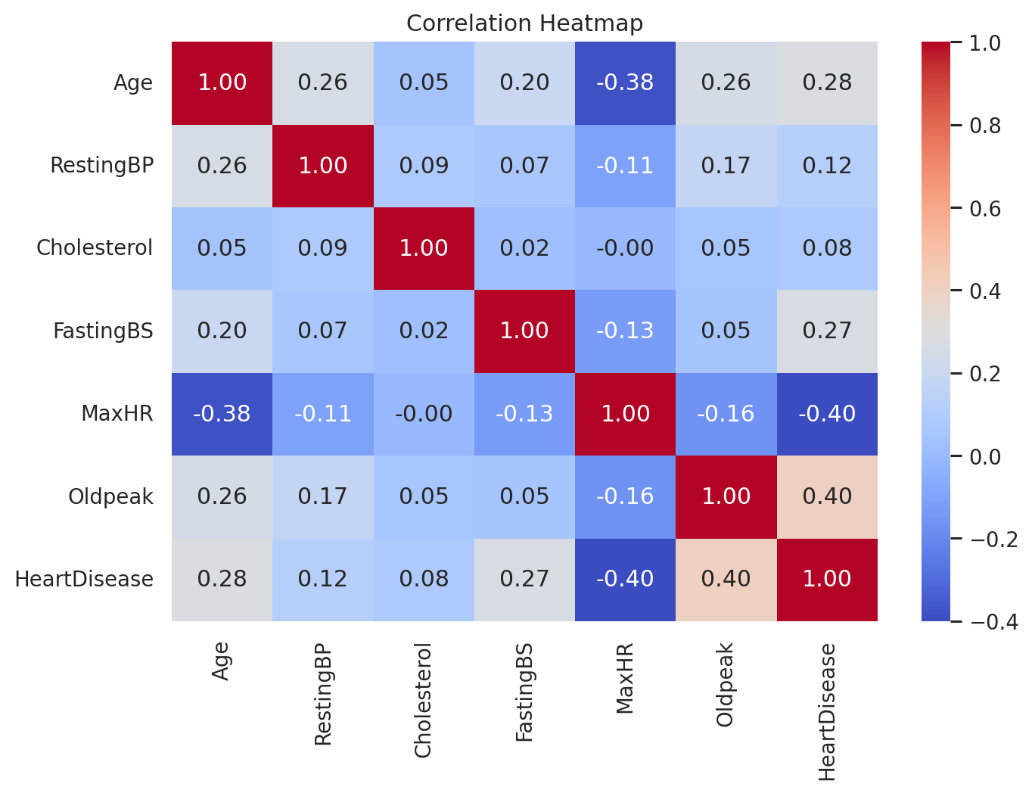
Figure 12: Model Performance Comparison
The model comparison chart displays accuracy, precision, recall, F1-score, and ROC AUC for all six baseline algorithms. The results demonstrate that different algorithms emphasize different trade-offs, which supports selecting and tuning a model using several metrics rather than accuracy alone.
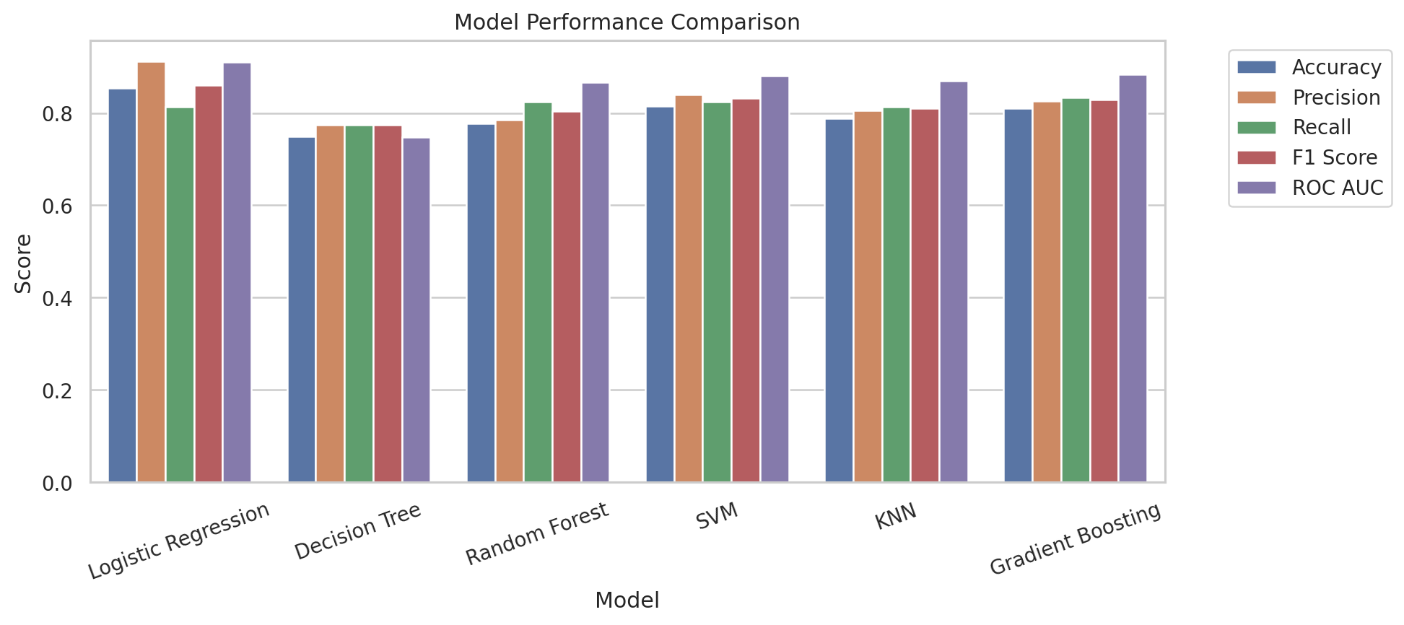
Figure 13: Confusion Matrix
The final tuned Random Forest correctly classified 70 normal patients and 95 heart-disease patients in the test set. It produced 12 false positives and 7 false negatives. False negatives are especially important in a screening context because they represent positive cases predicted as negative.
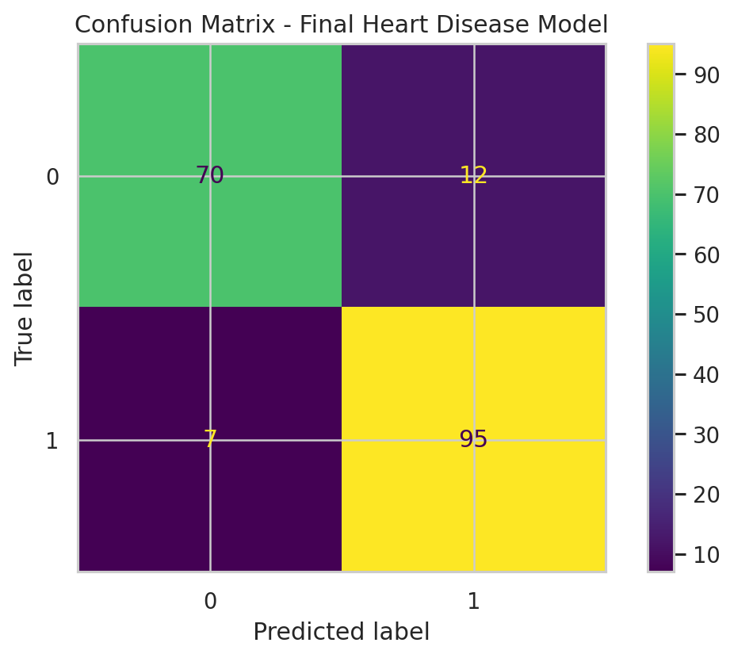
Figure 14: ROC Curve
The ROC curve summarizes the model's discrimination across classification thresholds. The tuned model achieved an ROC AUC of approximately 0.927, indicating strong ability to rank positive cases above negative cases on the held-out test set.
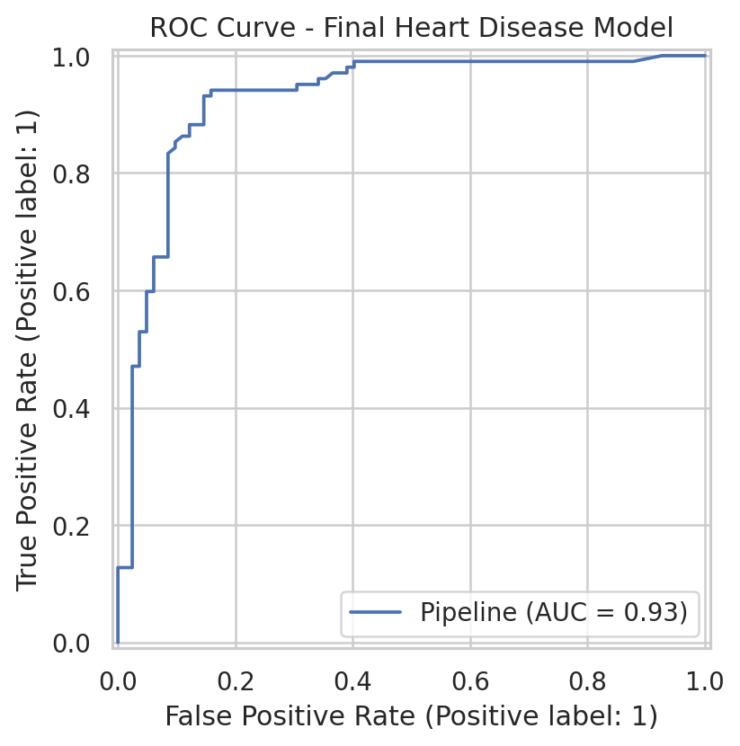

Model Deployment
The final tuned model was saved as best_heart_disease_model.pkl and deployed through a Streamlit application. The app contains input fields for sex, age, chest pain type, resting blood pressure, cholesterol, fasting blood sugar, resting ECG, maximum heart rate, exercise-induced angina, Oldpeak, and ST slope. It automatically creates the same engineered features used during training before sending the patient record to the saved pipeline.
After the user clicks the prediction button, the app displays the predicted class and the estimated probability of heart disease. It also shows the automatically generated age, blood pressure, cholesterol, and exercise-capacity categories, and a summary of the patient inputs. The app is titled Jana Mahmoud Abdalla Heart Disease Prediction App and includes the student ID 231001245.
The deployment code is included in app.py. The application can be started locally after installing the packages in requirements.txt by running the Streamlit command provided in README.txt.

Conclusion
This project successfully demonstrated a complete machine learning workflow for heart disease prediction. The workflow included data loading, data understanding, cleaning of invalid measurements, feature engineering, exploratory data analysis, preprocessing, feature selection, comparison of six classification algorithms, hyperparameter tuning, evaluation, model saving, and Streamlit deployment.
The tuned Random Forest achieved strong held-out test performance, including accuracy 0.897, precision 0.888, recall 0.931, F1-score 0.909, and ROC AUC 0.927. The analysis also showed useful patterns involving age, maximum heart rate, chest pain type, exercise-induced angina, and other clinical variables. However, the dataset is relatively small and the model should be treated as an educational screening-support demonstration, not a medical diagnostic system.
Future improvements could include external validation on independent patient cohorts, probability calibration, explainability methods such as feature importance or SHAP, comparison with additional algorithms, and public deployment through Streamlit Community Cloud.

