Palestine Technical University – Kadoorie
College of Information Technology and Artificial Intelligence
Computer Science Department
Graduation Project I
An Assistive Web-Based Platform
to Support Sign Language Learning and Communication
By:
Masa Mojahed Barham 202211748
Jana Raed Abu Saa 202220006
Doaa Omar Shahroor 202211945
Adham Saad Allah Habbash 202110150
Supervised by:
Dr-Sherin Hijazi
تقدير و شكر
بسم الله الرحمن الرحيم
قال تعالى:
﴿وَأَن لَّيْسَ لِلْإِنسَانِ إِلَّا مَا سَعَىٰ ۝ وَأَنَّ سَعْيَهُۥ سَوْفَ يُرَىٰ ۝ ثُمَّ يُجْزَىٰهُ ٱلْجَزَآءَ ٱلْأَوْفَىٰ﴾
صدق الله العظيم
لم يكن هذا العمل مجرّد متطلبٍ أكاديمي، بل محاولة لفهم ذواتنا ونحن نعبر مرحلة من العمر، ومرحلة من الوطن معاً ، في أروقة الجامعة، حيث تتقاطع الأسئلة العلمية مع أسئلة المعنى، تشكّل هذا المشروع بحب وشغف وبطئٍ وصبر، نتوجّه بالشكر العميق إلى أعضاء الهيئة التدريسية في قسم علم الحاسوب ، الذين لم يمنحونا المعرفة بوصفها معلومات، بل علّمونا كيف نفكّر، وكيف نُخطئ، وكيف نعيد المحاولة. كان حضورهم امتداداً للفكرة التي تؤمن بأن العلم موقف، وأن الجامعة ليست جدراناً بل وعياً يتكوّن. ونخصّ بالشكر الدكتورة شيرين حجازي، المشرفة على مشروع التخرج، التي رافقت هذا العمل بعينٍ ناقدة وقلبٍ صبور، فأتاحت لنا أن نختبر حدود أفكارنا، وأن ننضج أكاديميًا دون أن نفقد إنسانيتنا. كان إشرافها مساحة توازن بين الصرامة العلمية والاحترام العميق للجهد الفردي. ولا بدّ أن نشكر أنفسنا؛ على الاستمرار حين بدا الطريق مثقلاً، وعلى الإيمان بأن العمل، في هذا المكان، هو شكل من أشكال الصمود. نشكرنا لأننا اخترنا المعرفة في زمنٍ تُستنزف فيه الأرواح، واخترنا أن نكتب ونبني بينما وطننا ما زال يكتب تاريخه بالدم والصبر. هذا العمل نهديه إلى الوطن، الذي علّمنا أن لا معرفة بلا مسؤولية، ولا علم بلا موقف. إلى الشهداء، الذين سبقونا إلى الحقيقة الكبرى، وتركوا لنا عبء الحياة وواجب أن نكون جديرين بها. إلى الأسرى، الذين يختبرون الزمن في معناه القاسي، ويذكّروننا أن الحرية تبدأ فكرة قبل أن تكون واقع. ونشكر زملاءنا، شركاء التعب والبحث والسؤال، وأهلنا، الذين كانوا السند الصامت، والدعاء الذي لا يُكتب لكنه حاضر في كل سطر. هذا المشروع شهادة على مرحلة، وعلى جهدٍ صادق، وعلى إيمانٍ بأن المعرفة، في هذا الوطن، ليست ترفاً، بل فعل بقاء.
Chapter
Introduction
Chapter Introduction

0.1 Introduction
According to the Palestinian Central Bureau of Statistics, there are approximately 20,000 persons with hearing disabilities in Palestine, out of about 115,000 persons with different types of disabilities. Persons with disabilities represent around 2% of the total Palestinian population. These numbers are not only statistics; they reflect a human reality for a group that needs more support, empowerment, and practical solutions that help them communicate and participate in society with dignity and independence.
Article 2 of Law No. 4 concerning the Rights of Persons with Disabilities states that persons with disabilities have the right to enjoy a dignified and free life. This highlights the importance of using technology to serve this group, not only as a technical tool, but also as a way to promote inclusion, facilitate communication, and provide wider opportunities for learning and social interaction.
This graduation project aims to design and develop an interactive electronic platform that serves the deaf and hard-of-hearing community by providing technological solutions that support communication, learning, and social interaction. The idea of the project came from the need for a unified platform that combines several services in one easy-to-use environment, instead of depending on separate and limited solutions that do not meet all users’ needs.
The UnMute platform focuses on providing an accessible and inclusive digital environment that enables users to communicate with others, use assistive translation tools, access sign language learning content, and benefit from supportive features such as quick sign language phrases and an accessibility map. The platform also includes an administrative dashboard that helps manage content and monitor system activities.
The project was developed using a structured software engineering methodology by adopting the Prototyping Model to design and improve the system gradually. The work includes requirements analysis, system modeling, and user interface design, ensuring clarity, consistency, and the ability to improve and expand the platform in future stages.

0.2 Related Work

0.2.1 Tool 1: Lingvano
Lingvano is a web-based and mobile application designed to teach sign language through interactive video lessons and short quizzes. Developed by Lingvano GmbH, an Austrian company specialized in creating accessible educational technologies, the application aims to empower both deaf and hearing individuals to learn sign language effectively, promoting inclusive communication, understanding, and social integration among different communities. It provides a structured, user-friendly, and visual learning experience that helps users develop sign language skills at their own pace.
Key Features
- Interactive Video Lessons: Real instructors demonstrate sign language gestures in high-quality video sessions.
- Short Quizzes: Enable users to test their comprehension after each lesson.
- Vocabulary Practice: Offers categorized sign words to enhance vocabulary learning.
- Progress Tracking: Allows users to monitor and measure their learning progress.
- Multi-language Support: Includes sign languages such as ASL (American Sign Language) and BSL (British Sign Language).
- Accessible Visual Interface: Simple and clear design suitable for all age groups and learning levels.
Limitations
- The application does not provide real-time translation between spoken or written text and sign language.
- Lacks social interaction features or community-based communication tools.
- Does not include daily life assistance tools such as routine planners or accessibility maps.
- Arabic language is not supported, limiting its usability in Arabic-speaking regions.
- Requires a stable internet connection for most educational content.
Official Website: https://www.lingvano.com/asl/

0.2.2 Tool 2: Musheer
Musheer is an Arabic mobile application developed to support and empower the deaf and mute community by enhancing communication through sign language recognition and learning. The application was created by a group of Arab developers under the Musheer Project, with the aim of using artificial intelligence (AI) to recognize and translate hand gestures into text or spoken words in real time. Its main objective is to bridge the communication gap between the deaf community and the hearing world by providing an accessible digital tool that promotes understanding, inclusion, and equal participation in daily life. Musheer focuses primarily on Arabic Sign Language, making it one of the few regional solutions designed for Arabic-speaking users.
Key Features
- AI-based Gesture Recognition: Uses the device’s camera to detect and interpret sign language gestures in real time.
- Instant Translation: Converts recognized signs into written text or audible speech for easier communication.
- Arabic Sign Language Support: Specially tailored to Arabic-speaking users and regional sign variations.
- Educational Mode: Offers a library of signs and short lessons for users who wish to learn or practice sign language.
- User-friendly Interface: Simple and intuitive design suitable for all age groups.
- Offline Access: Some basic lessons and sign dictionaries are available without an internet connection.
Limitations
- Limited Content: The app mainly focuses on translation and lacks interactive learning materials or quizzes.
- No Social Interaction: Does not include features for communication or connection between users.
- Restricted to Arabic Only: Does not support other international sign languages.
- Limited Platform Availability: Primarily available for Android; iOS support is minimal.
- AI Accuracy Depends on Lighting and Camera Quality: Gesture recognition may be less effective under poor conditions.
Official Source: https://play.google.com/store/apps/details?id=com.musheer.musheer

0.2.3 Tool 3: Hand Talk
Hand Talk is an award-winning mobile and web application that provides real-time translation between text, voice, and sign language using a 3D virtual interpreter named Hugo. It was developed by the Brazilian company Hand Talk App, which specializes in assistive technology aimed at promoting accessibility and inclusion for the deaf and hard-of-hearing community. The main goal of Hand Talk is to break communication barriers by enabling seamless translation from spoken or written language into sign language instantly, allowing both deaf and hearing individuals to communicate effectively in everyday situations.
Key Features
- Real-time Translation: Converts spoken or written text into sign language animations instantly using a 3D avatar.
- 3D Virtual Interpreter (Hugo): A customizable animated character that performs accurate sign language gestures.
- Voice Input Support: Allows users to speak directly, and the app translates the speech into sign language.
- Multilingual Functionality: Supports multiple languages including Portuguese, English, and ASL.
- Educational Use: Helps users learn basic signs through visual examples and animations.
- Cross-Platform Availability: Accessible via both mobile devices and web browsers.
Limitations
- Limited Learning Content: Focuses mainly on translation rather than structured educational lessons.
- No Social Interaction: Does not include communication or community features for users.
- Limited Sign Language Range: Primarily supports Brazilian and American Sign Languages, lacking Arabic support.
- Requires Internet Connection: Translation and 3D rendering need continuous online access.
- Complex Animations on Older Devices: Performance may decrease on low-end smartphones.
Official Website: https://www.handtalk.me/en/app

0.2.4 Tool 4: Sokoon
Sokoon is an Arabic application designed to support and empower the deaf and mute community through digital sign language learning and social interaction. It was developed under the Sokoon Project, launched by the Qatari Ministry of Social Development and Family, with funding from the Social and Sports Contribution Fund (Daam) and in collaboration with the Mada Center for Assistive Technology. The main goal of Sokoon is to digitize Arabic sign language and create an inclusive communication platform that enables both deaf and hearing individuals to learn, communicate, and share knowledge in a unified environment.
Key Features
- Arabic Sign Language Learning: Provides video lessons that teach words and sentences in Arabic sign language.
- Search and Categorization: Allows users to search for specific signs and browse organized categories for easy access.
- Translation of Written and Spoken Sentences: Converts typed or spoken phrases into Arabic sign animations using digital avatars.
- Favorites and Word Requests: Users can save favorite words and request new signs to be added to the dictionary.
- Educational Content: Contains a large database with over 2,600 words and 480 sentences.
- Bilingual Interface: Supports both Arabic and English languages for accessibility.
- Government Collaboration: Developed with official support to promote inclusion and accessibility across the Arab world.
Limitations
- No Real-time Translation: Translations are pre-recorded and not performed instantly through live camera input.
- Limited Social Interaction: The app’s communication features are minimal compared to full social platforms.
- Restricted Language Scope: Focuses only on Arabic sign language without support for other international versions.
- Internet Dependency: Some features require a stable connection for video playback and updates.
- Limited Flexibility: Translations are based on a fixed dictionary, so newly coined words or expressions may not be recognized.
Official Websites:
- https://sokoon.msdf.gov.qa
- https://apps.apple.com/za/app/sokoon/id1635583968

0.2.5 Tool 5: Esharti
Esharti is an Arabic application designed to facilitate communication between deaf and hearing individuals through interactive translation and educational services. It also provides live video calls with certified sign language interpreters, allowing users to access professional translation in real time. The main goal of Esharti is to support deaf individuals and learners of sign language by combining education, translation, and direct interaction within a single platform.
Key Features
- Certified Training Courses: Offers structured lessons with certificates upon completion.
- Digital Sign Language Dictionary: Contains categorized sign language terms and phrases.
- Live Video Interpretation: Provides video calls with certified sign language interpreters.
- Online Workshops: Hosts live educational sessions and interactive discussions.
Limitations
- Some advanced features require a paid subscription.
- Does not offer a fully open social interaction network between users.
Official Website: https://esharti.net

0.2.6 Tool 6: Ava
Ava is an AI-powered accessibility application designed to assist deaf and hard-of-hearing individuals by providing real-time speech-to-text transcription during daily conversations, meetings, and events. Developed by the Ava Accessibility Team, the platform aims to make verbal communication fully accessible through advanced speech recognition and natural language processing (NLP) technologies. The main goal of Ava is to enable independent communication in everyday life by allowing users to see everything being said around them, directly on their screens, in real-time.
Key Features
- Real-Time Transcription: Converts spoken words into written text instantly with high accuracy.
- Multi-User Conversation Support: Allows multiple participants to join a live session and view captions together.
- Automatic Speaker Labeling: Identifies who is speaking for clearer and more organized transcripts.
- Cloud Synchronization: Saves conversations securely for later review or sharing.
- Multi-Platform Accessibility: Available on Android, iOS, and desktop browsers.
- AI-Powered Recognition: Continuously improves accuracy through adaptive machine learning.
- Customization Options: Users can adjust font size, color contrast, and notification settings for better readability.
Limitations
- Internet Dependency: Requires a stable connection for real-time transcription.
- Limited Offline Functionality: Voice-to-text services are unavailable without network access.
- Privacy Concerns: Conversations may be stored temporarily in the cloud.
- No Sign Language Translation: Focuses only on text captions rather than visual or gesture-based translation.
- Subscription-Based Features: Some advanced capabilities are only available in the premium version.
Official Website: https://www.ava.me/

0.2.7 Comparison Table
Feature Comparison of Existing Tools vs. Proposed System (UnMute)
Feature | Lingvano | Musheer | Hand Talk | Sokoon | Ava | Esharti | UnMute
Sign Language Learning
Real-time Translation (Voice/Text $↔$ Sign)
Voice-to-Text / Text-to-Voice
Artificial Intelligence Integration
Multilingual Support
Interactive Video Lessons
User Interaction & Ease of Use | $∼$ | $∼$ | $∼$
Social Communication / Community |  |  |  | $∼$ | $∼$
Daily Routine Organizer |  |  |  |  | $∼$
Quick Sign Phrases
Accessibility Map
Free Basic Features |  |  |  |  | $∼$ | $∼$
Legend: = Available, = Not available, $∼$ = Partially/Moderate.

0.2.8 Gap Analysis
Despite the existence of several applications designed to support the deaf and mute community, most of them focus on a single aspect—either education, translation, or communication. None provides a comprehensive, user-friendly platform that combines these essential services in one system.
The proposed system, Unmute, fills this gap by integrating interactive learning, real-time translation, social communication, and daily assistance tools into one inclusive web-based solution designed to empower the deaf and mute community in the Arab world.

0.3 Problem Statement
Deaf and mute individuals face significant challenges in communication, education, and social inclusion. They often struggle to interact effectively with others and to understand spoken lan-guage, which limits their participation in social, educational, and professional life. Although several platforms and applications have been developed to support this community, most of them focus on a single aspect—such as sign language learning, real-time translation, or lim-ited communication—without offering a unified and user-friendly environment that combines all these features in one place. Moreover, many existing solutions lack advanced artificial in-telligence capable of accurately recognizing gestures or adapting to regional variations of sign language, which makes them less effective in real-life use. To address these challenges, the Un-mute platform was designed as a comprehensive technical solution that empowers the deaf and mute community through real-time communication, interactive learning, and intelligent transla-tion. It features a bilingual, accessible interface that promotes inclusion and ease of use for all users. The platform integrates assistive technologies and a prototype-based translation module to support communication through text, voice-related input, and basic camera-based gesture recognition. convert it into sign language translations in real time, making it an effective tool for enhancing communication between deaf and mute individuals and the wider community. By combining technology with human-centered design, Unmute aims to foster independence, accessibility, and full integration for the deaf and mute community.

0.4 Objectives
The main objective of the Unmute platform is to design and develop an inclusive web-based platform that supports deaf, hard-of-hearing, and mute users by combining communication, learning, social interaction, and daily assistance tools in one accessible environment. The platform aims to reduce communication barriers and provide users with practical digital services that support independence, inclusion, and easier interaction with society. The specific objectives of the Unmute platform are:
1. To develop a bilingual web platform that supports both Arabic and English interfaces, making the system accessible to a wider range of users.
2. To provide an interactive translation workspace that supports communication through text, voice-related input, and a camera-based gesture recognition prototype.
3. To support sign language learning by offering educational video lessons, categorized learning content, and simple interactive assessments.
4. To create a social communication space where users can share posts, interact through comments and reactions, send friend requests, and communicate with others.
5. To provide a daily routine planner that helps users organize their tasks, manage their time, and follow their daily activities in a clear visual way.
6. To offer quick predefined sign phrases that can assist users in common daily communication situations.
7. To include an accessibility map that helps users locate supportive centers, services, and disability-friendly places.
8. To provide an admin dashboard that allows administrators to manage users, educational content, posts, places, messages, and platform activities.
9. To support accessibility customization by allowing users to adjust font size, background color, text color, and interface language according to their needs.
10. To enhance digital and social inclusion by giving deaf, hard-of-hearing, and mute users a platform that supports communication, education, and participation in daily life.

0.5 Benefit
The Unmute platform provides several benefits for deaf, hard-of-hearing, and mute users, as well as for the wider community. Its value comes from combining different support services into one web-based platform instead of requiring users to depend on separate applications for communication, learning, social interaction, and daily assistance. The main benefits of the platform include:
1. Improving communication by providing tools that help users interact through text, voice-related input, sign language visual support, and basic gesture recognition.
2. Supporting self-learning through organized sign language lessons, educational videos, and simple assessments that allow users to improve their skills gradually.
3. Encouraging social inclusion by giving users a community space where they can publish posts, comment, react, build friendships, and exchange messages.
4. Helping users manage their daily lives through a routine planner that allows them to add, edit, complete, and organize daily tasks.
5. Facilitating access to supportive services through an interactive accessibility map that displays centers, places, and services relevant to users with disabilities.
6. Providing quick sign phrases that help users communicate in common daily situations more easily and quickly.
7. Offering a bilingual interface in Arabic and English, which makes the platform more suitable for local users while still being understandable to a wider audience.
8. Improving accessibility by allowing users to customize the interface through font size control, background color selection, text color selection, and language switching.
9. Supporting administrators in managing platform content, users, social interactions, learning resources, and accessibility places from one organized dashboard.
10. Raising awareness about the needs of deaf, hard-of-hearing, and mute individuals by presenting technology as a practical tool for inclusion, communication, and equal participation.

0.6 Constraints
During the analysis, design, and implementation stages of the Unmute platform, the development team faced several technical and practical constraints. These limitations helped guide the project toward a realistic prototype that can be improved and expanded in future work. The main constraints are:
1. Real-time sign language translation is technically complex because hand gestures may differ from one person to another depending on movement speed, hand shape, camera angle, lighting conditions, and regional sign language variations. Therefore, the current translator module was implemented as a prototype that supports basic camera-based gesture recognition rather than a complete sign language translation system.
2. Comprehensive Arabic sign language datasets are limited, especially datasets that are suitable for training accurate machine learning models. To reduce this limitation, the platform relies on the MediaPipe Hands model to detect hand landmarks through the camera without requiring the team to build a full custom-trained model from scratch.
3. Arabic sign language is not fully standardized across all regions, which makes it difficult to design one translation model that accurately covers all signs and variations. This constraint required focusing on selected signs, predefined phrases, and extendable learning content.
4. Real-world testing with target users was limited. During field observation and communication with deaf-related centers, it became clear that some users may not be fully familiar with technology-based tools, which made collecting direct feedback more challenging.
5. The accuracy of the camera-based gesture recognition depends on external conditions such as camera quality, lighting, hand visibility, and background noise in the image. These factors may affect recognition results and require further improvement in future versions.
6. The project required knowledge from different areas, including web development, database design, user interface design, accessibility, sign language learning, and computer vision. Managing all these parts within the graduation project timeline was a practical challenge.
7. Some platform features, such as advanced real-time translation, richer sign language datasets, and deeper expert validation, require additional collaboration with certified sign language specialists and more time for testing and refinement.
8. Since the system is web-based, several features depend on internet availability and browser permissions, especially the accessibility map, media content, and camera-based translator module.
9. Security and privacy were important constraints because the platform stores user accounts, social posts, messages, and profile information. Therefore, the system needs continuous improvement to strengthen data protection, access control, and secure communication.
10. The current version of the platform represents a functional academic prototype. It provides the main structure and core services of Unmute, but future versions can improve performance, translation accuracy, mobile support, and real-time interaction.
Chapter
Software Development Model
Chapter Software Development Model

0.7 Chosen Model: Prototyping
The Prototyping Model was chosen for developing the Unmute platform because it aligns with the nature of the project, which involves highly interactive features and serves users whose needs cannot be fully defined at the early stages of development. This model focuses on creating initial prototypes that represent simplified versions of the platform’s key functionalities, enabling the development team to better understand the requirements, evaluate usability, and identify design issues before moving to the full implementation phase.
Prototyping provides an iterative approach where the prototype is continuously refined and enhanced until the system’s structure, interface, and features become clear, stable, and ready for final development. Given that Unmute includes multiple modules—such as real-time translation, social interaction, sign language learning, daily routine management, and an accessibility map—building prototypes for each module ensures that every feature is effective, cohesive, and aligned with the overall platform goals.
Thus, the Prototyping Model supports the development of a more accurate and mature platform through cycles of design, evaluation, and refinement, making it the most suitable development methodology for the Unmute project.

0.8 Justification
The decision to develop the Unmute platform was based on a clear analysis of the existing gaps in current technologies serving the deaf and hard-of-hearing community. Most available applications are fragmented—each focusing on a single function such as translation or sign-language lessons—without offering a fully integrated digital ecosystem that supports communication, education, social interaction, and daily assistance.
Furthermore, many existing global solutions lack support for linguistic and cultural diversity, especially for Arabic and regional sign languages. This creates a significant accessibility barrier and limits their usability for a large portion of the deaf community. For this reason, developing a bilingual (Arabic/English), culturally adaptive, and scalable platform became a fundamental need.
Field visits to deaf centers further highlighted a major digital divide, where many individuals still rely on traditional or inefficient communication methods, and lack access to up-to-date educational sign-language resources or inclusive social platforms.
Therefore, Unmute was chosen because it directly addresses these unmet needs through:
- A comprehensive educational environment
- Intelligent real-time translation
- A dedicated social networking space
- Daily-life support tools
- A safe and accessible user experience
- A flexible architecture designed for future expansion
Thus, the platform is not merely an additional application—it represents a holistic, impactful solution that fills a long-standing technological, educational, and social gap, and actively promotes digital inclusion for the deaf community.

0.9 Functional Requirements
Our Unmute system is built upon a set of functional requirements that define what the system must do to achieve its intended goals. These requirements represent the main features that allow users to interact, translate, learn, and communicate effectively within the platform. The main functional requirements are listed below:
- User Registration
The system shall allow new users to create accounts by entering required information such as name, email, password, and user type. The system shall validate the entered data, prevent duplicate email registration, and store user information securely in the database.
- User Login
The system shall allow registered users to log in using their email or username and password. The system shall verify the entered credentials, start a secure user session, and redirect the user to the appropriate interface according to their role.
- User Logout
The system shall allow users to log out safely from their accounts. When the user logs out, the system shall end the active session and redirect the user to the login page.
- Password Recovery
The system shall provide a secure password recovery process for users who forget their passwords. The user shall enter their registered email, and the system shall generate a secure time-limited reset token that allows the user to create a new password.
- Main Dashboard
he system shall provide a main dashboard after login. The dashboard shall act as the central navigation page that gives users access to the main platform modules, including the social community, translator, learning section, daily tasks, accessibility map, and profile page.
- User Profile Management
The system shall allow users to manage their personal profile information. Users shall be able to view their profile, update personal details, change their password, and view basic activity information such as posts and friends when available.
- Translator Workspace
The system shall provide an interactive translator workspace that supports communication assistance through text input, voice-related input, visual sign representations, and a camera-based gesture recognition prototype. The camera-based component shall use hand landmark detection to recognize selected basic gestures and display the recognized result to the user.
- Interactive Learning Module
The system shall provide a learning section that includes sign language educational content such as videos, categories, and simple interactive assessments. Users shall be able to browse learning materials and practice selected signs in an organized way.
- Social Community Module
The system shall allow users to participate in a social communication environment. Users shall be able to create posts, view posts, add comments, react to posts, and interact with content shared by other users.
- Friend Request Management
The system shall allow users to build social connections by sending friend requests to other users. The recipient shall be able to accept or reject the request, and the system shall update the friendship status in the database.
- Messaging
The system shall allow users to exchange private text messages with accepted friends inside the social community section. Messages shall be stored in the database and displayed in the chat interface to support direct communication between friends.
- Notifications
The system shall provide notifications for important user interactions such as friend requests, comments, reactions, and messages. Notifications shall help users stay aware of activities related to their account and social interactions.
- Daily Routine Planner
The system shall allow users to organize their daily tasks. Users shall be able to add, edit, delete, reorder, and mark tasks as completed. The system shall save task data in the database so users can manage their routine easily..
- Accessibility Map
The system shall provide an interactive map that displays supportive centers, services, and disability-friendly places. When location permission is allowed, the map can show the user’s location and nearby places to help users find relevant services more easily.
- Support Messages
The system shall allow users or visitors to send support or contact messages to the platform administration. These messages shall be stored and displayed in the admin control panel so administrators can review and manage them when needed.
- Control Panel
The system shall provide an admin control panel that allows Super Admins and Admins to manage platform data according to their permissions. Through this dashboard, they can view, search, add, edit, update, remove, suspend, or reactivate records depending on the type of data. This includes managing users, posts, comments, learning videos, sign language gestures, support messages, daily tasks, and accessibility centers. User accounts are not permanently deleted; they can only be suspended or reactivated when needed.
- Search
The system shall provide search functionality to help users and administrators find information quickly. Users shall be able to search for lessons, tasks, locations, users, posts, and chat contacts. Super Admins and Admins shall be able to search management records inside the control panel, such as users, posts, comments, messages, tasks, learning videos, sign language gestures, and accessibility centers.
- Add
The system shall allow users to add new data or content when allowed, such as posts, comments, private messages, and daily tasks.
- Edit
The system shall allow users to edit their own data when allowed, such as profile details and daily tasks.
- Update
The system shall allow users to save updated data after editing it, such as profile information, password, and daily tasks.
- Delete
The system shall allow users to delete removable data or content when allowed, such as their own posts and daily tasks. User accounts are not permanently deleted.
- Bilingual Interface
The system shall support both Arabic and English interfaces. Users shall be able to switch between languages, and the layout direction shall adjust according to the selected language, using right-to-left direction for Arabic and left-to-right direction for English.
- Accessibility Customization
The system shall allow users to customize the interface according to their visual comfort. Users shall be able to adjust font size, choose background colors, choose text colors, and reset the interface settings when needed.

0.10 Non-Functional Requirements
In addition to the functional requirements, we included non-functional requirements that ensure the system’s quality, performance, and security. These requirements describe the general attributes that guarantee a smooth, secure, and user-friendly experience for all users.
- Usability
The UnMute platform achieves usability by providing a simple and clear interface that allows users to access the main features without difficulty. After login, the main dashboard presents the core modules, such as the social community, translator, learning section, daily tasks, accessibility map, and profile page, in an organized way. The platform also uses clear buttons, readable labels, simple forms, and direct navigation to help users interact with the system easily without needing advanced technical knowledge.
- Accessibility
The UnMute platform supports accessibility by focusing on the needs of deaf, hard-of-hearing, and mute users. The system provides visual communication support through sign language learning content, visual sign representations, and a camera-based gesture recognition prototype. It also includes interface customization options such as font size adjustment, background color selection, text color selection, and bilingual Arabic/English support with RTL and LTR layout directions. These features make the platform easier to use for users with different accessibility needs.
- Adaptability
The UnMute platform achieves adaptability by providing interfaces that adjust to different devices and screen sizes, including desktops, laptops, tablets, and mobile phones. This is applied across the main platform pages, such as the dashboard, social community, learning section, daily routine planner, accessibility map, profile page, and control panel. The pages use flexible layouts and readable elements to allow users to access the system comfortably from different devices.
- Security
. User passwords are stored using secure hashing instead of plain text. The system also uses login sessions to keep users authenticated after successful login. In addition, the platform separates normal users, Admins, and Super Admins, so administrative features can only be accessed by authorized accounts. Password recovery is also handled using reset tokens, which helps protect the account recovery process.
- Reliability
The UnMute platform achieves reliability by maintaining stable operation during the testing period. After deploying the platform on a domain, the main features were tested regularly, including registration, login, social posts, messaging, daily tasks, learning content, accessibility map, and the control panel. Reliability was evaluated using Mean Time To Failure (MTTF), where MTTF = Total Operating Time / Number of Failures. During one month of testing, the total testing period was 720 hours, with one domain-related downtime of about 12 hours. Therefore, the actual operating time was 708 hours, the observed MTTF was 708 hours, and the observed availability during testing was approximately 98.33%.
- Privacy
The UnMute platform supports privacy by limiting access to data based on user roles and permissions. Each user accesses the platform through a personal account and session, which allows users to manage their own profile, posts, messages, and daily tasks when permitted. Private messages are exchanged only between connected friends inside the social community section. In the control panel, administrative access is restricted to Admins and Super Admins according to their allowed privileges. User accounts are not permanently deleted; they can be suspended or reactivated to control access while keeping account data preserved.
- Scalability
The UnMute platform supports scalability by using a database-based structure that allows platform data to grow and be managed efficiently. The system allows new users, posts, comments, messages, daily tasks, learning content, sign language gestures, and accessibility centers to be added and updated without changing the main structure of the platform. The admin control panel also supports scalability by allowing authorized administrators to manage and expand platform content when needed. This makes the system suitable for future growth and additional feature development.
- Maintainability
The UnMute platform achieves maintainability by organizing the system into separated modules and files for each main feature, such as the social community, learning section, translator workspace, daily tasks, accessibility map, user profile, and control panel. The project separates interface design, client-side scripts, server-side logic, database operations, and the Python gesture recognition service. This structure makes it easier to locate errors, fix bugs, update specific features, and add future improvements without affecting the entire system.
- Compatibility
TThe UnMute platform supports compatibility by being developed as a web-based system using standard web technologies such as HTML, CSS, JavaScript, PHP, and MySQL. The platform was tested on modern web browsers, especially Google Chrome, to ensure that the main pages and features work correctly. Since the system runs through a browser and uses common web technologies, users can access it without needing special software installation.
- Data Integrity
each record to its related user or feature. For example, posts, comments, messages, daily tasks, and notifications are connected to user accounts, while accessibility centers and learning videos are stored in organized tables. The system also validates important inputs before adding or updating data, which helps prevent incorrect records and keeps the stored information accurate, consistent, and properly related.
- User Experience Consistency
The UnMute platform supports user experience consistency by using a unified visual style across the main pages. Common interface elements such as headers, buttons, cards, forms, colors, icons, and navigation sections are designed in a similar way throughout the platform. This consistency helps users move between pages easily without needing to relearn how each section works.

0.11 Use-Case Diagram
Use Case Diagram

0.12 Use-Case Scenarios

0.12.1 Registration
Use-Case Scenario: Registration
Description | Allows users to create a new account in the system.
Actors | Normal User, Deaf/Mute User.
Source | Registration Form
Input | First name, last name, email, password, password confirmation, and user type.
Series of Operations | 1.The user opens the registration form.  2. The user enters the required account information.  3. The system validates the entered data.  4.The system checks that the email is not already registered.  5.The system securely stores the new user account in the database.  The system displays a success message or redirects the user to login.
Output | New user account created successfully.

0.12.2 Login
Use-Case Scenario: Login
Description | Allows users to access the system using their credentials.
Actors | Normal User, Deaf/Mute User, Admin, Super Admin.
Source | Login Form
Input | Email or username, password
Series of Operations | 1. The user enters the login credentials.  2. The system validates the entered information.  3. The system verifies the credentials with the stored account data.  4.The system starts a secure session after successful login.  5.The system redirects the user to the appropriate interface according to the user role.
Output | User successfully logged into the system.

0.12.3 Logout
Use-Case Scenario: Logout
Description | Allows users to safely exit the system.
Actors | All users
Source | Logout button
Input | Logout request
Series of Operations | 1. User selects logout.  2. System ends the active session.  3. User is redirected to login page.
Output | Session terminated successfully.

0.12.4 Messaging
Use-Case Scenario: Messaging
Description | Allows users to exchange private text messages with accepted friends inside the social community section.
Actors | Normal User, Deaf/Mute User
Source | Messaging /Chat Interface
Input | Text message or voice recording
Series of Operations | 1.The user opens the messaging interface.  2.The user selects an accepted friend from the chat list.  3.The user writes a text message.  4.The system saves the message in the database.  5.The system displays the message in the conversation area.  6.The system sends a notification to the receiver.
Output | Message sent and displayed.

0.12.5 Translator Workspace
Use-Case Scenario: Translator Workspac
Description | Allows users to use the translator workspace for communication assistance through text input, voice-related input, visual sign representations, and a camera-based gesture recognition prototype..
Actors | Normal User, Deaf/Mute User.
Source | Translator Workspace
Input | Text, voice, or live camera input
Series of Operations | 1.The user opens the translator workspace.  2.The user chooses the input method, such as text, voice-related input, or camera input.  3.The system processes the entered input.  4.For camera input, the system uses hand landmark detection to recognize selected basic gestures.  5.The system displays the translated or recognized result to the user.

0.12.6 Search
Use-Case Scenario: Search
Description | Allows users to search for content or users within the system.
Actors | Normal User, Deaf/Mute User, Admin, Super Admin
Source | Search bar
Input | Search Keywords
Series of Operations | 1.The user enters a keyword in the search field.  2.The system receives the search request.  3.The system searches the related section based on where the search is used.  3.The system retrieves matching results, such as lessons, tasks, locations, users, posts, chat contacts, or control panel records.  4.The system displays the matching results to the user.
Output | Search results list.

0.12.7 Password Recovery
Use-Case Scenario: Password Recovery
Description | Allows users to reset their forgotten passwords using their registered email
Actors | Normal User, Deaf/Mute User.
Source | Forgot Password Page
Input | Registered email address
Series of Operations | 1.The user opens the password recovery page.  2.The user enters the registered email address.  3.The system validates that the email exists in the database.  4.The system generates a secure reset token with an expiration time.  5.The system sends or provides a password reset link.  6.The user opens the reset link and enters a new password.  7.The system updates the password securely.
Output | Secure password reset link delivered, and password updated successfully.

0.12.8 User Profile Management
Use-Case Scenario: User Profile Management
Description | Allows users to manage account settings and view personal achievements.
Actors | Normal User, Deaf/Mute User
Source | Profile Page
Input | Updated personal information, profile image, password change request, or profile settings
Series of Operations | 1.The user opens the profile page.  2.The system displays the user’s profile information and basic activity data.  3.The user edits the allowed profile fields or requests a password change.  4.The system validates the updated information.  5.The system saves the changes.  6.The system displays the updated profile information.
Output | Updated profile and live statistics displayed.

0.12.9 Social Community Module
Use-Case Scenario: Social Feed and Posts
Description | Allows users to publish posts, comment, and like.
Actors | Normal User, Deaf/Mute User.
Source | Social Feed
Input | Post text, uploaded media, comment, or reaction
Series of Operations | 1.The user opens the social community page.  2.The system displays posts shared by users.  3.The user creates a new post, uploads media, adds a comment, or reacts to a post.  4.The system validates the entered content.  5.The system saves the post, comment, or reaction.  6.The system displays the updated social content to users.
textbfOutput | The social content or interaction is published and displayed successfully

0.12.10 Friend Request Management
Use-Case Scenario: Social Community Module
Description | Allows users to build social connections by sending, accepting, or rejecting friend requests
Actors | Normal User, Deaf/Mute User.
Source | Social Community Page
Input | Friend request action
Series of Operations | 1.The user searches for another user or selects a user profile.  2.The user sends a friend request.  3.The system stores the request with a pending status.  4.The recipient views the received friend request.  5.The recipient accepts or rejects the request.  6.The system updates the friendship status according to the recipient’s action.
Output | The friend request is sent, accepted, or rejected successfully

0.12.11 Interactive Learning Module
Use-Case Scenario: Interactive Learning Module
Description | Allows users to access sign language learning content and practice selected signs.
Actors | Normal User, Deaf/Mute User
Source | Learning Section
Input | Selected learning category, lesson, video, or assessment
Series of Operations | 1.The user opens the learning section.  2.The system displays available learning categories and content.  3.The user selects a lesson, video, or practice activity.  4.The system displays the selected learning material.  5.The user can practice the content or complete a simple assessment when available.  6.The system displays the learning result or feedback.
Output | Learning experience successfully delivered.

0.12.12 Add
Use-Case Scenario: Add
Description | Allows users, Admins, and Super Admins to add new data or content to the platform according to their roles and permissions.
Actors | Normal User, Deaf/Mute User, Admin, Super Admin.
Source | Social Community Page, Messaging Interface, Daily Routine Planner Page, Profile Page, and Admin Control Panel.
Input | Required information based on the selected page or section
Series of Operations | 1.The user or administrator opens the page where new data can be added.  2.The user or administrator enters the required information.  3.The system validates the entered data.  4.The system saves the new data in the related section.  5.The system displays the added item in the appropriate interface.
Output | New data or content is added successfully

0.12.13 Edit
Use-Case Scenario: Edit
Description | Allows users, Admins, and Super Admins to edit existing data according to their roles and permissions.
Actors | Normal User, Deaf/Mute User, Admin, Super Admin
Source | Profile Page, Daily Routine Planner Page, and Admin Control Panel
Input | Selected item and modified information
Series of Operations | 1.The user or administrator opens the page that contains the data to be edited.  2.The user or administrator selects the item or 3.information to edit.  4.The system displays the current data.  5.The user or administrator modifies the allowed fields.  6.The system validates the modified information.  7.The system prepares the changes to be saved.
Output | The selected data is edited and ready to be updated.

0.12.14 Update
Use-Case Scenario: Update
Description | Allows the system to save modified data and replace the old record with the updated information according to the user’s role and permissions.
Actors | Normal User, Deaf/Mute User, Admin, Super Admin.
Source | Save Changes button, Update button, Profile Page, Daily Routine Planner Page, and Admin Control Panel.
Input | Modified data submitted by the user or administrato
Series of Operations | 1.The user or administrator submits the modified data.  2.The system checks the user’s permission to update the selected record.  3.The system validates the modified data.  4.The system replaces the old data with the updated information.  5.The system displays a success message and shows the updated record.
Output | The selected record is updated and saved successfully.

0.12.15 Delete
Use-Case Scenario: Delete
Description | Allows users, Admins, and Super Admins to delete removable data according to their roles and permissions. User accounts are not permanently deleted.
Actors | Normal User, Deaf/Mute User, Admin, Super Admin
Source | Delete button, Social Community Page, Daily Routine Planner Page, and Admin Control Panel
Input | Delete request for a selected removable item
Series of Operations | 1.The user or administrator selects the item to be deleted.  2.The user or administrator clicks the delete button.  3.The system checks the user’s permission to delete the selected item.  4.The system may ask for confirmation before deletion.  5.The system removes the selected item if deletion is allowed.  6.The system updates the related interface after deletion.
Output | The selected item is deleted successfully, or an error message is displayed if deletion is not allowed

0.12.16 Control Panel
Use-Case Scenario: Control Panel
Description | Allows Admins and Super Admins to manage platform data according to their permissions.
Actors | Admin, Super Admin.
Source | Admin Control Panel.
Input | Selected management section, selected record, and required action.
Series of Operations | 1. The Admin or Super Admin opens the control panel.  2. The system displays the available management sections according to the administrator’s permissions.  3. The Admin or Super Admin selects a section such as users, posts, comments, learning videos, sign language gestures, support messages, daily tasks, messages, or accessibility centers.  4. The Admin or Super Admin performs the allowed action, such as view, search, add, edit, update, remove, suspend, or reactivate.  5. The system validates the action and checks the administrator’s permission.  6. The system applies the change and updates the related records.  7. The system displays the updated data in the control panel.
Output | Platform records are managed successfully according to the administrator’s permissions.

0.12.17 Accessibility Map
Use-Case Scenario: Accessibility Map
Description | Allows users to view accessibility centers and supportive places on an interactive map
Actors | Normal User, Deaf/Mute User
Source | Accessibility Map Page
Input | User location permission or selected/search location
Series of Operations | 1.The user opens the accessibility map page.  2.The system displays accessibility centers and supportive places on the map.  3.The user may allow location access or search for a specific location.  4.The system shows the user’s location when permission is allowed.  5.The system displays nearby or selected places with their information.
Output | Accessibility centers and supportive places are displayed on the map

0.12.18 Daily Routine Planner
Use-Case Scenario: Daily Routine Planner
Description | Allows users to organize and manage their daily tasks
Actors | Normal User, Deaf/Mute User
Source | Daily Routine Planner Page
Input | Task title, task details, time, status, or order change
Series of Operations | 1.The user opens the daily routine planner page.  2.The system displays the user’s saved daily tasks.  3.The user adds a new task, edits an existing task, deletes a task, changes the task order, or marks a task as completed.  4.The system validates the task information.  5.The system saves the changes.  The system displays the updated task list.
Output | The daily routine planner is updated successfully.

0.12.19 Support Messages
Use-Case Scenario: Support Messages
Description | Allows users or visitors to send support or contact messages to the platform administration.
Actors | Normal User, Deaf/Mute User, Visitor.
Source | Contact Admin form available across platform pages.
Input | Sender name, sender email, and message content.
Series of Operations | 1. The user or visitor opens the contact or support form.  2. The user or visitor enters the required information and message content.  3. The system validates the entered data.  4. The system saves the message.  5. The system makes the message available for administrators in the control panel.
Output | The support message is sent successfully.

0.12.20 Accessibility Customization
Use-Case Scenario: Accessibility Customization
Description | Allows users to customize the interface according to their visual comfort.
Actors | Normal User, Deaf/Mute User.
Source | Accessibility controls or interface settings.
Input | Font size option, background color, text color, or reset request.
Series of Operations | 1. The user opens the accessibility controls or interface settings.  2. The user selects a visual customization option, such as font size, background color, or text color.  3. The system applies the selected visual change to the interface.  4. The user may reset the interface settings when needed.
Output | The interface appearance is customized according to the user’s selected visual preferences.

0.12.21 Bilingual Interface
Use-Case Scenario: Bilingual Interface
Description | Allows users to switch the platform interface between Arabic and English.
Actors | Normal User, Deaf/Mute User, Admin, Super Admin.
Source | Language switch button or interface language option.
Input | Selected language: Arabic or English.
Series of Operations | 1. The user selects the preferred language option.  2. The system changes the interface text according to the selected language.  3. The system adjusts the page direction based on the selected language.  4. If Arabic is selected, the layout direction changes to right-to-left.  5. If English is selected, the layout direction changes to left-to-right.  6. The system displays the interface in the selected language.
Output | The platform interface is displayed in the selected language and direction.

0.12.22 Notifications
Use-Case Scenario: Notifications
Description | Allows users to receive alerts about important social interactions inside the platform.
Actors | Normal User, Deaf/Mute User.
Source | Notifications icon or notifications section.
Input | System-generated notification event, such as friend request, accepted friend request, comment, reaction, or private message.
Series of Operations | 1. The user performs or receives an action that requires a notification.  2. The system creates a notification for the related user.  3. The system stores the notification.  4. The user opens the notifications icon or notifications section.  5. The system displays the user’s notifications.  6. The user views the notification, and the system may mark it as read.
Output | The user receives and views notifications about related platform activities.

0.12.23 Main Dashboard
Use-Case Scenario: Main Dashboard
Description | Allows users to access the main platform modules after logging in.
Actors | Normal User, Deaf/Mute User.
Source | Main Dashboard Page.
Input | User navigation request.
Series of Operations | 1. The user logs into the platform successfully.  2. The system redirects the user to the main dashboard.  3. The system displays the available platform modules.  4. The user selects one of the available modules, such as social community, translator, learning section, daily routine planner, accessibility map, or profile page.  5. The system redirects the user to the selected module.
Output | The user accesses the selected platform module successfully.
Chapter
System Design
Chapter System Design

0.13 Class Diagrams
Class Diagram

0.14 Sequence Diagrams

0.14.1 Sequence Diagram – User Login
Sequence Diagram – User Login

0.14.2 Sequence Diagram – Registration
Sequence Diagram – Registration

0.14.3 Sequence Diagram – Real-Time Translation
Sequence Diagram – Real-Time Translation

0.14.4 Sequence Diagram – chat communication
Sequence Diagram – chat communication

0.14.5 Sequence Diagram – learning module
Sequence Diagram – learning module

0.14.6 Sequence Diagram – admin management
Sequence Diagram – admin management

0.15 Activity Diagrams

0.15.1 Activity Diagram Registration
Activity Diagram Registration

0.15.2 Activity Diagram login
Activity Diagram login

0.15.3 Activity Diagram Learning Section
Activity Diagram Learning Section

0.15.4 Activity Diagram Social Feed & Chat
Activity Diagram Social Feed & Chat

0.15.5 Activity Diagram Translation
Activity Diagram Translation

0.15.6 Activity Diagram – Admin Add User
Activity Diagram – Admin Add User

0.15.7 Activity Diagram – Admin Edit User
Activity Diagram – Admin Edit User

0.15.8 Activity Diagram – Admin Delete User
Activity Diagram – Admin Delete User

0.15.9 Activity Diagram – Admin Add Learning Content
Activity Diagram – Admin Add Learning Content

0.16 ERD Diagrams
ERD Diagrams
Chapter
Coding and Implementation
Chapter Coding and Implementation

0.17 Development Environment
The UnMute platform was developed in a web-based development environment suitable for building, testing, and managing a dynamic PHP and MySQL application. Visual Studio Code was used to write and organize the project files, while XAMPP provided the local Apache server and MySQL database environment.
phpMyAdmin was used to import and manage the database tables, and Google Chrome was used to test the interfaces, responsiveness, and front-end behavior. In addition, a separate Python service was used in the translator workspace to support the camera-based gesture recognition prototype using Flask, OpenCV, and MediaPipe.

0.18 Tools

0.18.1 Visual Studio Code (VS Code)
Visual Studio Code is a lightweight yet powerful code editor widely used in web application development. It was used as the main tool for writing, organizing, and managing the front-end source code of the UnMute platform. VS Code provides features such as syntax highlighting, intelligent code suggestions, and real-time error detection, which helped improve code quality, reduce development errors, and enhance overall productivity during implementation.
Visual Studio Code (VS Code)

0.18.2 Web Browsers (Google Chrome)
Web browsers, particularly Google Chrome, were used extensively to test the platform’s user interfaces and interaction flow. Browser testing was conducted to verify correct navigation between pages, validate user actions, and ensure consistent behavior across different sections of the platform. Developer tools provided by the browser were also used to inspect elements, debug interface behavior, and optimize the user experience.
Web Browsers (Google Chrome)

0.18.3 Draw.io (Diagrams.net)
Draw.io was used to design and document the system’s UML diagrams, including use case, activity, sequence, and class diagrams. These diagrams played a key role in visualizing system functionality, defining user interactions, and illustrating the internal structure of the platform. Using Draw.io supported clear documentation and improved understanding of the system architecture throughout the project.
Draw.io (Diagrams.net)

0.18.4 ERDPlus
- ERDPlus was used to design and document the Entity–Relationship Diagram (ERD) of the UnMute platform.
- It helped define database entities, attributes, relationships, and cardinalities in a clear and structured manner before implementation.
- Using ERDPlus contributed to building a well-organized data model and improved understanding of the platform’s data structure.
ERDPlus

0.18.5 MediaPipe-Based Gesture Recognition Support
- MediaPipe was used to support the camera-based gesture recognition prototype in the translator workspace. It helps detect hand landmarks from camera input and provides the basic tracking needed to recognize selected hand gestures.
- In the UnMute platform, this feature is used as a prototype support tool, not as a complete sign language translation system. This makes the translator module more realistic and suitable for the current project scope.
- This feature provides a practical foundation for hand gesture detection and can be improved in future versions by adding more supported signs, improving testing conditions, and using richer sign language datasets.
MediaPipe-Based Gesture Recognition Support

0.18.6 MySQL Workbench
MySQL Workbench was used as the main database management tool for the UnMute platform. It helped the team import the database file, create and modify tables, execute SQL queries, and manage the MySQL database during development.
It was also used to check the stored data and verify that platform operations were working correctly, such as adding users, saving posts, storing messages, managing tasks, and displaying accessibility places. This helped ensure that the connection between the PHP files and the MySQL database was functioning properly.
MySQL Workbench

0.19 Languages

0.19.1 HTML
HTML5 was used to define the structural layout of all system pages and interface components. It provided a clear and organized structure for content presentation, forms, and navigation elements across the platform.

0.19.2 CSS
CSS3 was used to design and style the user interfaces of the UnMute platform. It ensured visual consistency, responsive layouts, and accessibility across different screen sizes. CSS3 also contributed to enhancing the overall user experience by maintaining a clean and readable interface design.

0.19.3 JavaScript
JavaScript was used to implement dynamic and interactive behavior within the platform. It handled user input, controlled interface elements, and managed event-driven interactions, allowing the system to respond effectively to user actions.

0.19.4 PHP
PHP was used to implement the server-side logic and backend functionality within the platform. It handled database queries, processed user requests, and managed data operations, allowing the system to respond effectively to client-side interactions and deliver dynamic content to users.

0.19.5 SQL
SQL was used to create and manage the MySQL database of the UnMute platform. It was used to define tables, insert records, update data, delete records, and retrieve the information needed by the platform.
SQL queries were important for connecting the system modules with stored data. For example, when a user creates a post, sends a message, adds a task, updates a profile, or views places on the map, the system uses SQL queries to store or retrieve the required information.

0.19.6 Python
Python was used to support the translator workspace through a separate service for camera-based gesture recognition. This service uses computer vision tools to process camera input and detect hand landmarks.
In the UnMute platform, Python works with Flask, OpenCV, and MediaPipe to support the gesture recognition prototype. This part provides a foundation for recognizing selected hand gestures and can be improved in future versions.

0.20 Frameworks, Libraries, and Database Technologies
The UnMute platform uses a set of frameworks, libraries, and database technologies that support the implementation and operation of the system modules. These technologies were selected based on the project needs, including web development, database management, local server execution, map visualization, and camera-based gesture recognition.

0.20.1 MySQL
MySQL was used as the main relational database management system for the UnMute platform. It stores and manages the data required by the system, including users, posts, comments, reactions, friend requests, friendships, messages, notifications, tasks, places, learning content, quizzes, quick phrases, password reset records, and admin messages.
MySQL was suitable for this project because it works well with PHP and XAMPP. It also provides structured data storage, efficient querying, and clear relationships between tables.

0.20.2 Apache Server
Apache Server was used through XAMPP to run the PHP files of the platform locally. It allowed the system pages to be accessed through a local web server during development and testing.
Apache was important because PHP files need a server environment to execute properly. Through Apache, the team was able to test the platform modules and connect them with the database before preparing the final version.

0.20.3 Flask
Flask was used as a lightweight Python web framework for the translator support service. It helped create a small backend service that supports the camera-based gesture recognition prototype in the translator workspace.
Flask was selected because it is simple, flexible, and suitable for building small services that can be connected to web applications. In this project, it was used as part of the prototype implementation for gesture recognition support.

0.20.4 MediaPipe
MediaPipe was used for hand landmark detection in the translator prototype. It helps identify important points on the user’s hand from camera input, which can be used to recognize selected gestures.
Using MediaPipe reduced the need to build a full hand detection model from scratch. It provided a practical way to support basic gesture recognition within the limitations of a graduation project.

0.20.5 OpenCV
OpenCV was used with Python to process camera frames in the translator support service. It helped read camera input, handle image frames, and prepare them for hand landmark detection using MediaPipe.
OpenCV is useful for computer vision tasks, and in this project it supported the camera-based part of the translator workspace. It helped connect the webcam input with the gesture recognition process.

0.20.6 Leaflet.js and OpenStreetMap
Leaflet.js and OpenStreetMap were used to support the accessibility map feature. Leaflet.js is a JavaScript library used to display interactive maps, while OpenStreetMap provides the map data.
In the UnMute platform, the map feature helps display supportive centers, services, and disability-friendly places. It can also use the user’s location, when permission is allowed, to help users find nearby places more easily.

0.21 User Interface Design

0.21.1 Home Page Interface
Home Page
The Home Page is the main entry point of the UnMute platform. It introduces the platform as an inclusive communication system designed to support deaf and hard-of-hearing users through sign language translation and accessible communication tools. The page provides a clear overview of the platform purpose and directs users to start communication or access other sections.

0.21.2 Project Team Members
Project Team Members
The Project Team Members page presents the members who contributed to developing the UnMute platform. It highlights the collaborative nature of the project and credits each member for their role in building the system.

0.21.3 About Us
About Us
The About Us page explains the mission of the UnMute platform, which focuses on breaking communication barriers for deaf and hard-of-hearing individuals. It highlights the platform role in enabling instant communication, social inclusion, and accessible learning through assistive technology.

0.21.4 Registration Page
Registration Page
The Registration Page allows new users to create an account on the UnMute platform by entering basic personal information. It enables users to join the system and access its communication and accessibility features.

0.21.5 Login Page
Login Page
The Login Page allows registered users to securely access the UnMute platform by entering their username or email and password. It also provides options for account registration and password recovery, ensuring easy and accessible system entry.

0.21.6 Password Recovery
Password Recovery
The Password Recovery interface allows users to reset their forgotten passwords by entering their registered email address to receive a secure recovery link.

0.21.7 Password Reset Email Notification
Password Reset Email Notification
This interface displays the password reset email received within the user’s Gmail account. The email includes a secure verification link that allows the user to complete the password recovery process and create a new password.

0.21.8 Main Dashboard
Main Dashboard
The Main Dashboard serves as the central interface of the UnMute platform after login. It provides quick access to the core features, including social interaction, instant translation, learning resources, daily tasks, and location mapping.

0.21.9 Learning Library
Learning Library
The Learning Library page provides educational content to help users learn sign language in an interactive way. It includes instructional videos, practice exercises, and simple quizzes to support gradual learning and skill development.

0.21.10 Sign Language Translator
Sign Language Translator
The Sign Language Translator page allows users to translate text or voice into sign language using camera input or audio recognition. It enables instant and accessible communication between deaf users and others.

0.21.11 Daily Tasks Schedule
Daily Tasks Schedule
The Daily Tasks Schedule page helps users organize their daily activities by displaying tasks with specific times and categories. It supports time management and routine planning in a clear and easy-to-use format.

0.21.12 Social Feed
Social Feed
The Social Feed page allows users to share posts, interact with others, and communicate using accessible tools such as instant translation and sign language support. It enhances social interaction and real-time communication within the platform.

0.21.13 Instant Chat
Instant Chat
The Instant Chat page allows users to exchange private text messages with other members inside the UnMute platform. The interface includes a list of available users, a conversation area, and a message input field, which helps users communicate directly in a simple and accessible way.

0.21.14 Instant Chat
Instant Chat
The Chat with Translation interface supports accessible communication by combining instant messaging with translation assistance. It helps users understand messages more easily and improves interaction between deaf or hard-of-hearing users and other platform members.

0.21.15 Centers Map
Centers Map
The Centers Map page displays supportive, rehabilitation, and integration centers on an interactive map. It helps users easily locate nearby services related to care, training, and social support.

0.21.16 User Profile
User Profile
The User Profile interface displays the user profile dashboard, allowing users to update their personal information, view social statistics such as posts and friends, and manage account settings.

0.21.17 Admin Dashboard
Admin Dashboard
The Admin Dashboard represents the central management interface of the UnMute platform. It allows administrators to monitor users, manage content, review posts and comments, handle support messages, and control the educational library and accessibility map. The interface includes a sidebar navigation menu, management tables, search tools, and action buttons that support organized and secure platform administration.
Chapter
TESTING AND EVALUATION
Chapter TESTING AND EVALUATION

0.22 Introduction
This chapter presents the testing and evaluation phase of the UnMute platform. The objective of this phase is to verify that the implemented modules function correctly, meet the defined functional and non-functional requirements, and provide an acceptable user experience for deaf, hard-of-hearing, mute, and general users.
Testing was conducted across three main phases:
- System Testing
Structured testing was performed on the platform modules to verify that the main functions work correctly, including registration, login, social community, messaging, learning, translator workspace, daily tasks, accessibility map, accessibility customization, bilingual interface, and the admin control panel.
- User Acceptance Testing (UAT)
Real users from different backgrounds interacted with the live platform using 15 registered test accounts and provided feedback about usability, accessibility, navigation, and overall satisfaction.
- Performance Evaluation
The platform was evaluated during the testing period to check stability, availability, and response during normal use after deployment on the domain.
The testing environment included Google Chrome on Windows 10/11, the live hosted database environment, and 15 registered test accounts used during the testing sessions. The platform components tested included the PHP backend, MariaDB database, Python/Flask gesture recognition service, Leaflet.js map, and JavaScript communication between the interface and server-side files.

0.23 Testing Environment

0.23.1 System Testing
System testing was performed to verify that the implemented platform modules work correctly according to the defined functional requirements in Chapter 2. Each test case was identified with a unique code (TC-xx), a test case description, the applied input or action, the expected result, and the actual result.

0.23.1.1 Authentication Module Testing
The authentication module covers user registration, login, logout, and password recovery. These tests verify that the system correctly handles valid and invalid inputs, prevents duplicate email registration, protects passwords using secure hashing, and manages user sessions properly. The screenshots below show examples of the authentication testing process, including successful registration, duplicate email validation, invalid login credentials, and password recovery request.
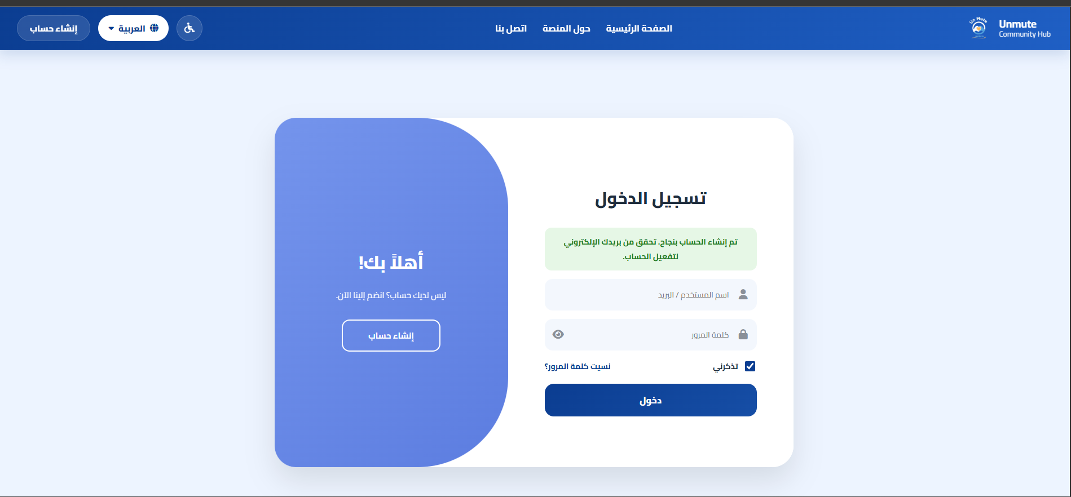
Successful User Registration Test
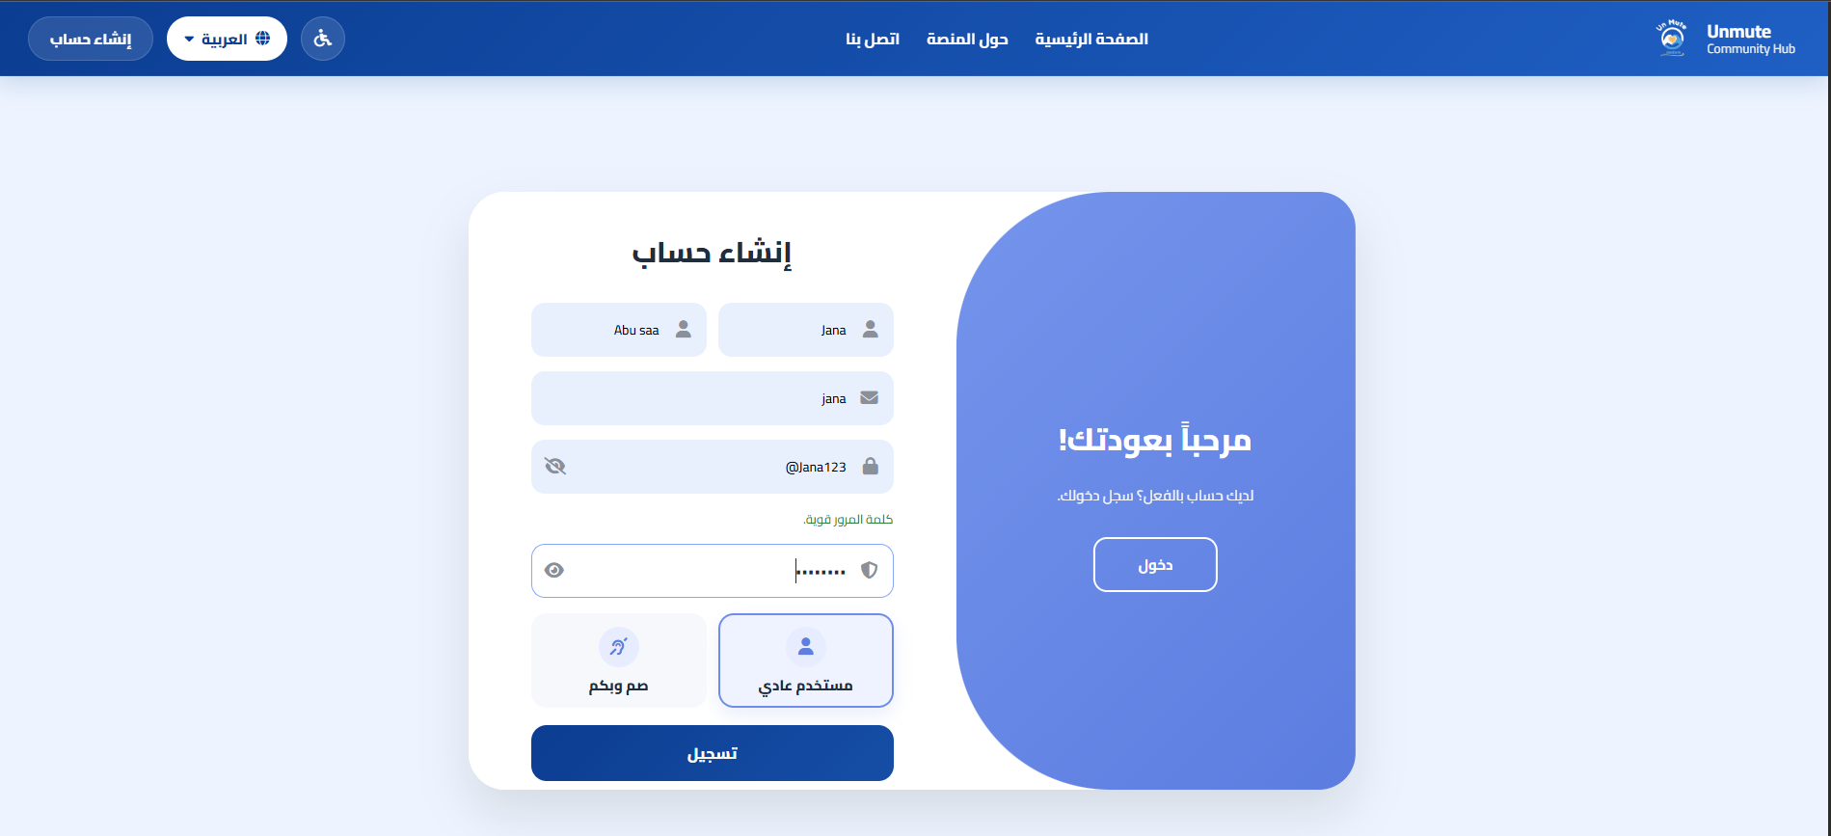
User Registration Form Test
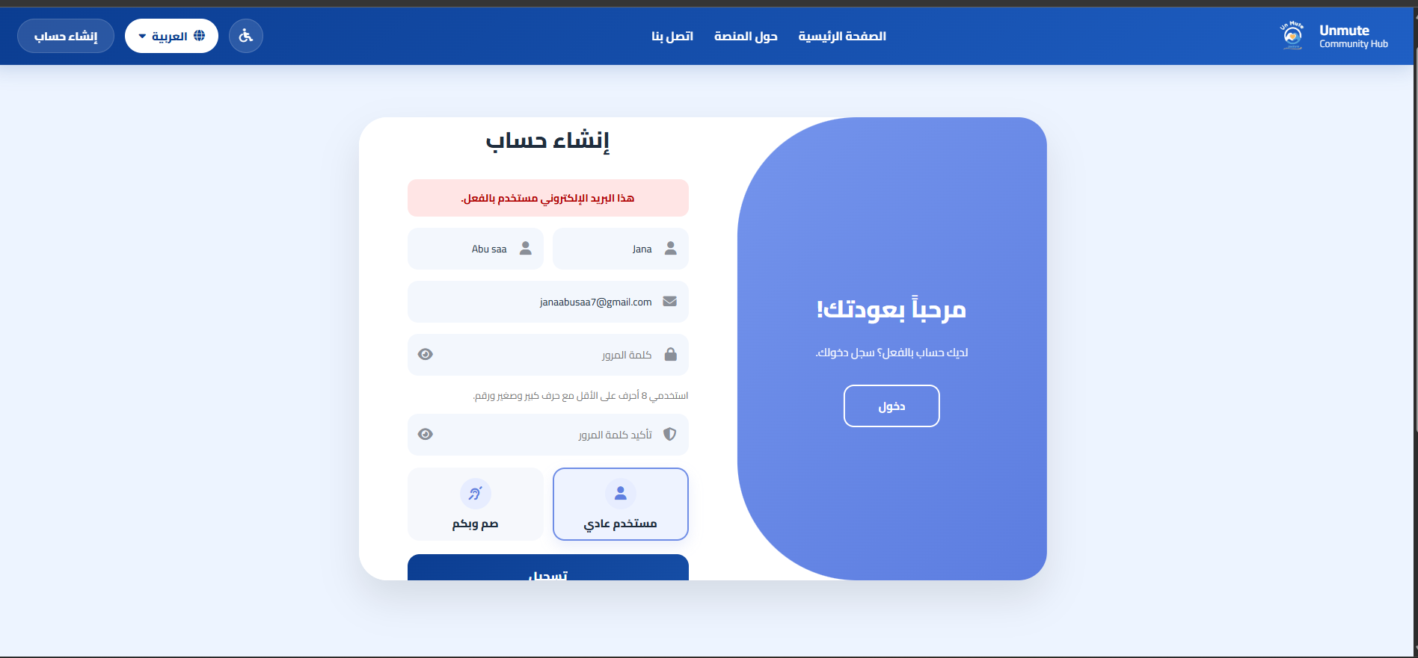
Duplicate Email Validation Test
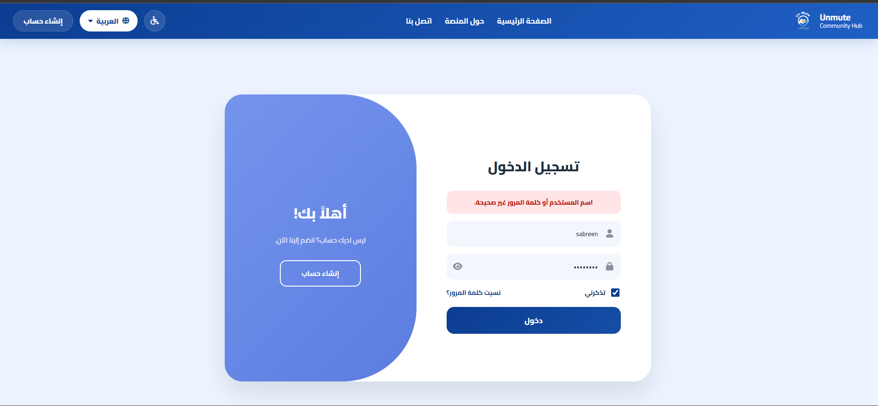
Invalid Login Credentials Test
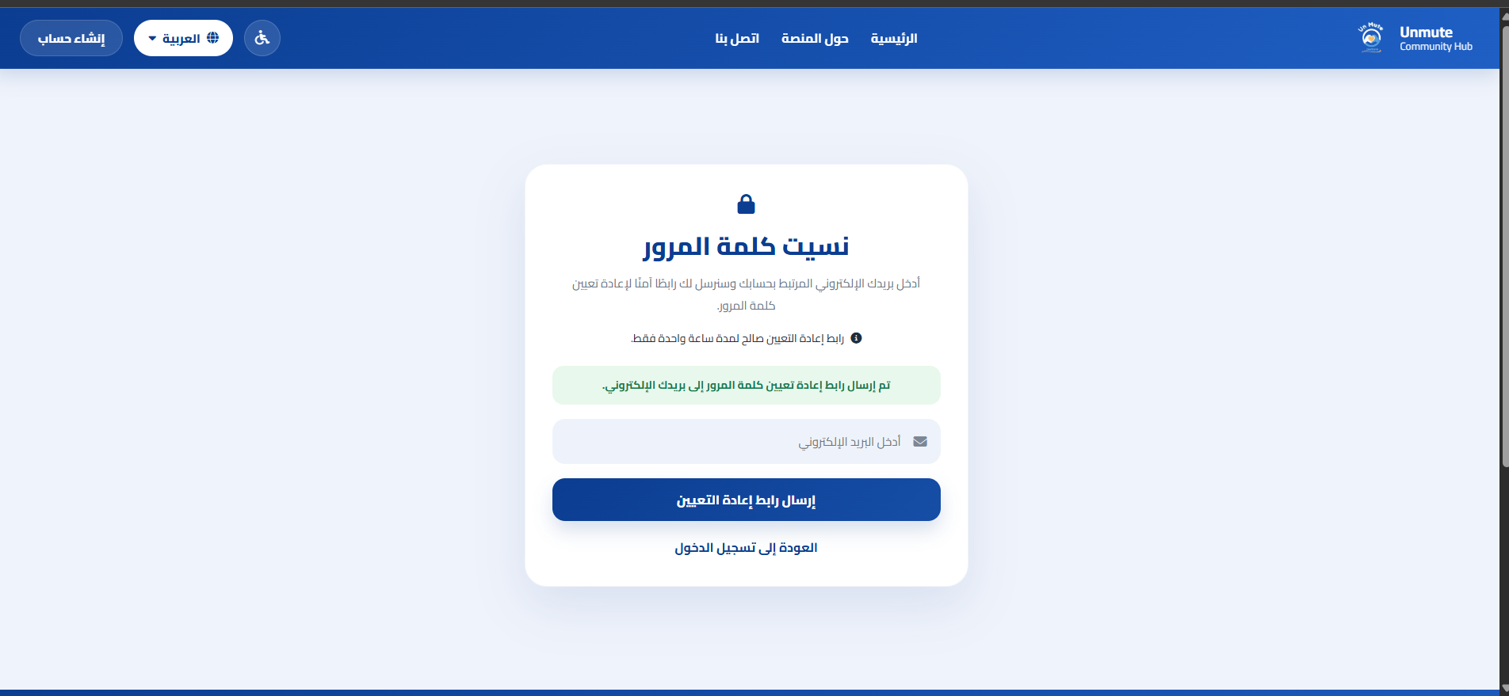
Password Recovery Request Test
Authentication Module Test Cases
TC# | Test Case Description | Input / Action | Expected Result | Result
TC-01 | User Registration – Valid Data | Enter valid registration data and submit the form. | The account is created successfully, and a success message is displayed. | Pass
TC-02 | User Registration – Duplicate Email | Submit the registration form using an already registered email address. | The system displays an error message and prevents creating a duplicate account. | Pass
TC-03 | User Login – Valid Credentials | Enter a correct email or username with the correct password and click Login. | A user session is created, and the user is redirected to the appropriate interface. | Pass
TC-04 | User Login – Invalid Credentials | Enter an incorrect username/email or password. | The system displays an error message and prevents login. | Pass
TC-05 | User Logout | Click the logout button from an authenticated page. | The active session is ended, and the user is redirected to the login page. | Pass
TC-06 | Password Recovery – Valid Email | Enter a registered email address in the password recovery form and submit the request. | The system sends a password reset link and displays a success message. | Pass
TC-07 | Password Recovery – Invalid or Expired Token | Open an invalid or expired password reset link. | The system rejects the token and prevents password reset. | Pass
“‘

0.23.1.2 User Profile and Dashboard Testing
These tests verify that authenticated users can access the main dashboard, view their profile information, and update their personal profile data. This module was tested to ensure that users can navigate to the main platform features after login, view their account details correctly, update allowed profile fields, and upload a profile picture when needed.
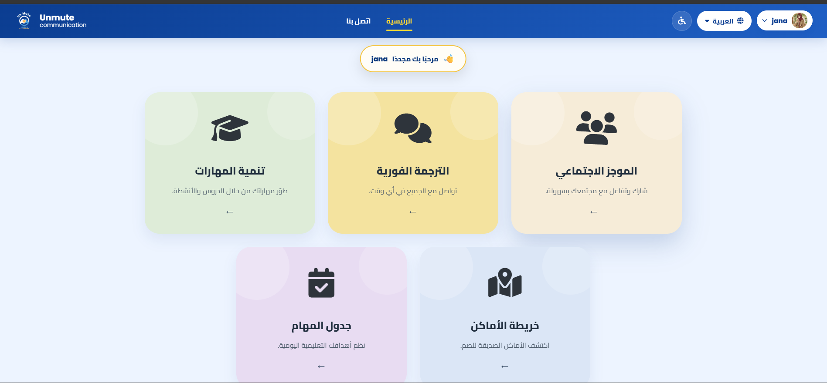
Main Dashboard Access Test
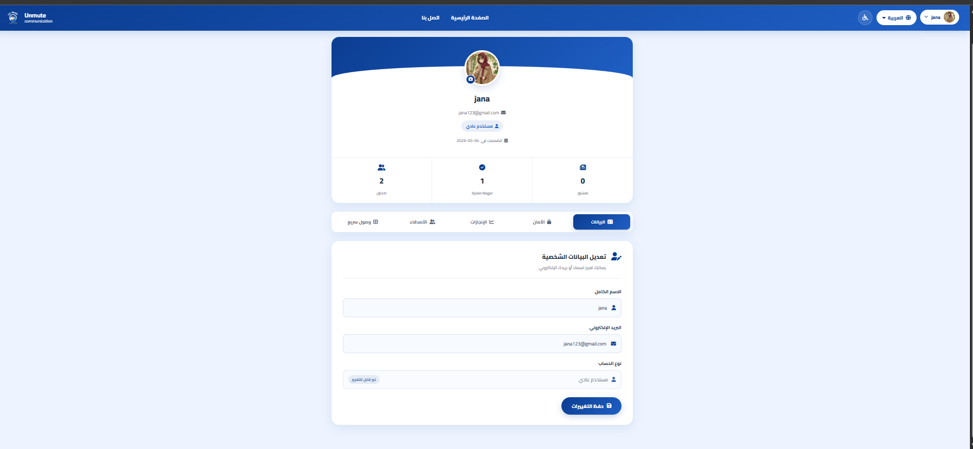
User Profile View Test
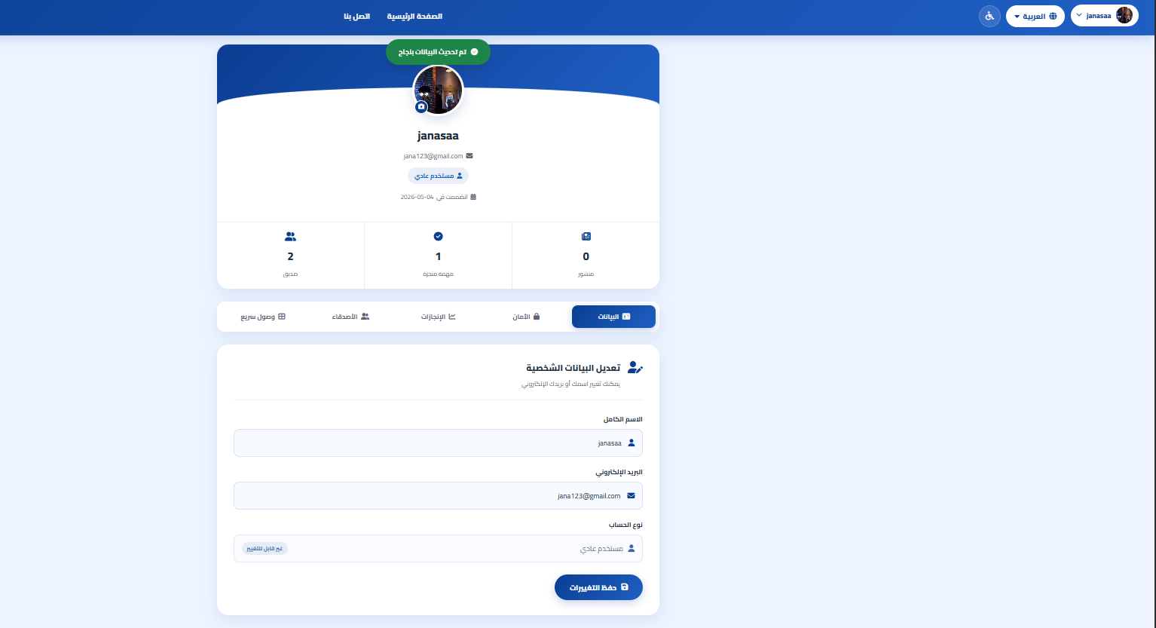
Profile Information and picture Update Test
User Profile and Dashboard Test Cases
TC# | Test Case Description | Input / Action | Expected Result | Result
TC-08 | Main Dashboard Access | Log in successfully and navigate to the main dashboard. | The dashboard displays the main platform modules, such as Translator, Social Community, Learning, Daily Tasks, Accessibility Map, and Profile. | Pass
TC-09 | Profile Page – View | Navigate to the User Profile page after login. | The profile page displays the user’s name, email, user type, profile picture or default avatar, and basic activity information. | Pass
TC-10 | Profile Update – Change Personal Information and picture | Edit allowed profile information and submit the update form. | The updated information is saved successfully and displayed on the profile page. | Pass

0.23.1.3 Translator Workspace Testing
These tests verify the translator workspace in the implemented input modes, including text input and camera-based gesture recognition using the MediaPipe/Flask service. The purpose of these tests is to ensure that the translator interface displays sign results for typed words and recognizes selected hand gestures through the connected camera service.
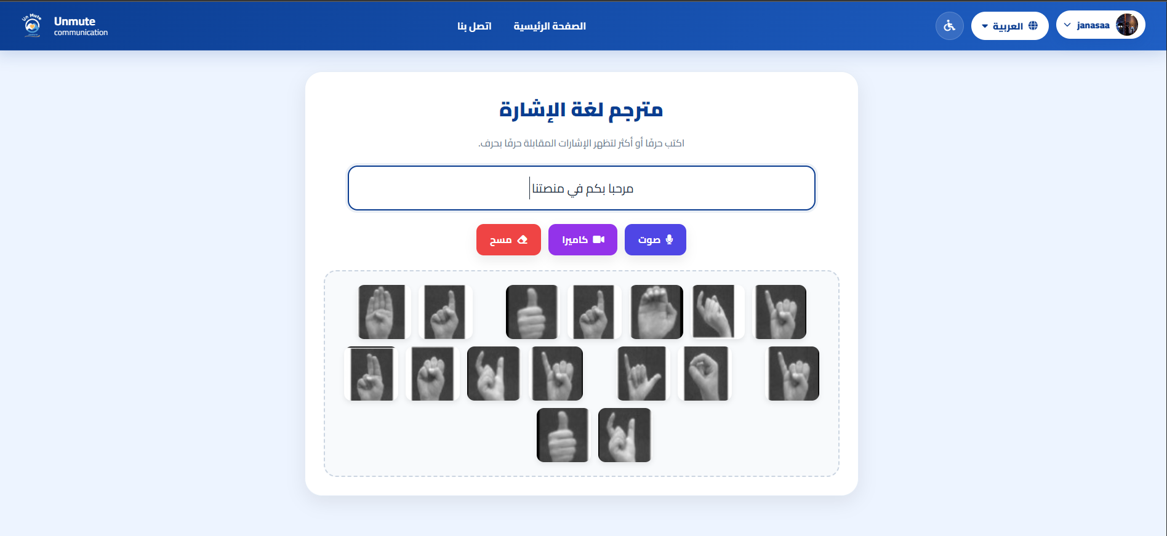
Text Input Translation Test
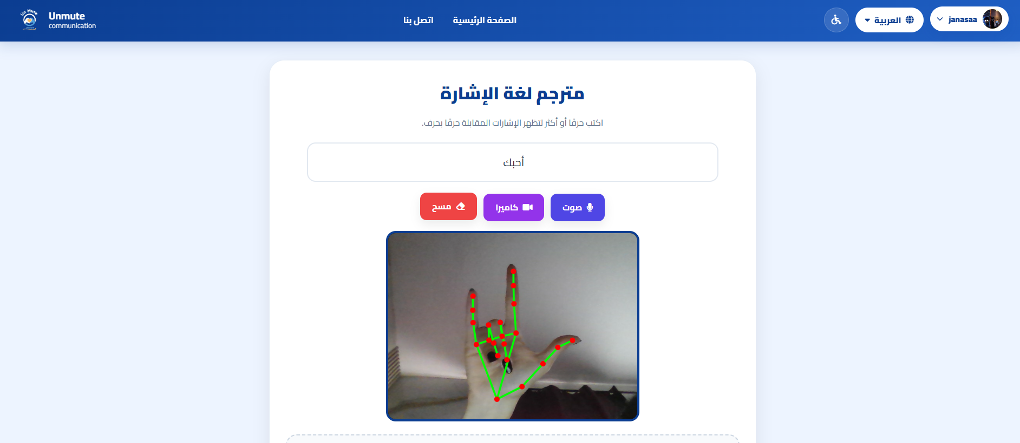
Camera Gesture Recognition Test
Translator Workspace Test Cases
TC# | Test Case Description | Input / Action | Expected Result | Result
TC-12 | Translator – Text Input Mode | Type the word “مرحبا” into the text input field. | The corresponding sign language representation is displayed below the text input area. | Pass
TC-13 | Translator – Camera Gesture Recognition | Enable the camera and show a supported hand gesture toward the webcam. | The system recognizes the selected gesture and displays the corresponding result on the translator interface. | Pass
TC-14 | Translator – No Hand Visible | Enable the camera while no hand is visible in the frame. | The system displays a suitable message without crashing or causing an error. | Pass
TC-15 | Translator – Fist Gesture | Show a closed fist to the camera. | The system recognizes the fist gesture and displays the corresponding result. | Pass
TC-16 | Translator – Thumbs Up Gesture | Show a thumbs-up gesture to the camera. | The system recognizes the thumbs-up gesture and displays the corresponding result. | Pass

0.23.1.4 Learning Module Testing
These tests verify the learning module, including learning video management, video-based challenges, and AI training interaction. The purpose of these tests is to ensure that users can open learning activities, watch sign language videos, answer challenge questions, and use the AI training feature correctly. The admin side was also tested to ensure that learning videos can be managed through the control panel.
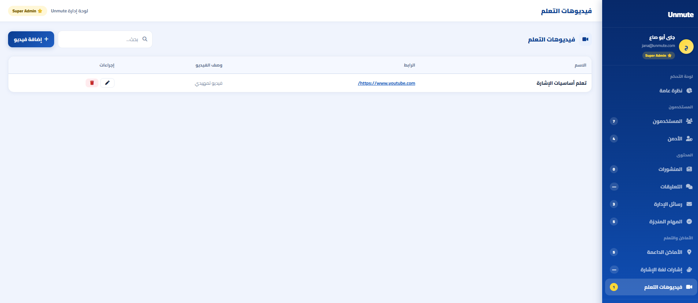
Learning Content Management Test
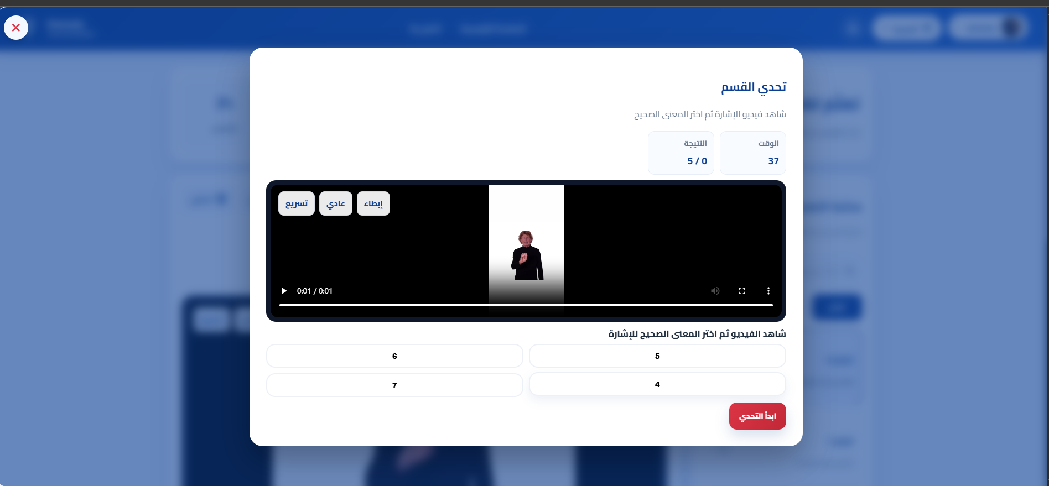
Learning Challenge Test
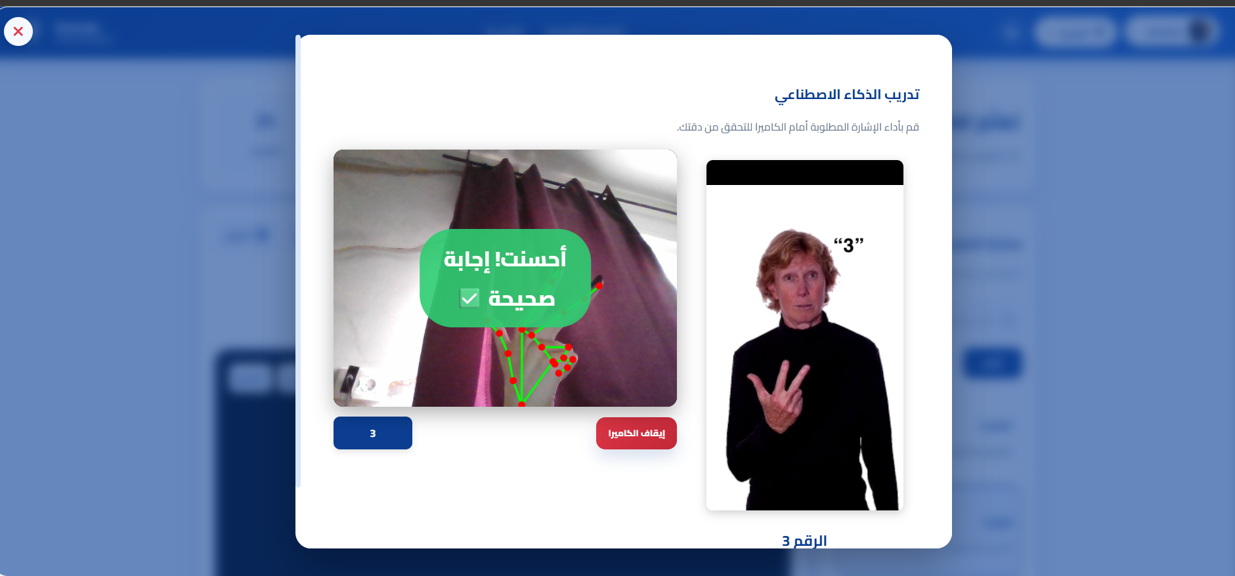
AI Training Recognition Test
Learning Module Test Cases
TC# | Test Case Description | Input / Action | Expected Result | Result
TC-17 | Learning Videos – Browse Content | Open the learning section and view the available learning videos. | The system displays the available learning videos in an organized way. | Pass
TC-18 | Play Learning Video | Open a learning video from the learning module. | The selected video is displayed and can be played correctly. | Pass
TC-19 | Learning Challenge – Open Challenge | Open the challenge related to a learning video. | The system displays the challenge window with the video, answer choices, score, and timer. | Pass
TC-20 | Learning Challenge – Answer Question | Select an answer from the challenge choices. | The system checks the selected answer and displays the appropriate feedback. | Pass
TC-21 | AI Training – Gesture Recognition | Start the AI training feature and perform the required sign in front of the camera. | The system detects the hand gesture and displays feedback based on the recognized result. | Pass
TC-22 | Admin Manage Learning Videos | The Admin or Super Admin adds, edits, searches, or deletes learning video records through the control panel. | The learning video records are managed successfully and the updated data is displayed in the control panel. | Pass

0.23.1.5 Social Community and Messaging Testing
These tests verify the social communication module, including post creation, media upload, reactions, comments, friend requests, notifications, and private messaging between accepted friends. The purpose of these tests is to ensure that users can interact socially, build connections, and exchange messages correctly inside the platform.
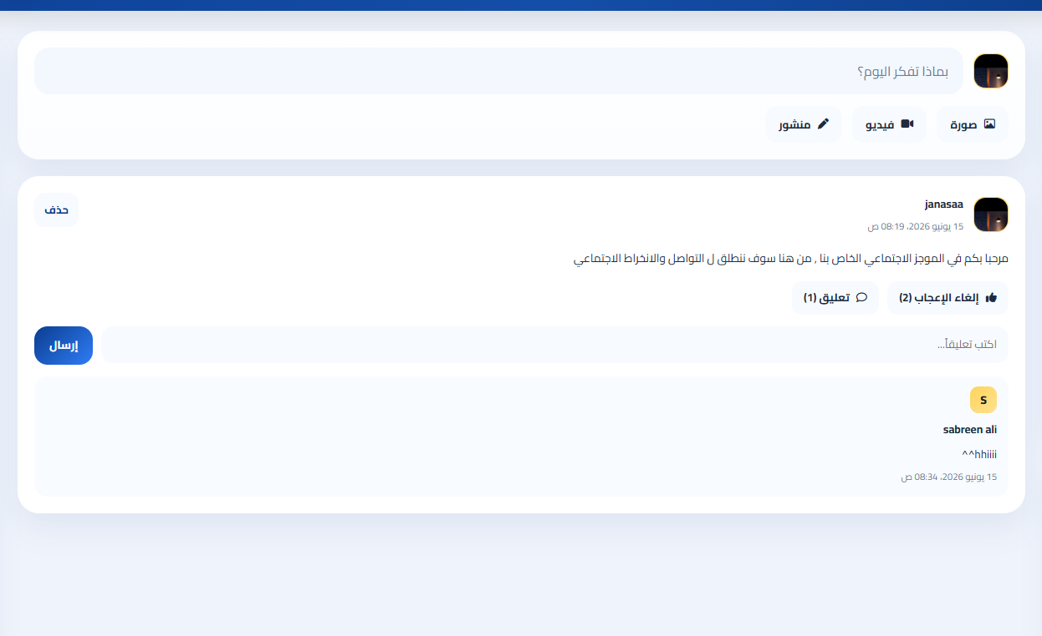
Social Post Creation and Interaction Test
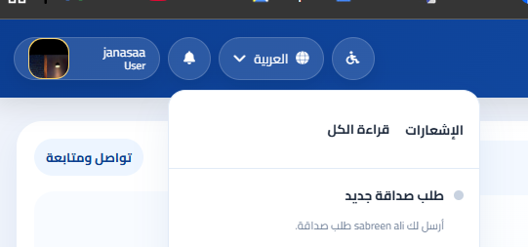
Friend Request and Notification Test
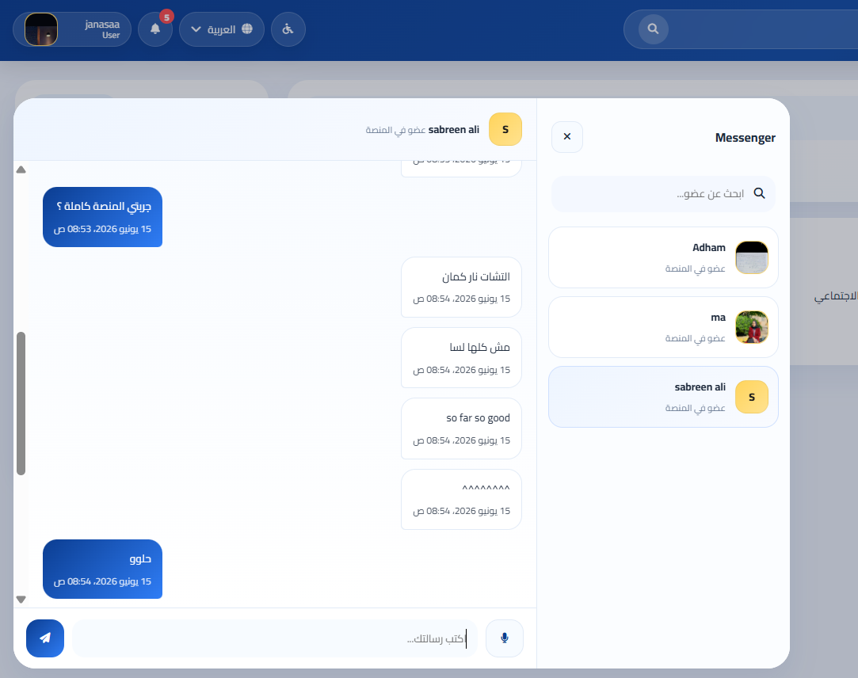
Private Messaging Test
Social Community and Messaging Test Cases
TC# | Test Case Description | Input / Action | Expected Result | Result
TC-23 | Create Post – Text Only | Type content in the post creation area and click publish. | The post is created successfully and displayed in the social feed with the correct author information. | Pass
TC-24 | Create Post – With Media | Attach an image or video file to the post and submit it. | The post is created successfully, and the uploaded media is displayed inside the post card. | Pass
TC-25 | React to Post | Click the reaction button on a visible post. | The reaction is saved successfully, and the reaction count is updated in the feed. | Pass
TC-26 | Add Comment on Post | Type a comment and submit it on a selected post. | The comment is saved successfully and displayed below the related post. | Pass
TC-27 | Send Friend Request | Click the add friend button for another user. | The friend request is sent successfully, and the request status is updated. | Pass
TC-28 | Accept Friend Request | The recipient accepts a pending friend request. | The friendship is created successfully, and both users can communicate as connected friends. | Pass
TC-29 | Send Private Message | Open a chat with an accepted friend, type a message, and click send. | The message is sent successfully and displayed in the conversation window. | Pass
TC-30 | View Chat Messages | The recipient opens the chat conversation. | The conversation messages are displayed correctly, and the user can continue the chat. | Pass

0.23.1.6 Daily Routine Planner Testing
These tests verify that users can manage their daily routine tasks, including adding, editing, completing, deleting, and reordering tasks.
Daily Routine Planner Test Cases
TC# | Test Case Description | Input / Action | Expected Result | Result
TC-31 | Add Daily Task | Enter task details and click Add. | The task is saved and displayed in the planner. | Pass
TC-32 | Mark Task as Done | Click the completion option on a task. | The task status is updated and displayed as completed. | Pass
TC-33 | Edit Daily Task | Modify task details and save changes. | The updated task information is displayed correctly. | Pass
TC-34 | Delete Daily Task | Click Delete on a selected task. | The task is removed from the planner. | Pass
TC-35 | Reorder Tasks | Move a task to a different position. | The new task order is saved and displayed correctly. | Pass

0.23.1.7 Accessibility Map Testing
These tests verify that users can view and interact with the accessibility map, including loading places, viewing place details, filtering places, detecting the user location, and managing accessibility places through the control panel. The map was tested with Leaflet.js and OpenStreetMap to ensure that place markers and location features work correctly.
Accessibility Map Test Cases
TC# | Test Case Description | Input / Action | Expected Result | Result
TC-36 | Load Accessibility Map | Navigate to the accessibility map page. | The map loads correctly and displays the available accessibility places. | Pass
TC-37 | View Place Details | Click on any place marker on the map. | The system displays the selected place information, such as name, category, location, and description. | Pass
TC-38 | Filter Places by Category | Select a specific place category from the filter options. | The map updates and displays places that match the selected category. | Pass
TC-39 | User Location Detection | Click the location button and allow browser location permission. | The system detects and displays the user’s current location on the map. | Pass
TC-40 | Admin Add Accessibility Place | The Admin or Super Admin enters place information through the control panel and saves it. | The new accessibility place is saved successfully and becomes available on the map. | Pass

0.23.1.8 Control Panel Testing
These tests verify the admin control panel, including access control, user management, content management, support message handling, and account status control. The purpose of these tests is to ensure that Admins and Super Admins can manage platform records according to their assigned permissions.
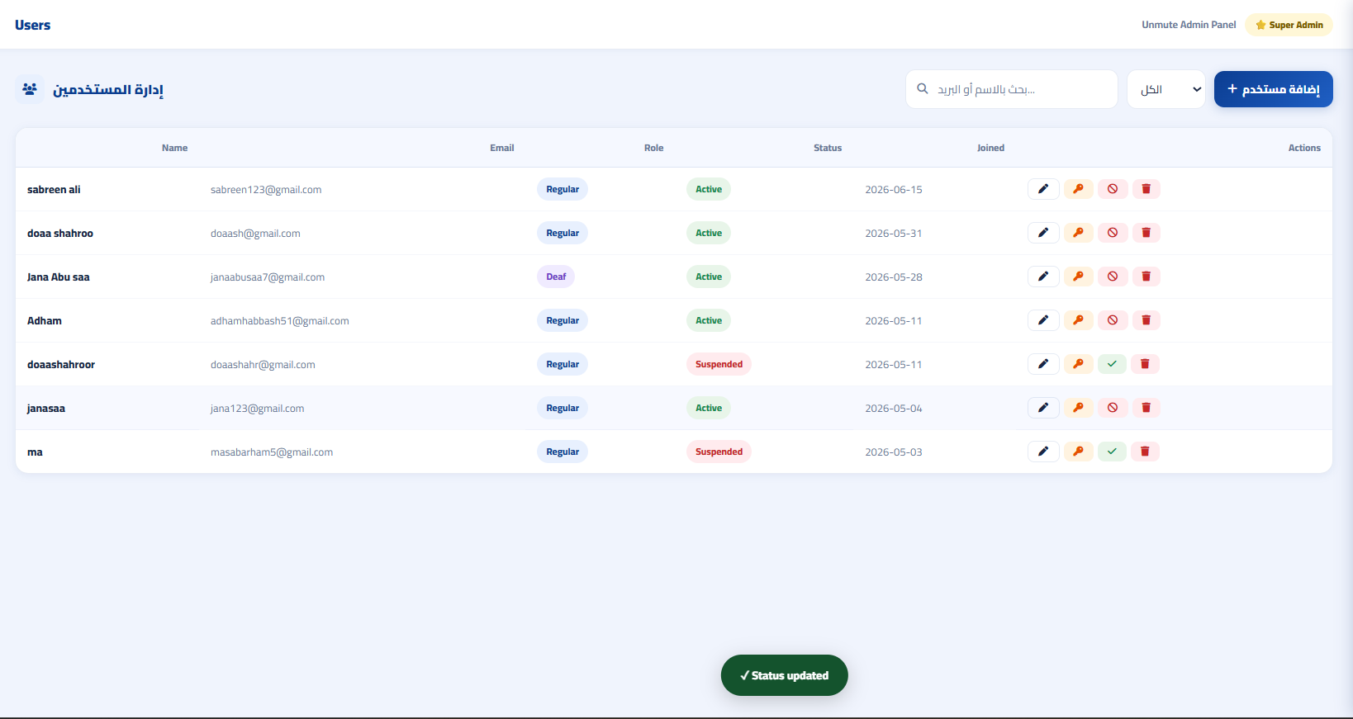
Users Management and Account Status Test
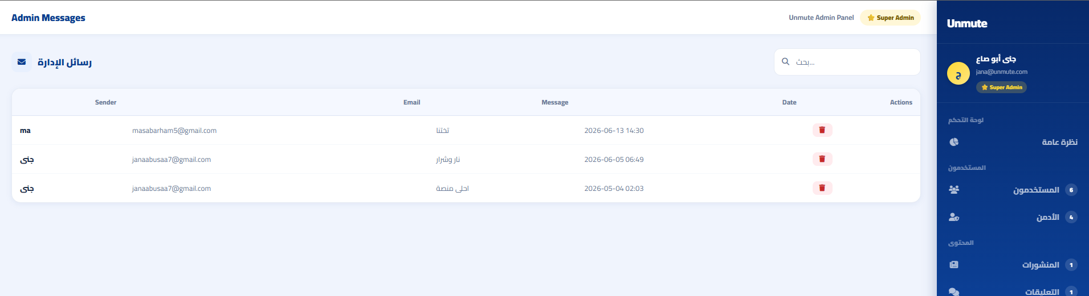
Support Messages Management Test
Control Panel Test Cases
TC# | Test Case Description | Input / Action | Expected Result | Result
TC-41 | Admin Access Control | Attempt to access the control panel using a normal user account and an admin account. | The control panel is accessible only to authorized Admin or Super Admin accounts. | Pass
TC-42 | View and Search User List | Open the users management section and use the search field. | User records are displayed, and the search function filters the results correctly. | Pass
TC-43 | Suspend and Reactivate User Account | Select a user account and change its status through the control panel. | The user account status is updated successfully without permanently deleting the account. | Pass
TC-44 | Manage Learning Content | Add or edit learning content through the control panel. | The learning content is saved successfully and displayed correctly when allowed. | Pass
TC-45 | View Support Messages | Open the messages section from the control panel. | Contact messages are displayed with sender information and message content. | Pass

0.23.1.9 Bilingual Interface and Accessibility Customization Testing
These tests verify that users can switch the platform interface between Arabic and English and customize the interface appearance according to their visual preferences. This includes changing the language direction, adjusting font size, changing interface colors, and resetting the interface settings.
Bilingual Interface and Accessibility Customization Test Cases
TC# | Test Case Description | Input / Action | Expected Result | Result
TC-46 | Switch Interface Language to English | Click the language switch option from Arabic. | The interface text changes to English, and the page direction changes from RTL to LTR. | Pass
TC-47 | Switch Interface Language Back to Arabic | Click the language switch option from English. | The interface text changes back to Arabic, and the page direction changes from LTR to RTL. | Pass
TC-48 | Increase Font Size | Use the font size increase option in the accessibility controls. | The text size increases, and the interface remains readable and usable. | Pass
TC-49 | Change Interface Colors | Select a background color or text color from the accessibility controls. | The selected color is applied successfully to the interface. | Pass
TC-50 | Reset Interface Settings | Click the reset option in the accessibility controls. | The interface settings return to their default appearance. | Pass

0.23.1.10 System Testing Summary
A total of 50 test cases were executed across the main platform modules. The following table summarizes the system testing results:
System Testing Summary
Module | Total TCs | Passed | Failed | Pass Rate
Authentication | 7 | 7 | 0 | 100%
User Profile and Dashboard | 4 | 4 | 0 | 100%
Translator Workspace | 5 | 5 | 0 | 100%
Learning Module | 6 | 6 | 0 | 100%
Social Community and Messaging | 8 | 8 | 0 | 100%
Daily Routine Planner | 5 | 5 | 0 | 100%
Accessibility Map | 5 | 5 | 0 | 100%
Control Panel | 5 | 5 | 0 | 100%
Bilingual Interface and Accessibility Customization | 5 | 5 | 0 | 100%
Total | 50 | 50 | 0 | 100%
All 50 test cases passed successfully. This confirms that the UnMute platform functions worked correctly during system testing and that the implemented modules satisfy the defined functional requirements in Chapter 2.

0.23.2 Integration Testing
Integration testing was performed to verify that the main components of the UnMute platform communicate and operate correctly together. This testing focused on checking the connection between the user interface, PHP backend files, MariaDB database, JavaScript requests, Leaflet.js map, notification-related actions, password recovery process, and the Python/Flask gesture recognition service.
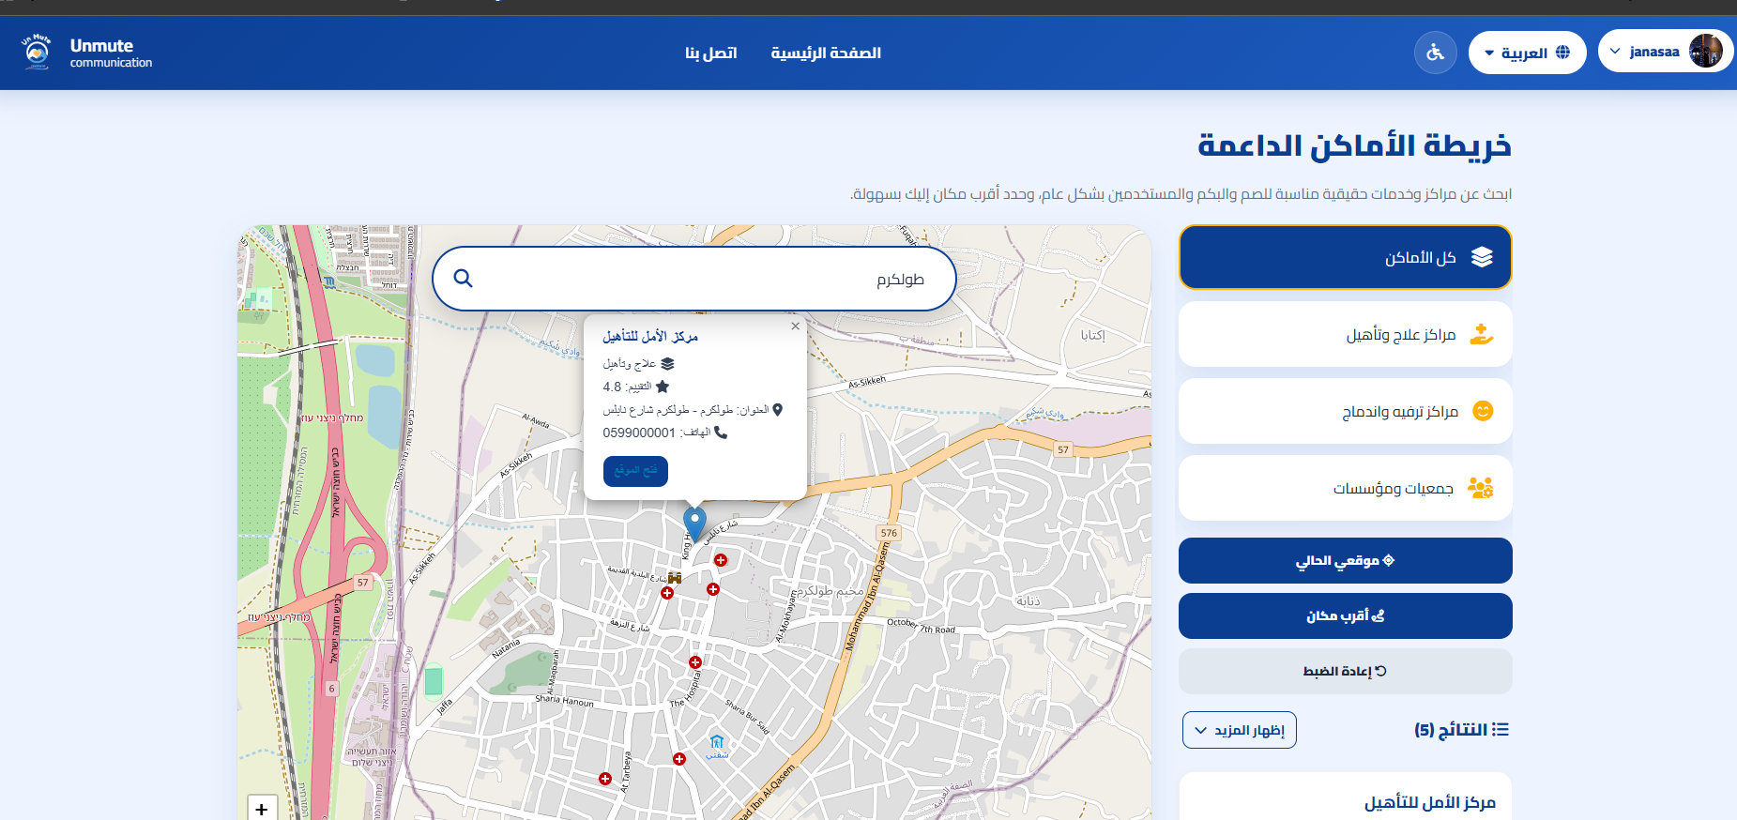
Accessibility Map Data Integration Test
The figure above shows an example of integration between the accessibility places data and the interactive map. The place markers are loaded and displayed correctly on the Leaflet.js map, and clicking on a marker opens a popup containing the related place details.
Integration Testing Results
Integration Point | Scenario Tested | Expected Result | Result
PHP Backend – MariaDB Database | A user registers using valid account information, and the backend saves the account data in the database. | The user account is saved successfully, and the password is stored securely using hashing instead of plain text. | Pass
PHP Backend – MariaDB Database | A user creates a social post, and the backend stores and retrieves the post data. | The post is saved successfully and displayed in the social feed with the correct author information. | Pass
JavaScript – PHP Messaging Files | A user sends a private message through the chat interface. | The message is saved successfully and displayed in the conversation window for the connected friend. | Pass
Leaflet.js – Places Data | The accessibility map page loads the available places and displays them on the map. | The map displays the accessibility places correctly as interactive markers, and the related place details appear when a marker is selected. | Pass
Translator Interface – Flask Gesture Recognition Service | The camera-based translator sends gesture input to the Flask service for recognition. | The recognized gesture result is returned and displayed in the translator workspace. | Pass
Notification System – Social Events | A social interaction occurs, such as a friend request, message, comment, or reaction. | The related user receives a notification, and it appears correctly in the notifications section. | Pass
Password Recovery – Database and Email Process | A user requests password recovery using a registered email. | A reset token is generated, the recovery link is sent, and the user can reset the password securely. | Pass
All tested integration points passed successfully. This confirms that the main platform layers communicate correctly and that data flows as expected between the frontend, backend, database, map service, notification system, password recovery process, and gesture recognition service.
“‘latex

0.23.3 User Acceptance Testing (UAT)
User Acceptance Testing was conducted to check whether the UnMute platform was easy to understand, easy to use, and suitable for the final project evaluation. The testing was done using 15 registered test accounts that covered the main system roles, including normal users, deaf/mute user accounts, Admins, and Super Admins.
The test accounts were used by the project team and a few non-team users to try the main platform features. The testing focused on common actions such as registration, login, navigation, social interaction, messaging, learning activities, translator workspace, daily tasks, accessibility map, language switching, accessibility customization, and the admin control panel.

0.23.3.1 UAT Evaluation Results
The UAT results showed that the platform was generally clear and usable. Testers were able to complete the main tasks successfully, such as creating accounts, logging in, moving between pages, creating posts, sending messages, managing daily tasks, using the learning module, testing the translator workspace, viewing accessibility places on the map, switching between Arabic and English, customizing the interface, and managing platform records through the control panel.
User Acceptance Testing Evaluation Results
# | Area Evaluated | Evaluation Result | Status
1 | Interface Navigation | Users were able to move between the main pages from the dashboard and navigation menus without difficulty. | Accepted
2 | Registration and Login | Test accounts were created successfully, and users were able to log in and log out correctly. | Accepted
3 | Social Community and Messaging | Posts, comments, reactions, friend requests, notifications, and private messages worked correctly during testing. | Accepted
4 | Learning Module and Translator Workspace | Learning videos, challenges, AI training, text translation, and camera-based gesture recognition worked correctly during testing. | Accepted
5 | Daily Routine Planner and Accessibility Map | Users were able to manage daily tasks, and the accessibility map displayed places and details correctly. | Accepted
6 | Bilingual Interface and Accessibility Customization | Language switching, RTL/LTR direction, font size adjustment, and color customization worked correctly. | Accepted
7 | Control Panel | Admin and Super Admin accounts were able to manage platform records, including users, content, messages, accessibility places, and account status. | Accepted
Overall, the UAT results indicate that the UnMute platform was acceptable for the final project evaluation. The platform was clear, usable, and organized across its main modules. The feedback collected during testing helped confirm that the main features, interface navigation, communication tools, learning module, translator workspace, accessibility map, and control panel worked as expected.

0.23.4 Issues Found and Resolved During Testing
During testing, several minor issues were noticed and corrected before the final submission. These issues were mainly related to interface behavior, adaptability, and user interaction. The following table summarizes the main issues and the applied solutions.
Issues Found and Resolved During Testing
# | Issue Found | Cause | Resolution Applied | Status
1 | Some interface elements were not displayed properly on smaller screens. | The layout needed better adjustment for different screen sizes. | The CSS layout was improved to make pages more adaptable on different devices. | Resolved
2 | Some Arabic text needed better alignment in specific sections. | RTL layout and Arabic text direction required adjustment. | RTL direction and text alignment were reviewed and improved. | Resolved
3 | Some social or chat updates needed clearer refresh behavior after user actions. | The interface needed better update behavior after adding or sending data. | The related interface update behavior was improved. | Resolved
4 | Some accessibility settings needed to remain more consistent across pages. | Interface customization was not fully consistent in all sections. | Font size and color customization behavior was reviewed and improved. | Resolved
5 | Some control panel actions needed clearer feedback after execution. | The control panel needed clearer success or update messages. | Feedback messages and updated table views were improved after admin actions. | Resolved

0.23.5 Performance Evaluation
Performance evaluation was conducted to check the stability and availability of the UnMute platform during the testing period. After deploying the platform on a domain, the system was tested regularly to ensure that the main features remained accessible and usable during normal use.
During one month of testing, the total testing period was 720 hours. One domain-related downtime of approximately 12 hours was recorded. Therefore, the actual operating time was 708 hours.
The observed availability was calculated as follows:
$$Availability=\frac{Operating Time}{Total Testing Time}×100$$
$$Availability=\frac{708}{720}×100=98.33\%$$
Reliability was also evaluated using Mean Time To Failure (MTTF):
$$MTTF=\frac{Total Operating Time}{Number of Failures}$$
$$MTTF=\frac{708}{1}=708 hours$$
The results show that the platform achieved an observed availability of approximately 98.33% during the testing period. The recorded downtime was related to domain access and did not indicate damage to the internal system functions. After access was restored, the platform continued to operate normally.

0.23.6 Chapter Summary
The testing and evaluation phase of the UnMute platform showed positive results across the testing activities conducted in this chapter. System testing verified the main platform modules through 50 test cases, and all test cases passed successfully with a 100% pass rate. This confirms that the implemented features worked correctly according to the defined functional requirements.
Integration testing confirmed that the main system components communicated properly with each other. The user interface, PHP backend files, MariaDB database, JavaScript communication, Leaflet.js map, password recovery process, notification-related actions, and Python/Flask gesture recognition service were tested to ensure that data flows correctly between the different platform layers.
User Acceptance Testing showed that the platform was clear, usable, and acceptable for the final project evaluation. The testing was performed using 15 registered test accounts that covered the main system roles, including normal users, deaf/mute user accounts, Admins, and Super Admins. The feedback collected during testing helped confirm that the main features, navigation flow, communication tools, learning module, translator workspace, accessibility map, and control panel worked as expected.
Performance evaluation showed that the platform achieved an observed availability of approximately 98.33% during the one-month testing period. The observed Mean Time To Failure (MTTF) was 708 hours, based on 708 hours of actual operating time and one domain-related downtime. The downtime was related to domain access and did not indicate damage to the internal system functions.
Overall, the testing results indicate that the UnMute platform is stable, usable, and suitable for final demonstration. The platform provides a strong foundation for future development and can be improved further by expanding the learning content, increasing the number of supported gestures, and enhancing real-world testing with more target users.

Conclusion
The UnMute platform achieved its main objective by providing an accessible and user-friendly web-based environment that supports communication, learning, and daily interaction. The implemented system brings together several important services, including social communication, sign language learning, translation assistance, daily task organization, accessibility mapping, and platform management.
The testing and evaluation phase showed that the main modules worked correctly and met the defined requirements. System testing confirmed that the platform features performed as expected, integration testing verified that the system components communicated properly, and performance evaluation showed acceptable stability during the testing period.
Although the main project goals were achieved, the platform can still be improved in future work. Possible improvements include expanding the supported sign language gestures, increasing the learning content, improving gesture recognition accuracy, enhancing system performance, and conducting wider testing with more target users.
Overall, UnMute represents a strong foundation for improving digital accessibility and supporting communication through a practical and integrated web platform..

Summary
This project presented the design and implementation of the UnMute platform, a web-based system developed to support communication, learning, and accessibility in one integrated environment. The platform was designed after analyzing the main problem, identifying user needs, and defining the functional and non-functional requirements.
The project followed a structured software engineering process that included analysis, design, implementation, testing, and evaluation. The final platform includes several main modules, such as registration and login, profile management, social community, private messaging, translator workspace, learning videos and challenges, AI training, daily routine planner, accessibility map, bilingual interface, accessibility customization, support messages, and an admin control panel.
In summary, the UnMute platform provides a practical web-based solution that combines communication, learning, accessibility support, and administrative management in a single system.

Appendices

Appendix A: System Interfaces
This appendix presents additional screenshots of the UnMute platform interfaces. It includes the main system pages such as the home page, login and registration pages, user dashboard, social community page, learning section, translator workspace, daily routine planner, accessibility map, admin control panel, and data management screens. These screenshots provide visual support for the system design, user interface, and interaction flow.

Appendix B: Database Design
This appendix includes the database design of the UnMute platform. It presents the Entity Relationship Diagram (ERD), database tables, attributes, and relationships. This appendix shows how platform data is structured, stored, and connected within the system.

Appendix C: UML Diagrams
This appendix contains the UML diagrams related to the UnMute platform. It includes use case diagrams, activity diagrams, sequence diagrams, and class diagrams that describe the system structure, behavior, and interactions between users and system components.

Coding Samples / Snapshots
This section presents selected code samples and interface screenshots from the UnMute platform to illustrate the practical implementation of the system. The purpose of these samples is to demonstrate how the core functionalities were implemented, rather than presenting the complete source code. The included materials focus on key system components and provide insight into the development approach used in the project.
The included materials are:
- Front-end code snippets demonstrating user interface structure and interaction handling.
- Back-end code samples illustrating system logic and data processing.
- Database design and implementation snapshots, including selected tables and relationships.

References
Sommerville, I. (2016). Software Engineering (10th ed.). Pearson Education.
Pressman, R. S., & Maxim, B. R. (2019). Software Engineering: A Practitioner’s Approach. McGraw-Hill.
Mozilla Developer Network (MDN). (n.d.). Web Development Documentation. Retrieved June 15, 2026, from https://developer.mozilla.org/
W3Schools. (n.d.). Web Development Tutorials. Retrieved June 15, 2026, from https://www.w3schools.com/
Lingvano. (n.d.). Sign Language Learning Platform. Retrieved October 27, 2025, from https://www.lingvano.com/asl/
Musheer. (n.d.). Musheer Mobile Application. Retrieved October 27, 2025, from https://play.google.com/store/apps/details?id=com.musheer.musheer
Hand Talk. (n.d.). Sign Language Translation Platform. Retrieved October 27, 2025, from https://www.handtalk.me/en/
Ministry of Social Development & Family. (n.d.). Sokoon Platform. Retrieved October 27, 2025, from https://sokoon.msdf.gov.qa/
Ava. (n.d.). Accessibility Communication Platform. Retrieved October 27, 2025, from https://www.ava.me/
Esharti. (n.d.). Arabic Sign Language Platform. Retrieved October 27, 2025, from https://esharti.net
PHP Group. (n.d.). PHP Manual. Retrieved June 15, 2026, from https://www.php.net/manual/en/
PHP Group. (n.d.). PHP Manual: password_hash. Retrieved June 15, 2026, from https://www.php.net/manual/en/function.password-hash.php
PHP Group. (n.d.). PHP Manual: MySQLi Prepared Statements. Retrieved June 15, 2026, from https://www.php.net/manual/en/mysqli.quickstart.prepared-statements.php
MariaDB Foundation. (n.d.). MariaDB Documentation. Retrieved June 15, 2026, from https://mariadb.org/documentation/
Oracle. (n.d.). MySQL Documentation. Retrieved June 15, 2026, from https://dev.mysql.com/doc/
Mozilla Developer Network (MDN). (n.d.). HTML Documentation. Retrieved June 15, 2026, from https://developer.mozilla.org/en-US/docs/Web/HTML
Mozilla Developer Network (MDN). (n.d.). CSS Documentation. Retrieved June 15, 2026, from https://developer.mozilla.org/en-US/docs/Web/CSS
Mozilla Developer Network (MDN). (n.d.). JavaScript Documentation. Retrieved June 15, 2026, from https://developer.mozilla.org/en-US/docs/Web/JavaScript
Mozilla Developer Network (MDN). (n.d.). Fetch API. Retrieved June 15, 2026, from https://developer.mozilla.org/en-US/docs/Web/API/Fetch_API
Pallets Projects. (n.d.). Flask Documentation. Retrieved June 15, 2026, from https://flask.palletsprojects.com/
Python Software Foundation. (n.d.). Python Documentation. Retrieved June 15, 2026, from https://docs.python.org/3/
OpenCV. (n.d.). OpenCV Documentation. Retrieved June 15, 2026, from https://docs.opencv.org/
Google AI Edge. (n.d.). MediaPipe Hand Landmarker Guide. Retrieved June 15, 2026, from https://ai.google.dev/edge/mediapipe/solutions/vision/hand_landmarker
Leaflet. (n.d.). Leaflet Documentation. Retrieved June 15, 2026, from https://leafletjs.com/reference.html
OpenStreetMap Foundation. (n.d.). OpenStreetMap. Retrieved June 15, 2026, from https://www.openstreetmap.org/
InfinityFree. (n.d.). Free Web Hosting Documentation. Retrieved June 15, 2026, from https://www.infinityfree.com/
Apache Friends. (n.d.). XAMPP Documentation. Retrieved June 15, 2026, from https://www.apachefriends.org/
Microsoft. (n.d.). Visual Studio Code Documentation. Retrieved June 15, 2026, from https://code.visualstudio.com/docs

