**EXPENSE TRACKING APP**

------------------------------------------------------------------------------------------------------------

My app makes it easy to split expenses with housemates, trips, groups, friends, and family.

Splitting bills with friends and family can be stressful or awkward. This apps help roommates, travelers, couples, and friends organize their shared expenses so everyone knows who owes who.

Classes created :-

1. LoginSignup - contains login , signup and quit
2. AccountDetails – contains all your details and variables
3. Home – contains home page of app
4. AddExpense – Create expense
5. SplitEqual – Split expense equally
6. SplitAmt – Split expense unequally
7. BorrowMoney – Display current borrowed details
8. LendMoney – Display current lend details
9. SettleUp – Settle up your borrowed money balance
10. SettledUp – Settle up your lended money balance
11. Activity – Display all the activity you involved
12. AddFriends – Make friend with other user by sending request
13. AccpectFriends – Accpect friend request
14. Transfer – Transfer unknown accounts balance to known user account by snding request
15. Group – Contains group details , information , activity
16. GroupAccount – Contains dynamic arraylist , hashmap etc to maintain group balance
17. GroupHome – Home page for group
18. GroupSplitEqual – Split expense equally
19. GroupSplitAmt – Split expense unequally
20. GroupSettleUp – Settle up your borrowed balance in group
21. GroupSettledUp – Settle up your friends balance in group
22. GroupActivity – Store all group activity of user like transaction etc.
23. GroupStats – Display group statistic
24. AddGroup – Create group by giving necessary details

First page of app

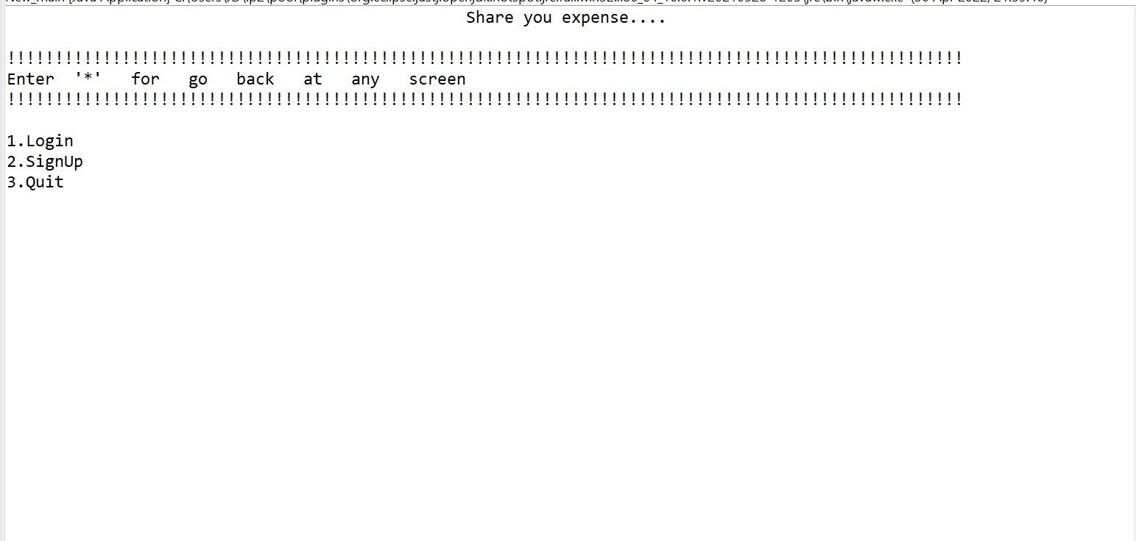Options available:- 1 - Login , 2 – Signup , 3 – Quit

3 – Exit the app.

2 – Signup page to create account by giving necessary details

|  |  |  |  |  |  |
| --- | --- | --- | --- | --- | --- |
| Name of the field | Data types | Regex used | Example | Constraint | Error msg  shown |
| Name | String | Atleast 2 character , Maximum upto 30 character, allows space , numbers , symbols etc.  The first character of the username must be an alphabetic character | John Doe-Smith  Hector Sausage-Hausen  Mathias d'Arras  Ai Wong | [2-30] character | *Name cannot be empty  *Atleast two character require |
| User Name | String | The username consists of 6 to 30 characters inclusive.  only contain alphanumeric characters and underscores (_),  The first character of the username must be an alphabetic character | magicalworld  witchoria  sightunseen_ | [a-z]  [A-Z]  [0-9]  [_] | *Username cannot be empty  *Usernameshould be atleast 6 character numeric, alphabet, underscoreallowed. |
| Email | String | Valid email ids | developer961@mail.com  Bloggs"@example.com |  | *Enter valid email address |
| Password | String | 6 to 30 character inclusive.  Atleast 1 Capital letters , Small letters, Numeric , Special character | Vicky3#  Gg@12345678  Jd!@#$%^&*()0 | [a-z]  [A-Z]  [special characters]  [0-9] | *include both lower case and upper case character  *include atleast one number and symbol  *be atleast 6 character and maximum 30 character |

Password is encrypted using “MD5 Hashing Technique”

It is a cryptographic hash function that generates a 128-bits hash value. This algorithm is defined under java.security package in Java programming.

Example:-

Password: myPassword

Encrypted password using MD5: deb1536f480475f7d593219aa1afd74c

These information stores in AccountDetails class

1. Login Page

|  |  |  |  |  |  |
| --- | --- | --- | --- | --- | --- |
| Name of the field | Data types | Regex used | Example | constraint | Error message shown |
| Username or Email | String | The username consists of 6 to 30 characters inclusive.  only contain alphanumeric characters and underscores (_),  The first character of the username must be an alphabetic character | magicalworl  witchoria  sightunseen_  j[j@gmail.com](mailto:Jj@gmail.com)  n[u@email.com](mailto:Nu@email.com) | [a-z]  [A-Z]  [0-9]  [_] | *Enter valid username  Or email address  * Email address not register |
| Password | String | 6 to 30 character inclusive.  Atleast 1 Capital letters , Small letters, Numeric , Special character | Vicky3#  Gg@12345678  Jd!@#$%^&*()0 | [a-z]  [A-Z]  [special characters]  [0-9] | * Enter valid password  * Email or password is wrong  Please check again |

Forgot Password

Enter valid email address which have account in app. Or else you ill have options

To redirect to signup page for create account

If email address is valid and already registered in app you il receive one time password on mail . Once you entered valid and same otp you redirect to set password page where you can set new password then pull back to login page .

|  |  |  |  |
| --- | --- | --- | --- |
| Name of field | Data types | Regex used | Error message shown |
| Email id | String | Valid email address | *Enter valid email address  *Email address not register |
| One time password | Characters | Valid one time password | *Incorrect opt  Please try again |
| New Password | String | 6 to 30 character inclusive.  Atleast 1 Capital letters , Small letters, Numeric , Special character | *include both lower case and upper case character  *include atleast one number and symbol  *be atleast 6 character and maximum 30 character |
| Confirm Password | String | 6 to 30 character inclusive.  Atleast 1 Capital letters , Small letters, Numeric , Special character | *include both lower case and upper case character  *include atleast one number and symbol  *be atleast 6 character and maximum 30 character |

Home Page

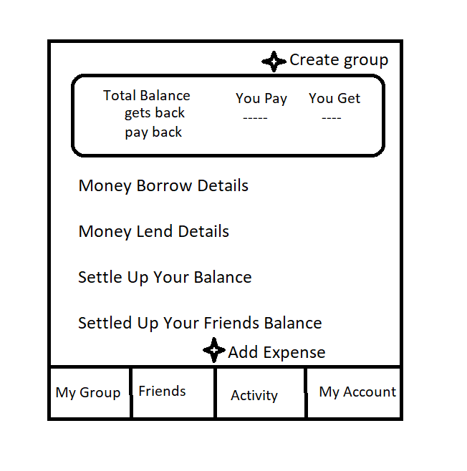

Add Expense

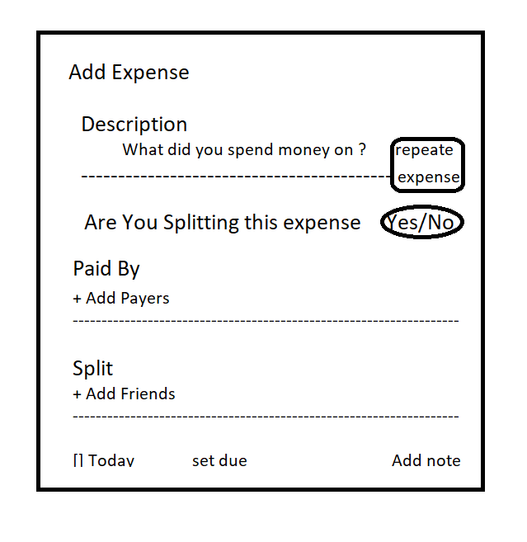

Add payer

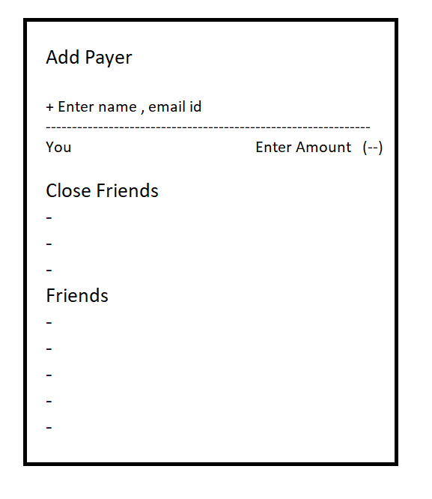

Add Friends

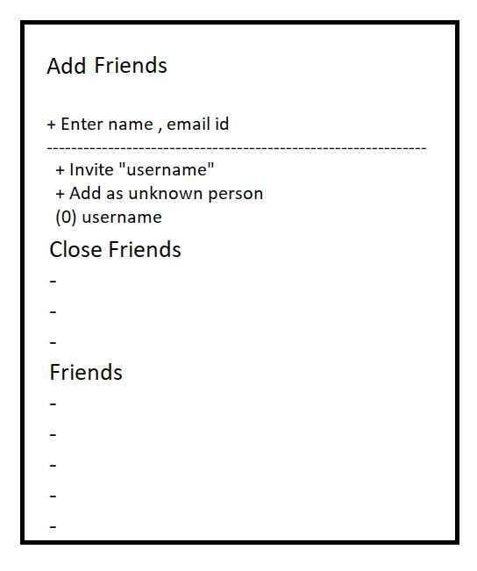

Num pad for entering total amount

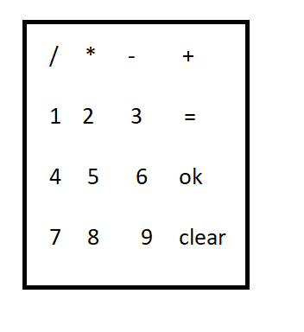

Account display

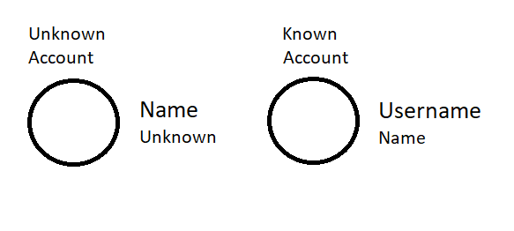

Split Amount

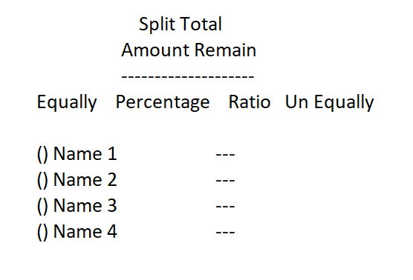

|  |  |  |  |
| --- | --- | --- | --- |
| Name of the field | Data types | Regex used | Error message shown |
| Money | Double | *Two decimal allowed  *enter up to one core amount | *Amount should not be empty  *Amount should not be negative |

# **Expense splitting experience**

App allow you to split the expense multiple times in multiple different ways.

Scenorio :-

5 friends go for dinner. 3 are vegetarians , 2 are non-vegetarians . 3 of them eat icecream. Out of these 3, 2 of them are vegetarians. And the bill needs to be split 3 ways (veg, non-veg & icecream)

*1)*The total bill is 35,500. Split 10,500 between 3 vegetarians equally

*Balance – 25,000*

*2)*The remaining bill is 25,000 . Split 15,000 unequally (7,000 & 8,000) for 2 non vegetarians

Balance – 10,000

3)Again split remaining 8,000 equally for 3 peoples who ate icecream

4)Now 2,000 remaining . This is for Service charge + other taxes . This split can be carried out by split by percentage by entering tax percentage of each food ate by 5 peoples or split the taxes based on our current share of food expenses.

By this we overcome the hard situation which involves large calculation , mistakes , corrections etc is very hard to user.

Now Background functions

Here the all values you entered and final calculation , balances are stored in each user account that is AccountDetail class.

And this scenerio and splitting expense and expense breakout are stored in Activity class with Date, Time, Description, TotalMoney, Added by, Payer , Receiver, Type of expense, etc.

You can delete or edit the entire expense added, by deleting or editing the activity this will affect all other users balance who involves in the activity.

So changes made with prior clarity of all others.

Settle Up your balance :-

This Shows the list of Users who you need to payback money

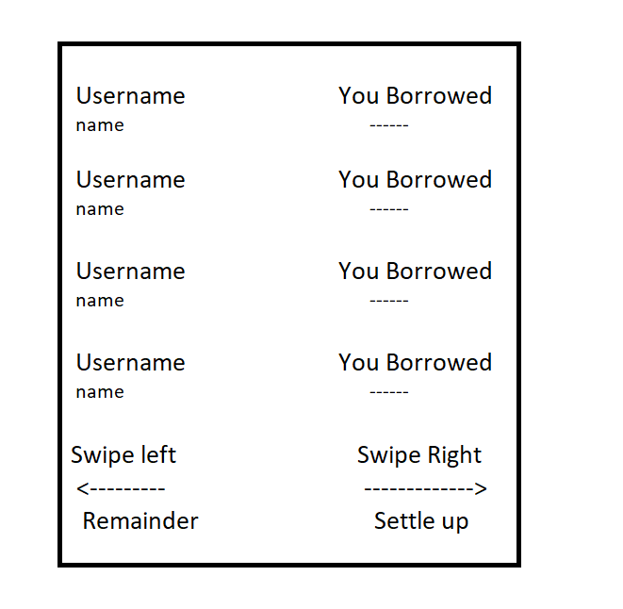

Swipe left :- to send remainder( simple text message to convey message to user) through mail. This can be done by SMTP (simple mail transfer protocol)

Swipe Right :- to Settle up the balance amount . You can edit the total amount so that you pay amount accordingly

Settle Up Your Friends Balance :-

This display the list of username who borrowed money from you and balnce amount they nee to pay you aside.

This List includes the unknown account user also.

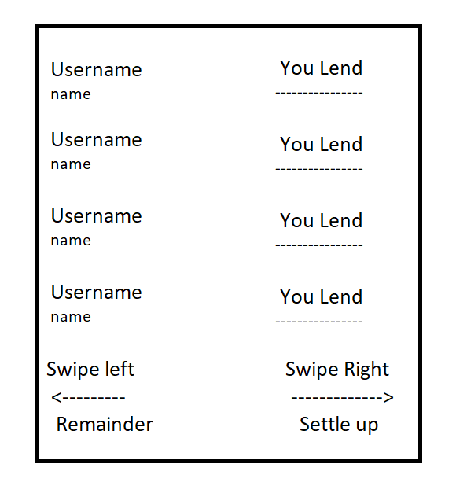

Swipe left :- Send remainder text message to the user through the mail and this also be done by smtp

Swipe right :- Settle up the balance and you allow to edit the balance money to settle accordingly.

|  |  |  |  |  |  |
| --- | --- | --- | --- | --- | --- |
| Name of Field | Data types | Regex used | constraints | example | Error message shown |
| User name | String | The username consists of 6 to 30 characters inclusive.  only contain alphanumeric characters and underscores (_),  The first character of the username must be an alphabetic character | [a-z]  [A-Z]  [0-9]  [_] | Jj_1  Hari57  bonni69 | *Username cannot be empty  *Usernameshould be atleast 6 character numeric, alphabet, underscoreallowed.  *Username not in the list . Please enter name from the list |
| Amount | Double | Upto 1 core. As digits 8 digits allowed  No neagtive value or less than one | [99999999 – 1] | 1000  33005  39999  1111110 | *Amount should be greater than 1  *Enter a numberic value  *Digits allowed upto 8 |

These also stored and displayed in activity in detail.

Users can delete or edit the activity. Which affects the users current balance

Friends :- Display all friends and unknown accounts along with the balance and also can settle up and remaind by swiping account name

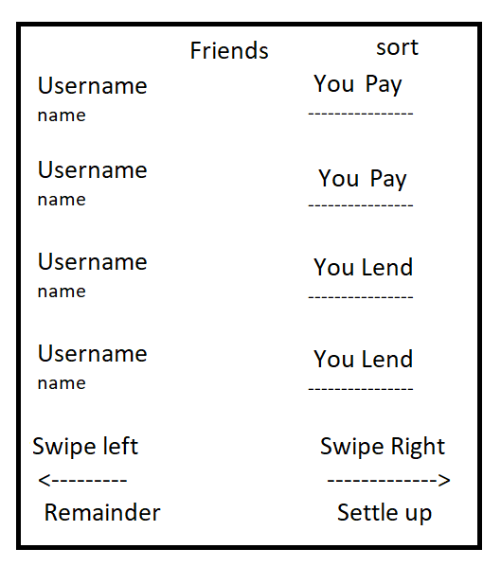

You can sort the friend the list by :- Friend who owes you, Friend who you owes, Unknown accounts, Friends with outstanding balance

You can add friends here by entering their user name.

My Group :- Display all the groups you joined and created .

With your balance

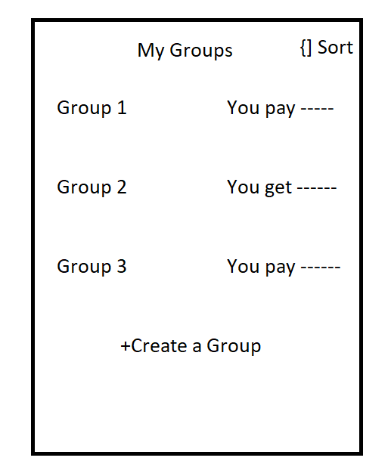

Sort the list on :- All Groups , Group owes you , Group you owes, Outstanding balance

You'll also have create group link to create a new group from here

|  |  |  |  |
| --- | --- | --- | --- |
| Name of field | Data types | Constraints | Error message shown |
| Group name | String | Upto 256 character | Limit exceed |
| Add members | String | Username constraints | *UserName not existed  *Username is incorrect |

This data's are stored in Group class with Group name , Group members name , and account details . And a HashMap with user AccountDetail which store Group id as key and group object as value in that.

And new object is created for every user in group account class to maintain the group expense and other details related with group and this group account object also stored in account detail class in an hashmap with group id as key.

Group Home Page : -

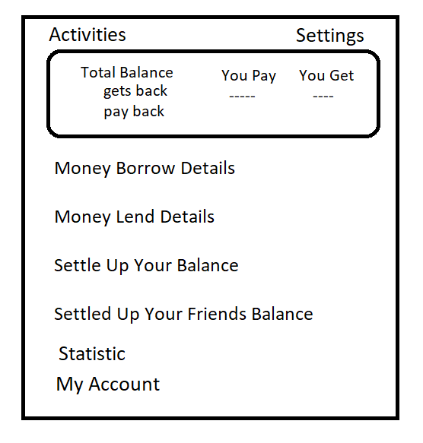

Only two options are extra compare to Home page that is statistic and my account

Statistics :- Which study and manipulation of data, including ways to gather, review, analyze, and draw conclusions from data.

Here we display a bar graph and pi cart to display the group expense accordingly to the type of expense, user expense .

This helps to review the expense and other stuff sharing in the group and take better analysis .

My account:- Which display the expense you contribute to the group and other necessary details

Group settings :-

* Export as a spread sheet
* Edit Group name
* Display group member
* Add group member
* Remove group member this only done if that member doesn’t have any balance with any other in group member.
* Delete group , this can be done once all the members are settle up with other members
* Add , remove or change group image.

Activity :-

The main functions of this app

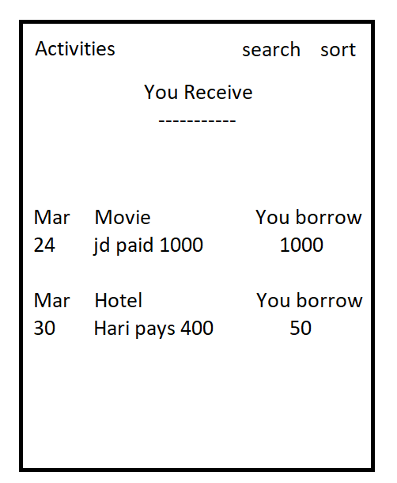

Sort :- All Activity, Payment made, Payment received , Payment dues

Search :- Search by description of expense

Also we can see the detailed activity by clicking activities

This can be edited and deleted by users

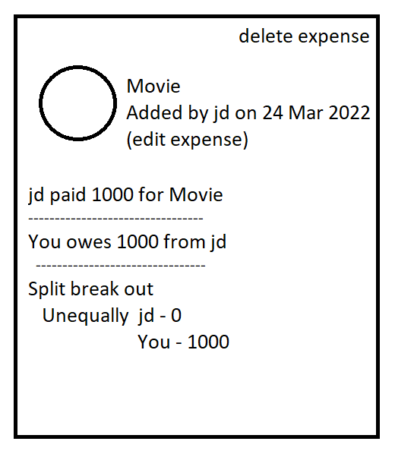

EXTRA FEATURES

***You can transfer the unknown account balances and activity to a known user account by requesting transfer account .***

Scenario :- If you spent for your best friends, friend and you don’t know their name or any thing about him. But you spent money for him and you want to add that too in app. You can enter name and choose

1. Invite friends ,it will ask for email id or phone number. if you know his email id or phone number and you entered it . This will done two things

* It shows account if-f the entered email id or phone number is already register in app or else
* It save it as a unknown account with known email id , Sends added expense detail to that mail id and also invite link to that person , If suppose he create an account with that email id then the expense automatically changes from unknown to known account and it will notify the users too.

1. Add as unknown person , it will not ask you anything just save it as an unknown account and activity and expense recorded.

The above two case are save that account as unknown user and Now you came to know that the person (friend of your friend) has existing account on app or create an account on another email not that email you entered on invite friend.

Here the features Transfer Account helps

You'll find transfer account bar on the unknown accounts by choosing that it ask for a user name to merge the account . Here you enter that existing account name of that person . Here it send request to user with your username , unknown username along with activities and payments done also with note if added anything with that request . After users verifies that thing and have two options

1. Yes, It was me!!
2. No, Iam not that person

Also have add notes options to share any message to you

If that user accept you request then all the activity and remaining balance are transfer to that user account and you can proceed further activity with that user and the unknown account you saved is permanently delete your account

If suppose that user finds something wrong or feels anything included extra and ignore that request by “No, Iam not that person”, then it will notify you that user not accept your request and you see any note if he attached with it.

------------------------------------------------------------------------------------------------------------

***You can have one or more email ids under one account. ***

Scenario: -

If suppose you have two email id primary and secondary . If anyone knows your primary email id and add expense on that but you have account on your secondary email id this came out confusion for user and cause many problem.

Now, if you add multiple email id under one user account then you easily overcome this problem.

Here you can raise a question that if I have two separate accounts on two email ids and what should I do now?

Simple ! We have merge account options on My account settings there you can merge your another account by entering username, email address , password of another account . Note this will transfer your second account details and activity and permanently delete that account so be care on choosing which account your going to merge .

After merge deleted account friends are get notified that “Username1 is changes to Username2”.

This helps your friends to came to know the new account.

***You can merge your multiple accounts into one***

------------------------------------------------------------------------------------------------------------

***Split online bill through the app***

Scenario :- If you ordered food for your friend through online food ordering app like swiggy , zomato like app and you want to split that amount among your friends . In this case you can easily fetch that expense and add to app in a easy way.

First step :- Select the online app for example swiggy

Second step :- Its ask you login credentials for swiggy like phone number and otp

Third step :- Once your account verified and login then it display the list of ordered history .

Fourth step :- By choosing that order it separate each dishes with quantity and amount .

Fifth step :- Now add your friends and select payer and finally select friends for each dishes separately .

By 5 step you can easily split the online bills . It will save your time .

------------------------------------------------------------------------------------------------------------

***Add Expense by Item Wise***

Scenario :- If you have grocery bill share by many peoples and you have to add that expense. Its difficult to calculate each person amount individually. So to solve this problem add your expense as item wise by giving item name, quantity, total cost of that item . Then you just choose the person name those who are own that item . By this we reduce your calculation and save time .

------------------------------------------------------------------------------------------------------------

***Quick add expense***

If you want to add your short expense like , you borrower 1000 Rs from username1 for taxi. This type short expense take much time to add . First choose payer and then enter amount and choose friends and share unequally etc.. Seems like a long process for this little expense.

So, to overcome this problem we add an option call Quick add expense

I -/- (Borrow or Lend) money -/-(Money) Rs for -/-(Description) to -/-(username).

User need to choose 4 options on a single page itself.

And we have “add expense by voice” option also. You can add this quick expense by saying this sentence. It will save more time for user.

And the best thing about this feature is. This option available on home screen widget. So, user can add expense without entering app.

------------------------------------------------------------------------------------------------------------

***Add Expense by Scanning Bills OCR technology (Optical Character Recognition)

This feature is common in all apps. Scanning bills by OCR technology. Ocr is the electronic or mechanical conversion of images of typed, handwritten or printed text into machine-encoded text.

By this we fetch item name, quantity, total amount of the item. Users' needs to add friends and payers and choose members for each amount items.

------------------------------------------------------------------------------------------------------------

***Settle up your balance by online payments ***

You can settle up balance amount by online money transfer app like Paytm, phone pe, Google pay. You can also have options for record cash payments

When you use a payment service, your payment is shared with that company under its Privacy Policy and Terms, including any fees if applicable. App charges no additional fees.

------------------------------------------------------------------------------------------------------------

***Import and Export balance through spread sheets and other format***

This is important that if any user have already use any other splitting expense app. And find this app is better than others and moved

But here if user wants to retrieve their old amount balance and activity from the old app used. User need to upload their expense spread sheet which is export from the old app they used. By uploading we fetch the details and all necessary things.

Or else you can add up your balance manually by entering necessary details like

Friend name , contact number (or) email id, You Get (or) You pay, Total amount.

Here one more things that some app can’t able to export bill on normal version.

For example lets take “Split wise” apps allows user to export their balance only on pro version. Not all user have pro version and moreover user those who have pro version may will not move to other app right!. So, for this problem we have add a function called import from screen shot.

User need to open their split wise app and goes to friends section and take a screenshot of that and upload here in import from screenshot option.

By this app can detect your friend name balance amount and status that need to pay or get back.

But the thing is you’ll not able to import activities .

Same way you can export your balance as a excel sheet or pdf or image file either your personal expense or expense with friend or group expense or all of your expense etc.

------------------------------------------------------------------------------------------------------------

***Save as draft***

This option will help, when you add expense by entering all necessary details

But at the time of adding you got confused or something mismatch anything u need to close app but the added things got deleted if you close as, it is. Before closing you have an option called “save draft” this options saves entered details as a draft and it will remain save for next one week, if you need to continue that expense you can get it by saved draft window, or it will automatically delete after one week. This can be done manually also by open saved draft and delete it.

------------------------------------------------------------------------------------------------------------

***My Wallet***

User have their own wallet in app which used to following

1. Add money to wallet from bank by Upi apps
2. Send money to bank account directly
3. Settle up your balance amount by using wallet money

And also you will receive different color of coins when you done payment using wallet money. By earning this coins will get some extra offer or discount on transaction.

But this features high cost of maintenance and security