# Scraping Methods – Wikipedia

## Inspect HTML first

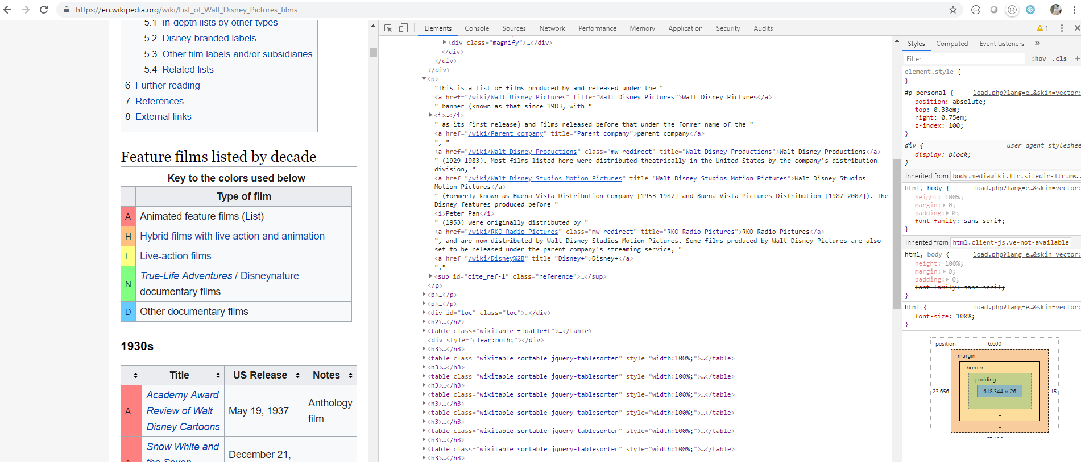

## Imports & URL Inspection with Beautiful Soup

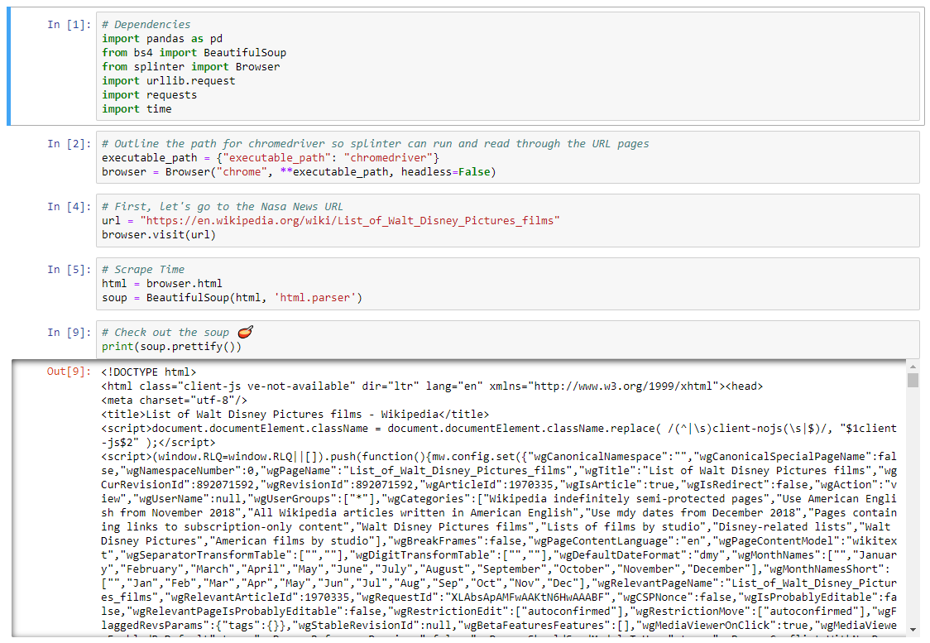

## Tables with Pandas

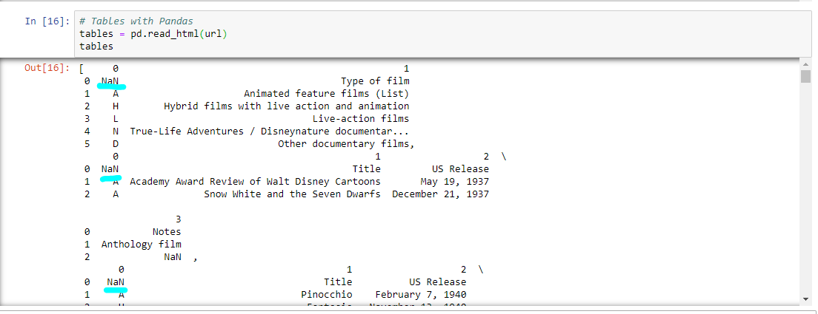

## DataFrame & Slicing

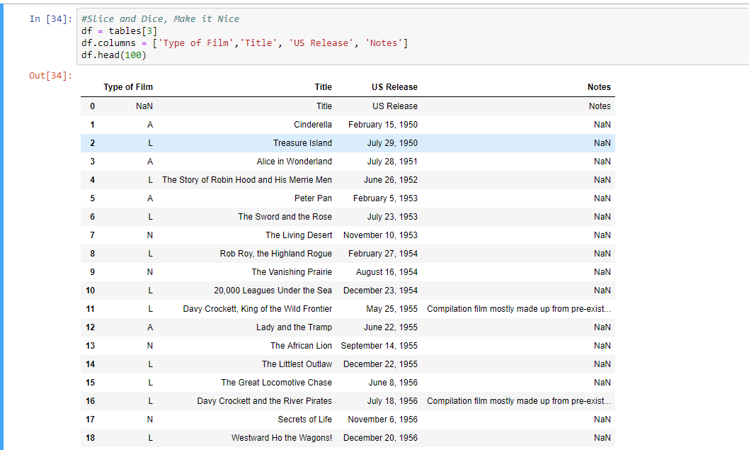

## Drop NaN’s & Unneeded Columns

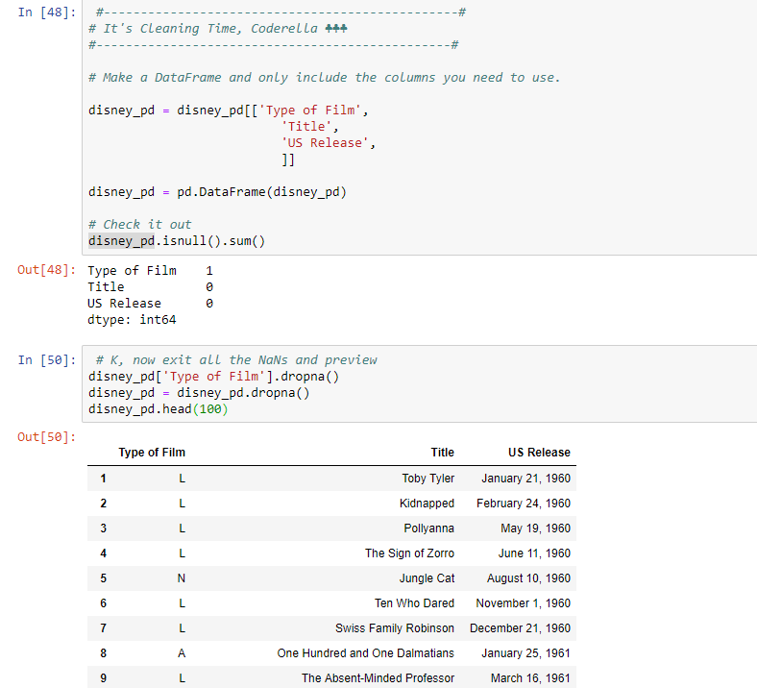

# Scraping Methods – List Disney

## Inspect HTML first

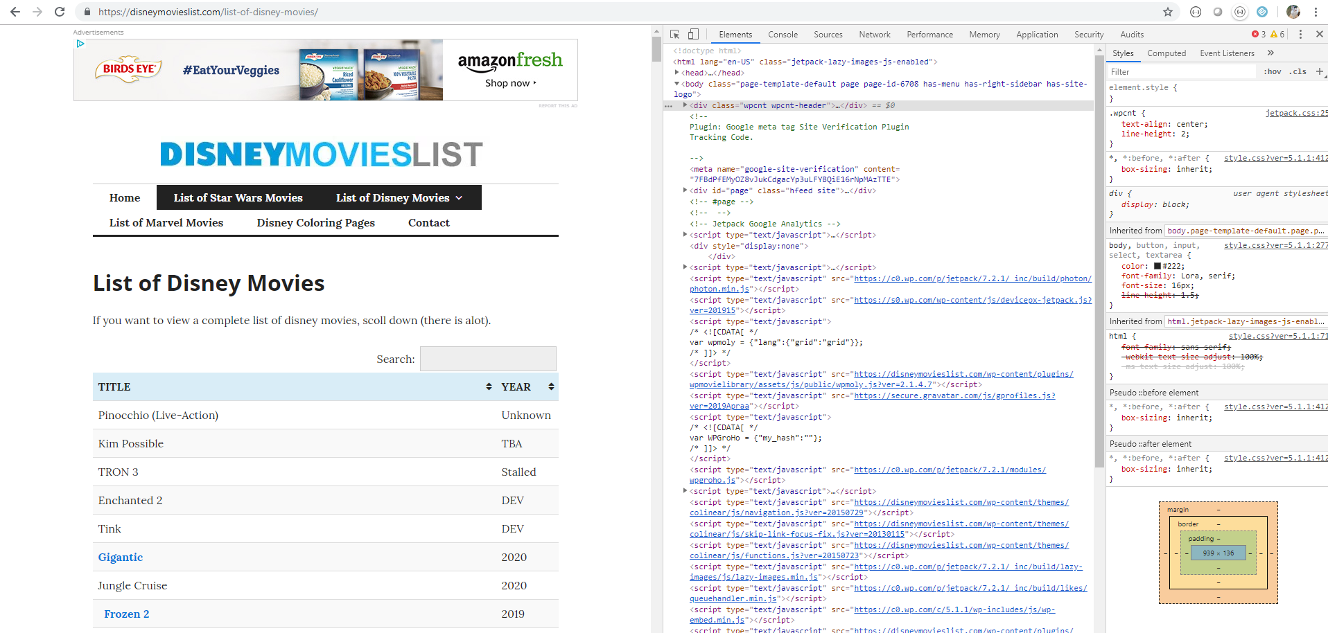

## Imports & URL Inspection with Beautiful Soup

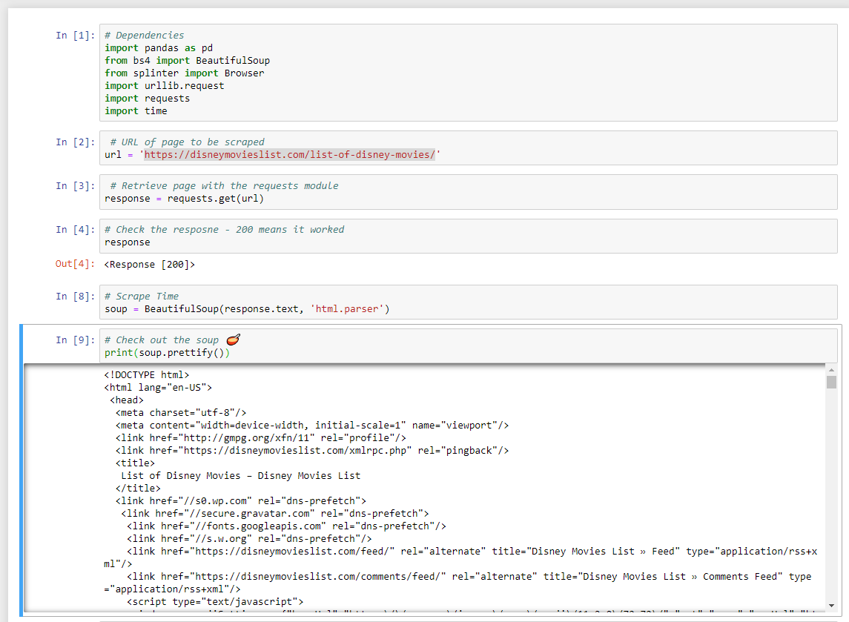

## Tables with Pandas

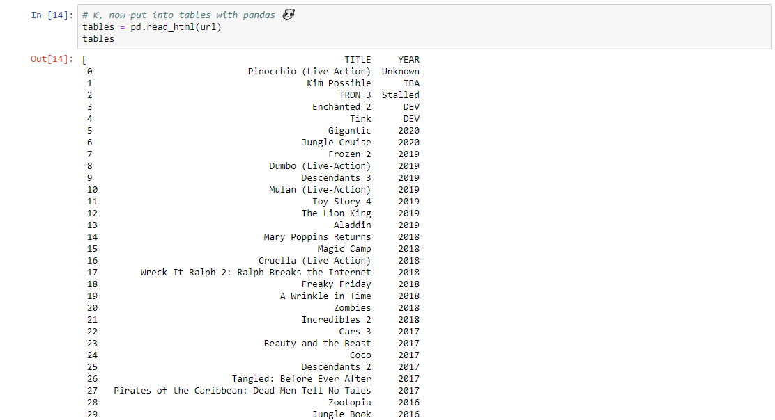

## DataFrame & Slicing

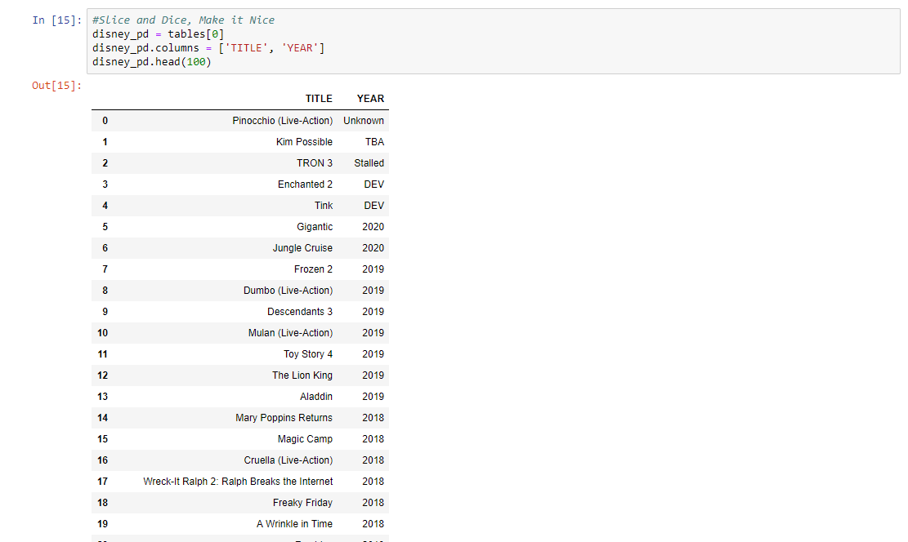

## Check for NaN’s

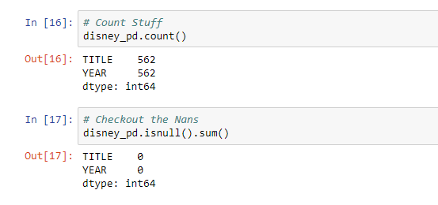

Yay! No NaN’s!

# Transform & Load Methods (all)

## Load CSV – Wikipedia Disney

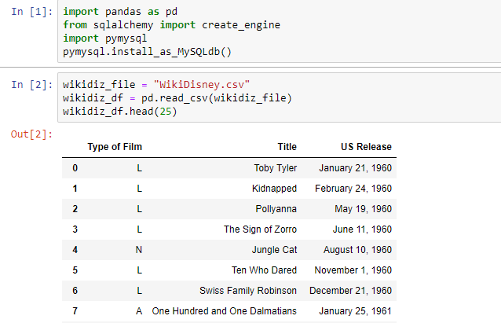

## Load CSV – List Disney

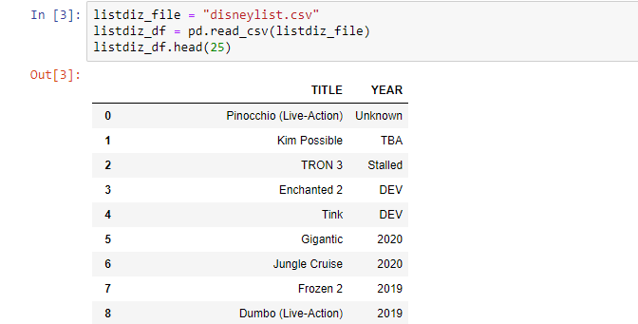

## Load CSV – IMDB Disney

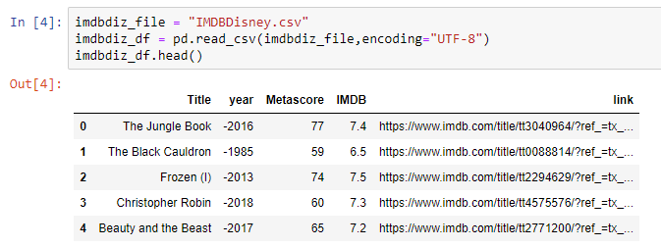

## Load CSV – Gross Movie Sales, Disney Characters, Disney Voice Actors

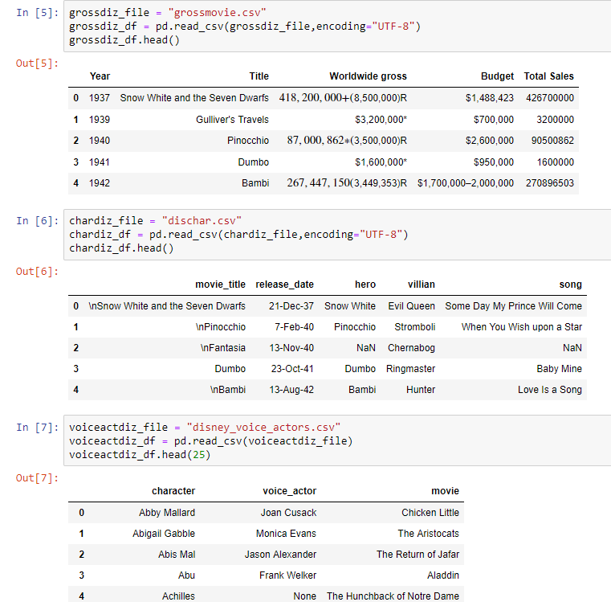

## Connect to SQL & Load

