Analysis Report: Static vs Negative Plasticity, varying $\eta$

Data Folders Used
- static w=0.0: C:\work_hard\byte\data\norm_plasticity\rawdata\2026-03-06_16-23-39_static_w_0_0
- static w=1.0: C:\work_hard\byte\data\norm_plasticity\rawdata\2026-03-06_16-15-32_static_w_1_0
- plastic w=0.95, eta=0.01, mod=-0.5: C:\work_hard\byte\data\norm_plasticity\rawdata\2026-03-06_16-41-30_plastic_w_0_95_eta_0_01_mod_neg_0_5
- plastic w=0.95, eta=0.025, mod=-0.5: C:\work_hard\byte\data\norm_plasticity\rawdata\2026-03-06_16-42-27_plastic_w_0_95_eta_0_025_mod_neg_0_5
- plastic w=0.95, eta=0.05, mod=-0.5: C:\work_hard\byte\data\norm_plasticity\rawdata\2026-03-06_16-43-19_plastic_w_0_95_eta_0_05_mod_neg_0_5
- plastic w=0.95, eta=0.1, mod=-0.5: C:\work_hard\byte\data\norm_plasticity\rawdata\2026-03-06_16-43-59_plastic_w_0_95_eta_0_1_mod_neg_0_5

Kolmogorov-Smirnov Test Results

static w=0.0 vs static w=1.0
Metric | Value
KS statistic | 0.2580
p-value | 4.9774e-15

static w=0.0 vs plastic w=0.95, eta=0.01, mod=-0.5
Metric | Value
KS statistic | 0.2420
p-value | 2.9511e-13

static w=0.0 vs plastic w=0.95, eta=0.025, mod=-0.5
Metric | Value
KS statistic | 0.1520
p-value | 1.8605e-05

static w=0.0 vs plastic w=0.95, eta=0.05, mod=-0.5
Metric | Value
KS statistic | 0.0980
p-value | 1.6379e-02

static w=0.0 vs plastic w=0.95, eta=0.1, mod=-0.5
Metric | Value
KS statistic | 0.0940
p-value | 2.4066e-02

static w=1.0 vs plastic w=0.95, eta=0.01, mod=-0.5
Metric | Value
KS statistic | 0.1360
p-value | 1.8891e-04

static w=1.0 vs plastic w=0.95, eta=0.025, mod=-0.5
Metric | Value
KS statistic | 0.2020
p-value | 2.4453e-09

static w=1.0 vs plastic w=0.95, eta=0.05, mod=-0.5
Metric | Value
KS statistic | 0.2240
p-value | 2.1068e-11

static w=1.0 vs plastic w=0.95, eta=0.1, mod=-0.5
Metric | Value
KS statistic | 0.2340
p-value | 2.0520e-12

plastic w=0.95, eta=0.01, mod=-0.5 vs plastic w=0.95, eta=0.025, mod=-0.5
Metric | Value
KS statistic | 0.1140
p-value | 2.9901e-03

plastic w=0.95, eta=0.01, mod=-0.5 vs plastic w=0.95, eta=0.05, mod=-0.5
Metric | Value
KS statistic | 0.1660
p-value | 1.9751e-06

plastic w=0.95, eta=0.01, mod=-0.5 vs plastic w=0.95, eta=0.1, mod=-0.5
Metric | Value
KS statistic | 0.1640
p-value | 2.7548e-06

plastic w=0.95, eta=0.025, mod=-0.5 vs plastic w=0.95, eta=0.05, mod=-0.5
Metric | Value
KS statistic | 0.0740
p-value | 1.2940e-01

plastic w=0.95, eta=0.025, mod=-0.5 vs plastic w=0.95, eta=0.1, mod=-0.5
Metric | Value
KS statistic | 0.0920
p-value | 2.8996e-02

plastic w=0.95, eta=0.05, mod=-0.5 vs plastic w=0.95, eta=0.1, mod=-0.5
Metric | Value
KS statistic | 0.0540
p-value | 4.5992e-01

Figures

Connection weight 1→6 (mean ± 95% CI)
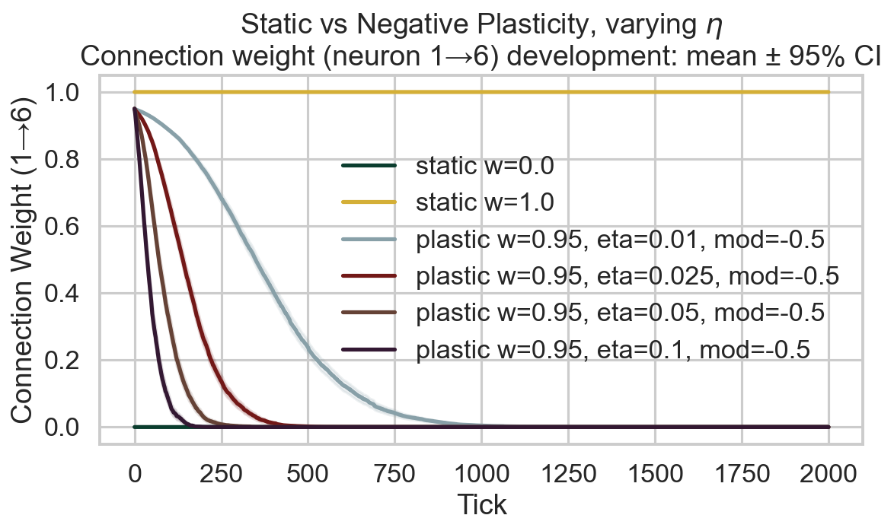

Survival race
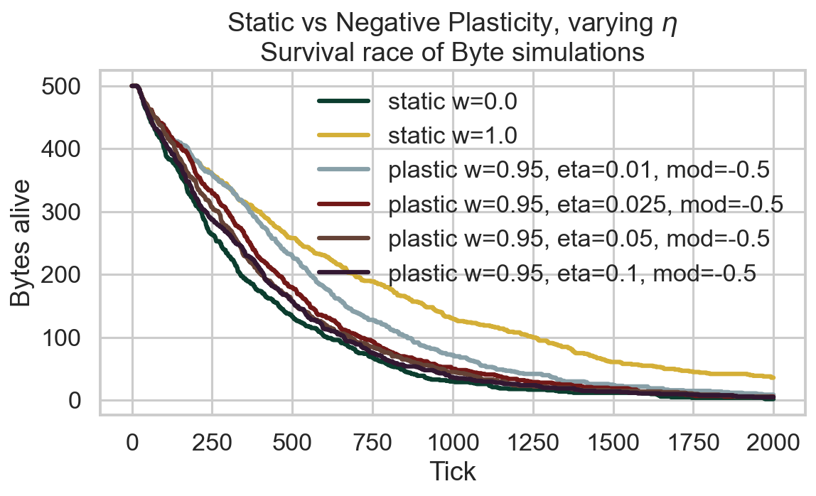

Survival time distribution
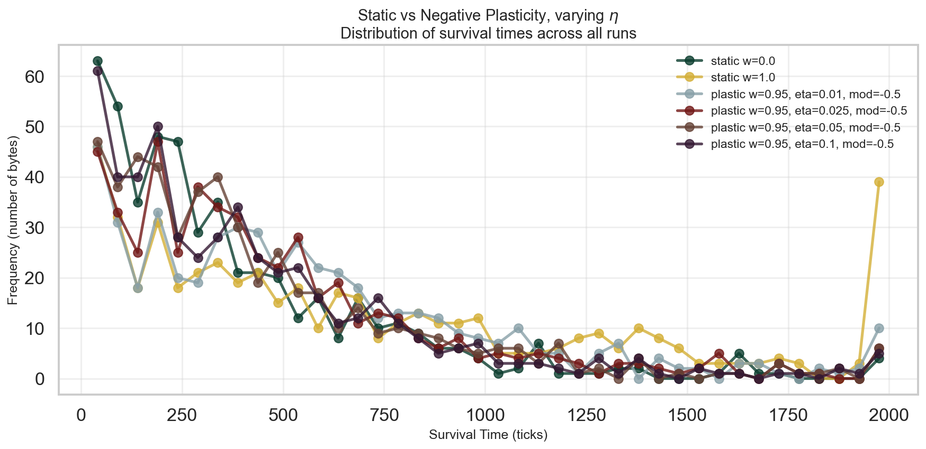

Survival CCDF (log-log)
