Analysis Report: Static vs Positive Plasticity, varying $\eta$

Data Folders Used
- static w=0.0: C:\work_hard\byte\data\norm_plasticity\rawdata\2026-03-06_16-23-39_static_w_0_0
- static w=1.0: C:\work_hard\byte\data\norm_plasticity\rawdata\2026-03-06_16-15-32_static_w_1_0
- plastic w=0.05, eta=0.01, mod=0.5: C:\work_hard\byte\data\norm_plasticity\rawdata\2026-03-06_15-38-58_plastic_w_0_05_eta_0_01_mod_0_5
- plastic w=0.05, eta=0.025, mod=0.5: C:\work_hard\byte\data\norm_plasticity\rawdata\2026-03-06_16-09-42_plastic_w_0_05_eta_0_025_mod_0_5
- plastic w=0.05, eta=0.05, mod=0.5: C:\work_hard\byte\data\norm_plasticity\rawdata\2026-03-06_16-12-09_plastic_w_0_05_eta_0_05_mod_0_5
- plastic w=0.05, eta=0.1, mod=0.5: C:\work_hard\byte\data\norm_plasticity\rawdata\2026-03-06_16-13-17_plastic_w_0_05_eta_0_1_mod_0_5

Kolmogorov-Smirnov Test Results

static w=0.0 vs static w=1.0
Metric | Value
KS statistic | 0.2580
p-value | 4.9774e-15

static w=0.0 vs plastic w=0.05, eta=0.01, mod=0.5
Metric | Value
KS statistic | 0.1880
p-value | 3.8737e-08

static w=0.0 vs plastic w=0.05, eta=0.025, mod=0.5
Metric | Value
KS statistic | 0.2180
p-value | 8.1013e-11

static w=0.0 vs plastic w=0.05, eta=0.05, mod=0.5
Metric | Value
KS statistic | 0.2080
p-value | 7.0312e-10

static w=0.0 vs plastic w=0.05, eta=0.1, mod=0.5
Metric | Value
KS statistic | 0.2380
p-value | 7.8480e-13

static w=1.0 vs plastic w=0.05, eta=0.01, mod=0.5
Metric | Value
KS statistic | 0.1560
p-value | 1.0005e-05

static w=1.0 vs plastic w=0.05, eta=0.025, mod=0.5
Metric | Value
KS statistic | 0.0820
p-value | 6.9301e-02

static w=1.0 vs plastic w=0.05, eta=0.05, mod=0.5
Metric | Value
KS statistic | 0.0740
p-value | 1.2940e-01

static w=1.0 vs plastic w=0.05, eta=0.1, mod=0.5
Metric | Value
KS statistic | 0.0480
p-value | 6.1262e-01

plastic w=0.05, eta=0.01, mod=0.5 vs plastic w=0.05, eta=0.025, mod=0.5
Metric | Value
KS statistic | 0.0860
p-value | 4.9503e-02

plastic w=0.05, eta=0.01, mod=0.5 vs plastic w=0.05, eta=0.05, mod=0.5
Metric | Value
KS statistic | 0.0960
p-value | 1.9894e-02

plastic w=0.05, eta=0.01, mod=0.5 vs plastic w=0.05, eta=0.1, mod=0.5
Metric | Value
KS statistic | 0.1220
p-value | 1.1593e-03

plastic w=0.05, eta=0.025, mod=0.5 vs plastic w=0.05, eta=0.05, mod=0.5
Metric | Value
KS statistic | 0.0280
p-value | 9.8968e-01

plastic w=0.05, eta=0.025, mod=0.5 vs plastic w=0.05, eta=0.1, mod=0.5
Metric | Value
KS statistic | 0.0560
p-value | 4.1349e-01

plastic w=0.05, eta=0.05, mod=0.5 vs plastic w=0.05, eta=0.1, mod=0.5
Metric | Value
KS statistic | 0.0520
p-value | 5.0892e-01

Figures

Connection weight 1→6 (mean ± 95% CI)
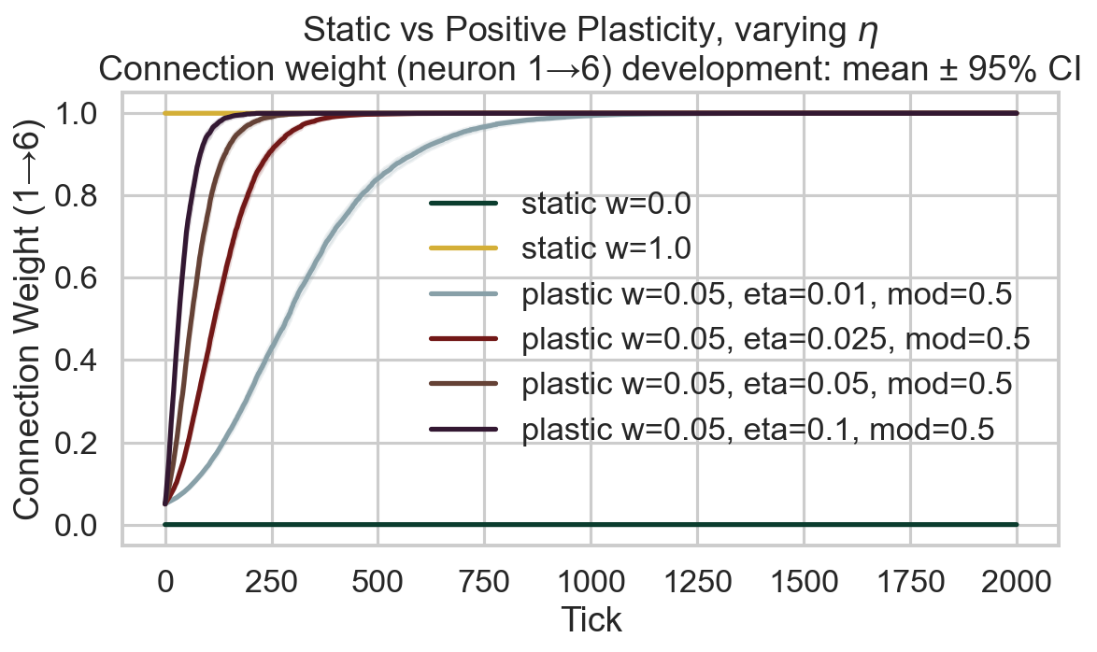

Survival race
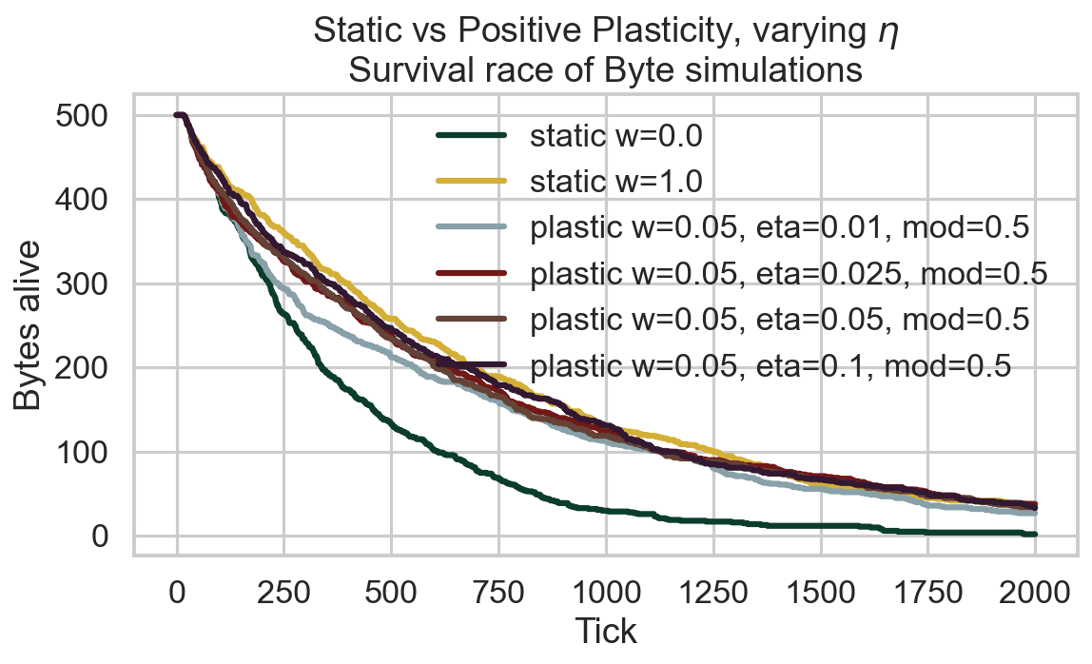

Survival time distribution
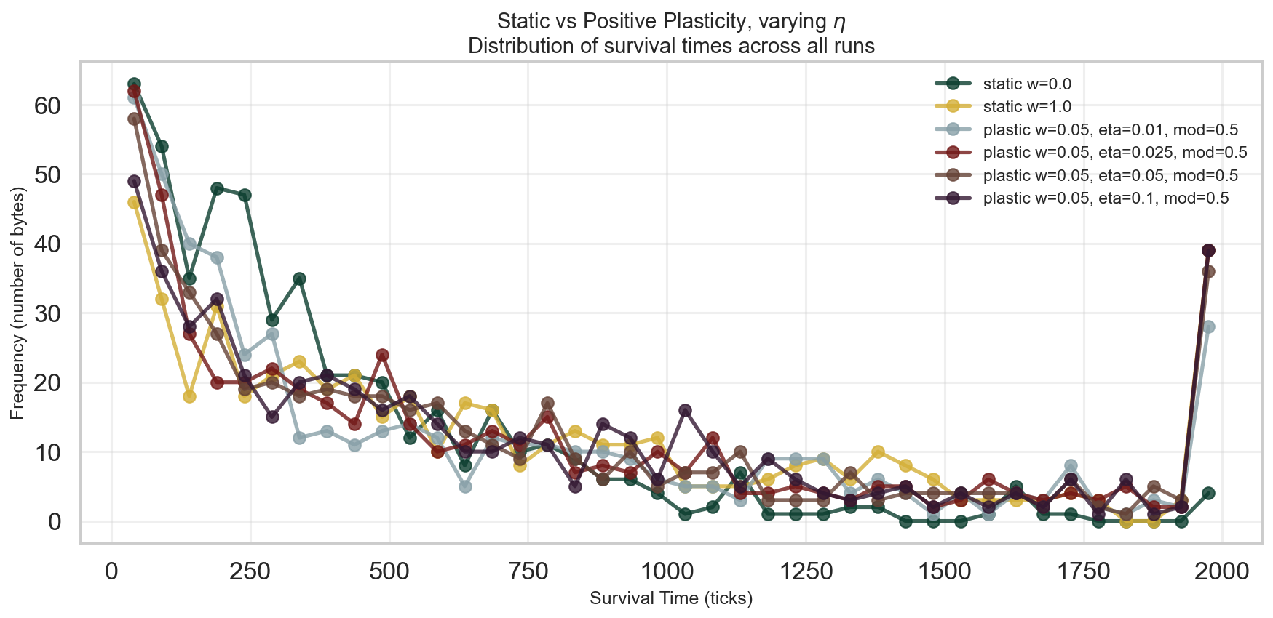

Survival CCDF (log-log)
