Analysis Report: Static vs Plasticity, varying modulation weight

Data Folders Used
- static w=0.0: C:\work_hard\byte\data\norm_plasticity\rawdata\2026-03-06_16-23-39_static_w_0_0
- static w=1.0: C:\work_hard\byte\data\norm_plasticity\rawdata\2026-03-06_16-15-32_static_w_1_0
- plastic w=0.05, eta=0.01, mod=1.0: C:\work_hard\byte\data\norm_plasticity\rawdata\2026-03-06_15-34-06_plastic_w_0_05_eta_0_01_mod_1
- plastic w=0.05, eta=0.01, mod=0.5: C:\work_hard\byte\data\norm_plasticity\rawdata\2026-03-06_15-38-58_plastic_w_0_05_eta_0_01_mod_0_5
- plastic w=0.05, eta=0.01, mod=0.2: C:\work_hard\byte\data\norm_plasticity\rawdata\2026-03-06_15-41-14_plastic_w_0_05_eta_0_01_mod_0_2
- plastic w=0.05, eta=0.01, mod=0.1: C:\work_hard\byte\data\norm_plasticity\rawdata\2026-03-06_15-37-02_plastic_w_0_05_eta_0_01_mod_0_1
- plastic w=0.95, eta=0.01, mod=-1.0: C:\work_hard\byte\data\norm_plasticity\rawdata\2026-03-06_15-50-55_plastic_w_0_95_eta_0_01_mod_neg_1
- plastic w=0.95, eta=0.01, mod=-0.5: C:\work_hard\byte\data\norm_plasticity\rawdata\2026-03-06_15-51-47_plastic_w_0_95_eta_0_01_mod_neg_0_5
- plastic w=0.95, eta=0.01, mod=-0.2: C:\work_hard\byte\data\norm_plasticity\rawdata\2026-03-06_16-00-42_plastic_w_0_95_eta_0_01_mod_neg_0_2
- plastic w=0.95, eta=0.01, mod=-0.1: C:\work_hard\byte\data\norm_plasticity\rawdata\2026-03-06_16-03-28_plastic_w_0_95_eta_0_01_mod_neg_0_1

Kolmogorov-Smirnov Test Results

static w=0.0 vs static w=1.0
Metric | Value
KS statistic | 0.2580
p-value | 4.9774e-15

static w=0.0 vs plastic w=0.05, eta=0.01, mod=1.0
Metric | Value
KS statistic | 0.1880
p-value | 3.8737e-08

static w=0.0 vs plastic w=0.05, eta=0.01, mod=0.5
Metric | Value
KS statistic | 0.1880
p-value | 3.8737e-08

static w=0.0 vs plastic w=0.05, eta=0.01, mod=0.2
Metric | Value
KS statistic | 0.0720
p-value | 1.4973e-01

static w=0.0 vs plastic w=0.05, eta=0.01, mod=0.1
Metric | Value
KS statistic | 0.0380
p-value | 8.6368e-01

static w=0.0 vs plastic w=0.95, eta=0.01, mod=-1.0
Metric | Value
KS statistic | 0.1520
p-value | 1.8605e-05

static w=0.0 vs plastic w=0.95, eta=0.01, mod=-0.5
Metric | Value
KS statistic | 0.2420
p-value | 2.9511e-13

static w=0.0 vs plastic w=0.95, eta=0.01, mod=-0.2
Metric | Value
KS statistic | 0.2740
p-value | 6.3833e-17

static w=0.0 vs plastic w=0.95, eta=0.01, mod=-0.1
Metric | Value
KS statistic | 0.2580
p-value | 4.9774e-15

static w=1.0 vs plastic w=0.05, eta=0.01, mod=1.0
Metric | Value
KS statistic | 0.1280
p-value | 5.4588e-04

static w=1.0 vs plastic w=0.05, eta=0.01, mod=0.5
Metric | Value
KS statistic | 0.1560
p-value | 1.0005e-05

static w=1.0 vs plastic w=0.05, eta=0.01, mod=0.2
Metric | Value
KS statistic | 0.2340
p-value | 2.0520e-12

static w=1.0 vs plastic w=0.05, eta=0.01, mod=0.1
Metric | Value
KS statistic | 0.2460
p-value | 1.0910e-13

static w=1.0 vs plastic w=0.95, eta=0.01, mod=-1.0
Metric | Value
KS statistic | 0.2140
p-value | 1.9471e-10

static w=1.0 vs plastic w=0.95, eta=0.01, mod=-0.5
Metric | Value
KS statistic | 0.1360
p-value | 1.8891e-04

static w=1.0 vs plastic w=0.95, eta=0.01, mod=-0.2
Metric | Value
KS statistic | 0.0660
p-value | 2.2635e-01

static w=1.0 vs plastic w=0.95, eta=0.01, mod=-0.1
Metric | Value
KS statistic | 0.0340
p-value | 9.3511e-01

plastic w=0.05, eta=0.01, mod=1.0 vs plastic w=0.05, eta=0.01, mod=0.5
Metric | Value
KS statistic | 0.0340
p-value | 9.3511e-01

plastic w=0.05, eta=0.01, mod=1.0 vs plastic w=0.05, eta=0.01, mod=0.2
Metric | Value
KS statistic | 0.1580
p-value | 7.2924e-06

plastic w=0.05, eta=0.01, mod=1.0 vs plastic w=0.05, eta=0.01, mod=0.1
Metric | Value
KS statistic | 0.1820
p-value | 1.1894e-07

plastic w=0.05, eta=0.01, mod=1.0 vs plastic w=0.95, eta=0.01, mod=-1.0
Metric | Value
KS statistic | 0.1480
p-value | 3.4035e-05

plastic w=0.05, eta=0.01, mod=1.0 vs plastic w=0.95, eta=0.01, mod=-0.5
Metric | Value
KS statistic | 0.1240
p-value | 9.0558e-04

plastic w=0.05, eta=0.01, mod=1.0 vs plastic w=0.95, eta=0.01, mod=-0.2
Metric | Value
KS statistic | 0.1260
p-value | 7.0452e-04

plastic w=0.05, eta=0.01, mod=1.0 vs plastic w=0.95, eta=0.01, mod=-0.1
Metric | Value
KS statistic | 0.1280
p-value | 5.4588e-04

plastic w=0.05, eta=0.01, mod=0.5 vs plastic w=0.05, eta=0.01, mod=0.2
Metric | Value
KS statistic | 0.1500
p-value | 2.5215e-05

plastic w=0.05, eta=0.01, mod=0.5 vs plastic w=0.05, eta=0.01, mod=0.1
Metric | Value
KS statistic | 0.1740
p-value | 5.0092e-07

plastic w=0.05, eta=0.01, mod=0.5 vs plastic w=0.95, eta=0.01, mod=-1.0
Metric | Value
KS statistic | 0.1540
p-value | 1.3672e-05

plastic w=0.05, eta=0.01, mod=0.5 vs plastic w=0.95, eta=0.01, mod=-0.5
Metric | Value
KS statistic | 0.1540
p-value | 1.3672e-05

plastic w=0.05, eta=0.01, mod=0.5 vs plastic w=0.95, eta=0.01, mod=-0.2
Metric | Value
KS statistic | 0.1540
p-value | 1.3672e-05

plastic w=0.05, eta=0.01, mod=0.5 vs plastic w=0.95, eta=0.01, mod=-0.1
Metric | Value
KS statistic | 0.1560
p-value | 1.0005e-05

plastic w=0.05, eta=0.01, mod=0.2 vs plastic w=0.05, eta=0.01, mod=0.1
Metric | Value
KS statistic | 0.0480
p-value | 6.1262e-01

plastic w=0.05, eta=0.01, mod=0.2 vs plastic w=0.95, eta=0.01, mod=-1.0
Metric | Value
KS statistic | 0.1160
p-value | 2.3738e-03

plastic w=0.05, eta=0.01, mod=0.2 vs plastic w=0.95, eta=0.01, mod=-0.5
Metric | Value
KS statistic | 0.1980
p-value | 5.4973e-09

plastic w=0.05, eta=0.01, mod=0.2 vs plastic w=0.95, eta=0.01, mod=-0.2
Metric | Value
KS statistic | 0.2300
p-value | 5.2753e-12

plastic w=0.05, eta=0.01, mod=0.2 vs plastic w=0.95, eta=0.01, mod=-0.1
Metric | Value
KS statistic | 0.2340
p-value | 2.0520e-12

plastic w=0.05, eta=0.01, mod=0.1 vs plastic w=0.95, eta=0.01, mod=-1.0
Metric | Value
KS statistic | 0.1320
p-value | 3.2375e-04

plastic w=0.05, eta=0.01, mod=0.1 vs plastic w=0.95, eta=0.01, mod=-0.5
Metric | Value
KS statistic | 0.2140
p-value | 1.9471e-10

plastic w=0.05, eta=0.01, mod=0.1 vs plastic w=0.95, eta=0.01, mod=-0.2
Metric | Value
KS statistic | 0.2600
p-value | 2.9312e-15

plastic w=0.05, eta=0.01, mod=0.1 vs plastic w=0.95, eta=0.01, mod=-0.1
Metric | Value
KS statistic | 0.2460
p-value | 1.0910e-13

plastic w=0.95, eta=0.01, mod=-1.0 vs plastic w=0.95, eta=0.01, mod=-0.5
Metric | Value
KS statistic | 0.1100
p-value | 4.6867e-03

plastic w=0.95, eta=0.01, mod=-1.0 vs plastic w=0.95, eta=0.01, mod=-0.2
Metric | Value
KS statistic | 0.2400
p-value | 4.8227e-13

plastic w=0.95, eta=0.01, mod=-1.0 vs plastic w=0.95, eta=0.01, mod=-0.1
Metric | Value
KS statistic | 0.2160
p-value | 1.2586e-10

plastic w=0.95, eta=0.01, mod=-0.5 vs plastic w=0.95, eta=0.01, mod=-0.2
Metric | Value
KS statistic | 0.1560
p-value | 1.0005e-05

plastic w=0.95, eta=0.01, mod=-0.5 vs plastic w=0.95, eta=0.01, mod=-0.1
Metric | Value
KS statistic | 0.1500
p-value | 2.5215e-05

plastic w=0.95, eta=0.01, mod=-0.2 vs plastic w=0.95, eta=0.01, mod=-0.1
Metric | Value
KS statistic | 0.0760
p-value | 1.1137e-01

Figures

Connection weight 1→6 (mean ± 95% CI)
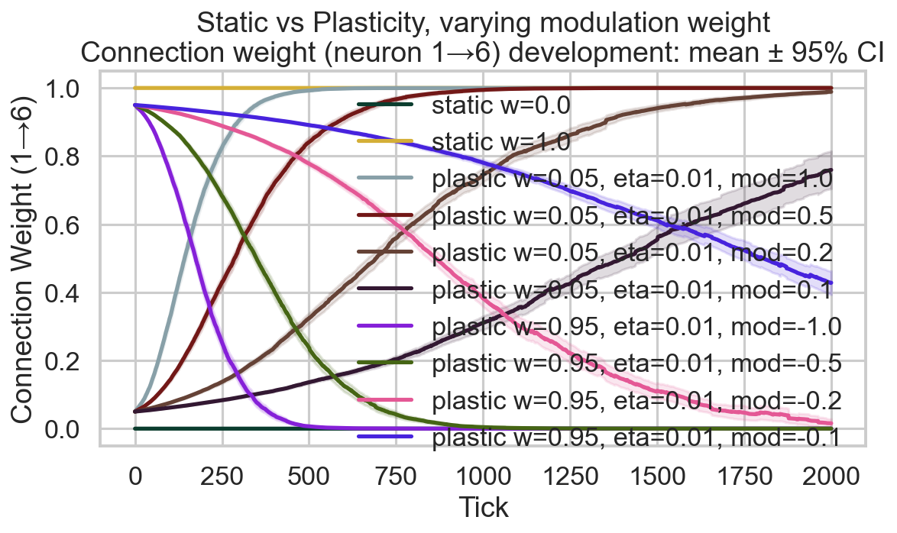

Survival race
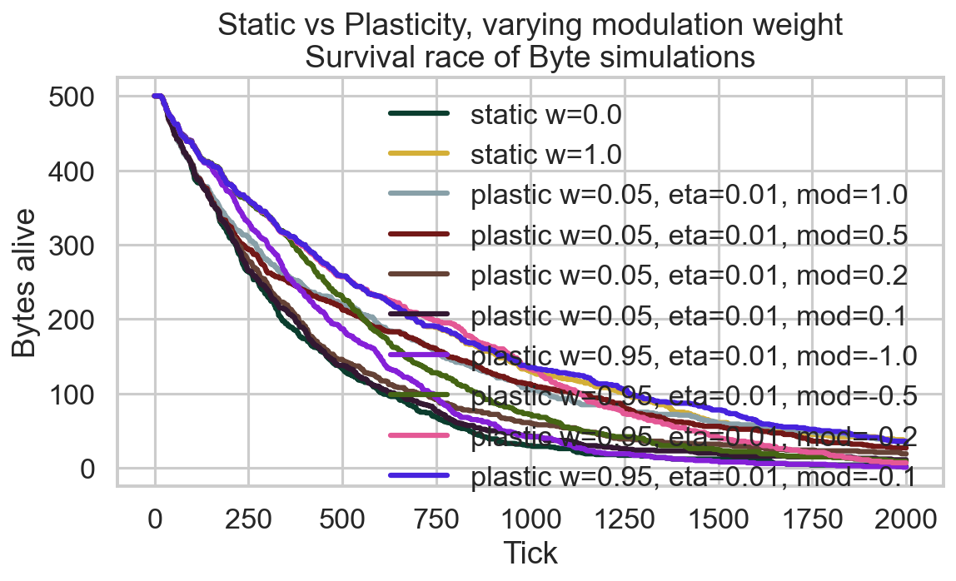

Survival time distribution
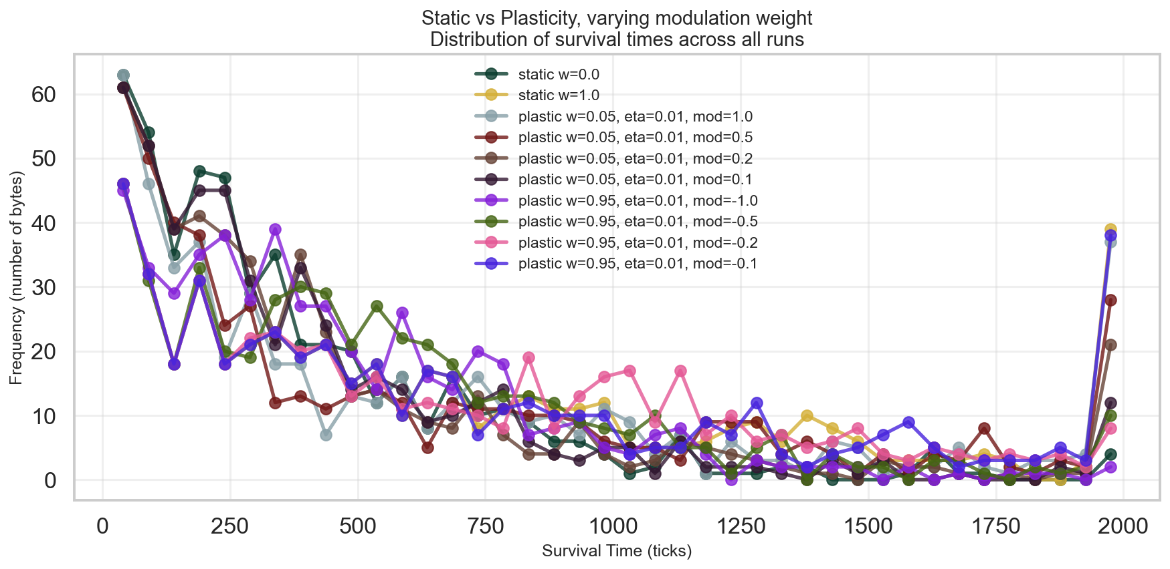

Survival CCDF (log-log)
