Analysis Report: first_ea_all

1. Experiment Information

1.1. Data overview
Group | Type | Dataset | Variants | Runs (total / per variant)
EA from Random | experiment | 2026-05-05_17-42-25_ea_from_random_genomes_all_runs_all.h5 | 10 | 3000 / 300
EA from Soft-Coded | experiment | 2026-05-06_09-34-55_ea_from_lookup_soft_genomes_all_runs_all.h5 | 10 | 3000 / 300
EA from Hard-Coded | experiment | 2026-05-06_11-31-03_ea_from_lookup_hard_genomes_all_runs_all.h5 | 10 | 3000 / 300
Random | benchmark | 2026-05-27_09-57-28_2026-05-05_17-42-25_ea_from_random_BM_random.h5 | 260 | 78000 / 300
Soft-Coded | benchmark | 2026-05-27_10-00-35_2026-05-05_17-42-25_ea_from_random_BM_lookup_soft.h5 | 1 | 300 / 300
Hard-Coded | benchmark | 2026-05-27_10-00-48_2026-05-05_17-42-25_ea_from_random_BM_lookup_hard.h5 | 1 | 300 / 300

1.2.Statistical Analysis Methodology
This report employs adaptive statistical analysis based on data distribution and group count. Four analytical scenarios are used:
1. TWO GROUPS, NORMALLY DISTRIBUTED DATA
• Omnibus Test: Welch's t-test (compares means)
• Effect Size: Cohen's d (interpretation: small ≥ 0.2, medium ≥ 0.5, large ≥ 0.8)
• Post-hoc: Not applicable (omnibus test serves as pairwise comparison)
• Significance threshold: p < 0.05
2. TWO GROUPS, NON-NORMALLY DISTRIBUTED DATA
• Omnibus Test: Mann-Whitney U test (compares distributions via ranks)
• Effect Size: Rank-Biserial r (interpretation: small ≥ 0.11, medium ≥ 0.28, large ≥ 0.43)
• Post-hoc: Not applicable (omnibus test serves as pairwise comparison)
• Significance threshold: p < 0.05
3. MORE THAN TWO GROUPS, NORMALLY DISTRIBUTED DATA
• Omnibus Test: One-way ANOVA (tests if any group means differ)
• Effect Size: Eta-squared η² (interpretation: small ≥ 0.01, medium ≥ 0.06, large ≥ 0.14)
• Post-hoc Pairwise Test: Welch's t-test (all pairs compared)
• Multiple Comparisons Correction: Tukey's HSD (controls Type I error across pairwise comparisons)
• Post-hoc Effect Size: Cohen's d (interpretation: small ≥ 0.2, medium ≥ 0.5, large ≥ 0.8)
• Significance threshold: p < 0.05 (omnibus and post-hoc)
4. MORE THAN TWO GROUPS, NON-NORMALLY DISTRIBUTED DATA
• Omnibus Test: Kruskal-Wallis (tests if any group distributions differ via ranks)
• Effect Size: Ordinal Epsilon-squared ε²R (interpretation: small ≥ 0.01, medium ≥ 0.08, large ≥ 0.26)
• Post-hoc Pairwise Test: Mann-Whitney U (all pairs compared)
• Multiple Comparisons Correction: Holm-Bonferroni (sequential adjustment of p-value thresholds)
• Post-hoc Effect Size: Rank-Biserial r (interpretation: small ≥ 0.11, medium ≥ 0.28, large ≥ 0.43)
• Significance threshold: p < 0.05 (omnibus and post-hoc)
Normality is assessed using the Shapiro-Wilk test (alpha = 0.05) for each group independently. If any group fails the normality test, the analysis uses non-parametric methods.
TIME SERIES
For metrics tracked per simulation tick (e.g., energy), per-tick data are analyzed using the Area Under the Curve (AUC) method:
• Each run's per-tick metric values (tick 0 to end of run) are integrated using the trapezoidal rule to produce a single AUC value per run
• AUC values are then compared across groups using the same adaptive statistical framework as above (Welch's t-test/Mann-Whitney U for 2 groups, ANOVA/Kruskal-Wallis for >2 groups)
• This approach is conservative and avoids temporal autocorrelation issues by summarizing the time-series into a single magnitude metric
• Visualizations show individual run curves (low opacity) overlaid with group mean curves (bold) and 95% confidence bands (shaded)
DISTRIBUTIONS
Distrinutions are compared using the Kolmogorov-Smirnov (KS) test: with Holm-Bonferroni post hoc corrections,
and effect size measured by the KS D statistic (interpreted as small ≥ 0.1, medium ≥ 0.3, large ≥ 0.5).
SURVIVAL CURVES
All groups' survival distributions are compared using the log-rank test:
• Omnibus Test: Log-rank test (rank-based non-parametric test comparing survival distributions)
• Post-hoc Pairwise Test: Pairwise log-rank tests (all group pairs compared)
• Multiple Comparisons Correction: Holm-Bonferroni (sequential adjustment of p-value thresholds)
• Post-hoc Effect Size: χ² per pair (interpretation depends on degrees of freedom and sample sizes)
• Significance threshold: p < 0.05 (omnibus and post-hoc)
• Assumptions: All data fully observed with no censoring; does not assume normality or constant hazards

1.3. Descriptive Statistics per Group
Statistic | EA from Random | EA from Soft-Coded | EA from Hard-Coded | Random | Soft-Coded | Hard-Coded
Mean | 187.22 ticks | 193.27 ticks | 215.57 ticks | 19.49 ticks | 37.51 ticks | 37.51 ticks
Median | 139.50 ticks | 164.00 ticks | 173.00 ticks | 17.00 ticks | 33.00 ticks | 33.00 ticks
Std Dev | 155.90 ticks | 132.51 ticks | 160.21 ticks | 5.59 ticks | 18.99 ticks | 18.99 ticks
Min | 16.00 ticks | 16.00 ticks | 16.00 ticks | 16.00 ticks | 16.00 ticks | 16.00 ticks
Max | 962.00 ticks | 723.00 ticks | 939.00 ticks | 97.00 ticks | 117.00 ticks | 117.00 ticks
Range | 946.00 ticks | 707.00 ticks | 923.00 ticks | 81.00 ticks | 101.00 ticks | 101.00 ticks
IQR (25th–75th percentile) | 209.25 ticks | 189.00 ticks | 223.00 ticks | 2.00 ticks | 23.00 ticks | 23.00 ticks
5th Percentile | 18.00 ticks | 24.00 ticks | 26.00 ticks | 16.00 ticks | 16.00 ticks | 16.00 ticks
25th Percentile | 65.00 ticks | 90.00 ticks | 90.00 ticks | 17.00 ticks | 23.00 ticks | 23.00 ticks
75th Percentile | 274.25 ticks | 279.00 ticks | 313.00 ticks | 19.00 ticks | 46.00 ticks | 46.00 ticks
95th Percentile | 512.05 ticks | 452.05 ticks | 534.00 ticks | 32.00 ticks | 76.05 ticks | 76.05 ticks
Skewness | 1.100 | 0.805 | 0.933 | 3.018 | 1.215 | 1.215
Kurtosis (excess) | 0.649 | 0.026 | 0.200 | 12.609 | 1.318 | 1.318
Coefficient of Variation | 83.27 % | 68.56 % | 74.32 % | 28.70 % | 50.64 % | 50.64 %

1.4. EA results
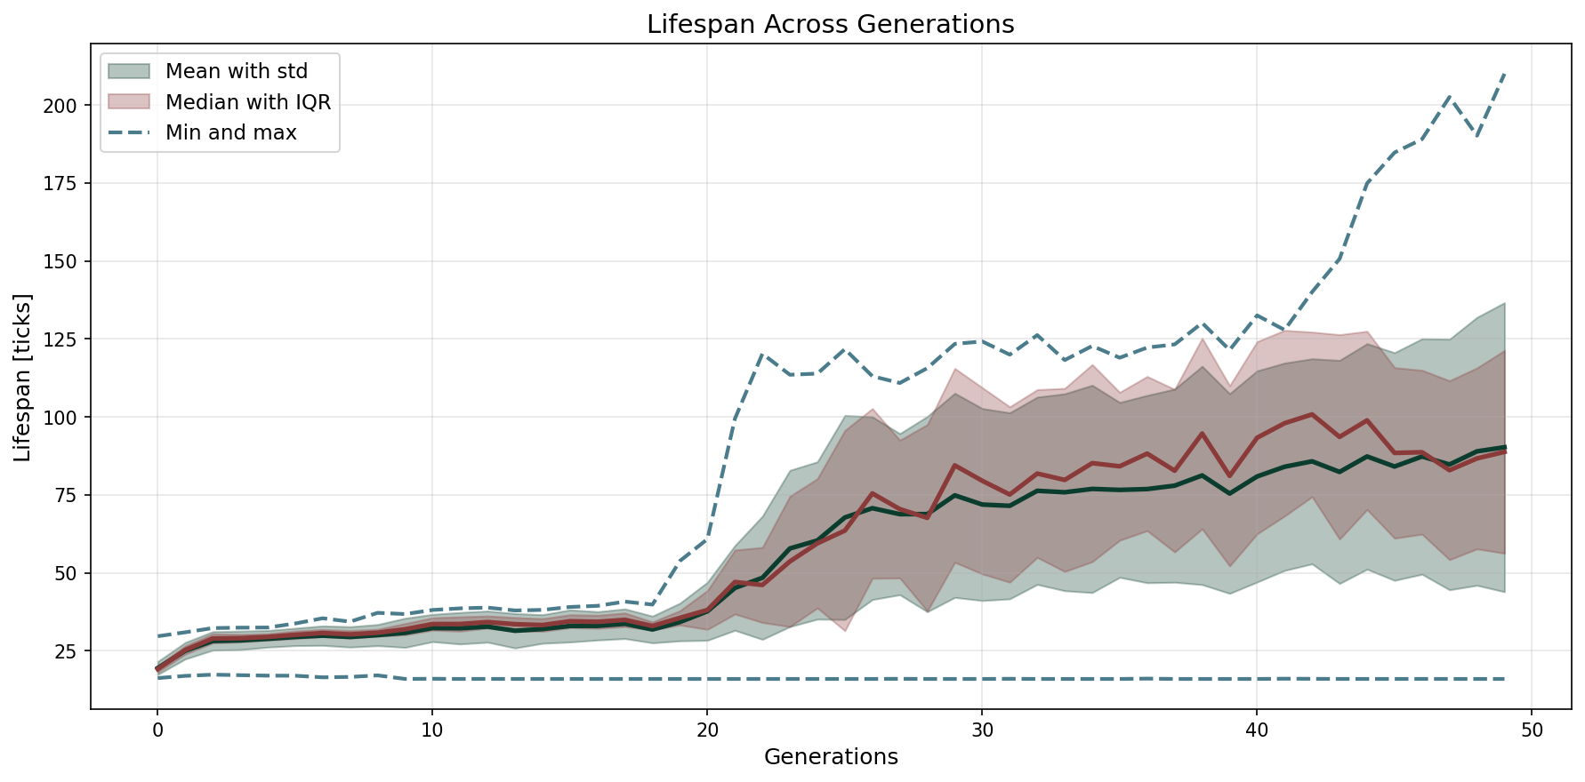
EA evolved from random network initialization. Population size = 250, elite = 10. In generation 50: mean = 69.0, median = 74.22, max = 131.59.

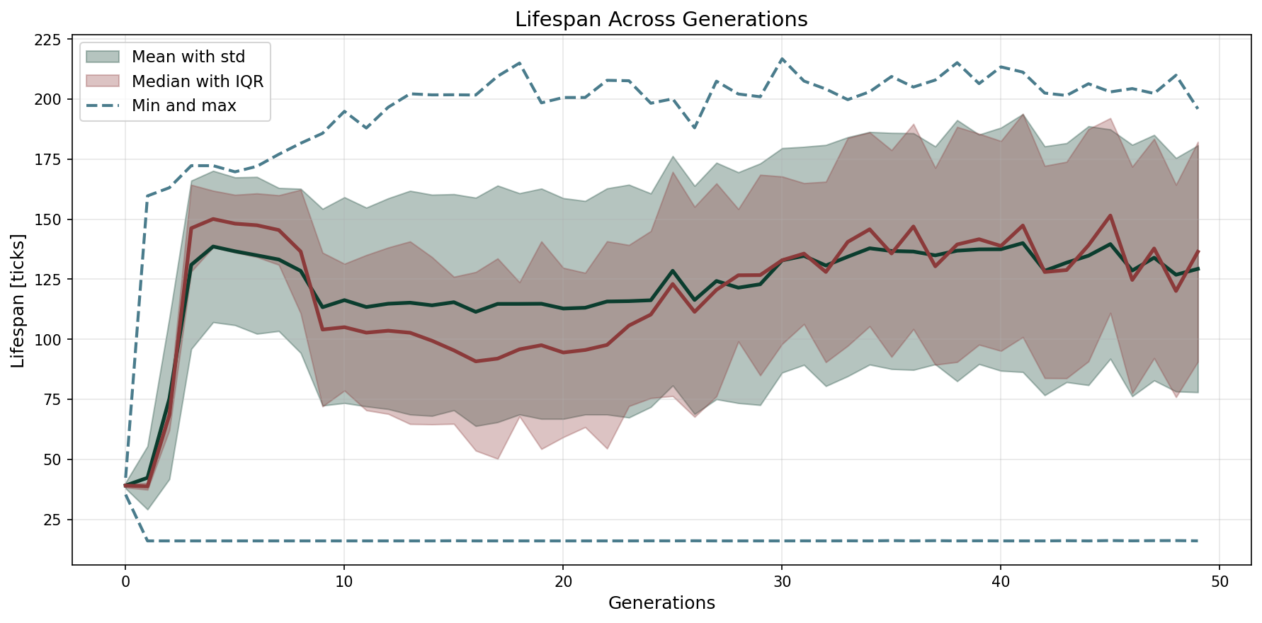
EA evolved from lookup soft initialization. Population size = 260, elite = 10. In generation 50: mean = 129.3, median = 136.4, max = 195.9.

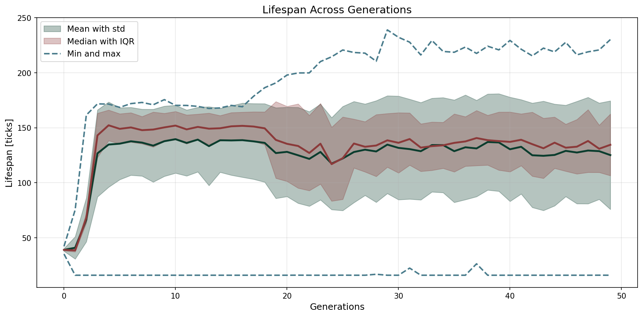
EA evolved from lookup hard initialization. Population size = 260, elite = 10. In generation 50: mean = 125.2, median = 134.5, max = 230.2.

2. Survival
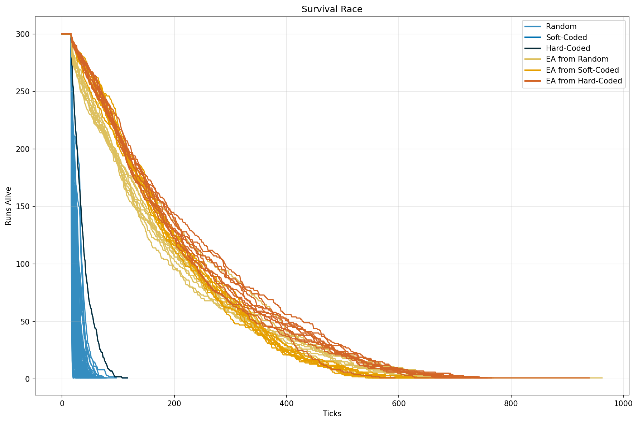

Omnibus
Group | Observed deaths | Expected deaths | (O - E) / E
EA from Random | 2999 | 8500.67 | -64.72 %
EA from Soft-Coded | 3000 | 8712.18 | -65.57 %
EA from Hard-Coded | 3000 | 9267.64 | -67.63 %
Random | 78000 | 60135.86 | 29.71 %
Soft-Coded | 300 | 491.32 | -38.94 %
Hard-Coded | 300 | 491.32 | -38.94 %

Omnibus log-rank test: χ²(5) = 50883.108, p = < 10⁻³⁰⁰. The difference between survival curves is significant at α = 0.05.

Pairwise Comparisons (Holm-Bonferroni corrected)
Group A | Group B | χ² | p (raw) | p (corrected)
EA from Hard-Coded | EA from Random | 76.271 | 2.47 × 10⁻¹⁸ | 7.42 × 10⁻¹⁸ *
EA from Hard-Coded | EA from Soft-Coded | 112.161 | 3.29 × 10⁻²⁶ | 1.32 × 10⁻²⁵ *
EA from Hard-Coded | Hard-Coded | 3507.144 | < 10⁻³⁰⁰ | < 10⁻³⁰⁰ *
EA from Hard-Coded | Random | 28834.935 | < 10⁻³⁰⁰ | < 10⁻³⁰⁰ *
EA from Hard-Coded | Soft-Coded | 3507.144 | < 10⁻³⁰⁰ | < 10⁻³⁰⁰ *
EA from Random | EA from Soft-Coded | 0.987 | 0.3204 | 0.6409
EA from Random | Hard-Coded | 2010.309 | < 10⁻³⁰⁰ | < 10⁻³⁰⁰ *
EA from Random | Random | 26200.911 | < 10⁻³⁰⁰ | < 10⁻³⁰⁰ *
EA from Random | Soft-Coded | 2010.309 | < 10⁻³⁰⁰ | < 10⁻³⁰⁰ *
EA from Soft-Coded | Hard-Coded | 3425.587 | < 10⁻³⁰⁰ | < 10⁻³⁰⁰ *
EA from Soft-Coded | Random | 28702.205 | < 10⁻³⁰⁰ | < 10⁻³⁰⁰ *
EA from Soft-Coded | Soft-Coded | 3425.587 | < 10⁻³⁰⁰ | < 10⁻³⁰⁰ *
Hard-Coded | Random | 1304.215 | 1.37 × 10⁻²⁸⁵ | 8.23 × 10⁻²⁸⁵ *
Hard-Coded | Soft-Coded | 0.000 | 1.0000 | 1.0000
Random | Soft-Coded | 1304.215 | 1.37 × 10⁻²⁸⁵ | 8.23 × 10⁻²⁸⁵ *

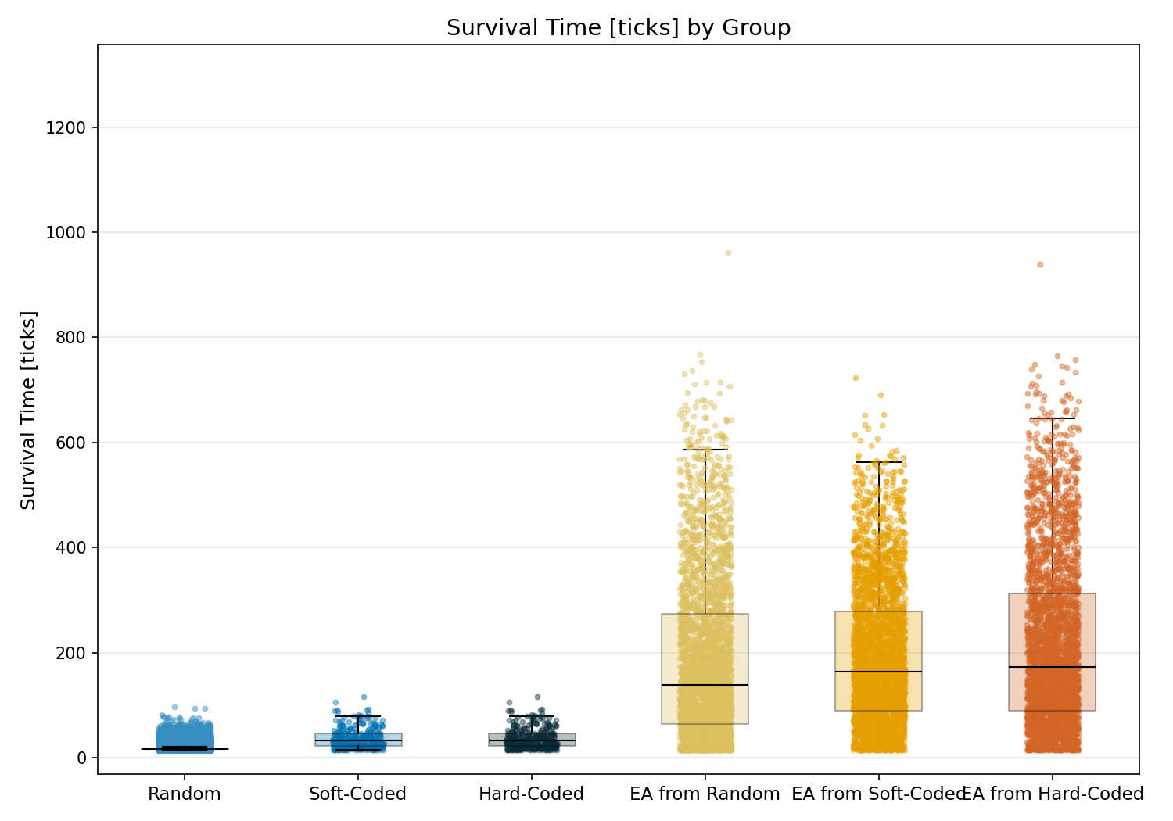

Statistic | Random | Soft-Coded | Hard-Coded | EA from Random | EA from Soft-Coded | EA from Hard-Coded
N | 78000 | 300 | 300 | 3000 | 3000 | 3000
Mean | 19.49 | 37.51 | 37.51 | 187.22 | 193.27 | 215.57
Std Dev | 5.59 | 19.03 | 19.03 | 155.93 | 132.53 | 160.24
SEM | 0.02 | 1.10 | 1.10 | 2.85 | 2.42 | 2.93
Median | 17.00 | 33.00 | 33.00 | 139.50 | 164.00 | 173.00
Min | 16.00 | 16.00 | 16.00 | 16.00 | 16.00 | 16.00
Max | 97.00 | 117.00 | 117.00 | 962.00 | 723.00 | 939.00
IQR | 2.00 | 23.00 | 23.00 | 209.25 | 189.00 | 223.00
P25 | 17.00 | 23.00 | 23.00 | 65.00 | 90.00 | 90.00
P75 | 19.00 | 46.00 | 46.00 | 274.25 | 279.00 | 313.00
Skewness | 3.018 | 1.215 | 1.215 | 1.100 | 0.805 | 0.933
Kurtosis | 12.609 | 1.318 | 1.318 | 0.649 | 0.026 | 0.200

Normality Testing (Shapiro-Wilk):
Group | W statistic | p-value
Random | 0.6083 | 2.28e-146
Soft-Coded | 0.8926 | 1.00e-13
Hard-Coded | 0.8926 | 1.00e-13
EA from Random | 0.8899 | 5.86e-42
EA from Soft-Coded | 0.9358 | 3.76e-34
EA from Hard-Coded | 0.9151 | 4.22e-38
Data is not normally distributed (alpha=0.05).

Kruskal-Wallis (omnibus test):
Test Name | Test Statistic | p-value | Epsilon-squared
Kruskal-Wallis | 22292.9226 | 0.00e+00 | 0.2544 (medium)

Pairwise Post-Hoc (Mann-Whitney U (Holm-Bonferroni correction)):
Group 1 | Group 2 | Statistic | p-value | Rank-Biserial r
Random | Soft-Coded | 3494324.5000 | 5.45e-102 | 0.7013 (large)
Random | Hard-Coded | 3494324.5000 | 5.45e-102 | 0.7013 (large)
Random | EA from Random | 13618851.5000 | 0.00e+00 | 0.8836 (large)
Random | EA from Soft-Coded | 6080771.0000 | 0.00e+00 | 0.9480 (large)
Random | EA from Hard-Coded | 6251053.5000 | 0.00e+00 | 0.9466 (large)
Soft-Coded | Hard-Coded | 45000.0000 | 1.00e+00 | 0.0000 (insignificant)
Soft-Coded | EA from Random | 129952.0000 | 3.30e-91 | 0.7112 (large)
Soft-Coded | EA from Soft-Coded | 77489.0000 | 6.52e-123 | 0.8278 (large)
Soft-Coded | EA from Hard-Coded | 75255.0000 | 2.67e-124 | 0.8328 (large)
Hard-Coded | EA from Random | 129952.0000 | 3.30e-91 | 0.7112 (large)
Hard-Coded | EA from Soft-Coded | 77489.0000 | 6.52e-123 | 0.8278 (large)
Hard-Coded | EA from Hard-Coded | 75255.0000 | 2.67e-124 | 0.8328 (large)
EA from Random | EA from Soft-Coded | 4151053.5000 | 5.93e-07 | 0.0775 (insignificant)
EA from Random | EA from Hard-Coded | 3953791.0000 | 1.56e-15 | 0.1214 (small)
EA from Soft-Coded | EA from Hard-Coded | 4272229.5000 | 1.37e-03 | 0.0506 (insignificant)

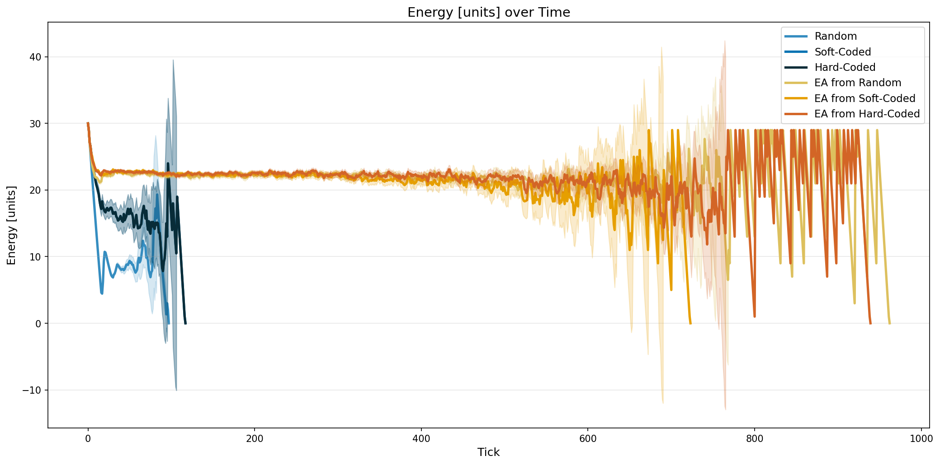

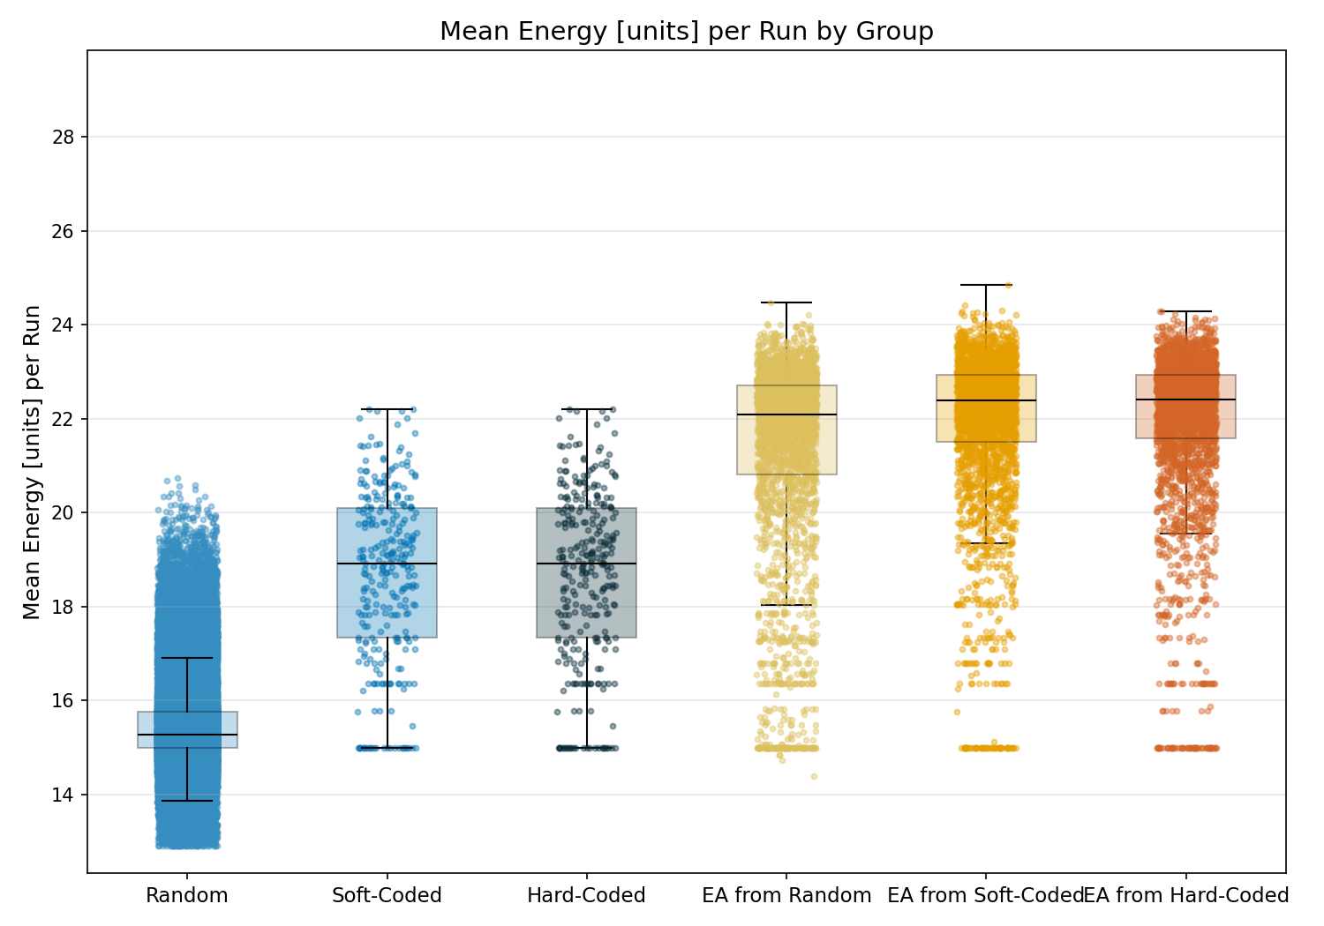

Statistic | Random | Soft-Coded | Hard-Coded | EA from Random | EA from Soft-Coded | EA from Hard-Coded
N | 78000 | 300 | 300 | 3000 | 3000 | 3000
Mean | 15.47 | 18.66 | 18.66 | 21.34 | 21.92 | 21.95
Std Dev | 0.92 | 1.83 | 1.83 | 2.12 | 1.66 | 1.66
SEM | 0.00 | 0.11 | 0.11 | 0.04 | 0.03 | 0.03
Median | 15.28 | 18.93 | 18.93 | 22.09 | 22.39 | 22.41
Min | 12.91 | 15.00 | 15.00 | 14.39 | 15.00 | 15.00
Max | 20.74 | 22.20 | 22.20 | 24.48 | 24.86 | 24.29
IQR | 0.76 | 2.75 | 2.75 | 1.90 | 1.44 | 1.36
P25 | 15.00 | 17.34 | 17.34 | 20.81 | 21.50 | 21.58
P75 | 15.76 | 20.09 | 20.09 | 22.72 | 22.94 | 22.94
Skewness | 1.208 | -0.394 | -0.394 | -1.616 | -2.071 | -2.216
Kurtosis | 2.537 | -0.580 | -0.580 | 1.901 | 4.988 | 5.651

Normality Testing (Shapiro-Wilk):
Group | W statistic | p-value
Random | 0.9016 | 2.10e-106
Soft-Coded | 0.9642 | 9.13e-07
Hard-Coded | 0.9642 | 9.13e-07
EA from Random | 0.8017 | 2.04e-51
EA from Soft-Coded | 0.7956 | 6.23e-52
EA from Hard-Coded | 0.7732 | 1.01e-53
Data is not normally distributed (alpha=0.05).

Kruskal-Wallis (omnibus test):
Test Name | Test Statistic | p-value | Epsilon-squared
Kruskal-Wallis | 23190.1719 | 0.00e+00 | 0.2647 (large)

Pairwise Post-Hoc (Mann-Whitney U (Holm-Bonferroni correction)):
Group 1 | Group 2 | Statistic | p-value | Rank-Biserial r
Random | Soft-Coded | 1965056.0000 | 0.00e+00 | 0.8320 (large)
Random | Hard-Coded | 1965056.0000 | 0.00e+00 | 0.8320 (large)
Random | EA from Random | 8163328.0000 | 0.00e+00 | 0.9302 (large)
Random | EA from Soft-Coded | 3457792.0000 | 0.00e+00 | 0.9704 (large)
Random | EA from Hard-Coded | 3649024.0000 | 0.00e+00 | 0.9688 (large)
Soft-Coded | Hard-Coded | 45000.0000 | 1.00e+00 | 0.0000 (insignificant)
Soft-Coded | EA from Random | 130126.0000 | 0.00e+00 | 0.7108 (large)
Soft-Coded | EA from Soft-Coded | 73897.5000 | 0.00e+00 | 0.8358 (large)
Soft-Coded | EA from Hard-Coded | 70868.5000 | 0.00e+00 | 0.8425 (large)
Hard-Coded | EA from Random | 130126.0000 | 0.00e+00 | 0.7108 (large)
Hard-Coded | EA from Soft-Coded | 73897.5000 | 0.00e+00 | 0.8358 (large)
Hard-Coded | EA from Hard-Coded | 70868.5000 | 0.00e+00 | 0.8425 (large)
EA from Random | EA from Soft-Coded | 3732049.0000 | 7.30e-30 | 0.1707 (small)
EA from Random | EA from Hard-Coded | 3676377.5000 | 4.82e-34 | 0.1830 (small)
EA from Soft-Coded | EA from Hard-Coded | 4450054.0000 | 9.13e-01 | 0.0111 (insignificant)

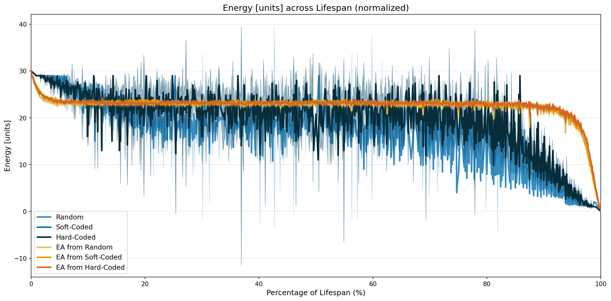

3. Genomes

3.1. Wiring

Effective Connection Strength (weight_initial × reliability)
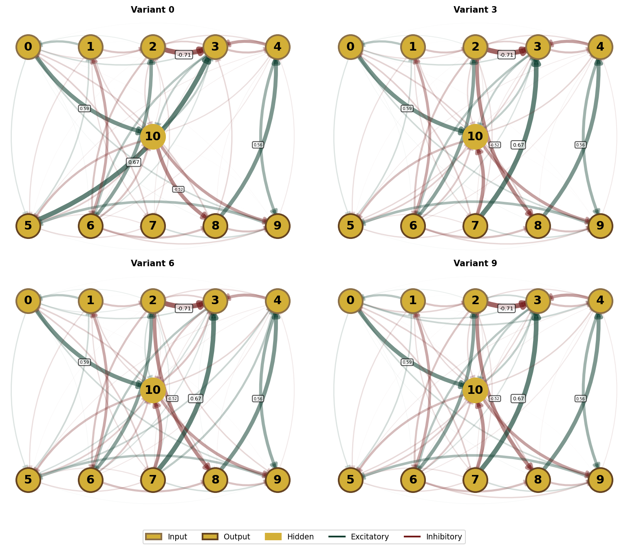

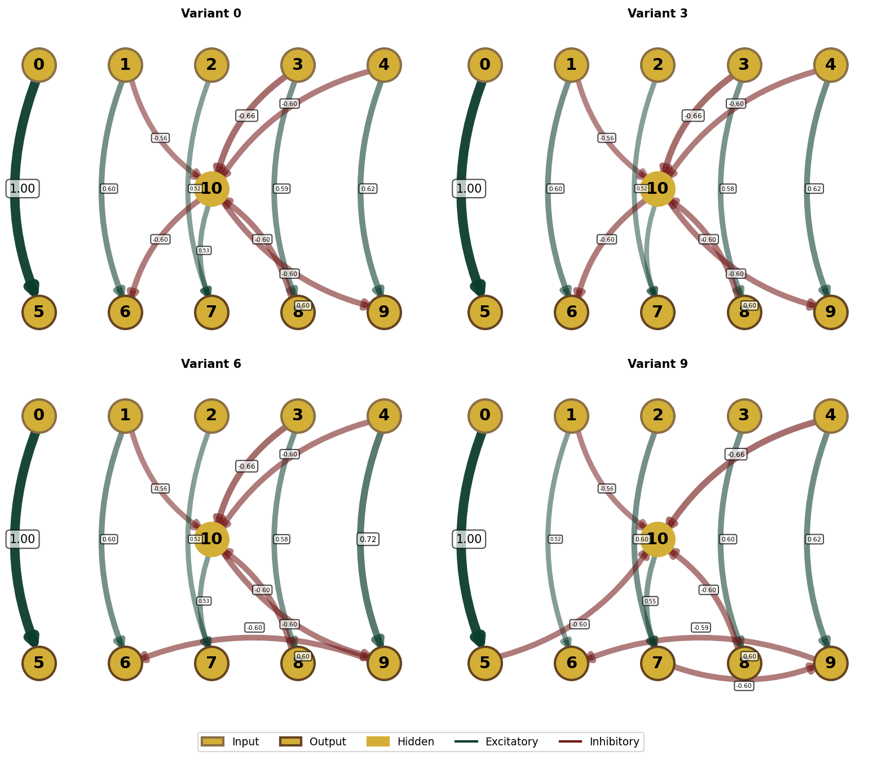

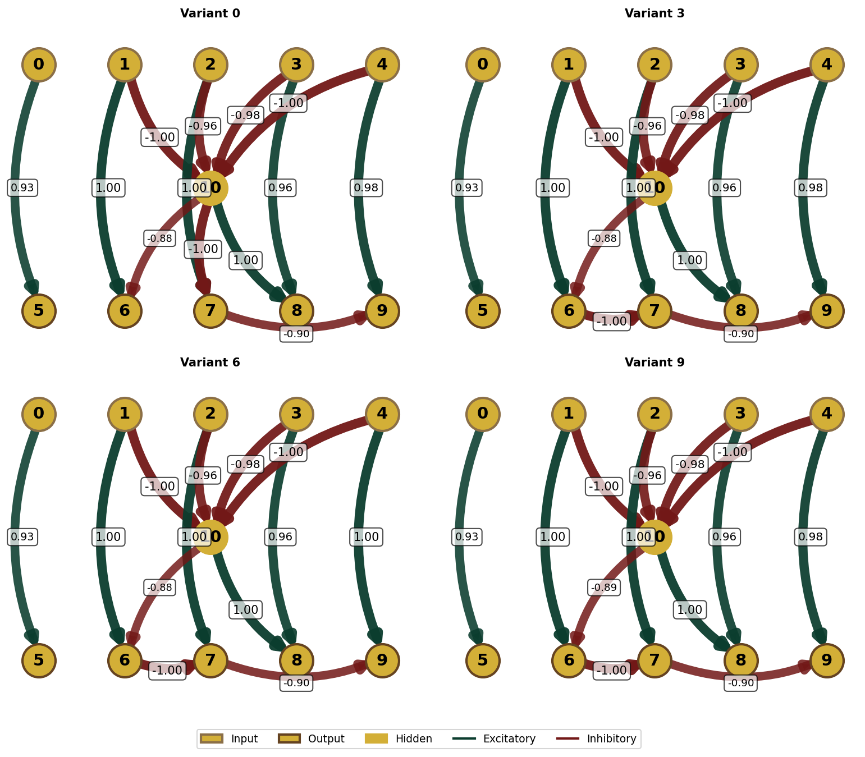

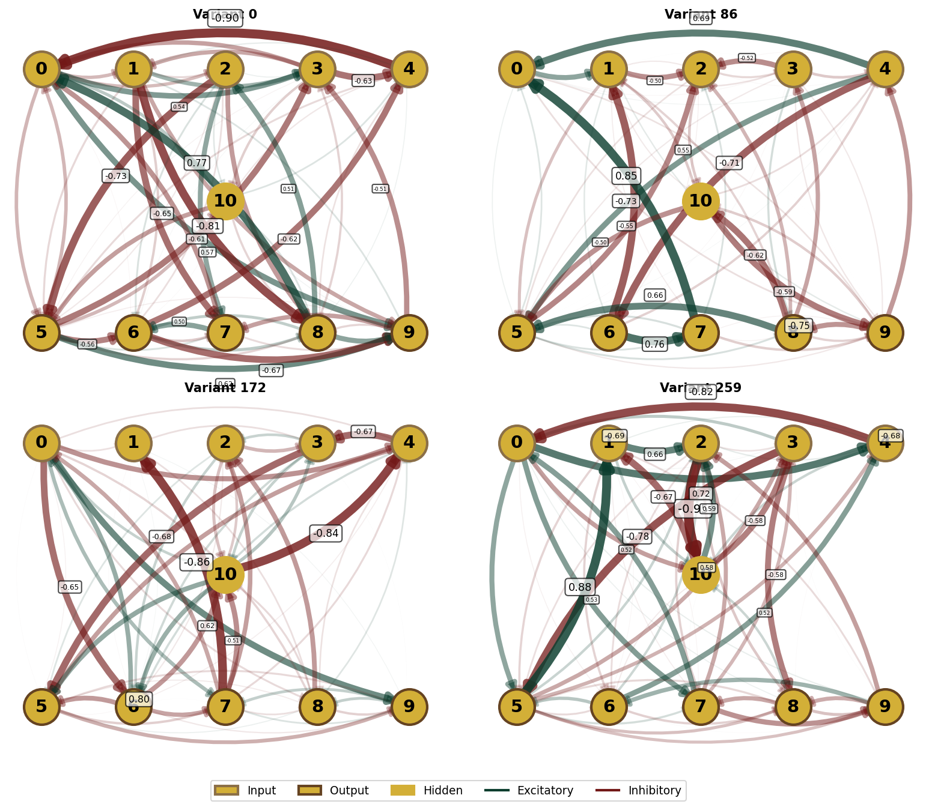

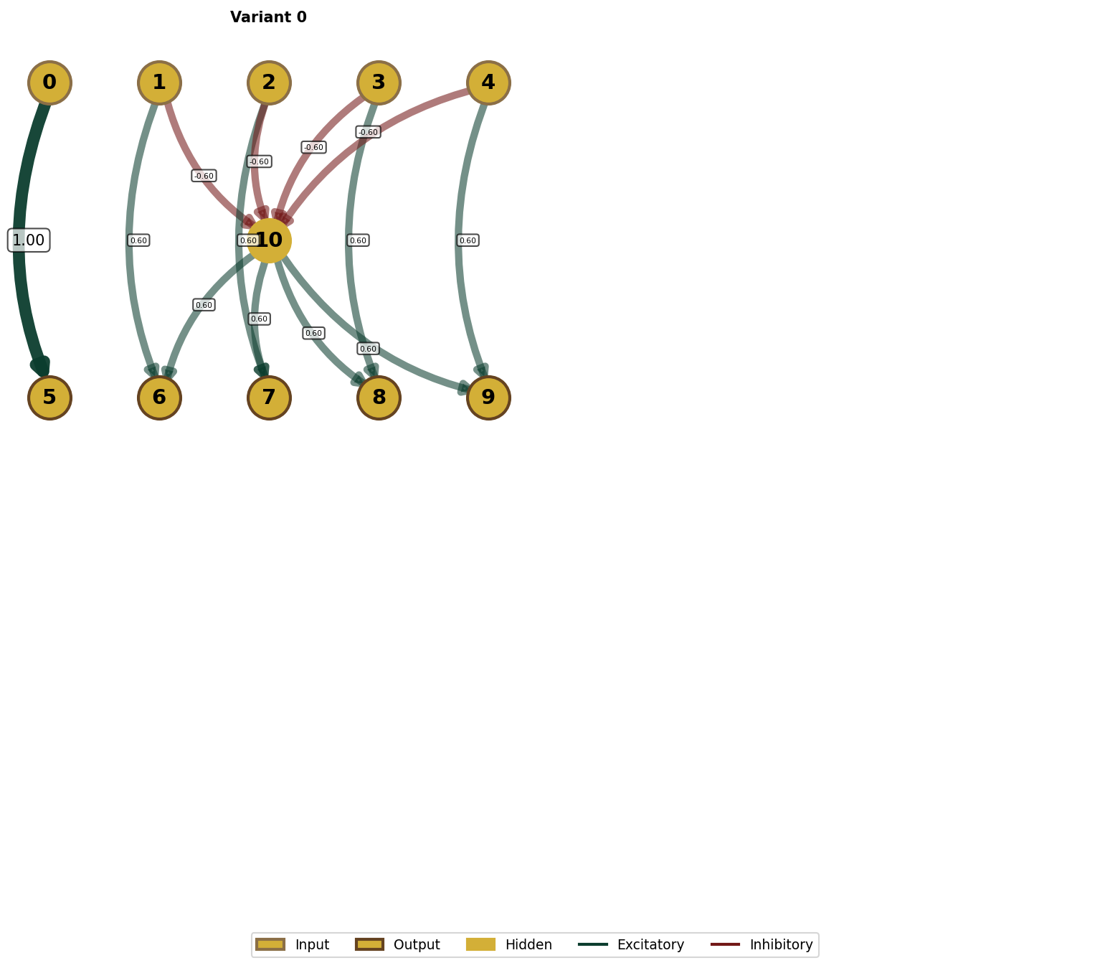

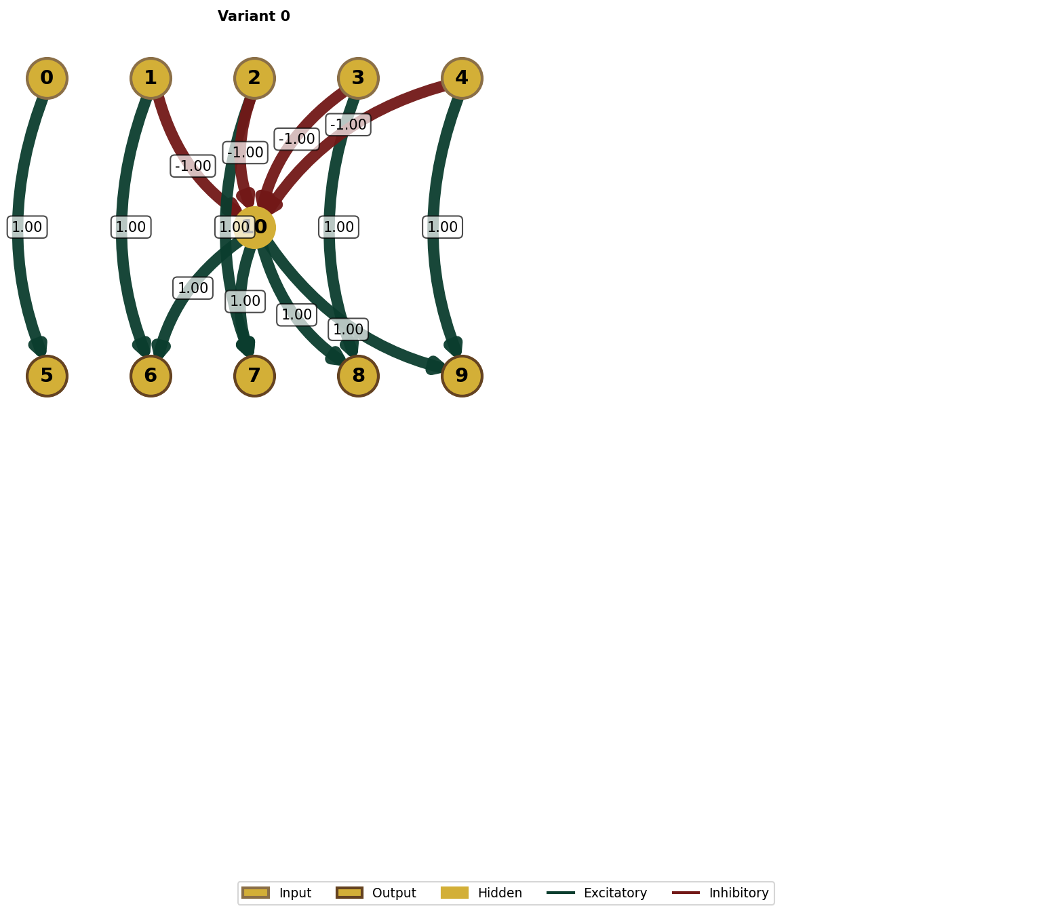

Raw Initial Weights (weight_initial)
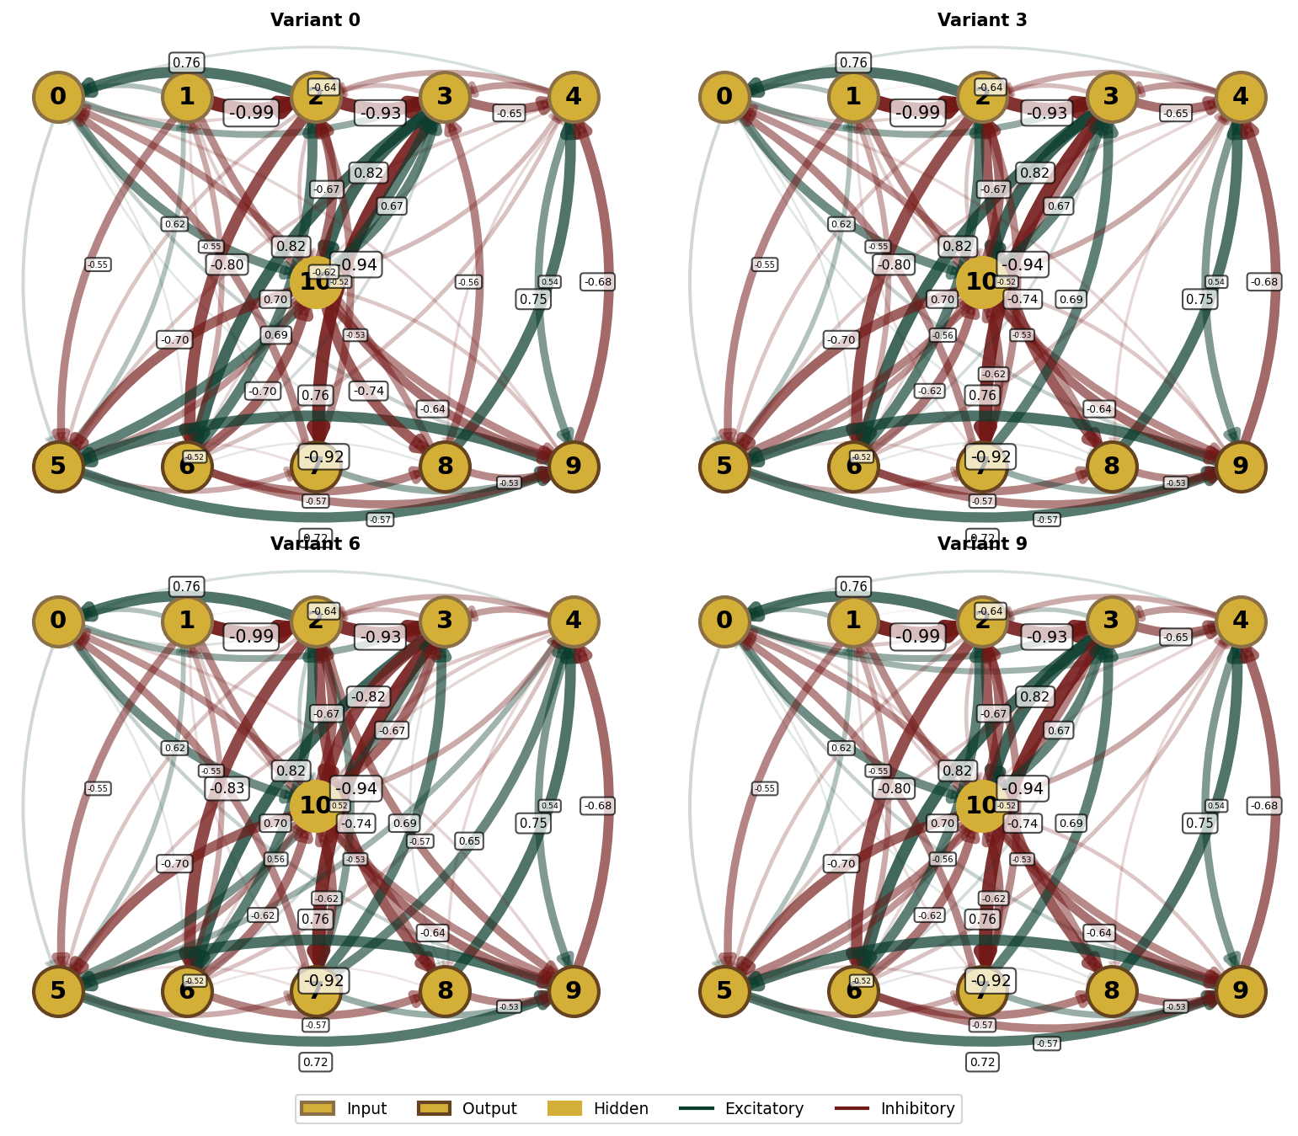

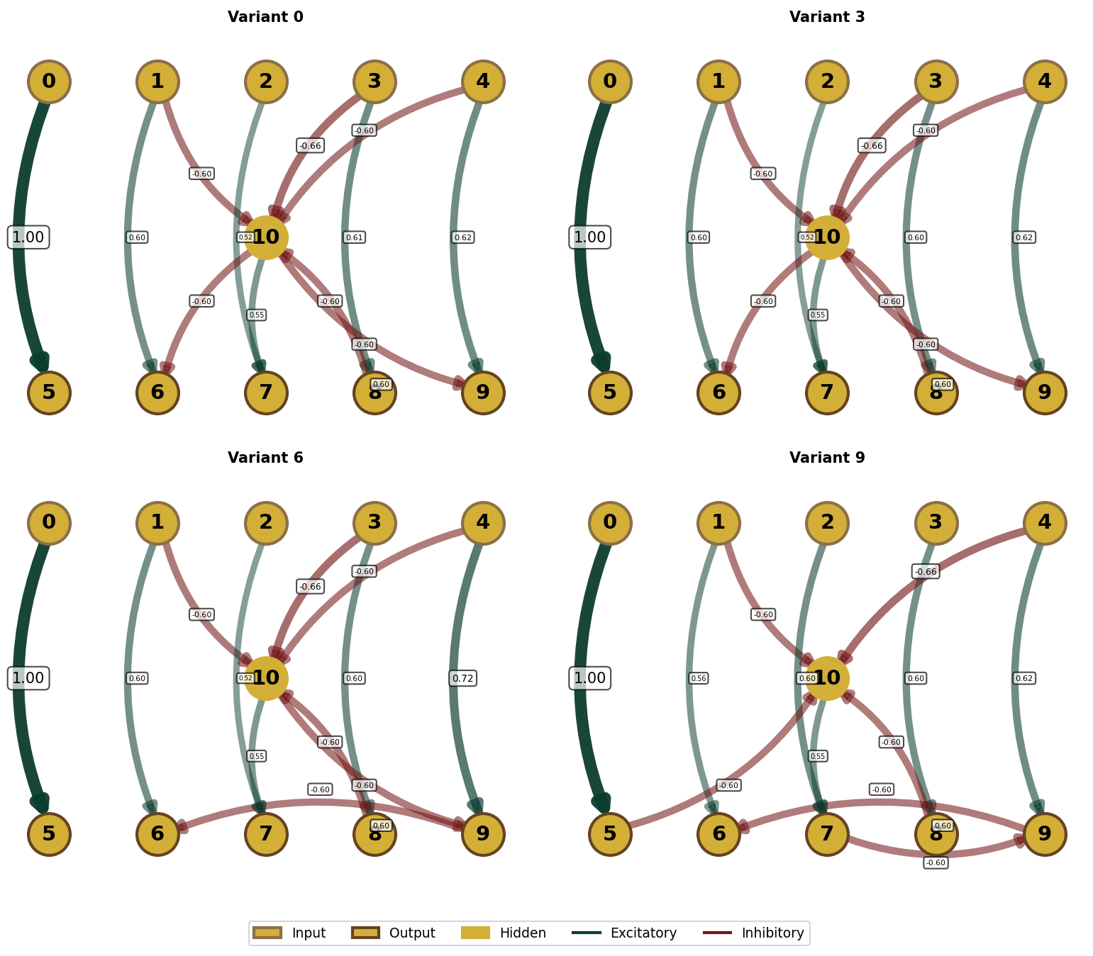

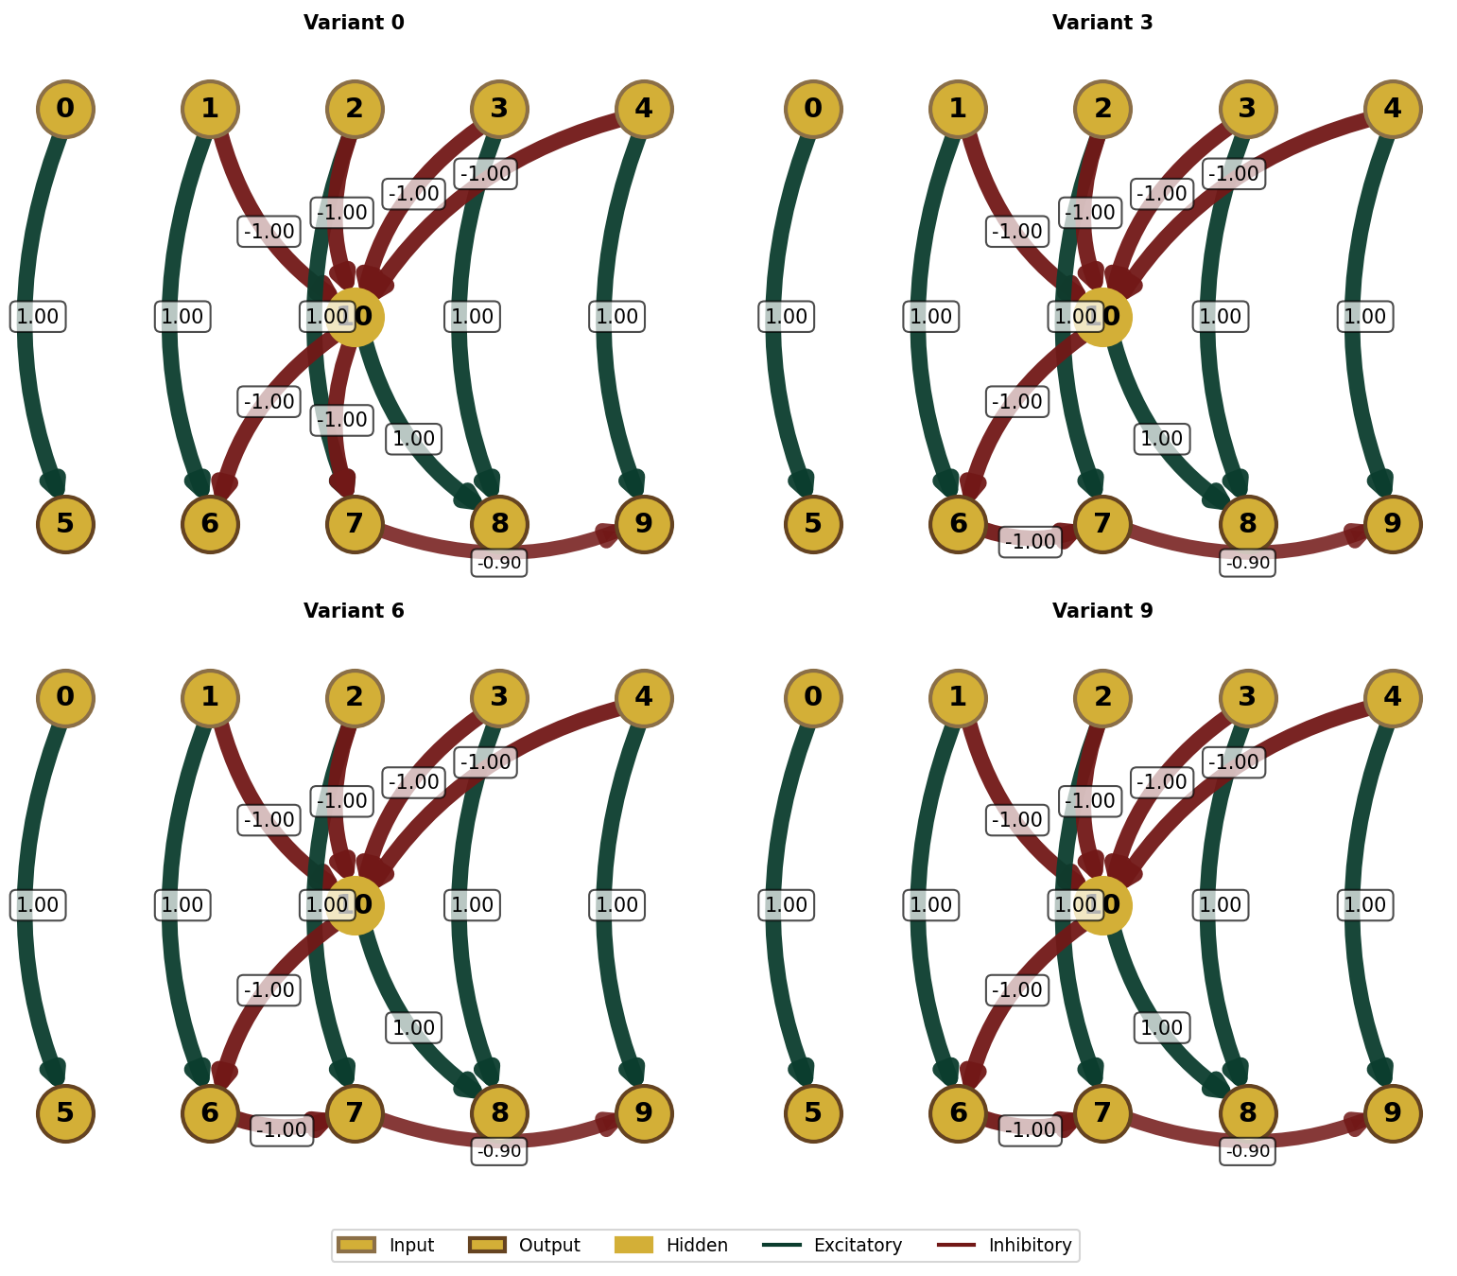

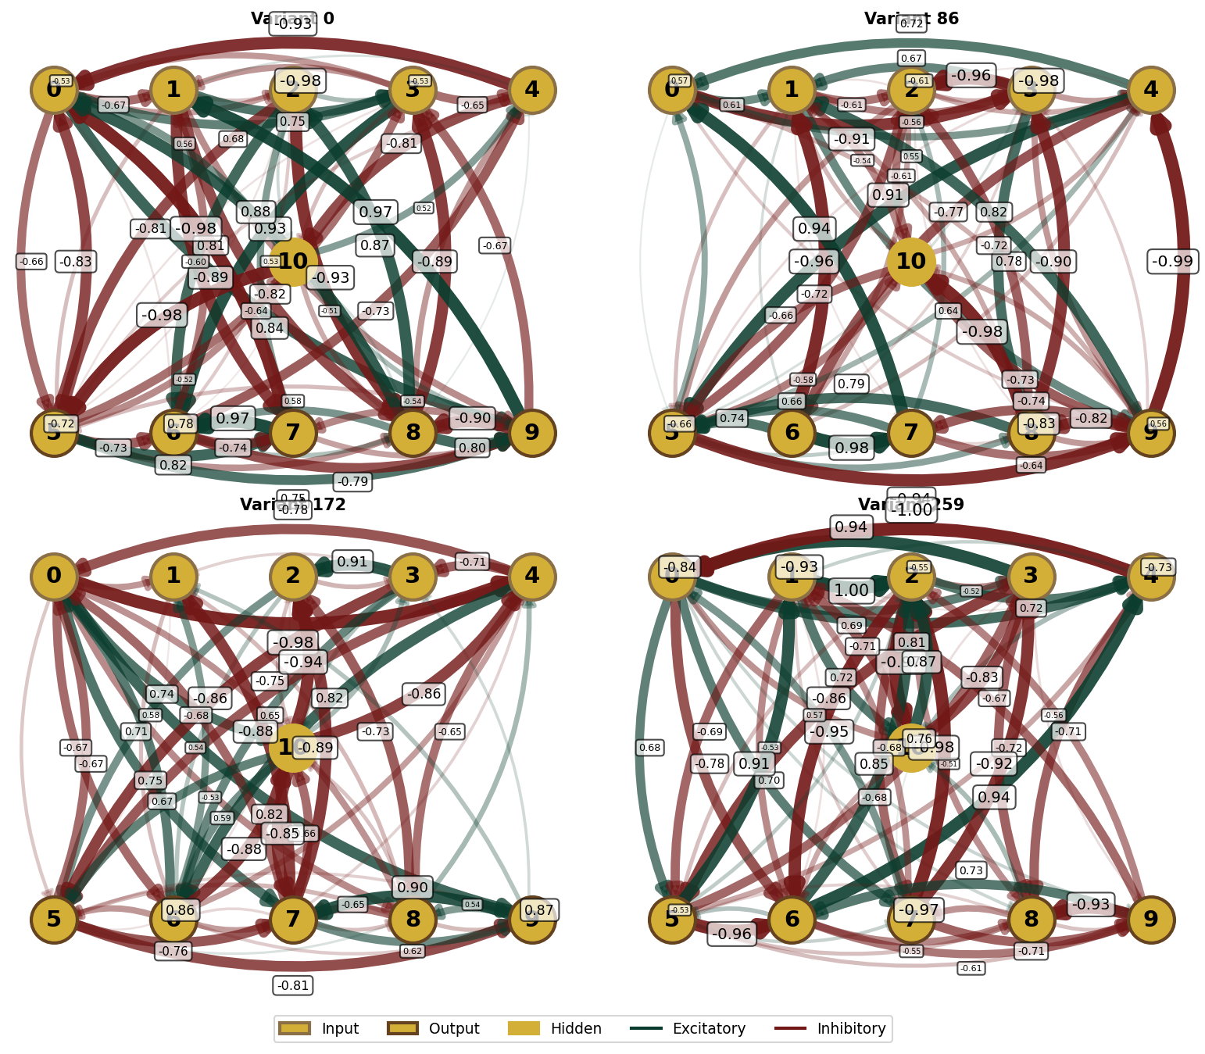

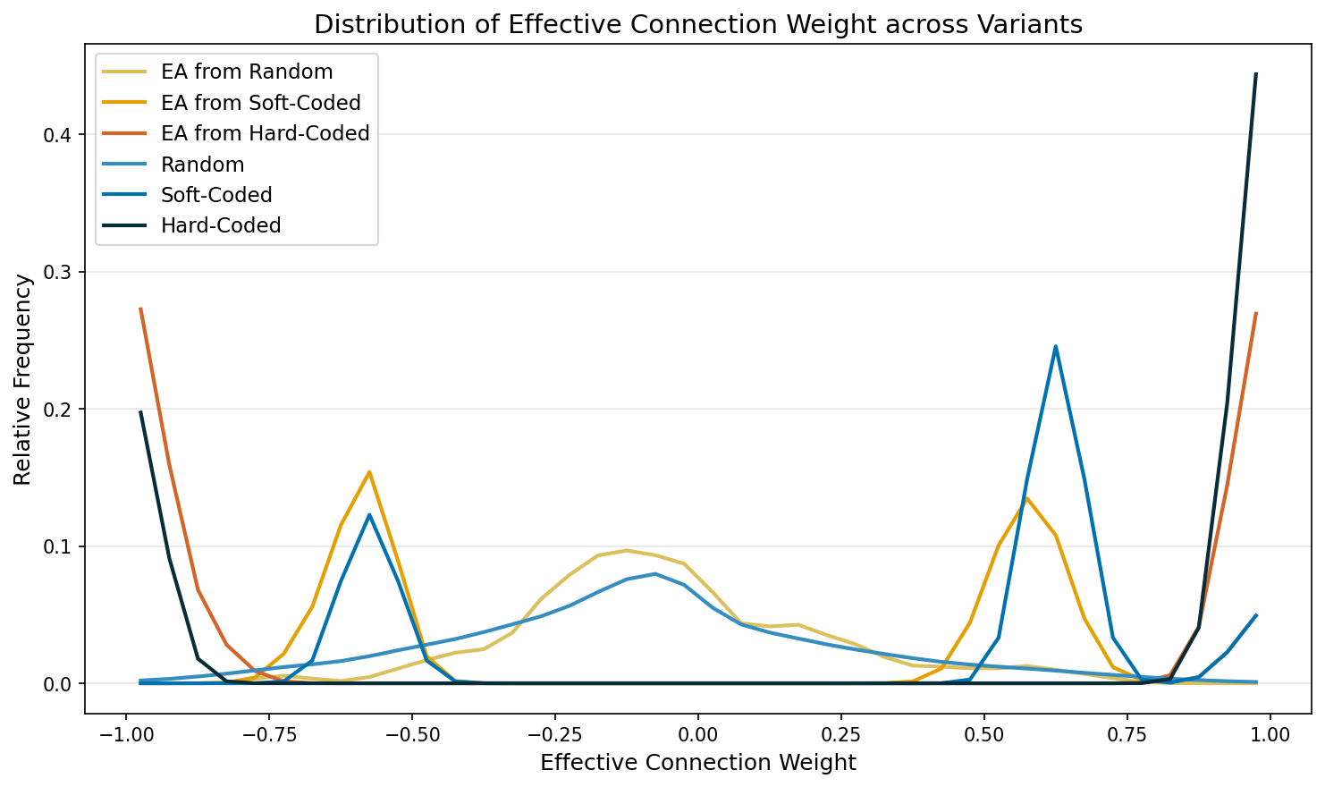

Distribution Comparison (Pairwise KS tests, Holm-Bonferroni corrected)
Group A | Group B | D (effect size) | Effect magnitude | p (raw) | p (corrected)
EA from Random | EA from Soft-Coded | 0.4891 | medium | 1.29 × 10⁻²⁴ | 1.55 × 10⁻²³ *
EA from Random | EA from Hard-Coded | 0.5385 | large | 4.36 × 10⁻³⁰ | 6.11 × 10⁻²⁹ *
EA from Random | Random | 0.1573 | small | 1.90 × 10⁻¹⁵ | 1.90 × 10⁻¹⁴ *
EA from Random | Soft-Coded | 0.6784 | large | 2.47 × 10⁻⁶ | 1.73 × 10⁻⁵ *
EA from Random | Hard-Coded | 0.6923 | large | 1.29 × 10⁻⁶ | 1.03 × 10⁻⁵ *
EA from Soft-Coded | EA from Hard-Coded | 0.5385 | large | 1.27 × 10⁻¹⁷ | 1.40 × 10⁻¹⁶ *
EA from Soft-Coded | Random | 0.4761 | medium | 2.21 × 10⁻²⁷ | 2.88 × 10⁻²⁶ *
EA from Soft-Coded | Soft-Coded | 0.4615 | medium | 0.0087 | 0.0262 *
EA from Soft-Coded | Hard-Coded | 0.6231 | large | 7.20 × 10⁻⁵ | 3.60 × 10⁻⁴ *
EA from Hard-Coded | Random | 0.5286 | large | 3.86 × 10⁻³⁴ | 5.78 × 10⁻³³ *
EA from Hard-Coded | Soft-Coded | 0.5385 | large | 0.0011 | 0.0045 *
EA from Hard-Coded | Hard-Coded | 0.4385 | medium | 0.0150 | 0.0262 *
Random | Soft-Coded | 0.6571 | large | 4.96 × 10⁻⁶ | 2.98 × 10⁻⁵ *
Random | Hard-Coded | 0.6923 | large | 9.61 × 10⁻⁷ | 8.65 × 10⁻⁶ *
Soft-Coded | Hard-Coded | 0.6154 | large | 0.0126 | 0.0262 *

Per-Variant Distributions
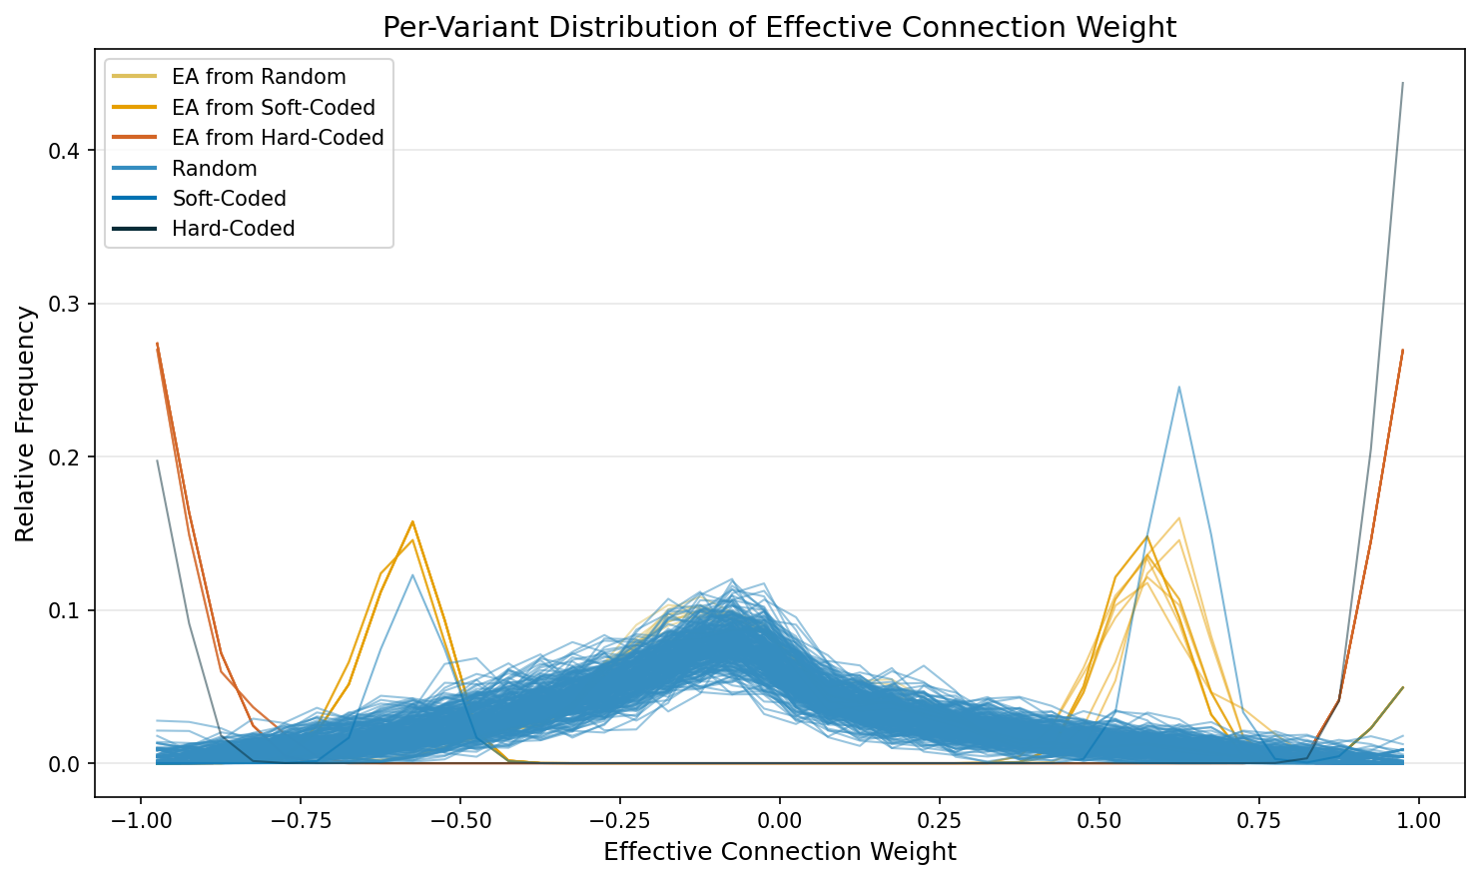

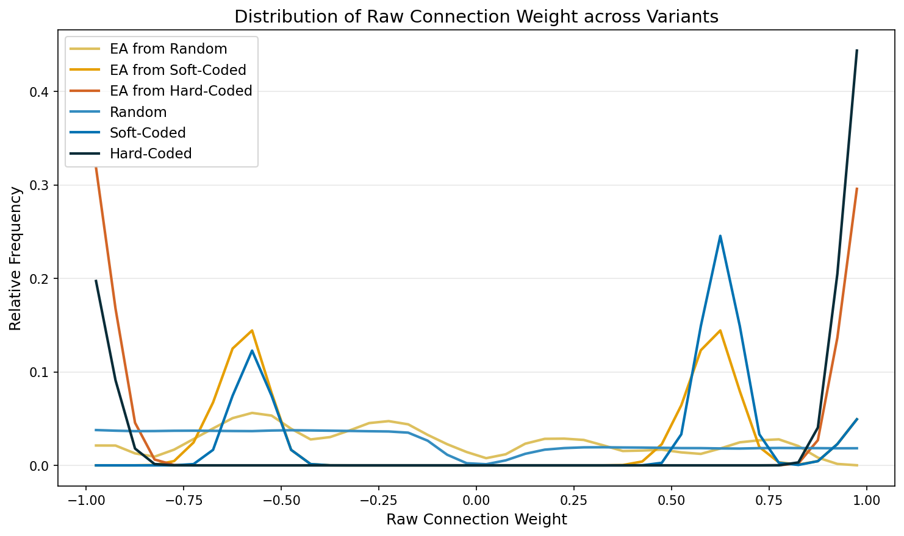

Distribution Comparison (Pairwise KS tests, Holm-Bonferroni corrected)
Group A | Group B | D (effect size) | Effect magnitude | p (raw) | p (corrected)
EA from Random | EA from Soft-Coded | 0.3857 | medium | 3.45 × 10⁻¹⁵ | 4.13 × 10⁻¹⁴ *
EA from Random | EA from Hard-Coded | 0.4829 | medium | 5.64 × 10⁻²⁴ | 7.90 × 10⁻²³ *
EA from Random | Random | 0.1319 | small | 5.68 × 10⁻¹¹ | 5.68 × 10⁻¹⁰ *
EA from Random | Soft-Coded | 0.5590 | large | 2.78 × 10⁻⁴ | 0.0017 *
EA from Random | Hard-Coded | 0.6923 | large | 1.29 × 10⁻⁶ | 1.03 × 10⁻⁵ *
EA from Soft-Coded | EA from Hard-Coded | 0.5385 | large | 1.27 × 10⁻¹⁷ | 1.66 × 10⁻¹⁶ *
EA from Soft-Coded | Random | 0.3566 | medium | 3.48 × 10⁻¹⁵ | 4.13 × 10⁻¹⁴ *
EA from Soft-Coded | Soft-Coded | 0.3077 | medium | 0.1800 | 0.3599
EA from Soft-Coded | Hard-Coded | 0.6231 | large | 7.20 × 10⁻⁵ | 5.04 × 10⁻⁴ *
EA from Hard-Coded | Random | 0.4657 | medium | 3.79 × 10⁻²⁶ | 5.68 × 10⁻²⁵ *
EA from Hard-Coded | Soft-Coded | 0.5385 | large | 0.0011 | 0.0045 *
EA from Hard-Coded | Hard-Coded | 0.2308 | small | 0.4991 | 0.4991
Random | Soft-Coded | 0.5462 | large | 3.65 × 10⁻⁴ | 0.0018 *
Random | Hard-Coded | 0.6923 | large | 9.61 × 10⁻⁷ | 8.65 × 10⁻⁶ *
Soft-Coded | Hard-Coded | 0.6154 | large | 0.0126 | 0.0379 *

Per-Variant Distributions
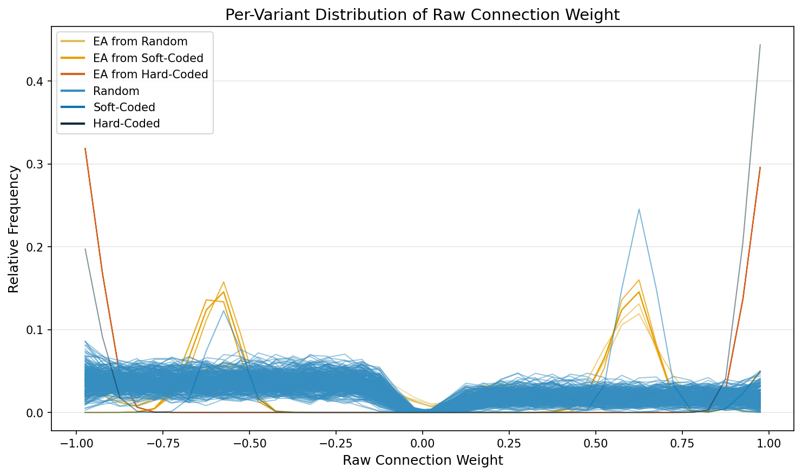

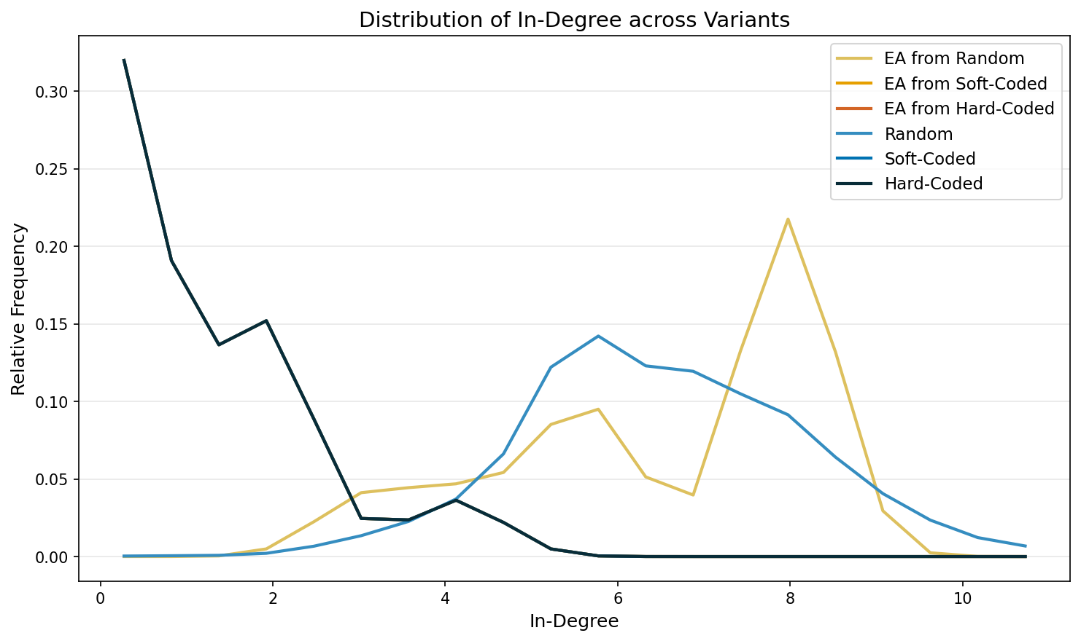

Distribution Comparison (Pairwise KS tests, Holm-Bonferroni corrected)
Group A | Group B | D (effect size) | Effect magnitude | p (raw) | p (corrected)
EA from Random | EA from Soft-Coded | 0.9091 | large | 1.31 × 10⁻⁴⁸ | 1.71 × 10⁻⁴⁷ *
EA from Random | EA from Hard-Coded | 0.9091 | large | 1.31 × 10⁻⁴⁸ | 1.71 × 10⁻⁴⁷ *
EA from Random | Random | 0.2647 | small | 4.97 × 10⁻⁷ | 3.48 × 10⁻⁶ *
EA from Random | Soft-Coded | 0.9091 | large | 5.53 × 10⁻¹⁰ | 4.97 × 10⁻⁹ *
EA from Random | Hard-Coded | 0.9091 | large | 5.53 × 10⁻¹⁰ | 4.97 × 10⁻⁹ *
EA from Soft-Coded | EA from Hard-Coded | 0.0000 | negligible | 1.0000 | 1.0000
EA from Soft-Coded | Random | 0.9066 | large | 8.32 × 10⁻¹⁰⁶ | 1.25 × 10⁻¹⁰⁴ *
EA from Soft-Coded | Soft-Coded | 0.0000 | negligible | 1.0000 | 1.0000
EA from Soft-Coded | Hard-Coded | 0.0000 | negligible | 1.0000 | 1.0000
EA from Hard-Coded | Random | 0.9066 | large | 8.32 × 10⁻¹⁰⁶ | 1.25 × 10⁻¹⁰⁴ *
EA from Hard-Coded | Soft-Coded | 0.0000 | negligible | 1.0000 | 1.0000
EA from Hard-Coded | Hard-Coded | 0.0000 | negligible | 1.0000 | 1.0000
Random | Soft-Coded | 0.9066 | large | 1.17 × 10⁻¹¹ | 1.29 × 10⁻¹⁰ *
Random | Hard-Coded | 0.9066 | large | 1.17 × 10⁻¹¹ | 1.29 × 10⁻¹⁰ *
Soft-Coded | Hard-Coded | 0.0000 | negligible | 1.0000 | 1.0000

Per-Variant Distributions
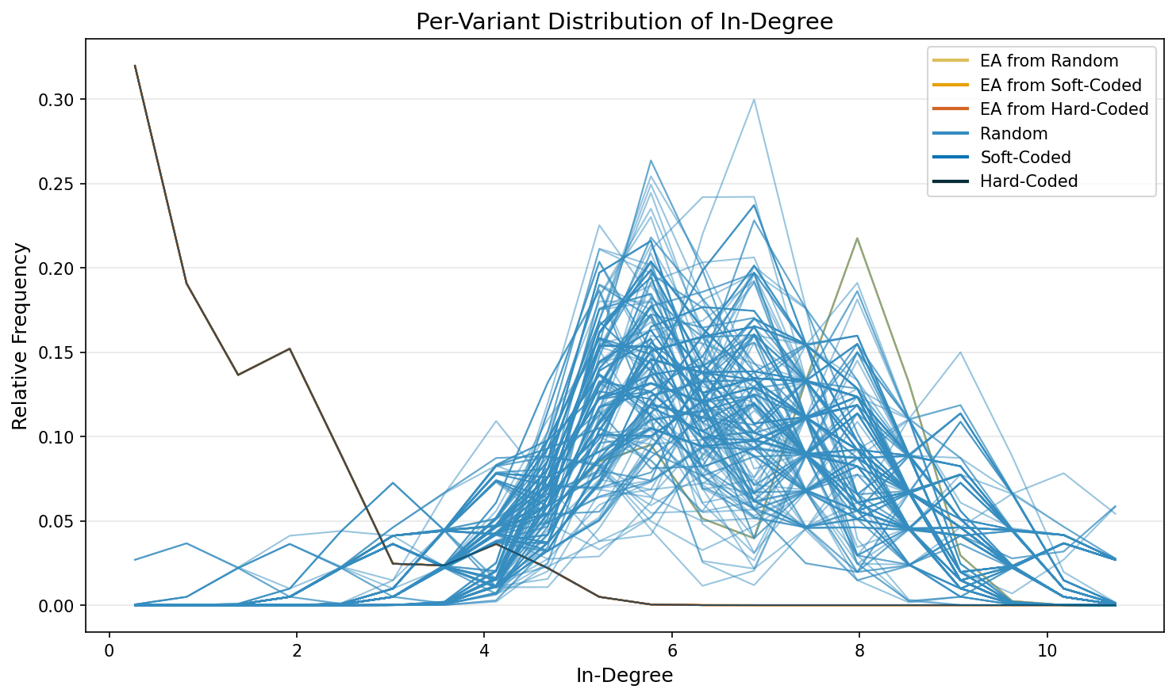

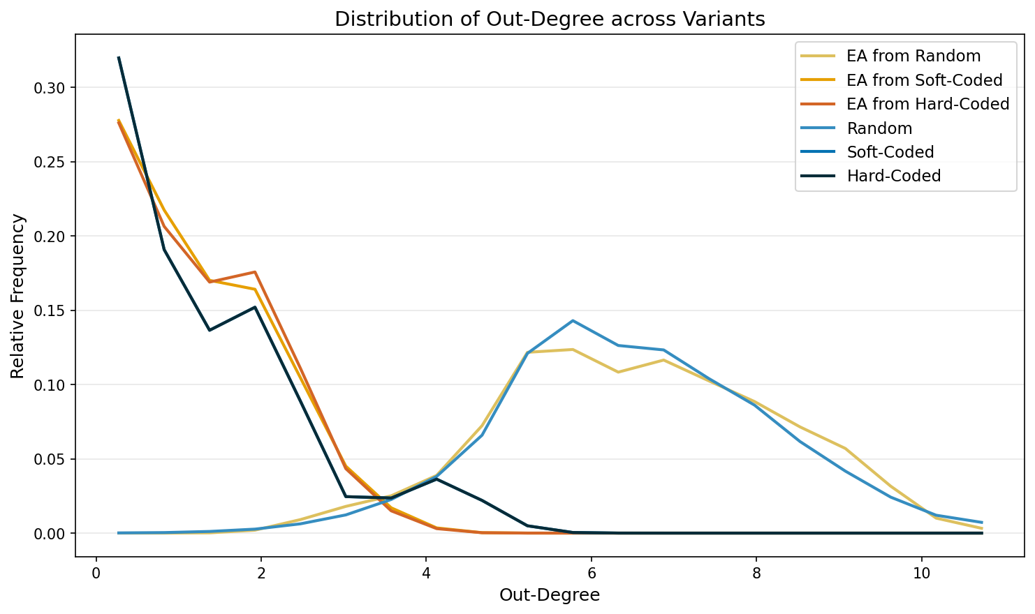

Distribution Comparison (Pairwise KS tests, Holm-Bonferroni corrected)
Group A | Group B | D (effect size) | Effect magnitude | p (raw) | p (corrected)
EA from Random | EA from Soft-Coded | 0.9636 | large | 2.10 × 10⁻⁵⁷ | 2.73 × 10⁻⁵⁶ *
EA from Random | EA from Hard-Coded | 0.9636 | large | 2.10 × 10⁻⁵⁷ | 2.73 × 10⁻⁵⁶ *
EA from Random | Random | 0.0552 | negligible | 0.8865 | 1.0000
EA from Random | Soft-Coded | 0.9091 | large | 5.53 × 10⁻¹⁰ | 4.97 × 10⁻⁹ *
EA from Random | Hard-Coded | 0.9091 | large | 5.53 × 10⁻¹⁰ | 4.97 × 10⁻⁹ *
EA from Soft-Coded | EA from Hard-Coded | 0.0273 | negligible | 1.0000 | 1.0000
EA from Soft-Coded | Random | 0.9752 | large | 6.55 × 10⁻¹⁵² | 9.83 × 10⁻¹⁵¹ *
EA from Soft-Coded | Soft-Coded | 0.1455 | small | 0.9697 | 1.0000
EA from Soft-Coded | Hard-Coded | 0.1455 | small | 0.9697 | 1.0000
EA from Hard-Coded | Random | 0.9752 | large | 6.55 × 10⁻¹⁵² | 9.83 × 10⁻¹⁵¹ *
EA from Hard-Coded | Soft-Coded | 0.1273 | small | 0.9922 | 1.0000
EA from Hard-Coded | Hard-Coded | 0.1273 | small | 0.9922 | 1.0000
Random | Soft-Coded | 0.9052 | large | 1.37 × 10⁻¹¹ | 1.51 × 10⁻¹⁰ *
Random | Hard-Coded | 0.9052 | large | 1.37 × 10⁻¹¹ | 1.51 × 10⁻¹⁰ *
Soft-Coded | Hard-Coded | 0.0000 | negligible | 1.0000 | 1.0000

Per-Variant Distributions
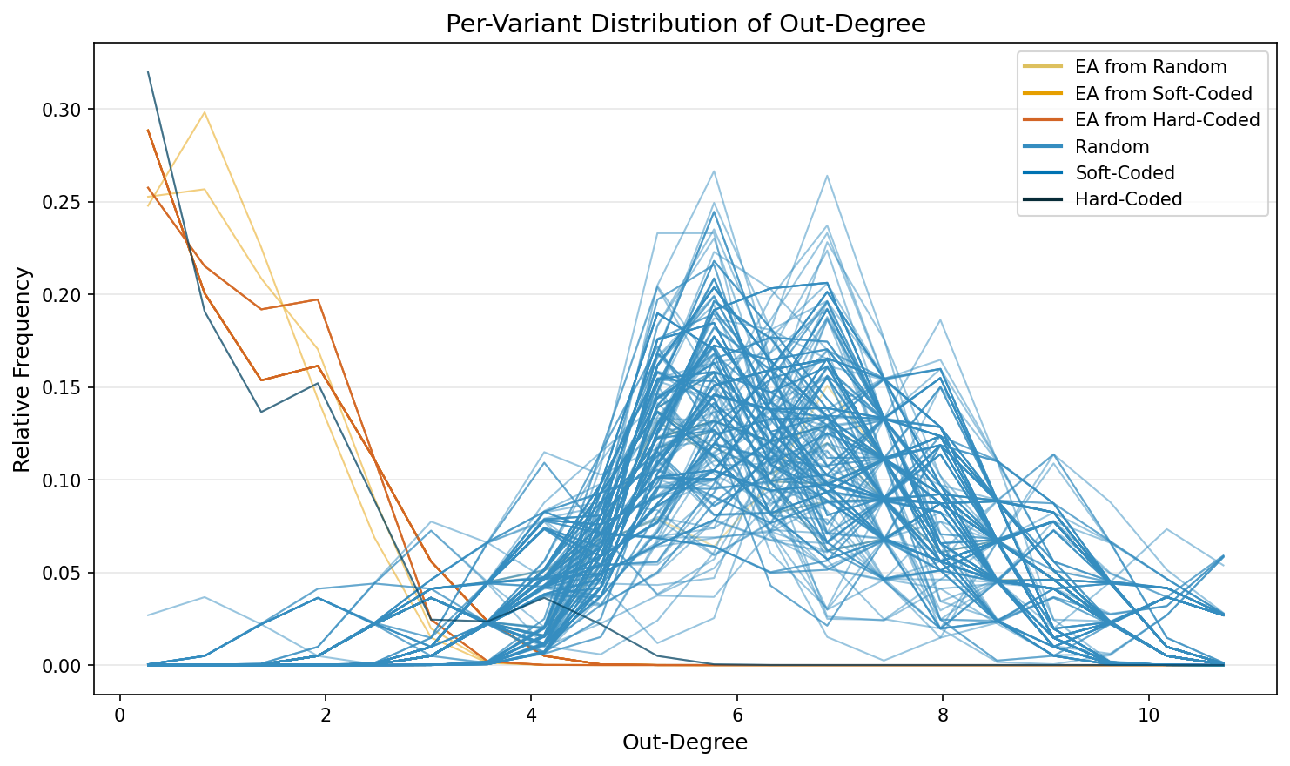

3.2. Tonic Activation
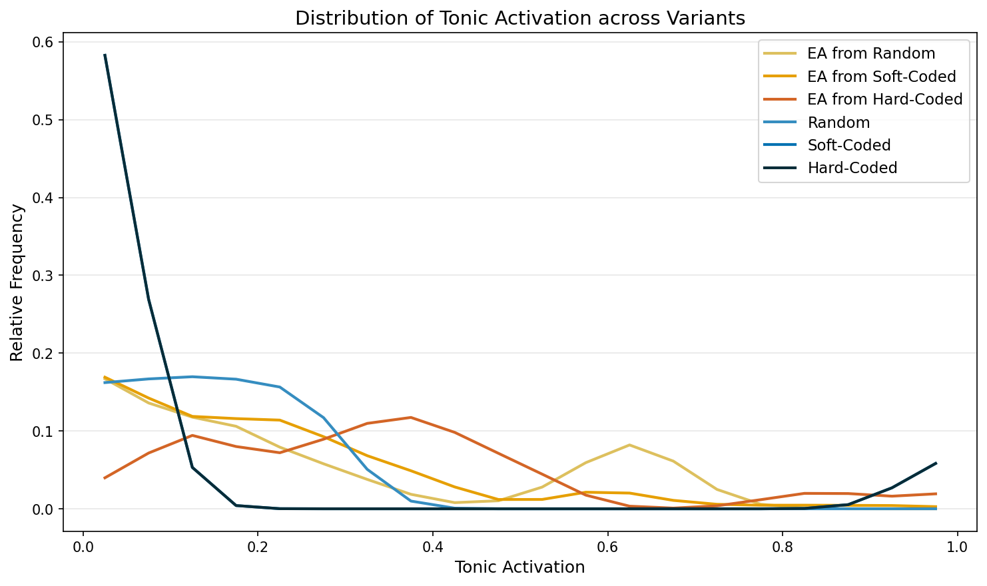

Distribution Comparison (Pairwise KS tests, Holm-Bonferroni corrected)
Group A | Group B | D (effect size) | Effect magnitude | p (raw) | p (corrected)
EA from Random | EA from Soft-Coded | 0.1818 | small | 0.0525 | 0.1050
EA from Random | EA from Hard-Coded | 0.2818 | small | 2.97 × 10⁻⁴ | 8.91 × 10⁻⁴ *
EA from Random | Random | 0.3182 | medium | 5.09 × 10⁻¹⁰ | 6.10 × 10⁻⁹ *
EA from Random | Soft-Coded | 0.7636 | large | 2.07 × 10⁻⁶ | 1.24 × 10⁻⁵ *
EA from Random | Hard-Coded | 0.7636 | large | 2.07 × 10⁻⁶ | 1.24 × 10⁻⁵ *
EA from Soft-Coded | EA from Hard-Coded | 0.3545 | medium | 1.56 × 10⁻⁶ | 1.09 × 10⁻⁵ *
EA from Soft-Coded | Random | 0.2399 | small | 7.70 × 10⁻⁶ | 3.08 × 10⁻⁵ *
EA from Soft-Coded | Soft-Coded | 0.8091 | large | 2.51 × 10⁻⁷ | 2.26 × 10⁻⁶ *
EA from Soft-Coded | Hard-Coded | 0.8091 | large | 2.51 × 10⁻⁷ | 2.26 × 10⁻⁶ *
EA from Hard-Coded | Random | 0.5608 | large | 8.26 × 10⁻³² | 1.24 × 10⁻³⁰ *
EA from Hard-Coded | Soft-Coded | 0.8909 | large | 2.13 × 10⁻⁹ | 2.34 × 10⁻⁸ *
EA from Hard-Coded | Hard-Coded | 0.8909 | large | 2.13 × 10⁻⁹ | 2.34 × 10⁻⁸ *
Random | Soft-Coded | 0.9091 | large | 8.80 × 10⁻¹² | 1.23 × 10⁻¹⁰ *
Random | Hard-Coded | 0.9091 | large | 8.80 × 10⁻¹² | 1.23 × 10⁻¹⁰ *
Soft-Coded | Hard-Coded | 0.0000 | negligible | 1.0000 | 1.0000

Per-Variant Distributions
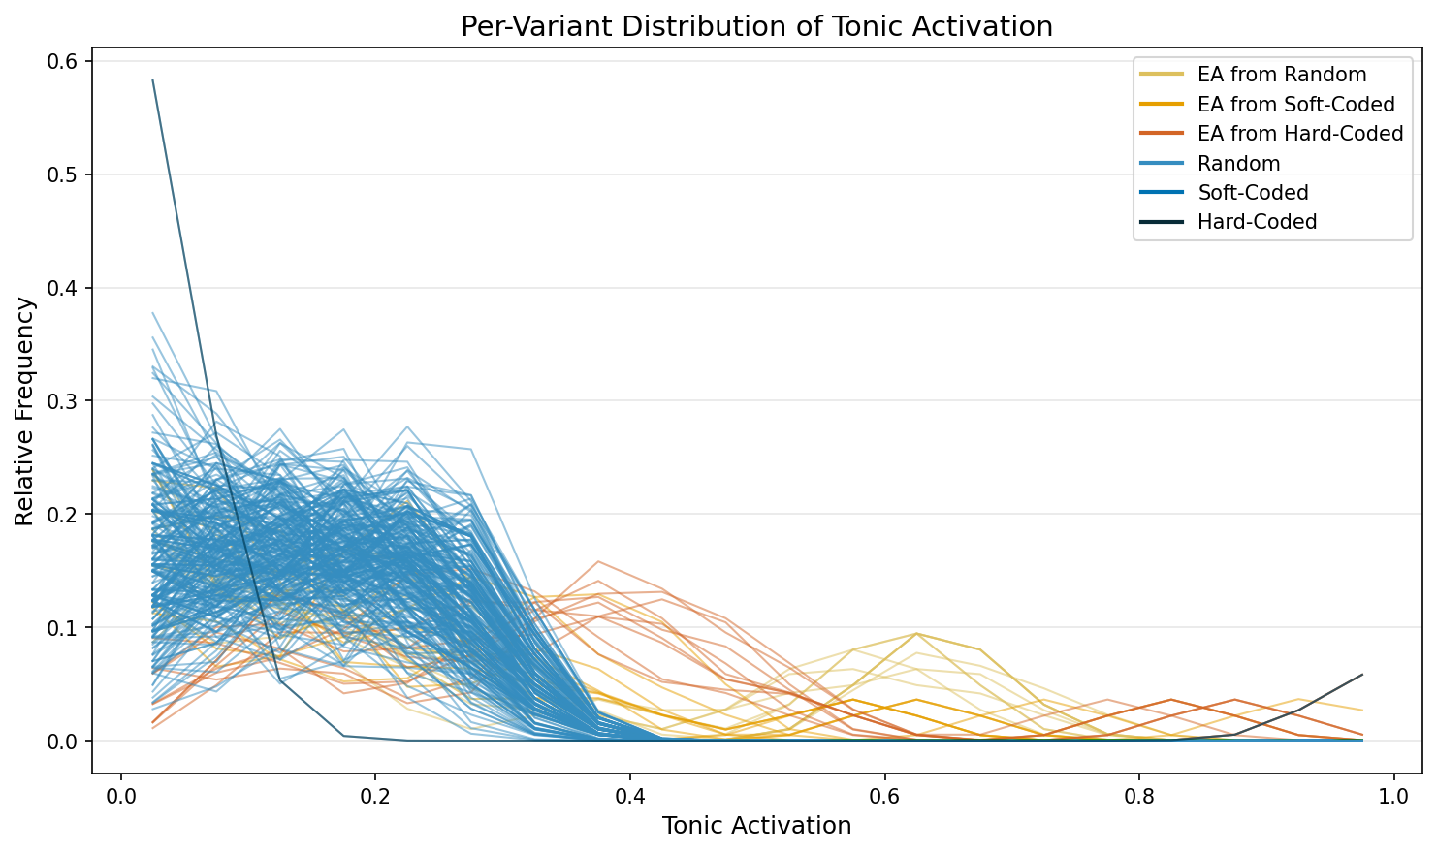

3.3. Plasticity
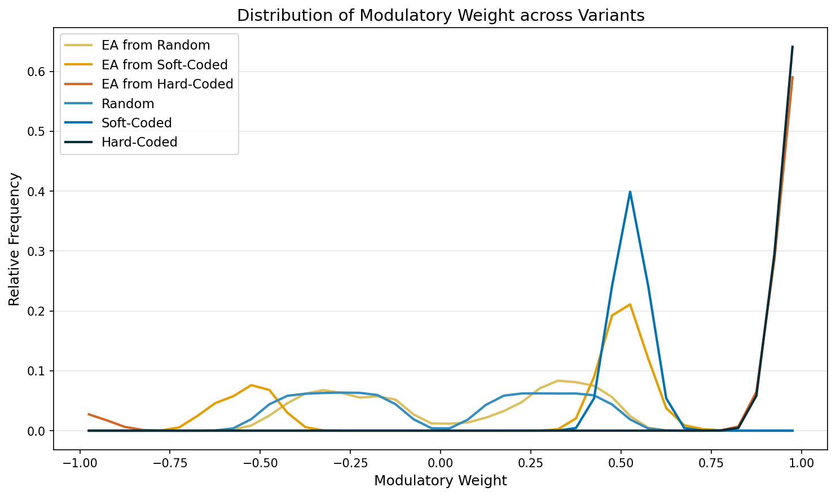

Distribution Comparison (Pairwise KS tests, Holm-Bonferroni corrected)
Group A | Group B | D (effect size) | Effect magnitude | p (raw) | p (corrected)
EA from Random | EA from Soft-Coded | 0.5868 | large | 3.92 × 10⁻³⁰ | 3.53 × 10⁻²⁹ *
EA from Random | EA from Hard-Coded | 0.9483 | large | 5.02 × 10⁻⁶⁴ | 6.02 × 10⁻⁶³ *
EA from Random | Random | 0.1105 | small | 2.28 × 10⁻⁹ | 9.14 × 10⁻⁹ *
EA from Random | Soft-Coded | 0.9988 | large | 6.58 × 10⁻²⁶ | 4.60 × 10⁻²⁵ *
EA from Random | Hard-Coded | 1.0000 | large | 5.06 × 10⁻²⁷ | 4.05 × 10⁻²⁶ *
EA from Soft-Coded | EA from Hard-Coded | 0.9483 | large | 1.04 × 10⁻³⁷ | 1.04 × 10⁻³⁶ *
EA from Soft-Coded | Random | 0.6174 | large | 5.74 × 10⁻³⁸ | 6.31 × 10⁻³⁷ *
EA from Soft-Coded | Soft-Coded | 0.5980 | large | 3.82 × 10⁻⁴ | 7.65 × 10⁻⁴ *
EA from Soft-Coded | Hard-Coded | 1.0000 | large | 3.62 × 10⁻¹⁶ | 2.17 × 10⁻¹⁵ *
EA from Hard-Coded | Random | 0.9483 | large | 4.96 × 10⁻⁷⁵ | 6.44 × 10⁻⁷⁴ *
EA from Hard-Coded | Soft-Coded | 0.9483 | large | 8.55 × 10⁻¹¹ | 4.28 × 10⁻¹⁰ *
EA from Hard-Coded | Hard-Coded | 0.1724 | small | 0.8797 | 0.8797
Random | Soft-Coded | 1.0000 | large | < 10⁻³⁰⁰ | < 10⁻³⁰⁰ *
Random | Hard-Coded | 1.0000 | large | < 10⁻³⁰⁰ | < 10⁻³⁰⁰ *
Soft-Coded | Hard-Coded | 1.0000 | large | 7.40 × 10⁻⁷ | 2.22 × 10⁻⁶ *

Per-Variant Distributions
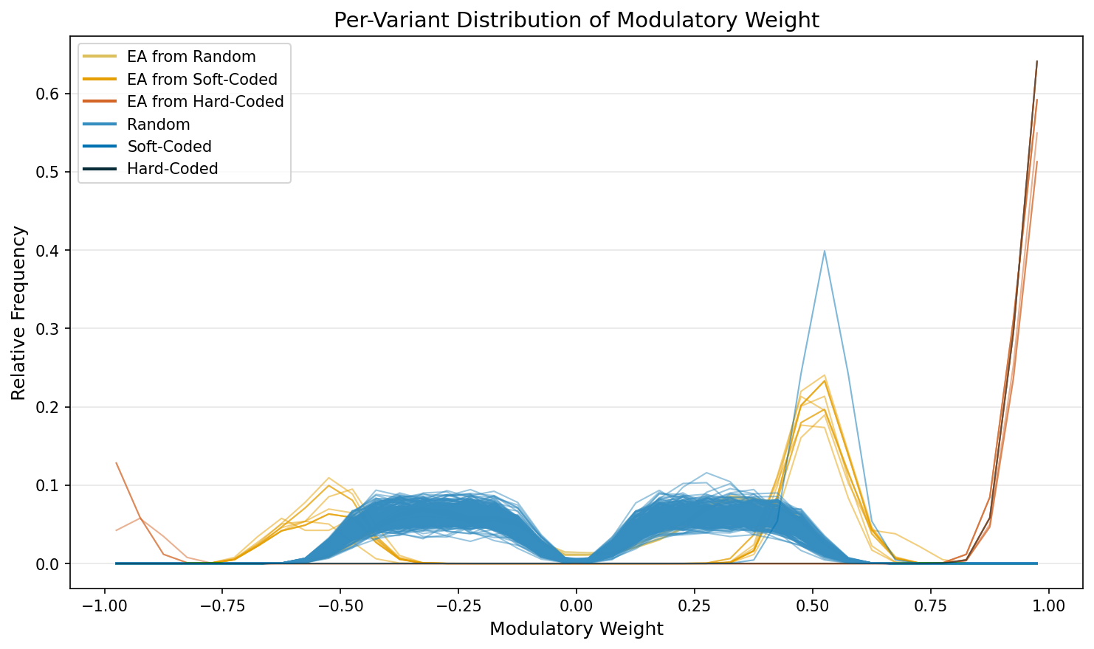

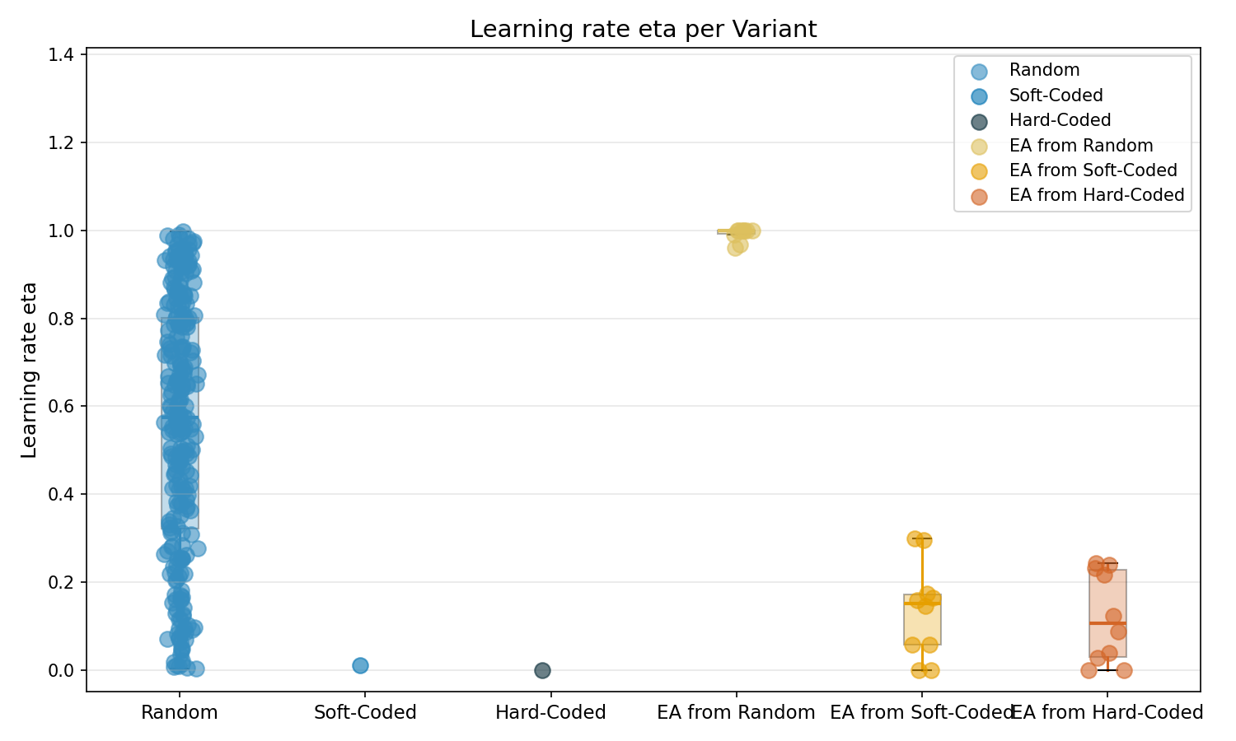

Statistical Comparison of Learning rate eta
Kruskal-Wallis: p = 8.63 × 10⁻¹³, Ordinal Epsilon-squared ε²R = 0.2117

Pairwise Comparisons (Holm-Bonferroni corrected)
Group A | Group B | Rank-Biserial r | p (raw) | p (corrected)
Random | Soft-Coded | -0.9692 | 0.0383 | 0.3448
Random | Hard-Coded | -1.0000 | 0.0077 | 0.0766
Random | EA from Random | 0.9838 | 1.32 × 10⁻⁷ | 1.98 × 10⁻⁶ *
Random | EA from Soft-Coded | -0.7800 | 2.88 × 10⁻⁵ | 3.75 × 10⁻⁴ *
Random | EA from Hard-Coded | -0.8069 | 1.51 × 10⁻⁵ | 2.12 × 10⁻⁴ *
Soft-Coded | Hard-Coded | -1.0000 | 1.0000 | 1.0000
Soft-Coded | EA from Random | 1.0000 | 0.0993 | 0.7945
Soft-Coded | EA from Soft-Coded | 0.6000 | 0.4281 | 1.0000
Soft-Coded | EA from Hard-Coded | 0.6000 | 0.4281 | 1.0000
Hard-Coded | EA from Random | 1.0000 | 0.0993 | 0.7945
Hard-Coded | EA from Soft-Coded | 0.8000 | 0.2640 | 1.0000
Hard-Coded | EA from Hard-Coded | 0.8000 | 0.2640 | 1.0000
EA from Random | EA from Soft-Coded | -1.0000 | 1.31 × 10⁻⁴ | 0.0016 *
EA from Random | EA from Hard-Coded | -1.0000 | 1.31 × 10⁻⁴ | 0.0016 *
EA from Soft-Coded | EA from Hard-Coded | -0.0800 | 0.7906 | 1.0000

4. Food
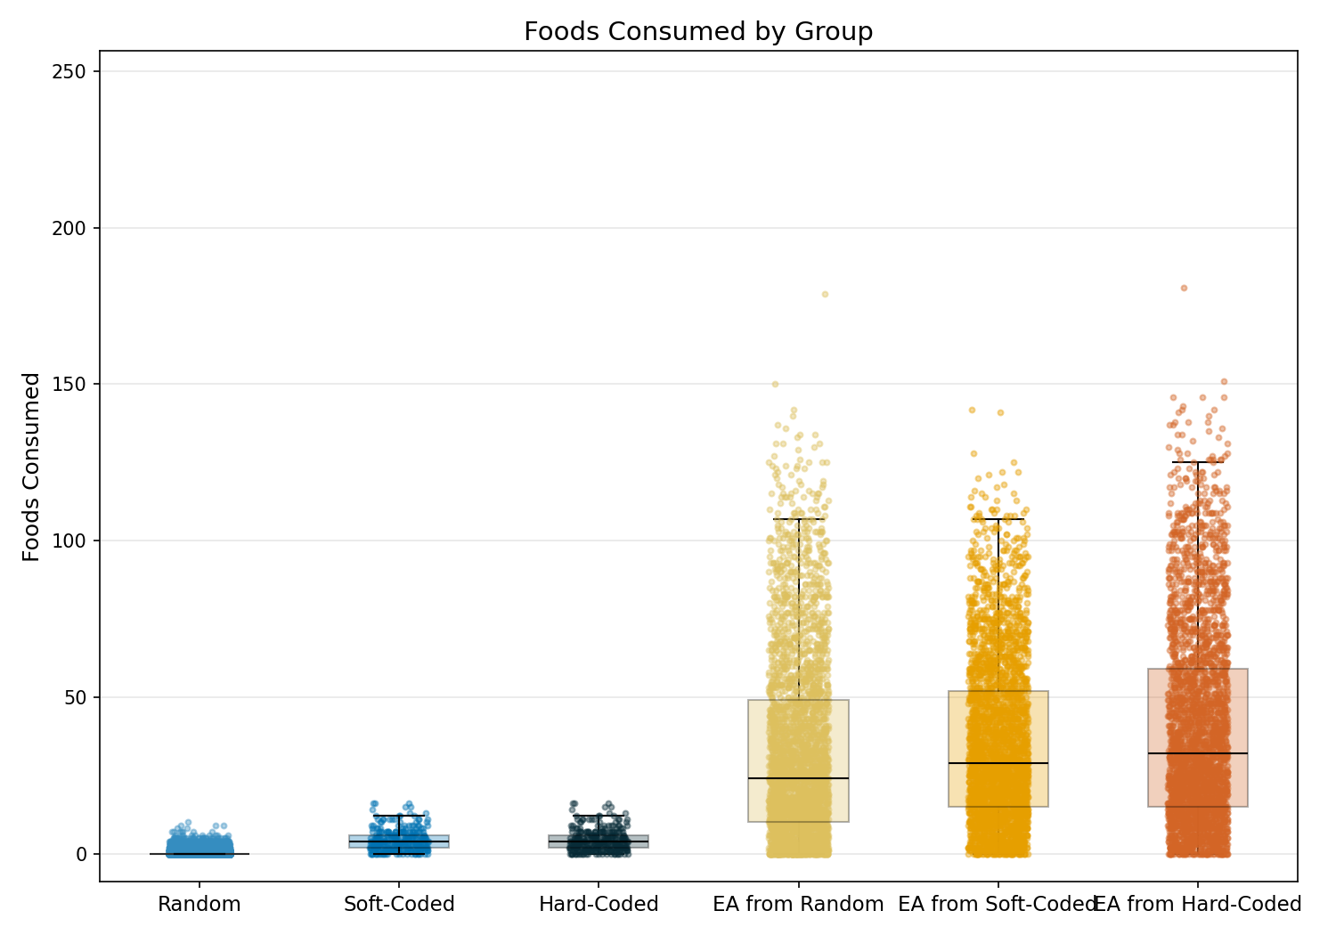

Statistic | Random | Soft-Coded | Hard-Coded | EA from Random | EA from Soft-Coded | EA from Hard-Coded
N | 78000 | 300 | 300 | 3000 | 3000 | 3000
Mean | 0.23 | 4.38 | 4.38 | 33.09 | 35.51 | 40.01
Std Dev | 0.55 | 3.41 | 3.41 | 29.95 | 26.27 | 31.59
SEM | 0.00 | 0.20 | 0.20 | 0.55 | 0.48 | 0.58
Median | 0.00 | 4.00 | 4.00 | 24.00 | 29.00 | 32.00
Min | 0.00 | 0.00 | 0.00 | 0.00 | 0.00 | 0.00
Max | 10.00 | 16.00 | 16.00 | 179.00 | 142.00 | 181.00
IQR | 0.00 | 4.00 | 4.00 | 39.00 | 37.00 | 44.00
P25 | 0.00 | 2.00 | 2.00 | 10.00 | 15.00 | 15.00
P75 | 0.00 | 6.00 | 6.00 | 49.00 | 52.00 | 59.00
Skewness | 3.349 | 1.044 | 1.044 | 1.102 | 0.816 | 0.924
Kurtosis | 18.130 | 0.964 | 0.964 | 0.653 | 0.086 | 0.194

Normality Testing (Shapiro-Wilk):
Group | W statistic | p-value
Random | 0.4611 | 1.62e-156
Soft-Coded | 0.9145 | 4.77e-12
Hard-Coded | 0.9145 | 4.77e-12
EA from Random | 0.8904 | 6.96e-42
EA from Soft-Coded | 0.9362 | 4.45e-34
EA from Hard-Coded | 0.9174 | 1.06e-37
Data is not normally distributed (alpha=0.05).

Kruskal-Wallis (omnibus test):
Test Name | Test Statistic | p-value | Epsilon-squared
Kruskal-Wallis | 38706.3777 | 0.00e+00 | 0.4418 (large)

Pairwise Post-Hoc (Mann-Whitney U (Holm-Bonferroni correction)):
Group 1 | Group 2 | Statistic | p-value | Rank-Biserial r
Random | Soft-Coded | 1575422.5000 | 0.00e+00 | 0.8653 (large)
Random | Hard-Coded | 1575422.5000 | 0.00e+00 | 0.8653 (large)
Random | EA from Random | 7896006.5000 | 0.00e+00 | 0.9325 (large)
Random | EA from Soft-Coded | 3068970.5000 | 0.00e+00 | 0.9738 (large)
Random | EA from Hard-Coded | 3030628.5000 | 0.00e+00 | 0.9741 (large)
Soft-Coded | Hard-Coded | 45000.0000 | 1.00e+00 | 0.0000 (insignificant)
Soft-Coded | EA from Random | 132145.5000 | 5.17e-90 | 0.7063 (large)
Soft-Coded | EA from Soft-Coded | 73093.5000 | 6.24e-126 | 0.8376 (large)
Soft-Coded | EA from Hard-Coded | 70315.0000 | 1.12e-127 | 0.8437 (large)
Hard-Coded | EA from Random | 132145.5000 | 5.17e-90 | 0.7063 (large)
Hard-Coded | EA from Soft-Coded | 73093.5000 | 6.24e-126 | 0.8376 (large)
Hard-Coded | EA from Hard-Coded | 70315.0000 | 1.12e-127 | 0.8437 (large)
EA from Random | EA from Soft-Coded | 4054896.0000 | 9.71e-11 | 0.0989 (insignificant)
EA from Random | EA from Hard-Coded | 3846595.5000 | 8.09e-22 | 0.1452 (small)
EA from Soft-Coded | EA from Hard-Coded | 4255385.5000 | 5.32e-04 | 0.0544 (insignificant)

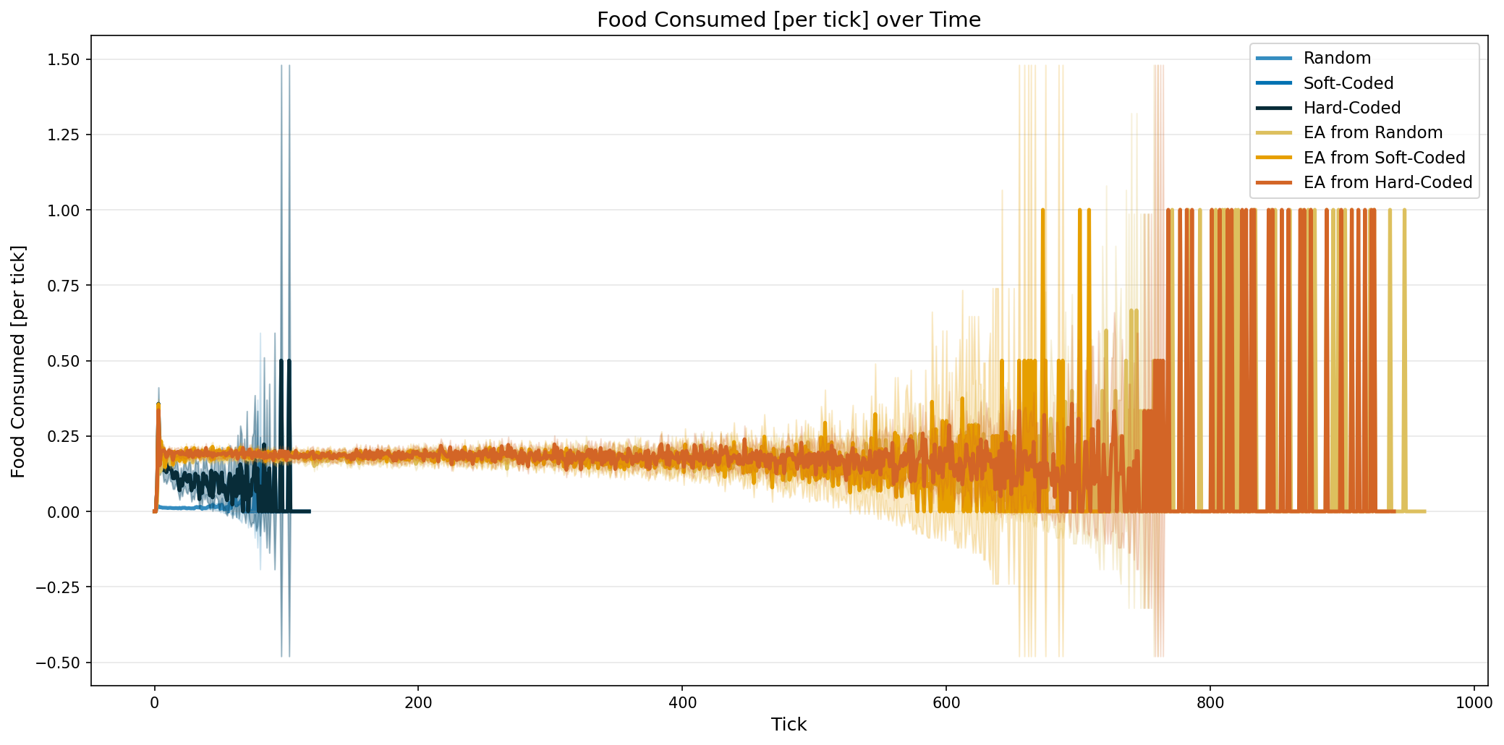

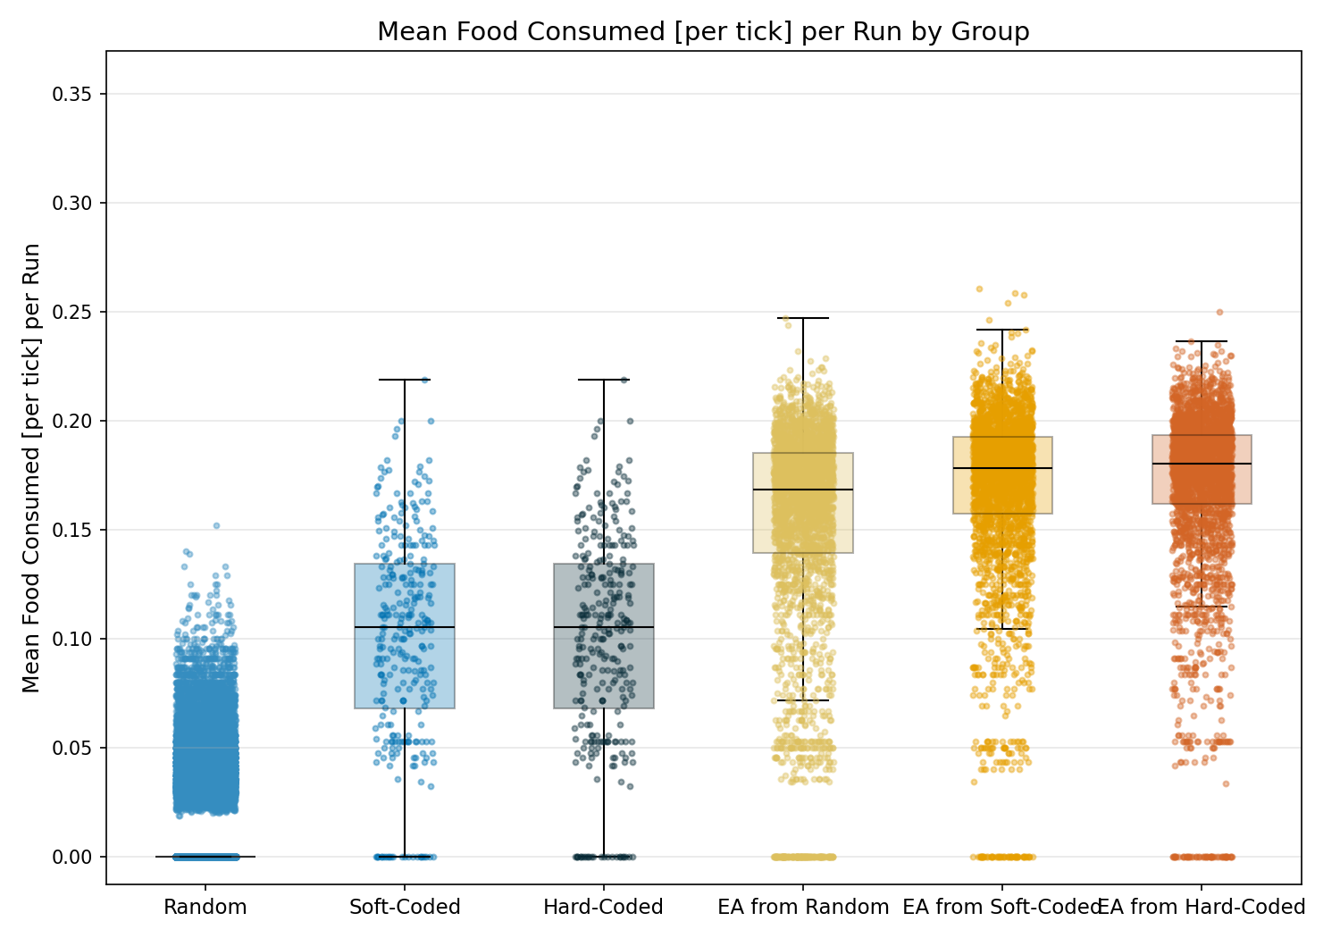

Statistic | Random | Soft-Coded | Hard-Coded | EA from Random | EA from Soft-Coded | EA from Hard-Coded
N | 78000 | 300 | 300 | 3000 | 3000 | 3000
Mean | 0.01 | 0.10 | 0.10 | 0.15 | 0.17 | 0.17
Std Dev | 0.02 | 0.05 | 0.05 | 0.05 | 0.04 | 0.04
SEM | 0.00 | 0.00 | 0.00 | 0.00 | 0.00 | 0.00
Median | 0.00 | 0.11 | 0.11 | 0.17 | 0.18 | 0.18
Min | 0.00 | 0.00 | 0.00 | 0.00 | 0.00 | 0.00
Max | 0.15 | 0.22 | 0.22 | 0.25 | 0.26 | 0.25
IQR | 0.00 | 0.07 | 0.07 | 0.05 | 0.04 | 0.03
P25 | 0.00 | 0.07 | 0.07 | 0.14 | 0.16 | 0.16
P75 | 0.00 | 0.13 | 0.13 | 0.19 | 0.19 | 0.19
Skewness | 2.183 | -0.335 | -0.335 | -1.573 | -1.984 | -2.134
Kurtosis | 4.174 | -0.393 | -0.393 | 1.875 | 5.043 | 5.661

Normality Testing (Shapiro-Wilk):
Group | W statistic | p-value
Random | 0.5039 | 7.48e-154
Soft-Coded | 0.9723 | 1.52e-05
Hard-Coded | 0.9723 | 1.52e-05
EA from Random | 0.8166 | 4.17e-50
EA from Soft-Coded | 0.8223 | 1.40e-49
EA from Hard-Coded | 0.7995 | 1.32e-51
Data is not normally distributed (alpha=0.05).

Kruskal-Wallis (omnibus test):
Test Name | Test Statistic | p-value | Epsilon-squared
Kruskal-Wallis | 38895.2092 | 0.00e+00 | 0.4440 (large)

Pairwise Post-Hoc (Mann-Whitney U (Holm-Bonferroni correction)):
Group 1 | Group 2 | Statistic | p-value | Rank-Biserial r
Random | Soft-Coded | 1356026.5000 | 0.00e+00 | 0.8841 (large)
Random | Hard-Coded | 1356026.5000 | 0.00e+00 | 0.8841 (large)
Random | EA from Random | 7325160.5000 | 0.00e+00 | 0.9374 (large)
Random | EA from Soft-Coded | 2760197.0000 | 0.00e+00 | 0.9764 (large)
Random | EA from Hard-Coded | 2715640.5000 | 0.00e+00 | 0.9768 (large)
Soft-Coded | Hard-Coded | 45000.0000 | 1.00e+00 | 0.0000 (insignificant)
Soft-Coded | EA from Random | 176114.0000 | 4.31e-67 | 0.6086 (large)
Soft-Coded | EA from Soft-Coded | 106034.5000 | 4.91e-105 | 0.7644 (large)
Soft-Coded | EA from Hard-Coded | 99176.5000 | 3.98e-109 | 0.7796 (large)
Hard-Coded | EA from Random | 176114.0000 | 4.31e-67 | 0.6086 (large)
Hard-Coded | EA from Soft-Coded | 106034.5000 | 4.91e-105 | 0.7644 (large)
Hard-Coded | EA from Hard-Coded | 99176.5000 | 3.98e-109 | 0.7796 (large)
EA from Random | EA from Soft-Coded | 3558122.0000 | 2.67e-44 | 0.2093 (small)
EA from Random | EA from Hard-Coded | 3377335.0000 | 2.93e-62 | 0.2495 (small)
EA from Soft-Coded | EA from Hard-Coded | 4318490.5000 | 1.36e-02 | 0.0403 (insignificant)

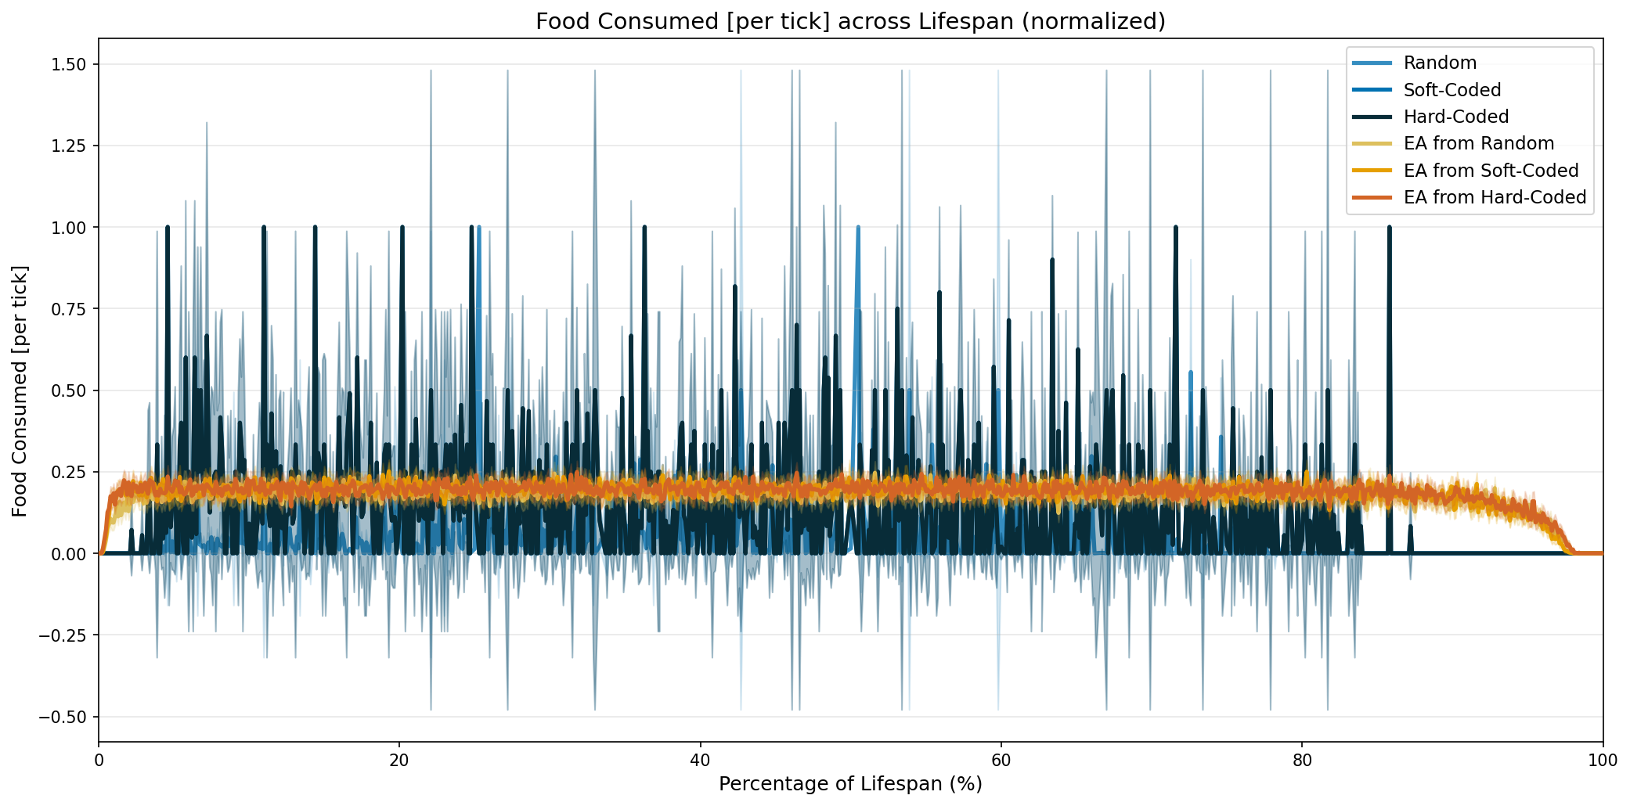

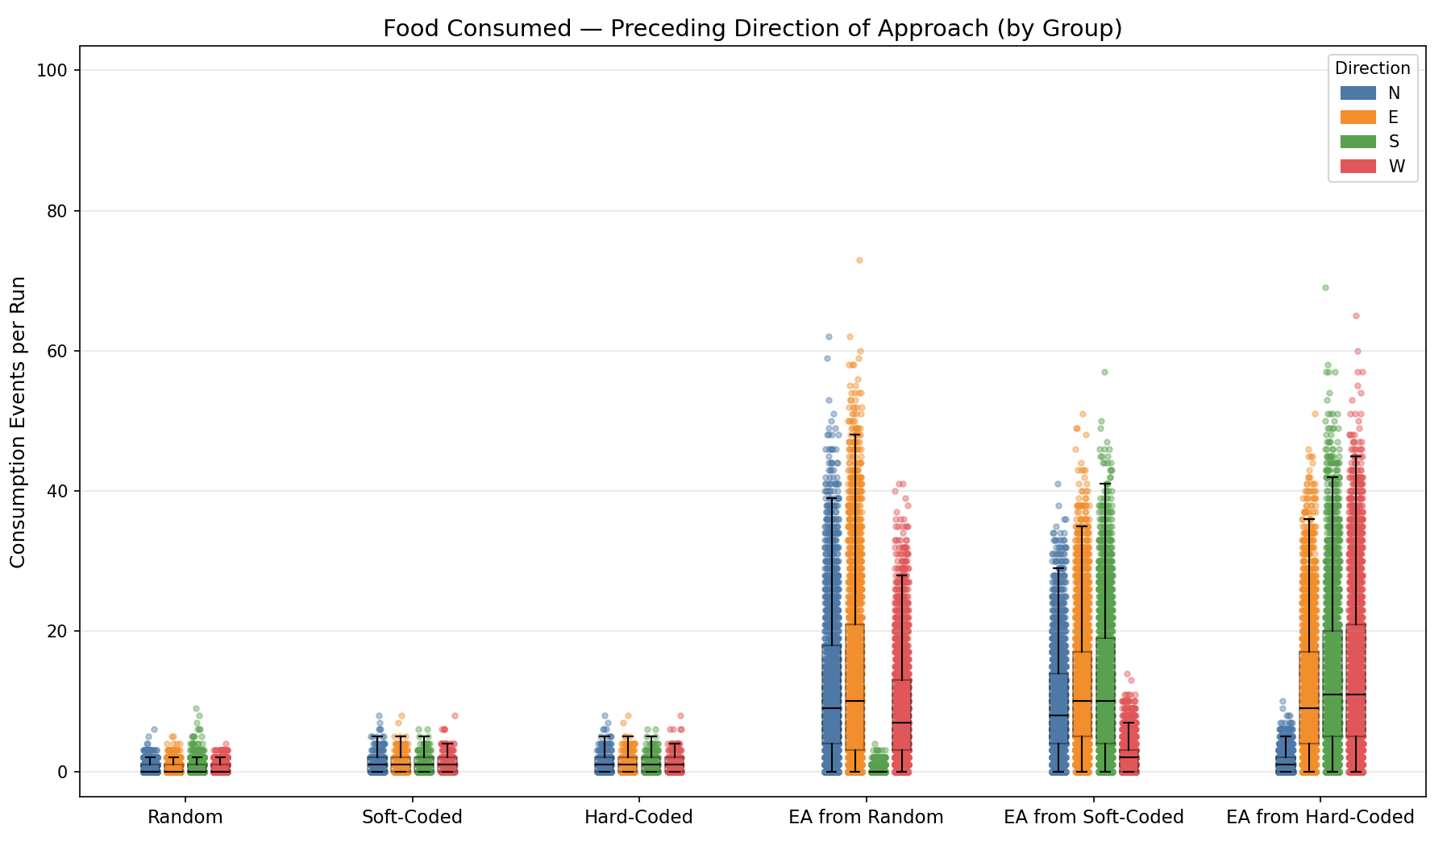

Statistical Comparison — Directional Preference per Group
For each group, the four directions (N/E/S/W) are compared as levels. One-way ANOVA (normally distributed data) or Kruskal-Wallis (non-normal) tests whether the group shows a directional preference. Pairwise post-hoc tests with Tukey's HSD (normal) or Holm-Bonferroni (non-normal) correction are reported for significant omnibus results.

Group: Random

Normality Testing (Shapiro-Wilk):
Direction | W statistic | p-value
N | 0.5855 | 4.53e-102
E | 0.5658 | 3.05e-103
S | 0.5639 | 2.35e-103
W | 0.5761 | 1.23e-102
Data is not normally distributed (alpha=0.05).

Kruskal-Wallis (omnibus test):
Test Name | Test Statistic | p-value | ε²
Kruskal-Wallis | 22.0488 | 6.37e-05 * | 0.0003 (insignificant)

Pairwise Post-Hoc (Mann-Whitney U (Holm-Bonferroni correction)):
Direction A | Direction B | Statistic | p-value | Rank-Biserial r
N | E | 102254556.5000 | 5.16e-04 * | -0.0207 (insignificant)
N | S | 100180019.5000 | 9.97e-01 | 0.0000 (insignificant)
N | W | 101417913.0000 | 7.93e-02 | -0.0123 (insignificant)
E | S | 98110777.0000 | 5.16e-04 * | 0.0207 (insignificant)
E | W | 99342551.5000 | 2.18e-01 | 0.0084 (insignificant)
S | W | 101417795.0000 | 7.93e-02 | -0.0123 (insignificant)

Group: Soft-Coded

Normality Testing (Shapiro-Wilk):
Direction | W statistic | p-value
N | 0.8087 | 1.06e-17
E | 0.7983 | 3.66e-18
S | 0.8042 | 6.65e-18
W | 0.7935 | 2.24e-18
Data is not normally distributed (alpha=0.05).

Kruskal-Wallis (omnibus test):
Test Name | Test Statistic | p-value | ε²
Kruskal-Wallis | 2.7818 | 4.27e-01 | -0.0002 (insignificant)
Omnibus test not significant (p ≥ 0.05). No post-hoc testing performed.

Group: Hard-Coded

Normality Testing (Shapiro-Wilk):
Direction | W statistic | p-value
N | 0.8087 | 1.06e-17
E | 0.7983 | 3.66e-18
S | 0.8042 | 6.65e-18
W | 0.7935 | 2.24e-18
Data is not normally distributed (alpha=0.05).

Kruskal-Wallis (omnibus test):
Test Name | Test Statistic | p-value | ε²
Kruskal-Wallis | 2.7818 | 4.27e-01 | -0.0002 (insignificant)
Omnibus test not significant (p ≥ 0.05). No post-hoc testing performed.

Group: EA from Random

Normality Testing (Shapiro-Wilk):
Direction | W statistic | p-value
N | 0.8921 | 7.47e-41
E | 0.8838 | 5.80e-42
S | 0.5049 | 4.99e-67
W | 0.8993 | 8.08e-40
Data is not normally distributed (alpha=0.05).

Kruskal-Wallis (omnibus test):
Test Name | Test Statistic | p-value | ε²
Kruskal-Wallis | 5472.2710 | 0.00e+00 * | 0.4789 (large)

Pairwise Post-Hoc (Mann-Whitney U (Holm-Bonferroni correction)):
Direction A | Direction B | Statistic | p-value | Rank-Biserial r
N | E | 3884627.5000 | 1.86e-03 * | 0.0475 (insignificant)
N | S | 7800755.0000 | 0.00e+00 * | -0.9127 (large)
N | W | 4560950.0000 | 1.79e-14 * | -0.1183 (small)
E | S | 7697890.5000 | 0.00e+00 * | -0.8875 (large)
E | W | 4719411.0000 | 2.16e-24 * | -0.1572 (small)
S | W | 278845.5000 | 0.00e+00 * | 0.9316 (large)

Group: EA from Soft-Coded

Normality Testing (Shapiro-Wilk):
Direction | W statistic | p-value
N | 0.9350 | 4.71e-34
E | 0.9271 | 1.19e-35
S | 0.9210 | 8.80e-37
W | 0.8538 | 4.44e-46
Data is not normally distributed (alpha=0.05).

Kruskal-Wallis (omnibus test):
Test Name | Test Statistic | p-value | ε²
Kruskal-Wallis | 3661.4926 | 0.00e+00 * | 0.3106 (large)

Pairwise Post-Hoc (Mann-Whitney U (Holm-Bonferroni correction)):
Direction A | Direction B | Statistic | p-value | Rank-Biserial r
N | E | 3770197.0000 | 5.18e-18 * | 0.1312 (small)
N | S | 3754419.5000 | 8.91e-19 * | 0.1348 (small)
N | W | 7378191.5000 | 0.00e+00 * | -0.7003 (large)
E | S | 4305306.0000 | 6.01e-01 | 0.0079 (insignificant)
E | W | 7604607.5000 | 0.00e+00 * | -0.7524 (large)
S | W | 7594915.5000 | 0.00e+00 * | -0.7502 (large)

Group: EA from Hard-Coded

Normality Testing (Shapiro-Wilk):
Direction | W statistic | p-value
N | 0.8091 | 1.97e-50
E | 0.9201 | 6.17e-37
S | 0.9094 | 9.40e-39
W | 0.9115 | 2.12e-38
Data is not normally distributed (alpha=0.05).

Kruskal-Wallis (omnibus test):
Test Name | Test Statistic | p-value | ε²
Kruskal-Wallis | 4781.5362 | 0.00e+00 * | 0.4058 (large)

Pairwise Post-Hoc (Mann-Whitney U (Holm-Bonferroni correction)):
Direction A | Direction B | Statistic | p-value | Rank-Biserial r
N | E | 757850.0000 | 0.00e+00 * | 0.8252 (large)
N | S | 673341.5000 | 0.00e+00 * | 0.8447 (large)
N | W | 602503.0000 | 0.00e+00 * | 0.8611 (large)
E | S | 3942739.5000 | 3.10e-09 * | 0.0908 (insignificant)
E | W | 3836505.0000 | 5.23e-14 * | 0.1153 (small)
S | W | 4228913.5000 | 9.89e-02 | 0.0248 (insignificant)

Directional Approach Bias (% Deviation from Expected) — per Variant
For each variant, all runs are pooled and the total food count per direction is summed. The expected count per direction is the variant's total food count ÷ 4. Bars show the mean deviation across variants; jitter shows individual variants.
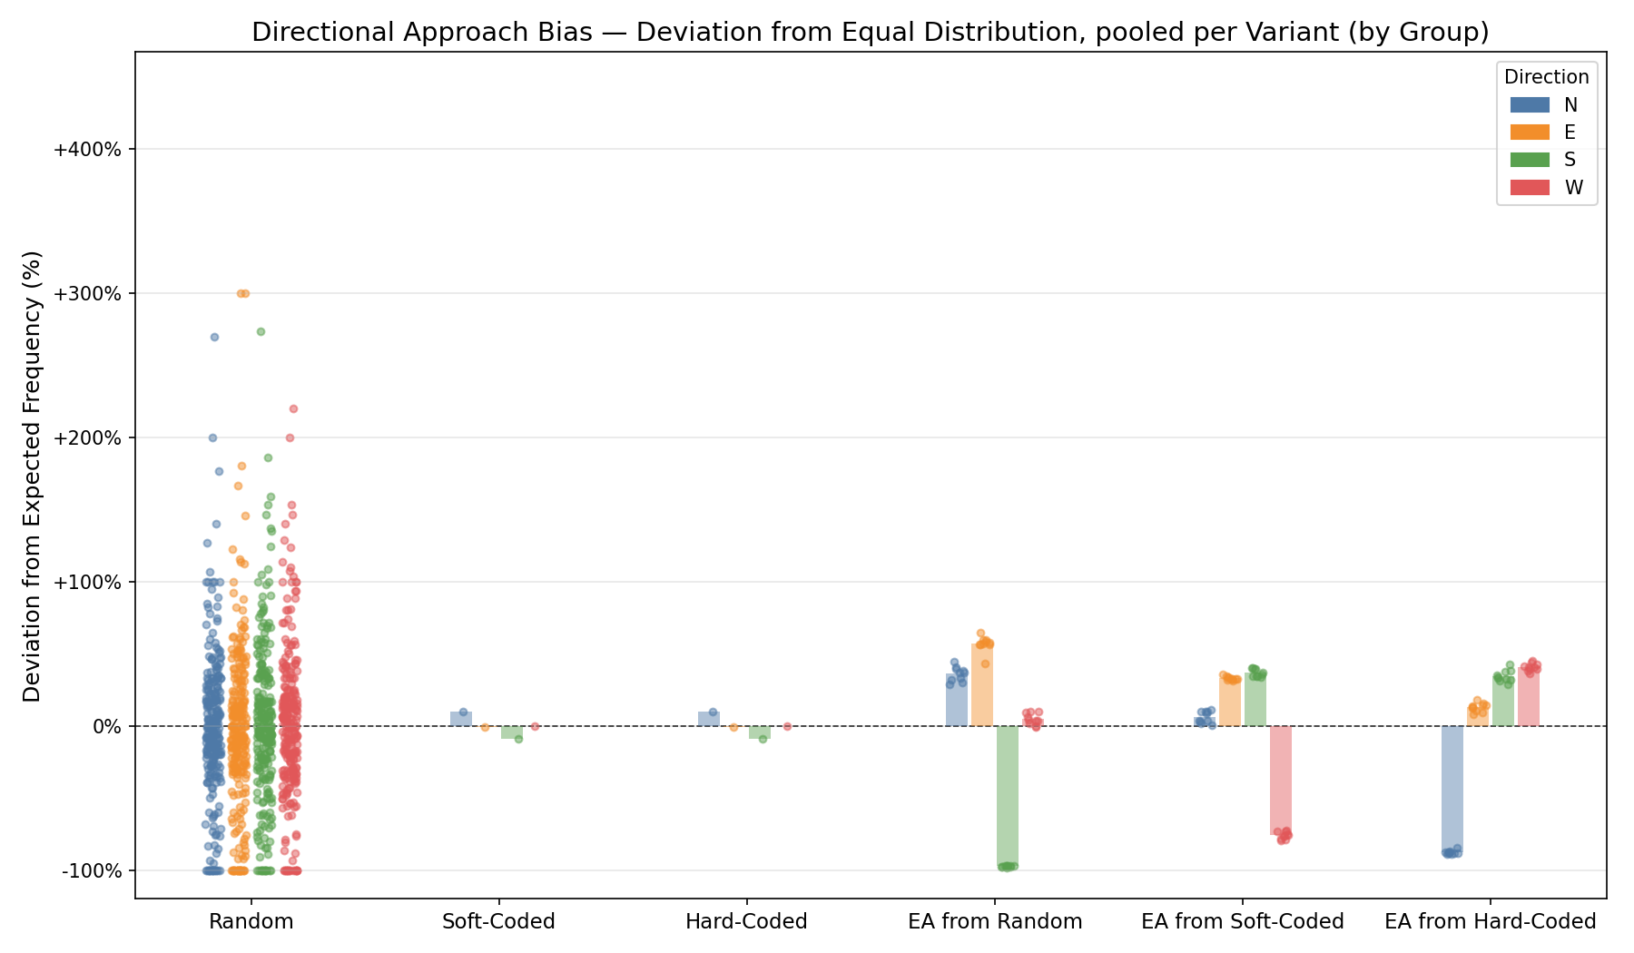

5. Movement
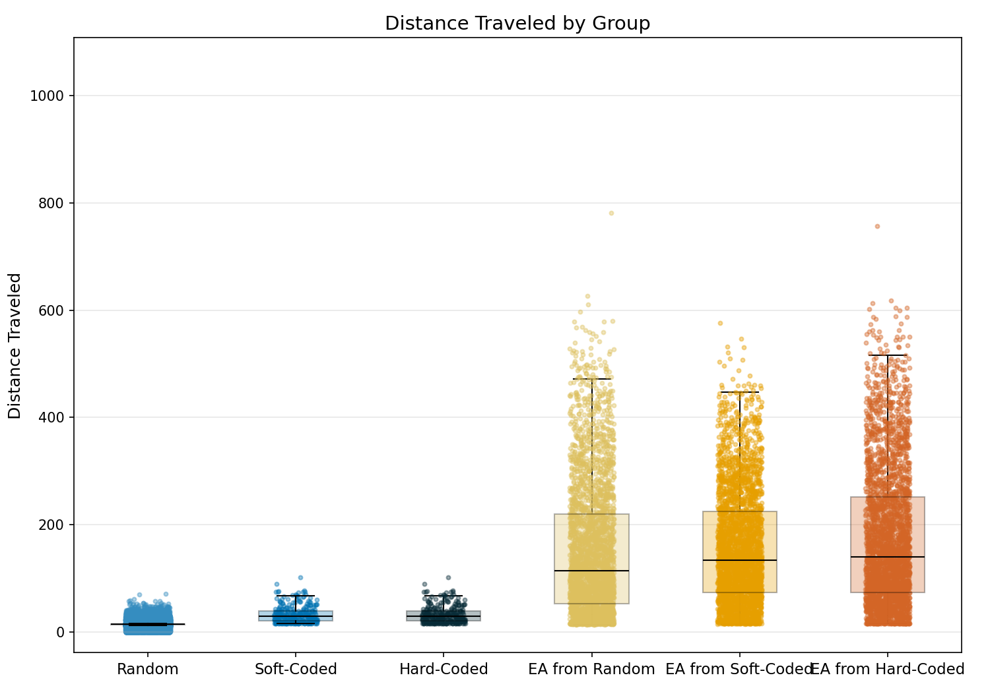

Statistic | Random | Soft-Coded | Hard-Coded | EA from Random | EA from Soft-Coded | EA from Hard-Coded
N | 78000 | 300 | 300 | 3000 | 3000 | 3000
Mean | 14.01 | 32.13 | 32.13 | 151.36 | 156.11 | 174.56
Std Dev | 4.31 | 15.93 | 15.93 | 124.93 | 106.08 | 128.91
SEM | 0.02 | 0.92 | 0.92 | 2.28 | 1.94 | 2.35
Median | 14.00 | 28.50 | 28.50 | 114.00 | 133.00 | 140.00
Min | 0.00 | 15.00 | 15.00 | 13.00 | 14.00 | 15.00
Max | 71.00 | 101.00 | 101.00 | 782.00 | 576.00 | 757.00
IQR | 1.00 | 19.00 | 19.00 | 168.00 | 150.25 | 177.25
P25 | 13.00 | 20.00 | 20.00 | 52.00 | 73.75 | 73.75
P75 | 14.00 | 39.00 | 39.00 | 220.00 | 224.00 | 251.00
Skewness | 1.587 | 1.268 | 1.268 | 1.104 | 0.808 | 0.940
Kurtosis | 10.366 | 1.457 | 1.457 | 0.672 | 0.037 | 0.220

Normality Testing (Shapiro-Wilk):
Group | W statistic | p-value
Random | 0.7342 | 1.67e-134
Soft-Coded | 0.8809 | 1.59e-14
Hard-Coded | 0.8809 | 1.59e-14
EA from Random | 0.8898 | 5.69e-42
EA from Soft-Coded | 0.9354 | 3.10e-34
EA from Hard-Coded | 0.9142 | 3.02e-38
Data is not normally distributed (alpha=0.05).

Kruskal-Wallis (omnibus test):
Test Name | Test Statistic | p-value | Epsilon-squared
Kruskal-Wallis | 25215.3750 | 0.00e+00 | 0.2878 (large)

Pairwise Post-Hoc (Mann-Whitney U (Holm-Bonferroni correction)):
Group 1 | Group 2 | Statistic | p-value | Rank-Biserial r
Random | Soft-Coded | 1058389.0000 | 1.19e-170 | 0.9095 (large)
Random | Hard-Coded | 1058389.0000 | 1.19e-170 | 0.9095 (large)
Random | EA from Random | 4545745.5000 | 0.00e+00 | 0.9611 (large)
Random | EA from Soft-Coded | 1789930.0000 | 0.00e+00 | 0.9847 (large)
Random | EA from Hard-Coded | 1677663.5000 | 0.00e+00 | 0.9857 (large)
Soft-Coded | Hard-Coded | 45000.0000 | 1.00e+00 | 0.0000 (insignificant)
Soft-Coded | EA from Random | 133615.5000 | 3.72e-89 | 0.7031 (large)
Soft-Coded | EA from Soft-Coded | 79689.0000 | 1.42e-121 | 0.8229 (large)
Soft-Coded | EA from Hard-Coded | 77279.5000 | 4.74e-123 | 0.8283 (large)
Hard-Coded | EA from Random | 133615.5000 | 3.72e-89 | 0.7031 (large)
Hard-Coded | EA from Soft-Coded | 79689.0000 | 1.42e-121 | 0.8229 (large)
Hard-Coded | EA from Hard-Coded | 77279.5000 | 4.74e-123 | 0.8283 (large)
EA from Random | EA from Soft-Coded | 4150304.0000 | 5.59e-07 | 0.0777 (insignificant)
EA from Random | EA from Hard-Coded | 3944998.5000 | 5.23e-16 | 0.1233 (small)
EA from Soft-Coded | EA from Hard-Coded | 4263653.0000 | 8.53e-04 | 0.0525 (insignificant)

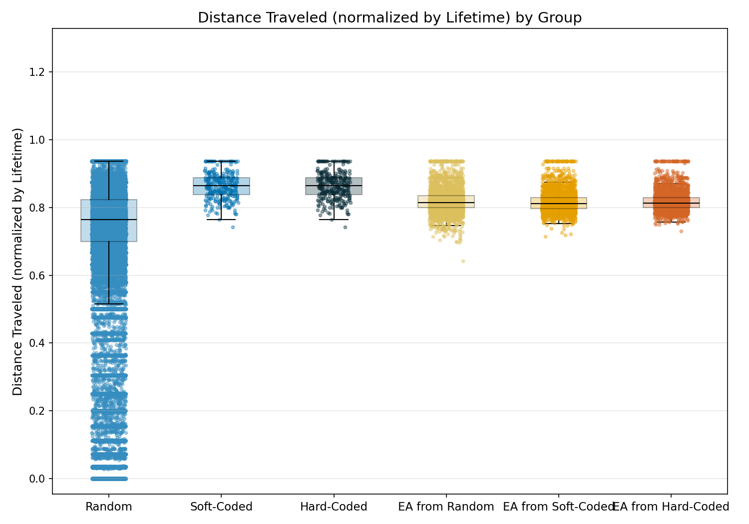

Statistic | Random | Soft-Coded | Hard-Coded | EA from Random | EA from Soft-Coded | EA from Hard-Coded
N | 78000 | 300 | 300 | 3000 | 3000 | 3000
Mean | 0.74 | 0.86 | 0.86 | 0.82 | 0.82 | 0.82
Std Dev | 0.17 | 0.04 | 0.04 | 0.04 | 0.03 | 0.03
SEM | 0.00 | 0.00 | 0.00 | 0.00 | 0.00 | 0.00
Median | 0.76 | 0.86 | 0.86 | 0.82 | 0.81 | 0.81
Min | 0.00 | 0.74 | 0.74 | 0.64 | 0.71 | 0.73
Max | 0.94 | 0.94 | 0.94 | 0.94 | 0.94 | 0.94
IQR | 0.12 | 0.05 | 0.05 | 0.04 | 0.03 | 0.03
P25 | 0.70 | 0.84 | 0.84 | 0.80 | 0.80 | 0.80
P75 | 0.82 | 0.89 | 0.89 | 0.84 | 0.83 | 0.83
Skewness | -2.326 | -0.050 | -0.050 | 0.814 | 1.428 | 1.571
Kurtosis | 6.848 | -0.366 | -0.366 | 1.714 | 3.485 | 3.914

Normality Testing (Shapiro-Wilk):
Group | W statistic | p-value
Random | 0.7687 | 2.30e-130
Soft-Coded | 0.9839 | 1.91e-03
Hard-Coded | 0.9839 | 1.91e-03
EA from Random | 0.9344 | 1.90e-34
EA from Soft-Coded | 0.8986 | 1.03e-40
EA from Hard-Coded | 0.8852 | 1.35e-42
Data is not normally distributed (alpha=0.05).

Kruskal-Wallis (omnibus test):
Test Name | Test Statistic | p-value | Epsilon-squared
Kruskal-Wallis | 3560.9737 | 0.00e+00 | 0.0406 (small)

Pairwise Post-Hoc (Mann-Whitney U (Holm-Bonferroni correction)):
Group 1 | Group 2 | Statistic | p-value | Rank-Biserial r
Random | Soft-Coded | 4327386.0000 | 1.97e-79 | 0.6301 (large)
Random | Hard-Coded | 4327386.0000 | 1.97e-79 | 0.6301 (large)
Random | EA from Random | 75038268.5000 | 3.73e-246 | 0.3586 (medium)
Random | EA from Soft-Coded | 78340693.0000 | 3.95e-209 | 0.3304 (medium)
Random | EA from Hard-Coded | 77191817.0000 | 1.19e-221 | 0.3402 (medium)
Soft-Coded | Hard-Coded | 45000.0000 | 1.00e+00 | 0.0000 (insignificant)
Soft-Coded | EA from Random | 714509.5000 | 1.21e-62 | -0.5878 (large)
Soft-Coded | EA from Soft-Coded | 753144.5000 | 1.23e-81 | -0.6737 (large)
Soft-Coded | EA from Hard-Coded | 747794.0000 | 5.52e-79 | -0.6618 (large)
Hard-Coded | EA from Random | 714509.5000 | 1.21e-62 | -0.5878 (large)
Hard-Coded | EA from Soft-Coded | 753144.5000 | 1.23e-81 | -0.6737 (large)
Hard-Coded | EA from Hard-Coded | 747794.0000 | 5.52e-79 | -0.6618 (large)
EA from Random | EA from Soft-Coded | 4872806.5000 | 1.10e-07 | -0.0828 (insignificant)
EA from Random | EA from Hard-Coded | 4687169.5000 | 1.05e-02 | -0.0416 (insignificant)
EA from Soft-Coded | EA from Hard-Coded | 4281347.0000 | 3.35e-03 | 0.0486 (insignificant)

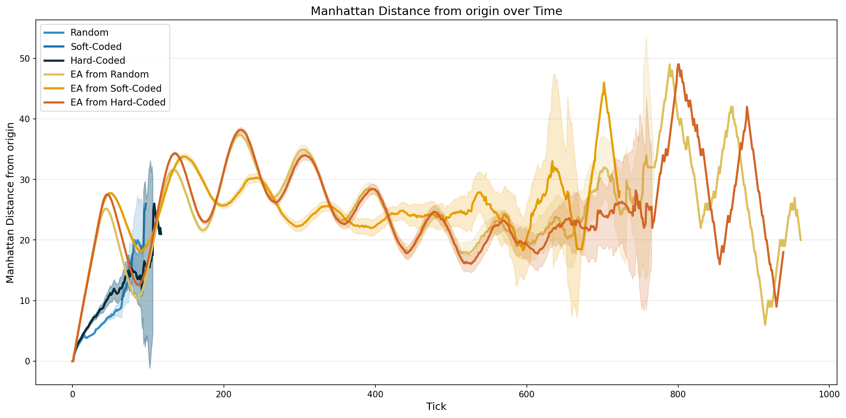

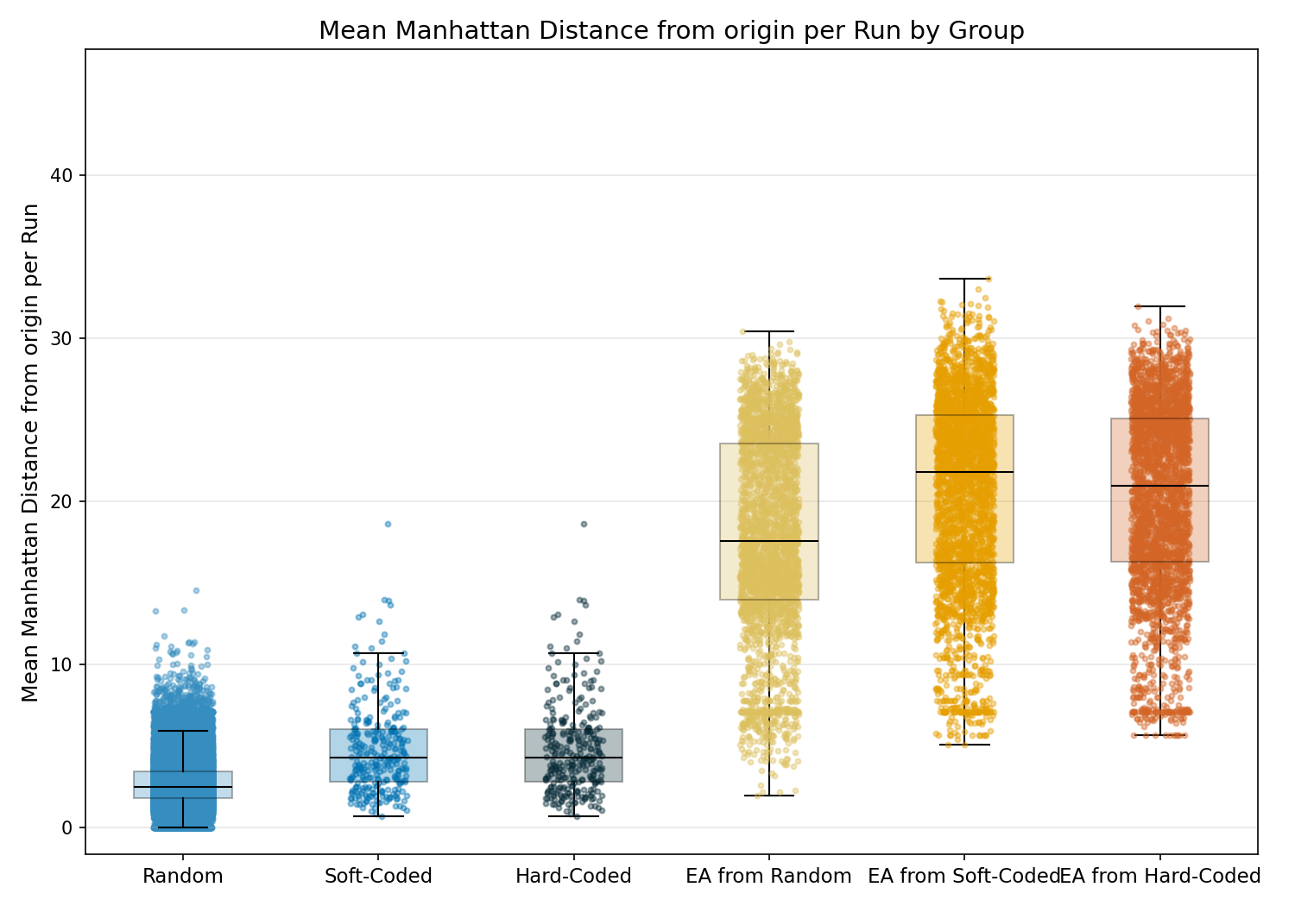

Statistic | Random | Soft-Coded | Hard-Coded | EA from Random | EA from Soft-Coded | EA from Hard-Coded
N | 78000 | 300 | 300 | 3000 | 3000 | 3000
Mean | 2.73 | 4.78 | 4.78 | 17.91 | 20.61 | 20.33
Std Dev | 1.36 | 2.76 | 2.76 | 6.14 | 5.95 | 5.71
SEM | 0.00 | 0.16 | 0.16 | 0.11 | 0.11 | 0.10
Median | 2.47 | 4.25 | 4.25 | 17.55 | 21.82 | 20.95
Min | 0.00 | 0.68 | 0.68 | 1.94 | 5.04 | 5.63
Max | 14.53 | 18.61 | 18.61 | 30.40 | 33.68 | 31.95
IQR | 1.66 | 3.24 | 3.24 | 9.60 | 9.07 | 8.83
P25 | 1.76 | 2.78 | 2.78 | 13.94 | 16.21 | 16.26
P75 | 3.42 | 6.02 | 6.02 | 23.53 | 25.29 | 25.10
Skewness | 1.126 | 1.324 | 1.324 | -0.254 | -0.517 | -0.499
Kurtosis | 1.859 | 2.528 | 2.528 | -0.753 | -0.467 | -0.496

Normality Testing (Shapiro-Wilk):
Group | W statistic | p-value
Random | 0.9329 | 1.86e-96
Soft-Coded | 0.9084 | 1.53e-12
Hard-Coded | 0.9084 | 1.53e-12
EA from Random | 0.9686 | 4.23e-25
EA from Soft-Coded | 0.9645 | 1.50e-26
EA from Hard-Coded | 0.9616 | 1.65e-27
Data is not normally distributed (alpha=0.05).

Kruskal-Wallis (omnibus test):
Test Name | Test Statistic | p-value | Epsilon-squared
Kruskal-Wallis | 24419.0919 | 0.00e+00 | 0.2787 (large)

Pairwise Post-Hoc (Mann-Whitney U (Holm-Bonferroni correction)):
Group 1 | Group 2 | Statistic | p-value | Rank-Biserial r
Random | Soft-Coded | 5856561.5000 | 5.82e-50 | 0.4994 (large)
Random | Hard-Coded | 5856561.5000 | 5.82e-50 | 0.4994 (large)
Random | EA from Random | 923040.5000 | 0.00e+00 | 0.9921 (large)
Random | EA from Soft-Coded | 146337.0000 | 0.00e+00 | 0.9987 (large)
Random | EA from Hard-Coded | 129758.0000 | 0.00e+00 | 0.9989 (large)
Soft-Coded | Hard-Coded | 45000.0000 | 1.00e+00 | 0.0000 (insignificant)
Soft-Coded | EA from Random | 25894.0000 | 4.11e-159 | 0.9425 (large)
Soft-Coded | EA from Soft-Coded | 10634.5000 | 1.38e-170 | 0.9764 (large)
Soft-Coded | EA from Hard-Coded | 9884.0000 | 4.35e-171 | 0.9780 (large)
Hard-Coded | EA from Random | 25894.0000 | 4.11e-159 | 0.9425 (large)
Hard-Coded | EA from Soft-Coded | 10634.5000 | 1.38e-170 | 0.9764 (large)
Hard-Coded | EA from Hard-Coded | 9884.0000 | 4.35e-171 | 0.9780 (large)
EA from Random | EA from Soft-Coded | 3383640.5000 | 2.13e-61 | 0.2481 (small)
EA from Random | EA from Hard-Coded | 3466132.0000 | 6.93e-53 | 0.2297 (small)
EA from Soft-Coded | EA from Hard-Coded | 4630776.5000 | 1.03e-01 | -0.0291 (insignificant)

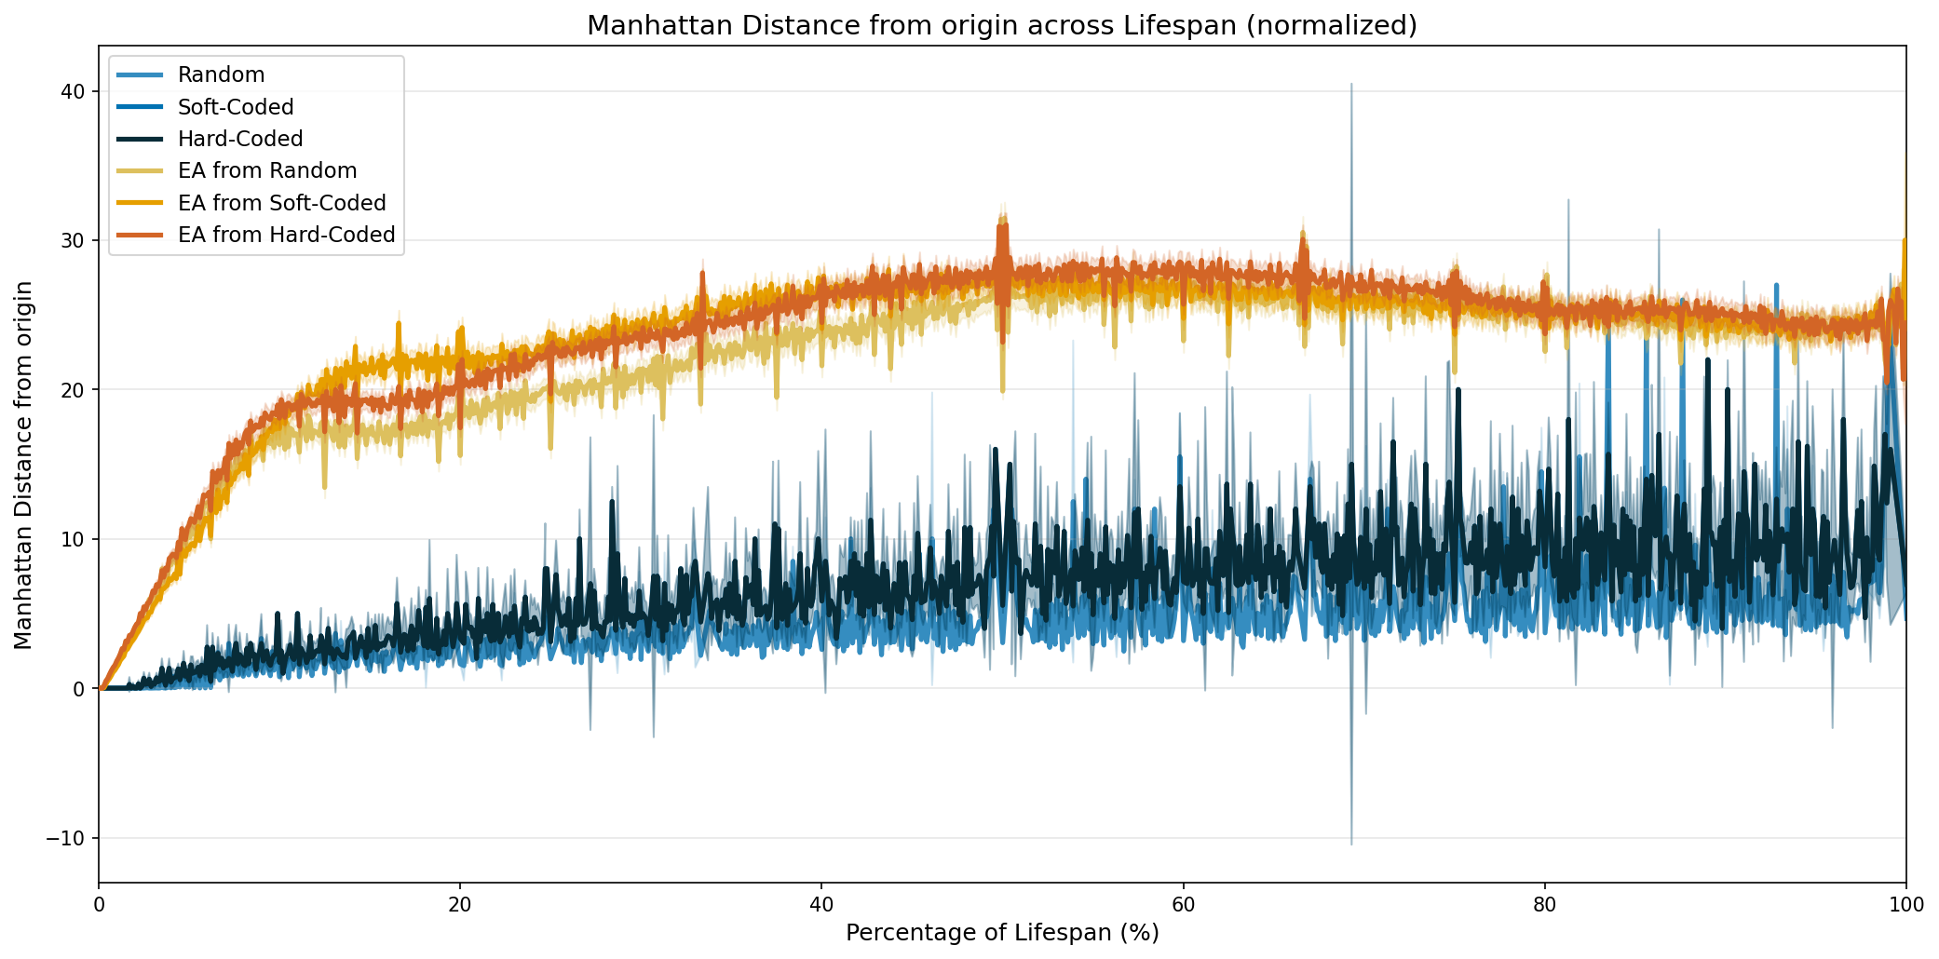

Heatmaps — EA from Hard-Coded
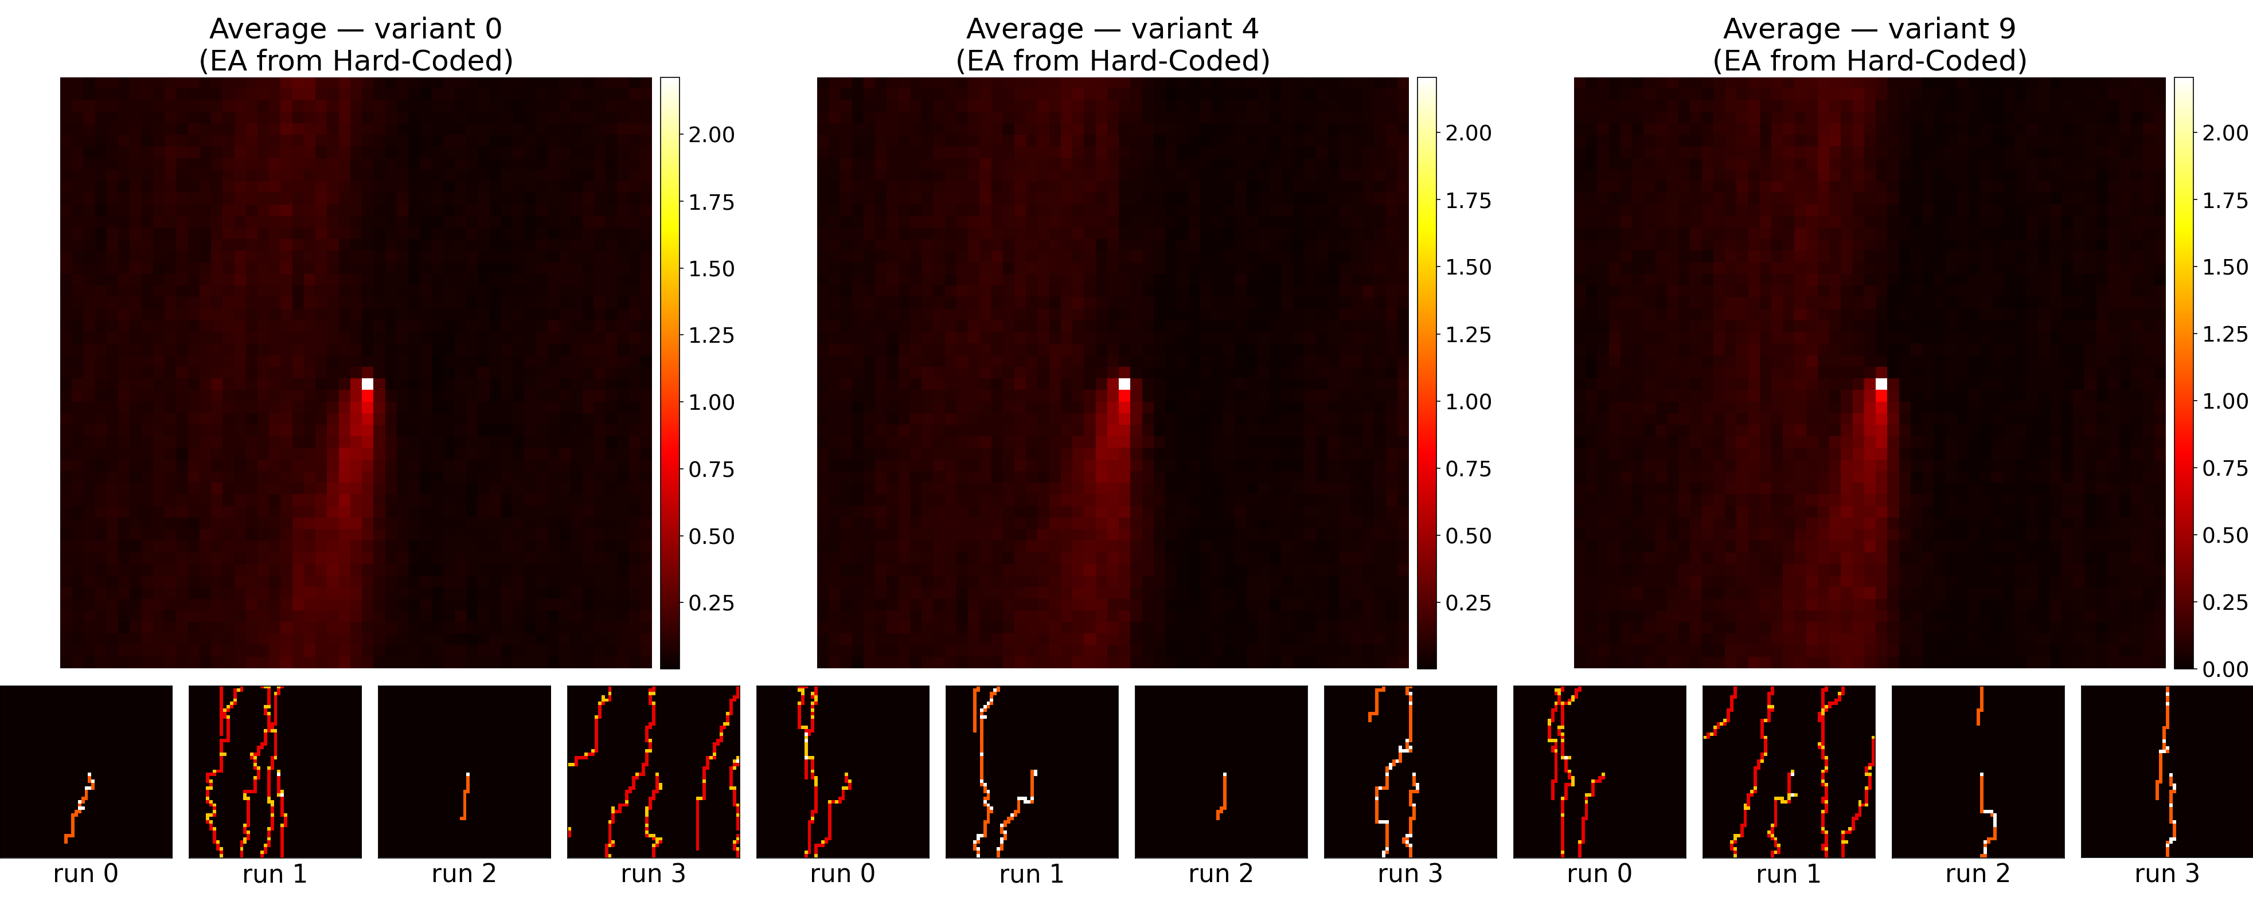

Heatmaps — EA from Random
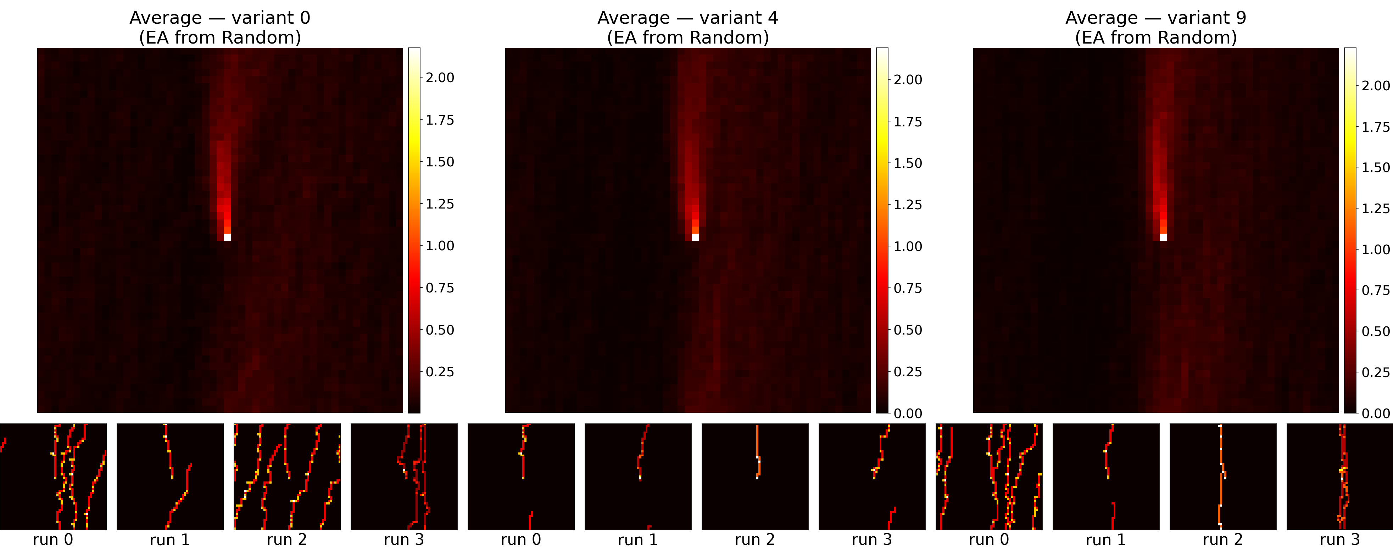

Heatmaps — EA from Soft-Coded
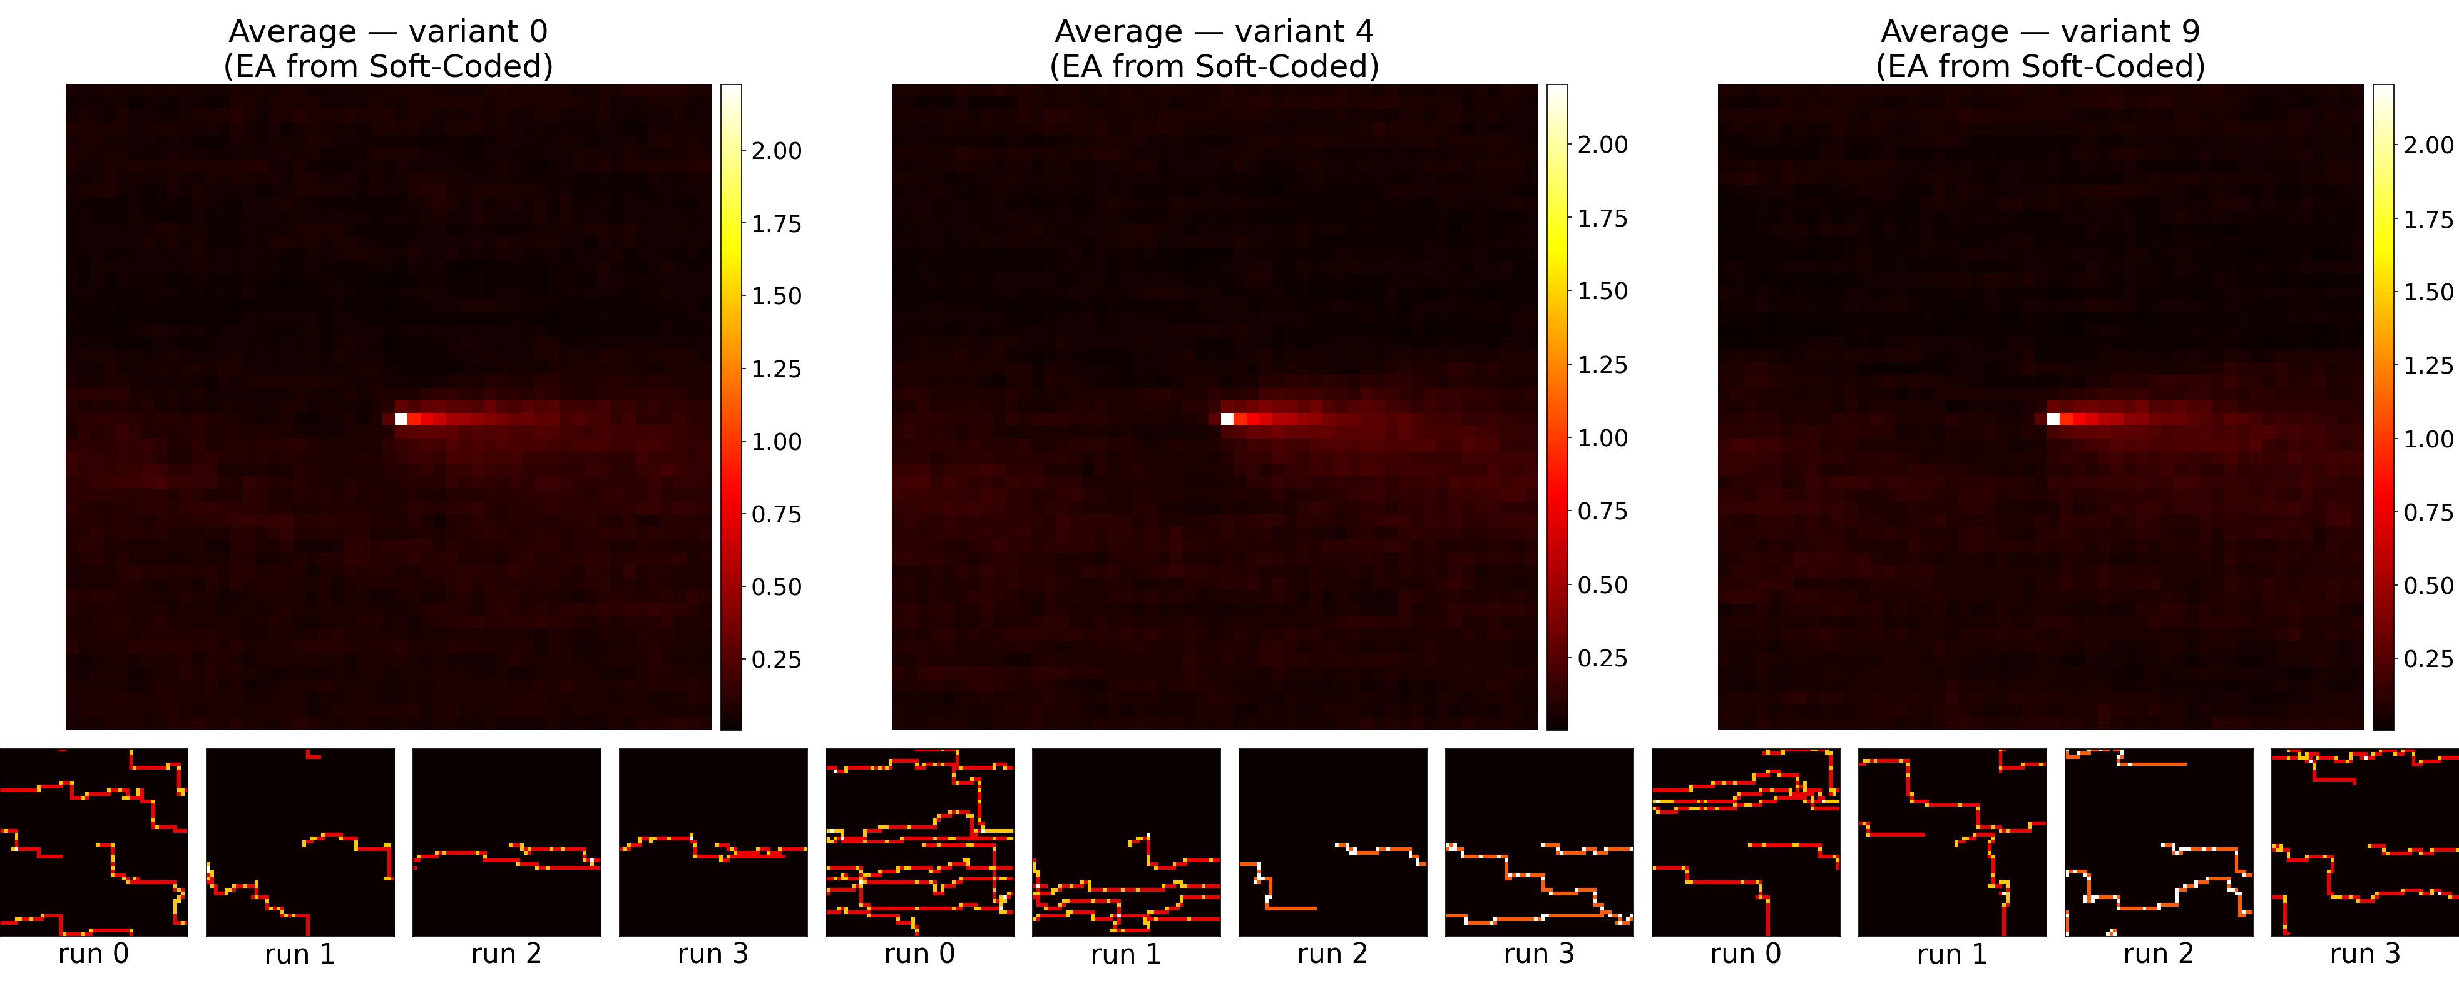

Heatmaps — Hard-Coded
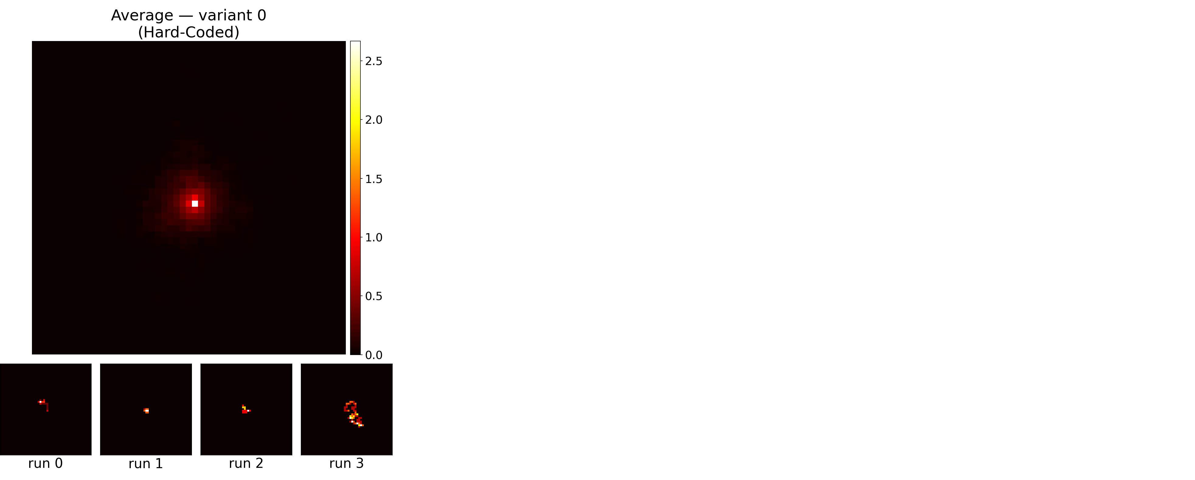

Heatmaps — Random
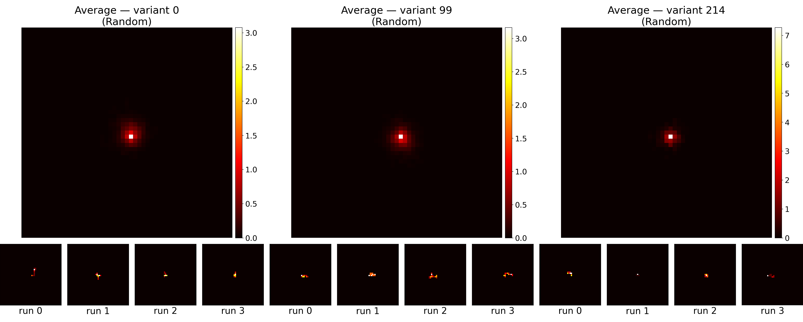

Heatmaps — Soft-Coded
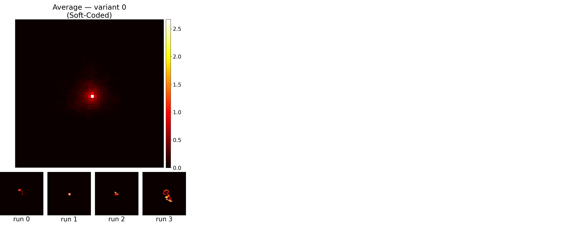

Movement Analysis — Directional Preferences

1. Directional Movement Distribution
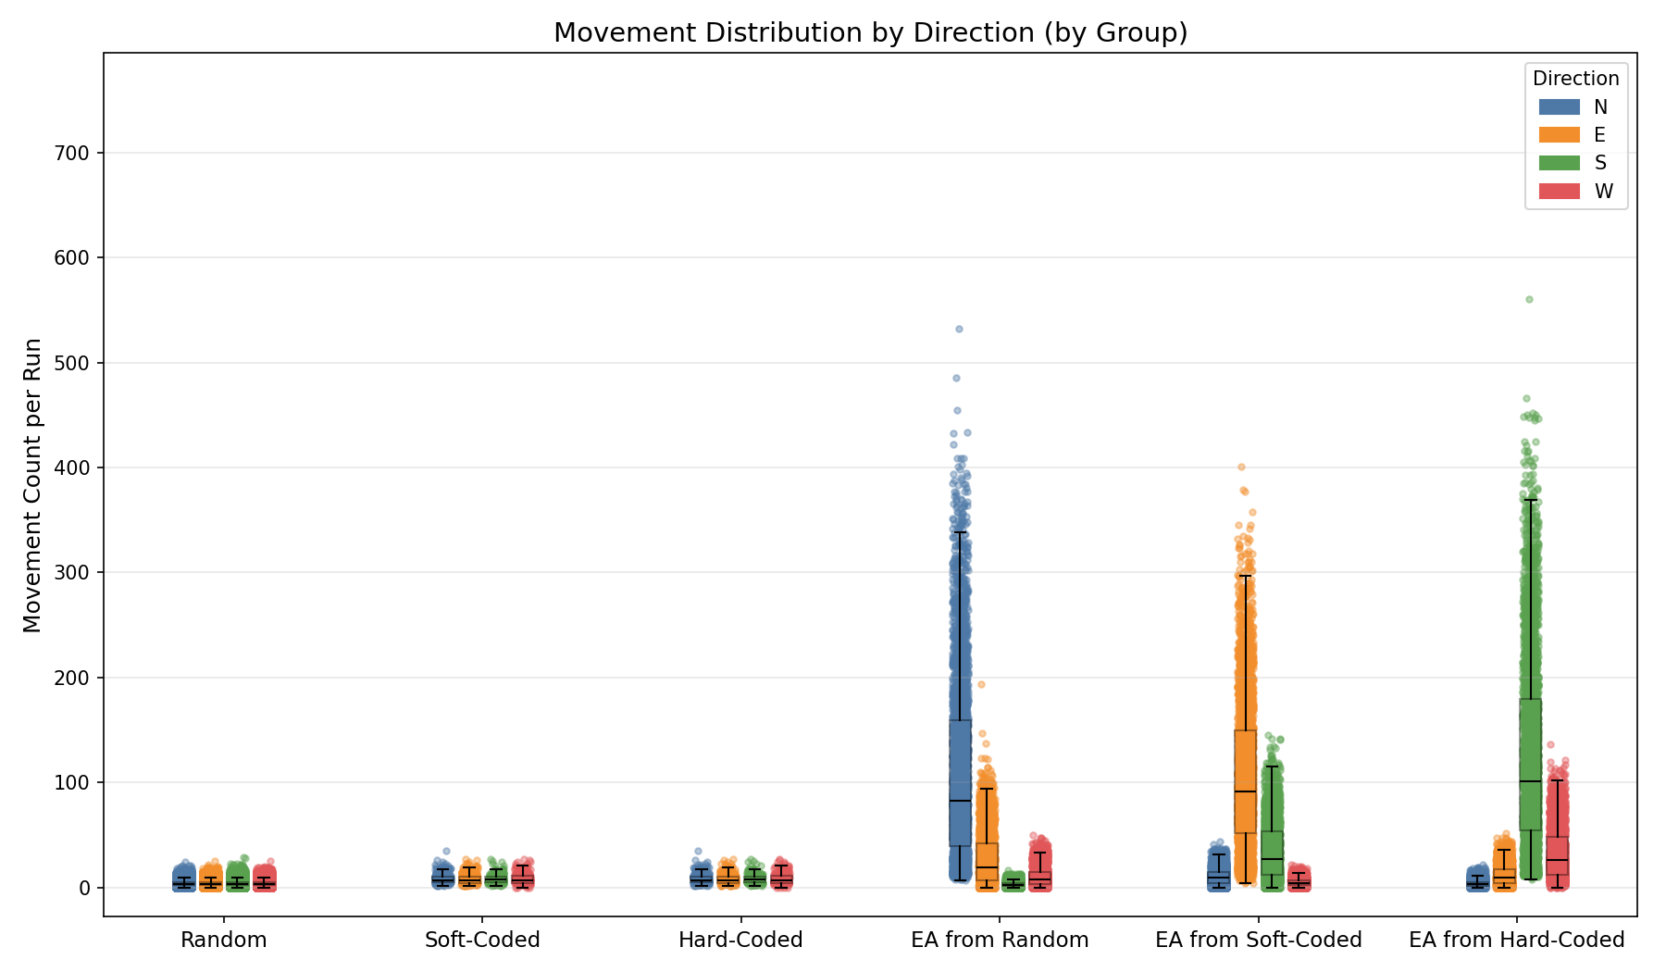

3. Statistical Comparison — Directional Preference per Group
For each group, the five movement types (N/E/S/W/stay) are compared as levels. One-way ANOVA (normally distributed data) or Kruskal-Wallis (non-normal) tests whether the group shows a directional preference. Pairwise post-hoc tests with Tukey's HSD (normal) or Holm-Bonferroni (non-normal) correction are reported for significant omnibus results.

Group: Random

Normality Testing (Shapiro-Wilk):
Direction | W statistic | p-value
N | 0.9091 | 2.61e-104
E | 0.9013 | 1.74e-106
S | 0.9168 | 5.29e-102
W | 0.9115 | 1.36e-103
Data is not normally distributed (alpha=0.05).

Kruskal-Wallis (omnibus test):
Test Name | Test Statistic | p-value | ε²
Kruskal-Wallis | 45.0387 | 9.08e-10 * | 0.0001 (insignificant)

Pairwise Post-Hoc (Mann-Whitney U (Holm-Bonferroni correction)):
Movement A | Movement B | Statistic | p-value | Rank-Biserial r
N | E | 2988444704.5000 | 6.63e-09 * | 0.0176 (insignificant)
N | S | 3029108446.5000 | 4.27e-01 | 0.0042 (insignificant)
N | W | 3034987136.5000 | 8.50e-01 | 0.0023 (insignificant)
E | S | 3082588216.0000 | 1.55e-05 * | -0.0133 (insignificant)
E | W | 3088793581.5000 | 5.06e-07 * | -0.0154 (insignificant)
S | W | 3048096461.0000 | 8.50e-01 | -0.0020 (insignificant)

Group: Soft-Coded

Normality Testing (Shapiro-Wilk):
Direction | W statistic | p-value
N | 0.8852 | 3.10e-14
E | 0.8949 | 1.48e-13
S | 0.9240 | 3.13e-11
W | 0.9121 | 3.02e-12
Data is not normally distributed (alpha=0.05).

Kruskal-Wallis (omnibus test):
Test Name | Test Statistic | p-value | ε²
Kruskal-Wallis | 0.9981 | 8.02e-01 | -0.0017 (insignificant)
Omnibus test not significant (p ≥ 0.05). No post-hoc testing performed.

Group: Hard-Coded

Normality Testing (Shapiro-Wilk):
Direction | W statistic | p-value
N | 0.8852 | 3.10e-14
E | 0.8949 | 1.48e-13
S | 0.9240 | 3.13e-11
W | 0.9121 | 3.02e-12
Data is not normally distributed (alpha=0.05).

Kruskal-Wallis (omnibus test):
Test Name | Test Statistic | p-value | ε²
Kruskal-Wallis | 0.9981 | 8.02e-01 | -0.0017 (insignificant)
Omnibus test not significant (p ≥ 0.05). No post-hoc testing performed.

Group: EA from Random

Normality Testing (Shapiro-Wilk):
Direction | W statistic | p-value
N | 0.8915 | 9.87e-42
E | 0.8757 | 7.82e-44
S | 0.8895 | 5.21e-42
W | 0.8936 | 1.95e-41
Data is not normally distributed (alpha=0.05).

Kruskal-Wallis (omnibus test):
Test Name | Test Statistic | p-value | ε²
Kruskal-Wallis | 7159.0083 | 0.00e+00 * | 0.5965 (large)

Pairwise Post-Hoc (Mann-Whitney U (Holm-Bonferroni correction)):
Movement A | Movement B | Statistic | p-value | Rank-Biserial r
N | E | 7616477.0000 | 0.00e+00 * | -0.6926 (large)
N | S | 8996925.0000 | 0.00e+00 * | -0.9993 (large)
N | W | 8625673.0000 | 0.00e+00 * | -0.9168 (large)
E | S | 7681511.5000 | 0.00e+00 * | -0.7070 (large)
E | W | 6200909.0000 | 5.75e-142 * | -0.3780 (medium)
S | W | 1875607.5000 | 0.00e+00 * | 0.5832 (large)

Group: EA from Soft-Coded

Normality Testing (Shapiro-Wilk):
Direction | W statistic | p-value
N | 0.9370 | 6.69e-34
E | 0.9383 | 1.26e-33
S | 0.9198 | 2.86e-37
W | 0.9123 | 1.42e-38
Data is not normally distributed (alpha=0.05).

Kruskal-Wallis (omnibus test):
Test Name | Test Statistic | p-value | ε²
Kruskal-Wallis | 7621.3329 | 0.00e+00 * | 0.6351 (large)

Pairwise Post-Hoc (Mann-Whitney U (Holm-Bonferroni correction)):
Movement A | Movement B | Statistic | p-value | Rank-Biserial r
N | E | 231042.0000 | 0.00e+00 * | 0.9487 (large)
N | S | 1907728.5000 | 0.00e+00 * | 0.5761 (large)
N | W | 6570382.0000 | 5.39e-210 * | -0.4601 (large)
E | S | 7541108.5000 | 0.00e+00 * | -0.6758 (large)
E | W | 8975275.5000 | 0.00e+00 * | -0.9945 (large)
S | W | 8079842.0000 | 0.00e+00 * | -0.7955 (large)

Group: EA from Hard-Coded

Normality Testing (Shapiro-Wilk):
Direction | W statistic | p-value
N | 0.8828 | 6.55e-43
E | 0.9184 | 1.59e-37
S | 0.9130 | 1.90e-38
W | 0.9093 | 4.62e-39
Data is not normally distributed (alpha=0.05).

Kruskal-Wallis (omnibus test):
Test Name | Test Statistic | p-value | ε²
Kruskal-Wallis | 8114.3665 | 0.00e+00 * | 0.6762 (large)

Pairwise Post-Hoc (Mann-Whitney U (Holm-Bonferroni correction)):
Movement A | Movement B | Statistic | p-value | Rank-Biserial r
N | E | 2031651.0000 | 5.45e-298 * | 0.5485 (large)
N | S | 7204.0000 | 0.00e+00 * | 0.9984 (large)
N | W | 536230.0000 | 0.00e+00 * | 0.8808 (large)
E | S | 258008.0000 | 0.00e+00 * | 0.9427 (large)
E | W | 1970479.5000 | 0.00e+00 * | 0.5621 (large)
S | W | 7740951.0000 | 0.00e+00 * | -0.7202 (large)

4. Directional Motion Bias (excluding "stay")
For each variant, all runs are pooled and the total movement count per direction is summed. The expected count per direction is the variant's total movement count ÷ 4. Bars show the mean deviation across variants; jitter shows individual variants.
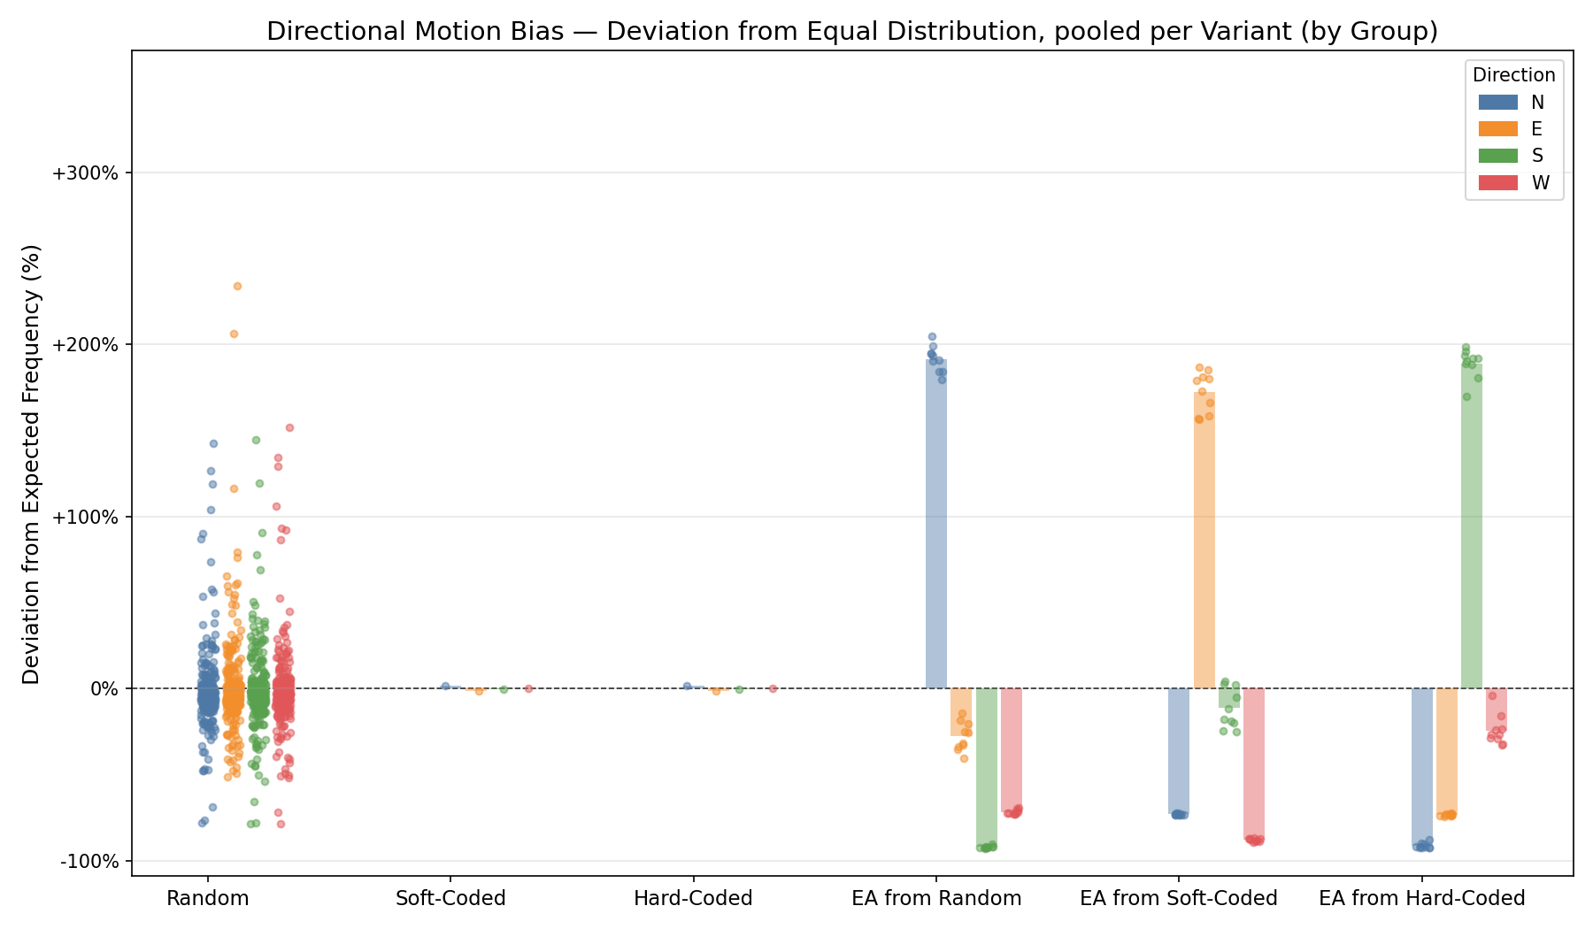

6. Decisions

Decision Analysis

1. Decision Counts per Run (All Decision Types)
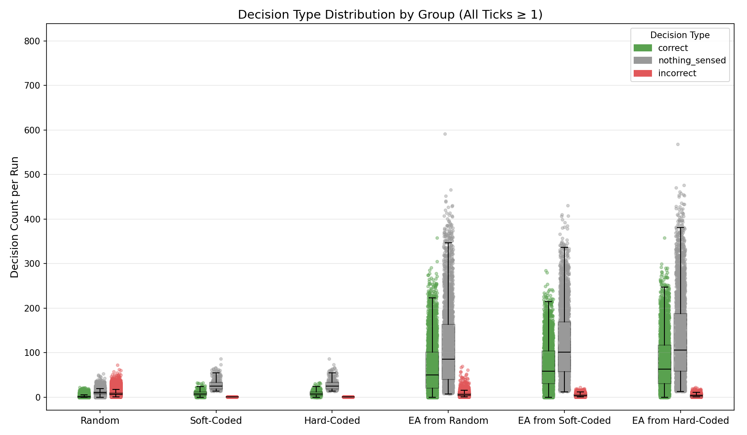

2. Decision Counts per Run (Informed Decisions Only)
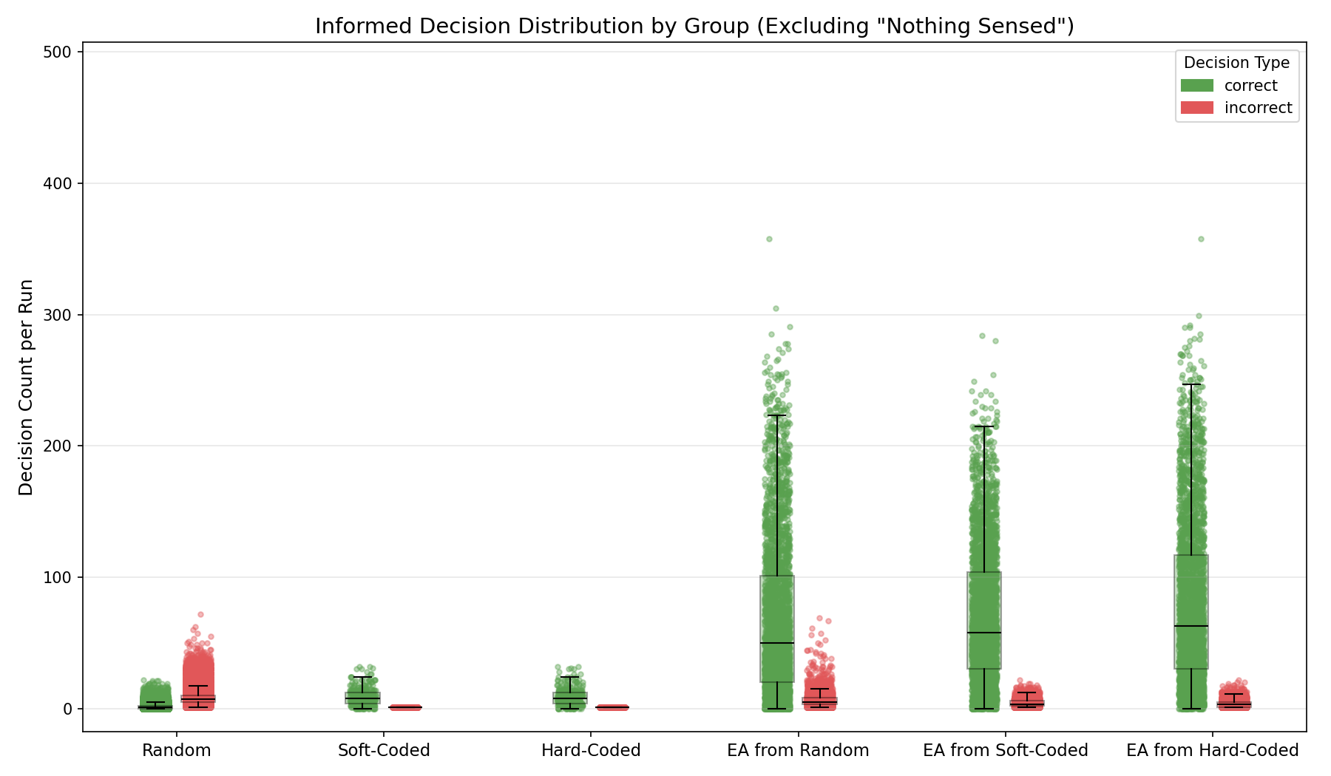

3. Decision Type Distribution (% Per Variant, All Types)
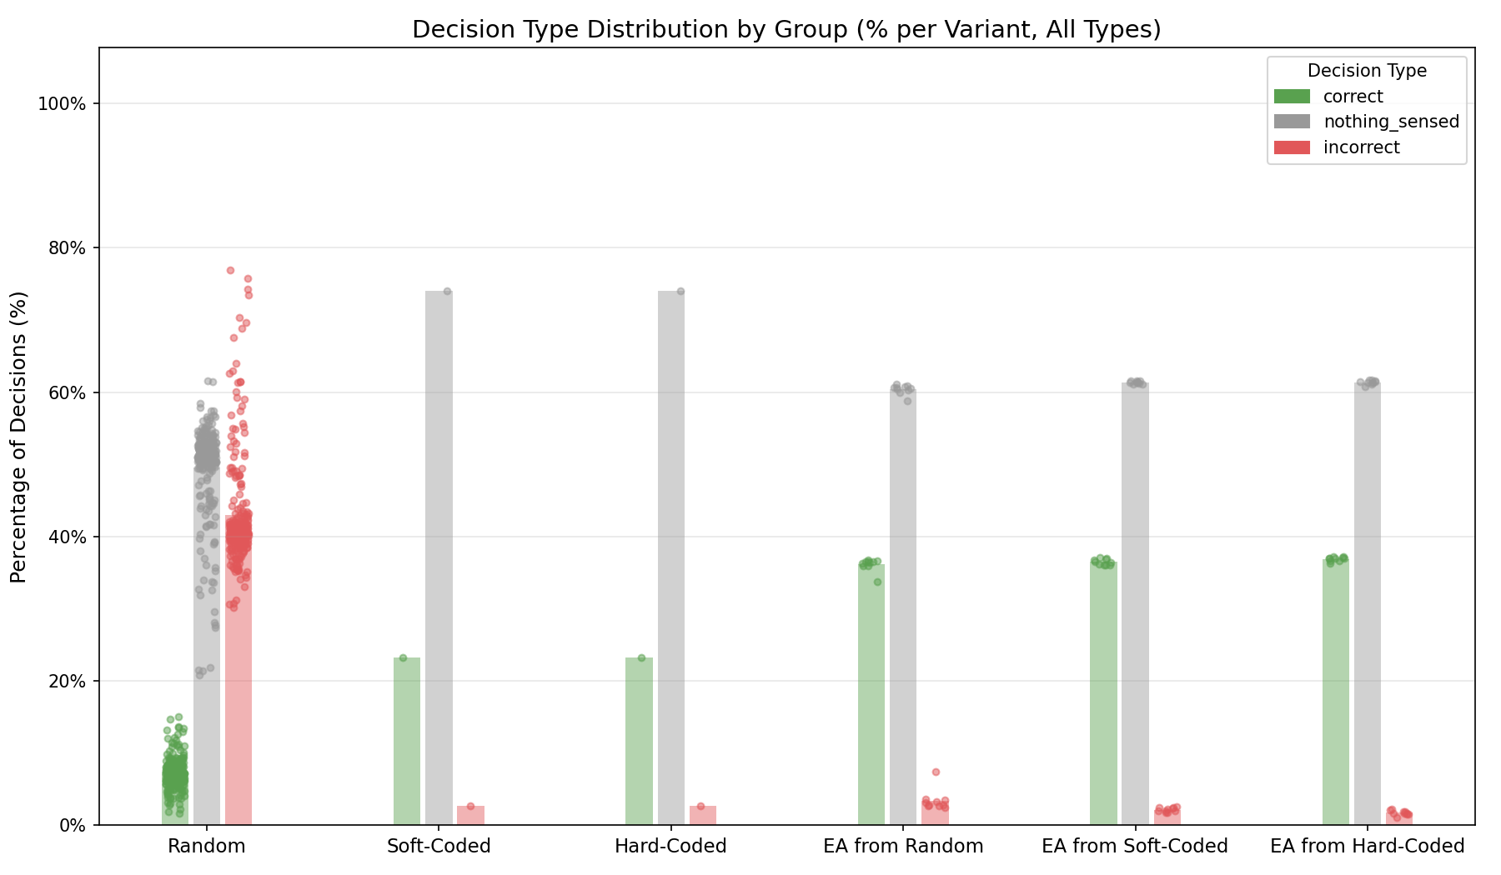

4. Informed Decision Distribution (% Per Variant, Excluding "Nothing Sensed")
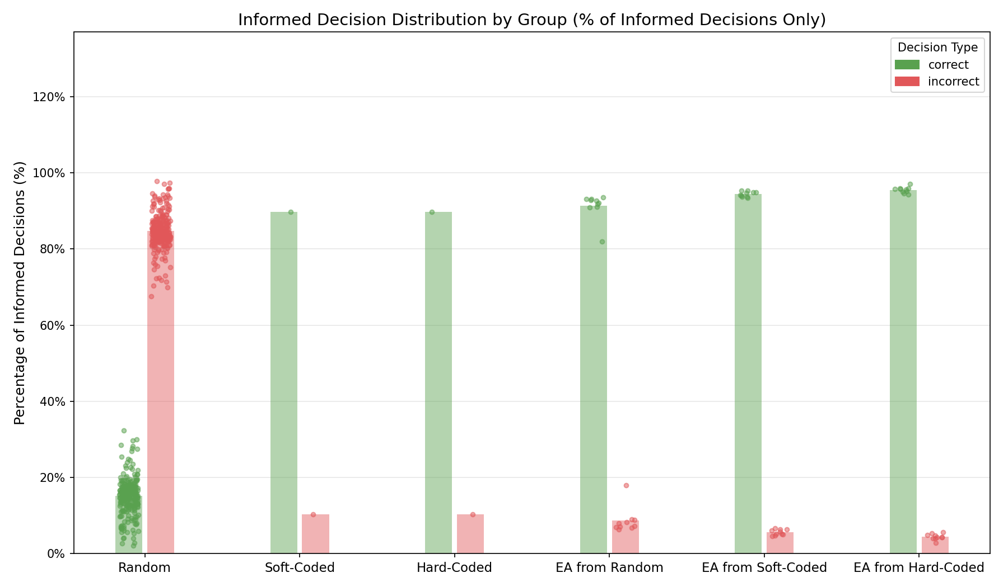

5. Statistical Comparison — Decision Quality Between Groups

Test 1: All Decision Types (Correct vs Nothing_Sensed vs Incorrect)
We test whether the three groups show different distributions across all decision types. Data are the % of each decision type per variant.

Decision Type: CORRECT
Test Name | Test Statistic | p-value | ε²
Kruskal-Wallis | 85.3604 | 6.33e-17 * | 0.2810 (large)
Result: Groups show SIGNIFICANT differences in correct rates (p < 0.05) ✓

Pairwise Post-Hoc (Mann-Whitney U (Holm-Bonferroni correction)):
Group A | Group B | Statistic | p-value | Rank-Biserial r
Random | Soft-Coded | 0.0000 | 8.43e-02 | 1.0000 (large)
Random | Hard-Coded | 0.0000 | 8.43e-02 | 1.0000 (large)
Random | EA from Random | 0.0000 | 1.23e-06 * | 1.0000 (large)
Random | EA from Soft-Coded | 0.0000 | 1.23e-06 * | 1.0000 (large)
Random | EA from Hard-Coded | 0.0000 | 1.23e-06 * | 1.0000 (large)
Soft-Coded | Hard-Coded | 0.5000 | 1.00e+00 | 0.0000 (insignificant)
Soft-Coded | EA from Random | 0.0000 | 1.00e+00 | 1.0000 (large)
Soft-Coded | EA from Soft-Coded | 0.0000 | 1.00e+00 | 1.0000 (large)
Soft-Coded | EA from Hard-Coded | 0.0000 | 1.00e+00 | 1.0000 (large)
Hard-Coded | EA from Random | 0.0000 | 1.00e+00 | 1.0000 (large)
Hard-Coded | EA from Soft-Coded | 0.0000 | 1.00e+00 | 1.0000 (large)
Hard-Coded | EA from Hard-Coded | 0.0000 | 1.00e+00 | 1.0000 (large)
EA from Random | EA from Soft-Coded | 38.0000 | 1.00e+00 | 0.2400 (small)
EA from Random | EA from Hard-Coded | 11.0000 | 4.33e-02 * | 0.7800 (large)
EA from Soft-Coded | EA from Hard-Coded | 21.0000 | 2.81e-01 | 0.5800 (large)

Decision Type: NOTHING_SENSED
Test Name | Test Statistic | p-value | ε²
Kruskal-Wallis | 83.6485 | 1.45e-16 * | 0.2750 (large)
Result: Groups show SIGNIFICANT differences in nothing_sensed rates (p < 0.05) ✓

Pairwise Post-Hoc (Mann-Whitney U (Holm-Bonferroni correction)):
Group A | Group B | Statistic | p-value | Rank-Biserial r
Random | Soft-Coded | 0.0000 | 8.57e-01 | 1.0000 (large)
Random | Hard-Coded | 0.0000 | 8.57e-01 | 1.0000 (large)
Random | EA from Random | 20.0000 | 1.68e-06 * | 0.9846 (large)
Random | EA from Soft-Coded | 13.0000 | 1.61e-06 * | 0.9900 (large)
Random | EA from Hard-Coded | 12.0000 | 1.61e-06 * | 0.9908 (large)
Soft-Coded | Hard-Coded | 0.5000 | 1.00e+00 | 0.0000 (insignificant)
Soft-Coded | EA from Random | 10.0000 | 1.00e+00 | -1.0000 (large)
Soft-Coded | EA from Soft-Coded | 10.0000 | 1.00e+00 | -1.0000 (large)
Soft-Coded | EA from Hard-Coded | 10.0000 | 1.00e+00 | -1.0000 (large)
Hard-Coded | EA from Random | 10.0000 | 1.00e+00 | -1.0000 (large)
Hard-Coded | EA from Soft-Coded | 10.0000 | 1.00e+00 | -1.0000 (large)
Hard-Coded | EA from Hard-Coded | 10.0000 | 1.00e+00 | -1.0000 (large)
EA from Random | EA from Soft-Coded | 2.0000 | 3.96e-03 * | 0.9600 (large)
EA from Random | EA from Hard-Coded | 3.0000 | 4.84e-03 * | 0.9400 (large)
EA from Soft-Coded | EA from Hard-Coded | 40.0000 | 1.00e+00 | 0.2000 (small)

Decision Type: INCORRECT
Test Name | Test Statistic | p-value | ε²
Kruskal-Wallis | 85.4928 | 5.93e-17 * | 0.2814 (large)
Result: Groups show SIGNIFICANT differences in incorrect rates (p < 0.05) ✓

Pairwise Post-Hoc (Mann-Whitney U (Holm-Bonferroni correction)):
Group A | Group B | Statistic | p-value | Rank-Biserial r
Random | Soft-Coded | 260.0000 | 7.28e-02 | -1.0000 (large)
Random | Hard-Coded | 260.0000 | 7.28e-02 | -1.0000 (large)
Random | EA from Random | 2600.0000 | 1.23e-06 * | -1.0000 (large)
Random | EA from Soft-Coded | 2600.0000 | 1.23e-06 * | -1.0000 (large)
Random | EA from Hard-Coded | 2600.0000 | 1.23e-06 * | -1.0000 (large)
Soft-Coded | Hard-Coded | 0.5000 | 1.00e+00 | 0.0000 (insignificant)
Soft-Coded | EA from Random | 2.0000 | 1.00e+00 | 0.6000 (large)
Soft-Coded | EA from Soft-Coded | 10.0000 | 1.00e+00 | -1.0000 (large)
Soft-Coded | EA from Hard-Coded | 10.0000 | 1.00e+00 | -1.0000 (large)
Hard-Coded | EA from Random | 2.0000 | 1.00e+00 | 0.6000 (large)
Hard-Coded | EA from Soft-Coded | 10.0000 | 1.00e+00 | -1.0000 (large)
Hard-Coded | EA from Hard-Coded | 10.0000 | 1.00e+00 | -1.0000 (large)
EA from Random | EA from Soft-Coded | 99.0000 | 2.71e-03 * | -0.9800 (large)
EA from Random | EA from Hard-Coded | 100.0000 | 2.19e-03 * | -1.0000 (large)
EA from Soft-Coded | EA from Hard-Coded | 86.0000 | 7.28e-02 | -0.7200 (large)

Test 2: Informed Decisions Only (Correct vs Incorrect)
We test whether the three groups show different rates of correct decisions among informed (non-uncertain) decisions only. Data are the % of correct decisions among informed decisions, per variant.
Test Name | Test Statistic | p-value | ε²
Kruskal-Wallis | 85.4955 | 5.93e-17 * | 0.2815 (large)
Result: Groups show SIGNIFICANT differences in correct decision rates (p < 0.05) ✓

Pairwise Post-Hoc (Mann-Whitney U (Holm-Bonferroni correction)):
Group A | Group B | Statistic | p-value | Rank-Biserial r
Random | Soft-Coded | 0.0000 | 7.28e-02 | 1.0000 (large)
Random | Hard-Coded | 0.0000 | 7.28e-02 | 1.0000 (large)
Random | EA from Random | 0.0000 | 1.23e-06 * | 1.0000 (large)
Random | EA from Soft-Coded | 0.0000 | 1.23e-06 * | 1.0000 (large)
Random | EA from Hard-Coded | 0.0000 | 1.23e-06 * | 1.0000 (large)
Soft-Coded | Hard-Coded | 0.5000 | 1.00e+00 | 0.0000 (insignificant)
Soft-Coded | EA from Random | 1.0000 | 1.00e+00 | 0.8000 (large)
Soft-Coded | EA from Soft-Coded | 0.0000 | 1.00e+00 | 1.0000 (large)
Soft-Coded | EA from Hard-Coded | 0.0000 | 1.00e+00 | 1.0000 (large)
Hard-Coded | EA from Random | 1.0000 | 1.00e+00 | 0.8000 (large)
Hard-Coded | EA from Soft-Coded | 0.0000 | 1.00e+00 | 1.0000 (large)
Hard-Coded | EA from Hard-Coded | 0.0000 | 1.00e+00 | 1.0000 (large)
EA from Random | EA from Soft-Coded | 1.0000 | 2.71e-03 * | 0.9800 (large)
EA from Random | EA from Hard-Coded | 0.0000 | 2.19e-03 * | 1.0000 (large)
EA from Soft-Coded | EA from Hard-Coded | 14.0000 | 7.28e-02 | 0.7200 (large)

