Analysis Report: Static vs Depression in 4 way plasticity

Data Folders Used
- static w=0.05: C:\work_hard\byte\data\4way_plasticity\rawdata\2026-03-06_17-42-59_static_w_0_05
- static w=1.0: C:\work_hard\byte\data\4way_plasticity\rawdata\2026-03-06_17-43-33_static_w_1_0
- depression w=0.95 eta=0.01 mod=-0.5: C:\work_hard\byte\data\4way_plasticity\rawdata\2026-03-06_18-07-58_depression_w_0_95_eta_0_01_mod_neg_0_5
- depression w=0.95 eta=0.025 mod=-0.5: C:\work_hard\byte\data\4way_plasticity\rawdata\2026-03-06_18-08-35_depression_w_0_95_eta_0_025_mod_neg_0_5

Kolmogorov-Smirnov Test Results

static w=0.05 vs static w=1.0
Metric | Value
KS statistic | 0.7120
p-value | 2.6466e-122

static w=0.05 vs depression w=0.95 eta=0.01 mod=-0.5
Metric | Value
KS statistic | 0.7120
p-value | 2.6466e-122

static w=0.05 vs depression w=0.95 eta=0.025 mod=-0.5
Metric | Value
KS statistic | 0.6680
p-value | 4.0628e-106

static w=1.0 vs depression w=0.95 eta=0.01 mod=-0.5
Metric | Value
KS statistic | 0.3720
p-value | 3.5408e-31

static w=1.0 vs depression w=0.95 eta=0.025 mod=-0.5
Metric | Value
KS statistic | 0.5420
p-value | 1.0599e-67

depression w=0.95 eta=0.01 mod=-0.5 vs depression w=0.95 eta=0.025 mod=-0.5
Metric | Value
KS statistic | 0.4980
p-value | 1.0663e-56

Figures

Connection weight 1→6 (mean ± 95% CI)
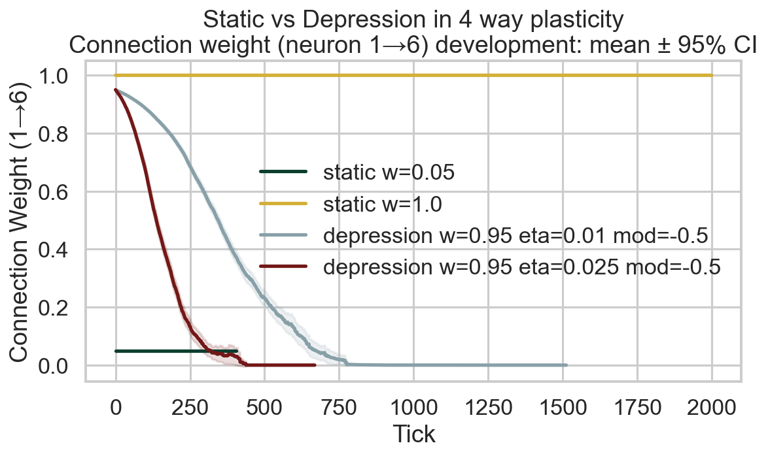

Survival race
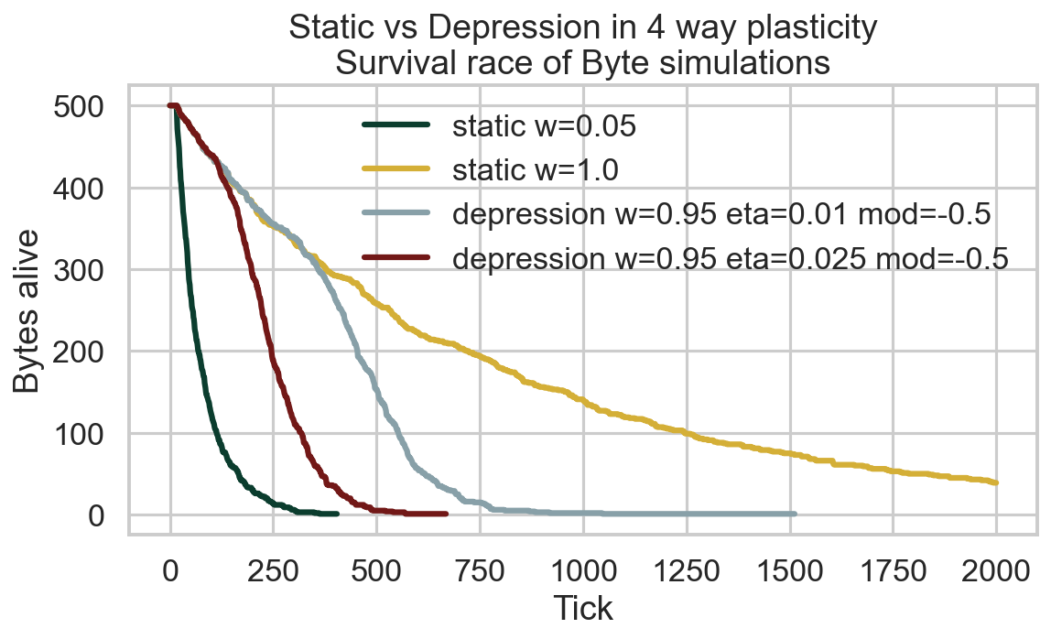

Survival time distribution
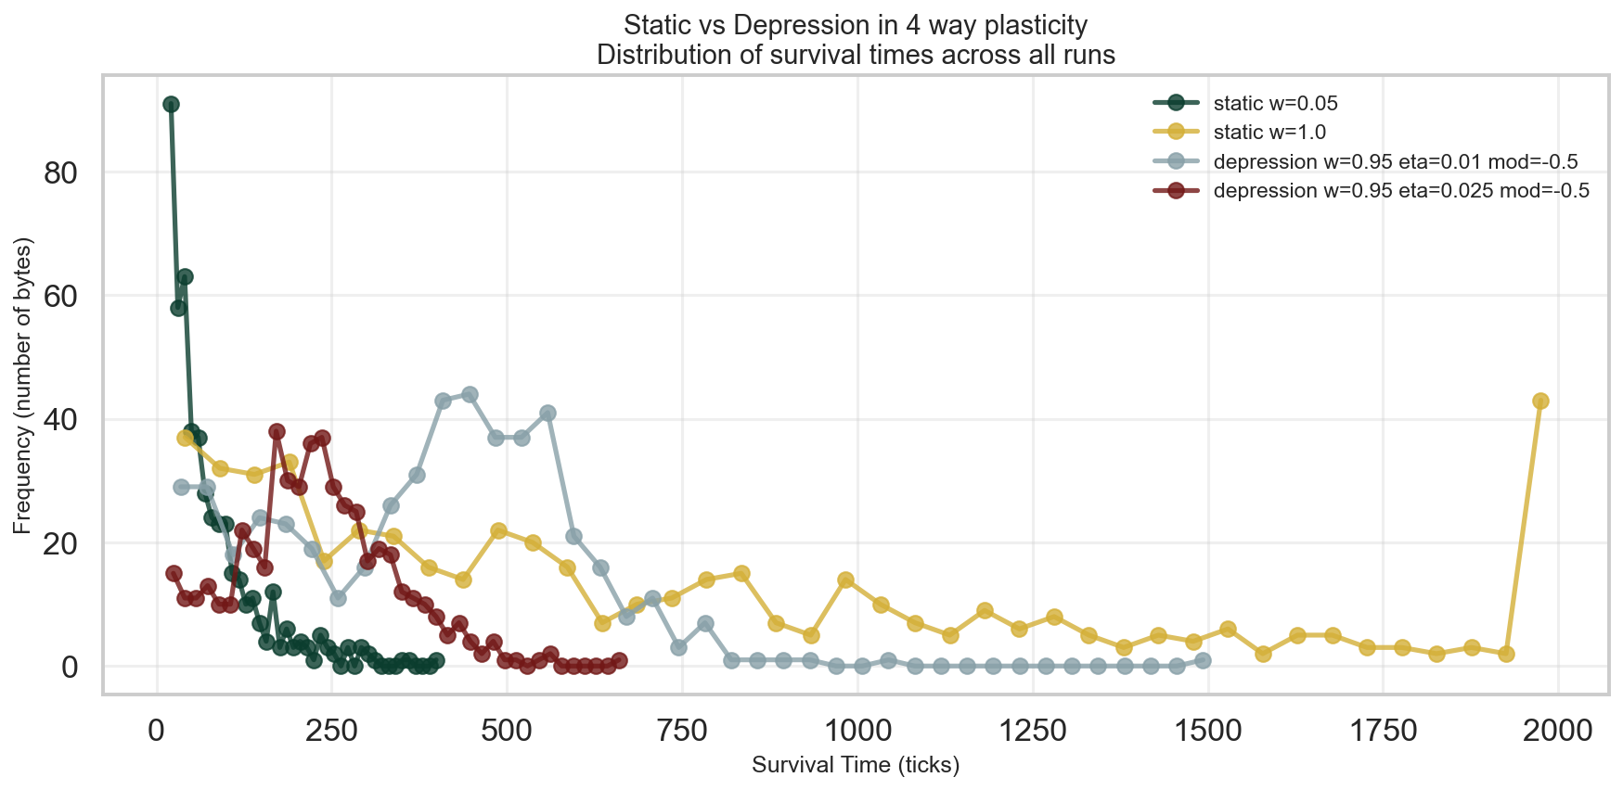

Survival CCDF (log-log)
