Analysis Report: Noise vs No Noise

Data Folders Used
- No noise: C:\Users\janad\OneDrive\Desktop\work_hard\Byte_Project\byte\data\noise_vs_nonoise\rawdata\2026-01-07_12-43-42_no_noise
- Noise = 0.5: C:\Users\janad\OneDrive\Desktop\work_hard\Byte_Project\byte\data\noise_vs_nonoise\rawdata\2026-01-07_13-37-40_noise_0_5
- Noise = 1.0: C:\Users\janad\OneDrive\Desktop\work_hard\Byte_Project\byte\data\noise_vs_nonoise\rawdata\2026-01-07_13-38-29_noise_1_0
- Random: C:\Users\janad\OneDrive\Desktop\work_hard\Byte_Project\byte\data\noise_vs_nonoise\rawdata\2026-01-08_17-37-19_random

Kolmogorov-Smirnov Test Results

No noise vs Noise = 0.5
Metric | Value
KS statistic | 0.0950
p-value | 2.3855e-04

No noise vs Noise = 1.0
Metric | Value
KS statistic | 0.3210
p-value | 5.9216e-46

No noise vs Random
Metric | Value
KS statistic | 0.3160
p-value | 1.6023e-44

Noise = 0.5 vs Noise = 1.0
Metric | Value
KS statistic | 0.2550
p-value | 5.7720e-29

Noise = 0.5 vs Random
Metric | Value
KS statistic | 0.3600
p-value | 5.7951e-58

Noise = 1.0 vs Random
Metric | Value
KS statistic | 0.3790
p-value | 2.3210e-64

Figures

Energy dynamics per run
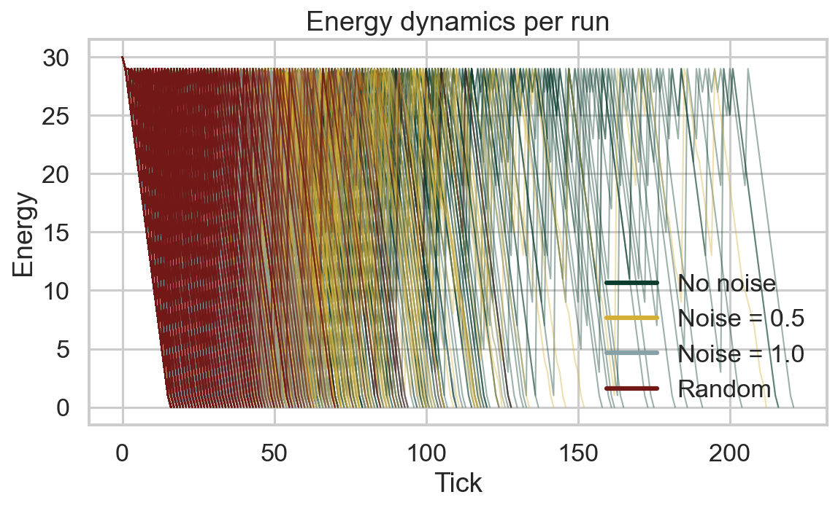

Food accumulation per run
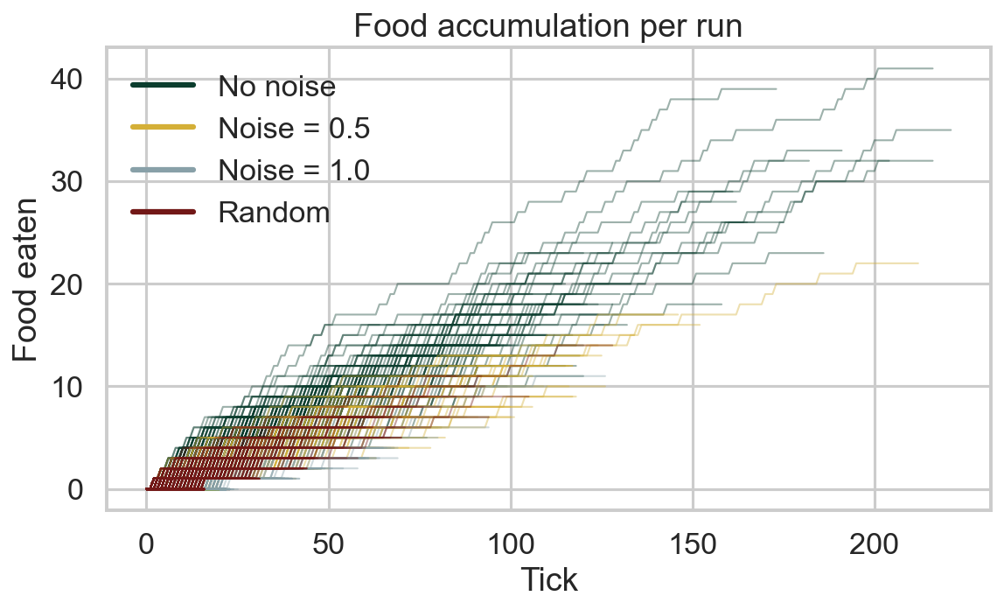

Distance accumulation per run
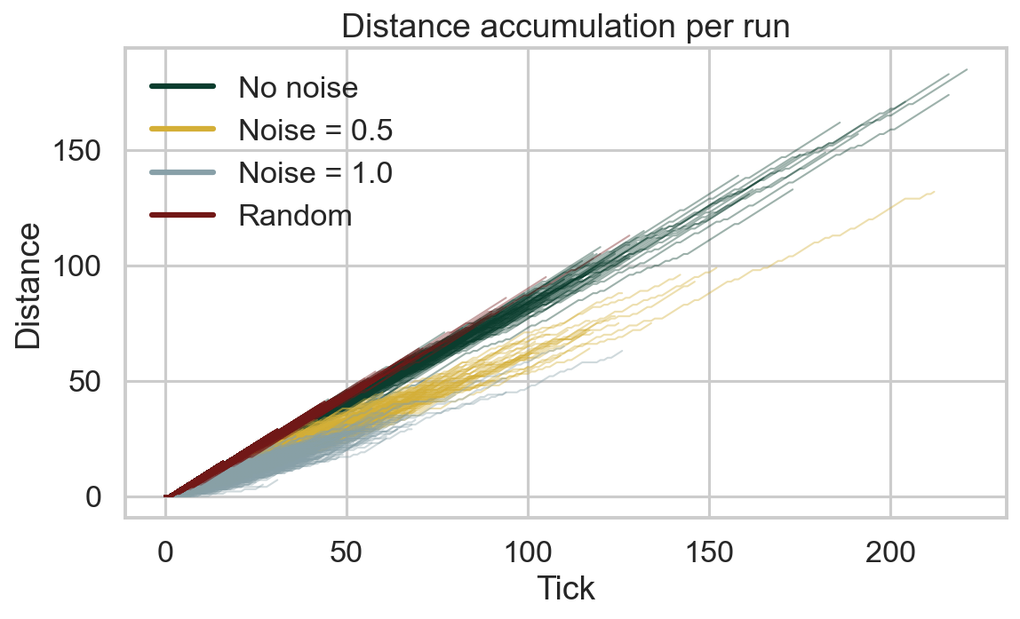

Survival race
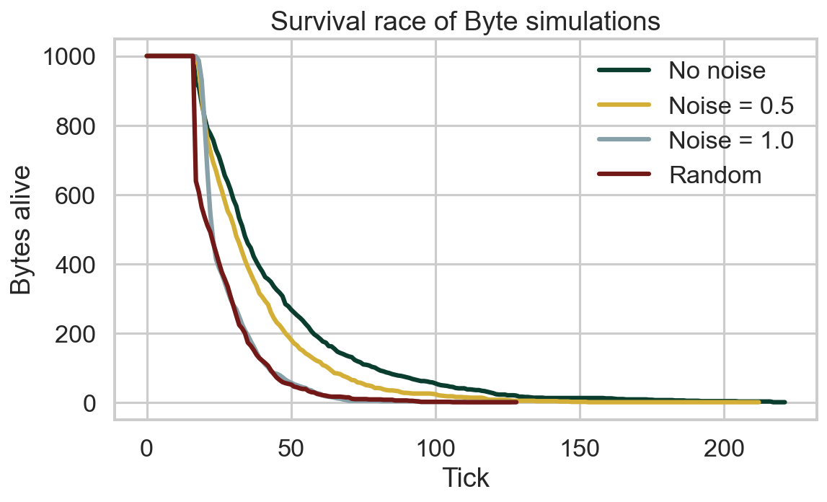

Survival CCDF (log-log)
