Analysis Report: Random Wiring Variants

median_survival

1. Experiment Information

Random Wiring Variants:
Experiment folder: 2026-03-08_15-39-28_random_no_regrow_all_tracked
Total random variants analyzed: 1000
Runs per variant: 100
Total data points (random): 100000

1.1. Summary Statistics - Random Wiring Variants
Summary of how long random wiring variants survive in the experimental environment. We measure survival time in simulation ticks across all 1000 variants to identify which wiring patterns lead to longer survival. We identify successful and unsuccessful variants using range-based thresholds: success is defined as achieving in the top 10% of the achievable performance range. This approach captures true performance excellence even if achieved only by a small number of variants and is used for detailed comparisons in subsequent sections.

Overall Descriptive Statistics (Across All Variants):
Summary statistics computed across individual lifetime measurements from all 1000 variants and 100 runs per variant.
Statistic | Value
Mean | 33.93 ticks
Median | 28.00 ticks
Std Dev | 26.85 ticks
Min | 16.00 ticks
Max | 795.00 ticks
Range | 779.00 ticks
IQR (25th-75th percentile) | 19.00 ticks
5th Percentile | 16.00 ticks
25th Percentile | 18.00 ticks
75th Percentile | 37.00 ticks
95th Percentile | 80.00 ticks
Skewness | 5.085
Kurtosis (excess) | 54.580
Coefficient of Variation | 79.14 %

Range-Based Performance Grouping:
Success is measured based on median survival across 100 runs with different randomizer seeds. The 1000 different wiring variants are split into successful and unsuccessful groups based on their performance. The achievable range of median liefetimes is split into percentiles. Variants in the 'successful' group had median lifetimes in the top 10% of that range, while variants in the 'unsuccessful' group had median lifetimes in the bottom 10% of that range. This approach respects natural performance gaps and identifies only the variants that truly solve the task well regardless of the number of variants that achieve this.
Metric | Value (ticks)
Successful threshold (top 10% of range) | >= 100.6
Unsuccessful threshold (bottom 10% of range) | <= 25.4
Variants identified in each group | Successful: 3, Unsuccessful: 394

Overall Descriptive Statistics per Variant:
Detailed breakdown of descriptive statistics computed across all variants. This table aggregates statistics per variant and then shows the highest, lowest, and average values of the 1000 variants. Heavy-tailed distributions are characterized by skewness and kurtosis; variants with high skewness or kurtosis have more extreme or rare events.
Statistic | Highest Value | Variant (Highest) | Lowest Value | Variant (Lowest) | Average
MEAN | 135.72 | variant_819 | 16.00 | variant_269 | 33.93
MEDIAN | 110.00 | variant_639 | 16.00 | variant_105 | 28.56
STD | 127.58 | variant_195 | 0.00 | variant_269 | 16.58
MIN | 30.00 | variant_461 | 16.00 | variant_02 | 17.89
MAX | 795.00 | variant_195 | 16.00 | variant_269 | 103.67
RANGE | 774.00 | variant_195 | 0.00 | variant_269 | 85.78
IQR | 140.00 | variant_177 | 0.00 | variant_107 | 17.76
P5 | 33.95 | variant_843 | 16.00 | variant_02 | 19.10
P25 | 67.00 | variant_52 | 16.00 | variant_09 | 22.32
P75 | 175.75 | variant_819 | 16.00 | variant_107 | 40.08
P95 | 407.85 | variant_177 | 16.00 | variant_18 | 65.82
SKEWNESS | 9.85 | variant_597 | -1.56 | variant_903 | 2.18
KURTOSIS | 95.01 | variant_567 | -1.50 | variant_884 | 7.53
CV | 128.73 | variant_195 | 0.00 | variant_269 | 43.49

1.2. Summary Statistics - Benchmark Variants
No benchmark variants provided for this analysis.

2. Survival Race Selection
The survival race plot tracks how many individuals from each wiring variant survive over time. Each curve represents a variant's cumulative survival, showing how fitness changes across the simulation. We use this visualization to identify which variants are robustly long-lived. The comparison table shows key statistics for successful versus unsuccessful variants, helping quantify the performance gap.
This plot shows the survival curves for all 1000 wiring variants. Variants are color-coded by their performance achievement (range-based thresholds):
• Green: Top 10% of variants (median survival ≥ 100.6 ticks) — 3 variants
• Red: Bottom 10% of variants (median survival ≤ 25.4 ticks) — 394 variants
• Gray: Middle range (other variants)
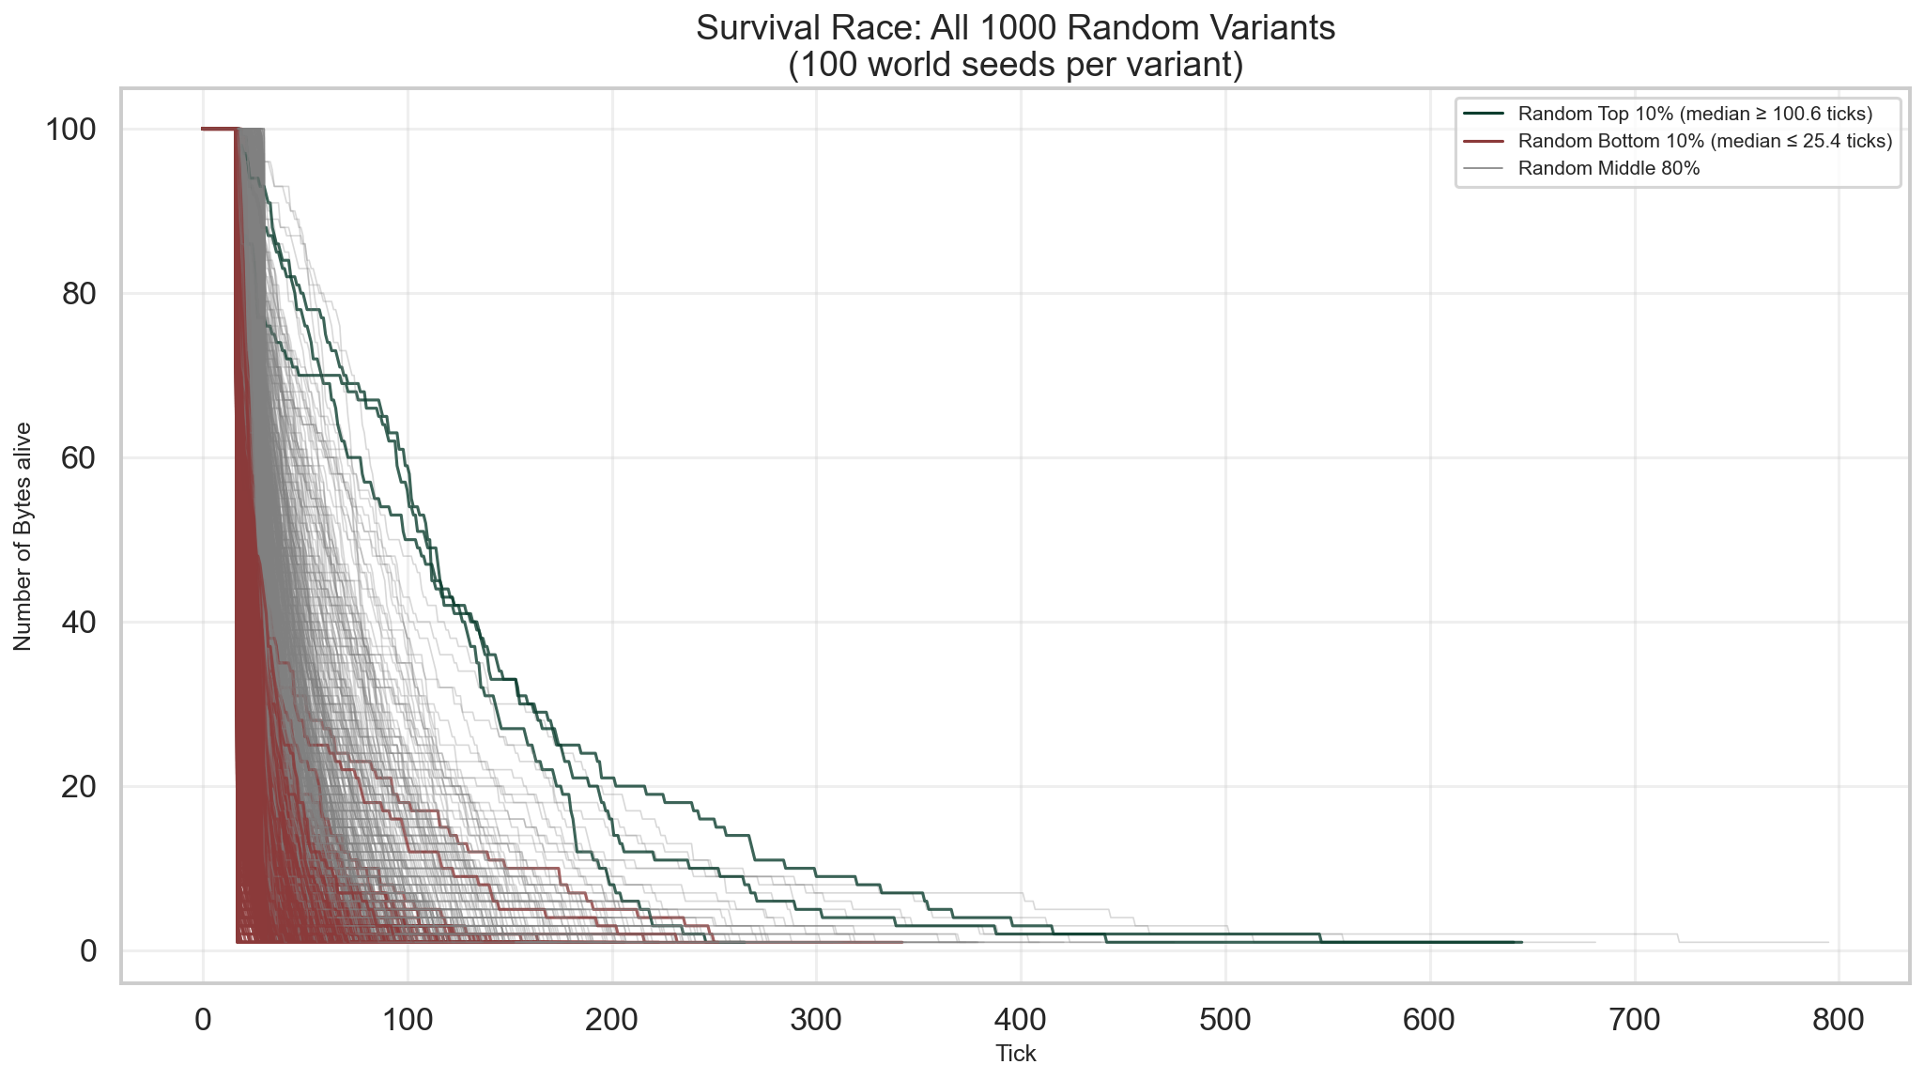

Successful vs Unsuccessful Comparison:
Metric | Successful (Top 10% of Variants) | Unsuccessful (Bottom 10% of Variants)
Number of runs | 300 | 39400
Mean (ticks) | 123.8 | 22.8
Median (ticks) | 108.0 | 17.0
Std Dev (ticks) | 96.5 | 13.2
Min (ticks) | 16.0 | 16.0
Max (ticks) | 645.0 | 342.0
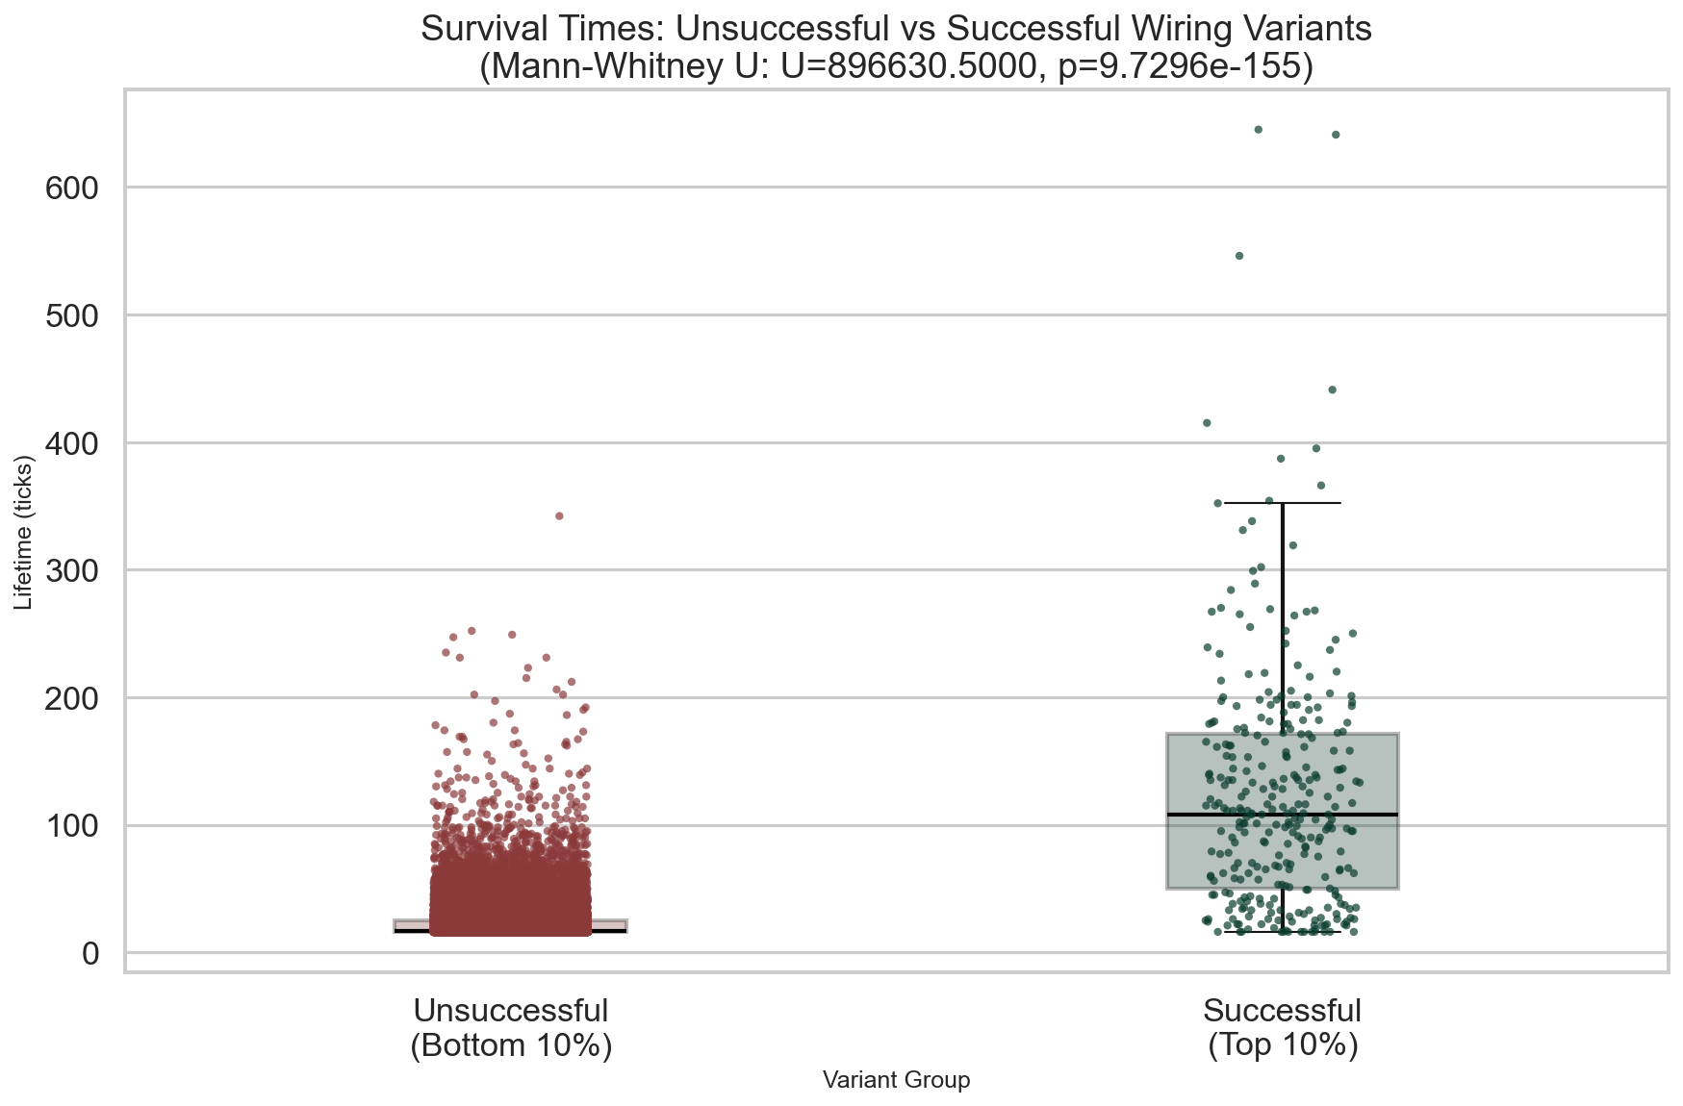

Variant Group Membership (for debugging/tracking):

Successful Variants (3 total):
variant_468, variant_639, variant_819

Unsuccessful Variants (394 total):
variant_09, variant_100, variant_101, variant_102, variant_103, variant_104, variant_105, variant_107, variant_108, variant_11, variant_111, variant_113, variant_116, variant_119, variant_121, variant_123, variant_124, variant_126, variant_127, variant_129, variant_131, variant_136, variant_138, variant_140, variant_142, variant_146, variant_149, variant_15, variant_154, variant_158, variant_162, variant_163, variant_169, variant_171, variant_178, variant_179, variant_18, variant_180, variant_181, variant_186, variant_187, variant_188, variant_189, variant_19, variant_190, variant_191, variant_196, variant_197, variant_199, variant_20, variant_200, variant_201, variant_209, variant_21, variant_212, variant_218, variant_220, variant_223, variant_225, variant_227, variant_228, variant_233, variant_236, variant_239, variant_241, variant_245, variant_250, variant_254, variant_255, variant_259, variant_262, variant_263, variant_264, variant_267, variant_269, variant_276, variant_278, variant_281, variant_282, variant_288, variant_295, variant_296, variant_297, variant_298, variant_30, variant_300, variant_305, variant_307, variant_311, variant_312, variant_317, variant_318, variant_319, variant_32, variant_323, variant_325, variant_337, variant_34, variant_340, variant_341, variant_342, variant_344, variant_347, variant_349, variant_35, variant_352, variant_353, variant_360, variant_362, variant_363, variant_366, variant_37, variant_371, variant_374, variant_375, variant_376, variant_377, variant_378, variant_38, variant_382, variant_385, variant_387, variant_388, variant_39, variant_391, variant_395, variant_396, variant_403, variant_404, variant_405, variant_406, variant_408, variant_410, variant_412, variant_413, variant_416, variant_417, variant_418, variant_420, variant_426, variant_428, variant_429, variant_430, variant_432, variant_434, variant_436, variant_439, variant_44, variant_441, variant_446, variant_449, variant_452, variant_454, variant_459, variant_46, variant_460, variant_463, variant_465, variant_467, variant_469, variant_471, variant_474, variant_477, variant_480, variant_481, variant_483, variant_487, variant_489, variant_49, variant_496, variant_497, variant_499, variant_50, variant_502, variant_505, variant_507, variant_510, variant_511, variant_513, variant_515, variant_518, variant_519, variant_521, variant_522, variant_525, variant_529, variant_536, variant_538, variant_542, variant_545, variant_546, variant_547, variant_549, variant_55, variant_550, variant_552, variant_554, variant_56, variant_561, variant_563, variant_564, variant_566, variant_567, variant_571, variant_574, variant_575, variant_576, variant_579, variant_58, variant_581, variant_582, variant_583, variant_585, variant_588, variant_590, variant_591, variant_593, variant_594, variant_595, variant_596, variant_597, variant_600, variant_601, variant_605, variant_61, variant_614, variant_617, variant_618, variant_619, variant_621, variant_622, variant_624, variant_626, variant_627, variant_628, variant_63, variant_632, variant_638, variant_641, variant_643, variant_644, variant_648, variant_649, variant_653, variant_654, variant_659, variant_66, variant_661, variant_663, variant_67, variant_673, variant_674, variant_675, variant_676, variant_678, variant_682, variant_684, variant_686, variant_689, variant_69, variant_691, variant_692, variant_696, variant_70, variant_700, variant_704, variant_709, variant_712, variant_714, variant_718, variant_72, variant_720, variant_722, variant_724, variant_726, variant_727, variant_729, variant_732, variant_734, variant_739, variant_74, variant_740, variant_741, variant_742, variant_744, variant_745, variant_746, variant_749, variant_75, variant_751, variant_753, variant_754, variant_755, variant_757, variant_758, variant_759, variant_76, variant_761, variant_762, variant_763, variant_77, variant_771, variant_772, variant_777, variant_778, variant_779, variant_780, variant_782, variant_786, variant_791, variant_793, variant_794, variant_798, variant_80, variant_802, variant_805, variant_806, variant_810, variant_812, variant_813, variant_815, variant_817, variant_818, variant_82, variant_820, variant_823, variant_824, variant_825, variant_826, variant_831, variant_833, variant_837, variant_846, variant_847, variant_848, variant_852, variant_853, variant_856, variant_858, variant_861, variant_865, variant_87, variant_874, variant_877, variant_879, variant_881, variant_883, variant_885, variant_886, variant_887, variant_888, variant_889, variant_89, variant_893, variant_895, variant_898, variant_899, variant_901, variant_906, variant_908, variant_909, variant_912, variant_918, variant_924, variant_929, variant_932, variant_937, variant_94, variant_941, variant_942, variant_947, variant_949, variant_953, variant_954, variant_956, variant_958, variant_965, variant_966, variant_967, variant_971, variant_972, variant_973, variant_974, variant_978, variant_979, variant_982, variant_984, variant_986, variant_987, variant_988, variant_99, variant_992, variant_993, variant_999

Differences between successful and unsuccessful random variants (Mann-Whitney U):
This statistical test compares whether successful and unsuccessful random variants have significantly different survival distributions.
Test Statistic | Value
U-statistic | 896630.5000
p-value | 9.7296e-155

3. Comparison between groups
Break down of successful versus unsuccessful variants across multiple metrics.

3.1. Movement Efficiency
For each cardinal direction (North, East, South, West), we calculate the ratio of movement commands to sensory detections. These are total numbers per run and only give a first overview indication of decision accuracy. A ratio close to 1.0 indicates tight coupling between sensing and movement. Ratios far from 1.0 (either higher or lower) indicate decoupling: movement without sensing, or moving more selectively despite sensing. This metric indicates fundamental differences in movement strategy between successful and unsuccessful variants but differences must be investigated on a tick-by-tick basis.
Movement Efficiency = Movement Count ÷ Sensing Count per direction
Direction | Unsuccessful (Mean ± Std) | Successful (Mean ± Std)
N | 1.125 ± 1.792 | 2.221 ± 2.099
E | 1.130 ± 1.801 | 0.357 ± 0.386
S | 1.100 ± 1.781 | 1.478 ± 1.448
W | 1.245 ± 1.943 | 0.876 ± 1.112
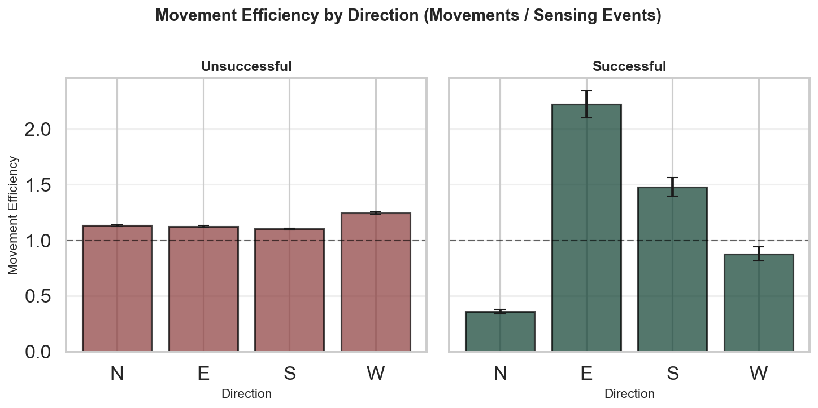

3.2. Decision Accuracy
Decision accuracy quantifies how often choices are aligned with food source locations. This measures, whether the wiring interprets sensory input to direct movement toward food. Higher accuracy indicates more direct coupling of decisions. We compare the distribution of accuracy values between successful and unsuccessful variants to determine whether fitness correlates with decision-making precision, or if other factors like movement efficiency play a larger role. Note that moving onto sensed food is a very shortsighted strategy that might not lead to an optimal solution in more complex tasks e.g. with food regrow in previous positions.
Decision Accuracy = Correct Decisions ÷ Total Decisions
Metric | Successful (Top 10%) | Unsuccessful (Bottom 10%)
Number of runs | 300 | 39400
Mean accuracy | 0.250 | 0.296
Median accuracy | 0.251 | 0.286
Std Dev | 0.092 | 0.168
Min | 0.000 | 0.000
Max | 0.750 | 1.000
Differences between successful and unsuccessful random variants (Mann-Whitney U):
Test Statistic | Value
U-statistic | 6913970.5000
p-value | 3.7645e-07

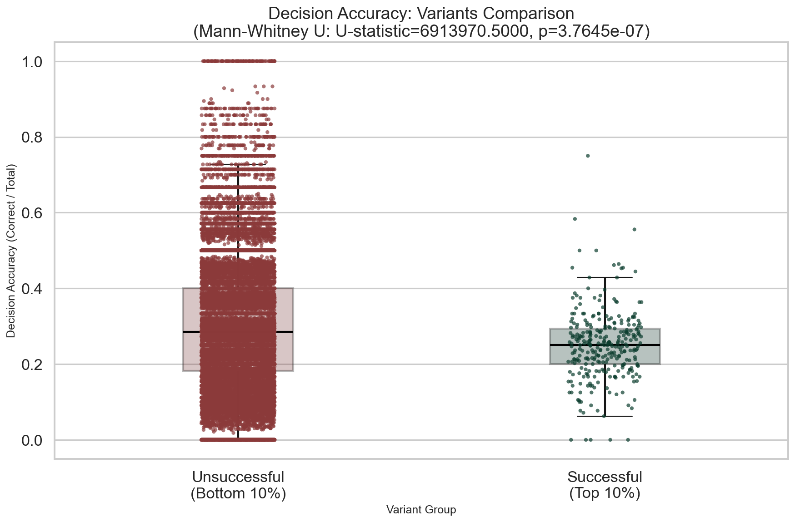

3.3. Distance travelled
Distance travelled total and normalized per tick for lifespan differences. We compare movement patterns between successful and unsuccessful variants to understand how spatial exploration versus local exploitation correlates with fitness.

3.3.1. Distance travelled absolute
Metric | Successful (Top 10%) | Unsuccessful (Bottom 10%)
Number of runs | 300 | 39400
Mean | 92.823 | 18.183
Median | 80.000 | 15.000
Std Dev | 74.460 | 9.525
Min | 8.000 | 0.000
Max | 525.000 | 194.000
Differences between successful and unsuccessful random variants (Mann-Whitney U):
Test Statistic | Value
U-statistic | 1062892.0
p-value | 3.7925e-139

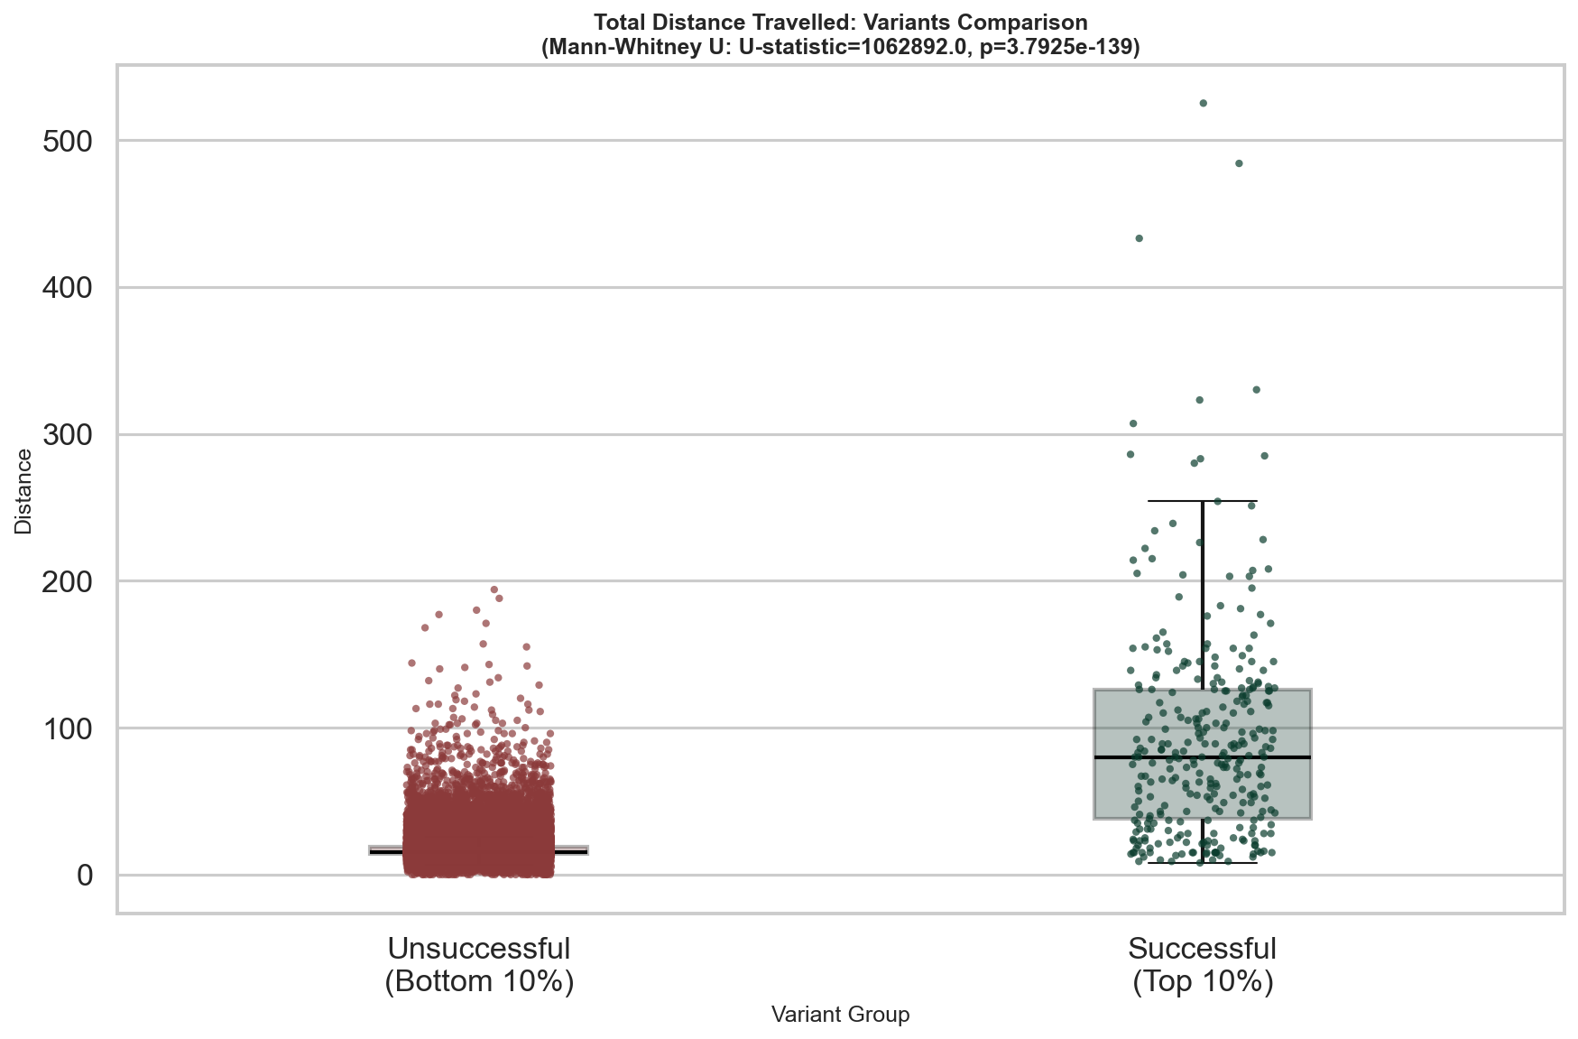

3.3.2. Distance travelled per tick
Metric | Successful (Top 10%) | Unsuccessful (Bottom 10%)
Number of runs | 300 | 39400
Mean | 0.752 | 0.824
Median | 0.776 | 0.875
Std Dev | 0.103 | 0.153
Min | 0.357 | 0.000
Max | 0.938 | 0.938
Differences between successful and unsuccessful random variants (Mann-Whitney U):
Test Statistic | Value
U-statistic | 8745068.5
p-value | 3.1366e-48

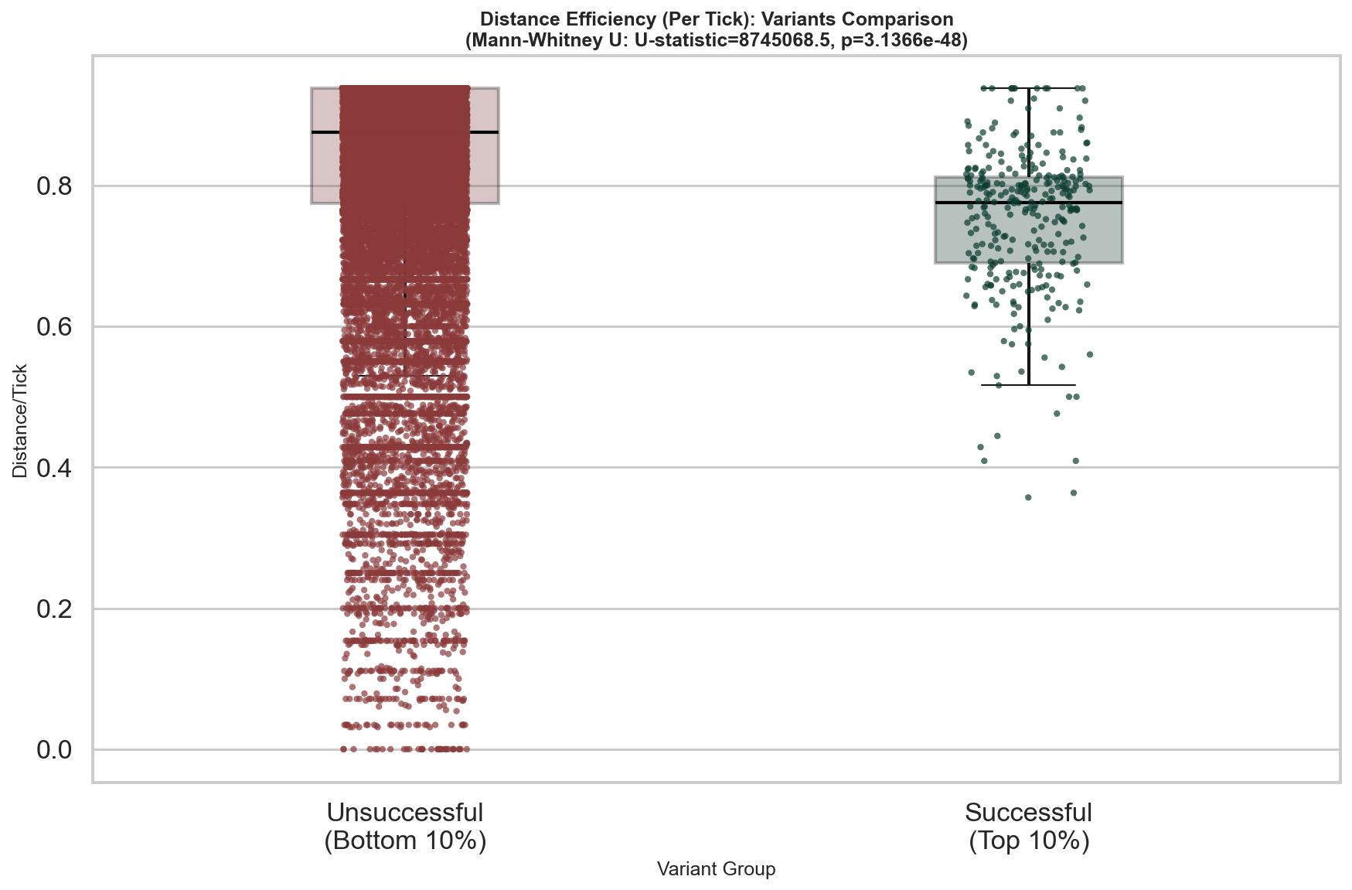

3.4. Food eaten
Food consumption is the ultimate solution of the task. The more food consumed, the longer the survival. Normalized per tick food consumption may be the metric most directly linked to survival fitness.

3.4.1. Food consumption absolute
Metric | Successful (Top 10%) | Unsuccessful (Bottom 10%)
Number of runs | 300 | 39400
Mean | 20.110 | 0.785
Median | 17.000 | 0.000
Std Dev | 18.638 | 1.576
Min | 0.000 | 0.000
Max | 122.000 | 40.000
Differences between successful and unsuccessful random variants (Mann-Whitney U):
Test Statistic | Value
U-statistic | 797037.5
p-value | 1.8570e-191

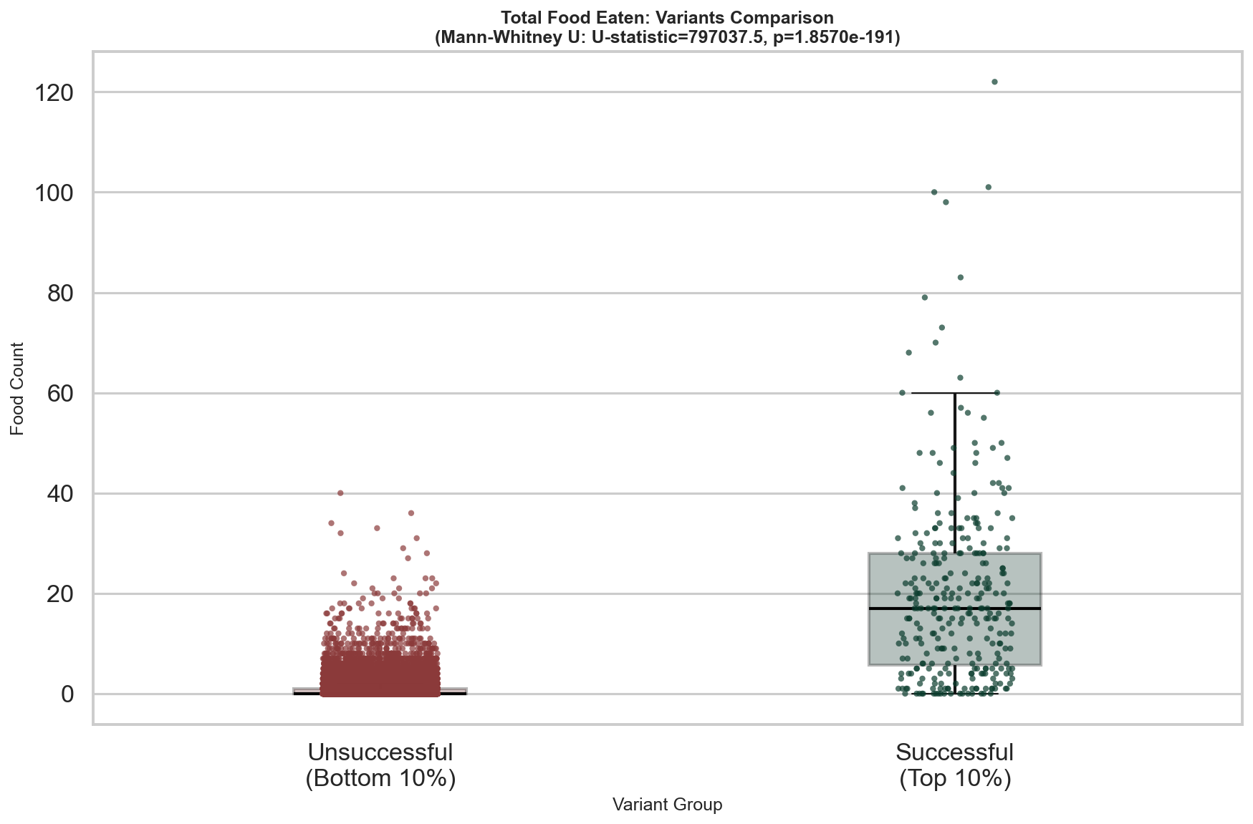

3.4.2. Food consumption per tick
Metric | Successful (Top 10%) | Unsuccessful (Bottom 10%)
Number of runs | 300 | 39400
Mean | 0.137 | 0.022
Median | 0.152 | 0.000
Std Dev | 0.054 | 0.031
Min | 0.000 | 0.000
Max | 0.227 | 0.185
Differences between successful and unsuccessful random variants (Mann-Whitney U):
Test Statistic | Value
U-statistic | 764851.5
p-value | 3.3969e-191

