Analysis Report: Static vs negative Plasticity

Data Folders Used
- static w=0.1: C:\work_hard\byte\data\plasticity_depression\rawdata\2026-03-05_20-03-16_static_w_0_1
- static w=0.9: C:\work_hard\byte\data\plasticity_depression\rawdata\2026-03-05_20-32-58_static_w_0_9
- plastic w=0.9, eta=0.01, mod=-0.05: C:\work_hard\byte\data\plasticity_depression\rawdata\2026-03-05_20-35-29_plastic_w_0_9_eta_0_01_mod_neg_0_05

Kolmogorov-Smirnov Test Results

static w=0.1 vs static w=0.9
Metric | Value
KS statistic | 0.2470
p-value | 3.4883e-27

static w=0.1 vs plastic w=0.9, eta=0.01, mod=-0.05
Metric | Value
KS statistic | 0.2460
p-value | 5.7691e-27

static w=0.9 vs plastic w=0.9, eta=0.01, mod=-0.05
Metric | Value
KS statistic | 0.0440
p-value | 2.8780e-01

Figures

Energy dynamics per run
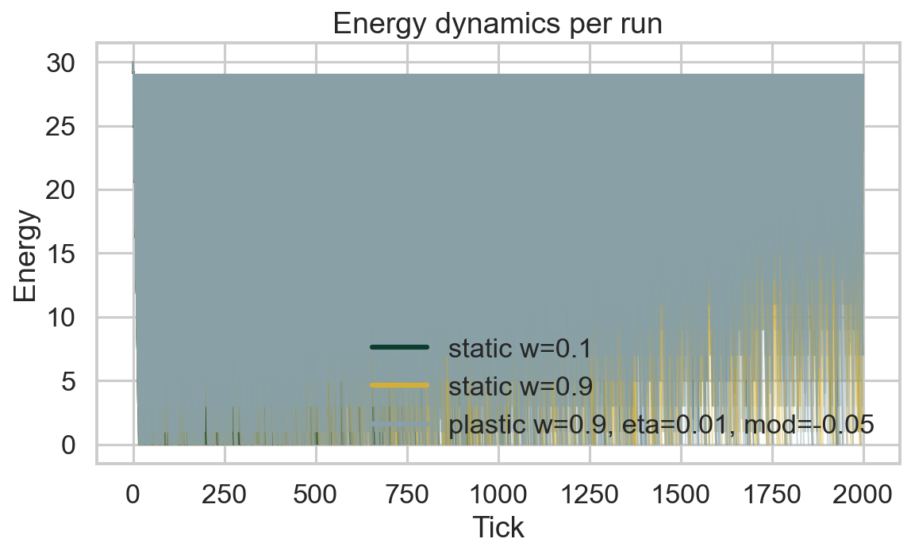

Food accumulation per run
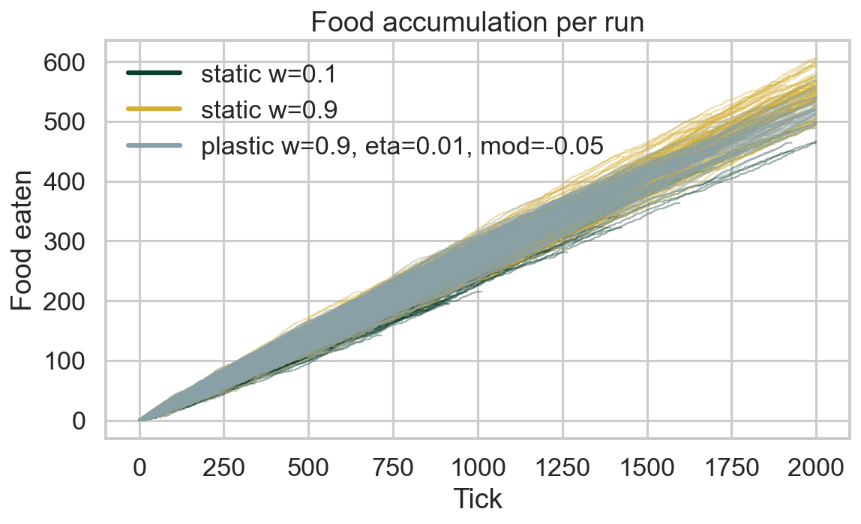

Distance accumulation per run
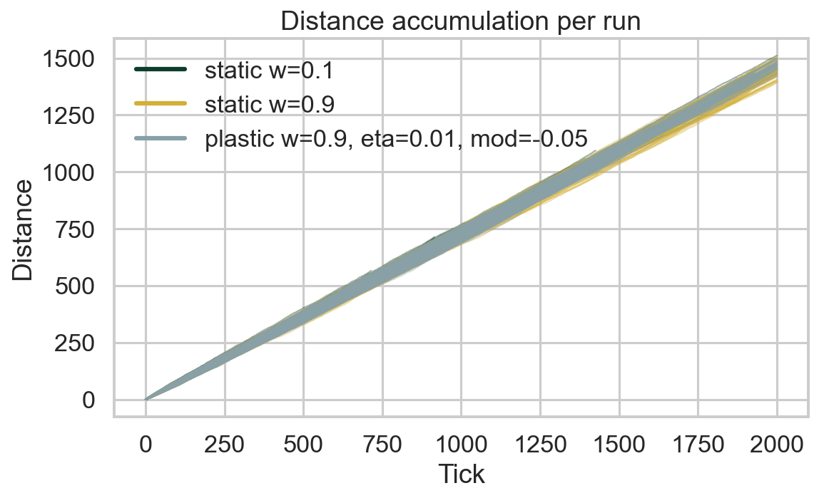

Connection weight 1→6 development per run
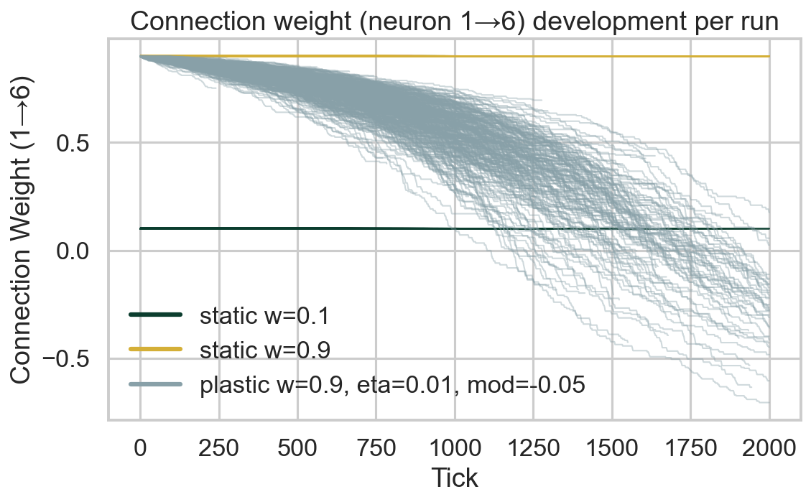

Connection weight 1→6 (mean ± 95% CI)
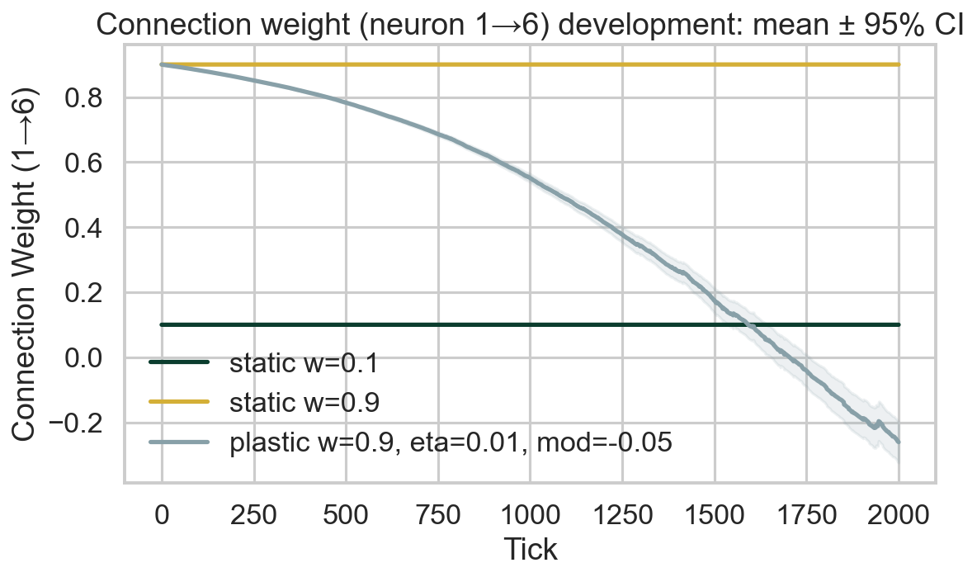

Survival race
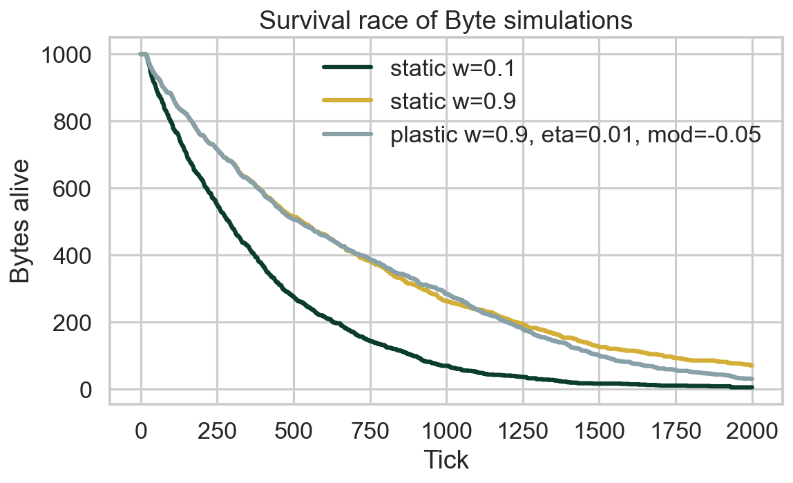

Survival time distribution
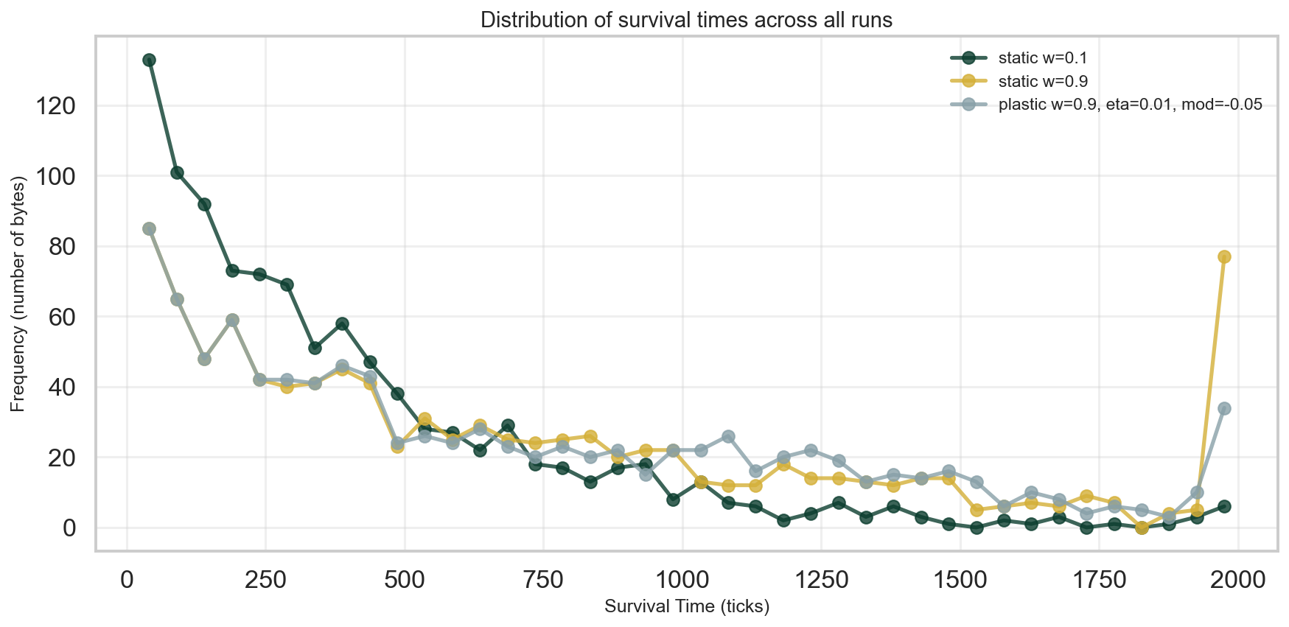

Survival CCDF (log-log)
