EA Analysis Report: first_ea

Experiment Parameters
Parameter | Value
Filename | 2026-05-05_17-42-25_ea_from_random
brain_max_decision_delay | 2.0
brain_n_neurons | 11
brain_noise_level | 0.05
experiment_evolutionary_algorithm_elite_selection_metric | average
experiment_evolutionary_algorithm_elite_size | 10
experiment_evolutionary_algorithm_mutation_method | simple
experiment_evolutionary_algorithm_mutation_rate | 0.1
experiment_evolutionary_algorithm_num_generations | 50
experiment_genome_type | random
experiment_max_ticks | 2000
experiment_n_runs | 300
experiment_population_size | 260
food_feeding_paradigm_initial | True
food_feeding_paradigm_regrow | False
food_initial_fraction_per_cell | 0.1
food_regrow_time | 3000
worm_decisionmaking_version | plasticity
worm_energy_capacity | 30
worm_metabolic_rate | 1
worm_movement_cost | 1

Benchmark: Hard-wired Lookup Parameters
Parameter | Value
Filename | 2026-05-05_17-28-53_lookup_hard
brain_max_decision_delay | 2.0
brain_n_neurons | 11
brain_noise_level | 0.05
experiment_evolutionary_algorithm_elite_selection_metric | average
experiment_evolutionary_algorithm_elite_size | 1
experiment_evolutionary_algorithm_mutation_method | simple
experiment_evolutionary_algorithm_mutation_rate | 0.1
experiment_evolutionary_algorithm_num_generations | 1
experiment_genome_type | lookup_hard
experiment_max_ticks | 2000
experiment_n_runs | 300
experiment_population_size | 1
food_feeding_paradigm_initial | True
food_feeding_paradigm_regrow | False
food_initial_fraction_per_cell | 0.1
food_regrow_time | 3000
worm_decisionmaking_version | plasticity
worm_energy_capacity | 30
worm_metabolic_rate | 1
worm_movement_cost | 1

Benchmark: Random networks Parameters
Parameter | Value
Filename | 2026-05-05_17-29-22_random
brain_max_decision_delay | 2.0
brain_n_neurons | 11
brain_noise_level | 0.05
experiment_evolutionary_algorithm_elite_selection_metric | average
experiment_evolutionary_algorithm_elite_size | 100
experiment_evolutionary_algorithm_mutation_method | simple
experiment_evolutionary_algorithm_mutation_rate | 0.1
experiment_evolutionary_algorithm_num_generations | 1
experiment_genome_type | random
experiment_max_ticks | 2000
experiment_n_runs | 300
experiment_population_size | 100
food_feeding_paradigm_initial | True
food_feeding_paradigm_regrow | False
food_initial_fraction_per_cell | 0.1
food_regrow_time | 3000
worm_decisionmaking_version | plasticity
worm_energy_capacity | 30
worm_metabolic_rate | 1
worm_movement_cost | 1

Benchmark: Soft-wired Lookup Parameters
Parameter | Value
Filename | 2026-05-05_17-28-28_lookup_soft
brain_max_decision_delay | 2.0
brain_n_neurons | 11
brain_noise_level | 0.05
experiment_evolutionary_algorithm_elite_selection_metric | average
experiment_evolutionary_algorithm_elite_size | 1
experiment_evolutionary_algorithm_mutation_method | simple
experiment_evolutionary_algorithm_mutation_rate | 0.1
experiment_evolutionary_algorithm_num_generations | 1
experiment_genome_type | lookup_soft
experiment_max_ticks | 2000
experiment_n_runs | 300
experiment_population_size | 1
food_feeding_paradigm_initial | True
food_feeding_paradigm_regrow | False
food_initial_fraction_per_cell | 0.1
food_regrow_time | 3000
worm_decisionmaking_version | plasticity
worm_energy_capacity | 30
worm_metabolic_rate | 1
worm_movement_cost | 1

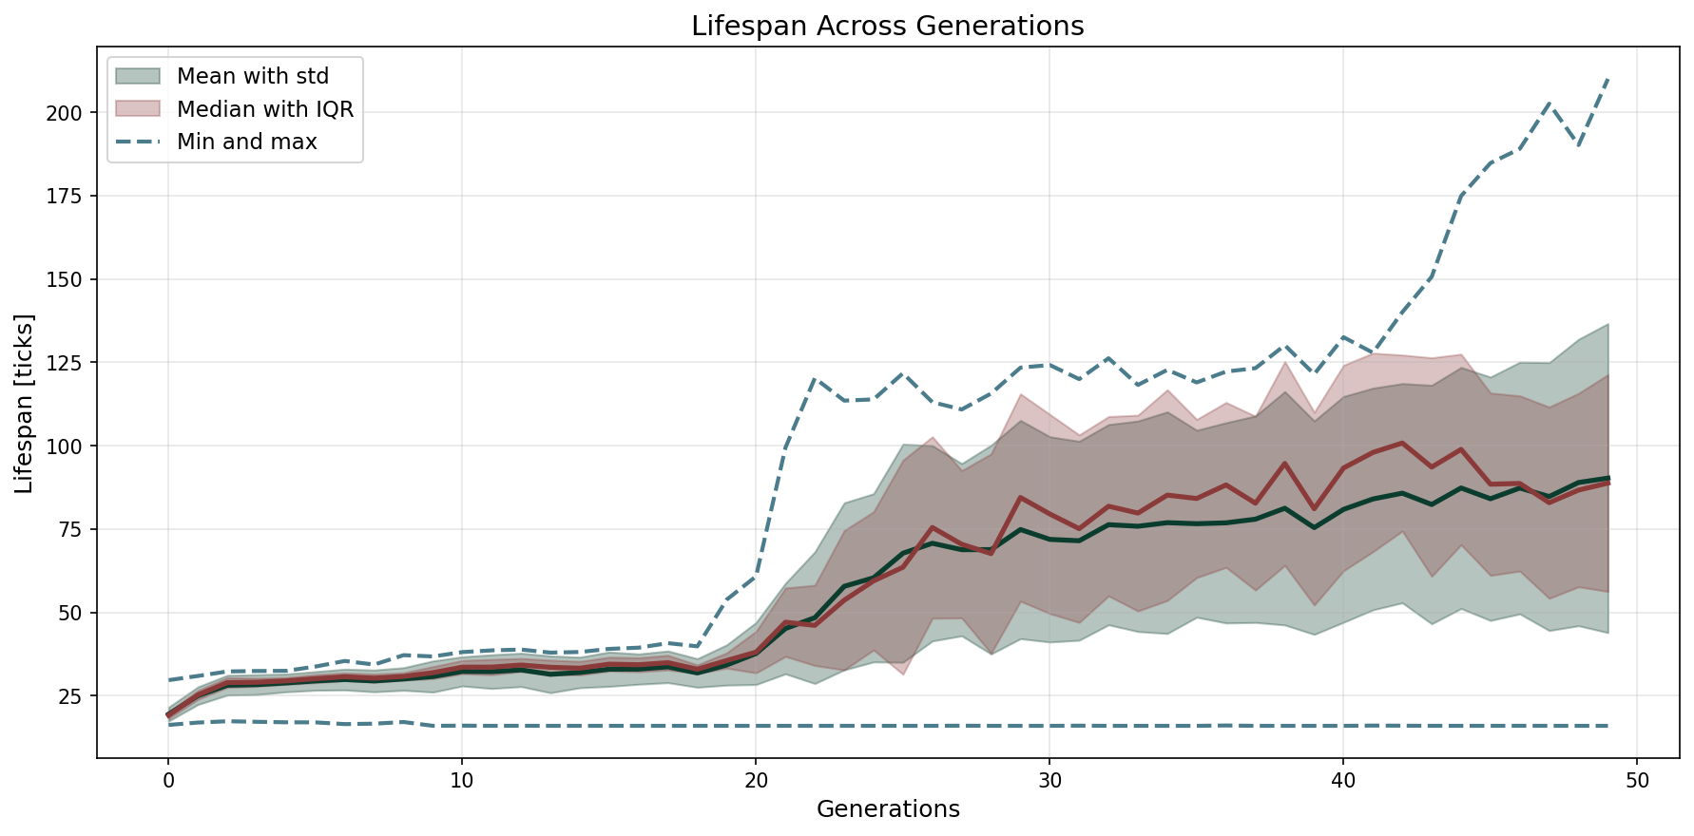

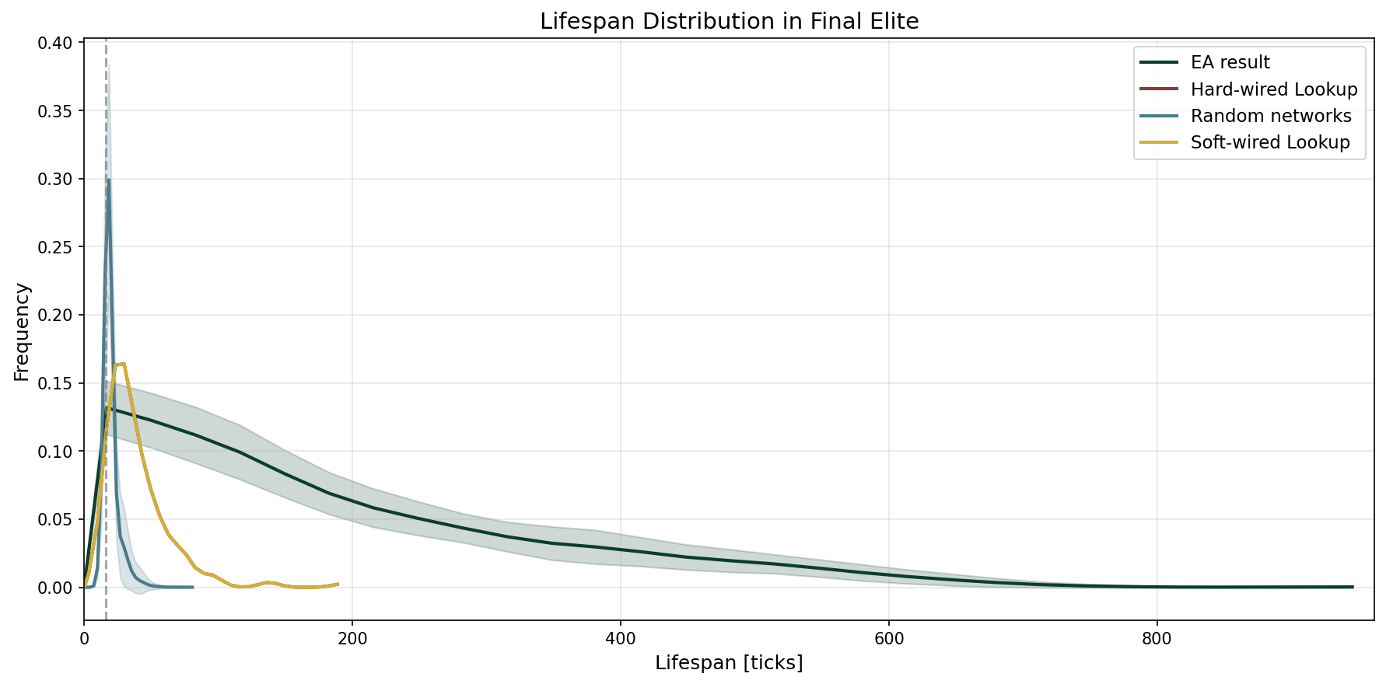

Network Visualizations
