Analysis Report: Random Wiring Variants

Convergence Check on hard-wired lookup variant

1. Experiment Information

Random Wiring Variants:
Experiment file: 2026-03-12_19-19-06_random_lookup.h5
Total random variants analyzed: 1
Runs per variant: 500
Total data points (random): 500

1.1. Summary Statistics - Random Wiring Variants
Summary of how long random wiring variants survive in the experimental environment. We measure survival time in simulation ticks across all 1 variants and 500 runs per variant. The statistics below provide a comprehensive overview of survival time distribution across all measurements.

Overall Descriptive Statistics (Across All Variants):
Statistic | Value
Mean | 99.29 ticks
Median | 87.00 ticks
Std Dev | 63.22 ticks
Min | 19.00 ticks
Max | 388.00 ticks
Range | 369.00 ticks
IQR (25th-75th percentile) | 71.00 ticks
5th Percentile | 29.00 ticks
25th Percentile | 53.00 ticks
75th Percentile | 124.00 ticks
95th Percentile | 230.25 ticks
Skewness | 1.650
Kurtosis (excess) | 3.351
Coefficient of Variation | 63.68 %

2. Survival Race
This plot shows the survival curves for all 1 wiring variants.
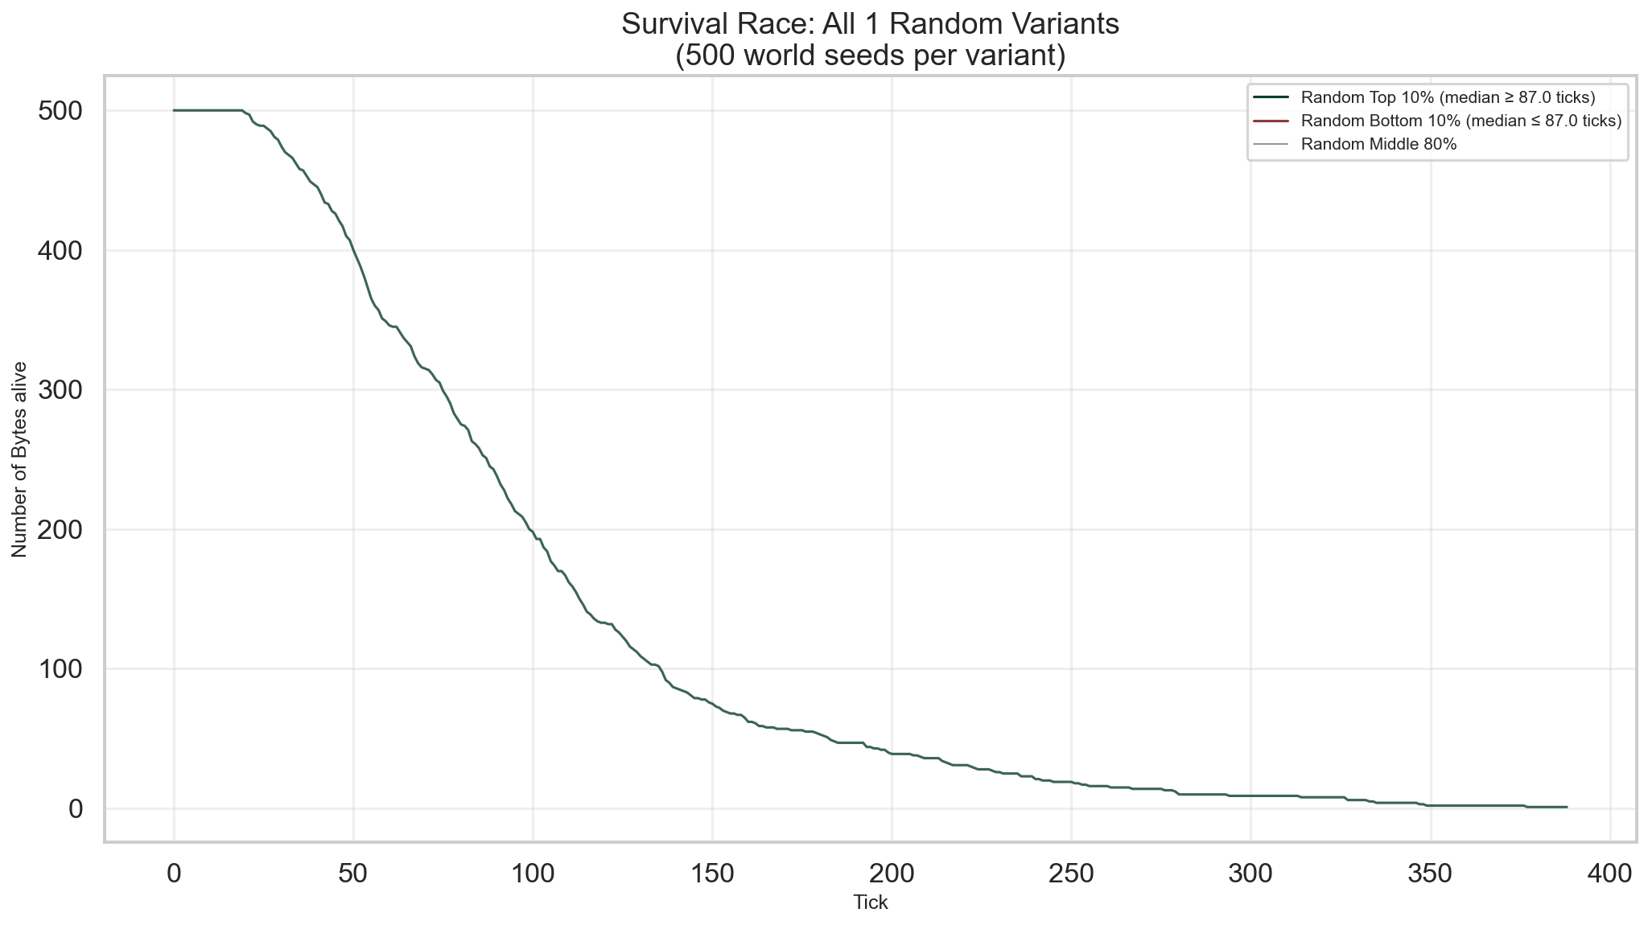

Network Development
Below are combined network visualizations showing initial wiring and the first three runtime states.
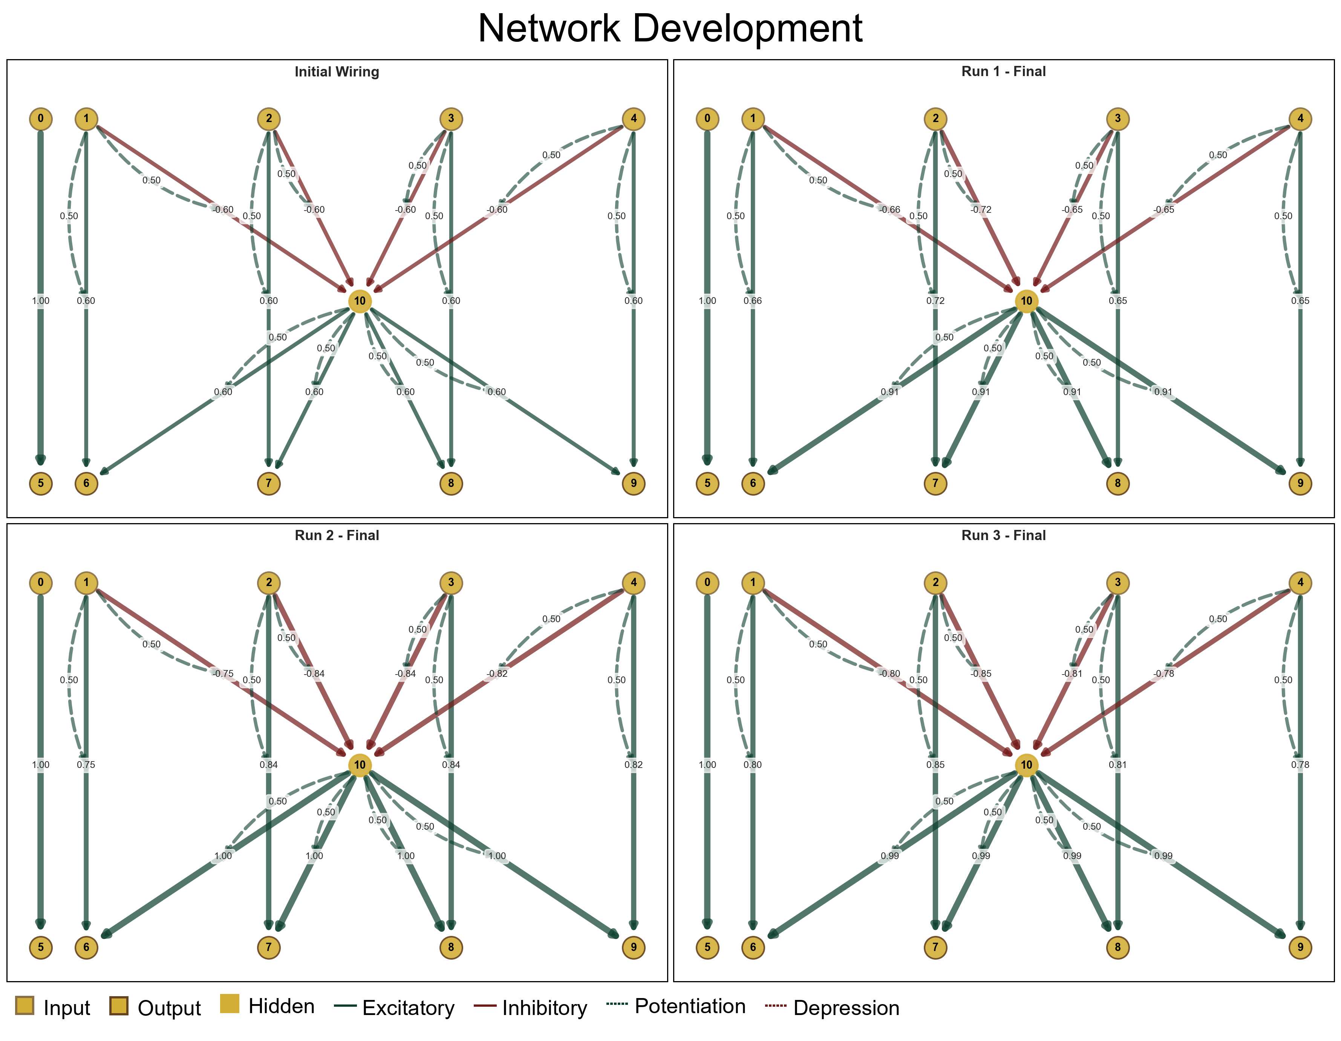

3. Convergence
We analyze the convergence of simulation metrics and of variance of simulation metrics over the number of runs. Each run subjects the same variant to a different world seed, which can be thought of as a different environment. Simulations should run a large enough number of runs to allow metrics to converge to stable values that are reliable readouts of the variant's performance, rather than dominated by chance from rng world seeds.

3.1. Survival Times
Convergence analysis of survival times (lifetime_ticks) across all runs. The left y-axis shows central tendency (rolling mean and median) and data spread (rolling IQR), while the right y-axis shows uncertainty estimates (bootstrap SE of median and SE of mean). Convergence is achieved when both the central tendency and uncertainty curves have stabilized.
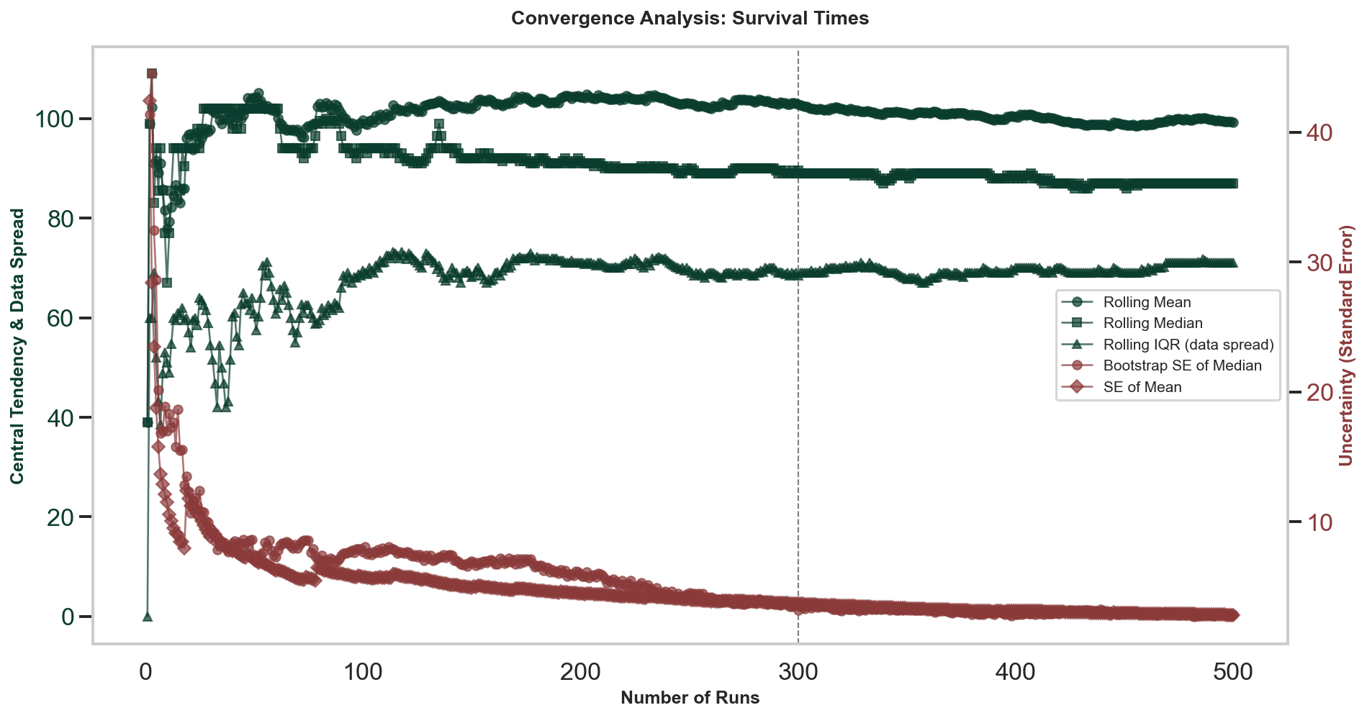

3.2. Food Consumed
Convergence analysis of food consumed across all runs. The left y-axis shows central tendency (rolling mean and median) and data spread (rolling IQR), while the right y-axis shows uncertainty estimates (bootstrap SE of median and SE of mean). Convergence is achieved when both the central tendency and uncertainty curves have stabilized.
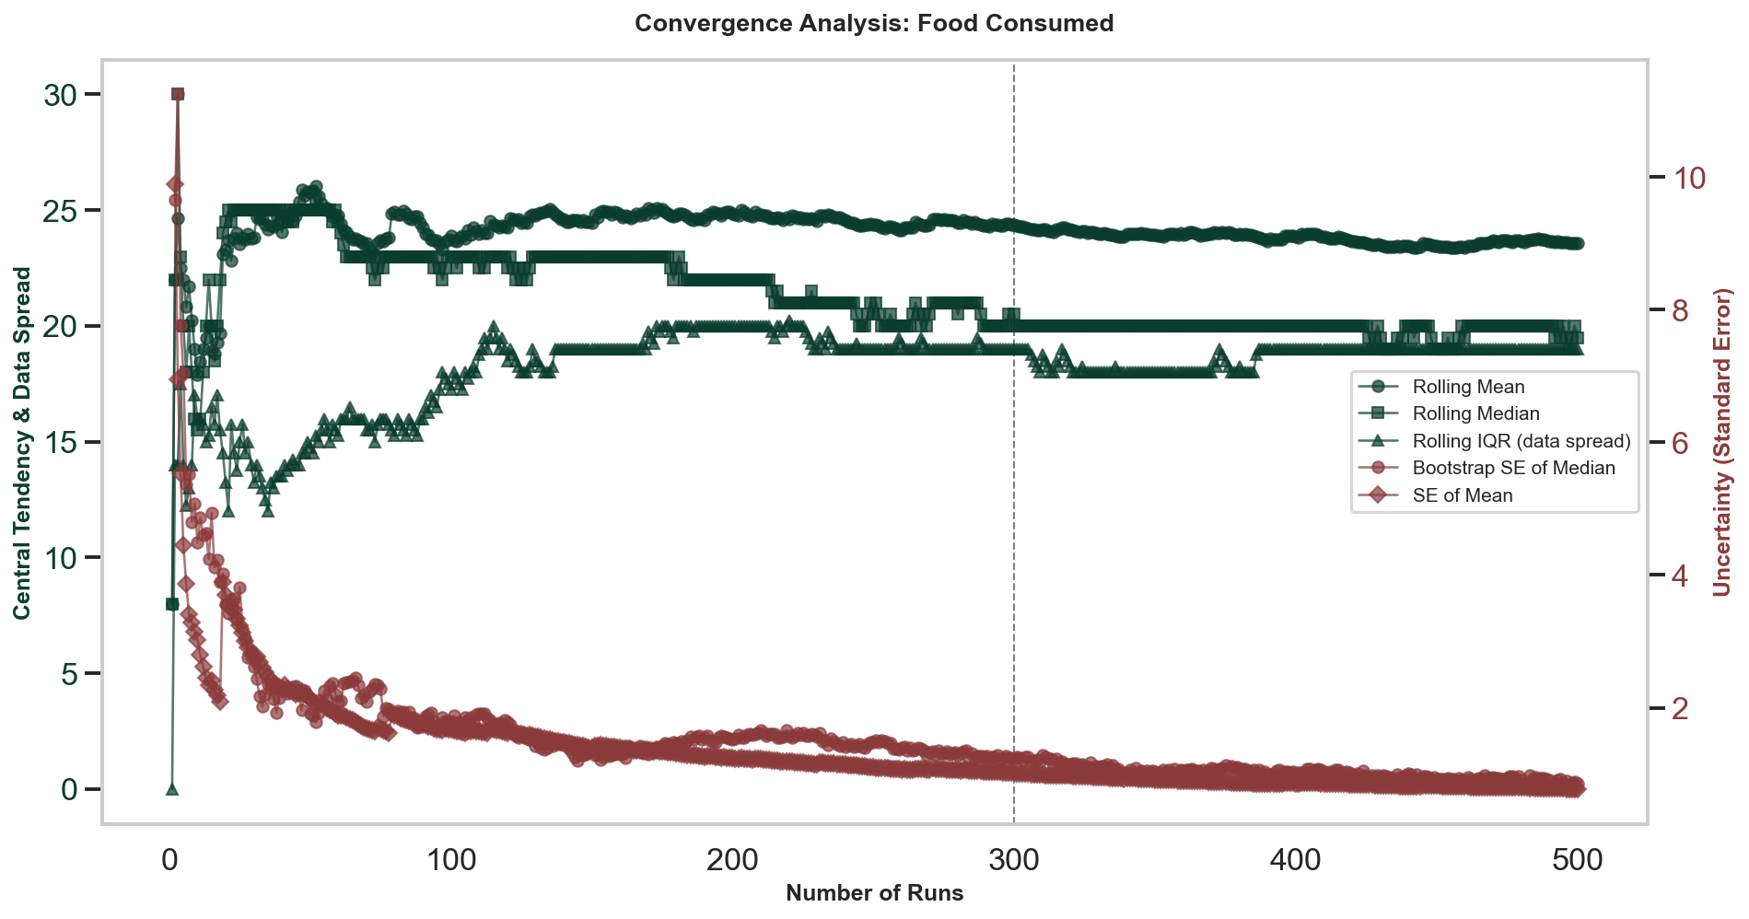

3.3. Distance Travelled
Convergence analysis of distance travelled across all runs. The left y-axis shows central tendency (rolling mean and median) and data spread (rolling IQR), while the right y-axis shows uncertainty estimates (bootstrap SE of median and SE of mean). Convergence is achieved when both the central tendency and uncertainty curves have stabilized.
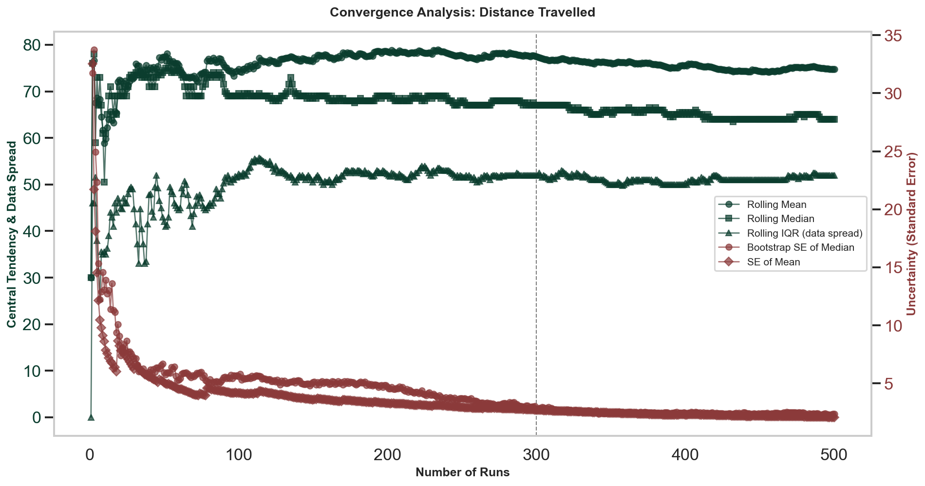

3.4. Decisions Made
Convergence analysis of decisions made across all runs. The left y-axis shows central tendency (rolling mean and median) and data spread (rolling IQR), while the right y-axis shows uncertainty estimates (bootstrap SE of median and SE of mean). Convergence is achieved when both the central tendency and uncertainty curves have stabilized.
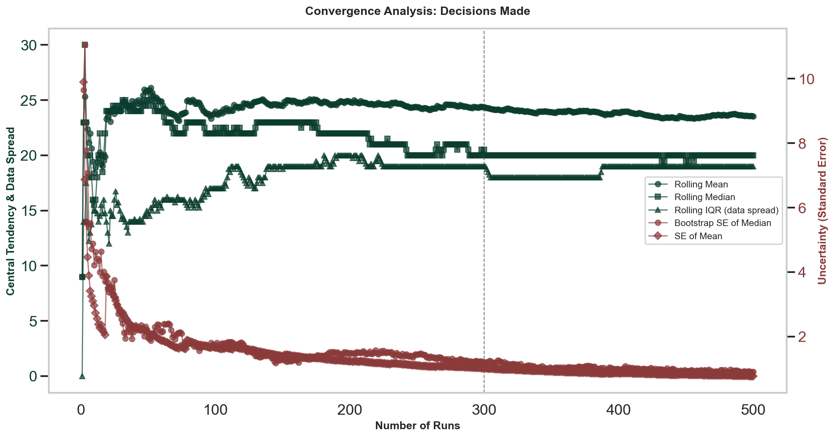

3.5. Food Consumption Per Tick
Convergence analysis of food consumption per tick (total food consumed divided by survival time). The left y-axis shows central tendency (rolling mean and median) and data spread (rolling IQR), while the right y-axis shows uncertainty estimates (bootstrap SE of median and SE of mean). Convergence is achieved when both the central tendency and uncertainty curves have stabilized.
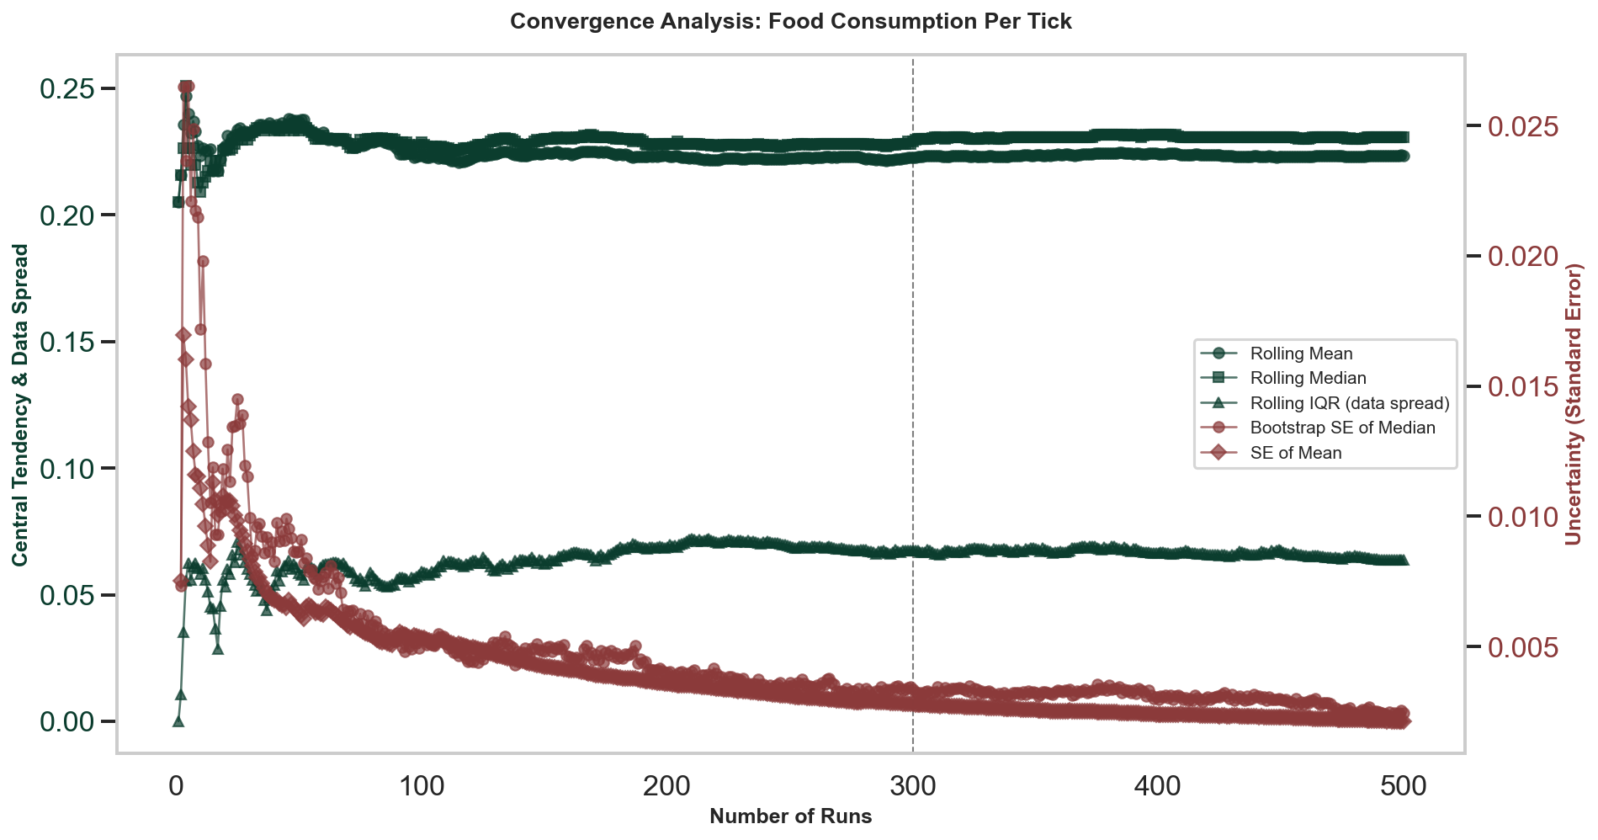

3.6. Distance Per Tick
Convergence analysis of distance travelled per tick (total distance divided by survival time). The left y-axis shows central tendency (rolling mean and median) and data spread (rolling IQR), while the right y-axis shows uncertainty estimates (bootstrap SE of median and SE of mean). Convergence is achieved when both the central tendency and uncertainty curves have stabilized.
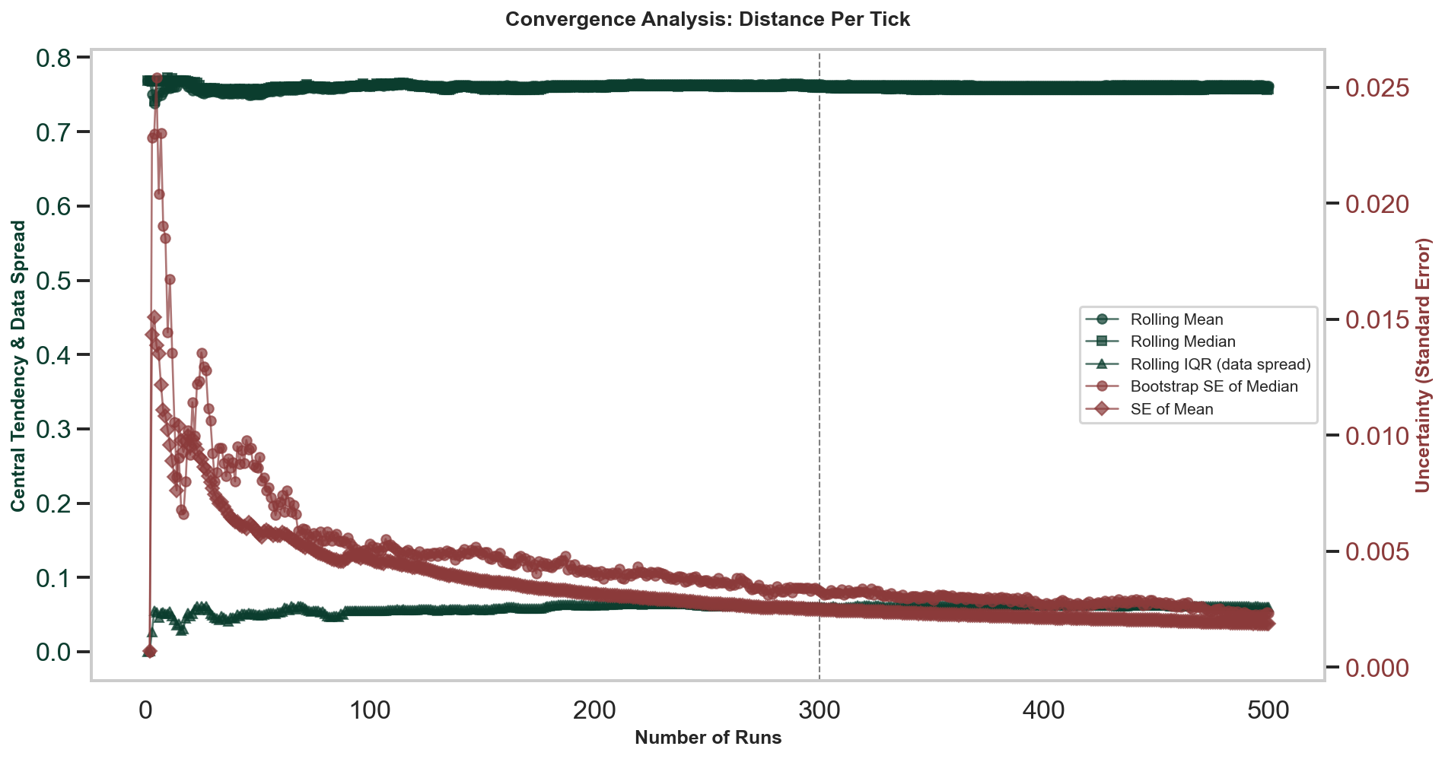

3.7. Decisions Per Tick
Convergence analysis of decisions made per tick (total decisions divided by survival time). The left y-axis shows central tendency (rolling mean and median) and data spread (rolling IQR), while the right y-axis shows uncertainty estimates (bootstrap SE of median and SE of mean). Convergence is achieved when both the central tendency and uncertainty curves have stabilized.
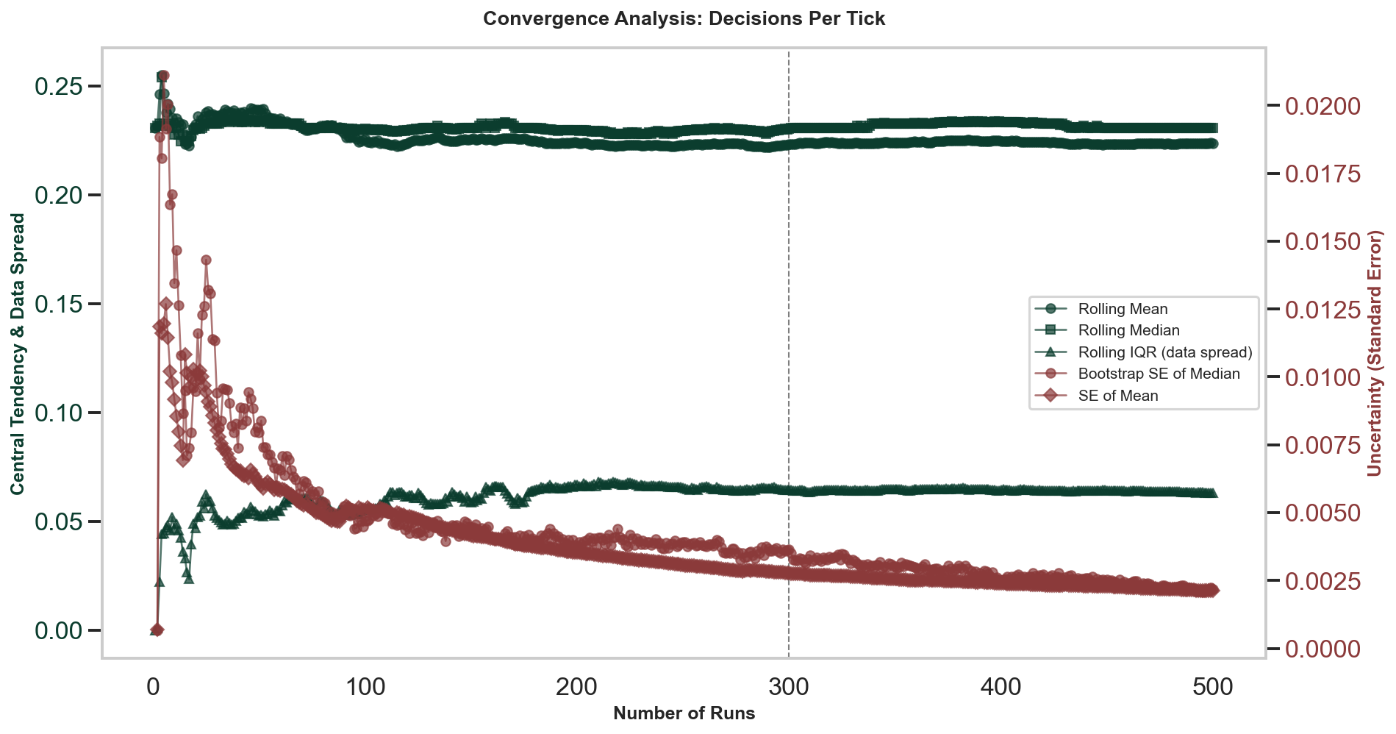

3.8. Connection Weights
Convergence analysis of synaptic connection weights for representative connections. Two representative connections are shown: Connection 1→6 and Connection 3→10. Each plot shows the left y-axis with central tendency (rolling mean and median) and data spread (rolling IQR), while the right y-axis shows uncertainty estimates (bootstrap SE of median and SE of mean). Convergence is achieved when both the central tendency and uncertainty curves have stabilized.
