Analysis Report: random_vs_lookup

1. Experiment Information

Experiment:
Dataset: 2026-04-09_15-30-03_random.h5
Number of variants: 1000
Runs per variant: 300
Total data points: 300000

Hard-wired Lookup:
Dataset: 2026-04-09_16-03-50_lookup.h5
Number of variants: 1
Runs per variant: 300
Total data points: 300

Statistical Analysis Methodology
This report employs adaptive statistical analysis based on data distribution and group count. Four analytical scenarios are used:
1. TWO GROUPS, NORMALLY DISTRIBUTED DATA
• Omnibus Test: Welch's t-test (compares means)
• Effect Size: Cohen's d (interpretation: small ≥ 0.2, medium ≥ 0.5, large ≥ 0.8)
• Post-hoc: Not applicable (omnibus test serves as pairwise comparison)
• Significance threshold: p < 0.05
2. TWO GROUPS, NON-NORMALLY DISTRIBUTED DATA
• Omnibus Test: Mann-Whitney U test (compares distributions via ranks)
• Effect Size: Rank-Biserial r (interpretation: small ≥ 0.11, medium ≥ 0.28, large ≥ 0.43)
• Post-hoc: Not applicable (omnibus test serves as pairwise comparison)
• Significance threshold: p < 0.05
3. MORE THAN TWO GROUPS, NORMALLY DISTRIBUTED DATA
• Omnibus Test: One-way ANOVA (tests if any group means differ)
• Effect Size: Eta-squared η² (interpretation: small ≥ 0.01, medium ≥ 0.06, large ≥ 0.14)
• Post-hoc Pairwise Test: Welch's t-test (all pairs compared)
• Multiple Comparisons Correction: Tukey's HSD (controls Type I error across pairwise comparisons)
• Post-hoc Effect Size: Cohen's d (interpretation: small ≥ 0.2, medium ≥ 0.5, large ≥ 0.8)
• Significance threshold: p < 0.05 (omnibus and post-hoc)
4. MORE THAN TWO GROUPS, NON-NORMALLY DISTRIBUTED DATA
• Omnibus Test: Kruskal-Wallis (tests if any group distributions differ via ranks)
• Effect Size: Ordinal Epsilon-squared ε²R (interpretation: small ≥ 0.01, medium ≥ 0.08, large ≥ 0.26)
• Post-hoc Pairwise Test: Mann-Whitney U (all pairs compared)
• Multiple Comparisons Correction: Holm-Bonferroni (sequential adjustment of p-value thresholds)
• Post-hoc Effect Size: Rank-Biserial r (interpretation: small ≥ 0.11, medium ≥ 0.28, large ≥ 0.43)
• Significance threshold: p < 0.05 (omnibus and post-hoc)
Normality is assessed using the Shapiro-Wilk test (alpha = 0.05) for each group independently. If any group fails the normality test, the analysis uses non-parametric methods.
PER-TICK METRICS (TEMPORAL ANALYSIS)
For metrics tracked per simulation tick (e.g., energy), per-tick data are analyzed using the Area Under the Curve (AUC) method:
• Each run's per-tick metric values (tick 0 to end of run) are integrated using the trapezoidal rule to produce a single AUC value per run
• AUC values are then compared across groups using the same adaptive statistical framework as above (Welch's t-test/Mann-Whitney U for 2 groups, ANOVA/Kruskal-Wallis for >2 groups)
• This approach is conservative and avoids temporal autocorrelation issues by summarizing the time-series into a single magnitude metric
• Visualizations show individual run curves (low opacity) overlaid with group mean curves (bold) and 95% confidence bands (shaded)

1.1. Overview Variants
Statistic | Value
Mean | 27.54 ticks
Median | 21.00 ticks
Std Dev | 17.84 ticks
Min | 16.00 ticks
Max | 604.00 ticks
Range | 588.00 ticks
IQR (25th-75th percentile) | 14.00 ticks
5th Percentile | 16.00 ticks
25th Percentile | 17.00 ticks
75th Percentile | 31.00 ticks
95th Percentile | 59.00 ticks
Skewness | 4.236
Kurtosis (excess) | 37.843
Coefficient of Variation | 64.77 %

Per-Variant Summary (Min, Max, Average across variants):
Statistic | Min (Variant) | Max (Variant) | Average
Mean | 16.00 ticks (variant_181) | 97.53 ticks (variant_491) | 27.54 ticks
Median | 16.00 ticks (variant_09) | 88.50 ticks (variant_491) | 22.83 ticks
Std Dev | 0.00 ticks (variant_181) | 87.09 ticks (variant_639) | 12.29 ticks
Min | 16.00 ticks (variant_01) | 30.00 ticks (variant_527) | 16.72 ticks
Max | 16.00 ticks (variant_181) | 604.00 ticks (variant_455) | 92.04 ticks
Range | 0.00 ticks (variant_181) | 588.00 ticks (variant_455) | 75.32 ticks
IQR (25th-75th percentile) | 0.00 ticks (variant_09) | 112.25 ticks (variant_639) | 12.71 ticks
5th Percentile | 16.00 ticks (variant_02) | 30.00 ticks (variant_370) | 17.37 ticks
25th Percentile | 16.00 ticks (variant_02) | 59.00 ticks (variant_491) | 19.24 ticks
75th Percentile | 16.00 ticks (variant_09) | 128.25 ticks (variant_491) | 31.95 ticks
95th Percentile | 16.00 ticks (variant_18) | 258.20 ticks (variant_639) | 51.96 ticks
Skewness | -0.019 (variant_194) | 17.234 (variant_605) | nan
Kurtosis (excess) | -1.221 (variant_194) | 295.003 (variant_605) | nan
Coefficient of Variation | 0.00 % (variant_181) | 112.65 % (variant_639) | 41.64 %

1.2. Overview Benchmarks
Statistic | Hard-wired Lookup
Mean | 102.91 ticks
Median | 89.50 ticks
Std Dev | 63.96 ticks
Min | 20.00 ticks
Max | 376.00 ticks
Range | 356.00 ticks
IQR (25th-75th percentile) | 68.50 ticks
5th Percentile | 29.95 ticks
25th Percentile | 56.75 ticks
75th Percentile | 125.25 ticks
95th Percentile | 239.00 ticks
Skewness | 1.550
Kurtosis (excess) | 2.796
Coefficient of Variation | 62.16 %
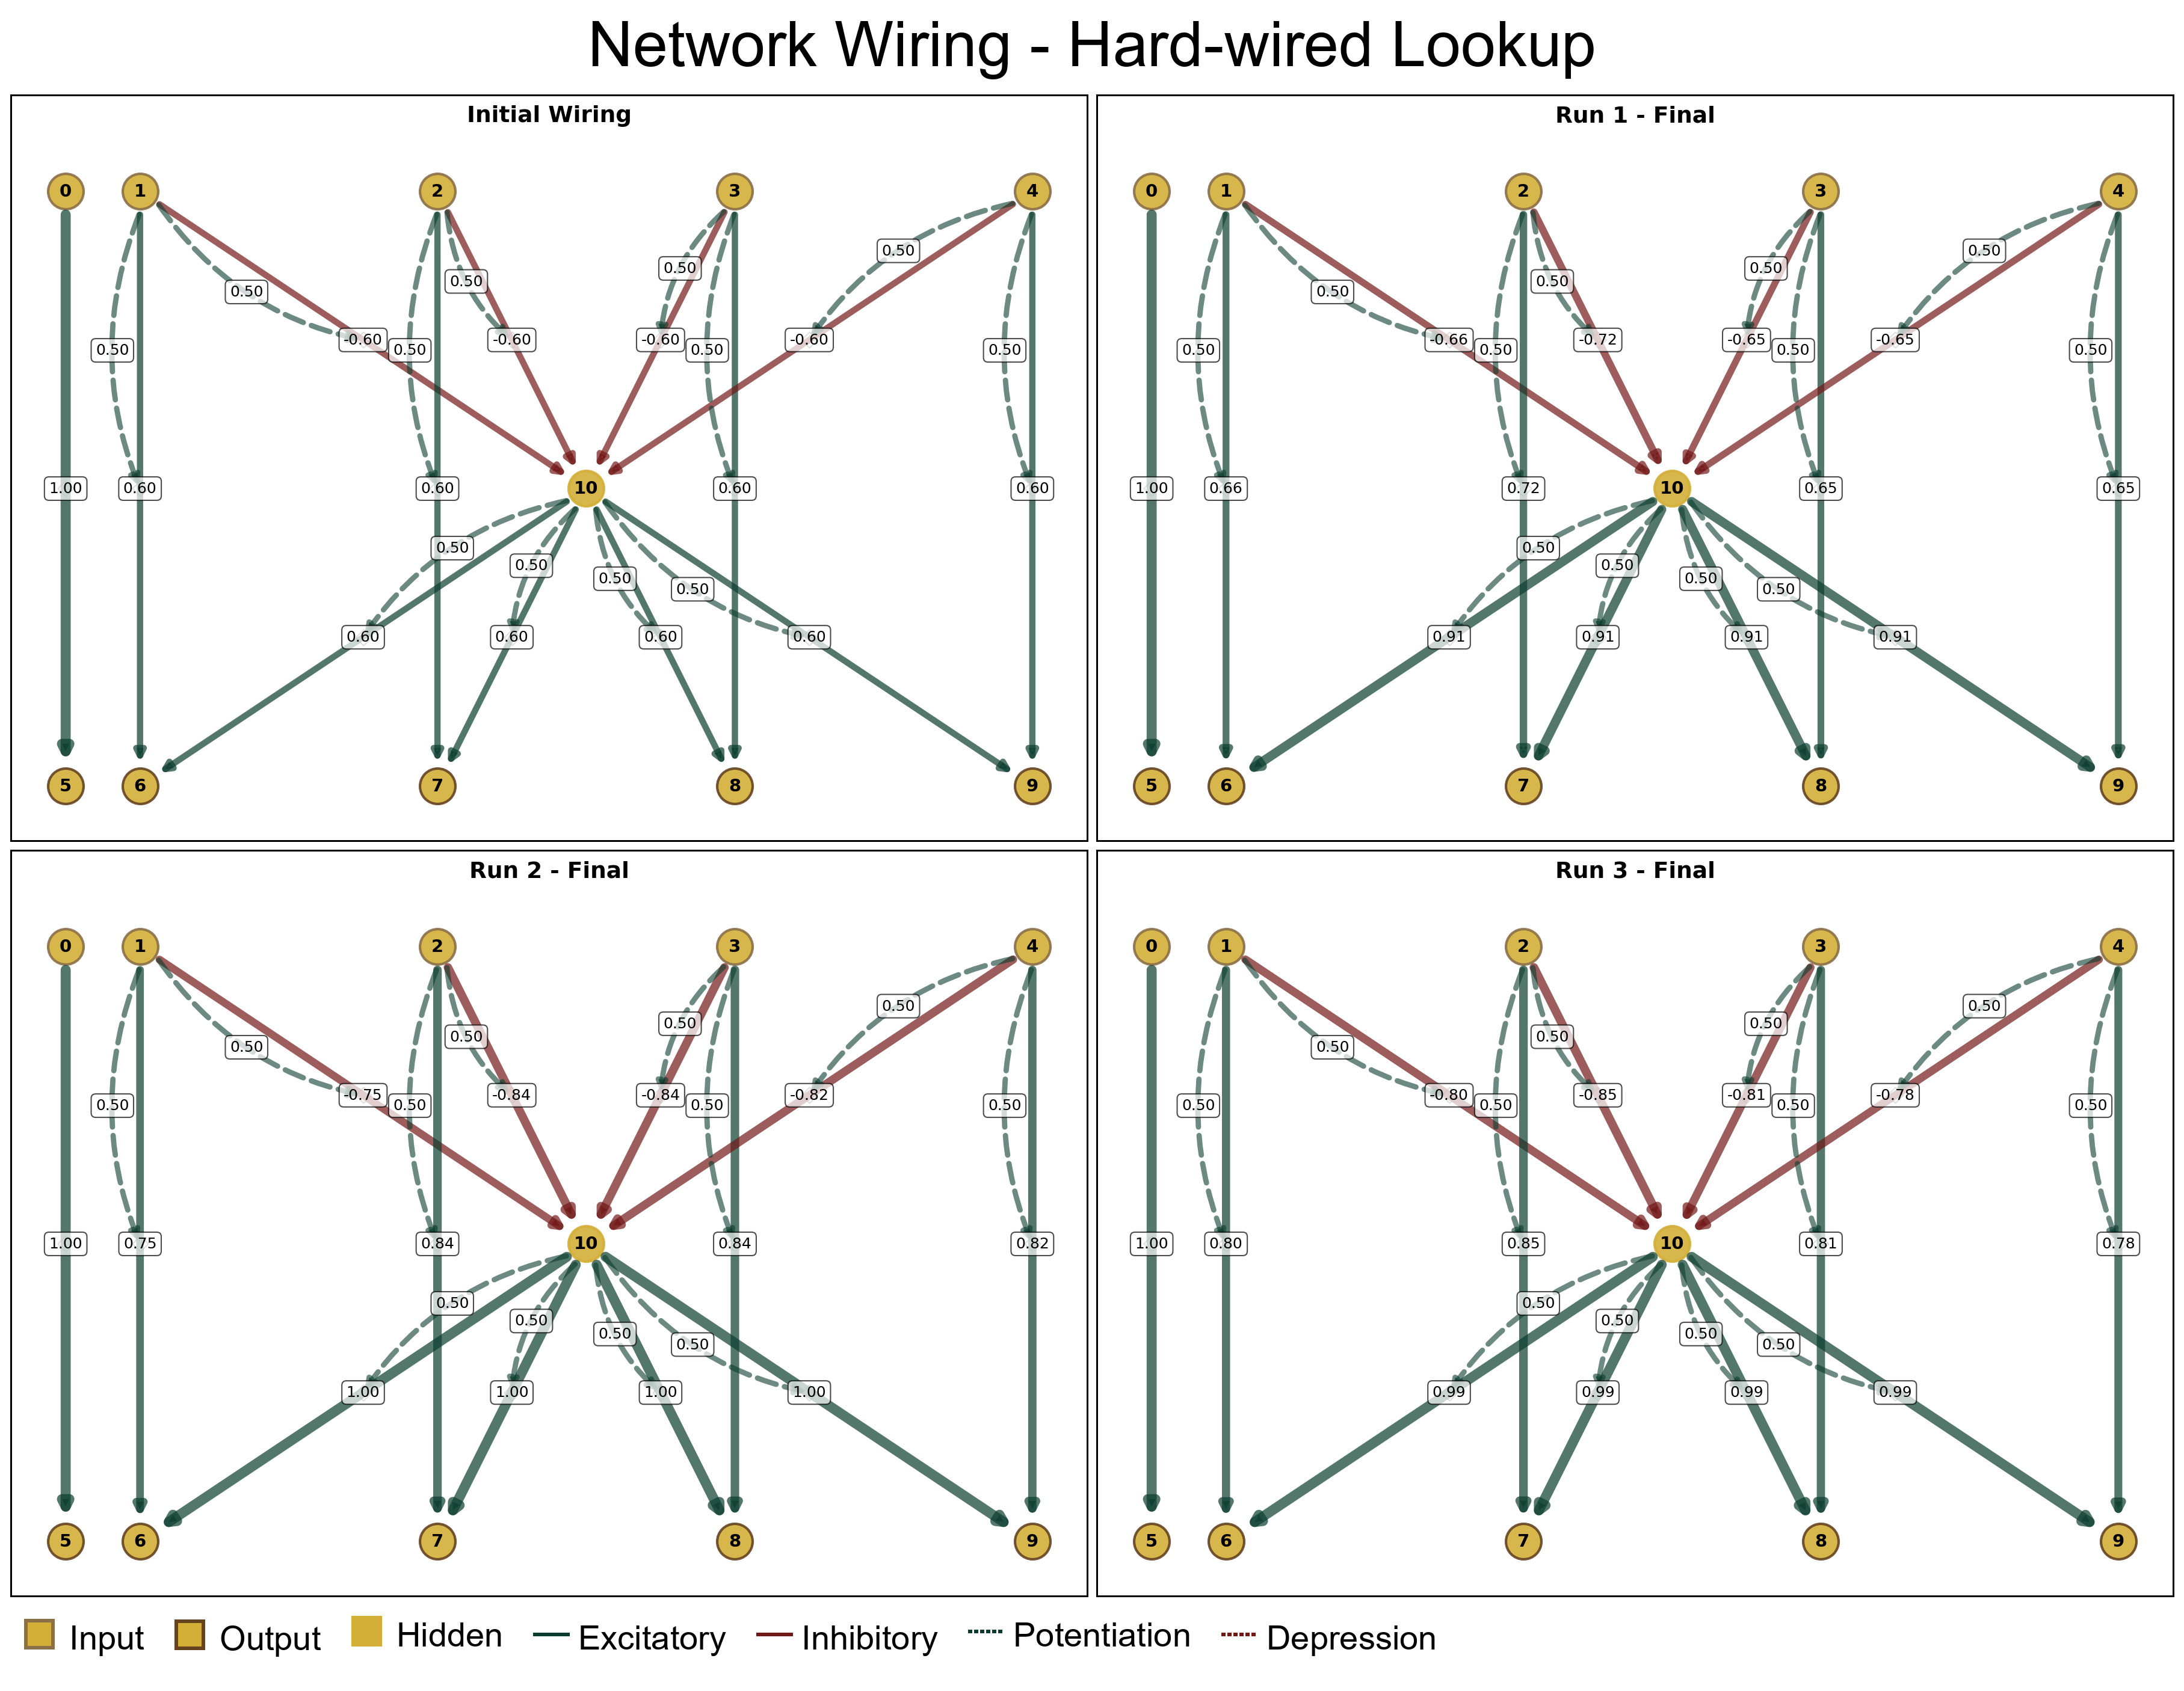

2. Group Selection
Thresholds based on median survival time (lifetime_ticks):
- Unsuccessful (bottom 10%): median < 23.25 ticks
- Successful (top 10%): median > 81.25 ticks
Group | Count | Variants
Successful (Top 10%) | 1 | 491
Unsuccessful (Bottom 10%) | 646 | 993, 984, 99, 987, 105, 522, 524, 56, 140, 561, 566, 14, 937, 149, 94, 942, 740, 729, 732, 374, 349, 35, 352, 353, 163, 742, 362, 154, 93, 158, 51, 918, 77, 336, 513, 574, 575, 576, 582, 18, 899, 901, 497, 499, 50, 588, 590, 591, 72, 597, 34, 75, 751, 755, 76, 366, 19, 191, 906, 181, 197, 199, 483, 477, 788, 376, 605, 377, 378, 704, 712, 69, 319, 32, 323, 763, 61, 489, 200, 209, 881, 21, 212, 465, 467, 469, 619, 625, 627, 630, 220, 87, 641, 396, 404, 786, 66, 269, 675, 288, 777, 780, 644, 443, 454, 459, 233, 855, 838, 847, 67, 673, 638, 436, 276, 278, 793, 798, 410, 429, 820, 245, 438, 439, 255, 815, 813, 263, 972, 973, 978, 82, 417, 418, 420, 110, 953, 956, 546, 515, 516, 518, 113, 967, 9, 101, 556, 74, 791, 529, 552, 979, 974, 971, 966, 121, 119, 116, 521, 585, 550, 542, 539, 571, 958, 123, 111, 663, 660, 416, 817, 264, 262, 259, 833, 831, 824, 823, 849, 632, 441, 44, 434, 428, 409, 80, 268, 659, 649, 674, 837, 860, 852, 460, 452, 449, 446, 645, 700, 70, 698, 779, 296, 295, 294, 802, 413, 686, 682, 676, 316, 308, 305, 300, 30, 298, 782, 406, 395, 388, 385, 639, 228, 225, 866, 864, 63, 628, 621, 620, 618, 89, 885, 496, 487, 696, 692, 691, 38, 717, 706, 382, 474, 481, 471, 187, 37, 186, 595, 720, 343, 340, 757, 33, 898, 766, 594, 593, 169, 896, 507, 917, 150, 912, 929, 924, 165, 160, 360, 746, 142, 724, 723, 941, 982, 146, 992, 11, 758, 613, 986, 107, 104, 100, 5, 558, 554, 551, 114, 122, 977, 120, 745, 363, 744, 739, 761, 734, 347, 375, 371, 726, 722, 365, 753, 364, 344, 342, 752, 754, 337, 749, 304, 301, 332, 774, 772, 771, 767, 762, 324, 694, 718, 714, 318, 314, 311, 307, 702, 699, 297, 401, 400, 398, 39, 387, 291, 285, 78, 778, 282, 805, 801, 804, 836, 826, 415, 414, 689, 684, 680, 678, 799, 412, 408, 800, 796, 797, 795, 794, 812, 281, 275, 654, 65, 648, 661, 816, 266, 808, 806, 267, 261, 265, 254, 827, 450, 861, 825, 251, 25, 241, 24, 635, 634, 633, 440, 432, 430, 848, 846, 84, 877, 643, 858, 856, 853, 236, 463, 46, 873, 874, 640, 227, 870, 218, 22, 223, 999, 2, 15, 214, 213, 624, 622, 62, 617, 891, 888, 887, 886, 883, 879, 204, 203, 201, 49, 609, 602, 484, 472, 20, 196, 189, 188, 185, 907, 184, 505, 503, 919, 502, 600, 596, 589, 895, 179, 178, 171, 17, 166, 921, 92, 920, 583, 580, 931, 58, 579, 578, 577, 510, 509, 508, 162, 913, 908, 932, 156, 927, 947, 151, 570, 569, 567, 564, 563, 560, 525, 519, 55, 549, 547, 545, 538, 536, 532, 53, 133, 131, 129, 138, 965, 959, 954, 134, 126, 125, 108, 127, 996, 687, 369, 7, 176, 193, 124, 535, 964, 137, 143, 946, 565, 960, 601, 926, 922, 175, 608, 494, 909, 480, 629, 427, 669, 192, 444, 647, 869, 863, 839, 626, 468, 246, 419, 250, 688, 677, 252, 781, 358, 381, 705, 372, 727, 818, 787, 132, 951, 315, 317, 760, 759, 970, 325, 715, 402, 631, 289, 284, 399, 226, 862, 180, 426, 657, 889, 170, 478, 934, 540, 841, 407, 423, 713, 391, 655, 770, 136, 73, 274, 258, 249, 792, 312, 331, 988, 102, 13, 985, 322, 239, 821, 168, 511, 421, 683, 650, 437, 351, 424, 205, 256, 936, 526, 949, 270, 221, 842, 167, 453, 247, 868, 339, 768, 810, 834, 384, 983, 568, 890, 603, 47, 893, 828, 448, 667, 157, 592, 614, 940, 144, 646, 653, 206, 345, 277, 98, 283, 784, 741, 840, 819, 665, 190, 211

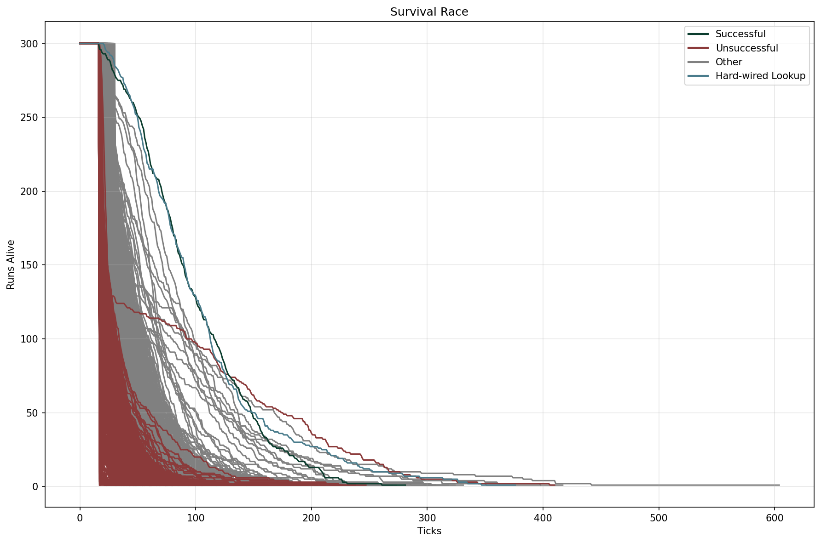

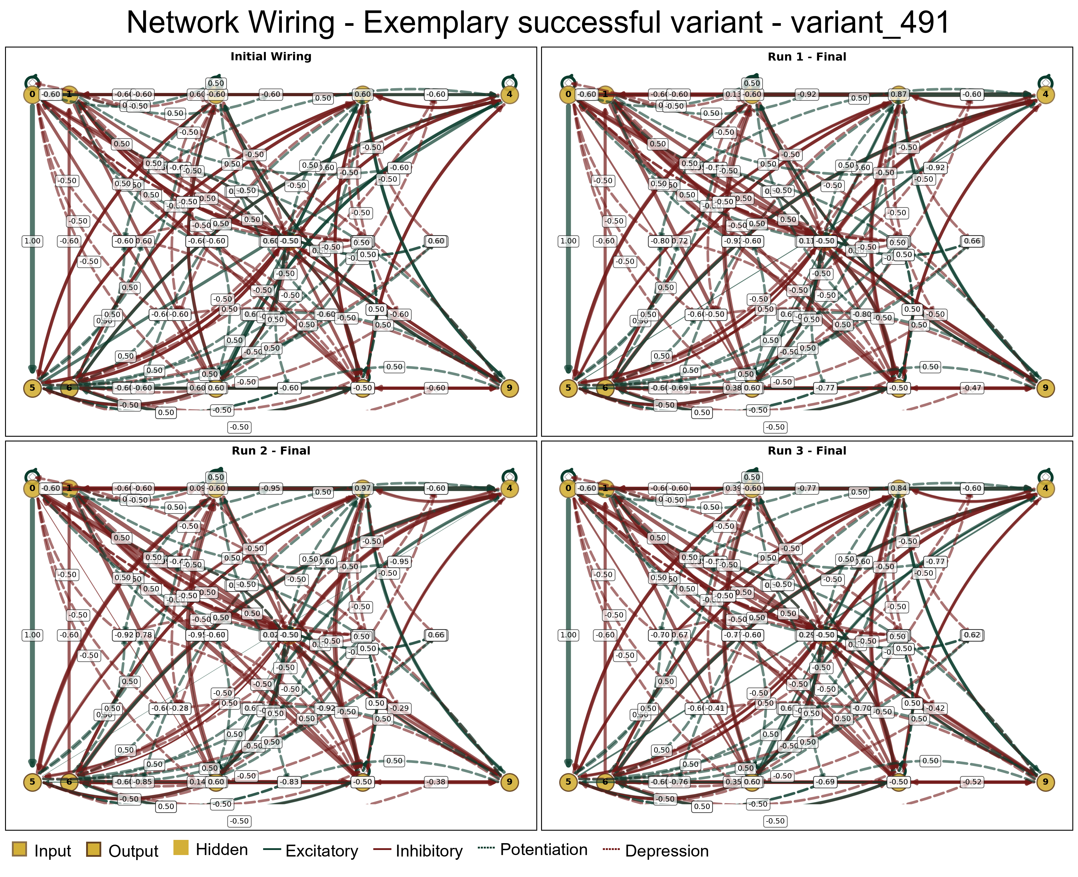

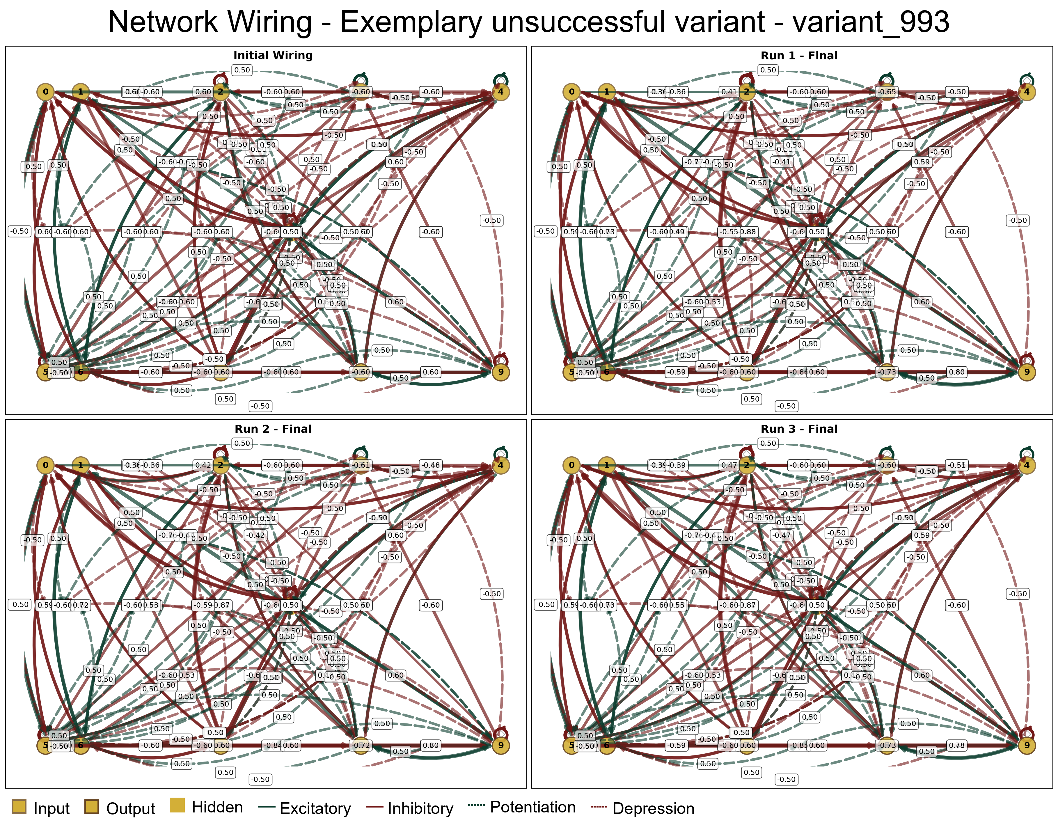

3. Comparison Successful vs. Unsuccessful (vs. Benchmarks)

3.1. Survival
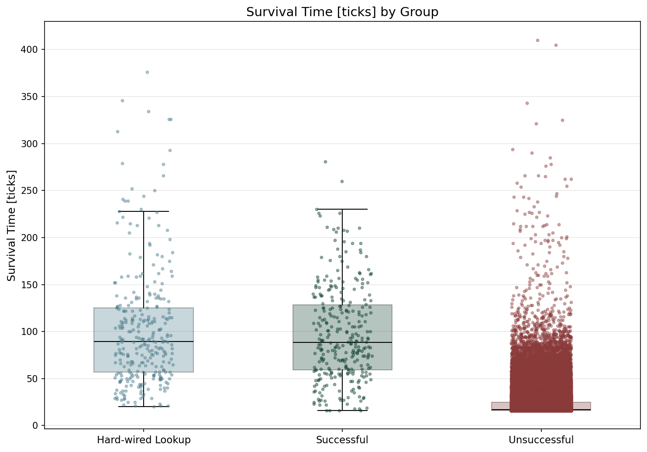

Statistic | Hard-wired Lookup | Successful | Unsuccessful
N | 300 | 300 | 193800
Mean | 102.91 | 97.53 | 22.36
Std Dev | 64.07 | 50.57 | 11.57
SEM | 3.70 | 2.92 | 0.03
Median | 89.50 | 88.50 | 17.00
Min | 20.00 | 16.00 | 16.00
Max | 376.00 | 281.00 | 410.00
IQR | 68.50 | 69.25 | 9.00
P25 | 56.75 | 59.00 | 16.00
P75 | 125.25 | 128.25 | 25.00
Skewness | 1.550 | 0.716 | 5.032
Kurtosis | 2.796 | 0.248 | 64.645

Normality Testing (Shapiro-Wilk):
Group | W statistic | p-value
Hard-wired Lookup | 0.8704 | 3.36e-15
Successful | 0.9609 | 3.24e-07
Unsuccessful | 0.5791 | 5.08e-172

Data is not normally distributed (alpha=0.05).

Kruskal-Wallis (omnibus test):
Test Name | Test Statistic | p-value | Epsilon-squared
Kruskal-Wallis | 1659.3360 | 0.00e+00 | 0.0085 (insignificant)

Pairwise Post-Hoc (Mann-Whitney U (Holm-Bonferroni correction)):
Group 1 | Group 2 | Statistic | p-value | Rank-Biserial r
Hard-wired Lookup | Successful | 44982.5000 | 9.94e-01 | 0.0004 (insignificant)
Hard-wired Lookup | Unsuccessful | 56668273.5000 | 9.64e-187 | -0.9494 (large)
Successful | Unsuccessful | 55996109.5000 | 5.20e-178 | -0.9263 (large)

Description of survival time differences between groups, statistical test results, and interpretation goes here.

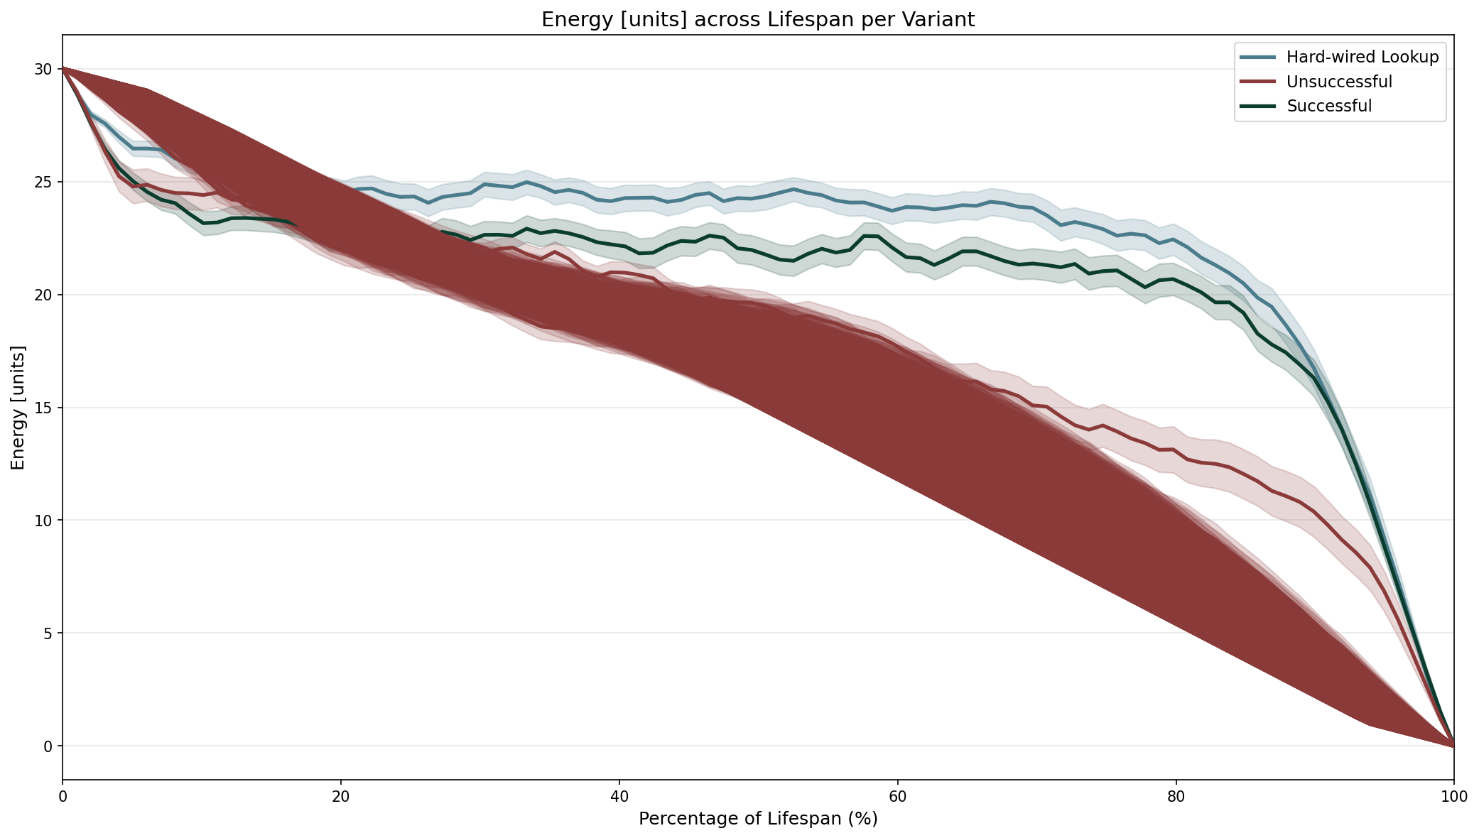

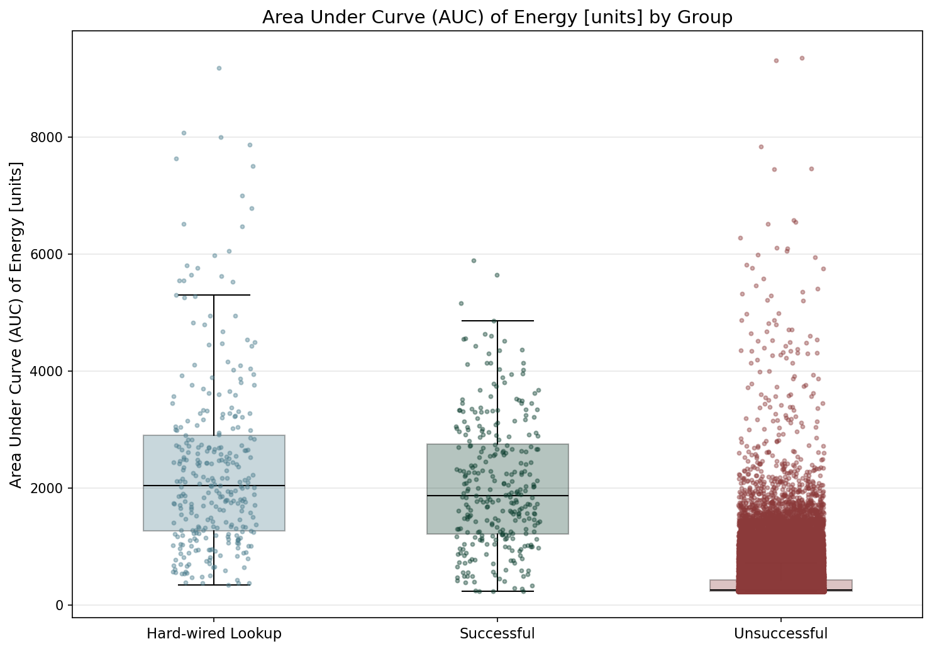

Statistic | Hard-wired Lookup | Successful | Unsuccessful
N | 300 | 300 | 193800
Mean | 2371.80 | 2062.94 | 368.89
Std Dev | 1556.66 | 1108.58 | 234.21
SEM | 89.87 | 64.00 | 0.53
Median | 2041.50 | 1878.00 | 263.00
Min | 352.00 | 240.00 | 240.00
Max | 9174.00 | 5890.00 | 9352.00
IQR | 1635.25 | 1538.25 | 193.00
P25 | 1267.50 | 1220.75 | 245.00
P75 | 2902.75 | 2759.00 | 438.00
Skewness | 1.552 | 0.654 | 6.022
Kurtosis | 2.841 | 0.082 | 99.237

Normality Testing (Shapiro-Wilk):
Group | W statistic | p-value
Hard-wired Lookup | 0.8713 | 3.86e-15
Successful | 0.9651 | 1.25e-06
Unsuccessful | 0.5661 | 4.65e-173

Data is not normally distributed (alpha=0.05).

Kruskal-Wallis (omnibus test):
Test Name | Test Statistic | p-value | Epsilon-squared
Kruskal-Wallis | 1631.0828 | 0.00e+00 | 0.0084 (insignificant)

Pairwise Post-Hoc (Mann-Whitney U (Holm-Bonferroni correction)):
Group 1 | Group 2 | Statistic | p-value | Rank-Biserial r
Hard-wired Lookup | Successful | 48301.5000 | 1.20e-01 | -0.0734 (insignificant)
Hard-wired Lookup | Unsuccessful | 57084080.0000 | 0.00e+00 | -0.9637 (large)
Successful | Unsuccessful | 56291200.0000 | 0.00e+00 | -0.9364 (large)

TBD

3.2. Food Consumption
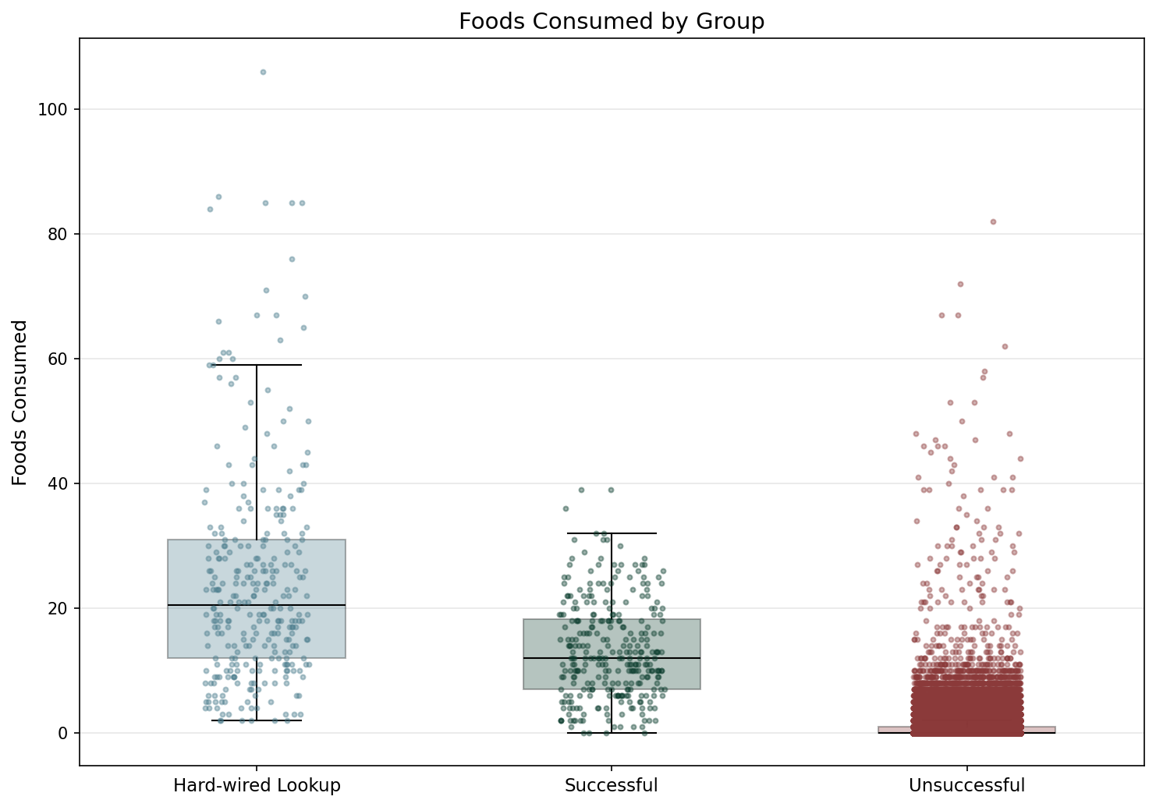

Statistic | Hard-wired Lookup | Successful | Unsuccessful
N | 300 | 300 | 193800
Mean | 24.38 | 13.32 | 0.73
Std Dev | 17.62 | 7.89 | 1.48
SEM | 1.02 | 0.46 | 0.00
Median | 20.50 | 12.00 | 0.00
Min | 2.00 | 0.00 | 0.00
Max | 106.00 | 39.00 | 82.00
IQR | 19.00 | 11.25 | 1.00
P25 | 12.00 | 7.00 | 0.00
P75 | 31.00 | 18.25 | 1.00
Skewness | 1.543 | 0.585 | 10.550
Kurtosis | 2.901 | -0.077 | 301.430

Normality Testing (Shapiro-Wilk):
Group | W statistic | p-value
Hard-wired Lookup | 0.8739 | 5.57e-15
Successful | 0.9670 | 2.38e-06
Unsuccessful | 0.4832 | 3.98e-179

Data is not normally distributed (alpha=0.05).

Kruskal-Wallis (omnibus test):
Test Name | Test Statistic | p-value | Epsilon-squared
Kruskal-Wallis | 2221.1749 | 0.00e+00 | 0.0114 (small)

Pairwise Post-Hoc (Mann-Whitney U (Holm-Bonferroni correction)):
Group 1 | Group 2 | Statistic | p-value | Rank-Biserial r
Hard-wired Lookup | Successful | 63735.5000 | 1.06e-18 | -0.4163 (medium)
Hard-wired Lookup | Unsuccessful | 57846525.0000 | 1.55e-252 | -0.9899 (large)
Successful | Unsuccessful | 56818962.0000 | 4.01e-235 | -0.9546 (large)

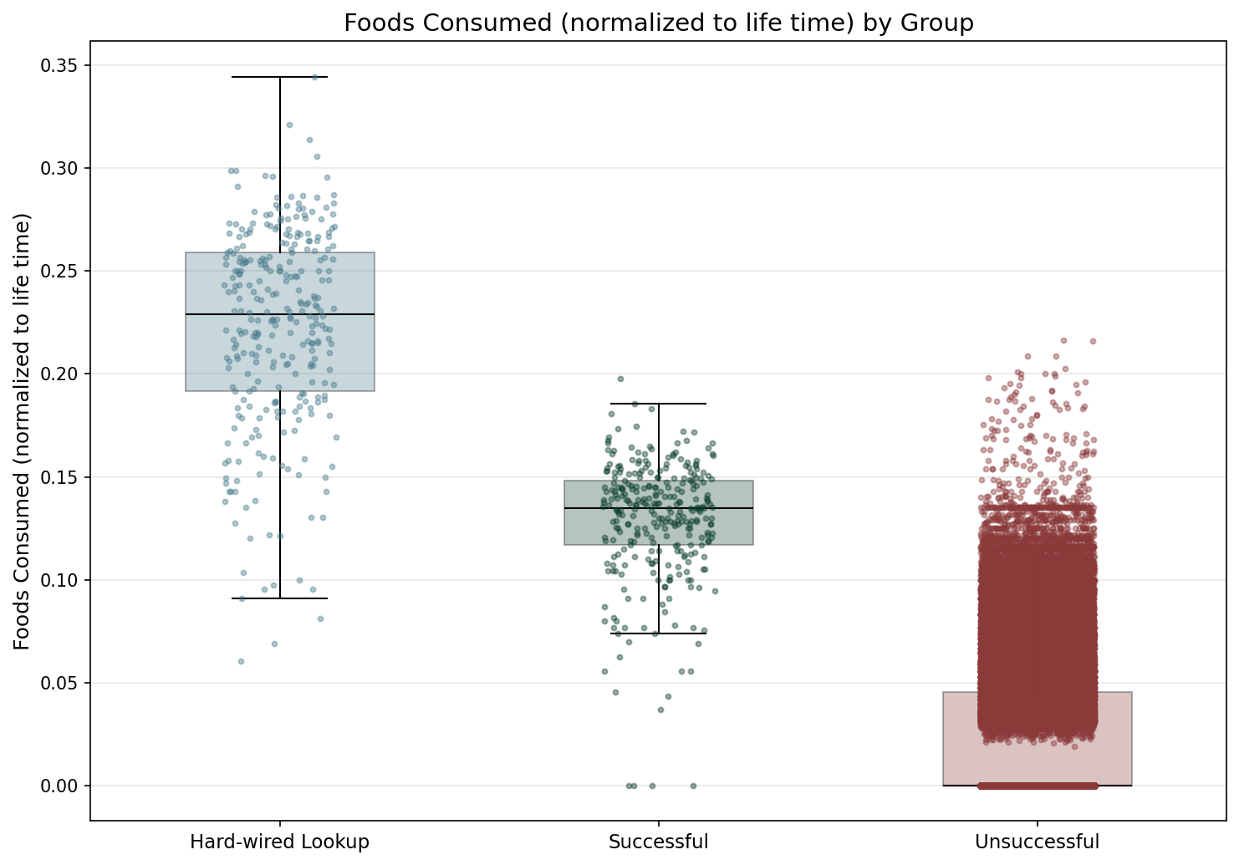

Statistic | Hard-wired Lookup | Successful | Unsuccessful
N | 300 | 300 | 193800
Mean | 0.22 | 0.13 | 0.02
Std Dev | 0.05 | 0.03 | 0.03
SEM | 0.00 | 0.00 | 0.00
Median | 0.23 | 0.13 | 0.00
Min | 0.06 | 0.00 | 0.00
Max | 0.34 | 0.20 | 0.22
IQR | 0.07 | 0.03 | 0.05
P25 | 0.19 | 0.12 | 0.00
P75 | 0.26 | 0.15 | 0.05
Skewness | -0.724 | -1.483 | 1.121
Kurtosis | 0.415 | 3.724 | 0.469

Normality Testing (Shapiro-Wilk):
Group | W statistic | p-value
Hard-wired Lookup | 0.9634 | 7.19e-07
Successful | 0.9008 | 4.02e-13
Unsuccessful | 0.7380 | 3.75e-156

Data is not normally distributed (alpha=0.05).

Kruskal-Wallis (omnibus test):
Test Name | Test Statistic | p-value | Epsilon-squared
Kruskal-Wallis | 2215.8285 | 0.00e+00 | 0.0114 (small)

Pairwise Post-Hoc (Mann-Whitney U (Holm-Bonferroni correction)):
Group 1 | Group 2 | Statistic | p-value | Rank-Biserial r
Hard-wired Lookup | Successful | 84694.0000 | 5.31e-78 | -0.8821 (large)
Hard-wired Lookup | Unsuccessful | 58063419.0000 | 3.26e-252 | -0.9974 (large)
Successful | Unsuccessful | 56992026.5000 | 3.20e-234 | -0.9605 (large)

Description of food consumption differences between groups, statistical test results, and interpretation goes here.
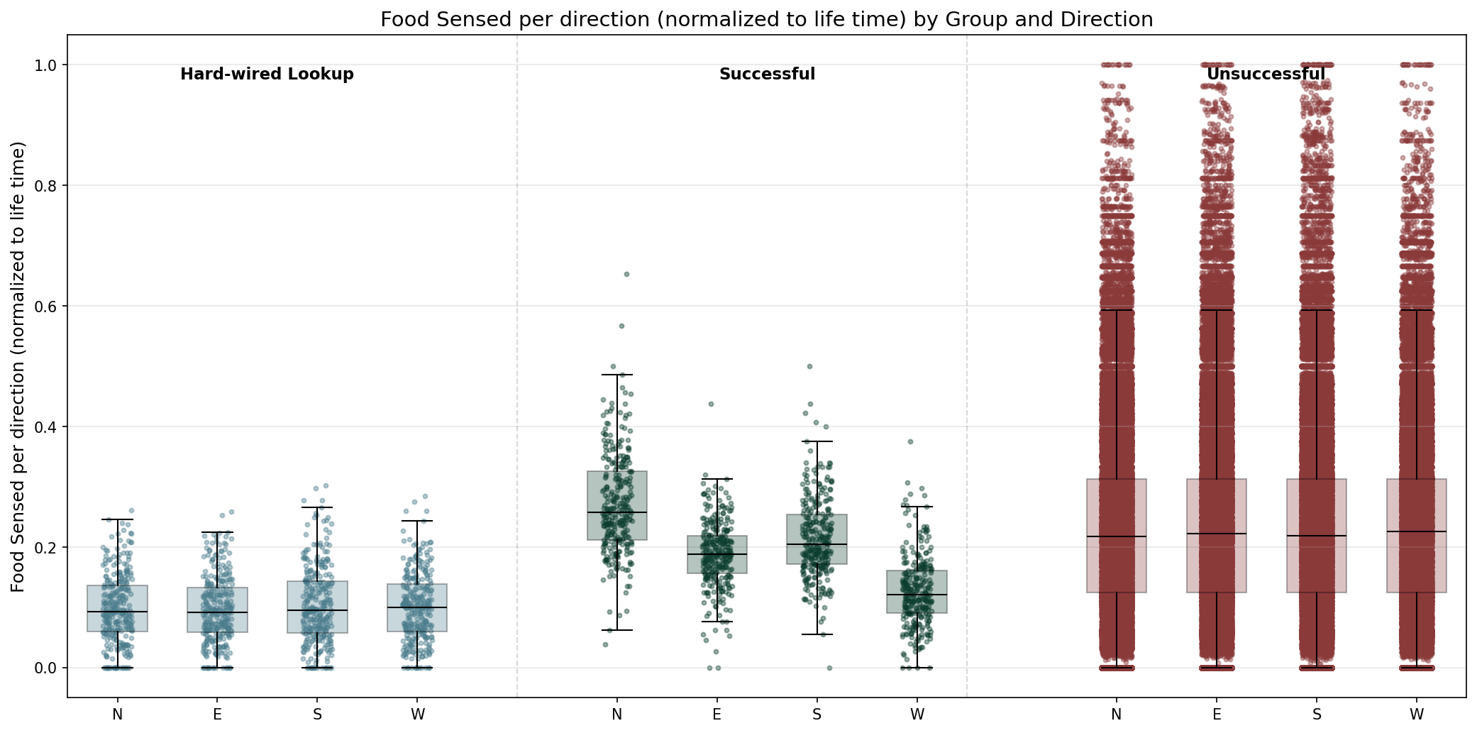

Statistic | North | East | South | West
N | 194400 | 194400 | 194400 | 194400
Mean | 0.23 | 0.23 | 0.23 | 0.23
Std Dev | 0.14 | 0.14 | 0.14 | 0.14
Median | 0.22 | 0.22 | 0.22 | 0.22
Min | 0.00 | 0.00 | 0.00 | 0.00
Max | 1.00 | 1.00 | 1.00 | 1.00

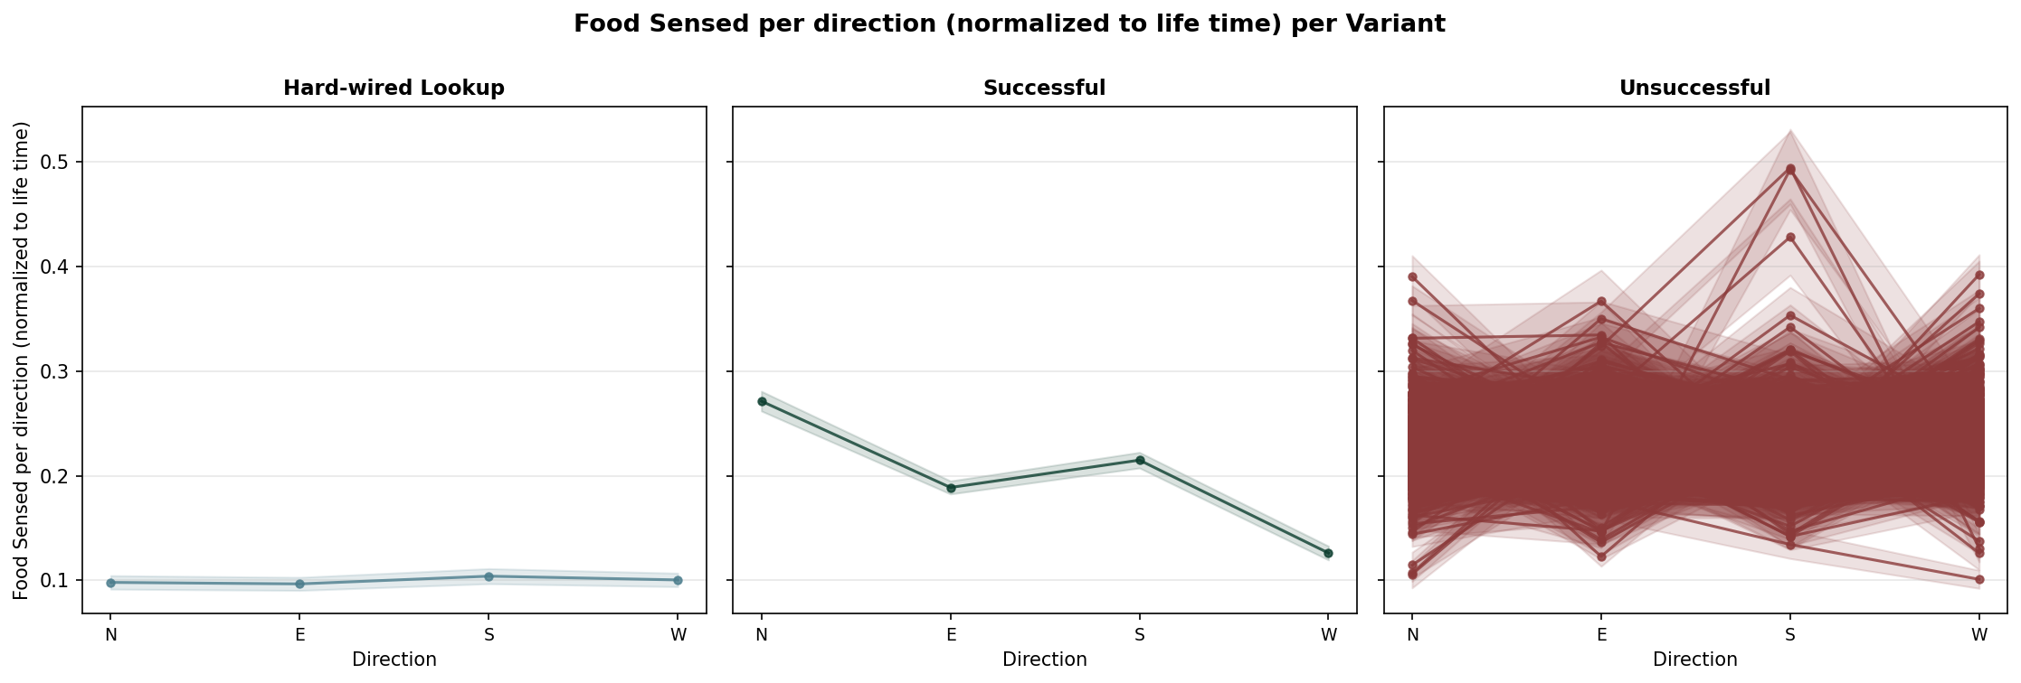

TBD

3.3. Movement

3.3.1. Movements Made
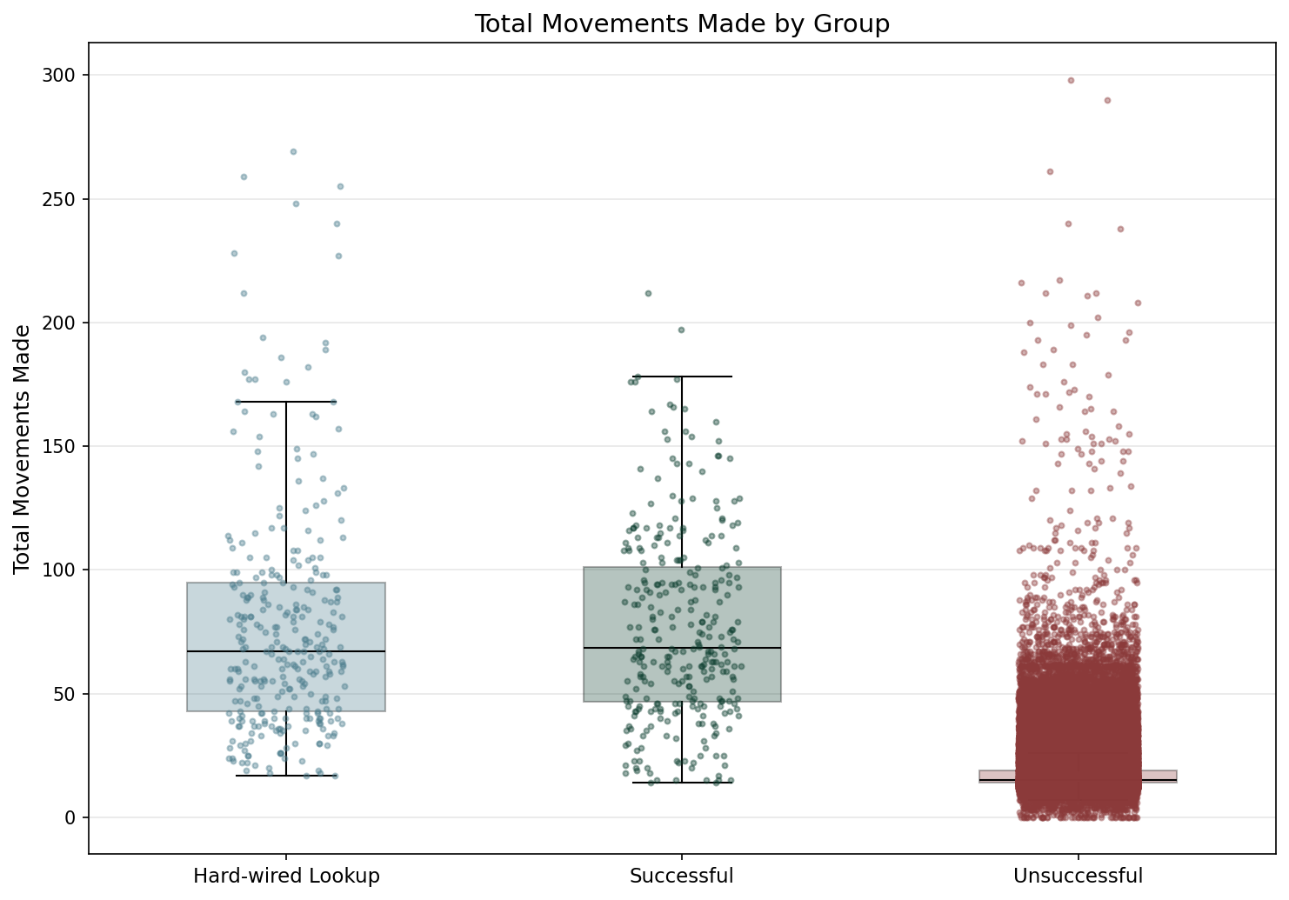

Statistic | Hard-wired Lookup | Successful | Unsuccessful
N | 300 | 300 | 193800
Mean | 77.52 | 76.61 | 17.86
Std Dev | 47.03 | 38.74 | 8.49
SEM | 2.72 | 2.24 | 0.02
Median | 67.00 | 68.50 | 15.00
Min | 17.00 | 14.00 | 0.00
Max | 269.00 | 212.00 | 298.00
IQR | 52.00 | 54.50 | 5.00
P25 | 43.00 | 46.75 | 14.00
P75 | 95.00 | 101.25 | 19.00
Skewness | 1.568 | 0.684 | 5.005
Kurtosis | 2.850 | 0.187 | 65.118

Normality Testing (Shapiro-Wilk):
Group | W statistic | p-value
Hard-wired Lookup | 0.8669 | 2.07e-15
Successful | 0.9627 | 5.72e-07
Unsuccessful | 0.6063 | 9.80e-170

Data is not normally distributed (alpha=0.05).

Kruskal-Wallis (omnibus test):
Test Name | Test Statistic | p-value | Epsilon-squared
Kruskal-Wallis | 1661.5249 | 0.00e+00 | 0.0085 (insignificant)

Pairwise Post-Hoc (Mann-Whitney U (Holm-Bonferroni correction)):
Group 1 | Group 2 | Statistic | p-value | Rank-Biserial r
Hard-wired Lookup | Successful | 43068.0000 | 3.63e-01 | 0.0429 (insignificant)
Hard-wired Lookup | Unsuccessful | 56801994.0000 | 1.12e-185 | -0.9540 (large)
Successful | Unsuccessful | 56321327.5000 | 1.58e-179 | -0.9374 (large)

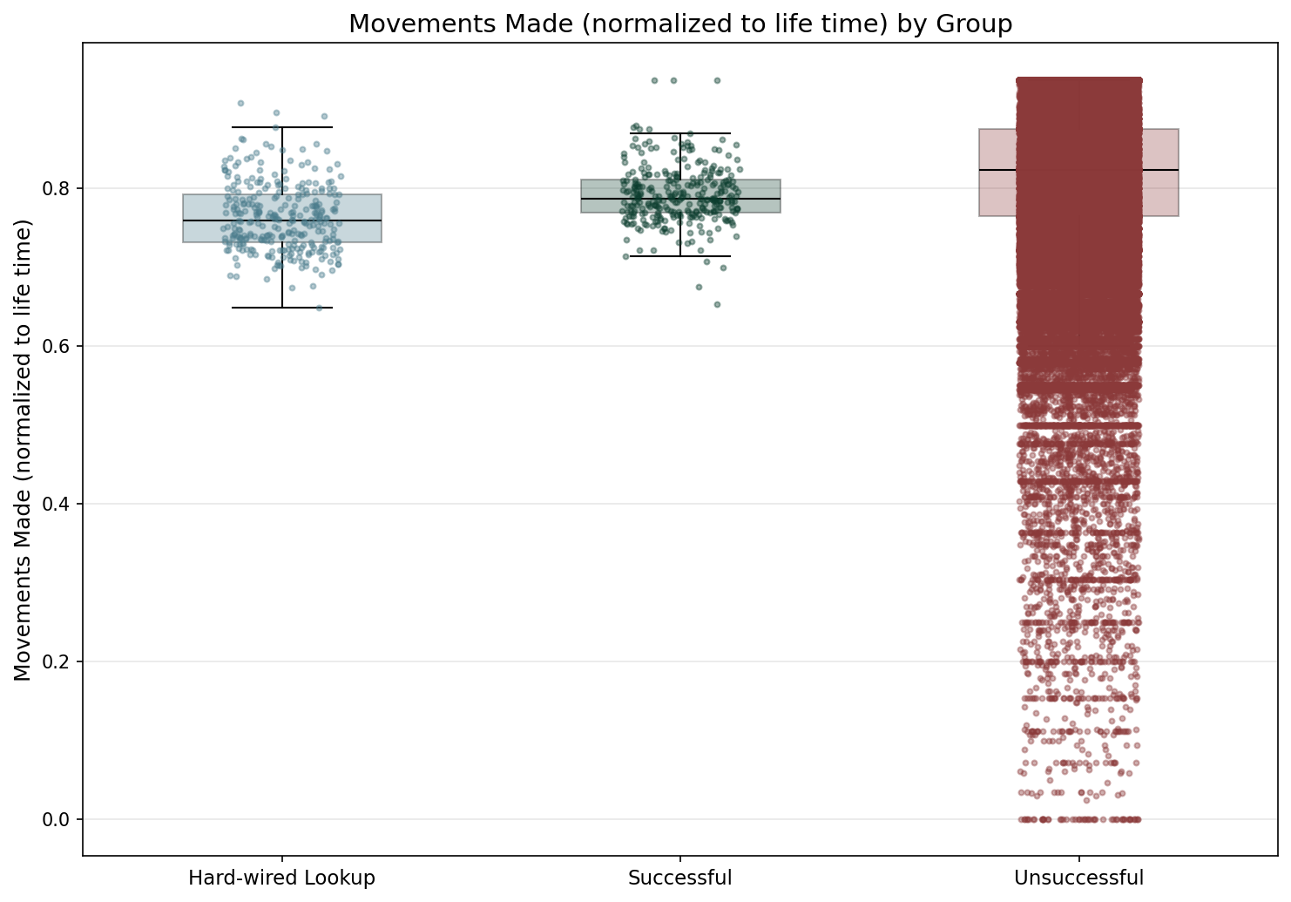

Statistic | Hard-wired Lookup | Successful | Unsuccessful
N | 300 | 300 | 193800
Mean | 0.76 | 0.79 | 0.81
Std Dev | 0.04 | 0.04 | 0.10
SEM | 0.00 | 0.00 | 0.00
Median | 0.76 | 0.79 | 0.82
Min | 0.65 | 0.65 | 0.00
Max | 0.91 | 0.94 | 0.94
IQR | 0.06 | 0.04 | 0.11
P25 | 0.73 | 0.77 | 0.76
P75 | 0.79 | 0.81 | 0.88
Skewness | 0.528 | 0.516 | -1.463
Kurtosis | 0.177 | 2.182 | 5.199

Normality Testing (Shapiro-Wilk):
Group | W statistic | p-value
Hard-wired Lookup | 0.9801 | 3.54e-04
Successful | 0.9624 | 5.12e-07
Unsuccessful | 0.8906 | 5.84e-129

Data is not normally distributed (alpha=0.05).

Kruskal-Wallis (omnibus test):
Test Name | Test Statistic | p-value | Epsilon-squared
Kruskal-Wallis | 220.1320 | 1.58e-48 | 0.0011 (insignificant)

Pairwise Post-Hoc (Mann-Whitney U (Holm-Bonferroni correction)):
Group 1 | Group 2 | Statistic | p-value | Rank-Biserial r
Hard-wired Lookup | Successful | 26236.5000 | 1.95e-18 | 0.4170 (medium)
Hard-wired Lookup | Unsuccessful | 16748088.0000 | 5.85e-37 | 0.4239 (medium)
Successful | Unsuccessful | 21805636.5000 | 4.76e-14 | 0.2499 (small)

TBD
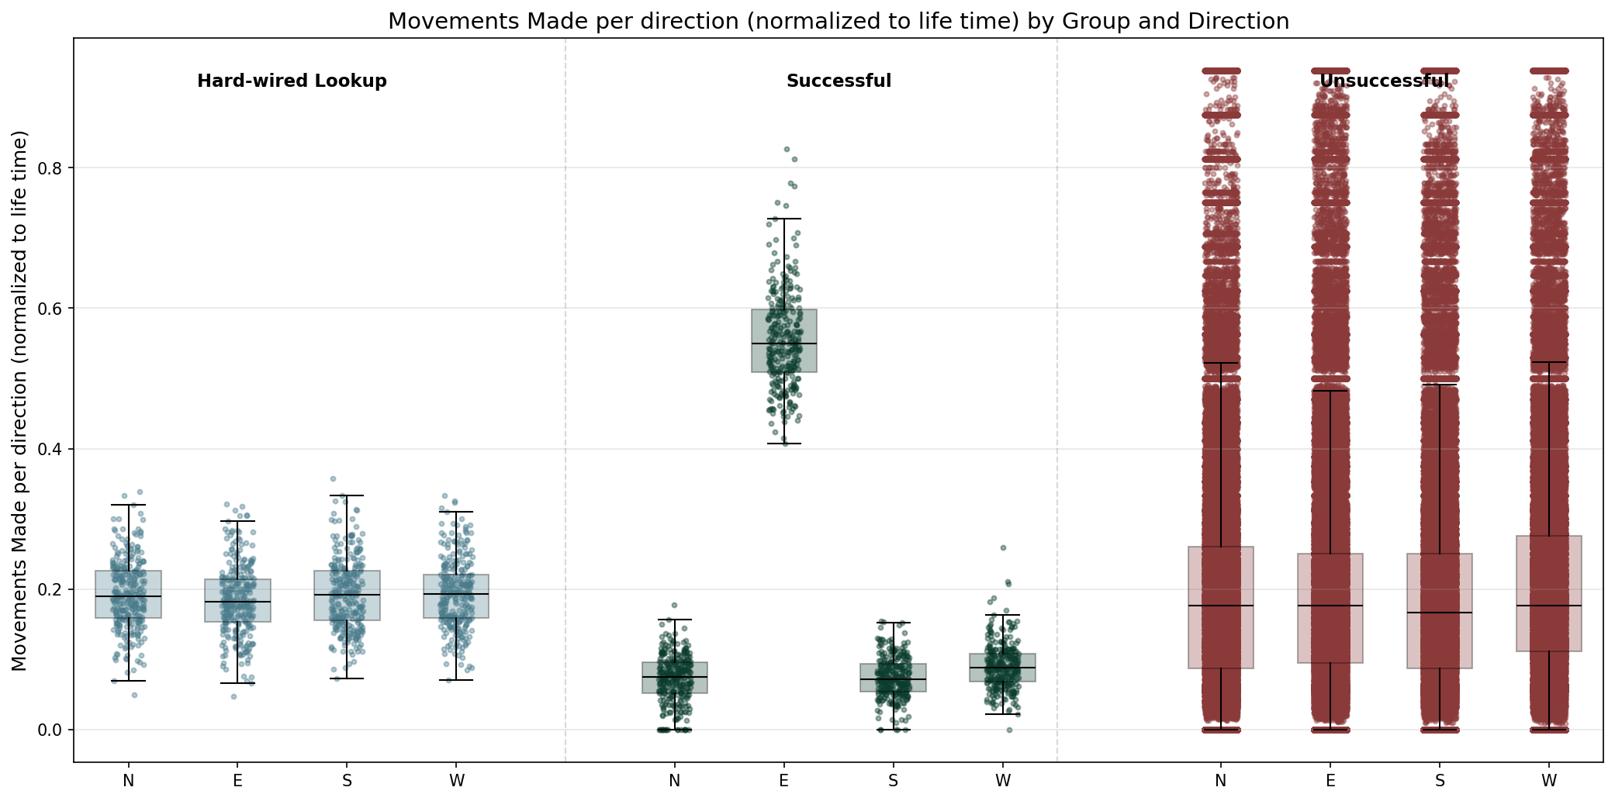

Statistic | North | East | South | West
N | 194400 | 194400 | 194400 | 194400
Mean | 0.20 | 0.20 | 0.20 | 0.22
Std Dev | 0.17 | 0.17 | 0.17 | 0.18
Median | 0.18 | 0.18 | 0.17 | 0.18
Min | 0.00 | 0.00 | 0.00 | 0.00
Max | 0.94 | 0.94 | 0.94 | 0.94

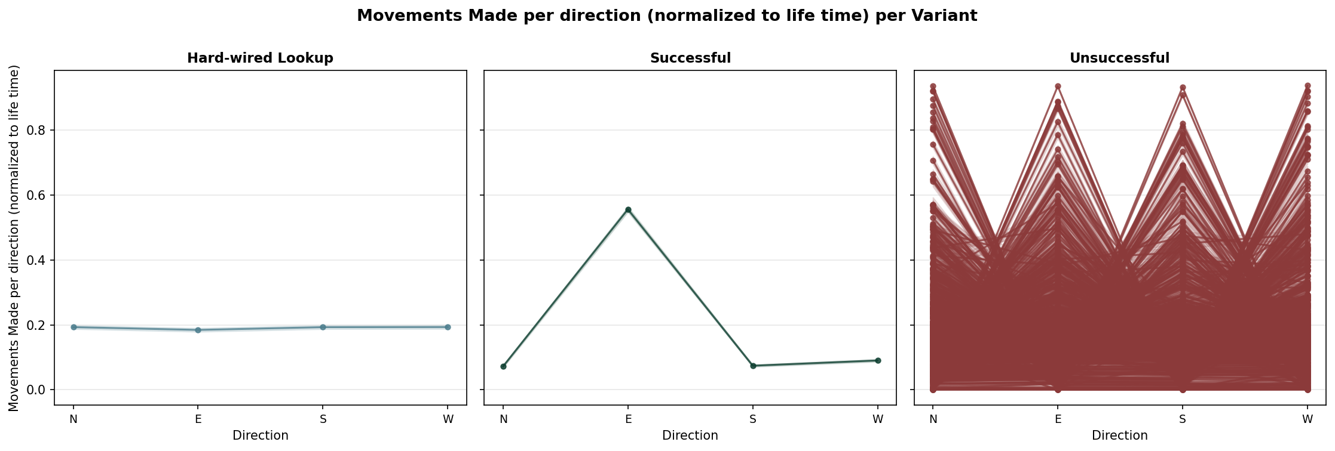

TBD

3.3.2. Ground Covered
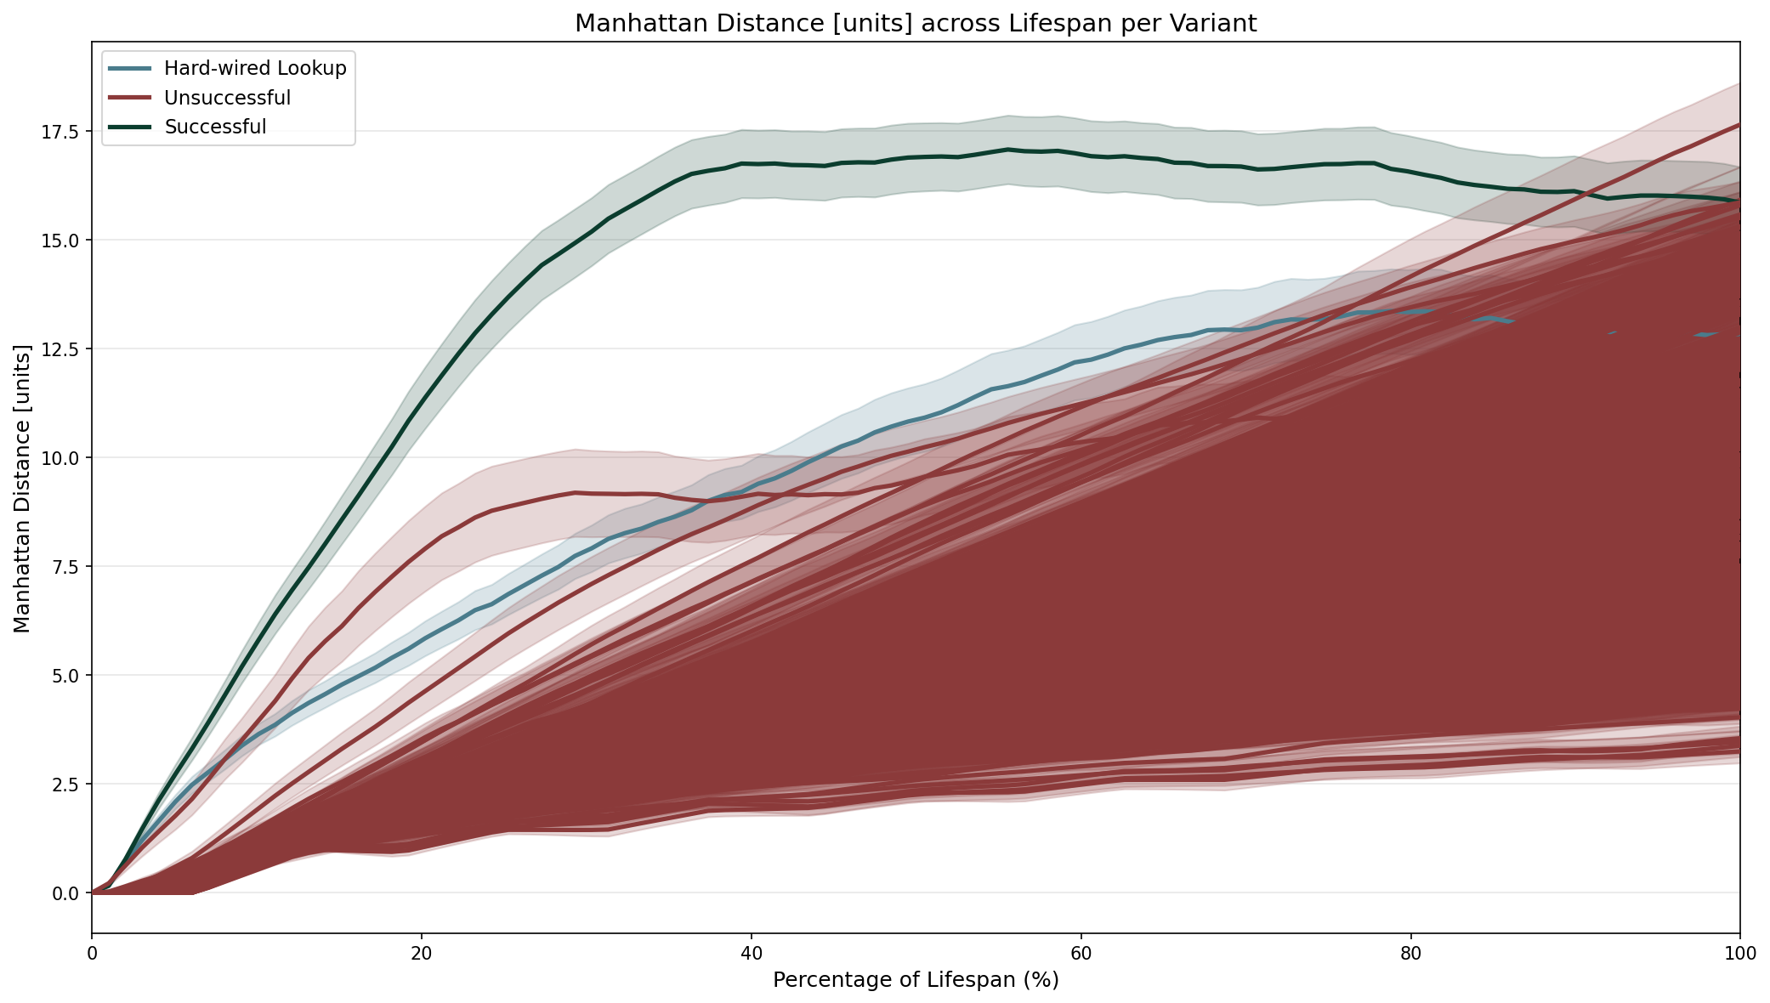

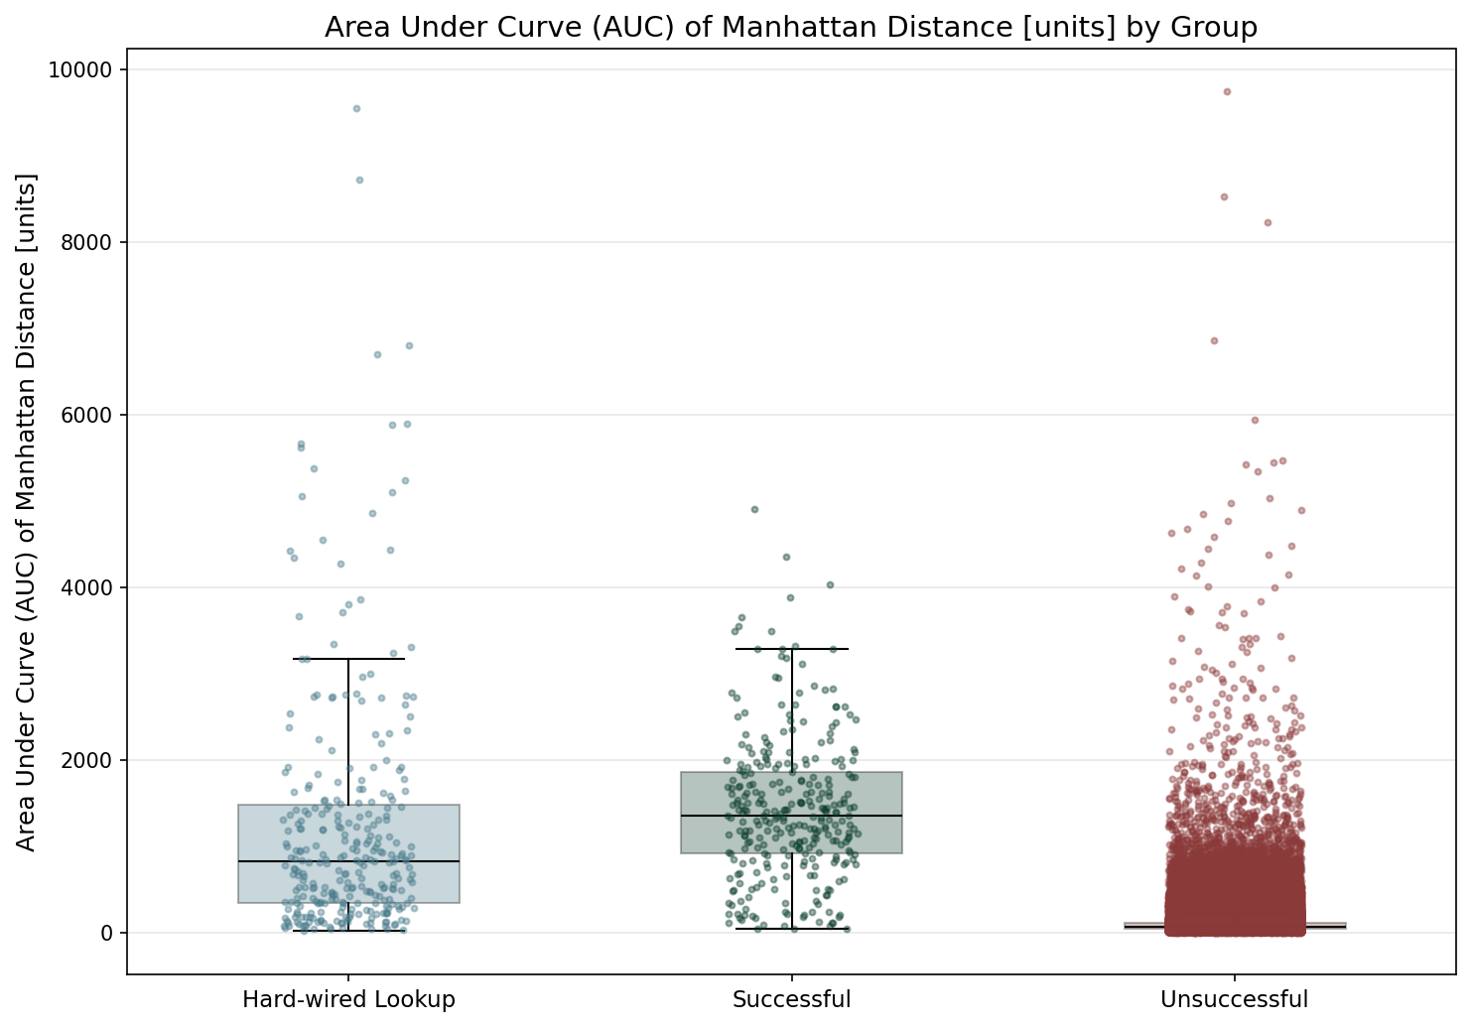

Statistic | Hard-wired Lookup | Successful | Unsuccessful
N | 300 | 300 | 193800
Mean | 1242.21 | 1435.49 | 99.92
Std Dev | 1433.96 | 833.90 | 143.75
SEM | 82.79 | 48.15 | 0.33
Median | 823.25 | 1353.75 | 68.50
Min | 21.50 | 47.50 | 0.00
Max | 9559.50 | 4910.00 | 9752.00
IQR | 1137.75 | 952.75 | 68.50
P25 | 342.88 | 915.75 | 43.00
P75 | 1480.62 | 1868.50 | 111.50
Skewness | 2.502 | 0.849 | 14.247
Kurtosis | 7.771 | 1.257 | 463.200

Normality Testing (Shapiro-Wilk):
Group | W statistic | p-value
Hard-wired Lookup | 0.7262 | 6.83e-22
Successful | 0.9558 | 6.96e-08
Unsuccessful | 0.3947 | 1.05e-184

Data is not normally distributed (alpha=0.05).

Kruskal-Wallis (omnibus test):
Test Name | Test Statistic | p-value | Epsilon-squared
Kruskal-Wallis | 1531.8738 | 0.00e+00 | 0.0079 (insignificant)

Pairwise Post-Hoc (Mann-Whitney U (Holm-Bonferroni correction)):
Group 1 | Group 2 | Statistic | p-value | Rank-Biserial r
Hard-wired Lookup | Successful | 31732.5000 | 4.13e-10 | 0.2948 (medium)
Hard-wired Lookup | Unsuccessful | 54893332.5000 | 5.88e-156 | -0.8883 (large)
Successful | Unsuccessful | 56920629.0000 | 6.06e-181 | -0.9581 (large)

TBD
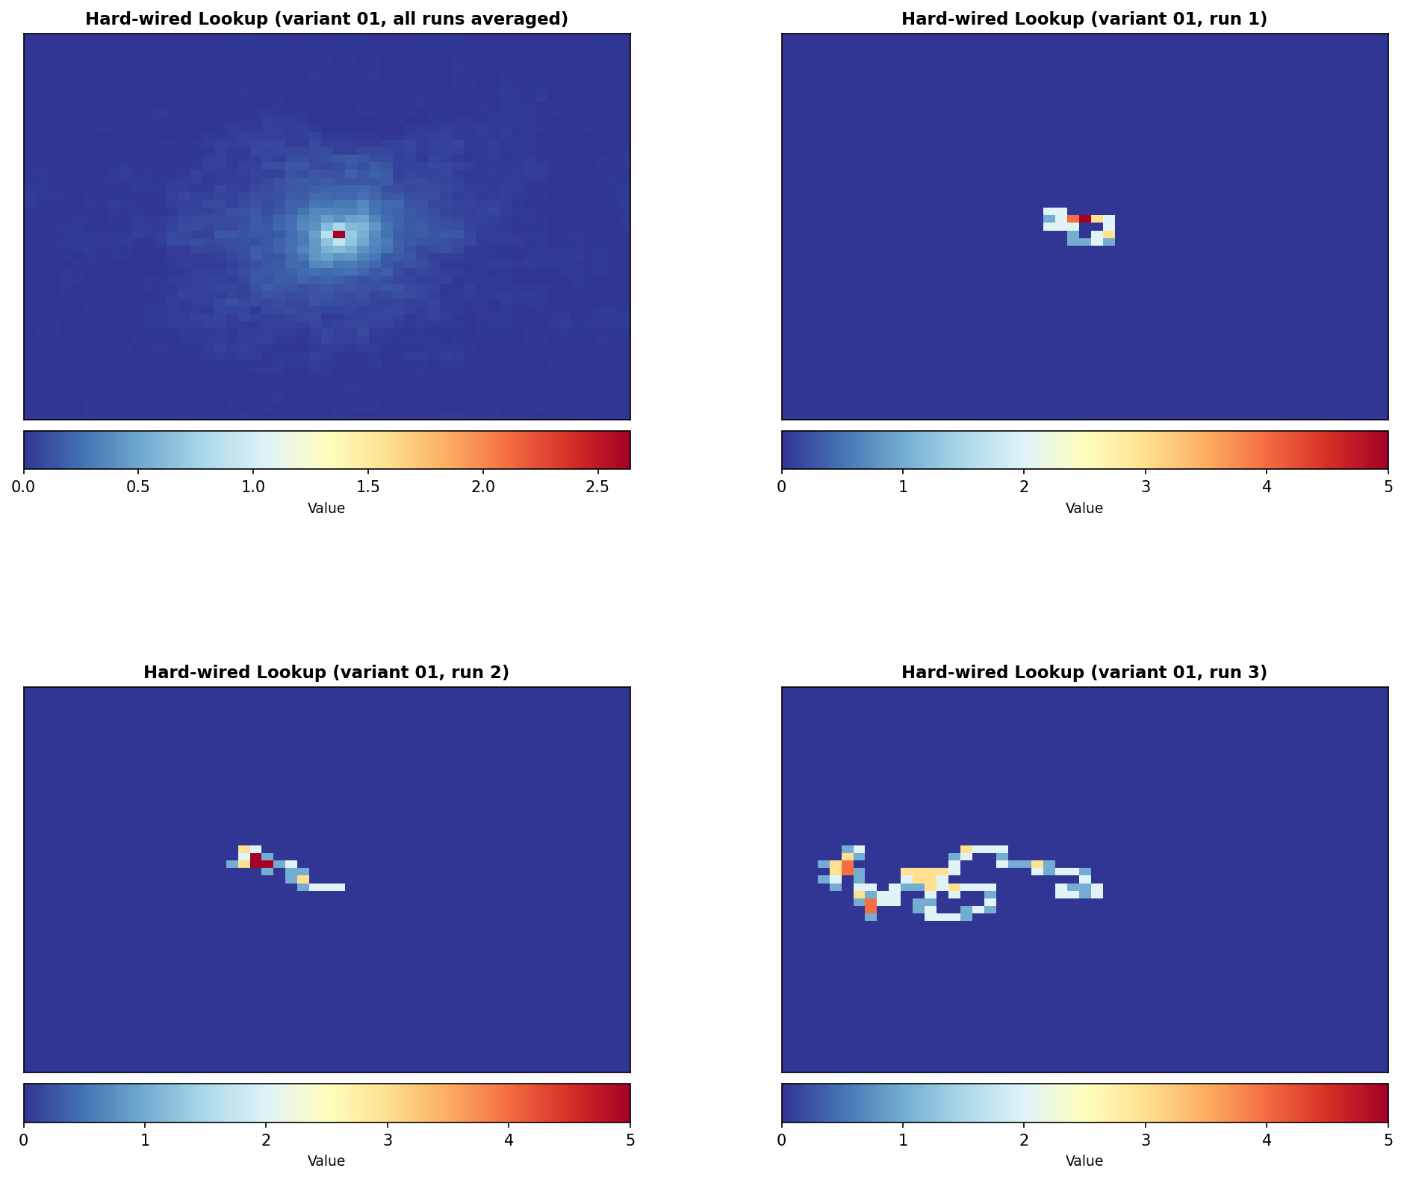
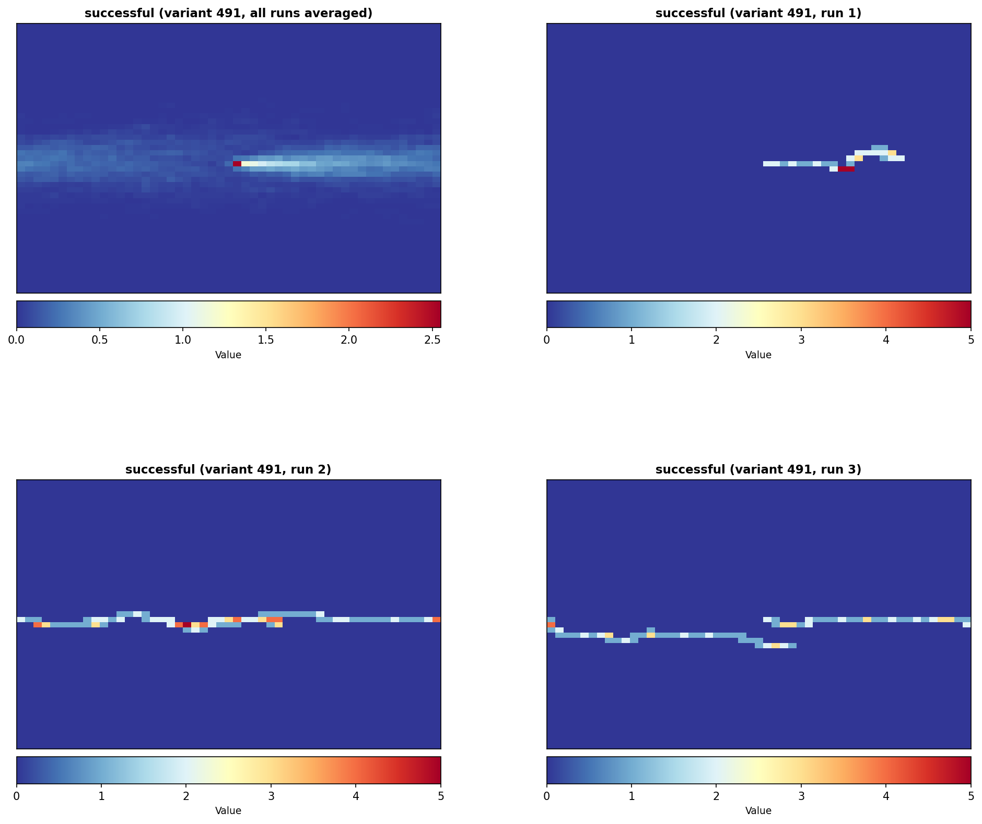
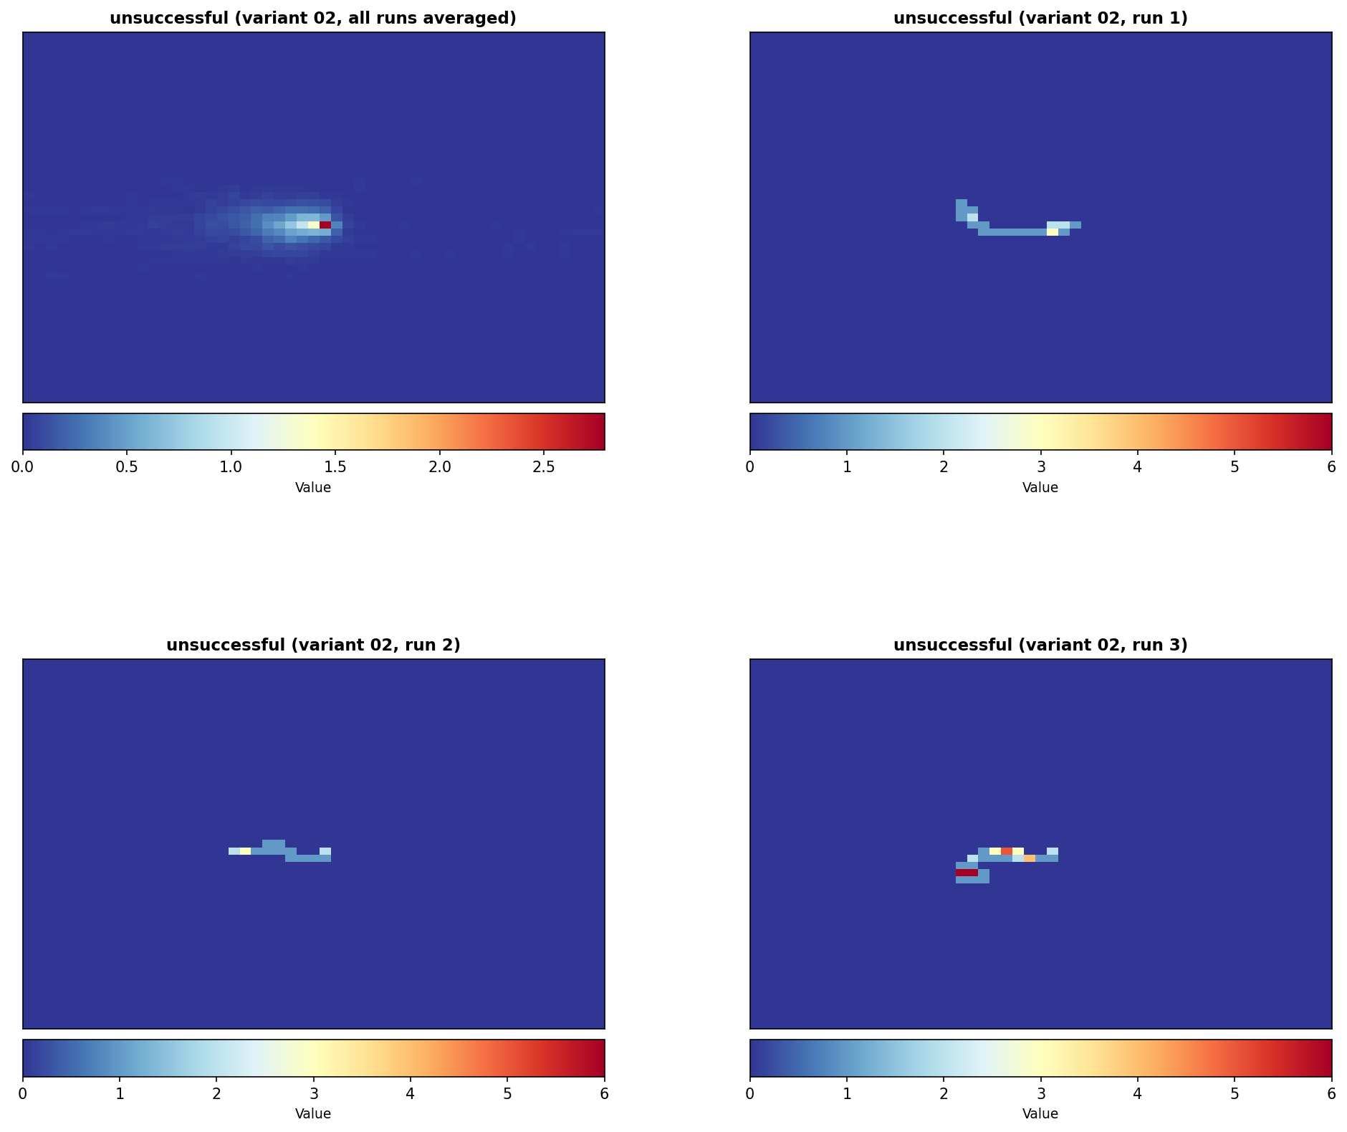
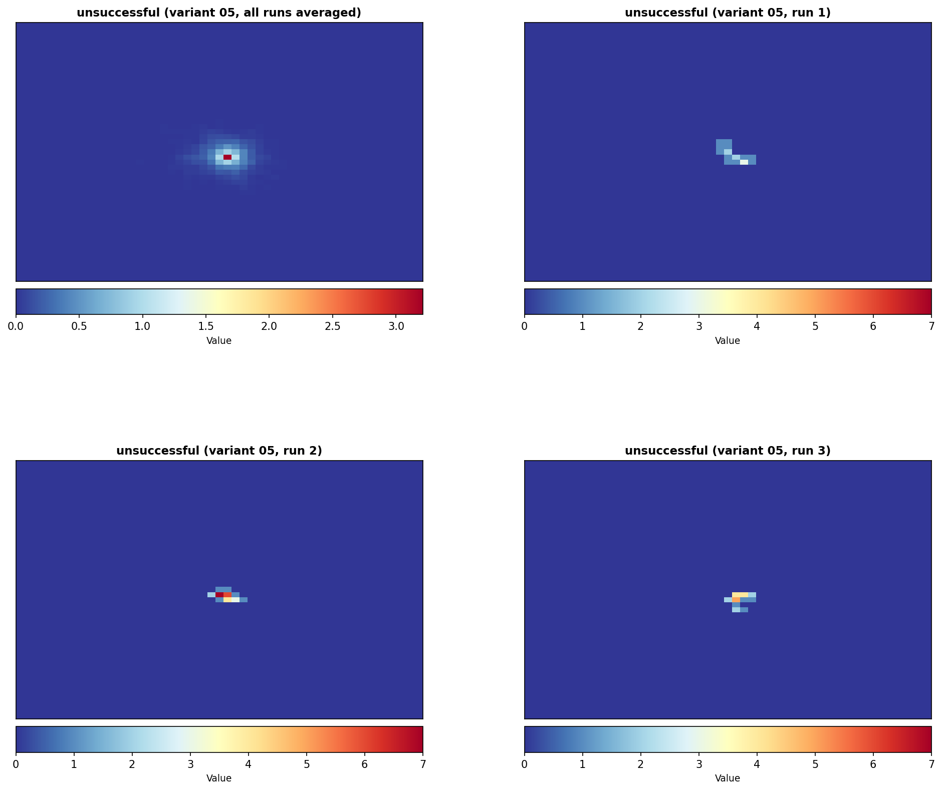
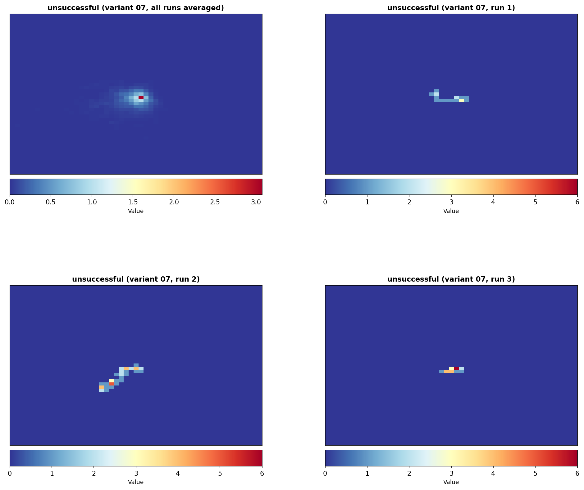

TBD

3.4. Decisions

3.4.1. Decisions Made
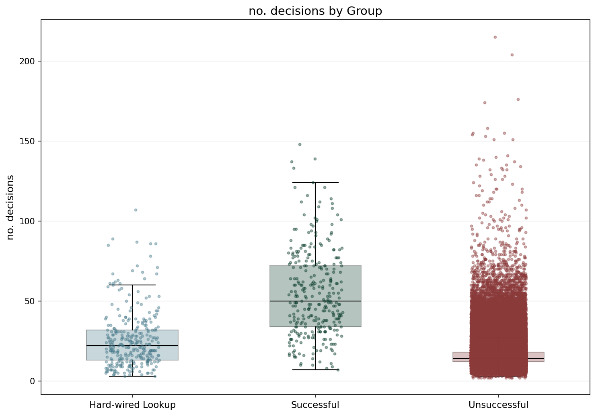

Statistic | Hard-wired Lookup | Successful | Unsuccessful
N | 300 | 300 | 193800
Mean | 25.74 | 54.61 | 16.29
Std Dev | 17.60 | 27.06 | 7.97
SEM | 1.02 | 1.56 | 0.02
Median | 22.00 | 50.00 | 14.00
Min | 3.00 | 7.00 | 2.00
Max | 107.00 | 148.00 | 215.00
IQR | 19.00 | 38.00 | 6.00
P25 | 13.00 | 34.00 | 12.00
P75 | 32.00 | 72.00 | 18.00
Skewness | 1.560 | 0.698 | 3.277
Kurtosis | 2.937 | 0.281 | 24.764

Normality Testing (Shapiro-Wilk):
Group | W statistic | p-value
Hard-wired Lookup | 0.8711 | 3.75e-15
Successful | 0.9649 | 1.18e-06
Unsuccessful | 0.7540 | 4.17e-154

Data is not normally distributed (alpha=0.05).

Kruskal-Wallis (omnibus test):
Test Name | Test Statistic | p-value | Epsilon-squared
Kruskal-Wallis | 818.0508 | 2.30e-178 | 0.0042 (insignificant)

Pairwise Post-Hoc (Mann-Whitney U (Holm-Bonferroni correction)):
Group 1 | Group 2 | Statistic | p-value | Rank-Biserial r
Hard-wired Lookup | Successful | 15153.0000 | 1.34e-44 | 0.6633 (large)
Hard-wired Lookup | Unsuccessful | 39433338.0000 | 8.74e-27 | -0.3565 (medium)
Successful | Unsuccessful | 54733363.5000 | 1.24e-154 | -0.8828 (large)

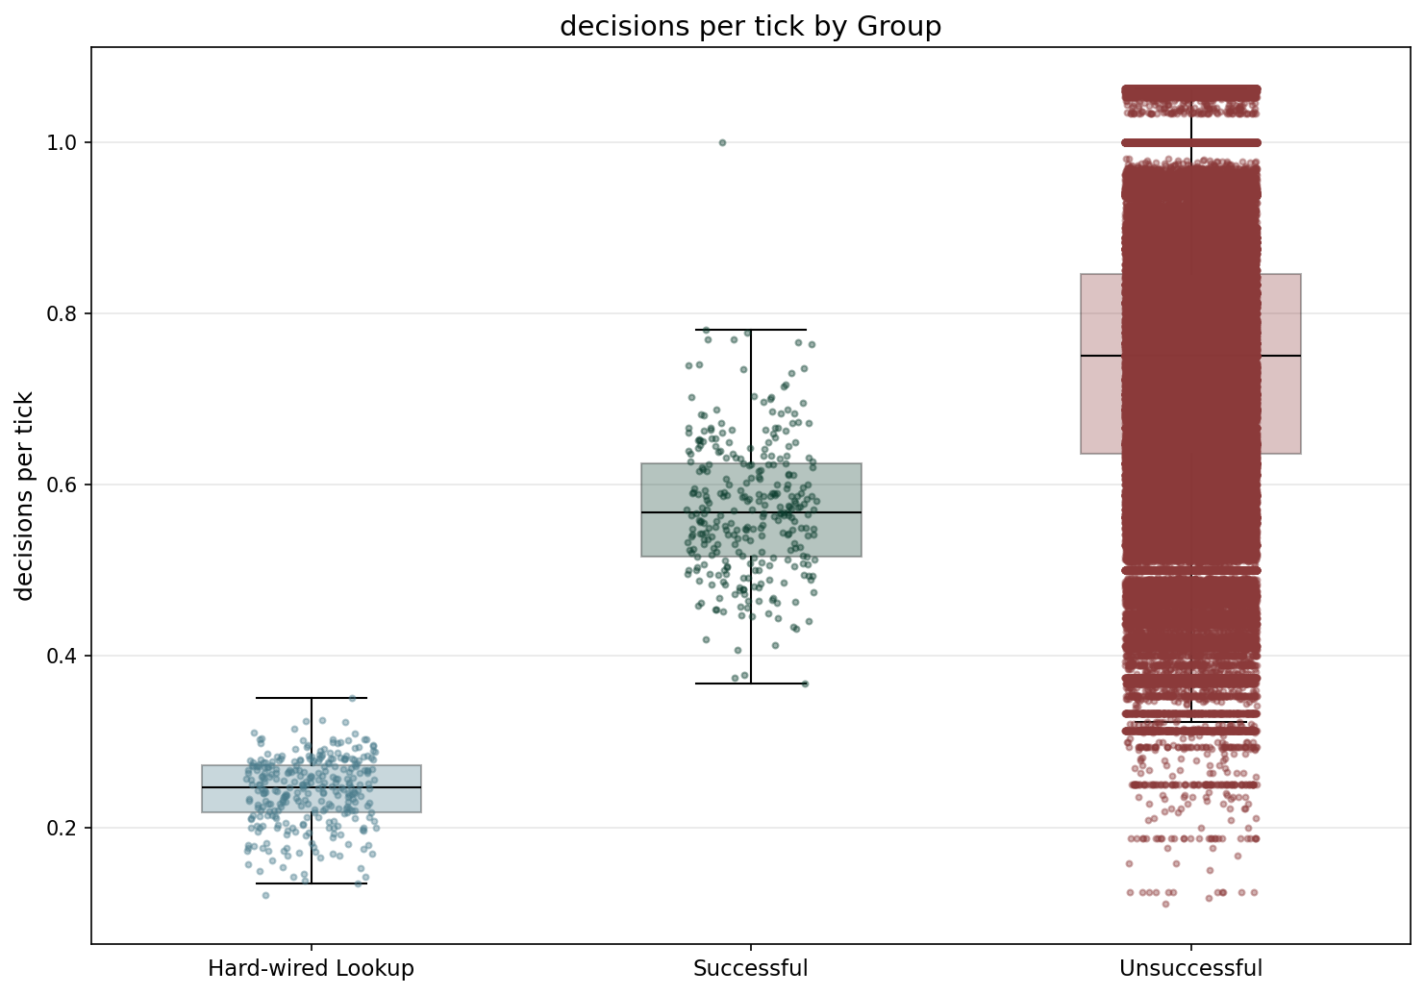

Statistic | Hard-wired Lookup | Successful | Unsuccessful
N | 300 | 300 | 193800
Mean | 0.24 | 0.57 | 0.74
Std Dev | 0.04 | 0.08 | 0.15
SEM | 0.00 | 0.00 | 0.00
Median | 0.25 | 0.57 | 0.75
Min | 0.12 | 0.37 | 0.11
Max | 0.35 | 1.00 | 1.06
IQR | 0.06 | 0.11 | 0.21
P25 | 0.22 | 0.52 | 0.64
P75 | 0.27 | 0.62 | 0.85
Skewness | -0.470 | 0.625 | -0.192
Kurtosis | -0.115 | 1.969 | -0.205

Normality Testing (Shapiro-Wilk):
Group | W statistic | p-value
Hard-wired Lookup | 0.9793 | 2.43e-04
Successful | 0.9764 | 7.50e-05
Unsuccessful | 0.9921 | 5.19e-63

Data is not normally distributed (alpha=0.05).

Kruskal-Wallis (omnibus test):
Test Name | Test Statistic | p-value | Epsilon-squared
Kruskal-Wallis | 1300.1878 | 4.65e-283 | 0.0067 (insignificant)

Pairwise Post-Hoc (Mann-Whitney U (Holm-Bonferroni correction)):
Group 1 | Group 2 | Statistic | p-value | Rank-Biserial r
Hard-wired Lookup | Successful | 0.0000 | 2.10e-99 | 1.0000 (large)
Hard-wired Lookup | Unsuccessful | 40328.0000 | 1.37e-196 | 0.9986 (large)
Successful | Unsuccessful | 9574598.0000 | 5.73e-90 | 0.6706 (large)

TBD

3.4.2. Correct Decisions
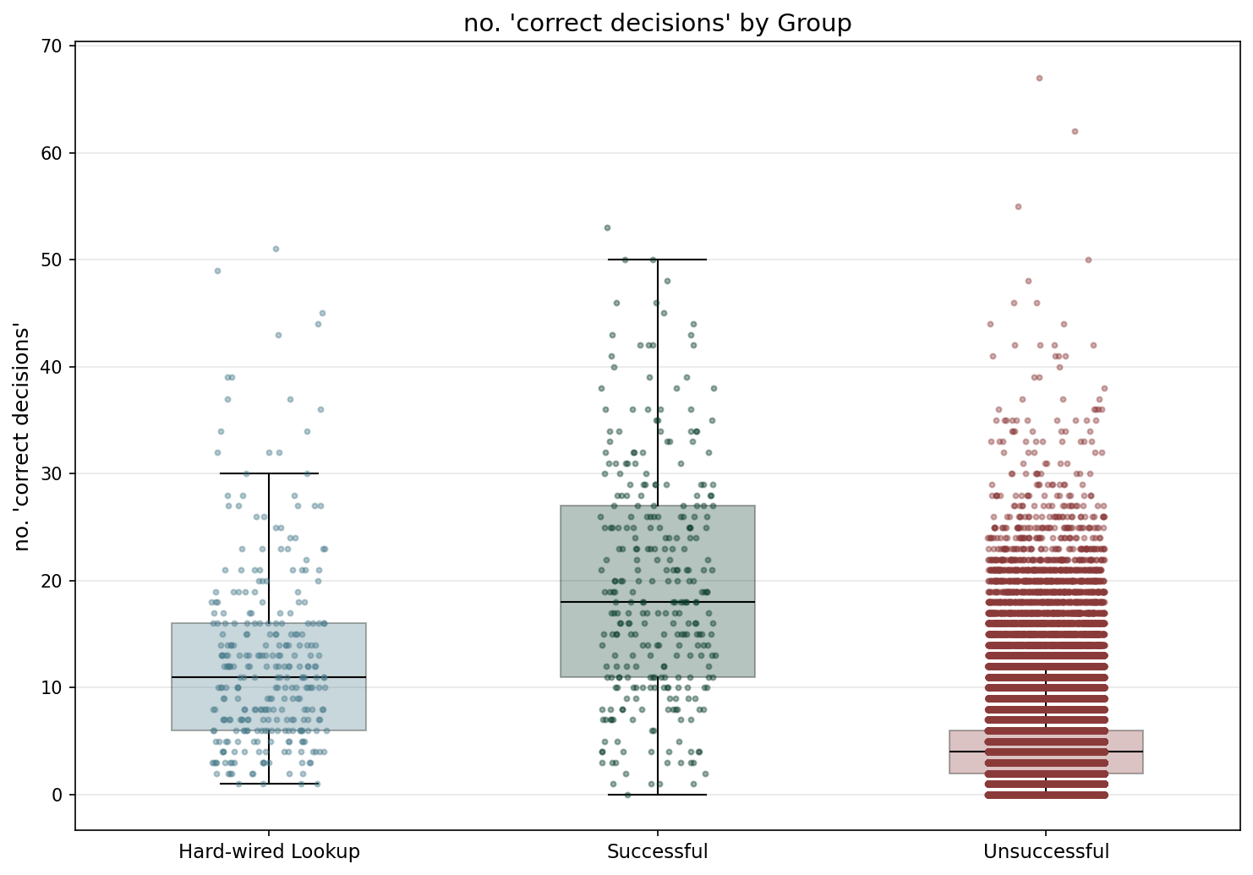

Statistic | Hard-wired Lookup | Successful | Unsuccessful
N | 300 | 300 | 193800
Mean | 12.72 | 19.73 | 4.32
Std Dev | 8.85 | 10.88 | 3.34
SEM | 0.51 | 0.63 | 0.01
Median | 11.00 | 18.00 | 4.00
Min | 1.00 | 0.00 | 0.00
Max | 51.00 | 53.00 | 67.00
IQR | 10.00 | 16.00 | 4.00
P25 | 6.00 | 11.00 | 2.00
P75 | 16.00 | 27.00 | 6.00
Skewness | 1.541 | 0.529 | 1.921
Kurtosis | 2.947 | -0.136 | 8.655

Normality Testing (Shapiro-Wilk):
Group | W statistic | p-value
Hard-wired Lookup | 0.8755 | 7.09e-15
Successful | 0.9740 | 2.89e-05
Unsuccessful | 0.8664 | 5.89e-135

Data is not normally distributed (alpha=0.05).

Kruskal-Wallis (omnibus test):
Test Name | Test Statistic | p-value | Epsilon-squared
Kruskal-Wallis | 1125.9633 | 3.16e-245 | 0.0058 (insignificant)

Pairwise Post-Hoc (Mann-Whitney U (Holm-Bonferroni correction)):
Group 1 | Group 2 | Statistic | p-value | Rank-Biserial r
Hard-wired Lookup | Successful | 26624.5000 | 4.71e-18 | 0.4083 (medium)
Hard-wired Lookup | Unsuccessful | 49591784.5000 | 2.15e-100 | -0.7059 (large)
Successful | Unsuccessful | 54076507.0000 | 4.45e-148 | -0.8602 (large)

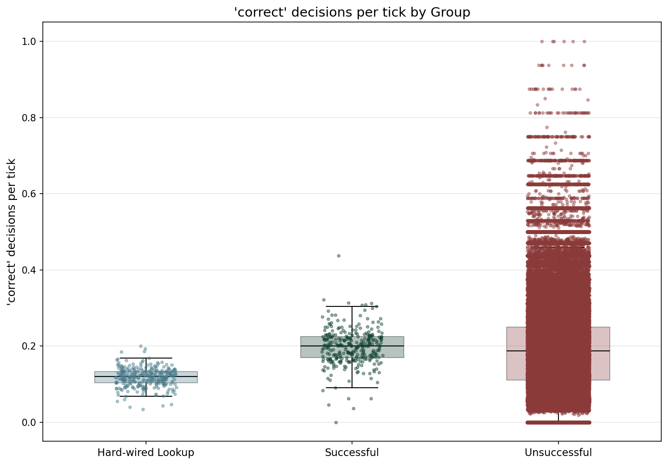

Statistic | Hard-wired Lookup | Successful | Unsuccessful
N | 300 | 300 | 193800
Mean | 0.12 | 0.20 | 0.19
Std Dev | 0.02 | 0.05 | 0.12
SEM | 0.00 | 0.00 | 0.00
Median | 0.12 | 0.20 | 0.19
Min | 0.03 | 0.00 | 0.00
Max | 0.20 | 0.44 | 1.00
IQR | 0.03 | 0.05 | 0.14
P25 | 0.10 | 0.17 | 0.11
P75 | 0.13 | 0.22 | 0.25
Skewness | -0.227 | 0.032 | 0.740
Kurtosis | 1.189 | 3.203 | 0.923

Normality Testing (Shapiro-Wilk):
Group | W statistic | p-value
Hard-wired Lookup | 0.9840 | 1.98e-03
Successful | 0.9618 | 4.26e-07
Unsuccessful | 0.9617 | 9.13e-100

Data is not normally distributed (alpha=0.05).

Kruskal-Wallis (omnibus test):
Test Name | Test Statistic | p-value | Epsilon-squared
Kruskal-Wallis | 159.4015 | 2.43e-35 | 0.0008 (insignificant)

Pairwise Post-Hoc (Mann-Whitney U (Holm-Bonferroni correction)):
Group 1 | Group 2 | Statistic | p-value | Rank-Biserial r
Hard-wired Lookup | Successful | 4849.5000 | 2.76e-79 | 0.8922 (large)
Hard-wired Lookup | Unsuccessful | 17197271.5000 | 3.27e-34 | 0.4084 (medium)
Successful | Unsuccessful | 31916345.5000 | 3.31e-03 | -0.0979 (insignificant)

TBD
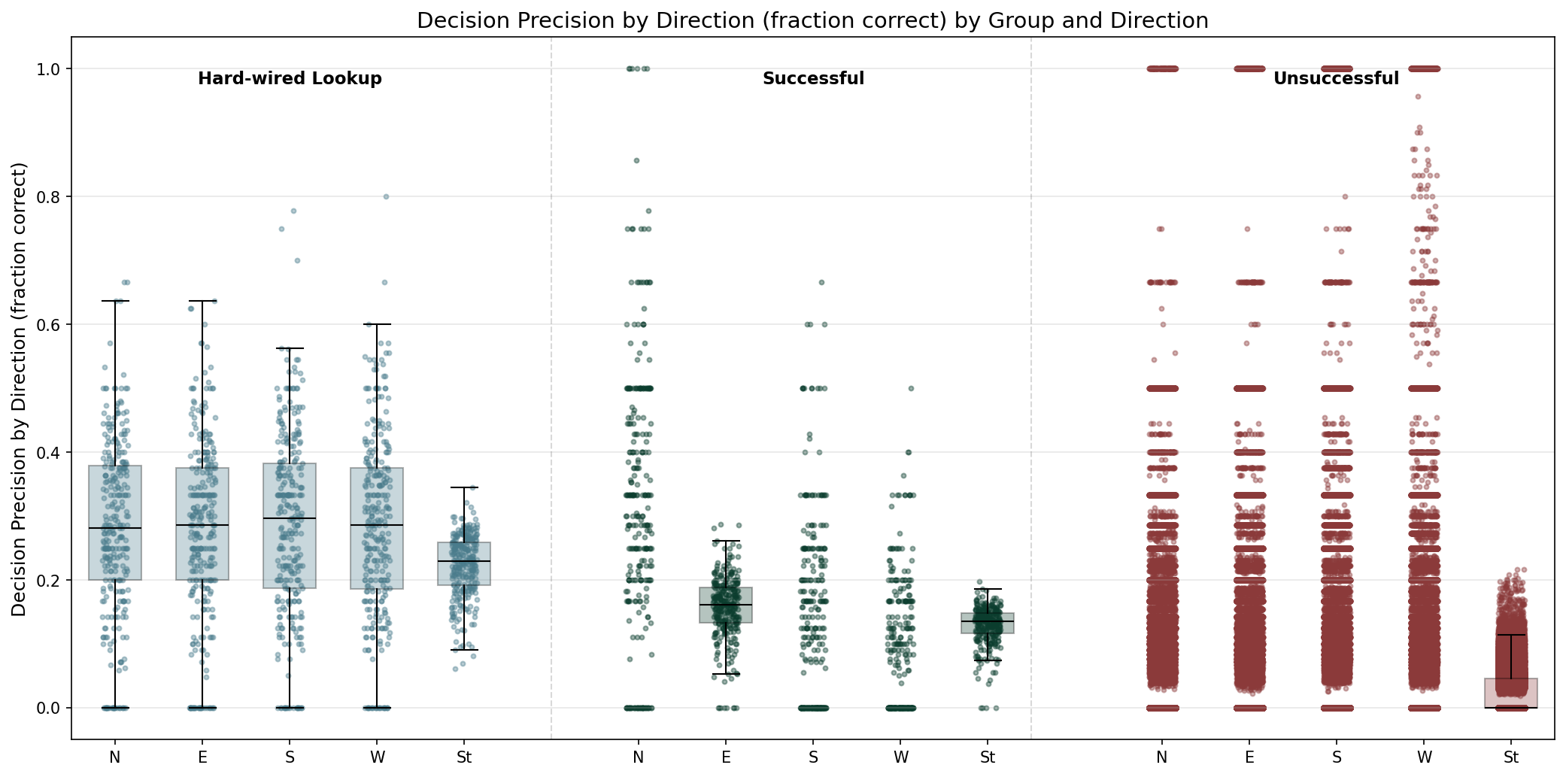

Statistic | North | East | South | West | Stay
N | 173307 | 174559 | 174105 | 177301 | 194400
Mean | 0.03 | 0.03 | 0.03 | 0.03 | 0.02
Std Dev | 0.08 | 0.08 | 0.09 | 0.09 | 0.03
Median | 0.00 | 0.00 | 0.00 | 0.00 | 0.00
Min | 0.00 | 0.00 | 0.00 | 0.00 | 0.00
Max | 1.00 | 1.00 | 1.00 | 1.00 | 0.34

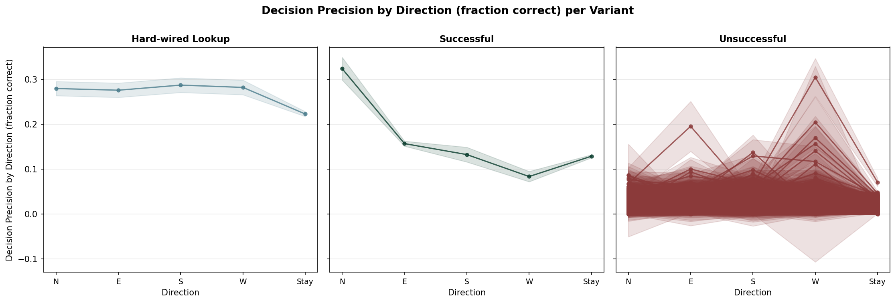

TBD

4. Summary
TBD

