EA Analysis Report: slow_mutation

Summary experiment parameters

Experiment Parameters
Parameter | Value
Filename | 2026-04-22_20-57-56_slow_mutation
brain_max_decision_delay | 2.0
brain_n_neurons | 11
brain_noise_level | 0.05
experiment_evolutionary_algorithm_elite_selection_metric | average
experiment_evolutionary_algorithm_elite_size | 3
experiment_evolutionary_algorithm_mutation_method | simple
experiment_evolutionary_algorithm_mutation_rate | 0.05
experiment_evolutionary_algorithm_num_generations | 100
experiment_genome_type | random
experiment_max_ticks | 2000
experiment_n_runs | 300
experiment_population_size | 100
food_feeding_paradigm_initial | True
food_feeding_paradigm_regrow | False
food_initial_fraction_per_cell | 0.25
food_regrow_time | 3000
worm_decisionmaking_version | plasticity
worm_energy_capacity | 30
worm_metabolic_rate | 1
worm_movement_cost | 1

Benchmark: Hard-wired Lookup Parameters
Parameter | Value
Filename | 2026-04-22_20-24-58_lookup
brain_max_decision_delay | 2.0
brain_n_neurons | 11
brain_noise_level | 0.05
experiment_evolutionary_algorithm_elite_selection_metric | average
experiment_evolutionary_algorithm_elite_size | 1
experiment_evolutionary_algorithm_mutation_method | simple
experiment_evolutionary_algorithm_mutation_rate | 0.3
experiment_evolutionary_algorithm_num_generations | 1
experiment_genome_type | lookup
experiment_max_ticks | 2000
experiment_n_runs | 300
experiment_population_size | 1
food_feeding_paradigm_initial | True
food_feeding_paradigm_regrow | False
food_initial_fraction_per_cell | 0.25
food_regrow_time | 3000
worm_decisionmaking_version | plasticity
worm_energy_capacity | 30
worm_metabolic_rate | 1
worm_movement_cost | 1

Benchmark: Random networks Parameters
Parameter | Value
Filename | 2026-04-22_20-38-37_random
brain_max_decision_delay | 2.0
brain_n_neurons | 11
brain_noise_level | 0.05
experiment_evolutionary_algorithm_elite_selection_metric | average
experiment_evolutionary_algorithm_elite_size | 1
experiment_evolutionary_algorithm_mutation_method | simple
experiment_evolutionary_algorithm_mutation_rate | 0.3
experiment_evolutionary_algorithm_num_generations | 1
experiment_genome_type | random
experiment_max_ticks | 2000
experiment_n_runs | 300
experiment_population_size | 100
food_feeding_paradigm_initial | True
food_feeding_paradigm_regrow | False
food_initial_fraction_per_cell | 0.25
food_regrow_time | 3000
worm_decisionmaking_version | plasticity
worm_energy_capacity | 30
worm_metabolic_rate | 1
worm_movement_cost | 1

EA Results / Fitness
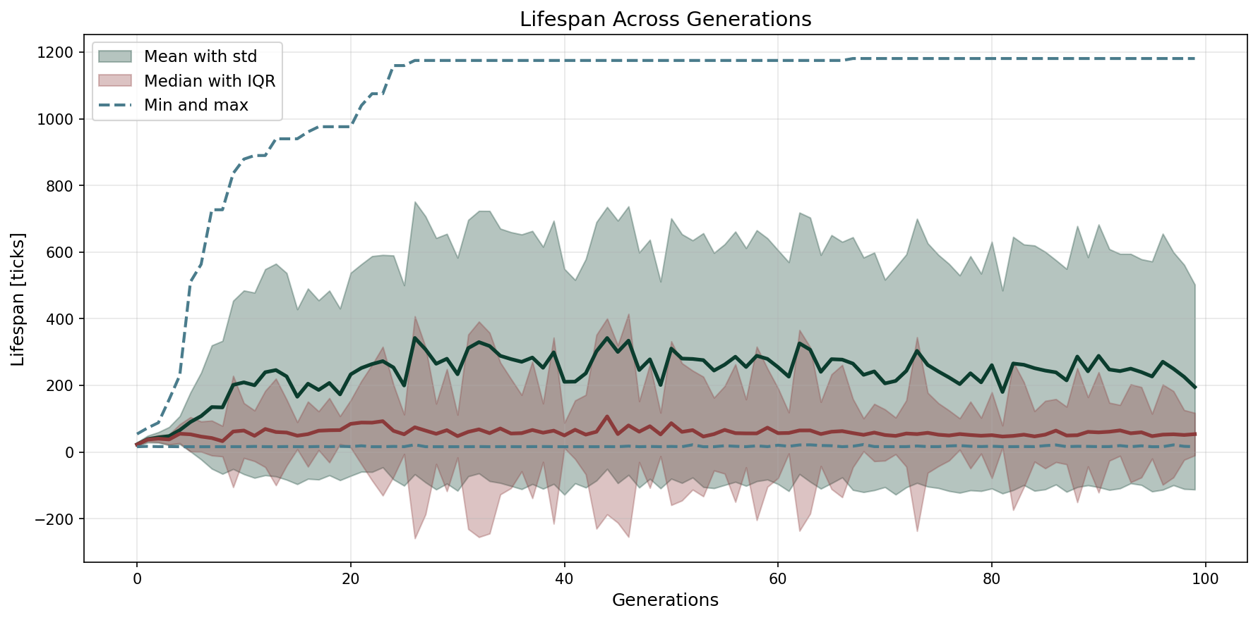

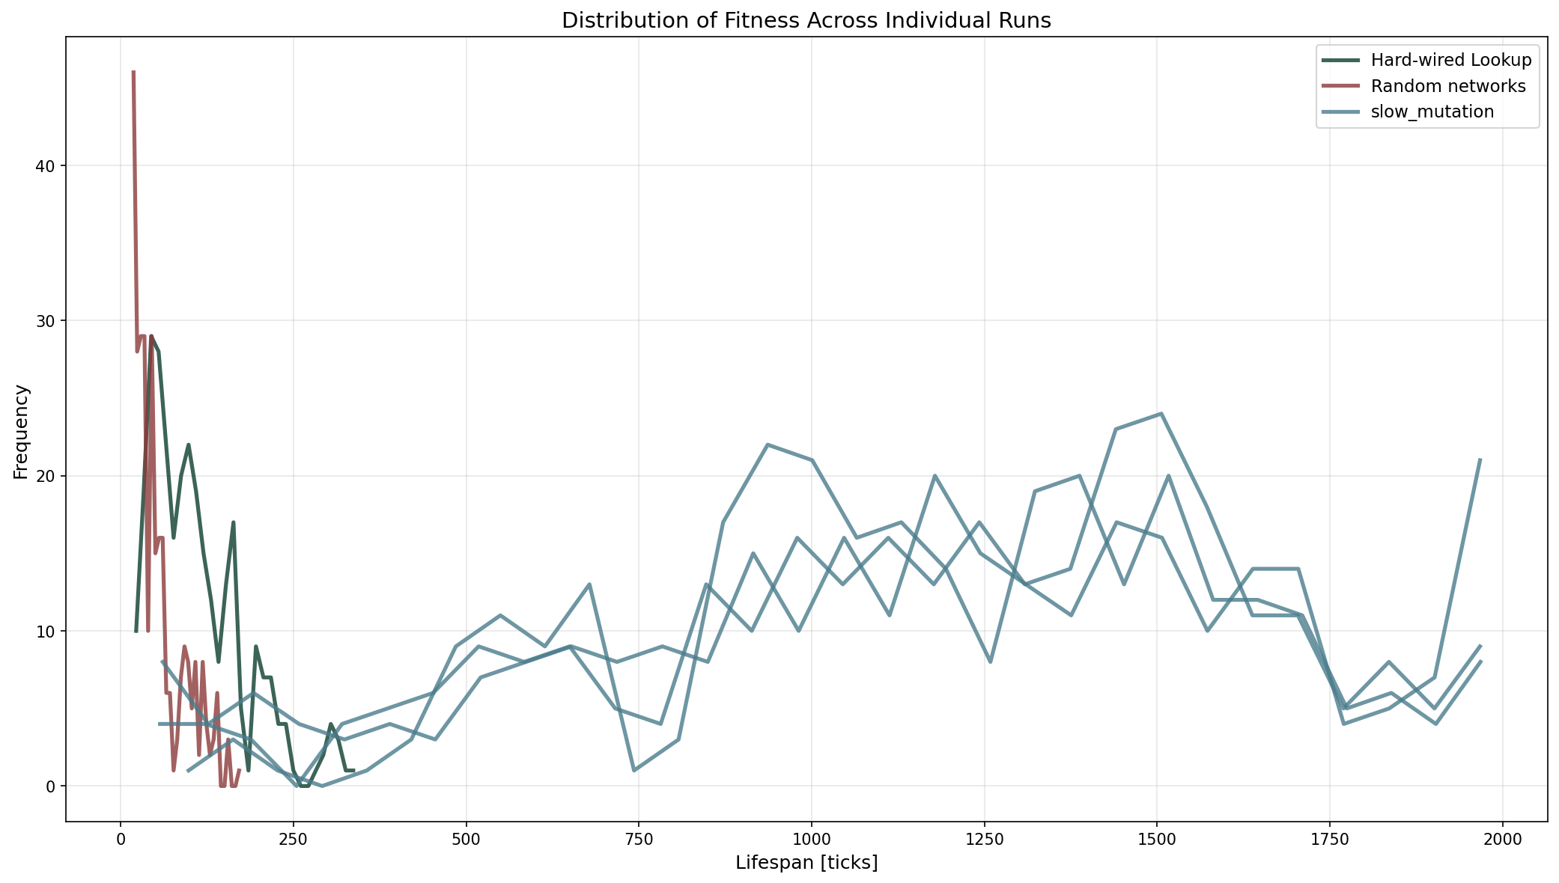

Connectivity

Network Topology Summary
Source | Exc Out-Deg | Exc In-Deg | Inh Out-Deg | Inh In-Deg | Self Conn | Exc Bidir | Inh Bidir | Neurons
Hard-wired Lookup | 0.82 | 0.82 | 0.36 | 0.36 | 0.000 | 0.000 | 0.000 | 11
Random networks | 2.18 | 2.18 | 4.36 | 4.36 | 0.636 | 0.104 | 0.188 | 11
slow_mutation | 2.27 | 2.27 | 4.27 | 4.27 | 0.758 | 0.140 | 0.241 | 11

