Analysis Report: Random Wiring Variants
overall_survival

Experiment Information
- Experiment folder: 2026-03-07_21-08-07_random_wiring_exc20_inh40_pot_10_dep_5
- Number of variants: 1000
- Runs per variant: 100

Summary Statistics

Mean survival time (ticks):
Metric | Value
Mean across variants | 60.3
Std across variants | 63.7
Min variant mean | 16.0
Max variant mean | 457.9

Median survival time (ticks):
Metric | Value
Mean median across variants | 28.8
Std median across variants | 14.0

Percentile Analysis (for ranking):
Metric | Value (ticks)
90th percentile threshold | 43.1
Variants in 90th percentile | 100
10th percentile threshold | 16.0

Statistical Test (Unsuccessful vs Successful):
Test | Value
Mann-Whitney U-statistic | 6335313.0000
p-value | 0.0000e+00

Comparison: Successful vs Unsuccessful Variants:
Metric | Successful (Top 10%) | Unsuccessful (Bottom 10%)
Number of runs | 10000 | 16100
Mean (ticks) | 92.4 | 18.5
Median (ticks) | 54.0 | 16.0
Std Dev (ticks) | 137.4 | 21.2
Min (ticks) | 16.0 | 16.0
Max (ticks) | 1000.0 | 1000.0

Analysis Figures and Results

1. Survival Race - All Variants
This plot shows the survival curves for all 1000 wiring variants. Lines are color-coded by percentile: green indicates top 10% (median ≥ 43.1 ticks), red indicates bottom 10% (median ≤ 16.0 ticks), and gray indicates the middle 80%.
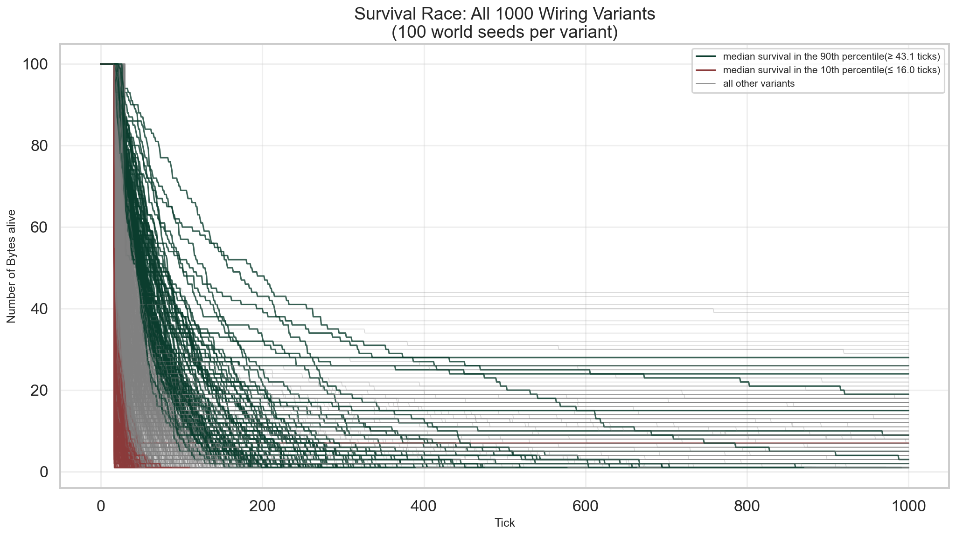

2. Survival Time Comparison: Unsuccessful vs Successful
Statistical Comparison of Lifetime Durations:
Metric | Successful (Top 10%) | Unsuccessful (Bottom 10%)
Number of runs | 10000 | 16100
Mean (ticks) | 92.4 | 18.5
Median (ticks) | 54.0 | 16.0
Std Dev (ticks) | 137.4 | 21.2
Min (ticks) | 16.0 | 16.0
Max (ticks) | 1000.0 | 1000.0
Mann-Whitney U Test Results (non-parametric test for non-normal distributions):
Test Statistic | Value
Mann-Whitney U-statistic | 6335313.0000
p-value | 0.0000e+00
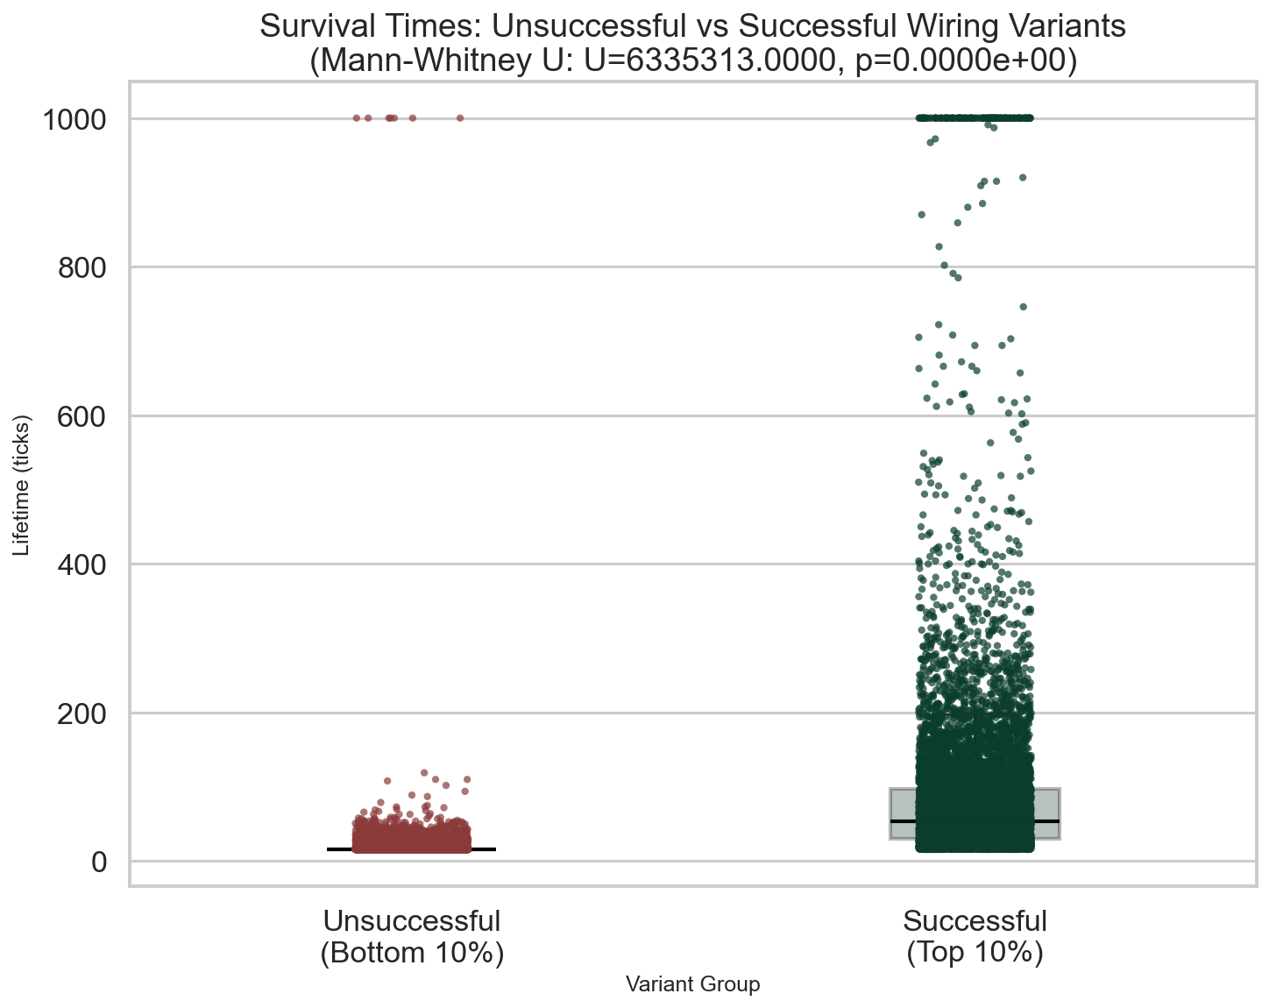

3. Movement Efficiency by Direction
Movement Efficiency = Movement Count ÷ Sensing Count per direction
Efficiency Statistics (Mean ± Std Dev):
Direction | Unsuccessful | Successful
N | 1.023 ± 1.805 | 0.873 ± 1.388
E | 1.228 ± 1.973 | 0.950 ± 1.525
S | 1.147 ± 1.963 | 1.055 ± 1.658
W | 1.334 ± 2.160 | 0.778 ± 1.279
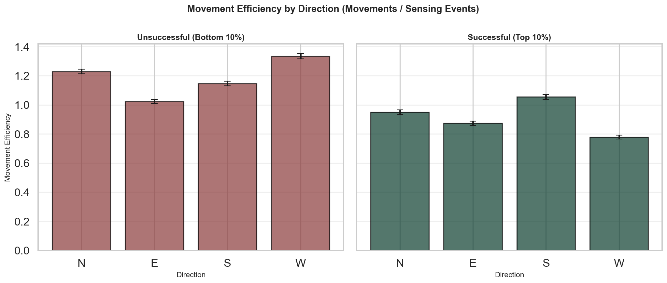

4. Decision Accuracy: Unsuccessful vs Successful
Decision Accuracy = Correct Decisions ÷ Total Decisions
Statistical Comparison of Decision Accuracy:
Metric | Successful (Top 10%) | Unsuccessful (Bottom 10%)
Number of runs | 10000 | 16100
Mean accuracy | 0.181 | 0.328
Median accuracy | 0.171 | 0.333
Std Dev | 0.124 | 0.170
Min | 0.000 | 0.000
Max | 1.000 | 1.000
Mann-Whitney U Test Results:
Test Statistic | Value
Mann-Whitney U-statistic | 122573739.0000
p-value | 0.0000e+00
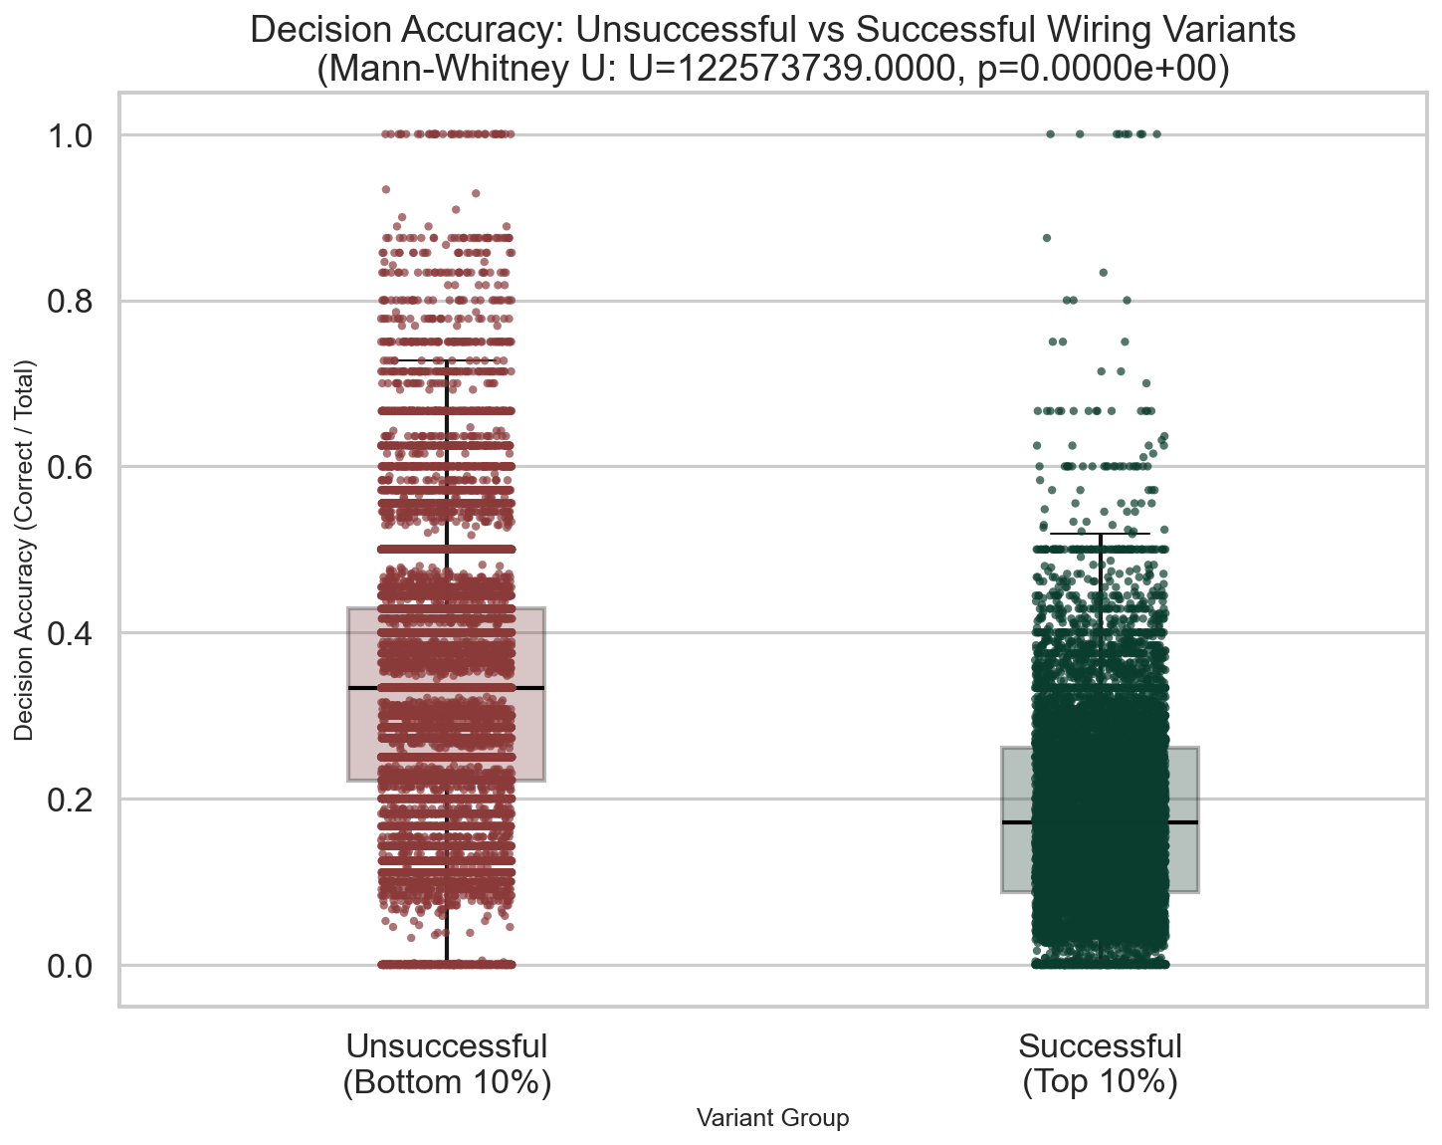

5. Decision Diagnostic Analysis: Why Accuracy Doesn't Predict Survival
A critical finding: unsuccessful variants have HIGHER decision accuracy (33%) than successful variants (18%), but shorter lifespans. This diagnostic analysis reveals why. A 'decision' only occurs when the worm senses food AND is not on food. A 'correct decision' is when movement matches sensed food direction.

Decision-Making Strategy Comparison:
Metric | Successful | Unsuccessful
Mean decisions/tick | 0.534 | 0.532
Median decisions/tick | 0.517 | 0.526
Mean total decisions/run | 53.2 | 10.0
Key Insight:
Unsuccessful variants make ~2x more decisions per tick than successful variants. This suggests they encounter food-sensing situations far more frequently, engaging in constant food-directed micro-corrections. While they make more correct food-directed moves, this strategy consumes energy inefficiently and leads to early starvation. Successful variants use a different movement strategy with fewer food-sensing decisions, achieving better long-term survival.

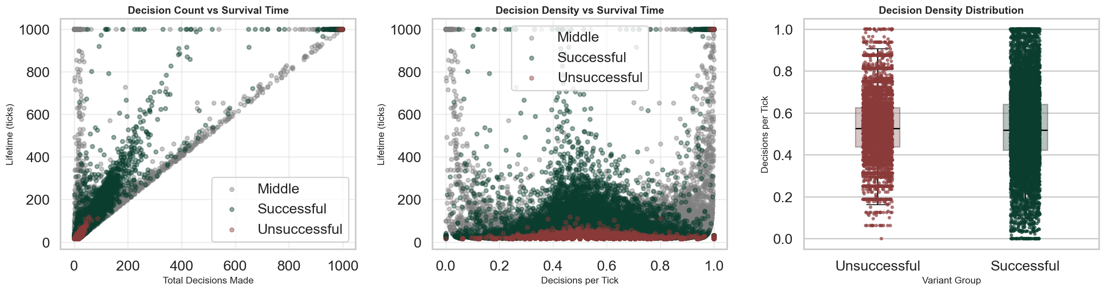

6. Total Distance Travelled: Unsuccessful vs Successful
Metric | Successful (Top 10%) | Unsuccessful (Bottom 10%)
Number of runs | 10000 | 16100
Mean | 42.741 | 16.363
Median | 27.000 | 15.000
Std Dev | 54.079 | 4.805
Min | 0.000 | 0.000
Max | 767.000 | 101.000
Mann-Whitney U Test Results:
Test Statistic | Value
Mann-Whitney U-statistic | 48552314.5
p-value | 0.0000e+00
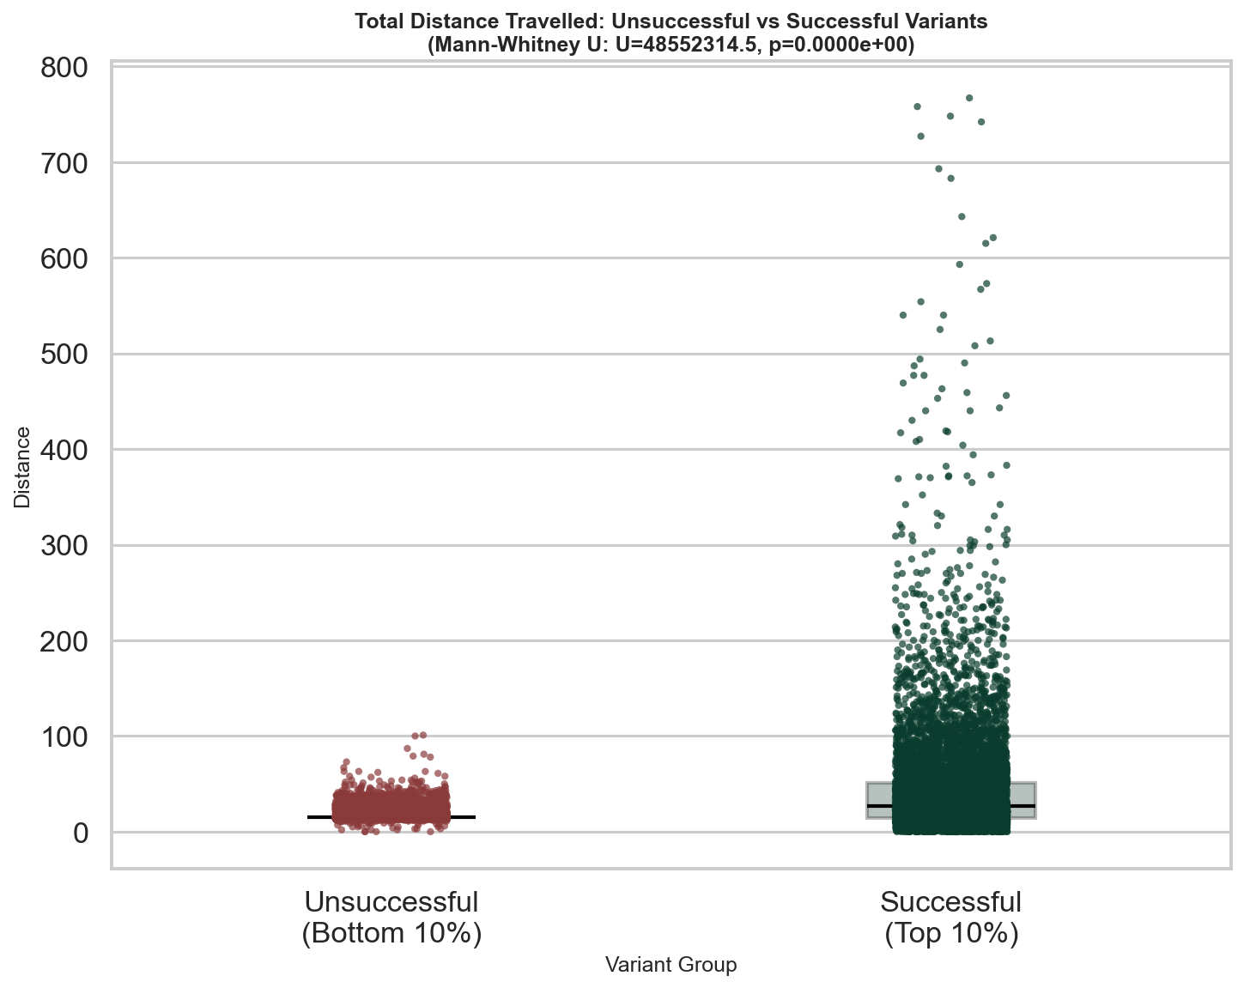

7. Distance Efficiency (Per Tick): Unsuccessful vs Successful
Metric | Successful (Top 10%) | Unsuccessful (Bottom 10%)
Number of runs | 10000 | 16100
Mean | 0.534 | 0.910
Median | 0.571 | 0.938
Std Dev | 0.238 | 0.058
Min | 0.000 | 0.000
Max | 0.938 | 0.938
Mann-Whitney U Test Results:
Test Statistic | Value
Mann-Whitney U-statistic | 157277054.5
p-value | 0.0000e+00
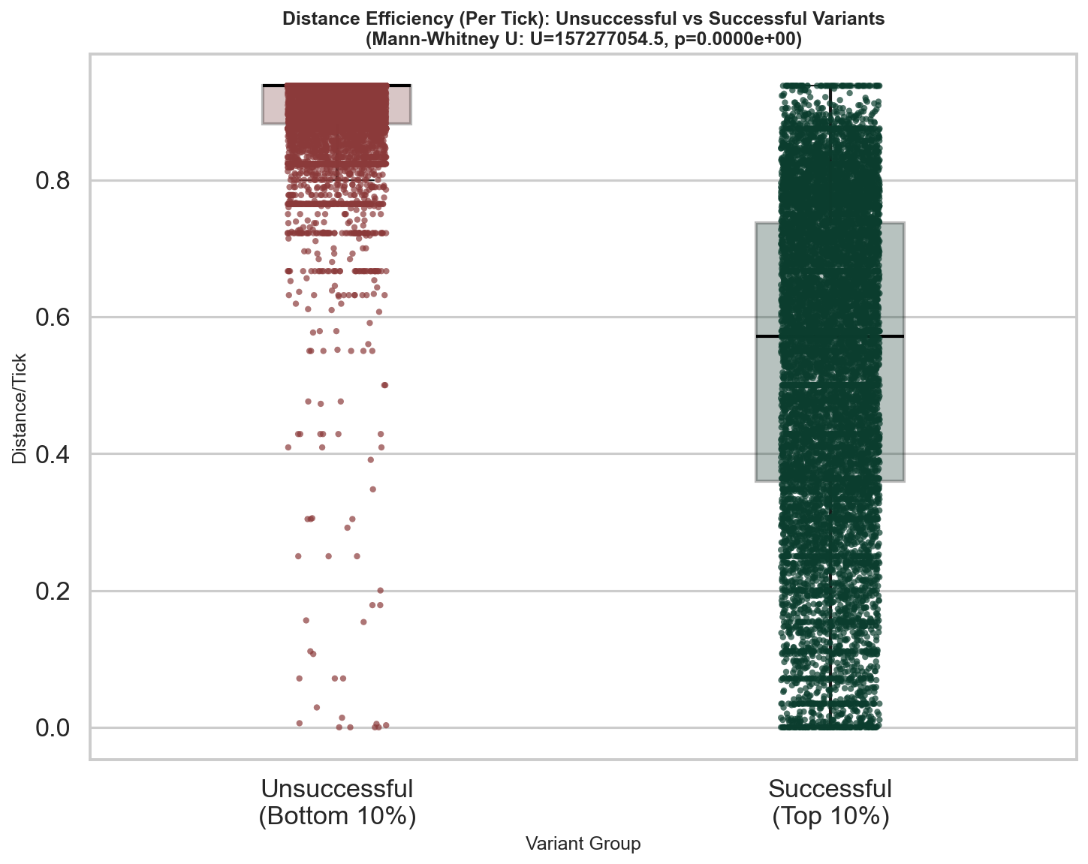

8. Total Food Eaten: Unsuccessful vs Successful
Metric | Successful (Top 10%) | Unsuccessful (Bottom 10%)
Number of runs | 10000 | 16100
Mean | 9.380 | 0.290
Median | 5.000 | 0.000
Std Dev | 15.362 | 1.624
Min | 0.000 | 0.000
Max | 216.000 | 72.000
Mann-Whitney U Test Results:
Test Statistic | Value
Mann-Whitney U-statistic | 14559927.5
p-value | 0.0000e+00
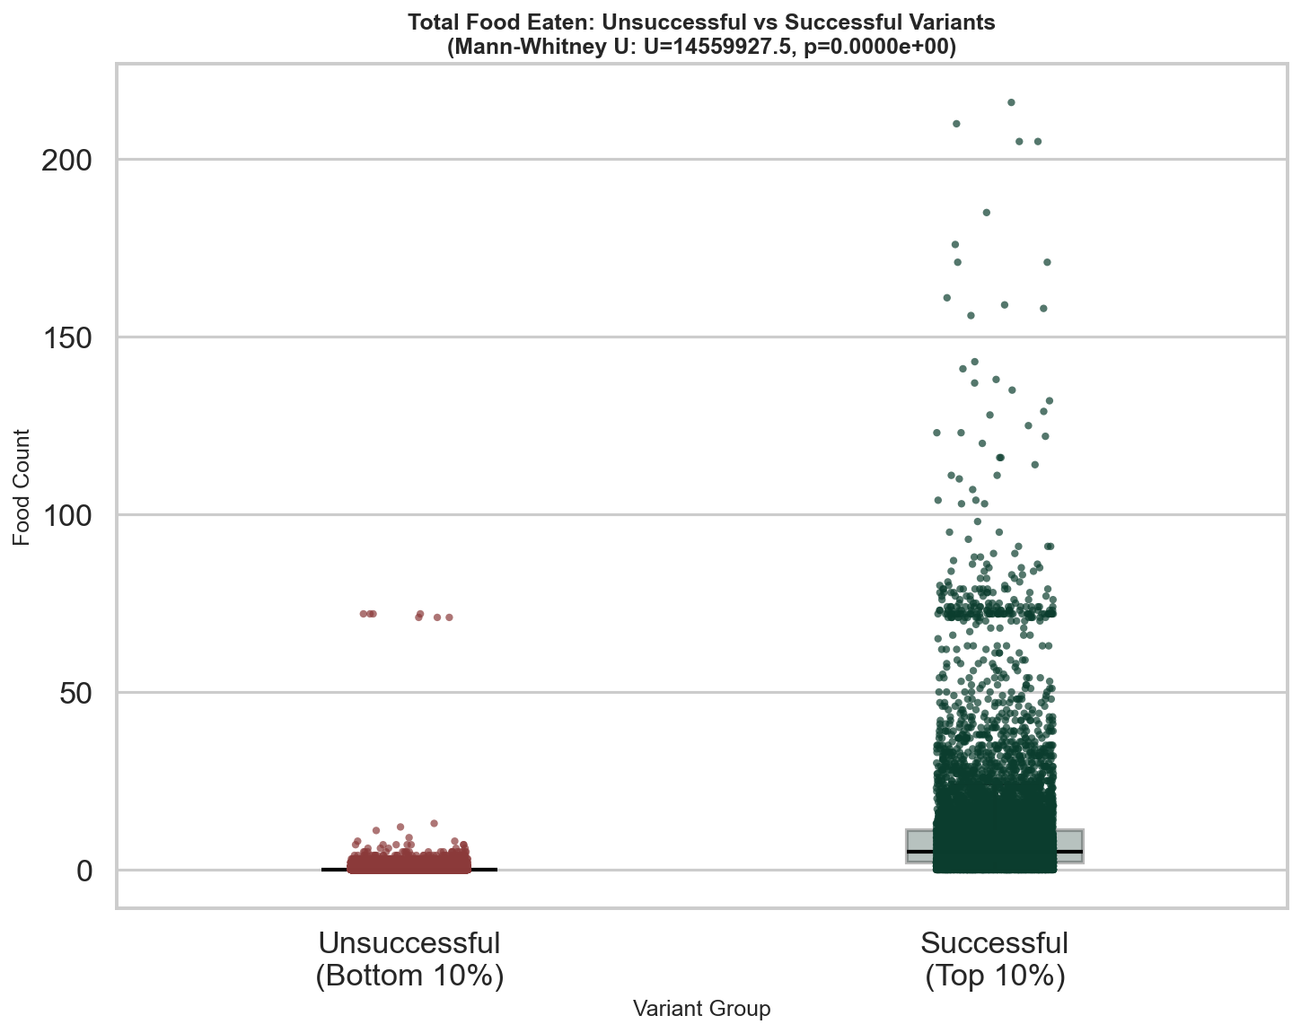

9. Food Consumption Rate (Per Tick): Unsuccessful vs Successful
Metric | Successful (Top 10%) | Unsuccessful (Bottom 10%)
Number of runs | 10000 | 16100
Mean | 0.081 | 0.010
Median | 0.082 | 0.000
Std Dev | 0.047 | 0.021
Min | 0.000 | 0.000
Max | 0.228 | 0.140
Mann-Whitney U Test Results:
Test Statistic | Value
Mann-Whitney U-statistic | 15978329.0
p-value | 0.0000e+00
