Analysis Report: Random Wiring Variants

analysis

1. Experiment Information

Random Wiring Variants:
Experiment folder: 2026-03-12_10-08-32_random_lookup
Total random variants analyzed: 1
Runs per variant: 100
Total data points (random): 100

Benchmark Variants:
Hard-wired Lookup: 50 data points (1 variants)

1.1. Summary Statistics - Random Wiring Variants
Summary of how long random wiring variants survive in the experimental environment. We measure survival time in simulation ticks across all 1 variants and 50 runs per variant. The statistics below provide a comprehensive overview of survival time distribution across all measurements.

Overall Descriptive Statistics (Across All Variants):
Statistic | Value
Mean | 104.14 ticks
Median | 102.00 ticks
Std Dev | 50.08 ticks
Min | 25.00 ticks
Max | 278.00 ticks
Range | 253.00 ticks
IQR (25th-75th percentile) | 60.75 ticks
5th Percentile | 41.90 ticks
25th Percentile | 69.50 ticks
75th Percentile | 130.25 ticks
95th Percentile | 197.70 ticks
Skewness | 1.011
Kurtosis (excess) | 1.544
Coefficient of Variation | 48.09 %

Per-variant Summary (Highest, Lowest, Average across variants):
Statistic | Highest (variant) | Lowest (variant) | Average (across variants)
Mean | 104.14 ticks (variant_01) | 104.14 ticks (variant_01) | 104.14 ticks
Median | 102.00 ticks (variant_01) | 102.00 ticks (variant_01) | 102.00 ticks
Std Dev | 50.08 ticks (variant_01) | 50.08 ticks (variant_01) | 50.08 ticks
Min | 25.00 ticks (variant_01) | 25.00 ticks (variant_01) | 25.00 ticks
Max | 278.00 ticks (variant_01) | 278.00 ticks (variant_01) | 278.00 ticks
Range | 253.00 ticks (variant_01) | 253.00 ticks (variant_01) | 253.00 ticks
IQR (25th-75th) | 60.75 ticks (variant_01) | 60.75 ticks (variant_01) | 60.75 ticks
5th Percentile | 41.90 ticks (variant_01) | 41.90 ticks (variant_01) | 41.90 ticks
25th Percentile | 69.50 ticks (variant_01) | 69.50 ticks (variant_01) | 69.50 ticks
75th Percentile | 130.25 ticks (variant_01) | 130.25 ticks (variant_01) | 130.25 ticks
95th Percentile | 197.70 ticks (variant_01) | 197.70 ticks (variant_01) | 197.70 ticks
Skewness | 1.011 (variant_01) | 1.011 (variant_01) | 1.011
Kurtosis (excess) | 1.544 (variant_01) | 1.544 (variant_01) | 1.544
Coefficient of Variation | 48.09 % (variant_01) | 48.09 % (variant_01) | 48.09 %

1.2. Summary Statistics - Benchmark Variants

Hard-wired Lookup
Statistic | Value
Mean | 104.14 ticks
Median | 102.00 ticks
Std Dev | 50.08 ticks
Min | 25.00 ticks
Max | 278.00 ticks
Range | 253.00 ticks
IQR (25th-75th percentile) | 60.75 ticks
5th Percentile | 41.90 ticks
25th Percentile | 69.50 ticks
75th Percentile | 130.25 ticks
95th Percentile | 197.70 ticks
Skewness | 1.011
Kurtosis (excess) | 1.544
Coefficient of Variation | 48.09 %

Network Development (Initial vs. Final States):
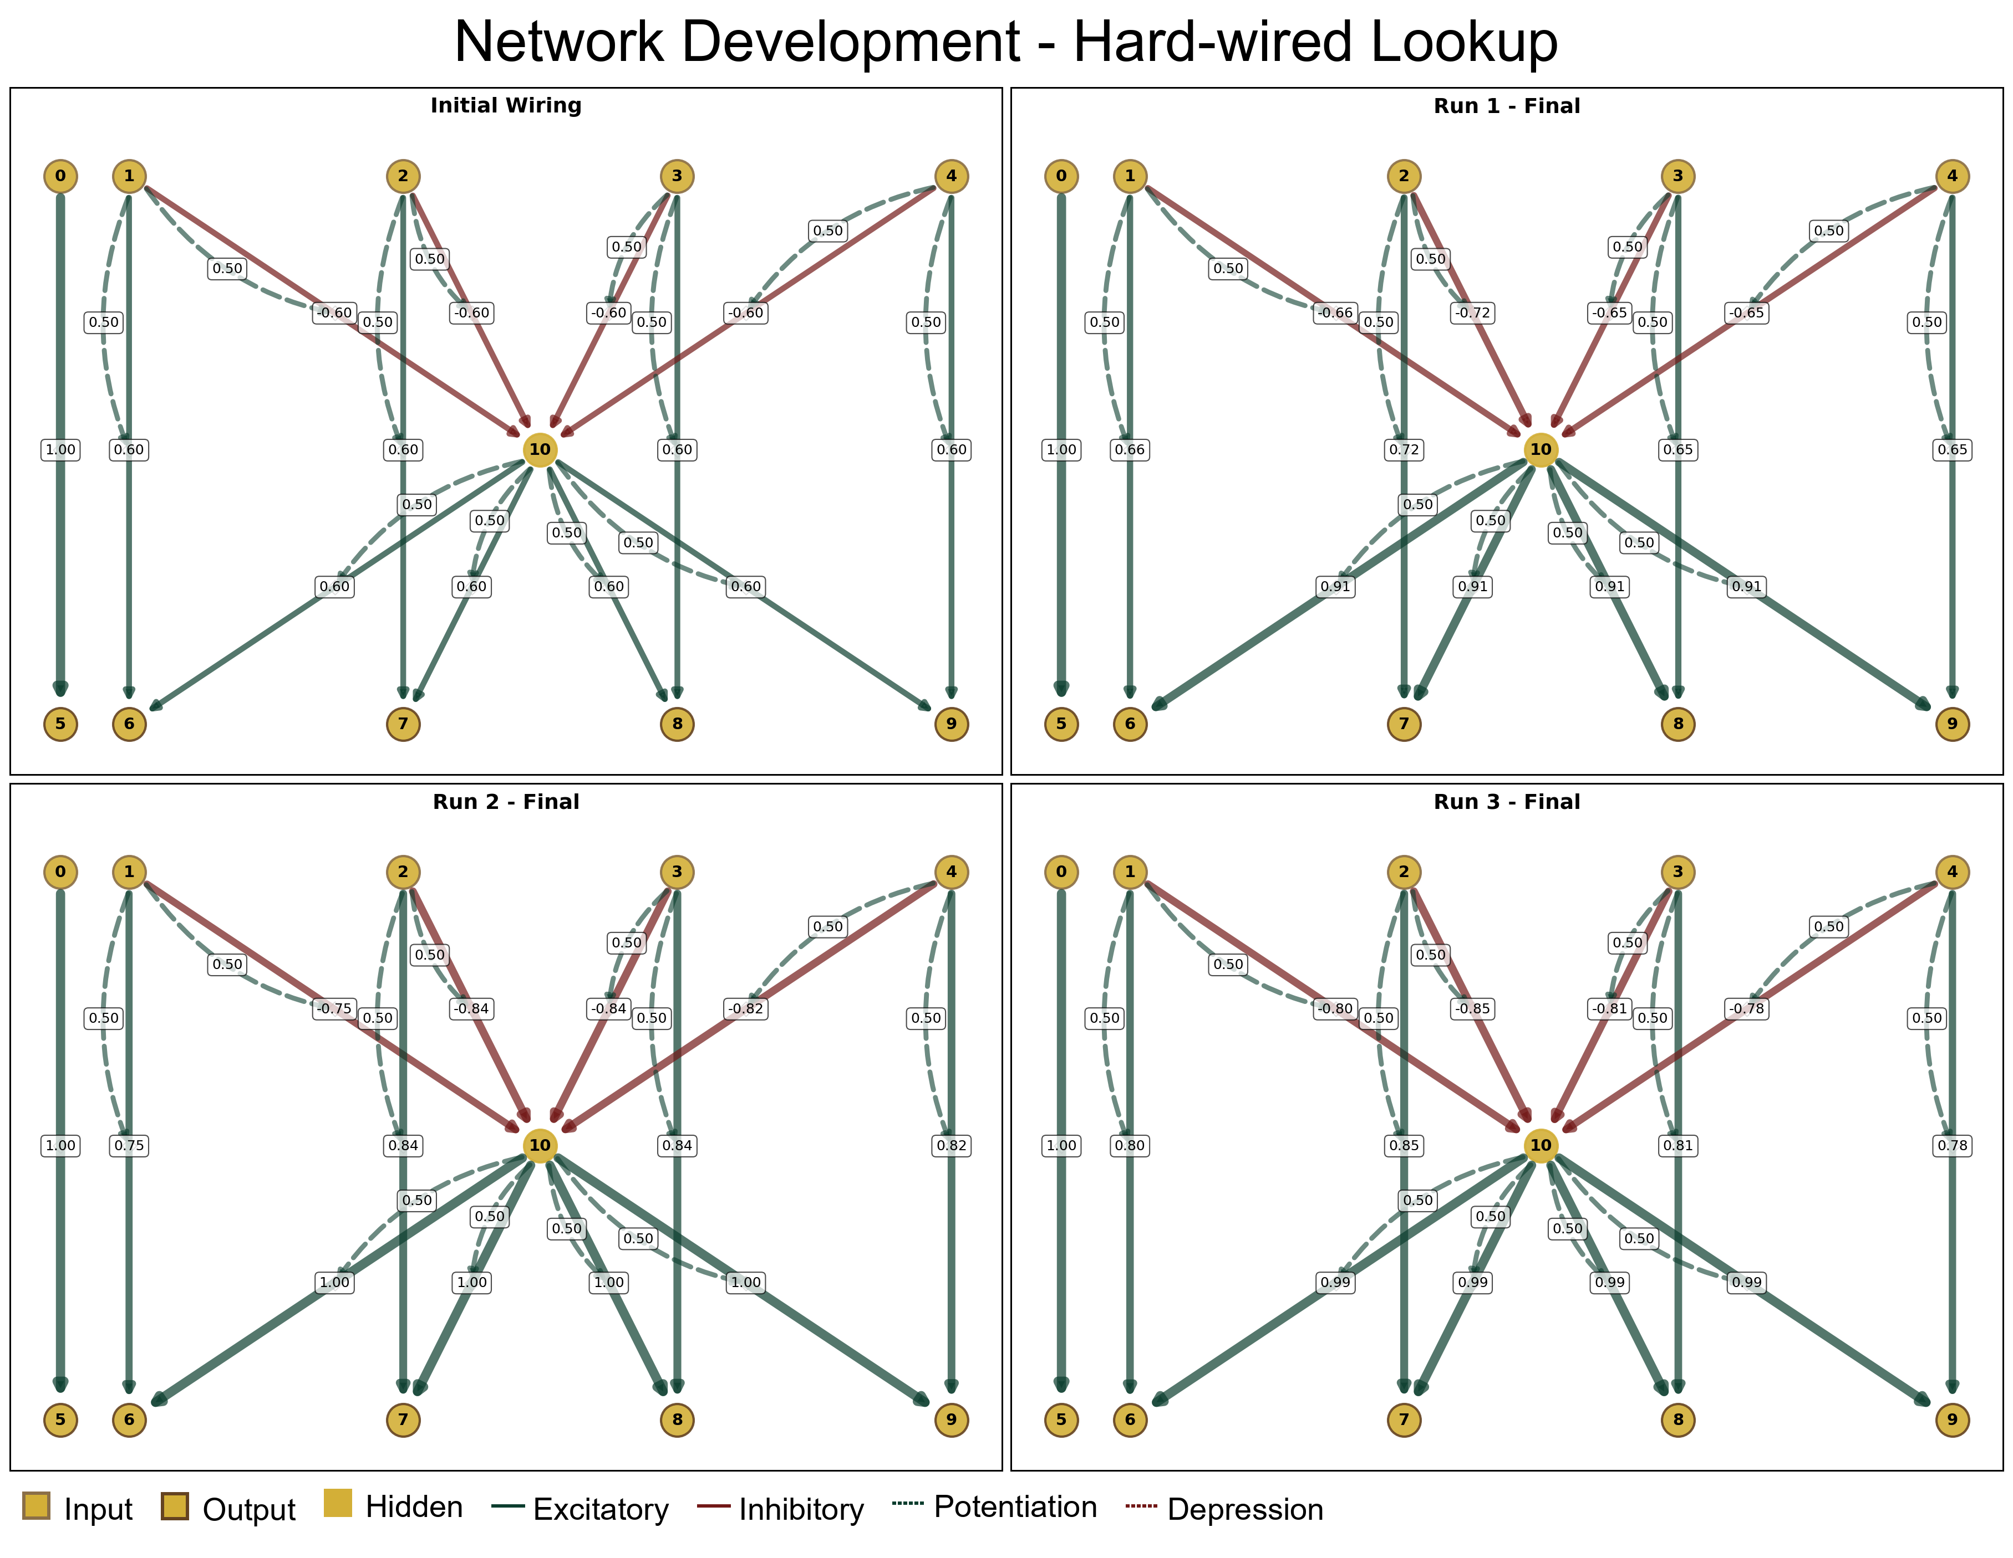

2. Group Selection Based on Survival Race
Success is measured based on median survival across 100 runs with different randomizer seeds. The 1 different wiring variants are split into successful and unsuccessful groups based on their performance. The achievable range of median liefetimes is split into percentiles. Variants in the 'successful' group had median lifetimes in the top 10% of that range, while variants in the 'unsuccessful' group had median lifetimes in the bottom 10% of that range. This approach respects natural performance gaps and identifies only the variants that truly solve the task well regardless of the number of variants that achieve this.
Metric | Value (ticks)
Successful threshold (top 10% of range) | >= 102.0
Unsuccessful threshold (bottom 10% of range) | <= 102.0
Variants identified in each group | Successful: 1, Unsuccessful: 1

Successful Variant Group (Top 10%): 1
Unsuccessful Variant Group (Bottom 10%): 1

The survival race plot tracks how many individuals from each wiring variant survive over time. Each curve represents a variant's cumulative survival, showing how fitness changes across the simulation. We use this visualization to identify which variants are robustly long-lived. The comparison table shows key statistics for successful versus unsuccessful variants, helping quantify the performance gap.
This plot shows the survival curves for all 1 wiring variants. Variants are color-coded by their performance achievement (range-based thresholds):
• Green: Top 10% of variants (median survival ≥ 102.0 ticks) — 1 variants
• Red: Bottom 10% of variants (median survival ≤ 102.0 ticks) — 1 variants
• Gray: Middle range (other variants)
• Colored lines: Benchmark variants
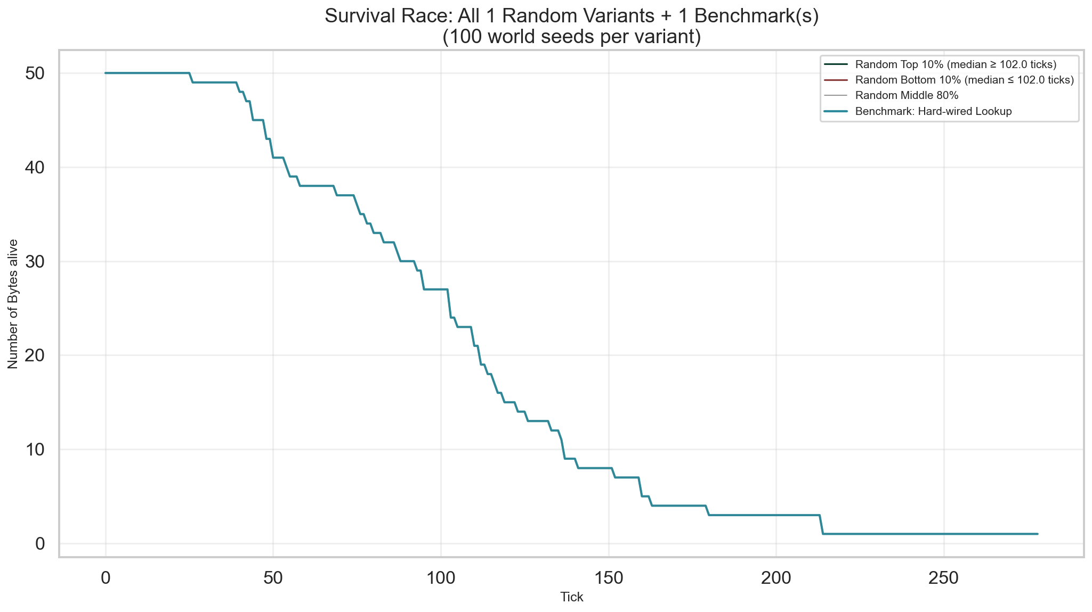

Successful vs Unsuccessful Comparison:
Metric | Successful (Top 10% of Variants) | Unsuccessful (Bottom 10% of Variants)
Number of runs | 50 | 50
Mean (ticks) | 104.1 | 104.1
Median (ticks) | 102.0 | 102.0
Std Dev (ticks) | 50.1 | 50.1
Min (ticks) | 25.0 | 25.0
Max (ticks) | 278.0 | 278.0

Network Development: Successful vs Unsuccessful Variants
Below are combined network visualizations showing initial wiring and the first three runtime states for representative variants from the successful and unsuccessful groups.

Successful Variants (Top 10%):
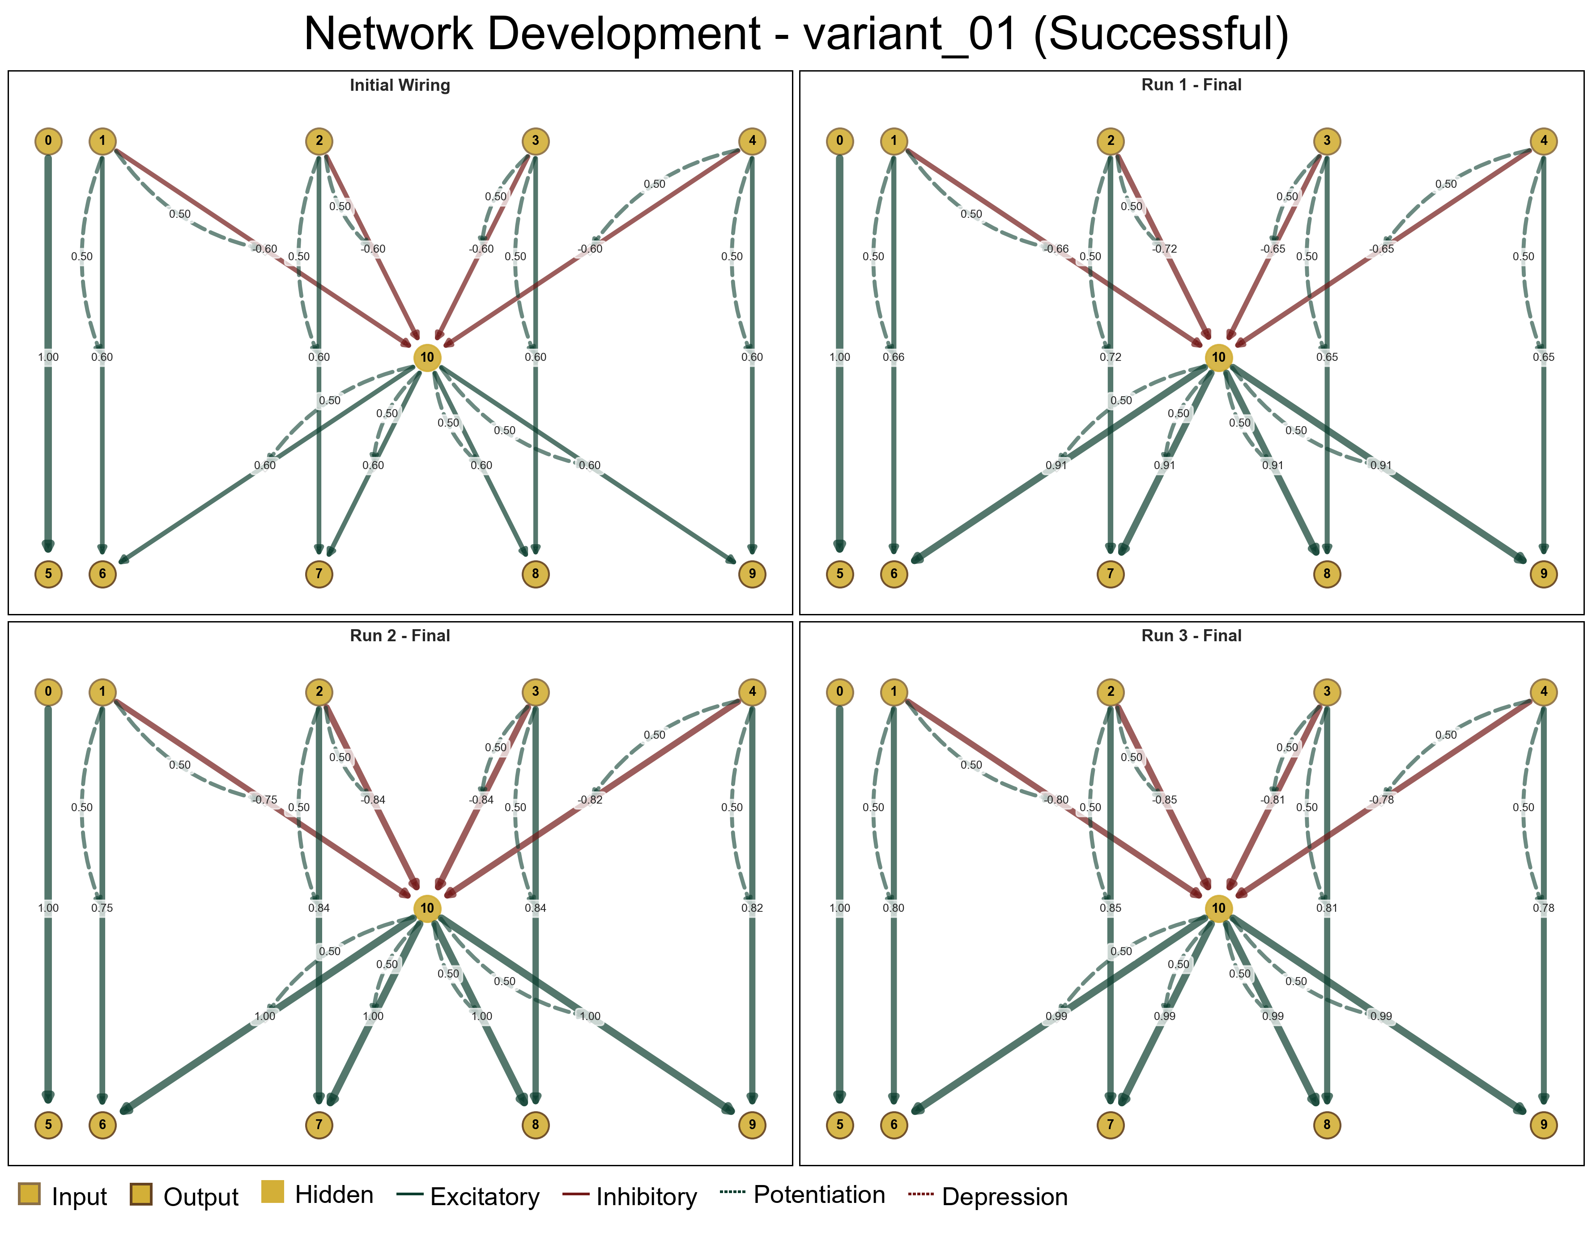

Unsuccessful Variants (Bottom 10%):
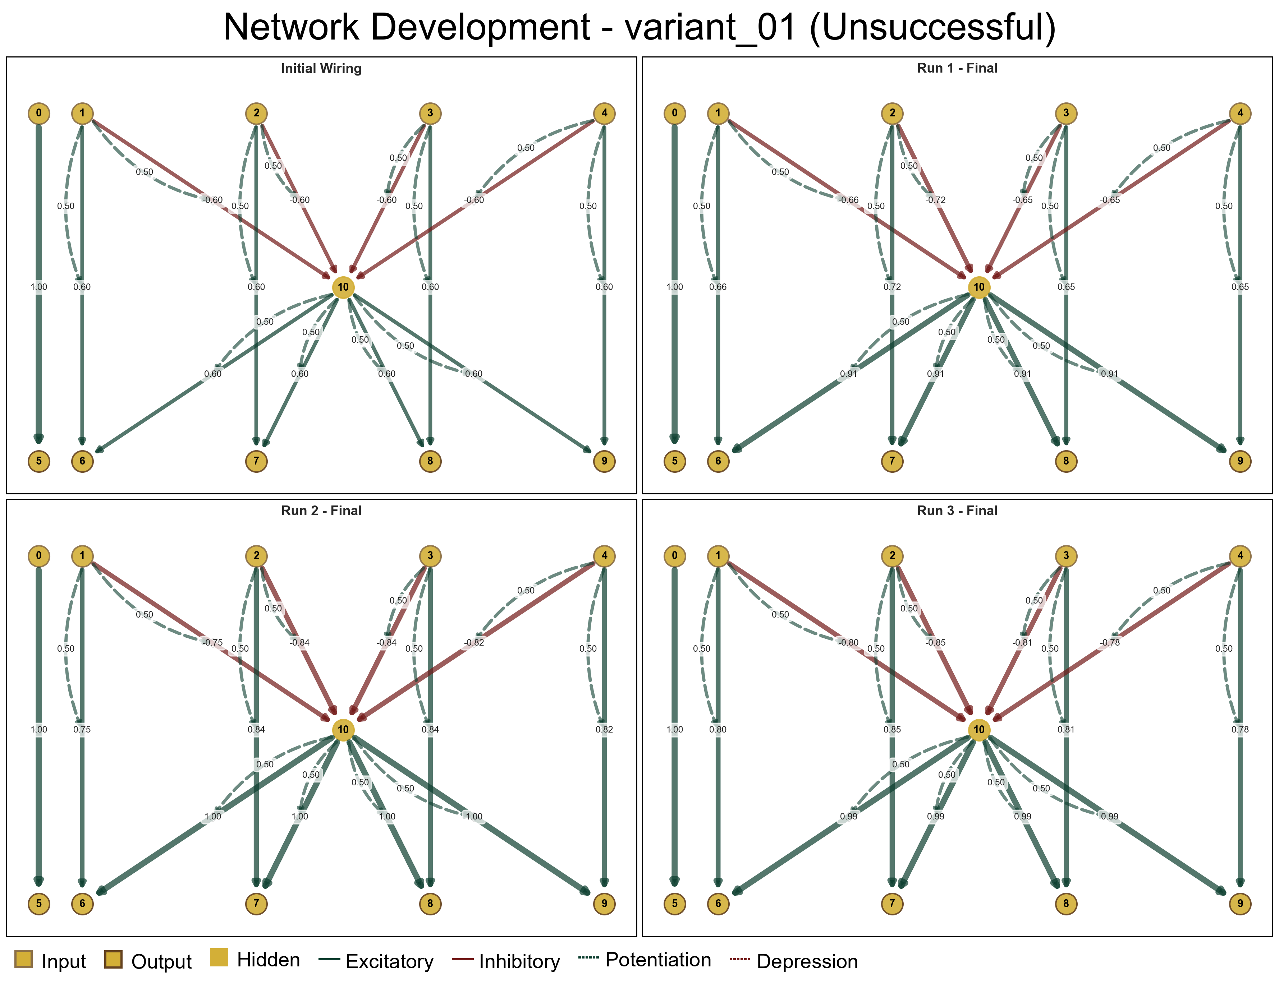

3. Comparison
This section compares metrics between successful and unsuccessful random variants, and against benchmark implementations where available. Survival times comparison helps validate our group selection; subsequent sections examine behavioral and performance metrics.

3.1. Survival Times
Comparison of lifetime survival between successful and unsuccessful variants. Note: This metric is somewhat redundant since we selected groups specifically based on survival time, but it provides useful verification of group separation and reveals distribution characteristics.
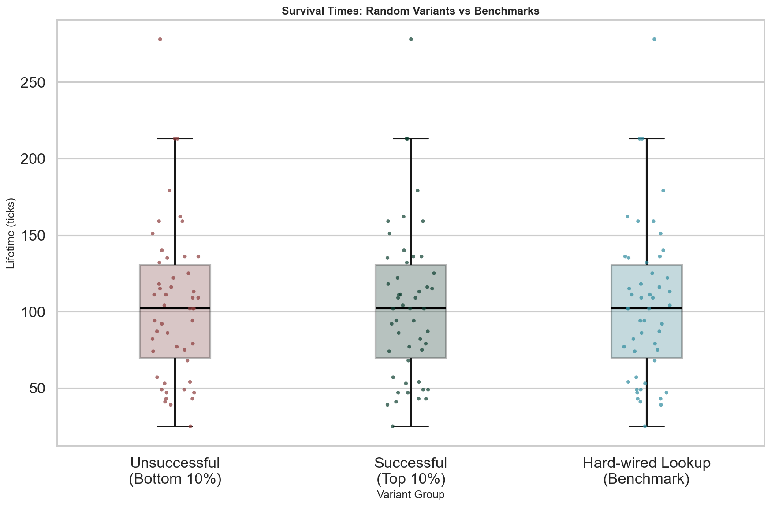

Metric | Successful (Top 10%) | Unsuccessful (Bottom 10%)
Number of runs | 50 | 50
Mean | 104.140 | 104.140
Median | 102.000 | 102.000
Std Dev | 50.082 | 50.082
Min | 25.000 | 25.000
Max | 278.000 | 278.000

Differences between successful, unsuccessful, and benchmark variants (Kruskal-Wallis):
Test Statistic | Value
H-statistic | 0.0000
p-value | 1.0000e+00

TBD - Interpretation of survival time differences.

3.2. Movement Efficiency
Movement efficiency quantifies how effectively variants use sensory information to guide movement. Calculated as movements divided by sensing events in each cardinal direction (N, E, S, W). A ratio close to 1.0 indicates tight coupling between sensing and acting; higher ratios suggest either deliberate multi-movement strategies or noisy sensor integration.
Movement Efficiency = Movement Count ÷ Sensing Count per direction
Direction | Unsuccessful (Mean ± Std) | Successful (Mean ± Std)
N | 2.002 ± 1.026 | 2.002 ± 1.026
E | 1.932 ± 1.038 | 1.932 ± 1.038
S | 2.199 ± 1.527 | 2.199 ± 1.527
W | 2.136 ± 1.212 | 2.136 ± 1.212

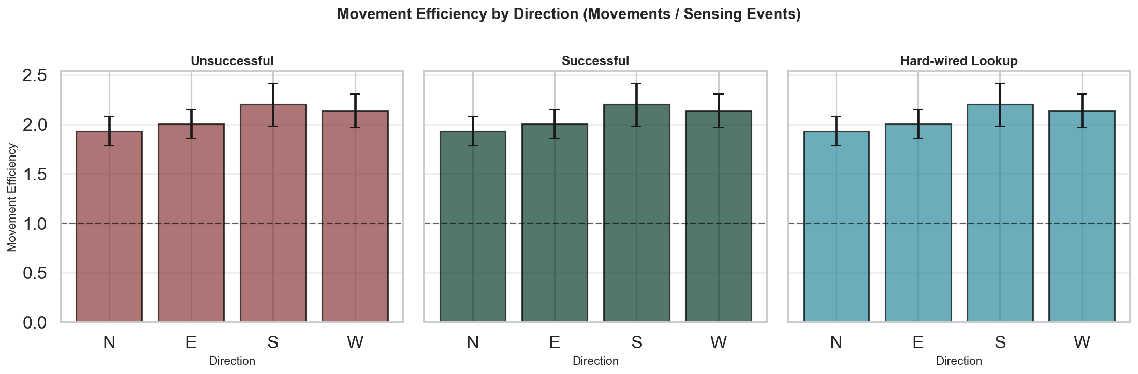

TBD - Interpretation of movement efficiency by direction.

3.3. Decision Accuracy
Decision accuracy quantifies how often choices are aligned with food source locations. This measures, whether the wiring interprets sensory input to direct movement toward food. Higher accuracy indicates more direct coupling of decisions. We compare the distribution of accuracy values between successful and unsuccessful variants to determine whether fitness correlates with decision-making precision, or if other factors like movement efficiency play a larger role. Note that moving onto sensed food is a very shortsighted strategy that might not lead to an optimal solution in more complex tasks e.g. with food regrow in previous positions.
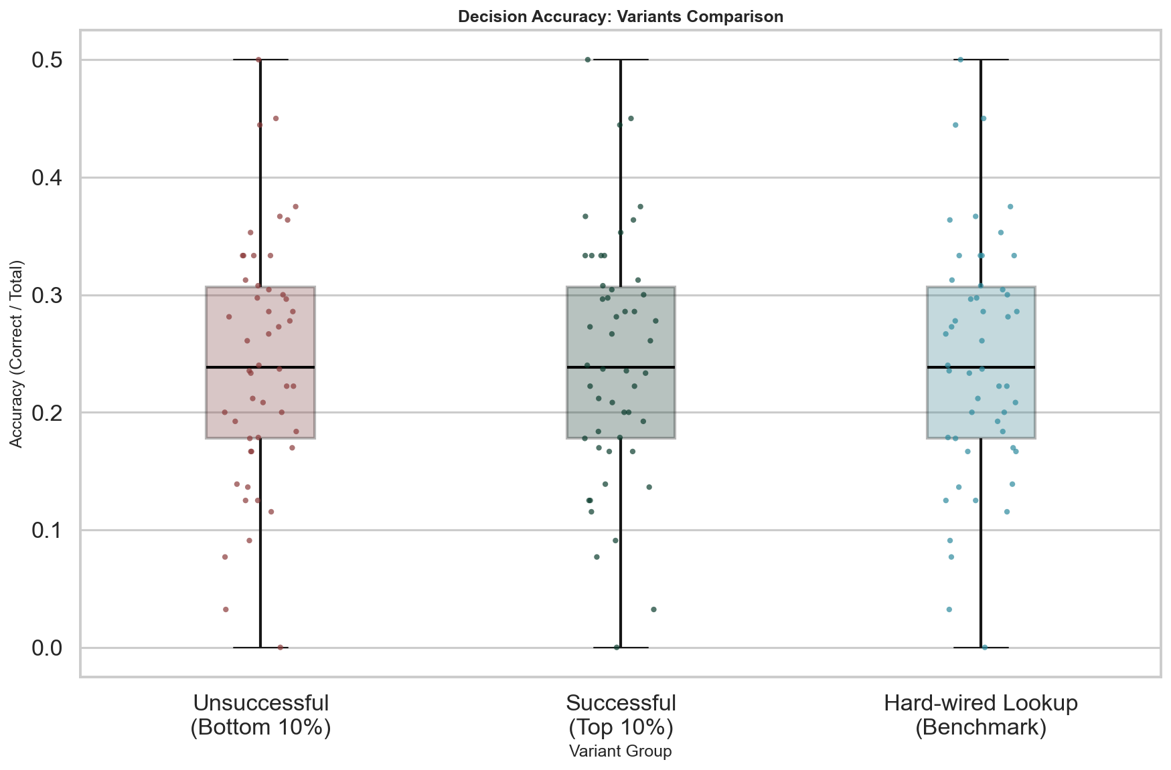

Decision Accuracy = Correct Decisions ÷ Total Decisions
Metric | Successful (Top 10%) | Unsuccessful (Bottom 10%)
Number of runs | 50 | 50
Mean | 0.244 | 0.244
Median | 0.238 | 0.238
Std Dev | 0.103 | 0.103
Min | 0.000 | 0.000
Max | 0.500 | 0.500

Differences between successful, unsuccessful, and benchmark variants (Kruskal-Wallis):
Test Statistic | Value
H-statistic | 0.0000
p-value | 1.0000e+00

TBD - Interpretation of decision accuracy differences.

3.4. Distance Traveled
Distance travelled total and normalized per tick for lifespan differences. We compare movement patterns between successful and unsuccessful variants to understand how spatial exploration versus local exploitation correlates with fitness.

3.4.1. Distance Traveled (Absolute)
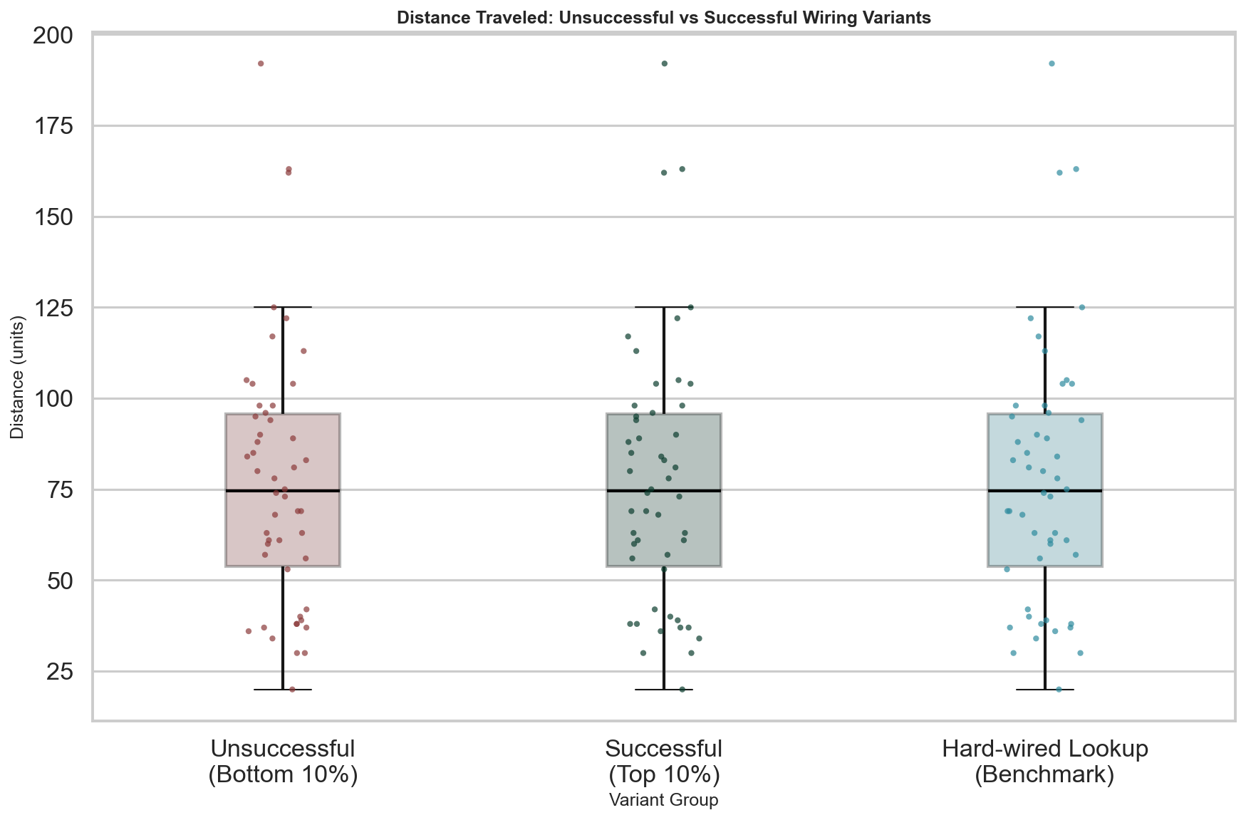

Metric | Successful (Top 10%) | Unsuccessful (Bottom 10%)
Number of runs | 50 | 50
Mean | 77.380 | 77.380
Median | 74.500 | 74.500
Std Dev | 35.804 | 35.804
Min | 20.000 | 20.000
Max | 192.000 | 192.000

Differences between successful, unsuccessful, and benchmark variants (Kruskal-Wallis):
Test Statistic | Value
H-statistic | 0.0000
p-value | 1.0000e+00

TBD - Interpretation of distance differences.

3.4.2. Distance Per Tick (Normalized)
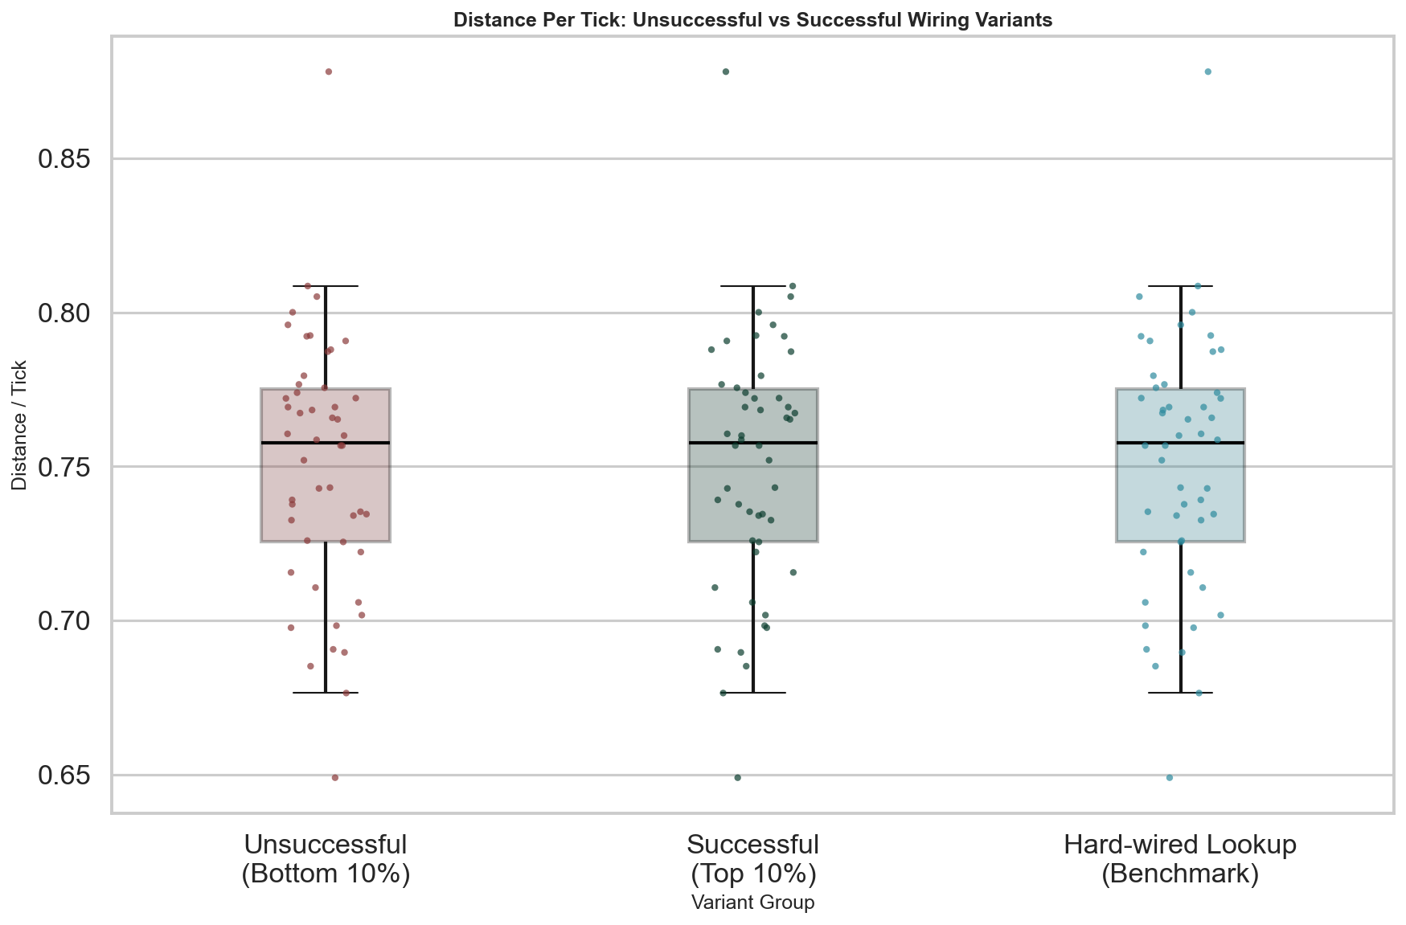

Metric | Successful (Top 10%) | Unsuccessful (Bottom 10%)
Number of runs | 50 | 50
Mean | 0.751 | 0.751
Median | 0.758 | 0.758
Std Dev | 0.041 | 0.041
Min | 0.649 | 0.649
Max | 0.878 | 0.878

Differences between successful, unsuccessful, and benchmark variants (Kruskal-Wallis):
Test Statistic | Value
H-statistic | 0.0000
p-value | 1.0000e+00

TBD - Interpretation of distance per tick differences.

3.5. Food Consumption
Food consumption is the ultimate solution of the task. The more food consumed, the longer the survival. Normalized per tick food consumption may be the metric most directly linked to survival fitness.

3.5.1. Food Consumption (Absolute)
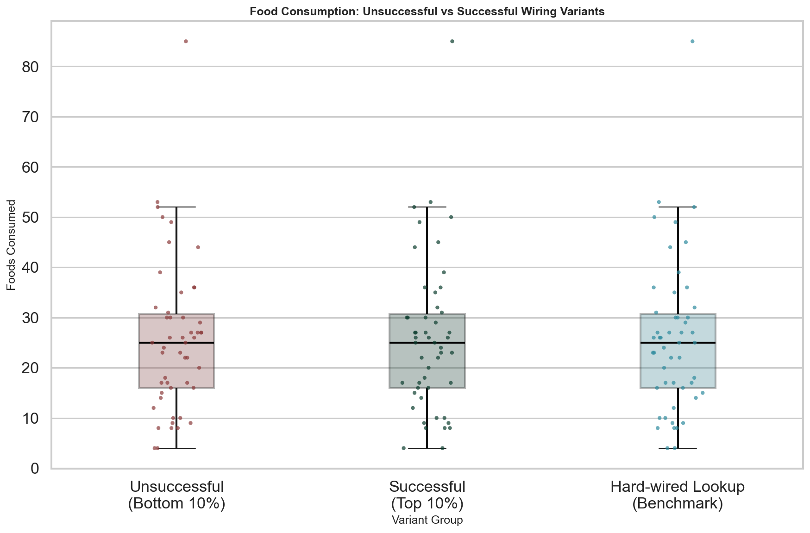

Metric | Successful (Top 10%) | Unsuccessful (Bottom 10%)
Number of runs | 50 | 50
Mean | 25.760 | 25.760
Median | 25.000 | 25.000
Std Dev | 15.057 | 15.057
Min | 4.000 | 4.000
Max | 85.000 | 85.000

Differences between successful, unsuccessful, and benchmark variants (Kruskal-Wallis):
Test Statistic | Value
H-statistic | 0.0000
p-value | 1.0000e+00

TBD - Interpretation of food consumption differences.

3.5.2. Food Per Tick (Normalized)
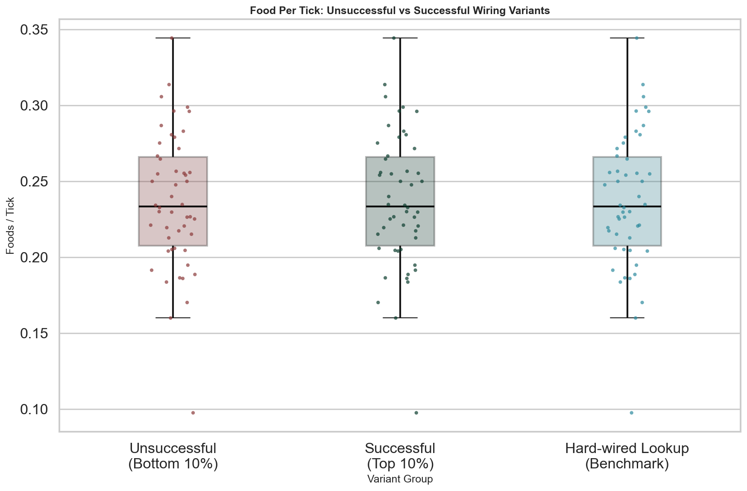

Metric | Successful (Top 10%) | Unsuccessful (Bottom 10%)
Number of runs | 50 | 50
Mean | 0.237 | 0.237
Median | 0.233 | 0.233
Std Dev | 0.044 | 0.044
Min | 0.098 | 0.098
Max | 0.344 | 0.344

Differences between successful, unsuccessful, and benchmark variants (Kruskal-Wallis):
Test Statistic | Value
H-statistic | 0.0000
p-value | 1.0000e+00

TBD - Interpretation of food per tick differences.

