Analysis Report: Static vs Potentiation in 4 way plasticity

Data Folders Used
- static w=0.05: C:\work_hard\byte\data\4way_plasticity\rawdata\2026-03-06_17-42-59_static_w_0_05
- static w=1.0: C:\work_hard\byte\data\4way_plasticity\rawdata\2026-03-06_17-43-33_static_w_1_0
- potentiation w=0.05 eta=0.01 mod=0.5: C:\work_hard\byte\data\4way_plasticity\rawdata\2026-03-06_17-49-56_potentiation_w_0_05_eta_0_01_mod_0_5
- potentiation w=0.05 eta=0.025 mod=0.5: C:\work_hard\byte\data\4way_plasticity\rawdata\2026-03-06_18-01-08_potentiation_w_0_05_eta_0_025_mod_0_5

Kolmogorov-Smirnov Test Results

static w=0.05 vs static w=1.0
Metric | Value
KS statistic | 0.7120
p-value | 2.6466e-122

static w=0.05 vs potentiation w=0.05 eta=0.01 mod=0.5
Metric | Value
KS statistic | 0.1020
p-value | 1.0969e-02

static w=0.05 vs potentiation w=0.05 eta=0.025 mod=0.5
Metric | Value
KS statistic | 0.3660
p-value | 3.6067e-30

static w=1.0 vs potentiation w=0.05 eta=0.01 mod=0.5
Metric | Value
KS statistic | 0.6360
p-value | 2.6200e-95

static w=1.0 vs potentiation w=0.05 eta=0.025 mod=0.5
Metric | Value
KS statistic | 0.3940
p-value | 4.9805e-35

potentiation w=0.05 eta=0.01 mod=0.5 vs potentiation w=0.05 eta=0.025 mod=0.5
Metric | Value
KS statistic | 0.2820
p-value | 6.5180e-18

Figures

Connection weight 1→6 (mean ± 95% CI)
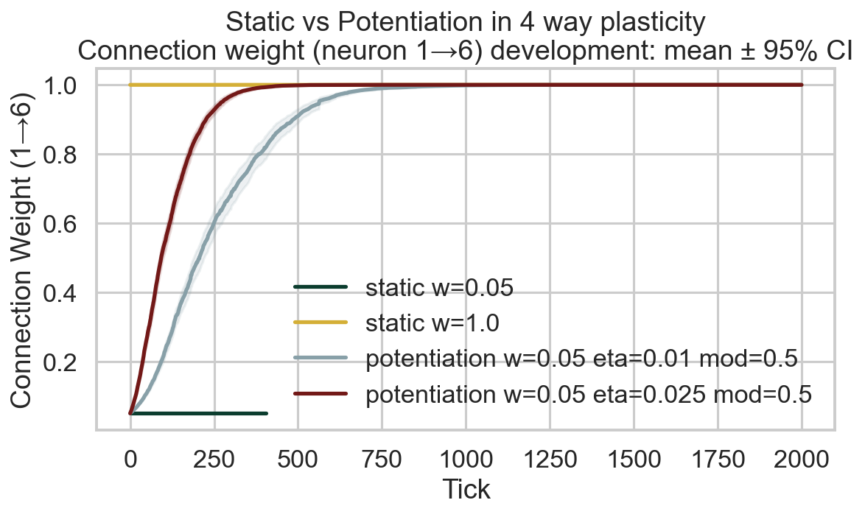

Survival race
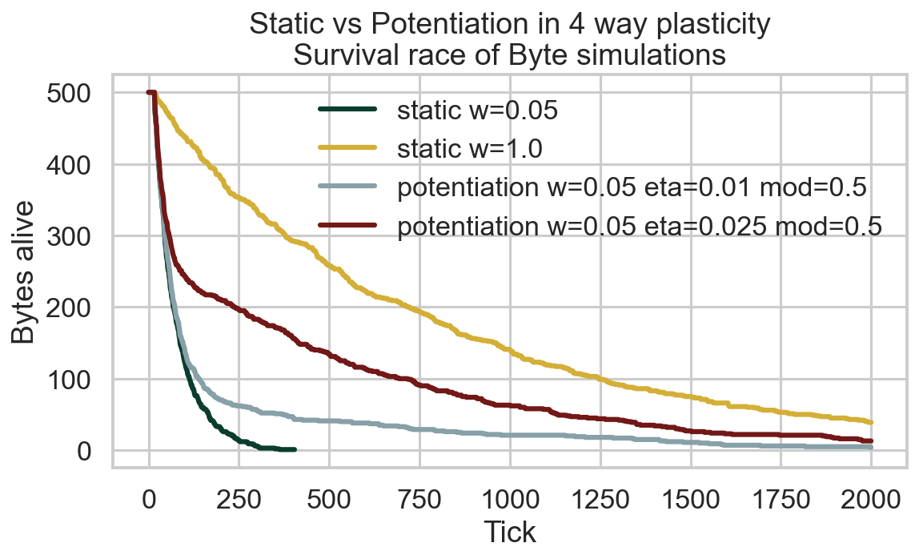

Survival time distribution
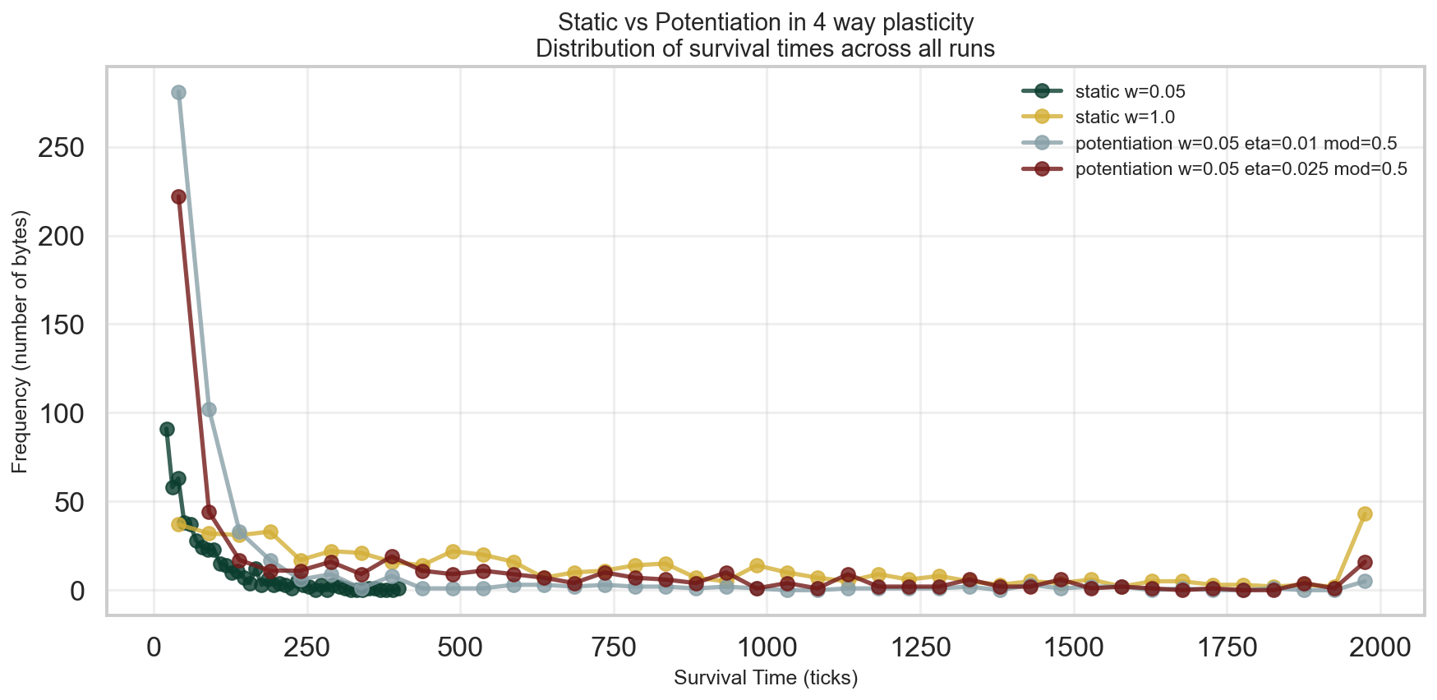

Survival CCDF (log-log)
