Analysis Report: Bidirectional plasticity in one decision

Data Folders Used
- static w=0.05: C:\work_hard\byte\data\bidirectional_plasticity\rawdata\2026-03-06_18-20-26_static_w_0_05
- static w=1.0: C:\work_hard\byte\data\bidirectional_plasticity\rawdata\2026-03-06_18-39-11_static_w_1_0
- bidirectional w=0.05, pot 1.0, dep -0.5: C:\work_hard\byte\data\bidirectional_plasticity\rawdata\2026-03-06_18-34-24_bi_w_0_05_pot_1_0_dep_0_5_eta_1
- potentiation w=0.05, pot 1.0: C:\work_hard\byte\data\bidirectional_plasticity\rawdata\2026-03-06_18-41-44_plast_w_0_05_pot_1_0
- depression w=0.05, dep -0.5: C:\work_hard\byte\data\bidirectional_plasticity\rawdata\2026-03-06_18-43-00_plast_w_0_05_dep_0_5

Kolmogorov-Smirnov Test Results

static w=0.05 vs static w=1.0
Metric | Value
KS statistic | 0.2440
p-value | 1.7982e-13

static w=0.05 vs bidirectional w=0.05, pot 1.0, dep -0.5
Metric | Value
KS statistic | 0.1380
p-value | 1.4342e-04

static w=0.05 vs potentiation w=0.05, pot 1.0
Metric | Value
KS statistic | 0.1660
p-value | 1.9751e-06

static w=0.05 vs depression w=0.05, dep -0.5
Metric | Value
KS statistic | 0.0360
p-value | 9.0269e-01

static w=1.0 vs bidirectional w=0.05, pot 1.0, dep -0.5
Metric | Value
KS statistic | 0.1720
p-value | 7.1024e-07

static w=1.0 vs potentiation w=0.05, pot 1.0
Metric | Value
KS statistic | 0.1300
p-value | 4.2124e-04

static w=1.0 vs depression w=0.05, dep -0.5
Metric | Value
KS statistic | 0.2680
p-value | 3.3771e-16

bidirectional w=0.05, pot 1.0, dep -0.5 vs potentiation w=0.05, pot 1.0
Metric | Value
KS statistic | 0.0560
p-value | 4.1349e-01

bidirectional w=0.05, pot 1.0, dep -0.5 vs depression w=0.05, dep -0.5
Metric | Value
KS statistic | 0.1600
p-value | 5.2933e-06

potentiation w=0.05, pot 1.0 vs depression w=0.05, dep -0.5
Metric | Value
KS statistic | 0.1840
p-value | 8.2170e-08

Figures

Connection weight 1→6 (mean ± 95% CI)
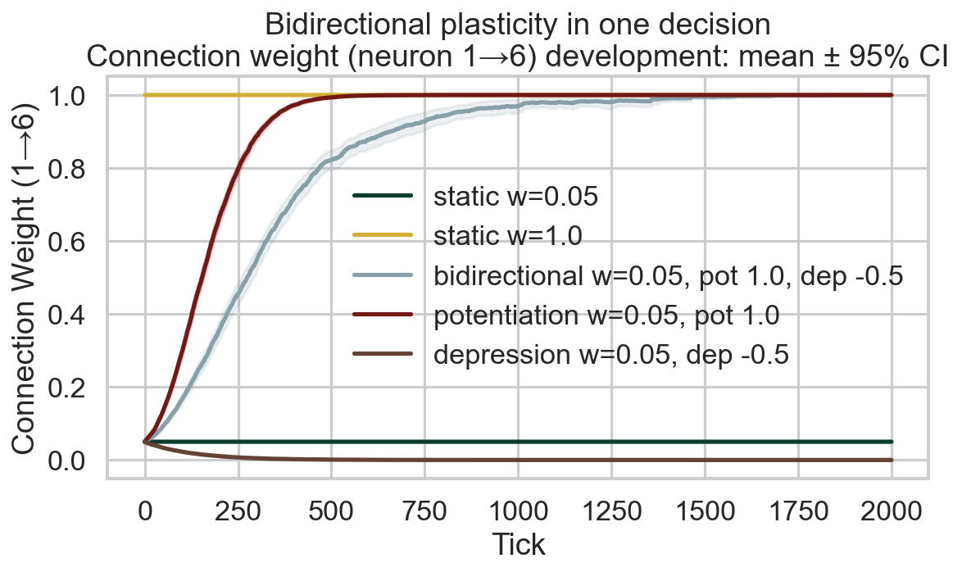

Survival race
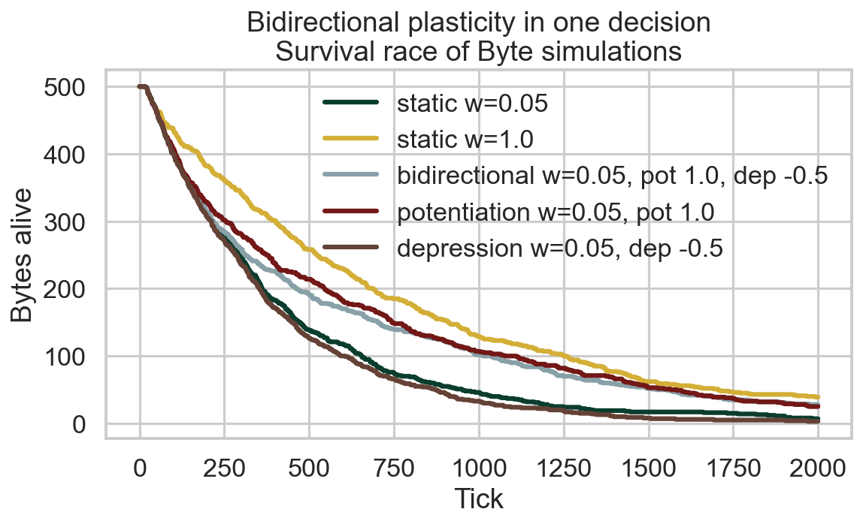

Survival time distribution
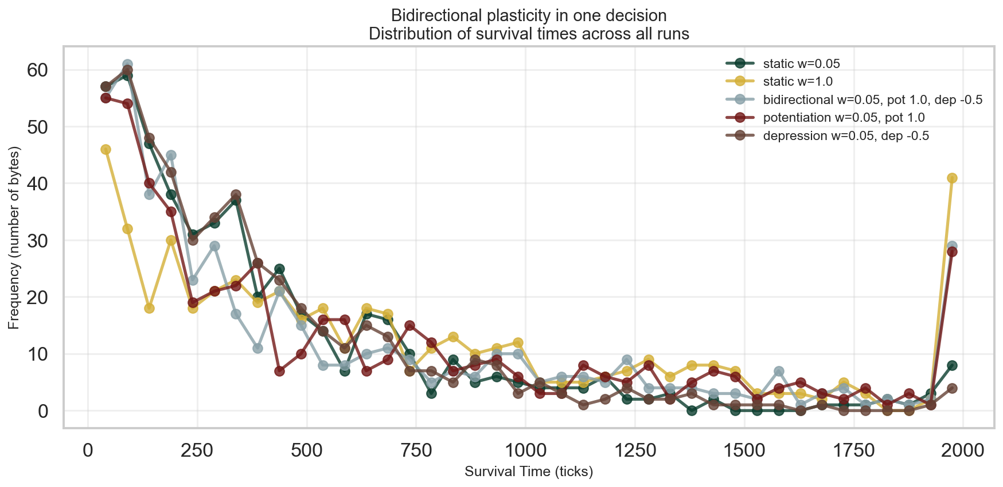

Survival CCDF (log-log)
