Analysis Report: Bidirectional plasticity in all 4 decisions

Data Folders Used
- static w=0.05: C:\work_hard\byte\data\bidirectional_plasticity\rawdata\2026-03-06_19-07-01_4dec_static_w_0_05
- static w=1.0: C:\work_hard\byte\data\bidirectional_plasticity\rawdata\2026-03-06_19-07-26_4dec_static_w_1_0
- bidirectional w=0.05, pot 1.0, dep -0.5: C:\work_hard\byte\data\bidirectional_plasticity\rawdata\2026-03-06_19-03-47_4dec_bi_pot_1_0_dep_0_5
- potentiation w=0.05, pot 1.0: C:\work_hard\byte\data\bidirectional_plasticity\rawdata\2026-03-06_19-05-04_4dec_plast_pot_1_0
- depression w=0.05, dep -0.5: C:\work_hard\byte\data\bidirectional_plasticity\rawdata\2026-03-06_19-06-18_4dec_plast_dep_0_5

Kolmogorov-Smirnov Test Results

static w=0.05 vs static w=1.0
Metric | Value
KS statistic | 0.7120
p-value | 2.6466e-122

static w=0.05 vs bidirectional w=0.05, pot 1.0, dep -0.5
Metric | Value
KS statistic | 0.1260
p-value | 7.0452e-04

static w=0.05 vs potentiation w=0.05, pot 1.0
Metric | Value
KS statistic | 0.3020
p-value | 1.6014e-20

static w=0.05 vs depression w=0.05, dep -0.5
Metric | Value
KS statistic | 0.0200
p-value | 9.9997e-01

static w=1.0 vs bidirectional w=0.05, pot 1.0, dep -0.5
Metric | Value
KS statistic | 0.6080
p-value | 1.8328e-86

static w=1.0 vs potentiation w=0.05, pot 1.0
Metric | Value
KS statistic | 0.4660
p-value | 2.1107e-49

static w=1.0 vs depression w=0.05, dep -0.5
Metric | Value
KS statistic | 0.7240
p-value | 5.2671e-127

bidirectional w=0.05, pot 1.0, dep -0.5 vs potentiation w=0.05, pot 1.0
Metric | Value
KS statistic | 0.1880
p-value | 3.8737e-08

bidirectional w=0.05, pot 1.0, dep -0.5 vs depression w=0.05, dep -0.5
Metric | Value
KS statistic | 0.1300
p-value | 4.2124e-04

potentiation w=0.05, pot 1.0 vs depression w=0.05, dep -0.5
Metric | Value
KS statistic | 0.3060
p-value | 4.5681e-21

Figures

Connection weight 1→6 (mean ± 95% CI)
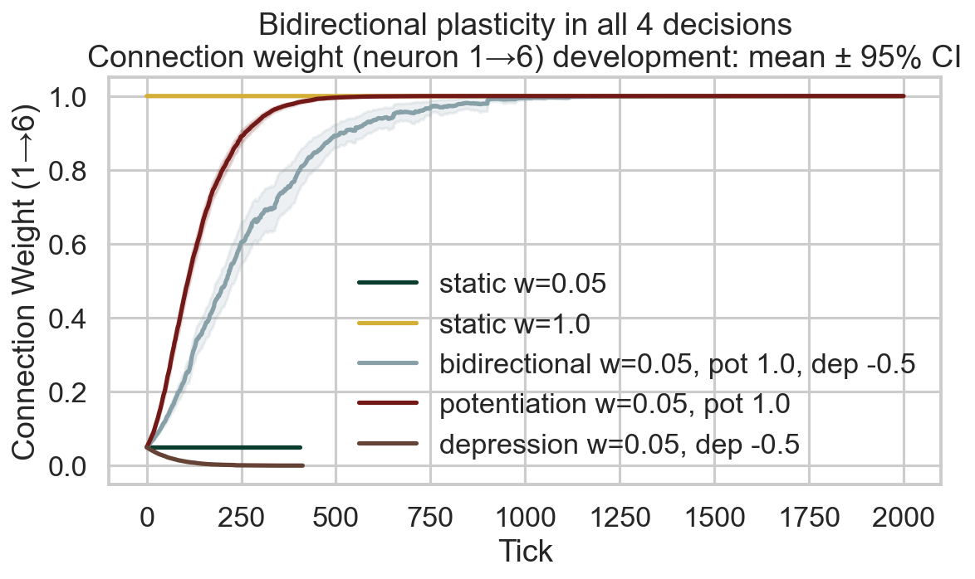

Direction occurrences
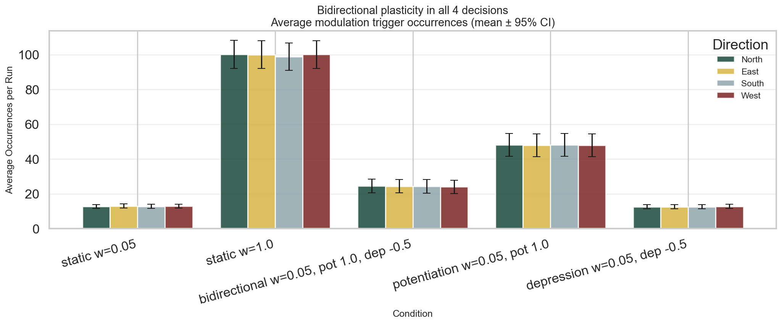

Survival race
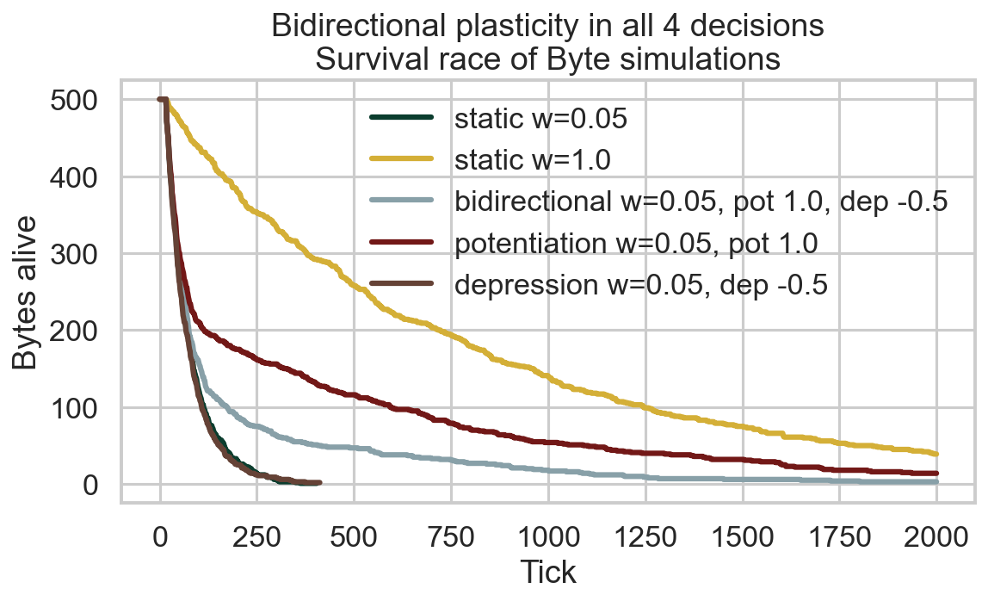

Survival time distribution
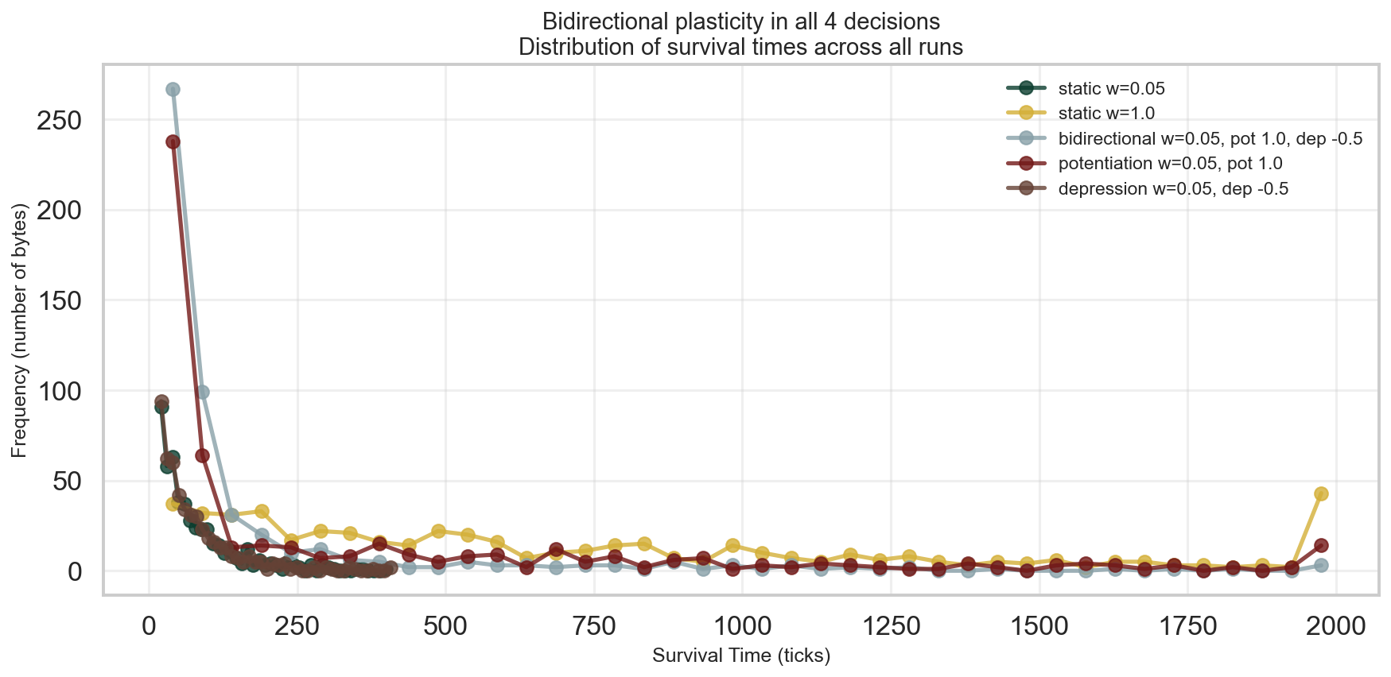

Survival CCDF (log-log)
