Analysis Report: Static vs Plasticity

Data Folders Used
- Static w=0.1: C:\work_hard\byte\data\plasticity_potentiation\rawdata\2026-03-04_13-21-15_static_w_0_1
- Static w=1.0: C:\work_hard\byte\data\plasticity_potentiation\rawdata\2026-03-04_13-19-06_static_w_1
- Plastic w=0.1, eta=0.025, mod=0.1: C:\work_hard\byte\data\plasticity_potentiation\rawdata\2026-03-04_13-24-36_plastic_w_0_1_eta_0_025_mod_0_1
- Plastic w=0.1, eta=0.025, mod=0.05: C:\work_hard\byte\data\plasticity_potentiation\rawdata\2026-03-05_15-29-04_plastic_w_0_1_eta_0_025_mod_0_05
- Plastic w=0.1, eta=0.01, mod=0.1: C:\work_hard\byte\data\plasticity_potentiation\rawdata\2026-03-05_15-20-01_plastic_w_0_1_eta_0_01_mod_0_1
- Plastic w=0.1, eta=0.01, mod=0.05: C:\work_hard\byte\data\plasticity_potentiation\rawdata\2026-03-05_15-41-21_plastic_w_0_1_eta_0_01_mod_0_05

Kolmogorov-Smirnov Test Results

Static w=0.1 vs Static w=1.0
Metric | Value
KS statistic | 0.2460
p-value | 5.7691e-27

Static w=0.1 vs Plastic w=0.1, eta=0.025, mod=0.1
Metric | Value
KS statistic | 0.2000
p-value | 6.6131e-18

Static w=0.1 vs Plastic w=0.1, eta=0.025, mod=0.05
Metric | Value
KS statistic | 0.1850
p-value | 2.2850e-15

Static w=0.1 vs Plastic w=0.1, eta=0.01, mod=0.1
Metric | Value
KS statistic | 0.1460
p-value | 1.0354e-09

Static w=0.1 vs Plastic w=0.1, eta=0.01, mod=0.05
Metric | Value
KS statistic | 0.1520
p-value | 1.7107e-10

Static w=1.0 vs Plastic w=0.1, eta=0.025, mod=0.1
Metric | Value
KS statistic | 0.0580
p-value | 6.9176e-02

Static w=1.0 vs Plastic w=0.1, eta=0.025, mod=0.05
Metric | Value
KS statistic | 0.1080
p-value | 1.6907e-05

Static w=1.0 vs Plastic w=0.1, eta=0.01, mod=0.1
Metric | Value
KS statistic | 0.1370
p-value | 1.3433e-08

Static w=1.0 vs Plastic w=0.1, eta=0.01, mod=0.05
Metric | Value
KS statistic | 0.1670
p-value | 1.3747e-12

Plastic w=0.1, eta=0.025, mod=0.1 vs Plastic w=0.1, eta=0.025, mod=0.05
Metric | Value
KS statistic | 0.0690
p-value | 1.7090e-02

Plastic w=0.1, eta=0.025, mod=0.1 vs Plastic w=0.1, eta=0.01, mod=0.1
Metric | Value
KS statistic | 0.0900
p-value | 6.0290e-04

Plastic w=0.1, eta=0.025, mod=0.1 vs Plastic w=0.1, eta=0.01, mod=0.05
Metric | Value
KS statistic | 0.1190
p-value | 1.3787e-06

Plastic w=0.1, eta=0.025, mod=0.05 vs Plastic w=0.1, eta=0.01, mod=0.1
Metric | Value
KS statistic | 0.0540
p-value | 1.0829e-01

Plastic w=0.1, eta=0.025, mod=0.05 vs Plastic w=0.1, eta=0.01, mod=0.05
Metric | Value
KS statistic | 0.0780
p-value | 4.5438e-03

Plastic w=0.1, eta=0.01, mod=0.1 vs Plastic w=0.1, eta=0.01, mod=0.05
Metric | Value
KS statistic | 0.0440
p-value | 2.8780e-01

Figures

Energy dynamics per run
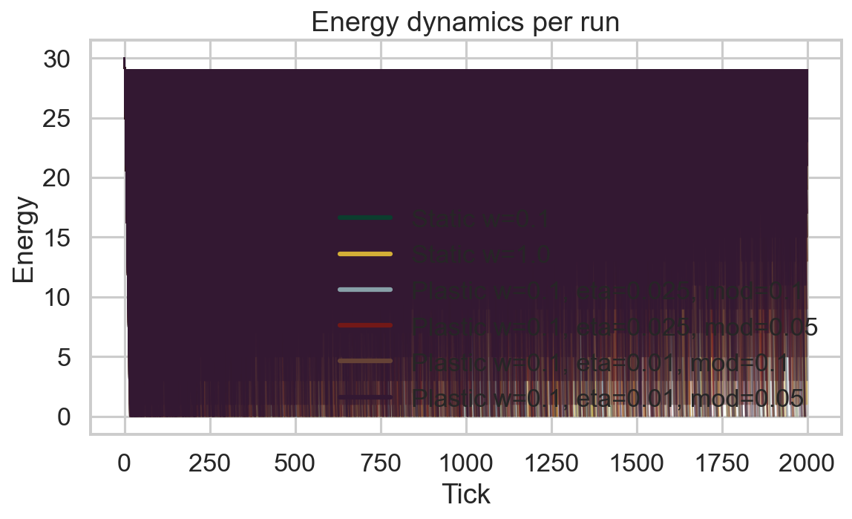

Food accumulation per run
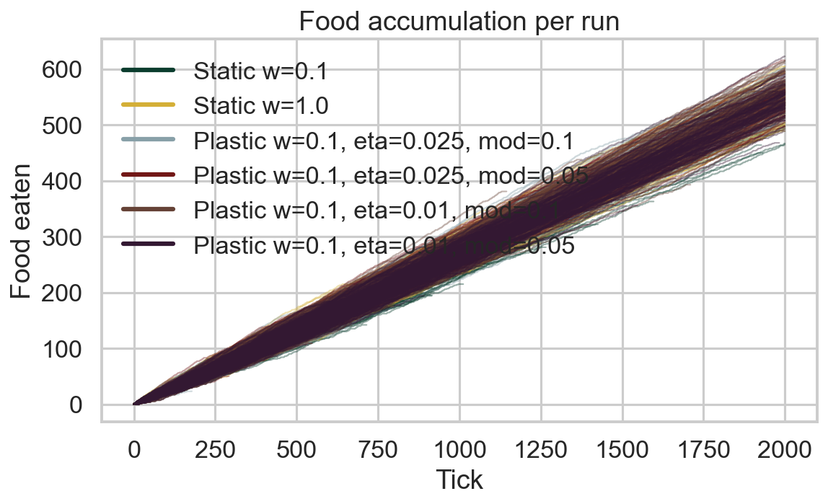

Distance accumulation per run
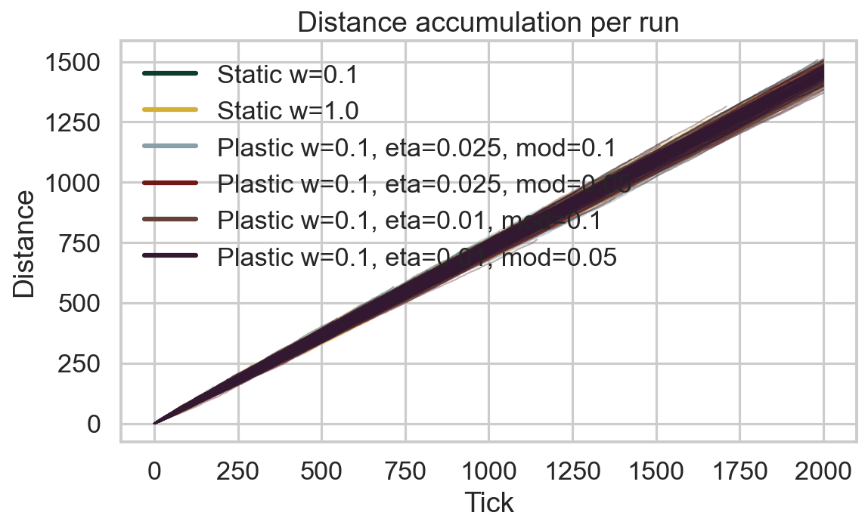

Connection weight 1→6 development per run
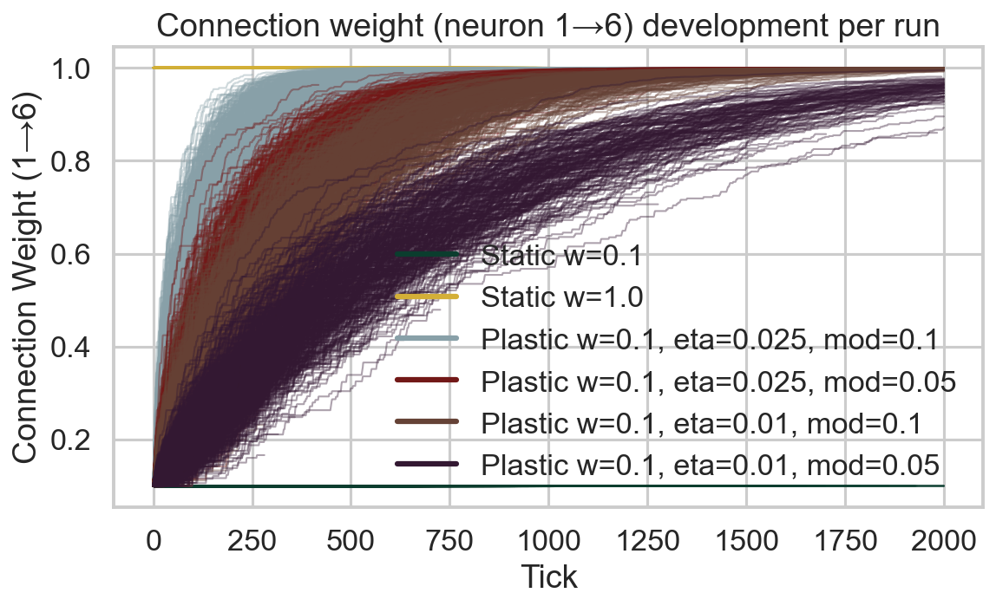

Connection weight 1→6 (mean ± 95% CI)
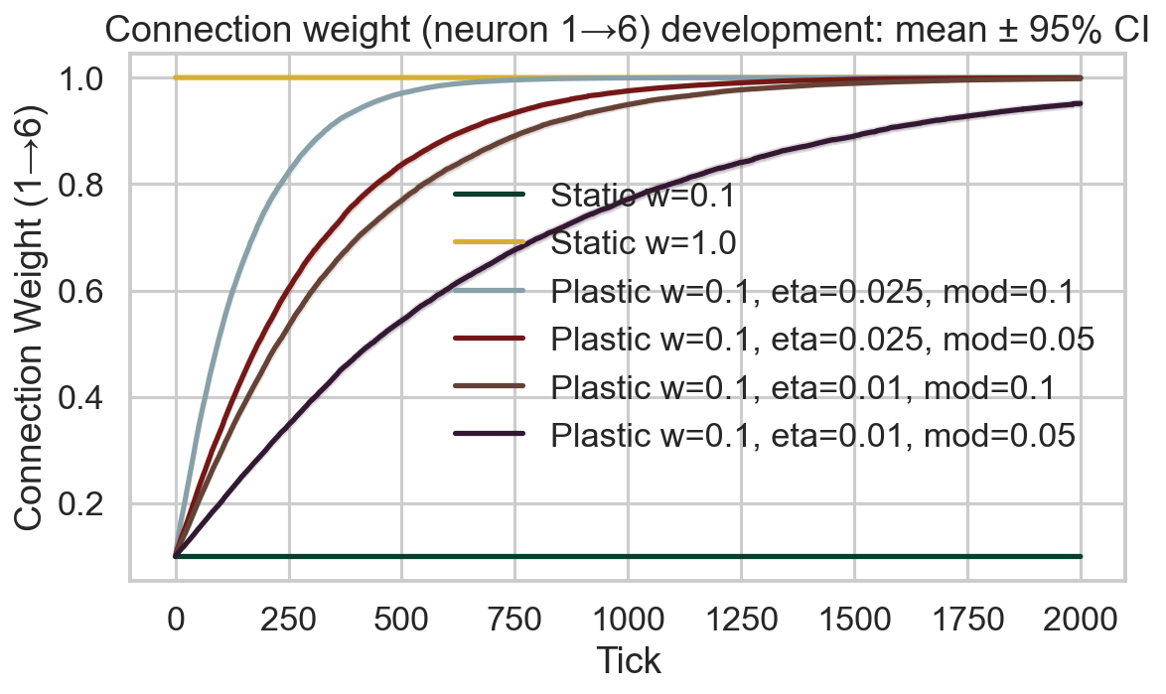

Survival race
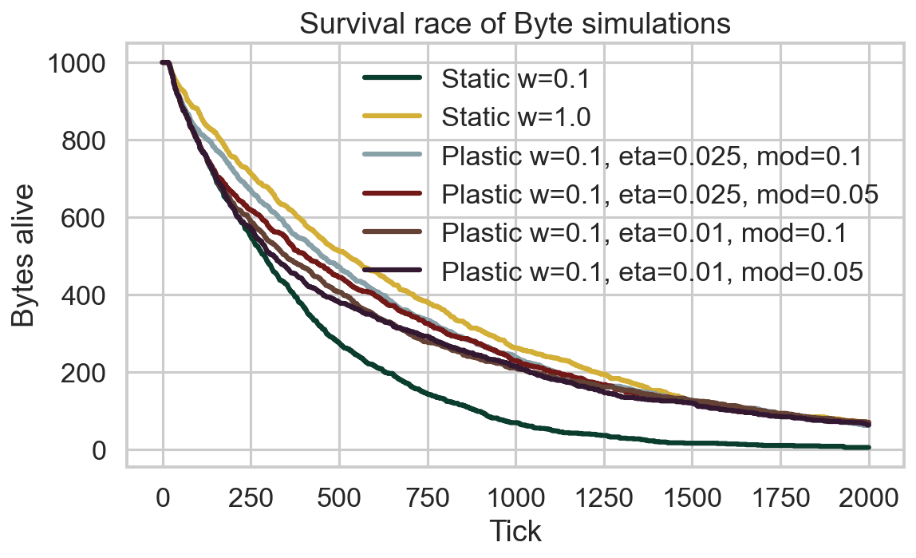

Survival time distribution
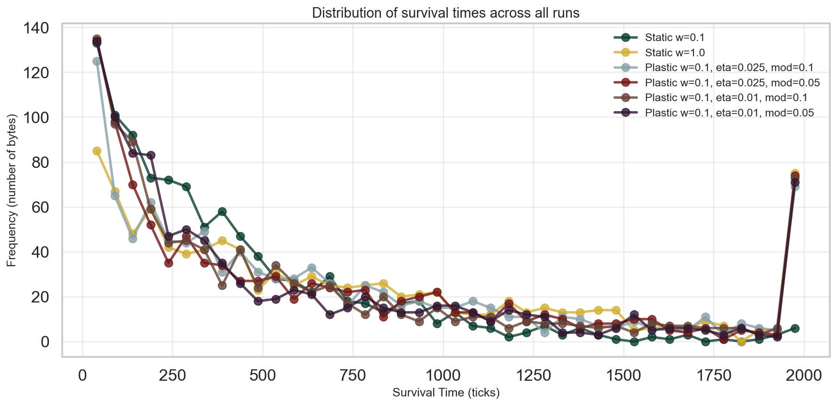

Survival CCDF (log-log)
