EA Analysis Report: initial_235_no_regrow

Experiment Parameters
Parameter | Value
Filename | 2026-06-22_18-07-42_no_regrow_initial_0.235
brain_max_decision_delay | 2.0
brain_n_neurons | 11
brain_noise_level | 0.05
experiment_evolutionary_algorithm_elite_selection_metric | average
experiment_evolutionary_algorithm_elite_size | 10
experiment_evolutionary_algorithm_mutation_method | simple
experiment_evolutionary_algorithm_mutation_rate | 0.1
experiment_evolutionary_algorithm_num_generations | 20
experiment_genome_type | random
experiment_max_ticks | 2000
experiment_n_runs | 300
experiment_population_size | 250
worm_decisionmaking_version | plasticity
worm_energy_capacity | 30
worm_metabolic_rate | 1
worm_movement_cost | 1

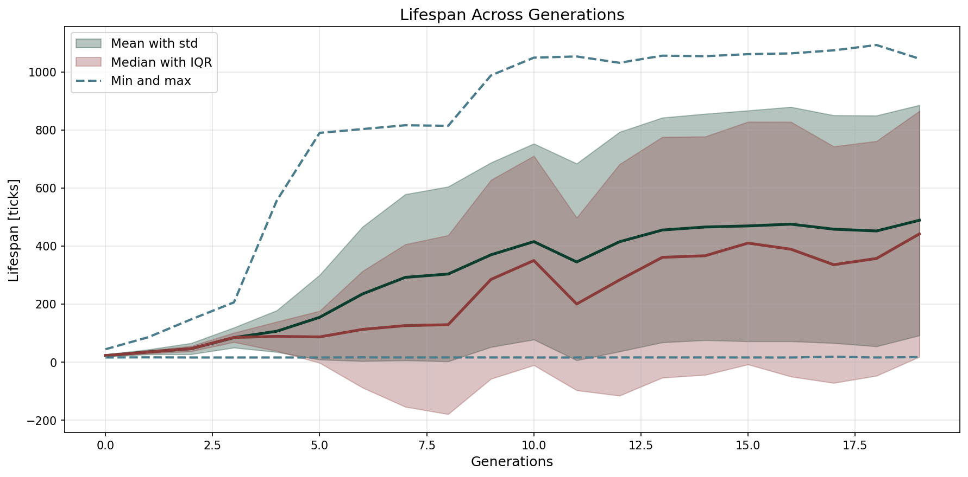

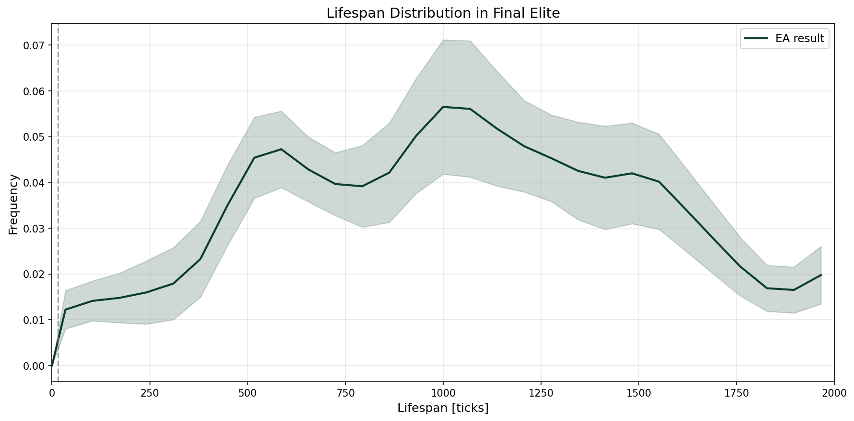

Network Visualizations
