Analysis Mitochondria distribution along sections through neuronal soma
Dr. Jana Dahlmanns
2023-03-26

Introduction
We analyzed the distribution of mitochondria in the soma of neurons. We used dissociated neuronal cultures that were treated under different conditions prior to fixation, staining and imaging.

The images
The cultures contained a natural mix of hippocampal cell types. Neurons were chosen for imaging based on general cell morphology. Here is an overview of all imaged cells.
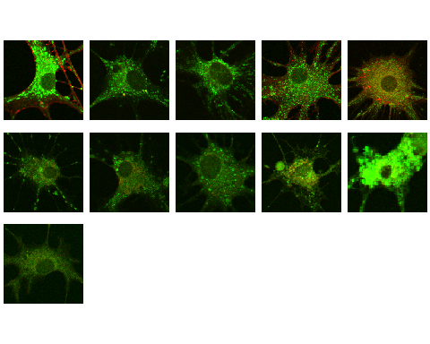
Thumbnails of all analyzed images
The analyzed images contained three color channels: The cells were stained with Mito-Tracker Green to capture mitochondria locations in the green channel, with Phallodin-Red to capture actin cytoskeleton in the red channel, and (some of the samples) with DAPI to capture DNA / nucleus location in the blue channel.
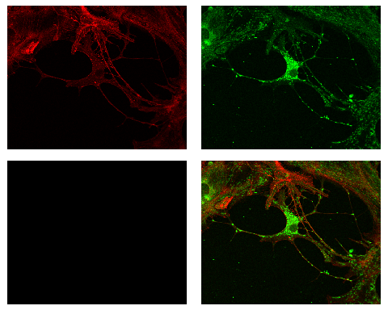
Exemplary image, separated into color channels and merge

Sample sizes
The number of analyzed images is currently 11 and is divided into different experimental conditions as follows:
condition | n
Activin 50ng/ml 14days | 5
Activin 50ng/ml 2days | 5
Control 14days | 1

Analysis steps
A user blinded to the experimental condition marked a starting point at the nuclear envelope and an endpoint at the somatic cell membrane. We then analyzed the green fluorescence intensity distribution along the connecting line as a marker for the localization distribution of mitochondria.

Intensity profiles
The original paper with this method [1], the authors normalized fluorescence intensities on the maximum intensity pixel of the given image. In my option, this is not the best solution, as there may be differences in the absolute fluorescence emission that stem from controllable sources (different fluorescence excitation intensity, different reaction times during staining) or uncontrollable sources (fluorophores not as efficient anymore due to light exposure during previous sample preparation, maybe even different fluorophore binding efficiency in different treatment conditions, imaging artefacts with unspecifically bound or unwashed fluorophores). I therefore normalized the fluorescence intensity values to the average of the 3 highest values of each cell’s profiles - which is a method not vulnerable to the described error sources.
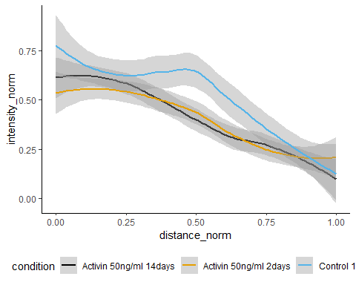
Normliazed intensity profiles along first sections through the soma

References
[1] Cangkrama M, Liu H, Whipman J, Zubair M, Matsushita M, Di Filippo M, et al. A Protumorigenic mDia2-MIRO1 Axis Controls Mitochondrial Positioning and Function in Cancer-Associated Fibroblasts. Cancer Res 2022;82:3701–17. https://doi.org/10.1158/0008-5472.CAN-22-0162.

Methods section to copy
TBA

