Analysis Mitochondria distribution along sections through neuronal soma
Dr. Jana Dahlmanns
2023-04-19

Introduction
We analyzed the distribution of mitochondria in the soma of neurons. We used dissociated neuronal cultures that were treated under different conditions prior to fixation, staining and imaging (staining protocol).

The images
The cultures contained a natural mix of hippocampal cell types. Neurons were chosen for imaging based on general cell morphology. Here is an overview of all imaged cells.
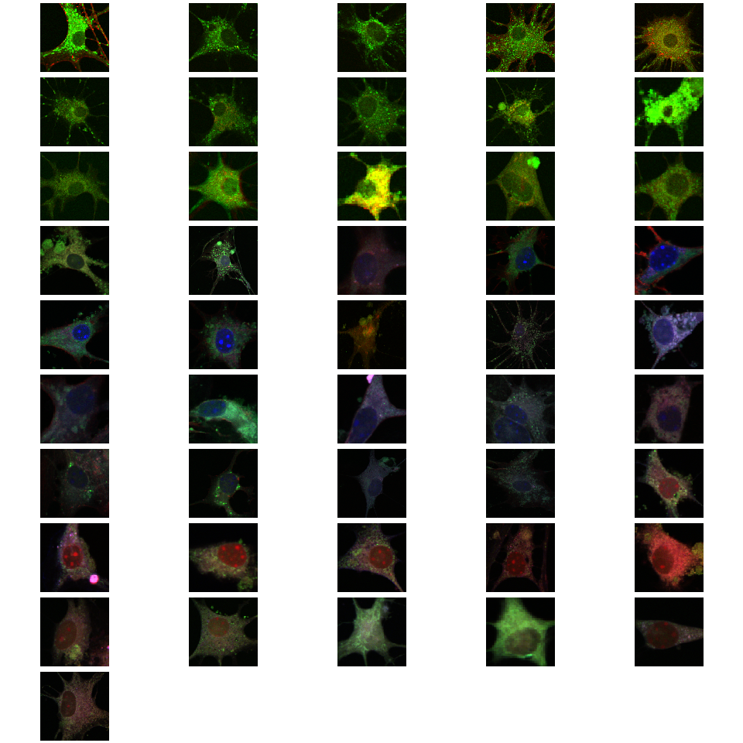
Thumbnails of all analyzed images
The analyzed images contained three color channels: The cells were stained with Mito-Tracker Green to capture mitochondria locations in the green channel, with Phallodin-Red to capture actin cytoskeleton in the red channel, and (some of the samples) with DAPI to capture DNA / nucleus location in the blue channel.
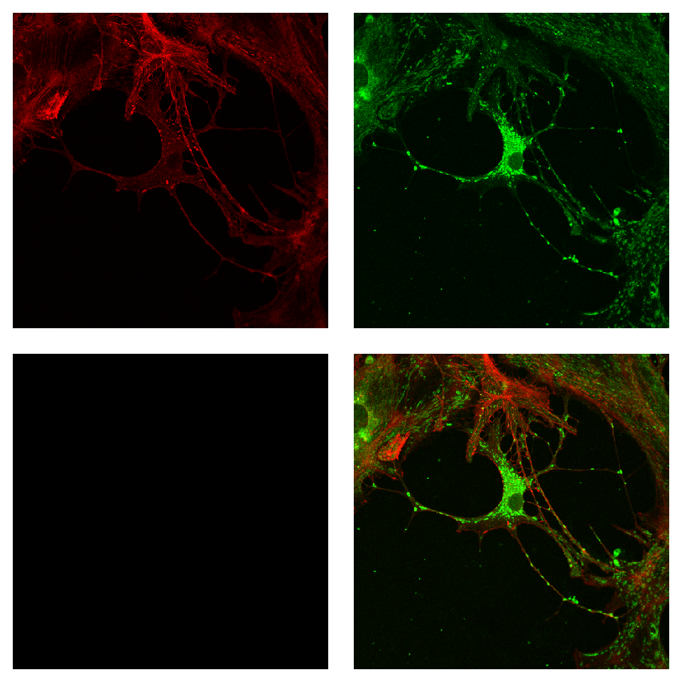
Exemplary image, separated into color channels and merge

Sample sizes
The number of analyzed images is currently 46 and is divided into different experimental conditions as follows:
condition | n
Activin 50ng/ml 14days | 5
Activin 50ng/ml 2days | 5
Control 14days | 9
Control 7days | 10
Follistatin 50ng/ml 14d | 2
Follistatin 50ng/ml 7d | 11
SMIFH2 10µM 14d | 4

Analysis steps
A user blinded to the experimental condition marked a starting point at the nuclear envelope and an endpoint at the somatic cell membrane. We then analyzed the green fluorescence intensity distribution along the connecting line as a marker for the distribution of mitochondria.

Intensity profiles
In the original paper with this method [1], the authors normalized fluorescence intensities on the maximum intensity pixel of the given image. In my opinion, this is not the best solution, as there may be differences in the absolute fluorescence emission that stem from controllable sources (different fluorescence excitation intensity, different reaction times during staining) or uncontrollable sources (fluorophores not as efficient anymore due to light exposure during previous sample preparation, maybe even different fluorophore binding efficiency in different treatment conditions, imaging artefacts with unspecifically bound or unwashed fluorophores). I therefore normalized the fluorescence intensity values to the average of the 3 highest values of each cell’s profiles - which is a method not as vulnerable to the described error sources.
Originally [1], one line was drawn per cell at the position of maximum soma extension from the nucleus. In neurons the overall somatic area outside of the nucleus is much less than in Cangkrama et al.’s cell type and neurons differ in shape from an even, round shape. We thus drew three different sections through the soma. The first in the direction of maximum soma extension (just as the original paper), the other two about 45 degrees clockwise and 45 degrees counterclockwise to the first line.
For comparability with the previous study, I plotted here the results, using the first (maximum length) somatic profiles only.
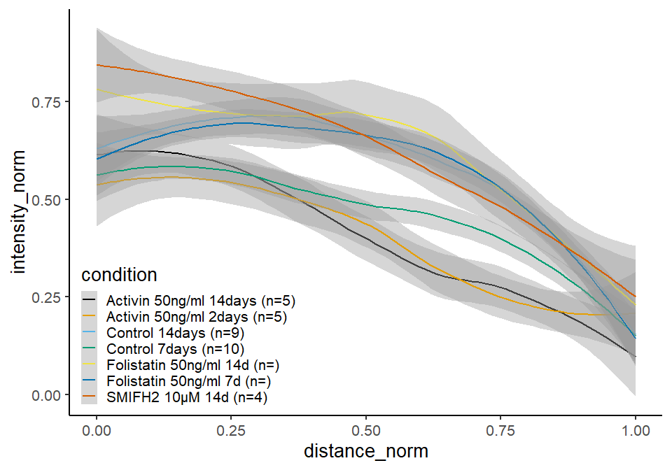
Normliazed intensity profiles along first sections through the soma
For the mentioned reasons, it is sensible to use several different sections in neurons to compensate for the uneven neuronal soma shape:
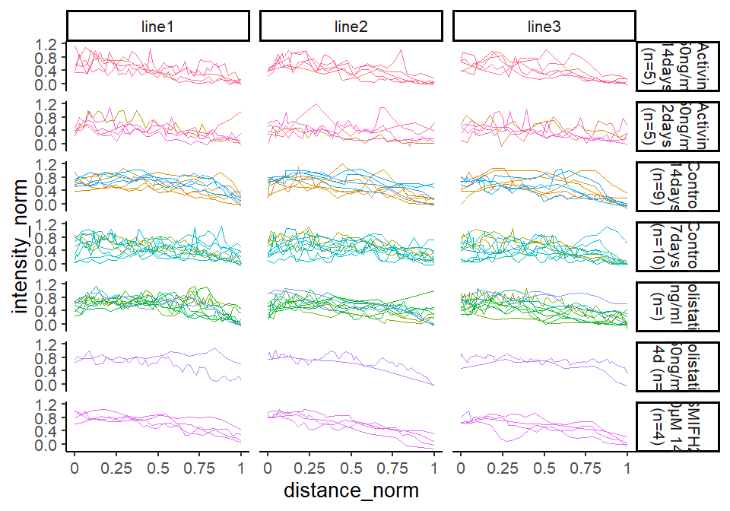
Normalized intensity profiles along sections through the soma
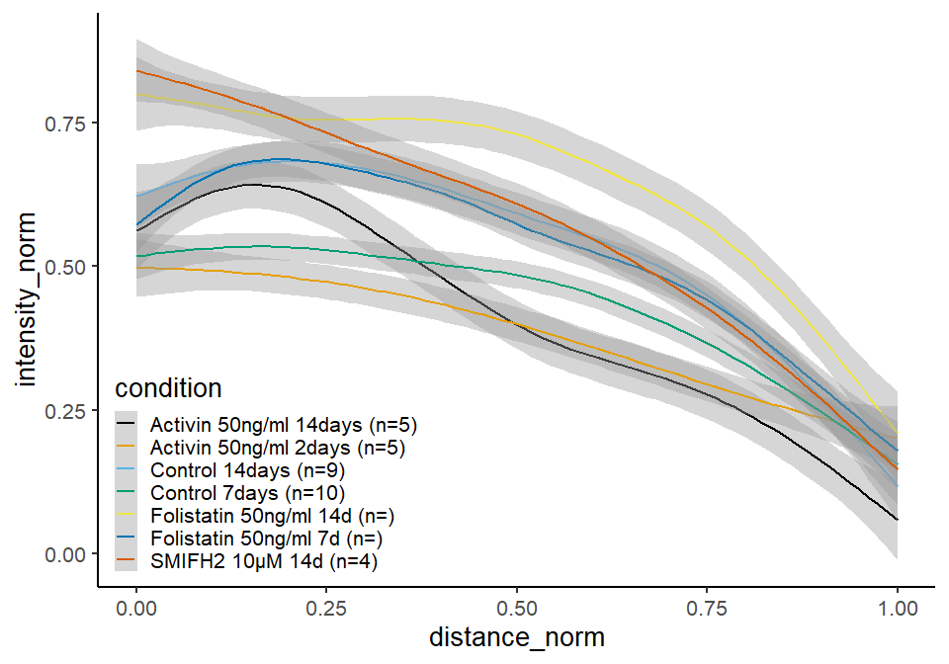
Normalized intensity profiles along sections through the soma

Statistical comparison
To test, whether the distributions are statistically significantly different, we …?? …

Idea1:
Fit lowest possible degree polynomial function (3rd degree) and compare coefficients 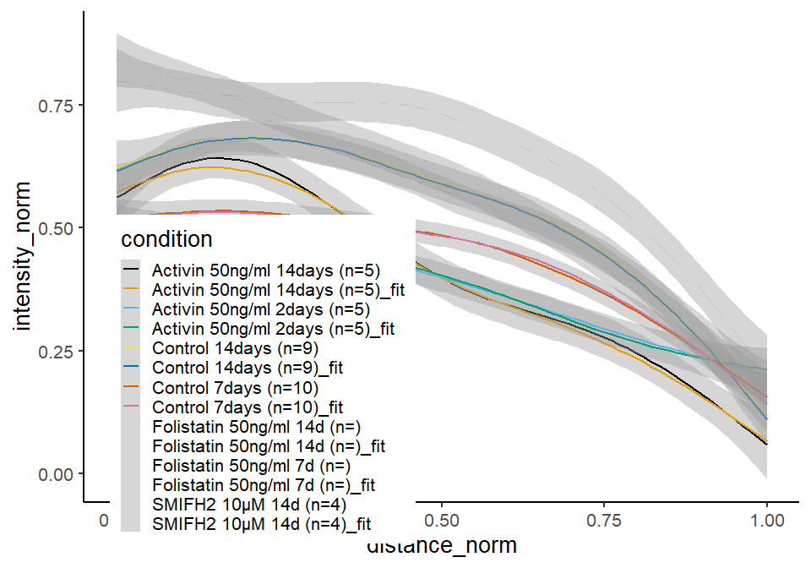
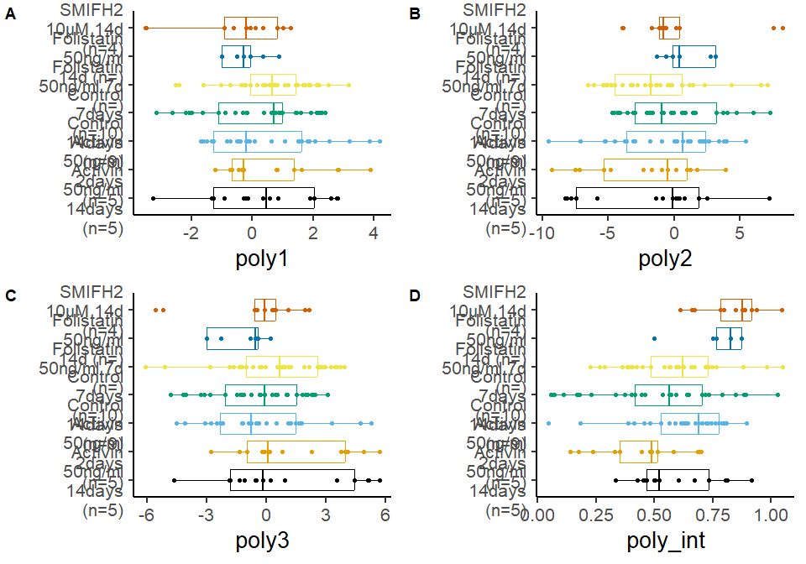
Normalized intensity profiles along sections through the soma with fitted curves

Idea2:
The original paper compared the different distributions by dividing them up into 10 sections (0-0.1 distance from the nucleus, 0.1-0.2, 0.2-0.3,…). Within each section, values are averaged and statistically compared through t-test or anova.
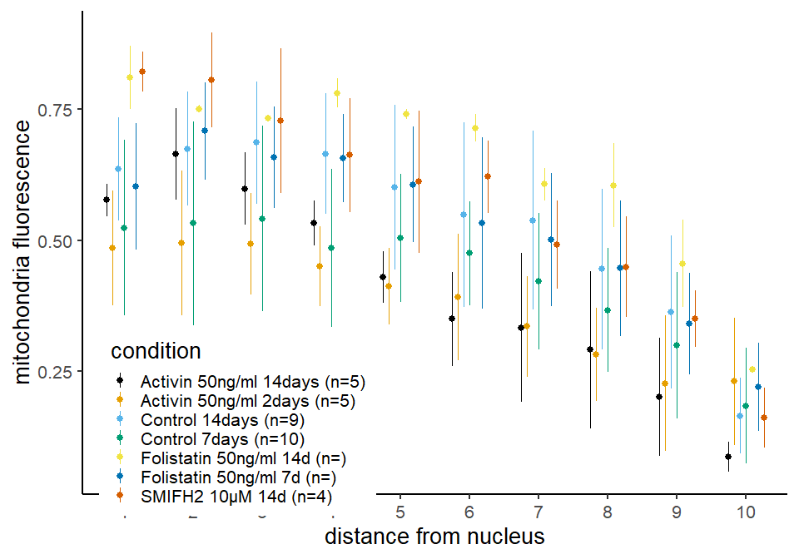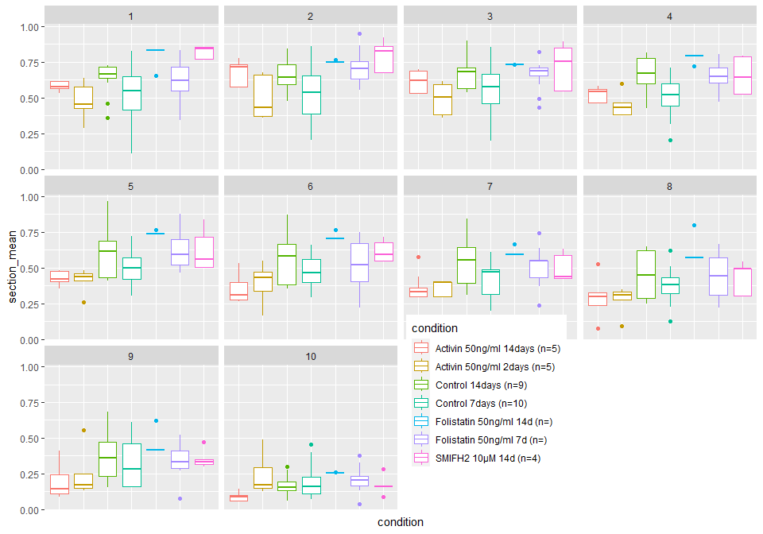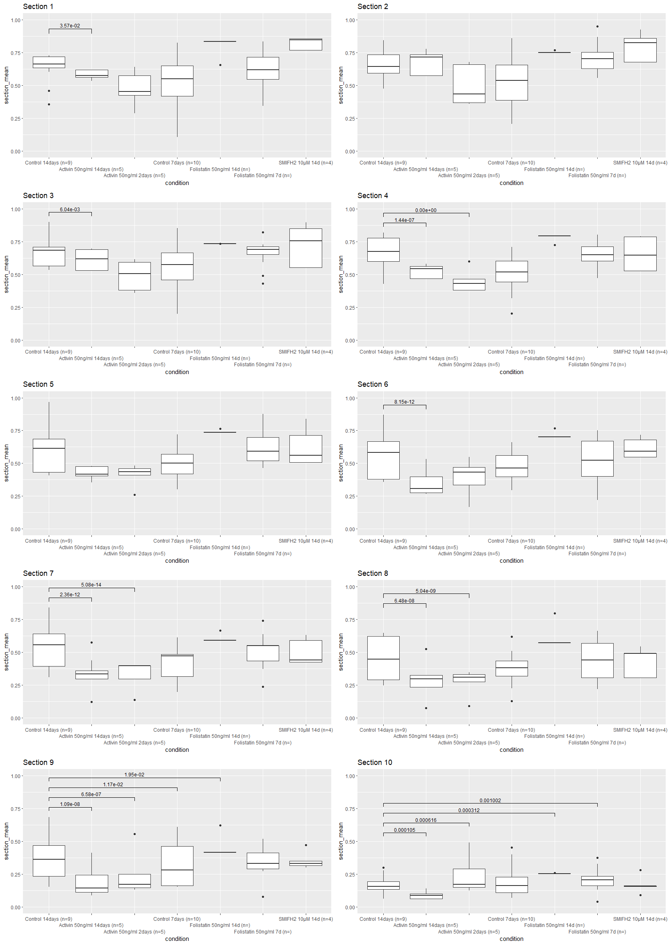
section | condition | mean | sd
1 | Activin 50ng/ml 14days (n=5) | 0.5769 | 0.0311
1 | Activin 50ng/ml 2days (n=5) | 0.4855 | 0.1093
1 | Control 14days (n=9) | 0.6367 | 0.09831
1 | Control 7days (n=10) | 0.5241 | 0.1681
1 | Folistatin 50ng/ml 14d (n=) | 0.8109 | 0.06097
1 | Folistatin 50ng/ml 7d (n=) | 0.603 | 0.121
1 | SMIFH2 10µM 14d (n=4) | 0.8216 | 0.03789
2 | Activin 50ng/ml 14days (n=5) | 0.6648 | 0.08714
2 | Activin 50ng/ml 2days (n=5) | 0.4952 | 0.1386
2 | Control 14days (n=9) | 0.6749 | 0.1082
2 | Control 7days (n=10) | 0.5322 | 0.1947
2 | Folistatin 50ng/ml 14d (n=) | 0.7512 | 0.00719
2 | Folistatin 50ng/ml 7d (n=) | 0.7085 | 0.09249
2 | SMIFH2 10µM 14d (n=4) | 0.8057 | 0.09063
3 | Activin 50ng/ml 14days (n=5) | 0.5985 | 0.06922
3 | Activin 50ng/ml 2days (n=5) | 0.4933 | 0.09656
3 | Control 14days (n=9) | 0.6863 | 0.1165
3 | Control 7days (n=10) | 0.5417 | 0.1773
3 | Folistatin 50ng/ml 14d (n=) | 0.7335 | 8.277e-05
3 | Folistatin 50ng/ml 7d (n=) | 0.6585 | 0.09682
3 | SMIFH2 10µM 14d (n=4) | 0.728 | 0.1386
4 | Activin 50ng/ml 14days (n=5) | 0.5328 | 0.04306
4 | Activin 50ng/ml 2days (n=5) | 0.4509 | 0.07605
4 | Control 14days (n=9) | 0.665 | 0.1153
4 | Control 7days (n=10) | 0.4856 | 0.151
4 | Folistatin 50ng/ml 14d (n=) | 0.781 | 0.02785
4 | Folistatin 50ng/ml 7d (n=) | 0.6567 | 0.08411
4 | SMIFH2 10µM 14d (n=4) | 0.6628 | 0.1091
5 | Activin 50ng/ml 14days (n=5) | 0.4296 | 0.04905
5 | Activin 50ng/ml 2days (n=5) | 0.4129 | 0.07299
5 | Control 14days (n=9) | 0.6013 | 0.1564
5 | Control 7days (n=10) | 0.504 | 0.1224
5 | Folistatin 50ng/ml 14d (n=) | 0.7408 | 0.009714
5 | Folistatin 50ng/ml 7d (n=) | 0.6067 | 0.1108
5 | SMIFH2 10µM 14d (n=4) | 0.6116 | 0.1356
6 | Activin 50ng/ml 14days (n=5) | 0.3498 | 0.08917
6 | Activin 50ng/ml 2days (n=5) | 0.392 | 0.1203
6 | Control 14days (n=9) | 0.5492 | 0.1763
6 | Control 7days (n=10) | 0.4754 | 0.0994
6 | Folistatin 50ng/ml 14d (n=) | 0.7148 | 0.02615
6 | Folistatin 50ng/ml 7d (n=) | 0.533 | 0.1631
6 | SMIFH2 10µM 14d (n=4) | 0.6212 | 0.0688
7 | Activin 50ng/ml 14days (n=5) | 0.3337 | 0.1421
7 | Activin 50ng/ml 2days (n=5) | 0.3357 | 0.09613
7 | Control 14days (n=9) | 0.5385 | 0.1711
7 | Control 7days (n=10) | 0.4225 | 0.1302
7 | Folistatin 50ng/ml 14d (n=) | 0.6071 | 0.03077
7 | Folistatin 50ng/ml 7d (n=) | 0.5005 | 0.1271
7 | SMIFH2 10µM 14d (n=4) | 0.492 | 0.08463
8 | Activin 50ng/ml 14days (n=5) | 0.2915 | 0.1502
8 | Activin 50ng/ml 2days (n=5) | 0.2828 | 0.08893
8 | Control 14days (n=9) | 0.4453 | 0.1535
8 | Control 7days (n=10) | 0.3669 | 0.1187
8 | Folistatin 50ng/ml 14d (n=) | 0.6051 | 0.0802
8 | Folistatin 50ng/ml 7d (n=) | 0.4466 | 0.1297
8 | SMIFH2 10µM 14d (n=4) | 0.4492 | 0.09618
9 | Activin 50ng/ml 14days (n=5) | 0.2011 | 0.1121
9 | Activin 50ng/ml 2days (n=5) | 0.2273 | 0.129
9 | Control 14days (n=9) | 0.3633 | 0.1463
9 | Control 7days (n=10) | 0.3 | 0.14
9 | Folistatin 50ng/ml 14d (n=) | 0.4558 | 0.08312
9 | Folistatin 50ng/ml 7d (n=) | 0.3408 | 0.09633
9 | SMIFH2 10µM 14d (n=4) | 0.3504 | 0.05462
10 | Activin 50ng/ml 14days (n=5) | 0.08703 | 0.02915
10 | Activin 50ng/ml 2days (n=5) | 0.2306 | 0.1209
10 | Control 14days (n=9) | 0.1647 | 0.07225
10 | Control 7days (n=10) | 0.1844 | 0.1108
10 | Folistatin 50ng/ml 14d (n=) | 0.2537 | 0.002749
10 | Folistatin 50ng/ml 7d (n=) | 0.2201 | 0.08443
10 | SMIFH2 10µM 14d (n=4) | 0.1615 | 0.05758

References
[1] Cangkrama M, Liu H, Whipman J, Zubair M, Matsushita M, Di Filippo M, et al. A Protumorigenic mDia2-MIRO1 Axis Controls Mitochondrial Positioning and Function in Cancer-Associated Fibroblasts. Cancer Res 2022;82:3701–17. https://doi.org/10.1158/0008-5472.CAN-22-0162.

Methods section to copy
TBA

