Analysis of vGlut stainings for Marc

Dr. Jana Dahlmanns

2023-03-18

## Analysis steps

### The images

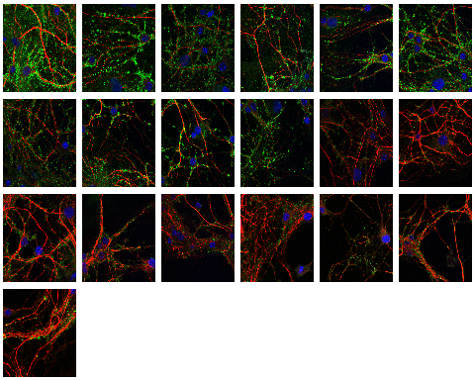

Thumbnails of all analyzed images

The analyzed images contained three color channels. The red channel captured MAP2 emission, the green channel captured vGlut emission and the blue channel captured DAPI emission.

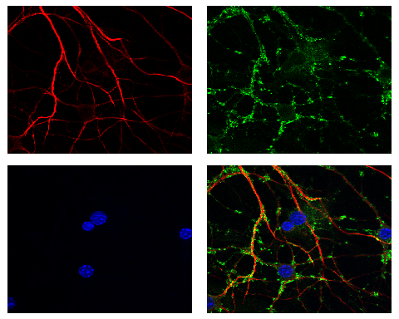

Exemplary image, separated into color channels and merge

### Intensity value range

As the illumination, imaging parameters, and, hence, also the fluorescence intensity, is not quantitatively comparable between recordings, the analysis was performed using parameters entered by the user. For both analyzed color channels (red and green), the user defined a range of intensity values to be included in the analysis: Values below the lower threshold were regarded as background fluorescence noise. Intensity values above the upper limit were regarded as fluorescence from unspecifically bound, unwashed antibodies.

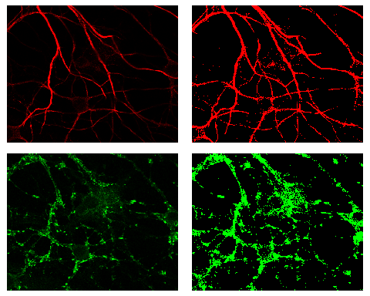

Left: Original images, Right: Images of all pixels, that were included in the analysis as they were within the user chosen range.

I calculated the sum of fluorescence intensity across the recorded field of view. In this summation, only the pixels within the chosen range were included - with this, the sum comprises the actual vGlut staining only and excluded the background fluorescence, as well as extremely bright artefacts.

### Normalization

As mentioned, the absolute fluorescence values are not quantitatively comparable between different recordings - at least not in the experimental design used here. The gathered vGlut fluorescence intensity values thus need to be normalized to the image they came from and to the “amount of neuron” that was in the respective field of view. A common way to do that would be to calculate the sum of fluorescence in the red MAP2- channel in the same way we did for the green vGlut channel and normalize vGlut signal to the MAP2 signal. The results for this are shown below.

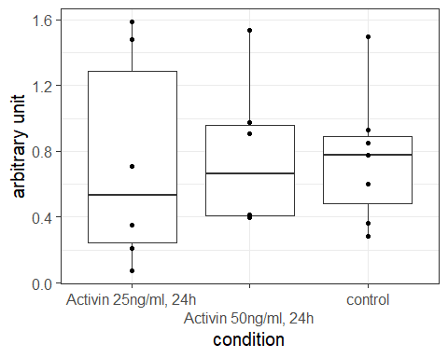

Results for normalization with intensity sum in red channel

Another - probably more sensible - approach to the normalization would be to define the red pixels withing range as before, but instead of accumulating their fluorescence, we use the number of within-range-pixels as normalization constant. With this normalization method, we get the following results.

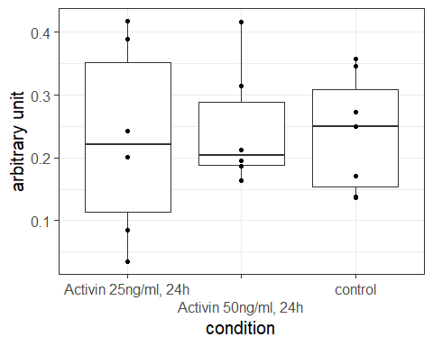

Results for normalization with red channel area

The fluorescence summation approach normalizes the vGlut fluorescence directly to the MAP2 emission, whereas the pixel-counting approach normalizes the vGlut fluorescence to the MAP2-stained area of the field of view, which is probably what we want here.

## Sample sizes

Number of analyzed images: 19

| condition | n |
| --- | --- |
| Activin 25ng/ml, 24h | 6 |
| Activin 50ng/ml, 24h | 6 |
| control | 7 |

## Resulting data table for further analysis

For conveniece, this table can also be found in results.csv.

| recording | condition | green_norm_red_int | green_norm_red_area |
| --- | --- | --- | --- |
| 070302023_activin25ngml24hl_HCculture_map2cy3_vglut1alexa488_DAPiblue_63x.tif | Activin 25ng/ml, 24h | 0.7101462 | 0.4181520 |
| 070302023_activin25ngml24hl_HCculture_map2cy3_vglut1alexa488_DAPiblue_63x_2.tif | Activin 25ng/ml, 24h | 1.5873719 | 0.3893465 |
| 070302023_activin25ngml24hl_HCculture_map2cy3_vglut1alexa488_DAPiblue_63x_3.tif | Activin 25ng/ml, 24h | 1.4793977 | 0.2422892 |
| 070302023_activin50ngml24hl_HCculture_map2cy3_vglut1alexa488_DAPiblue_63x.tif | Activin 50ng/ml, 24h | 0.9075276 | 0.3147272 |
| 070302023_activin50ngml24hl_HCculture_map2cy3_vglut1alexa488_DAPiblue_63x_2.tif | Activin 50ng/ml, 24h | 0.9740833 | 0.1861247 |
| 070302023_activin50ngml24hl_HCculture_map2cy3_vglut1alexa488_DAPiblue_63x_3.tif | Activin 50ng/ml, 24h | 1.5352059 | 0.4164010 |
| 070302023_control_HCculture_map2cy3_vglut1alexa488_DAPiblue_63x.tif | control | 0.8512198 | 0.2722292 |
| 070302023_control_HCculture_map2cy3_vglut1alexa488_DAPiblue_63x_2.tif | control | 0.7785397 | 0.2496397 |
| 070302023_control_HCculture_map2cy3_vglut1alexa488_DAPiblue_63x_2verschoben.tif | control | 0.9292916 | 0.3572501 |
| 070302023_control_HCculture_map2cy3_vglut1alexa488_DAPiblue_63x_3.tif | control | 1.4984793 | 0.3460961 |
| 130302023_activin25ngml24hl_HCculture_map2cy3_vglut1alexa488_DAPiblue_63x.tif | Activin 25ng/ml, 24h | 0.2072257 | 0.0842295 |
| 130302023_activin25ngml24hl_HCculture_map2cy3_vglut1alexa488_DAPiblue_63x_2.tif | Activin 25ng/ml, 24h | 0.0724795 | 0.0342621 |
| 130302023_activin25ngml24hl_HCculture_map2cy3_vglut1alexa488_DAPiblue_63x_3.tif | Activin 25ng/ml, 24h | 0.3527981 | 0.2007614 |
| 130302023_activin50ngml24hl_HCculture_map2cy3_vglut1alexa488_DAPiblue_63x.tif | Activin 50ng/ml, 24h | 0.4146430 | 0.2127217 |
| 130302023_activin50ngml24hl_HCculture_map2cy3_vglut1alexa488_DAPiblue_63x_2.tif | Activin 50ng/ml, 24h | 0.4095644 | 0.1951318 |
| 130302023_activin50ngml24hl_HCculture_map2cy3_vglut1alexa488_DAPiblue_63x_3.tif | Activin 50ng/ml, 24h | 0.3940255 | 0.1636308 |
| 130302023_control_HCculture_map2cy3_vglut1alexa488_DAPiblue_63x.tif | control | 0.6006935 | 0.1707188 |
| 130302023_control_HCculture_map2cy3_vglut1alexa488_DAPiblue_63x_2.tif | control | 0.3599783 | 0.1369841 |
| 130302023_control_HCculture_map2cy3_vglut1alexa488_DAPiblue_63x_3.tif | control | 0.2848450 | 0.1379987 |