BUSINESS ANALYSIS CAPSTONE PACKAGE
Schedule a Ride in Advance
Ride-hailing rider app feature: BRD, BPMN, wireframes, traceability matrix and Gherkin acceptance criteria
Version: 1.0 Date: 6 October 2026 Status: Draft for review
Prepared by: Business Analyst

Package contents
# | Artefact | What it shows | Companion file
1 | Business Requirements Document | Objective, scope, stakeholders, goals and KPIs, requirements, user stories with acceptance criteria | In this document
2 | BPMN process models | Three swimlane diagrams: book a ride, edit or cancel, assign and fulfil the trip | In this document
3 | Wireframes | Clickable 4-screen rider prototype plus the cancel-confirmation state | Interactive prototype (design artifact)
4 | Requirements Traceability Matrix | Business goal > requirement > story > criterion > screen > test scenario, with coverage and gaps | RTM_Schedule_Ride_Feature.xlsx
5 | Gherkin acceptance criteria | 29 scenarios covering the whole flow, tagged to stories, criteria, screens and tests | schedule_ride.feature

Headline results
Measure | Result
Business goals / requirements | 5 goals, 7 requirements (BR-1 to BR-7)
User stories and acceptance criteria | 5 stories plus 1 cross-cutting logging item; 23 acceptance criteria (16 from the BRD, 7 derived during test design)
Test scenarios | 29 Gherkin scenarios; every criterion, requirement and goal has at least one
Wireframe coverage | 5 of 11 screens/states wireframed; 6 still to design (see section 4.3)
Findings | 7 design gaps and 7 open questions raised for the product owner

This is an independent practice exercise. It is not affiliated with or endorsed by Uber Technologies, and the screens are original illustrative wireframes.

1. Business Requirements Document

1.1 Business objective
Enable riders to book a trip in advance (minutes to days ahead) rather than only on demand, so the platform captures demand from time-sensitive trips (flights, meetings, medical appointments) and improves driver-partner utilization through more predictable demand.

1.2 Background and problem statement
On-demand booking assumes the rider needs a car immediately. Riders with fixed-time commitments cannot reliably guarantee a vehicle at a specific future time. This leads to anxiety-driven early requests, missed appointments and lost bookings to competitors that offer scheduled rides.

1.3 Scope
In scope
- Riders schedule a pickup for a future date and time (15 minutes to 30 days ahead)
- Riders view, edit or cancel a scheduled ride before it is dispatched
- The system sends reminder notifications ahead of pickup
- Driver-partners receive scheduled trip requests within a pre-pickup window
Out of scope (this release)
- Recurring or repeating scheduled rides
- Scheduled rides for food delivery or freight
- Group scheduled rides with multiple riders

1.4 Stakeholders
Stakeholder | Interest
Riders | Reliable, predictable pickup for time-critical trips
Driver-partners | Advance visibility into upcoming trips; fair compensation for waiting and no-shows
Operations / dispatch | Balanced supply allocation between on-demand and scheduled demand
Product / engineering | Feature reliability and a low cancellation and no-show rate
Customer support | Fewer complaints about missed pickups

1.5 Business goals and success metrics
Goal | Business goal | KPI (from the BRD)
BG-01 | Capture demand from time-sensitive trips (flights, meetings, medical appointments) | Increase in overall trip volume attributable to scheduled bookings within 2 quarters post-launch
BG-02 | Deliver reliable, on-time scheduled pickups | >=90% of scheduled rides completed with on-time pickup (within 5 minutes of requested time)
BG-03 | Improve driver-partner utilization through predictable, advance demand | No KPI defined in BRD - owner and metric needed
BG-04 | Limit late rider cancellations | <5% rider-initiated cancellation rate after the cancellation cutoff
BG-05 | Reduce customer-support contacts about missed pickups | No KPI defined in BRD - owner and metric needed
Goals BG-03 and BG-05 have no KPI in the original BRD; this is raised as open question Q-02.

1.6 Business requirements
ID | Requirement | Goal(s)
BR-1 | Allow a rider to select a future pickup date and time when requesting a ride. | BG-01, BG-02
BR-2 | Confirm a scheduled ride only when a driver match is reasonably likely; otherwise notify the rider and suggest alternatives. | BG-02, BG-04
BR-3 | Allow riders to modify or cancel a scheduled ride up to a defined cutoff (e.g. 60 minutes before pickup) without penalty. | BG-04
BR-4 | Notify the rider by push notification at set intervals before pickup (e.g. 24 hours, 1 hour, 10 minutes). | BG-02, BG-04
BR-5 | Assign the trip to a driver-partner within a defined pre-pickup window and let the driver accept or decline. | BG-02, BG-03
BR-6 | Apply a cancellation fee if the rider cancels after the defined cutoff. | BG-03, BG-04
BR-7 | Log all scheduled-ride events for reporting and support. | BG-02, BG-05

1.7 Assumptions and constraints
- Existing driver matching and dispatch can be extended to prioritise scheduled trips within the pre-pickup window.
- The feature launches on iOS and Android together.
- Payment and surge pricing apply at pickup time, not booking time, unless stated otherwise.
- Values such as the 15-minute and 30-day booking window, the 60-minute cancellation cutoff and the 30-minute assignment window are examples in the BRD and need confirmation.

1.8 Risks
- Driver no-shows on scheduled trips could damage rider trust.
- Over-promising availability in low-supply areas could increase cancellations.
- Notification fatigue if the reminder cadence is not tuned.

1.9 User stories and acceptance criteria
Criteria marked Derived were added during test design to cover boundaries and edge cases; they are not in the original BRD.
US-01 Schedule a Future Ride (Must, BR-1, BR-2)
AC | Acceptance criterion | Source
AC-01.1 | Rider can pick a pickup date/time from 15 minutes to 30 days ahead after tapping 'Schedule for Later'. | BRD
AC-01.2 | Confirming a valid future time shows a booking confirmation with pickup location, time and estimated fare range. | BRD
AC-01.3 | If no driver supply is reasonably likely, rider sees a warning and alternative times instead of a confirmation. | BRD
AC-01.4 | Times earlier than 15 minutes or later than 30 days ahead are rejected with an error. | Derived
AC-01.5 | Review screen shows trip summary, fare estimate and cancellation policy before the rider confirms. | Derived
US-02 View and Manage Scheduled Rides (Must, BR-3)
AC | Acceptance criterion | Source
AC-02.1 | 'Your Trips' lists all upcoming scheduled rides with date, time and pickup/drop-off details. | BRD
AC-02.2 | Opening a scheduled ride shows its details with Edit and Cancel options. | BRD
AC-02.3 | With no scheduled rides, 'Your Trips' shows an empty state prompting the rider to schedule one. | BRD
US-03 Modify or Cancel a Scheduled Ride (Must, BR-3, BR-6)
AC | Acceptance criterion | Source
AC-03.1 | Cancelling more than 60 minutes before pickup is free and the rider receives a confirmation. | BRD
AC-03.2 | Cancelling within 60 minutes of pickup shows the applicable fee before the rider confirms. | BRD
AC-03.3 | Editing pickup time or location re-validates driver availability and updates the confirmation. | BRD
AC-03.4 | Rider can back out of a cancellation and the ride stays scheduled. | Derived
AC-03.5 | Once a trip is dispatched it can no longer be edited. | Derived
US-04 Receive Pickup Reminders (Should, BR-4)
AC | Acceptance criterion | Source
AC-04.1 | A rider booked more than 24 hours ahead gets a push reminder at 24 hours before pickup. | BRD
AC-04.2 | Reminders at 1 hour and 10 minutes before pickup include driver assignment status when available. | BRD
AC-04.3 | If device notifications are off, reminders still appear in the in-app notification center. | BRD
AC-04.4 | A ride booked less than 24 hours ahead gets no 24-hour reminder. | Derived
AC-04.5 | Cancelling a ride stops all pending reminders for it. | Derived
US-05 Driver Receives and Accepts Scheduled Trip (Must, BR-5)
AC | Acceptance criterion | Source
AC-05.1 | When the pre-pickup assignment window opens (e.g. 30 min), the driver receives a request with pickup time, location and fare. | BRD
AC-05.2 | Accepting locks the trip to that driver and removes it from other drivers' queues. | BRD
AC-05.3 | If the driver declines or times out, the trip is offered to a new driver without changing the rider's pickup time where possible. | BRD
AC-05.4 | If no driver accepts before the assignment window closes, the rider is notified. | Derived
US-X Cross-cutting: event logging (Must, BR-7)
AC | Acceptance criterion | Source
AC-X.1 | Booking, edit, cancel, driver-assignment and reminder events are logged with ride ID, rider ID and timestamp. | BRD

2. BPMN process models
The to-be process is split into three swimlane diagrams so each stays readable. Diagram 1 ends when a scheduled ride exists; Diagrams 2a and 2b cover changes before dispatch; Diagram 3 starts when the driver-assignment window opens.
Symbol | Meaning
Green circle / clock circle | Start event / timer start event
Red thick circle | End event
Rounded rectangle | Task (an activity done by the lane owner)
Diamond with X | Exclusive gateway (one path is taken)
Open bracket with text | Annotation (not part of the flow)

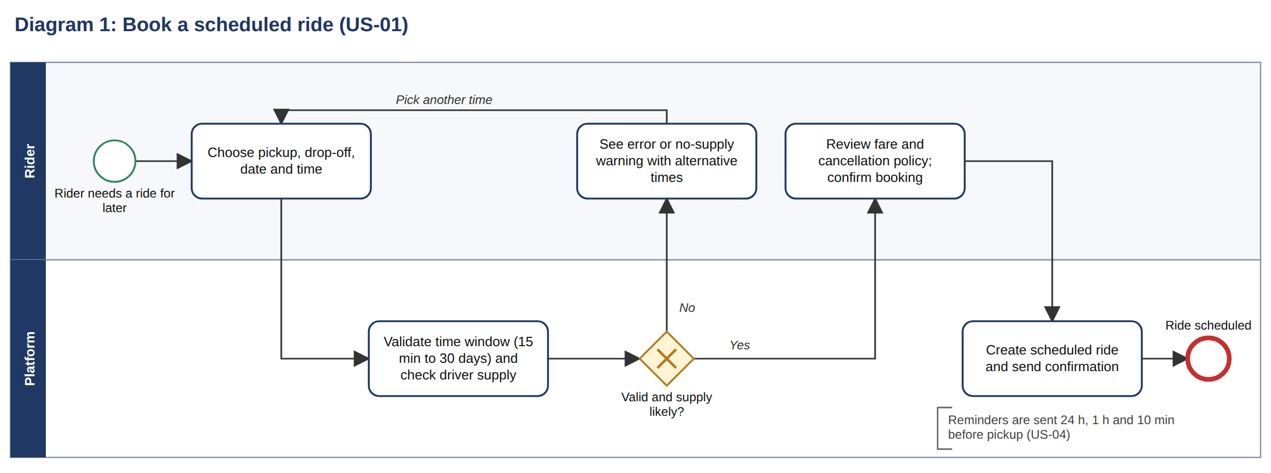
Diagram 1 covers US-01 and BR-1, BR-2. Related tests: TS-01 to TS-08. The no-supply branch (gateway answer No) is tested by TS-07; the invalid-time loop by TS-05 and TS-06.

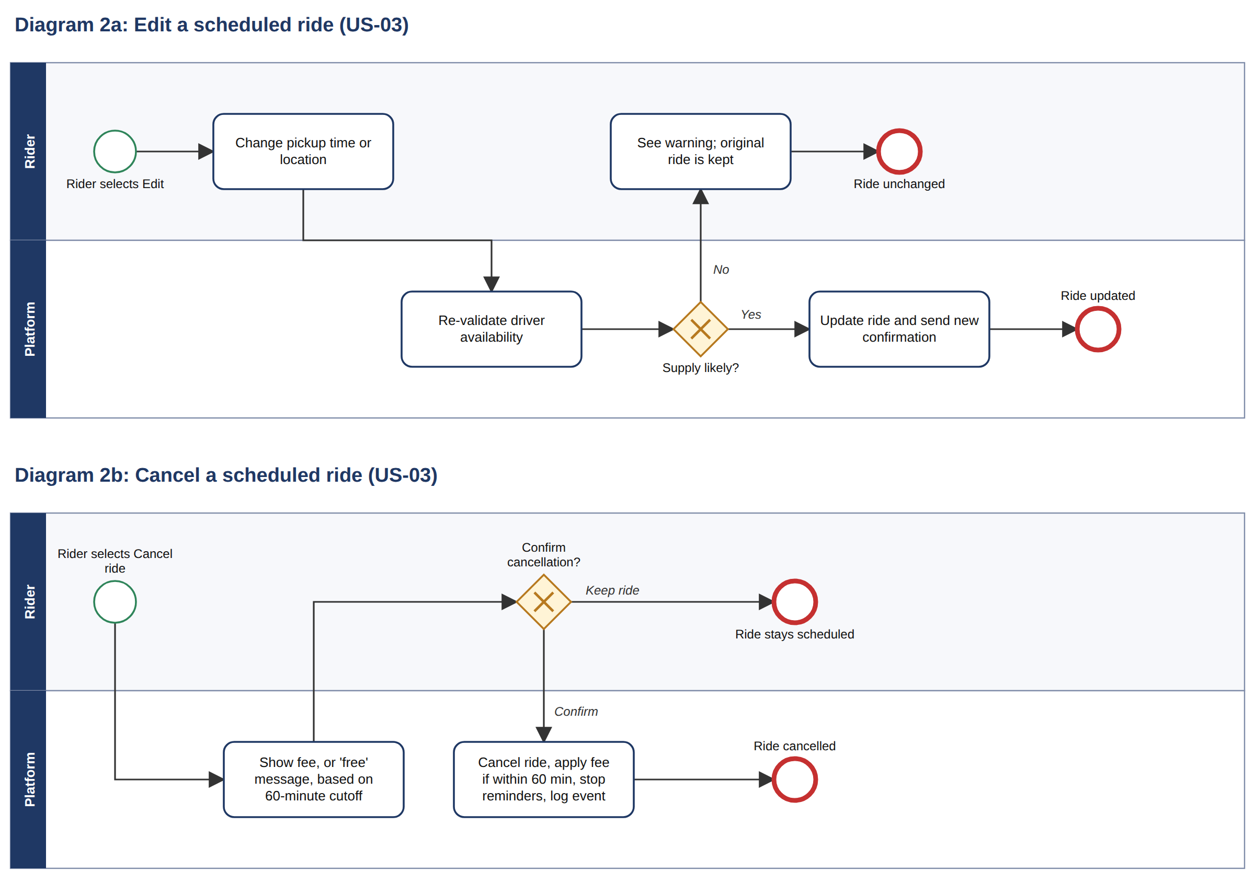
Diagrams 2a and 2b cover US-03 and BR-3, BR-6. Edit: TS-16, TS-17, TS-18. Cancel: TS-12 to TS-15. The 60-minute boundary is open question Q-01.

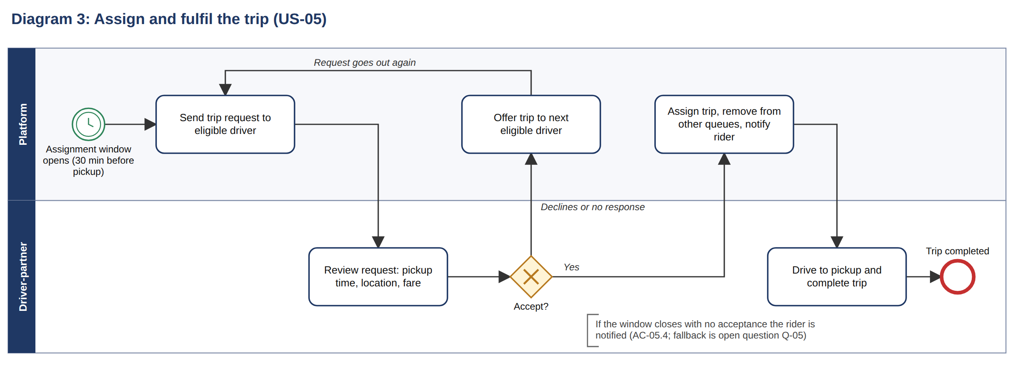
Diagram 3 covers US-05 and BR-5. Related tests: TS-24 to TS-28. The fallback when no driver accepts is not yet defined (open question Q-05).

3. Wireframes
A clickable 4-screen rider prototype was built for this feature (the design artifact Schedule a Ride - Prototype). The screenshots below are taken from it. Colour is used by meaning: black for forward navigation, green for confirming, red for destructive actions.

3.1 Main flow
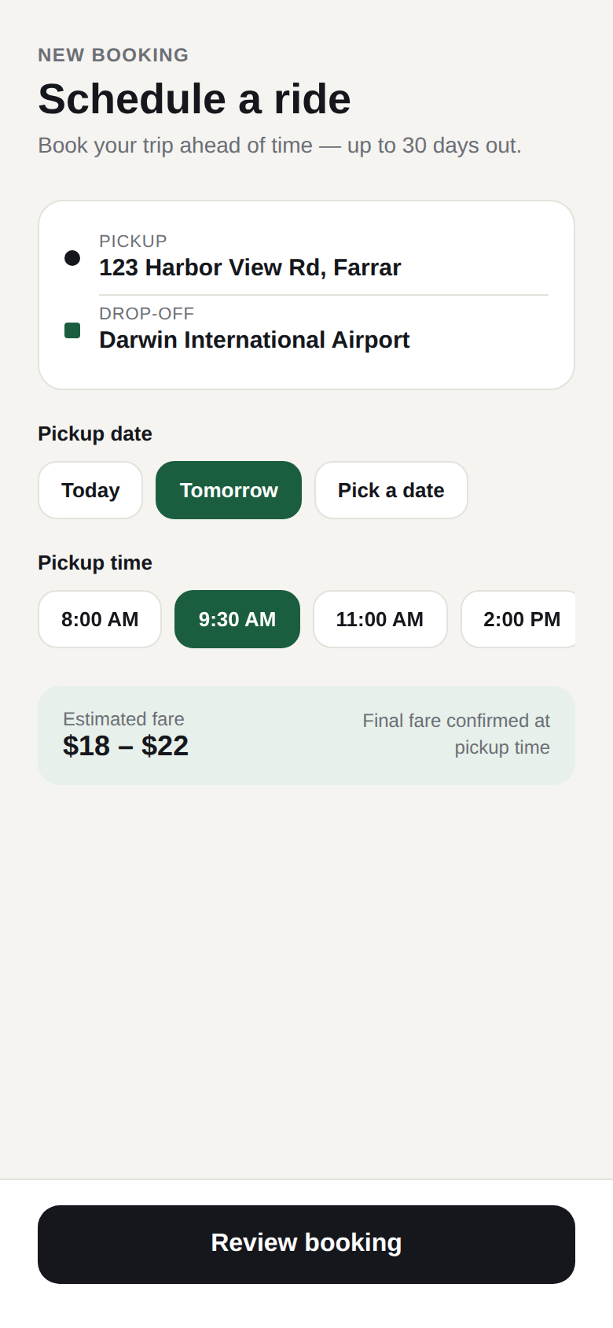  SCR-01  Schedule a ride | 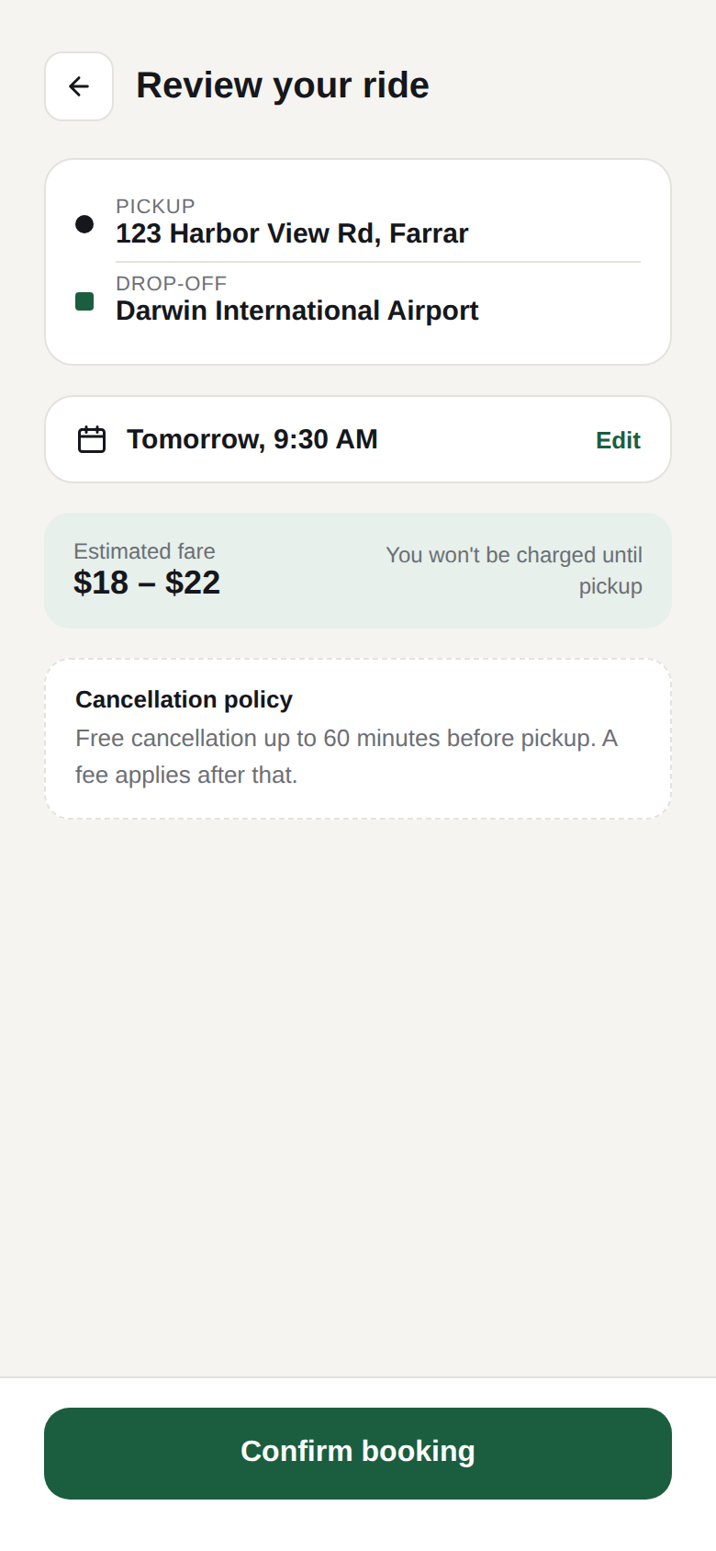  SCR-02  Review and confirm | 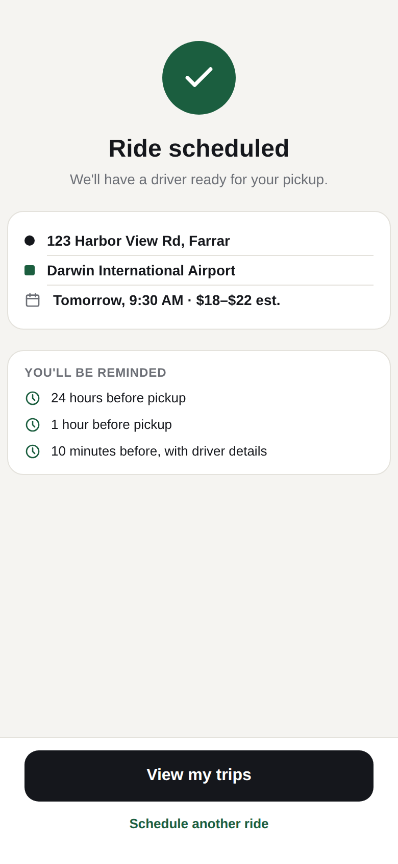  SCR-03  Booking confirmed | 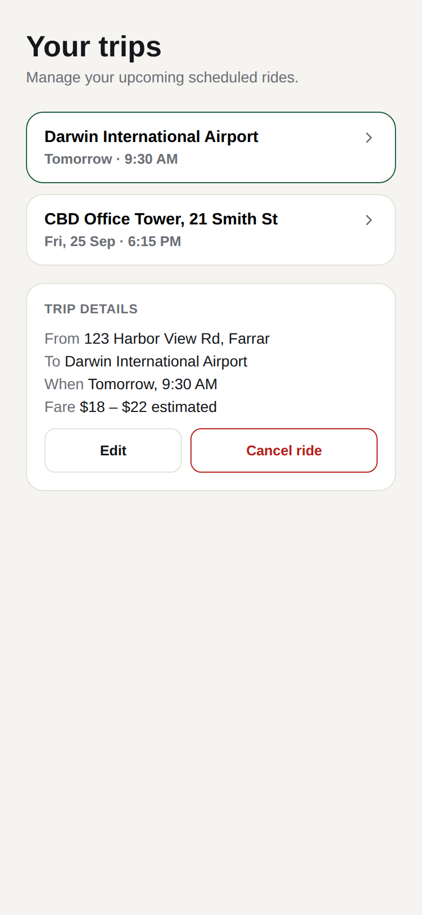  SCR-04  Your trips (list and details)

Flow: SCR-01 > SCR-02 > SCR-03 > SCR-04. From SCR-02, Edit returns to SCR-01. From SCR-04, Edit returns to SCR-01 and Cancel ride opens the confirmation state (SCR-04b).

3.2 Cancel confirmation state
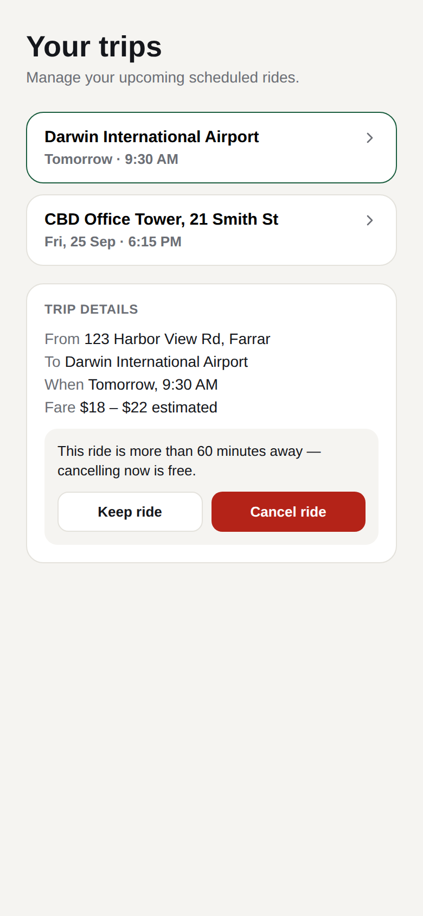  SCR-04b  Cancel confirmation (free) | What it demonstrates  - The free-cancellation message for a ride more than 60 minutes away (AC-03.1, TS-12).  - Keep ride returns to the unchanged booking (AC-03.4, TS-15).  - Cancel ride shows the confirmation banner and ends the flow.  The fee version of this state (AC-03.2) is not yet wireframed (SCR-06).

3.3 Screen inventory and wireframe status
ID | Screen / state | Status | Notes
SCR-01 | Schedule a ride | Wireframed | Pickup/drop-off, date chips, time chips, fare estimate. 'Pick a date' does not open a calendar in the prototype.
SCR-02 | Review & confirm | Wireframed | Trip summary, date/time, fare estimate, cancellation policy, Confirm booking.
SCR-03 | Booking confirmed | Wireframed | Success state, trip summary, reminder schedule (24h / 1h / 10 min).
SCR-04 | Your trips - list and trip details | Wireframed | Scheduled rides list, trip details, Edit and Cancel ride actions.
SCR-04b | Your trips - cancel confirmation (free) | Wireframed | Shown after tapping Cancel ride on a ride more than 60 minutes away.
SCR-05 | Schedule a ride - no-supply warning with alternative times | Not wireframed | Needed for AC-01.3.
SCR-06 | Your trips - cancel confirmation with fee | Not wireframed | Needed for AC-03.2 (prototype only shows the free-cancellation case).
SCR-07 | Your trips - empty state | Not wireframed | Needed for AC-02.3.
SCR-08 | Schedule a ride - invalid time error state | Not wireframed | Needed for AC-01.4. Error copy to be agreed.
NTF-01 | Push reminders and in-app notification center | Not wireframed | Needed for US-04.
DRV-01 | Driver app - scheduled trip request | Not wireframed | Needed for US-05. Driver app is outside the 4-screen rider prototype.

4. Requirements Traceability Matrix
Each row links one test scenario back through its acceptance criterion, requirement and business goal, and forward to the screens that show it. The Excel companion (RTM_Schedule_Ride_Feature.xlsx) holds the same matrix with live coverage formulas and a status column for test execution.

4.1 Traceability matrix
RTM | Goal(s) | Req | Story | AC | Screen(s) | Design | Test | Test scenario | Type | Priority
RTM-001 | BG-01, BG-02 | BR-1 | US-01 | AC-01.1 | SCR-01 | Wireframed | TS-01 | Select a valid future date and time | Positive | High
RTM-002 | BG-01, BG-02 | BR-1 | US-01 | AC-01.2 | SCR-02, SCR-03 | Wireframed | TS-02 | Confirm booking shows confirmation details | Positive | High
RTM-003 | BG-01, BG-02 | BR-1 | US-01 | AC-01.1 | SCR-01 | Wireframed | TS-03 | Earliest allowed time (15 minutes ahead) is accepted | Boundary | High
RTM-004 | BG-01, BG-02 | BR-1 | US-01 | AC-01.1 | SCR-01 | Wireframed | TS-04 | Latest allowed time (30 days ahead) is accepted | Boundary | Medium
RTM-005 | BG-01, BG-02 | BR-1 | US-01 | AC-01.4 | SCR-08 | Gap | TS-05 | Time less than 15 minutes ahead is rejected | Negative | High
RTM-006 | BG-01, BG-02 | BR-1 | US-01 | AC-01.4 | SCR-08 | Gap | TS-06 | Time more than 30 days ahead is rejected | Negative | Medium
RTM-007 | BG-02, BG-04 | BR-2 | US-01 | AC-01.3 | SCR-05 | Gap | TS-07 | No driver supply shows warning and alternative times | Negative | High
RTM-008 | BG-03, BG-04 | BR-6 | US-01 | AC-01.5 | SCR-02 | Wireframed | TS-08 | Review screen shows summary, fare and cancellation policy | Positive | Medium
RTM-009 | BG-04 | BR-3 | US-02 | AC-02.1 | SCR-04 | Wireframed | TS-09 | Upcoming scheduled rides are listed | Positive | High
RTM-010 | BG-04 | BR-3 | US-02 | AC-02.2 | SCR-04 | Wireframed | TS-10 | Ride details show Edit and Cancel options | Positive | High
RTM-011 | BG-04 | BR-3 | US-02 | AC-02.3 | SCR-07 | Gap | TS-11 | Empty state when no rides are scheduled | Alternate | Medium
RTM-012 | BG-04 | BR-3 | US-03 | AC-03.1 | SCR-04, SCR-04b | Wireframed | TS-12 | Cancel more than 60 minutes before pickup is free | Positive | High
RTM-013 | BG-04 | BR-3 | US-03 | AC-03.1 | SCR-04, SCR-04b | Wireframed | TS-13 | Cancel exactly 60 minutes before pickup (assumed free) | Boundary | High
RTM-014 | BG-03, BG-04 | BR-6 | US-03 | AC-03.2 | SCR-06 | Gap | TS-14 | Cancel within 60 minutes shows fee before confirming | Negative | High
RTM-015 | BG-04 | BR-3 | US-03 | AC-03.4 | SCR-04b | Wireframed | TS-15 | Rider keeps the ride after opening cancel | Alternate | Medium
RTM-016 | BG-04 | BR-3 | US-03 | AC-03.3 | SCR-01, SCR-02 | Wireframed | TS-16 | Edit pickup time re-validates availability | Positive | High
RTM-017 | BG-04 | BR-3 | US-03 | AC-03.3 | SCR-01, SCR-02 | Wireframed | TS-17 | Edit to a time with no supply is rejected | Negative | Medium
RTM-018 | BG-04 | BR-3 | US-03 | AC-03.5 | SCR-04 | Wireframed | TS-18 | Edit is unavailable after dispatch | Negative | Medium
RTM-019 | BG-02, BG-04 | BR-4 | US-04 | AC-04.1 | NTF-01, SCR-03 | Partial | TS-19 | 24-hour reminder is sent | Positive | Medium
RTM-020 | BG-02, BG-04 | BR-4 | US-04 | AC-04.2 | NTF-01 | Gap | TS-20 | 1-hour and 10-minute reminders show driver status | Positive | Medium
RTM-021 | BG-02, BG-04 | BR-4 | US-04 | AC-04.3 | NTF-01 | Gap | TS-21 | Notifications off still show in-app reminder | Alternate | Medium
RTM-022 | BG-02, BG-04 | BR-4 | US-04 | AC-04.4 | NTF-01 | Gap | TS-22 | No 24-hour reminder when booked less than 24 hours ahead | Boundary | Low
RTM-023 | BG-02, BG-04 | BR-4 | US-04 | AC-04.5 | NTF-01 | Gap | TS-23 | Cancelling a ride stops its reminders | Alternate | Low
RTM-024 | BG-02, BG-03 | BR-5 | US-05 | AC-05.1 | DRV-01 | Gap | TS-24 | Driver receives request when the assignment window opens | Positive | High
RTM-025 | BG-02, BG-03 | BR-5 | US-05 | AC-05.2 | DRV-01 | Gap | TS-25 | Accepting locks the trip to the driver | Positive | High
RTM-026 | BG-02, BG-03 | BR-5 | US-05 | AC-05.3 | DRV-01 | Gap | TS-26 | Declined request is reassigned | Alternate | High
RTM-027 | BG-02, BG-03 | BR-5 | US-05 | AC-05.3 | DRV-01 | Gap | TS-27 | Unanswered request times out and is reassigned | Alternate | High
RTM-028 | BG-02, BG-03 | BR-5 | US-05 | AC-05.4 | DRV-01, NTF-01 | Gap | TS-28 | No driver accepts before the window closes | Negative | High
RTM-029 | BG-02, BG-05 | BR-7 | US-X | AC-X.1 | N/A | N/A (back-end) | TS-29 | Lifecycle events are logged | Positive | Medium

4.2 Coverage summary
Story | Title | ACs | ACs with a test | Tests | ACs fully wireframed | ACs with design gap or partial
US-01 | Schedule a Future Ride | 5 | 5 of 5 | 8 | 3 | 2
US-02 | View and Manage Scheduled Rides | 3 | 3 of 3 | 3 | 2 | 1
US-03 | Modify or Cancel a Scheduled Ride | 5 | 5 of 5 | 7 | 4 | 1
US-04 | Receive Pickup Reminders | 5 | 5 of 5 | 5 | 0 | 5
US-05 | Driver Receives and Accepts Scheduled Trip | 4 | 4 of 4 | 5 | 0 | 4
US-X | Cross-cutting: event logging | 1 | 1 of 1 | 1 | 0 | 0
Total |  | 23 | 23 of 23 | 29 | 9 | 13
Every acceptance criterion, requirement and business goal has at least one test. Design coverage is the weaker side: all rider-facing happy paths are wireframed, but error states, notifications and the driver app are not.

4.3 Findings: design gaps and open questions
ID | Type | Finding | Impact | Recommendation
G-01 | Design gap | No wireframe for the no-supply warning with alternative times (AC-01.3, TS-07, TS-17). | BR-2 cannot be visually reviewed. | Add SCR-05 state to the prototype.
G-02 | Design gap | No wireframe for invalid-time error (AC-01.4, TS-05, TS-06). | Error copy and behaviour untested with stakeholders. | Add SCR-08 and agree error wording.
G-03 | Design gap | No empty state for 'Your trips' (AC-02.3, TS-11). | Edge case undesigned. | Add SCR-07.
G-04 | Design gap | Cancel-with-fee state not wireframed; prototype shows only the free-cancel case (AC-03.2, TS-14). | BR-6 fee disclosure unverified. | Add SCR-06 showing fee amount.
G-05 | Design gap | No wireframes for push reminders or the in-app notification center (US-04). | BR-4 channel behaviour unverified. | Add NTF-01 mock-ups.
G-06 | Design gap | Driver-side request screen not wireframed (US-05). | BR-5 has no visual reference. | Add DRV-01 in a separate driver prototype.
G-07 | Design simplification | Prototype 'Edit' returns to a blank SCR-01 and 'Pick a date' opens no calendar. | AC-03.3 flow only approximated. | Add a pre-filled edit mode and date picker.
Q-01 | Open question | Cancellation boundary at exactly 60 minutes: BR-3 says 'up to the cutoff' (free) while AC-03.1 says 'more than 60' and AC-03.2 says 'within 60'. | TS-13 outcome depends on the answer. | Product owner to confirm; TS-13 assumes free.
Q-02 | Open question | BG-03 and BG-05 have no KPI in the BRD. | Goals cannot be measured. | Stakeholders to propose metrics and owners.
Q-03 | Open question | Cancellation fee amount/formula and driver compensation are not specified (BR-6). | TS-14 cannot assert an amount. | Define fee schedule.
Q-04 | Open question | Can a rider cancel after dispatch, and at what fee? Scope only says edit/cancel 'before it is dispatched'. | AC-03.5 only covers edit. | Clarify post-dispatch cancel rules.
Q-05 | Open question | Fallback if no driver accepts before pickup (reassignment window, escalation to on-demand pool, rider compensation). | TS-28 expected result is incomplete. | Define fallback and timeout values.
Q-06 | Open question | 'Reasonably likely' supply threshold (BR-2) is undefined. | TS-07 and TS-17 need a testable rule. | Engineering to define the threshold.
Q-07 | Open question | BRD applies surge pricing at pickup, but the booking shows a fare range. | Rider messaging may mislead. | Confirm wording of the fare estimate.

5. Gherkin acceptance criteria
The full feature file (schedule_ride.feature) is reproduced below: 29 scenarios grouped into one Rule per user story. Every scenario carries tags for its test (@TS-nn), story (@US-nn), criterion (@AC-nn.n) and screen (@SCR-nn), so it can be traced in the RTM and run with a Cucumber-compatible tool. Scenarios tagged @derived cover criteria added during test design; @assumption marks a scenario that depends on an open question.

# Traceability: see RTM_Schedule_Ride_Feature.xlsx. Each scenario carries @TS (test), @US (story), @AC (criterion) and @SCR (screen) tags.
# Assumed 'now' for all time-based scenarios: 2026-10-06 09:00 local time.
# Scenarios tagged @derived cover criteria added during test design (not written in the BRD).
# Scenarios tagged @assumption depend on an open question (see Gaps and Questions sheet).

@schedule-ride @rider-app
Feature: Schedule a ride in advance
As a rider
I want to book, manage and be reminded about a ride for a future time
So that I have reliable transportation for planned, time-sensitive trips

Background:
Given the rider is signed in to the app
And the rider has a valid payment method on file
And the current local date and time is "2026-10-06 09:00"

# ---- US-01: Schedule a Future Ride ----
Rule: A rider can schedule a ride for a future date and time

@TS-01 @US-01 @AC-01.1 @SCR-01 @positive
Scenario: Select a valid future date and time
Given the rider has entered pickup "123 Harbor View Rd, Farrar" and drop-off "Darwin International Airport"
When the rider taps "Schedule for Later"
Then the rider can choose a pickup date and time
When the rider selects "2026-10-07" at "9:30 AM"
Then the booking summary shows the pickup time "Tomorrow, 9:30 AM"

@TS-02 @US-01 @AC-01.2 @SCR-02 @SCR-03 @positive
Scenario: Confirm booking shows confirmation details
Given the rider has selected "2026-10-07" at "9:30 AM" for a ride from "123 Harbor View Rd, Farrar" to "Darwin International Airport"
And driver supply is likely for that time and location
When the rider taps "Review booking"
And the rider taps "Confirm booking"
Then the app shows a booking confirmation
And the confirmation shows the pickup location, the pickup time "9:30 AM" and an estimated fare range
And the rider is not charged until pickup

@TS-03 @US-01 @AC-01.1 @SCR-01 @boundary
Scenario: Earliest allowed time (15 minutes ahead) is accepted
Given the rider is scheduling a ride
When the rider selects "2026-10-06" at "9:15 AM"
Then the time is accepted
And "Review booking" is available

@TS-04 @US-01 @AC-01.1 @SCR-01 @boundary
Scenario: Latest allowed time (30 days ahead) is accepted
Given the rider is scheduling a ride
When the rider selects "2026-11-05" at "9:00 AM"
Then the time is accepted
And "Review booking" is available

@TS-05 @US-01 @AC-01.4 @SCR-08 @negative @derived
Scenario: Time less than 15 minutes ahead is rejected
Given the rider is scheduling a ride
When the rider selects "2026-10-06" at "9:10 AM"
Then the app shows an error that pickup must be at least 15 minutes from now
And "Review booking" is not available

@TS-06 @US-01 @AC-01.4 @SCR-08 @negative @derived
Scenario: Time more than 30 days ahead is rejected
Given the rider is scheduling a ride
When the rider selects "2026-11-05" at "9:15 AM"
Then the app shows an error that pickup cannot be more than 30 days ahead
And "Review booking" is not available

@TS-07 @US-01 @AC-01.3 @SCR-05 @negative
Scenario: No driver supply shows warning and alternative times
Given the rider has selected "2026-10-07" at "3:00 AM" for a ride from "123 Harbor View Rd, Farrar" to "Darwin International Airport"
And driver supply is unlikely for that time and location
When the rider attempts to confirm the booking
Then the app shows a warning that a driver may not be available
And the app suggests alternative pickup times
And no scheduled ride is created

@TS-08 @US-01 @AC-01.5 @SCR-02 @positive @derived
Scenario: Review screen shows summary, fare and cancellation policy
Given the rider has selected "2026-10-07" at "9:30 AM" for a ride from "123 Harbor View Rd, Farrar" to "Darwin International Airport"
When the rider taps "Review booking"
Then the review screen shows the pickup, drop-off, date and time, and estimated fare
And the review screen shows "Free cancellation up to 60 minutes before pickup. A fee applies after that."

# ---- US-02: View and Manage Scheduled Rides ----
Rule: A rider can view their scheduled rides

@TS-09 @US-02 @AC-02.1 @SCR-04 @positive
Scenario: Upcoming scheduled rides are listed
Given the rider has these scheduled rides:
| drop-off | date | time |
| Darwin International Airport | 2026-10-07 | 9:30 AM |
| CBD Office Tower, 21 Smith St | 2026-10-09 | 6:15 PM |
When the rider opens "Your Trips"
Then both rides are listed
And each ride shows its date, time and pickup and drop-off details

@TS-10 @US-02 @AC-02.2 @SCR-04 @positive
Scenario: Ride details show Edit and Cancel options
Given the rider has a scheduled ride to "Darwin International Airport"
When the rider taps that ride in "Your Trips"
Then the ride details are shown
And the "Edit" and "Cancel ride" options are available

@TS-11 @US-02 @AC-02.3 @SCR-07 @alternate
Scenario: Empty state when no rides are scheduled
Given the rider has no scheduled rides
When the rider opens "Your Trips"
Then an empty state is shown
And the empty state prompts the rider to schedule a ride

# ---- US-03: Modify or Cancel a Scheduled Ride ----
Rule: A rider can modify or cancel a scheduled ride

@TS-12 @US-03 @AC-03.1 @SCR-04 @SCR-04b @positive
Scenario: Cancel more than 60 minutes before pickup is free
Given the rider has a scheduled ride for "2026-10-07" at "9:30 AM"
When the rider taps "Cancel ride"
Then the app states that cancelling now is free
When the rider confirms the cancellation
Then the ride is cancelled
And no cancellation fee is charged
And the rider sees a cancellation confirmation

@TS-13 @US-03 @AC-03.1 @SCR-04 @SCR-04b @boundary @assumption
Scenario: Cancel exactly 60 minutes before pickup (assumed free)
# ASSUMPTION: exactly 60 minutes is inside the free-cancellation window (see open question Q-01)
Given the rider has a scheduled ride with pickup at "2026-10-06" at "10:00 AM"
When the rider cancels the ride at "09:00 AM"
Then no cancellation fee is charged

@TS-14 @US-03 @AC-03.2 @SCR-06 @negative
Scenario: Cancel within 60 minutes shows fee before confirming
Given the rider has a scheduled ride with pickup at "2026-10-06" at "9:45 AM"
When the rider taps "Cancel ride"
Then the app shows the applicable cancellation fee before asking for confirmation
When the rider confirms the cancellation
Then the ride is cancelled
And the cancellation fee is applied

@TS-15 @US-03 @AC-03.4 @SCR-04b @alternate @derived
Scenario: Rider keeps the ride after opening cancel
Given the rider has a scheduled ride for "2026-10-07" at "9:30 AM"
And the rider has tapped "Cancel ride"
When the rider taps "Keep ride"
Then the ride remains scheduled
And no cancellation fee is charged

@TS-16 @US-03 @AC-03.3 @SCR-01 @SCR-02 @positive
Scenario: Edit pickup time re-validates availability
Given the rider has a scheduled ride for "2026-10-07" at "9:30 AM"
And driver supply is likely at "10:30 AM"
When the rider edits the pickup time to "10:30 AM"
Then the system re-validates driver availability
And the confirmation shows the pickup time "10:30 AM"

@TS-17 @US-03 @AC-03.3 @SCR-01 @SCR-02 @negative
Scenario: Edit to a time with no supply is rejected
Given the rider has a scheduled ride for "2026-10-07" at "9:30 AM"
And driver supply is unlikely at "3:00 AM"
When the rider edits the pickup time to "3:00 AM"
Then the app shows a warning that a driver may not be available
And the ride remains scheduled for "9:30 AM"

@TS-18 @US-03 @AC-03.5 @SCR-04 @negative @derived
Scenario: Edit is unavailable after dispatch
Given the rider has a scheduled ride that has been dispatched to a driver
When the rider opens the ride details
Then the "Edit" option is not available

# ---- US-04: Receive Pickup Reminders ----
Rule: A rider receives reminders before pickup

@TS-19 @US-04 @AC-04.1 @NTF-01 @SCR-03 @positive
Scenario: 24-hour reminder is sent
Given the rider has a scheduled ride for "2026-10-09" at "6:15 PM"
And push notifications are enabled
When the time reaches "2026-10-08" at "6:15 PM"
Then the rider receives a push notification reminder

@TS-20 @US-04 @AC-04.2 @NTF-01 @positive
Scenario Outline: 1-hour and 10-minute reminders show driver status
Given the rider has a scheduled ride for "2026-10-09" at "6:15 PM"
And the driver status is "<driver status>"
When "<interval>" remain before pickup
Then the rider receives a push notification reminder
And the reminder shows the driver assignment status "<driver status>"

Examples:
| interval | driver status |
| 1 hour | driver assigned |
| 1 hour | not yet assigned |
| 10 minutes | driver assigned |

@TS-21 @US-04 @AC-04.3 @NTF-01 @alternate
Scenario: Notifications off still show in-app reminder
Given the rider has a scheduled ride for "2026-10-09" at "6:15 PM"
And push notifications are disabled on the rider's device
When a reminder time is reached
Then the reminder appears in the in-app notification center

@TS-22 @US-04 @AC-04.4 @NTF-01 @boundary @derived
Scenario: No 24-hour reminder when booked less than 24 hours ahead
Given the rider books a ride for "2026-10-06" at "4:00 PM"
Then no 24-hour reminder is sent
When the time reaches "3:00 PM"
Then the rider receives the 1-hour reminder

@TS-23 @US-04 @AC-04.5 @NTF-01 @alternate @derived
Scenario: Cancelling a ride stops its reminders
Given the rider has a scheduled ride for "2026-10-09" at "6:15 PM"
When the rider cancels the ride
Then no further reminders are sent for that ride

# ---- US-05: Driver Receives and Accepts Scheduled Trip ----
Rule: A driver-partner can receive and accept a scheduled trip

@TS-24 @US-05 @AC-05.1 @DRV-01 @positive
Scenario: Driver receives request when the assignment window opens
Given a scheduled ride with pickup at "2026-10-09" at "6:15 PM"
And the assignment window opens 30 minutes before pickup
When the time reaches "2026-10-09" at "5:45 PM"
Then an eligible driver-partner receives a trip request
And the request shows the pickup time, pickup location and estimated fare

@TS-25 @US-05 @AC-05.2 @DRV-01 @positive
Scenario: Accepting locks the trip to the driver
Given a driver-partner has received a scheduled trip request
When the driver accepts the request
Then the trip is assigned to that driver
And the trip is removed from other drivers' request queues

@TS-26 @US-05 @AC-05.3 @DRV-01 @alternate
Scenario: Declined request is reassigned
Given a driver-partner has received a scheduled trip request
When the driver declines the request
Then the system offers the trip to a new driver
And the rider's pickup time is not changed where possible

@TS-27 @US-05 @AC-05.3 @DRV-01 @alternate
Scenario: Unanswered request times out and is reassigned
Given a driver-partner has received a scheduled trip request
When the driver does not respond within the timeout period
Then the system offers the trip to a new driver
And the rider's pickup time is not changed where possible

@TS-28 @US-05 @AC-05.4 @DRV-01 @NTF-01 @negative @derived
Scenario: No driver accepts before the window closes
Given a scheduled ride with no accepted driver
When the assignment window closes
Then the rider is notified that no driver has been assigned

# ---- US-X: Cross-cutting: event logging ----
Rule: Scheduled-ride events are logged

@TS-29 @US-X @AC-X.1 @positive
Scenario Outline: Lifecycle events are logged
Given the rider has a scheduled ride
When the event "<event>" occurs
Then the event is recorded with the ride ID, rider ID and a timestamp

Examples:
| event |
| booking created |
| booking edited |
| booking cancelled |
| driver assigned |
| reminder sent |

