IT Business Analysis Diagram Toolkit
Explanations and Worked Examples for 12 Core BA Diagrams, illustrated with an IT Helpdesk Ticketing System project
Prepared for: Business Analysis Study Notes

1. Business Process Model and Notation (BPMN) Diagram
What it is
A standardized graphical notation for modeling business processes as end-to-end workflows. BPMN uses a defined shape set — circles for start/end events, rounded rectangles for tasks/activities, diamonds for decision gateways, and arrows for sequence flow — and can group activities into "pools" and "lanes" to show which role or department performs each step. It is widely used because the notation is understood consistently across tools and organizations.
When to use it
- Documenting an as-is or to-be IT process for a process improvement or automation project
- Communicating a support or development workflow to both technical and non-technical stakeholders
- Identifying handoffs, delays, or decision points that could be automated
Example
The diagram below models an IT support ticket escalation process: once a ticket is created, an L1 Support agent triages it, a decision gateway checks whether it can be resolved at L1, and the process ends either by closing the ticket or escalating it to an L2 Engineer.
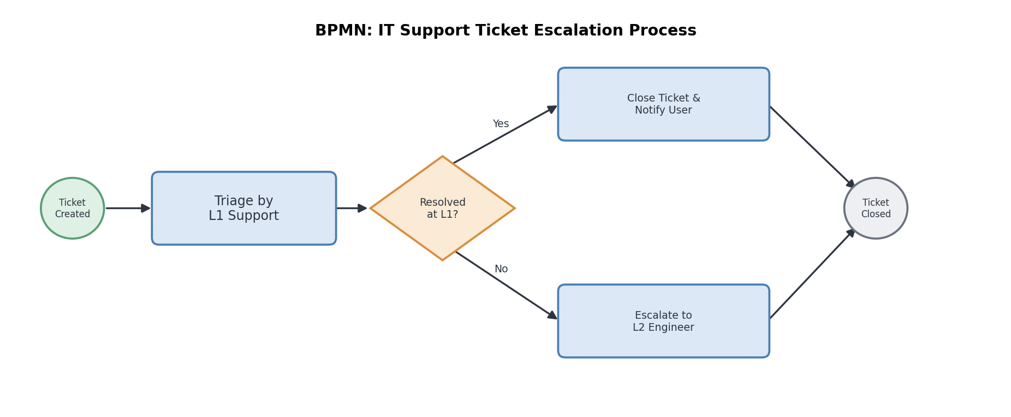

2. Use Case Diagram
What it is
A UML diagram that shows how external actors (users or other systems) interact with a system through discrete "use cases" — a functional goal the system fulfils. Actors are shown as stick figures, use cases as ovals inside a system boundary, and lines represent the association between an actor and a use case. Relationships such as «include» and «extend» describe how use cases relate to one another.
When to use it
- Scoping system requirements at a high level before detailed functional specification
- Clarifying which actor (user, admin, external system) triggers which functionality
- Providing a visual entry point into a larger requirements or user-story set
Example
For an IT Helpdesk Ticketing System, the "End User" actor interacts with use cases such as "Submit Ticket," "Track Ticket Status," and "Rate Resolution" (where "Submit Ticket" includes "Authenticate User"), while a "Support Agent" actor updates ticket status.
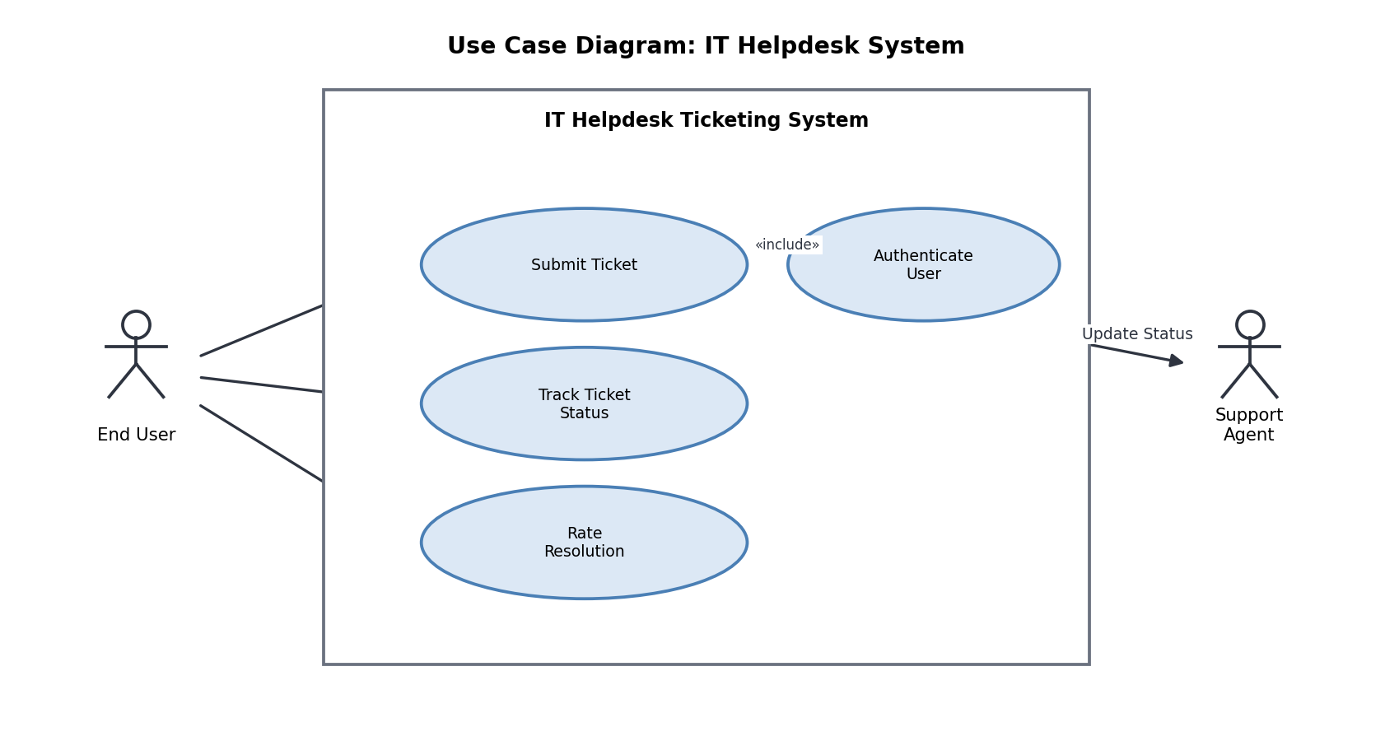

3. Entity-Relationship (ER) Diagram
What it is
A modeling technique for the logical structure of a database. Entities (real-world objects, e.g. User, Ticket) are shown as boxes containing attributes, and relationships between entities are shown as connecting lines annotated with cardinality (one-to-one, one-to-many, many-to-many). ER diagrams are typically produced during data modeling or database design activities.
When to use it
- Designing a new database schema or validating an existing one
- Clarifying data relationships and primary/foreign keys with a development team
- Supporting requirements that describe what data the system must store and how it relates
Example
A helpdesk ticketing database: a User raises many Tickets (1-to-many); each Ticket is assigned to one Agent (many-to-1); and each Ticket can have many Comments (1-to-many).
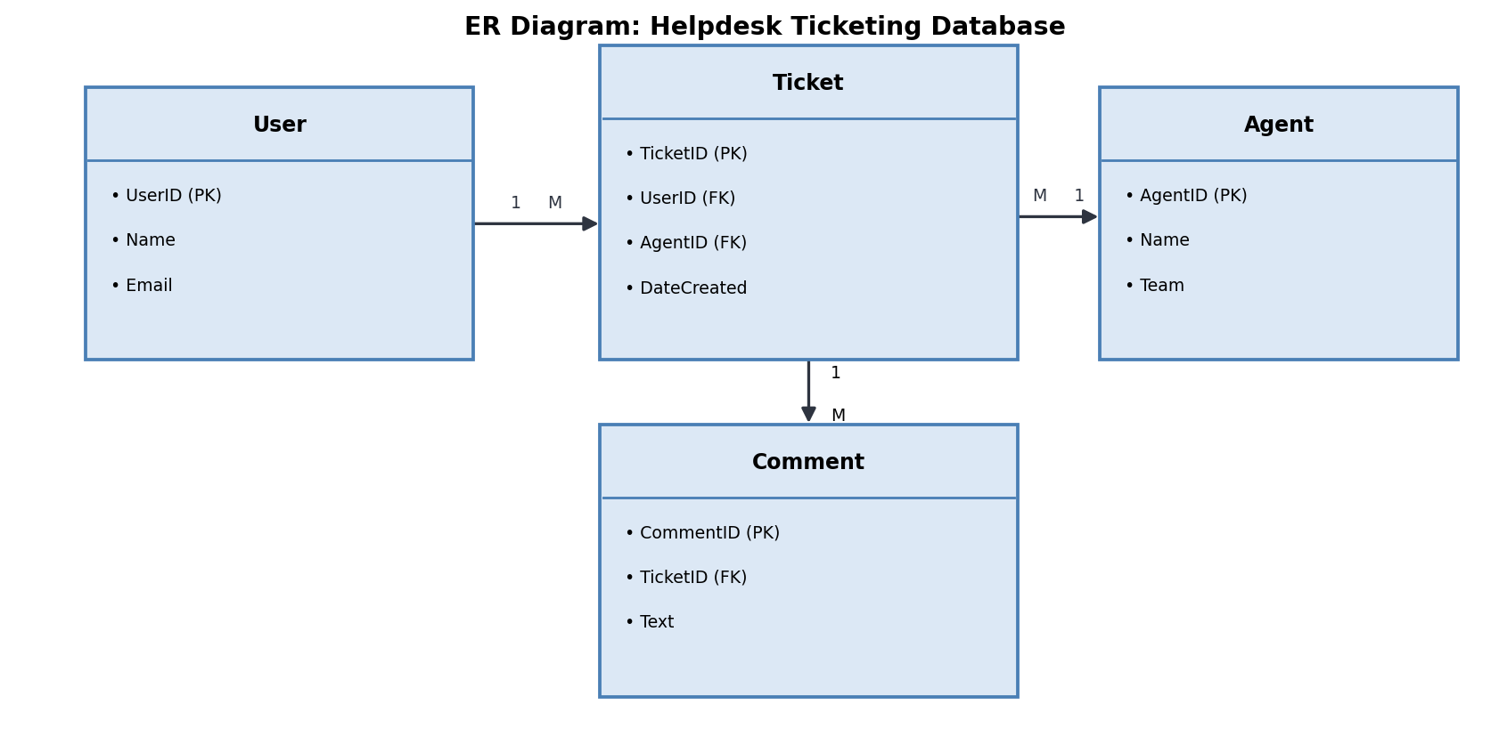

4. Data Flow Diagram (DFD)
What it is
A diagram showing how data moves through a system, independent of timing or control logic. It uses four core symbols: external entities (sources/destinations of data, drawn as squares), processes (transformations of data, drawn as circles or rounded rectangles), data stores (where data is held, drawn as open-ended rectangles), and data flows (labeled arrows). DFDs are usually built in levels — a Context/Level 0 diagram, then progressively detailed Level 1, Level 2 diagrams.
When to use it
- Analyzing how information moves between users, processes, and systems
- Identifying redundant or missing data stores and flows before system design
- Complementing a process model (like BPMN) with a data-centric view
Example
A Level 0 DFD for helpdesk ticket submission: the End User sends ticket details into the "Log Ticket" process, which writes a ticket record to the Ticket Database (data store) and produces an assignment notification sent on to the Support Agent.
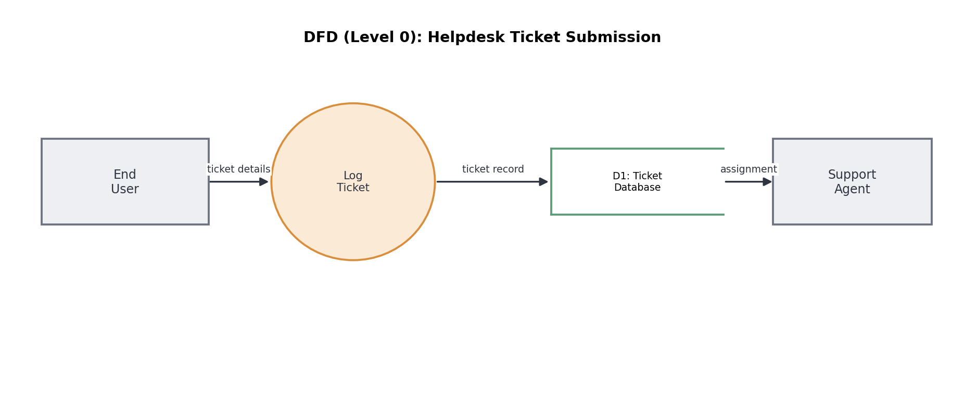

5. Wireframe or Mockup Diagram
What it is
A low-to-medium fidelity visual representation of a screen or page layout. Wireframes focus on structure, content placement, and navigation rather than final visual styling (colour, branding, imagery) — they are used to validate the user experience and information architecture before investing in visual design or development.
When to use it
- Validating screen layout and navigation flow with stakeholders early in a project
- Communicating UI requirements to designers and developers without prescribing visual style
- Iterating quickly on UX ideas before committing to high-fidelity design
Example
A wireframe for a helpdesk app dashboard shows a header bar, a search field, a "My Tickets" list with status tags, a "New Ticket" call-to-action button, and a bottom navigation bar with Tickets, Knowledge Base, and Profile tabs.
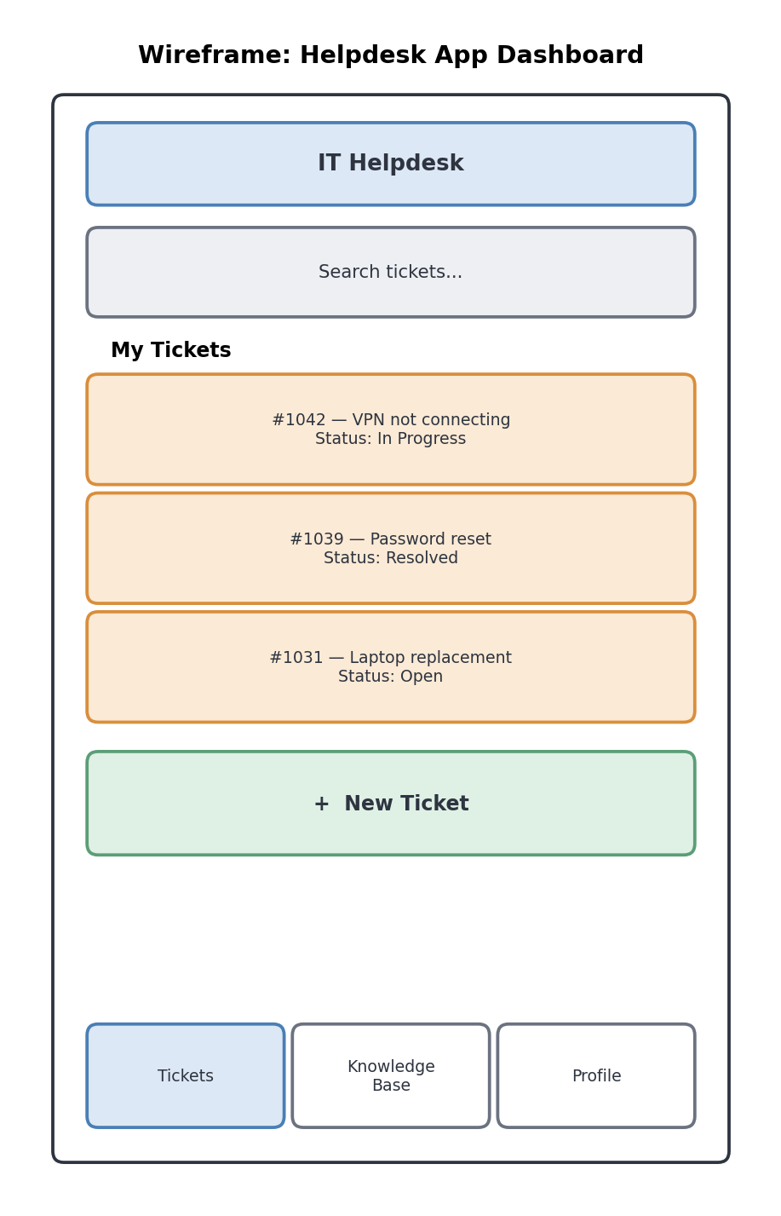

6. Swimlane Diagram (Cross-Functional Flowchart)
What it is
A process flowchart divided into parallel lanes (horizontal or vertical), where each lane represents a role, department, or system responsible for a set of steps. Swimlanes make responsibility and handoffs between parties explicit — an activity that crosses from one lane to another visually represents a handoff.
When to use it
- Documenting a process that spans multiple roles, teams, or departments
- Highlighting handoffs, delays, or accountability gaps between parties
- Clarifying "who does what" in a process for process improvement or onboarding
Example
An IT ticket escalation and fix process: L1 Support receives and triages the ticket and attempts a quick fix; L2 Engineer investigates the root cause and applies a fix; System Admin deploys the patch to production.
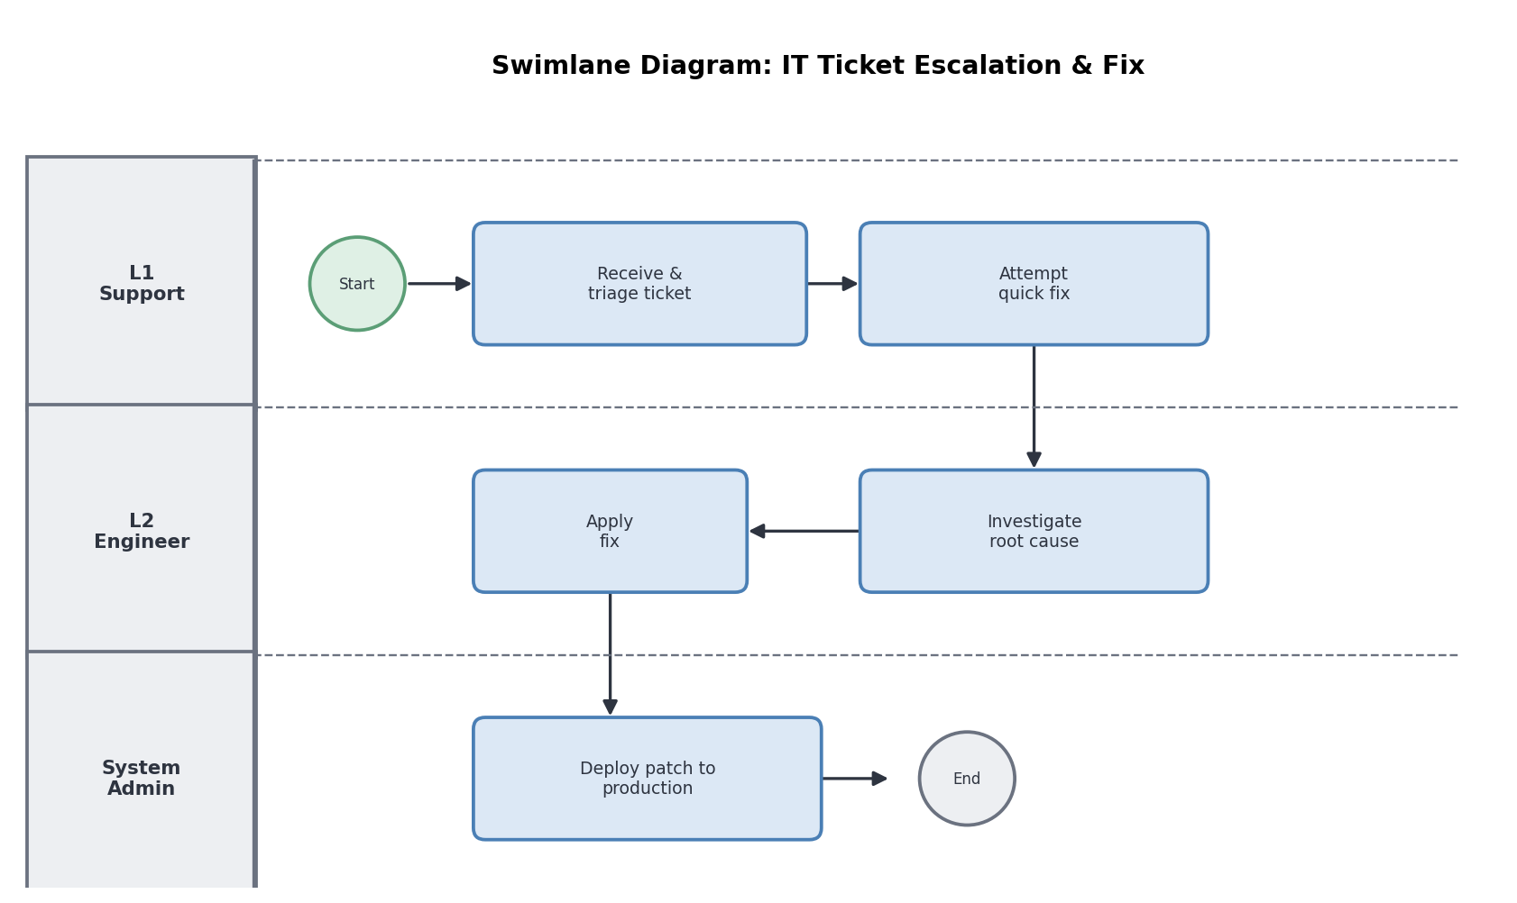

7. Gantt Chart
What it is
A horizontal bar chart used in project management to display a schedule of tasks against a timeline. Each bar represents a task's start date and duration; dependencies between tasks (e.g. one task cannot start until another finishes) are often shown with connecting lines or arrows. Gantt charts give a quick visual sense of overall project duration, overlaps, and critical milestones.
When to use it
- Planning and communicating a software project timeline to stakeholders or sponsors
- Tracking task dependencies and identifying scheduling conflicts across sprints
- Monitoring progress against planned delivery dates
Example
A helpdesk app development schedule across five sprints: Sprint 1 covers Requirements & Design, Sprints 2–3 run Backend and Frontend Development partly in parallel, Sprint 4 is QA & Testing, and Sprint 5 is Deployment & Release.
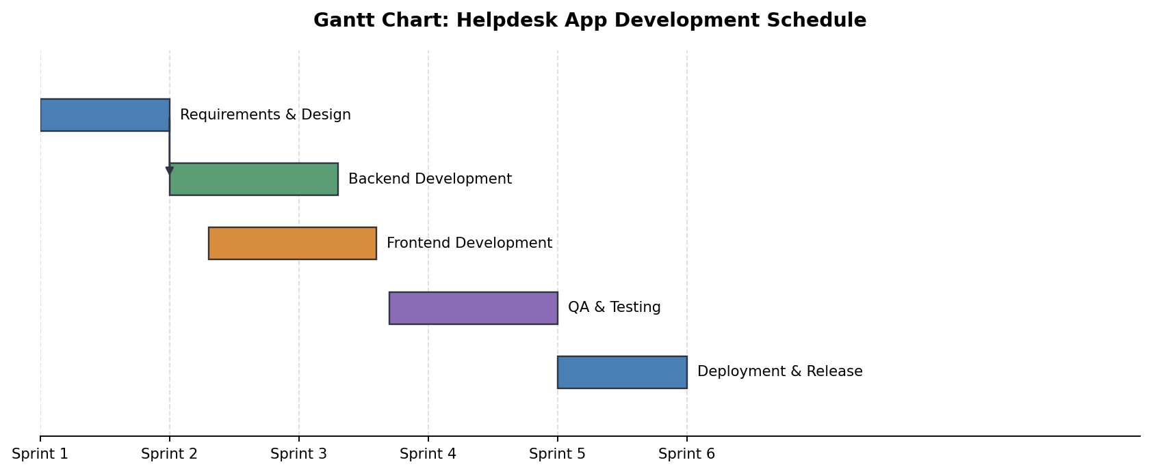

8. Stakeholder Map
What it is
A visual tool for identifying and prioritizing stakeholders based on attributes such as their level of power/influence and their level of interest in a project. A common format is a 2x2 grid, which sorts stakeholders into engagement strategies: manage closely, keep satisfied, keep informed, or monitor.
When to use it
- Planning stakeholder engagement and communication strategy at project initiation
- Identifying who needs to approve decisions versus who simply needs updates
- Surfacing stakeholders who may be overlooked but have high influence
Example
On a helpdesk system project, the Project Sponsor/CTO (high power, high interest) is managed closely; the IT Security & Compliance Officer (high power, low interest) is kept satisfied; End Users/Helpdesk Staff (low power, high interest) are kept informed; and Adjacent IT Teams (low power, low interest) are simply monitored.
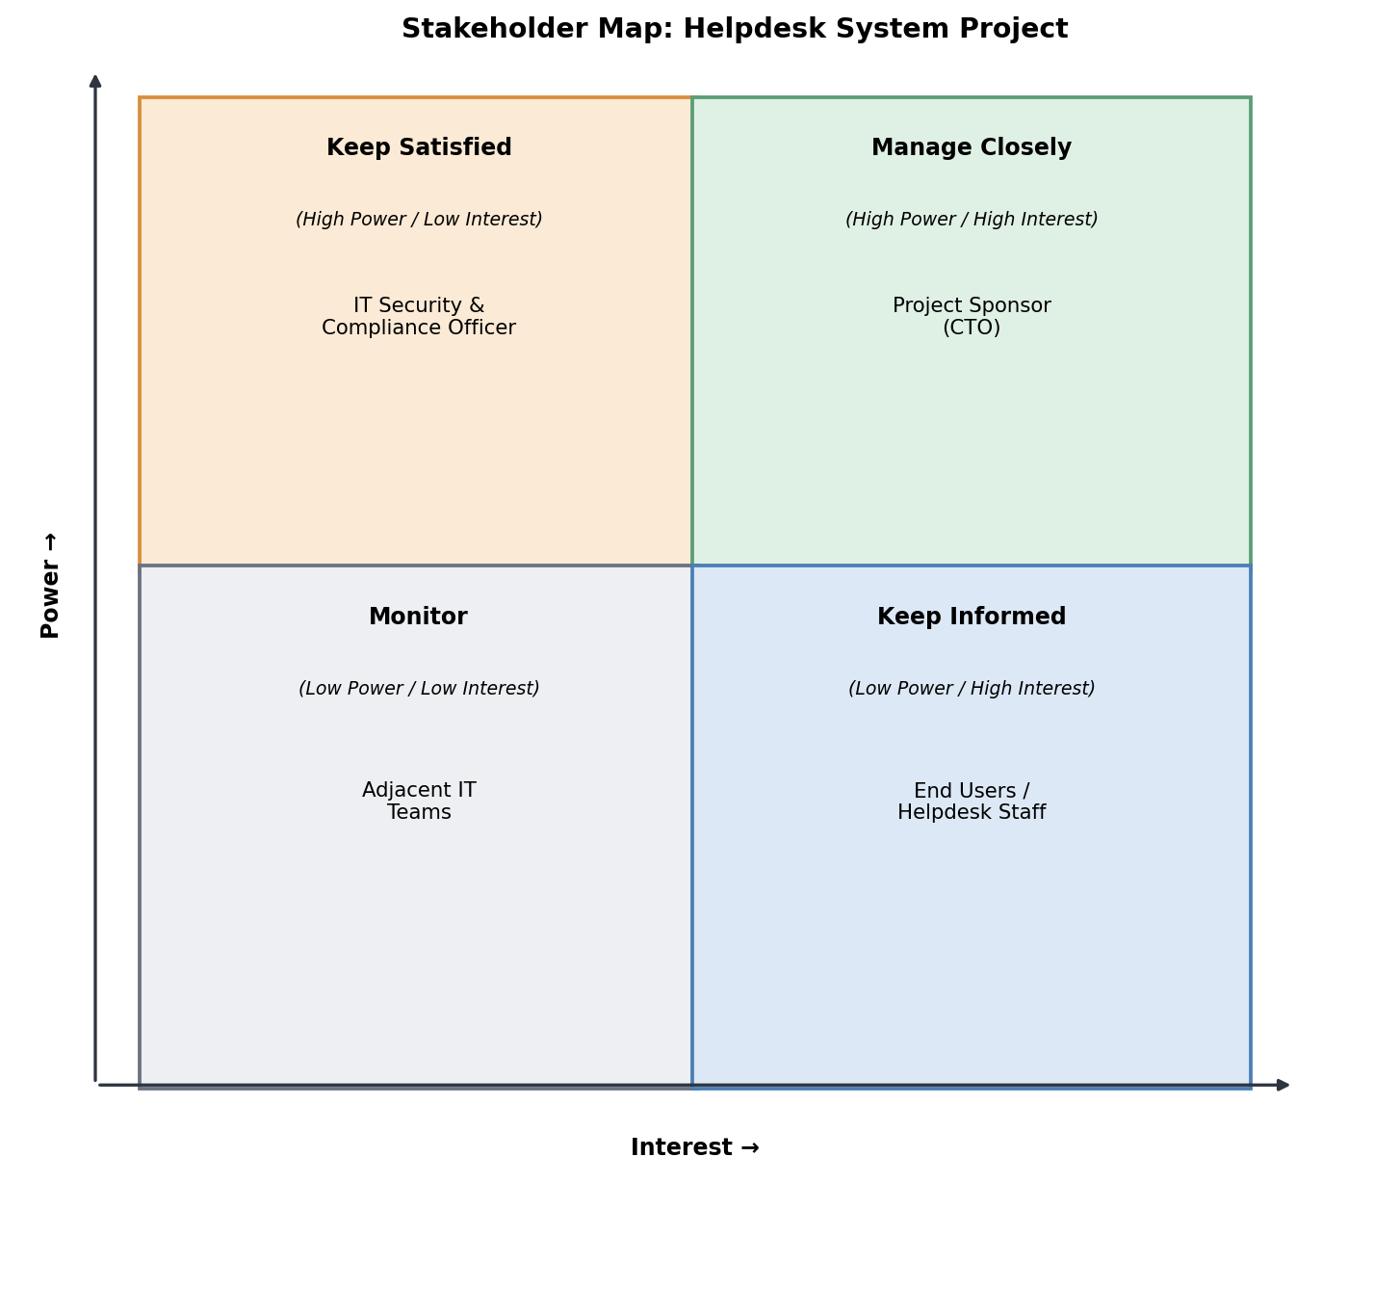

9. State Diagram
What it is
A UML diagram that models the different "states" an object, entity, or process can be in over its lifecycle, and the events or conditions that trigger transitions between states. States are shown as rounded boxes, transitions as labeled arrows, with a filled circle marking the initial state.
When to use it
- Modeling the lifecycle of an entity that changes status over time (e.g. an order, ticket, or account)
- Clarifying valid and invalid state transitions for system logic or business rules
- Supporting workflow or approval-process requirements in a software specification
Example
The lifecycle of a support ticket: Open moves to In Progress once assigned; In Progress moves to Resolved (Pending Confirm) once a fix is applied, then to Closed once the user confirms, or back to In Progress if reopened; In Progress can also return to Open if more information is requested.
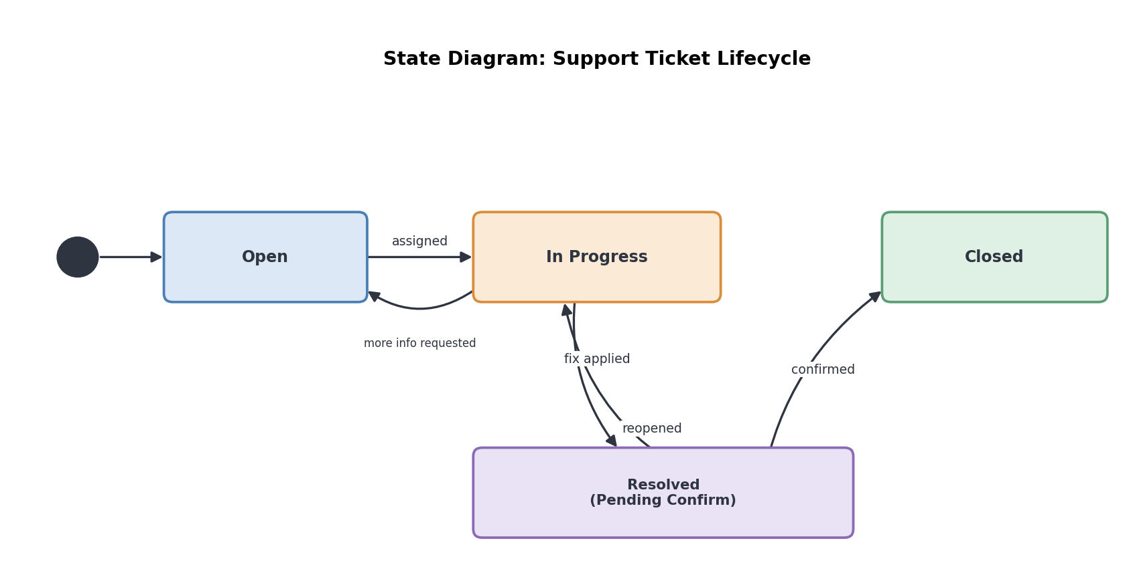

10. Requirement Traceability Matrix (RTM)
What it is
A table-based artifact that links each requirement to related project elements — its source, associated design specification, related test case(s), and current status. An RTM ensures every requirement can be traced forward to a design and test, and traced backward to its origin, which helps prevent requirements from being missed, forgotten, or delivered without verification.
When to use it
- Managing requirements on a software development project with formal sign-off
- Verifying that all requirements have been designed, built, and tested
- Supporting impact analysis when a requirement changes
Example
A simple RTM for a helpdesk system links requirement R-01 ("user shall log in via email/password") back to a stakeholder workshop, forward to an authentication module design reference and test case TC-005, with a status of "Passed."
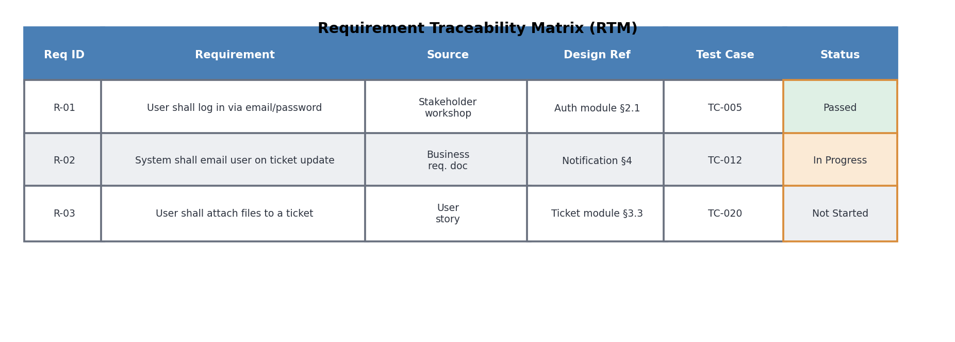

11. Gap Analysis Diagram
What it is
A visual comparison between the current state ("As-Is") of a process, system, or capability and the desired future state ("To-Be"), with the gap between them explicitly identified along with the actions needed to close it. It is commonly shown as two columns or states with a middle section calling out the difference.
When to use it
- Assessing whether a current IT system meets new business, security, or scalability requirements
- Building a business case for a system upgrade or cloud migration
- Planning remediation or improvement actions with clear ownership
Example
A helpdesk system cloud migration gap analysis: As-Is, the system is on-premise with no mobile access and manual reporting; the Gap is no mobile access and no REST API for integration; To-Be, the system is cloud-based with mobile access and automated reporting, achieved through migrating to a cloud platform and building a REST API and mobile app.
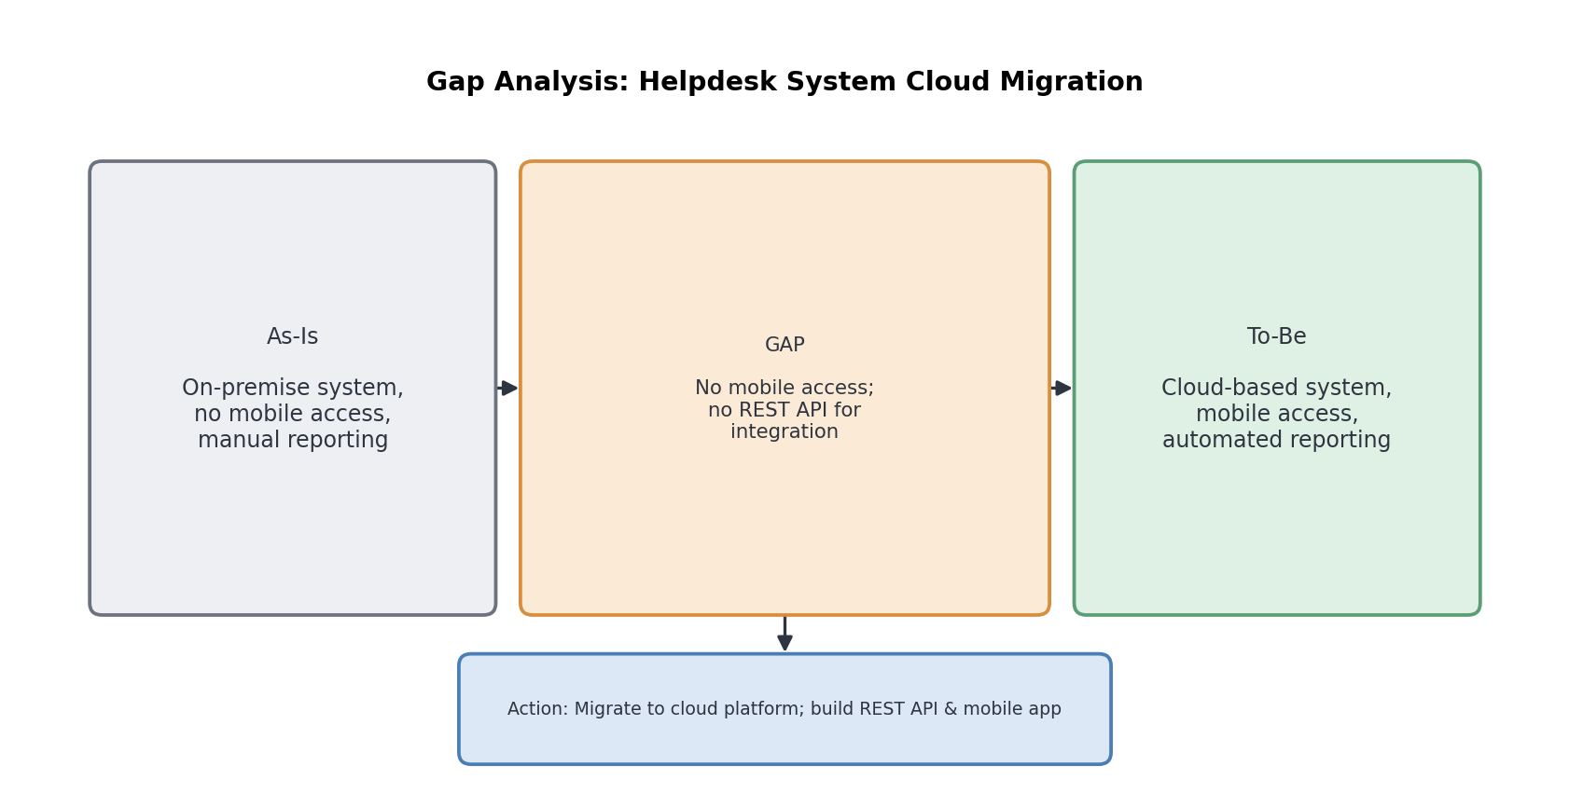

12. Activity Diagram
What it is
A UML diagram that models the workflow or logic of a process, similar to a traditional flowchart but with additional notation for parallel activities. Fork and join bars (thick black bars) show activities that happen simultaneously and later synchronize, while diamonds represent decision points. Activity diagrams can also use lane-like partitions to show which actor performs each activity.
When to use it
- Modeling detailed step-by-step logic of a system function, such as an authentication flow
- Showing activities that can happen in parallel rather than strictly sequentially
- Complementing a use case with the detailed flow of steps behind it
Example
A user login and authentication flow: after entering a username and password, a decision checks whether the credentials are valid. If yes, the system retrieves the user session, then verifies the MFA code and logs the login event in parallel (fork), before both are synchronized (join) to redirect the user to the dashboard. If invalid, an error is displayed.
