**Site Name:** South Eastern Idaho Community and Weather

**Site Domain:** seidweather.com

**Site Purpose:**

The purpose of this site is to bring weather information to the residents of south eastern Idaho communities. In addition to the weather, the site will include other outdoor events and activities. Preston, Soda Springs and Fish Haven are small towns, however, there are a lot of city run events and sports. This site will help residents know how to best plan for the activities by knowing what’s ahead with the weather.

**Description of the target audience:**

Persona One:

Andrea Petersen, age 42. Andrea is a stay-at-home mother of four kids ages 9-16. She has a bachelor’s degree in elementary education. She is always busy running her kids to lessons and activities. They have a very active family that enjoys spending time at the local parks and going on hikes. She will use the site o plan according to the weather. Her family will also benefit from having a resource for local activities and events. She uses her iPhone every day to plan and keep her family organized.

Persona Two:

Jolene Stanley, age 65. Jolene is not very comfortable using the internet. She likes to keep things simple and appreciates websites that are easy to navigate. She uses her home desktop computer to access the internet. She is single and is the caretaker of her 40-year-old son who has disabilities and lives at her home. Keeping track of the weather is a daily event for her as her son is sensitive to different weather conditions. They enjoy getting involved in their community and would love to be able to learn about all activities and events available on one website.

The second target audience are elderly persons over the age of 70. Perry has a lot of new houses that have been built in the past 15 years, but there are also several original homes and owners that have lived their entire lives in Perry. A lot of these individuals are widows and widowers. There are monthly events planned for this part of the community. This site will allow them to see the events and also plan accordingly for the weather. These individuals would most likely access the site from a home computer.

**Sitemap:**

Color Scheme:

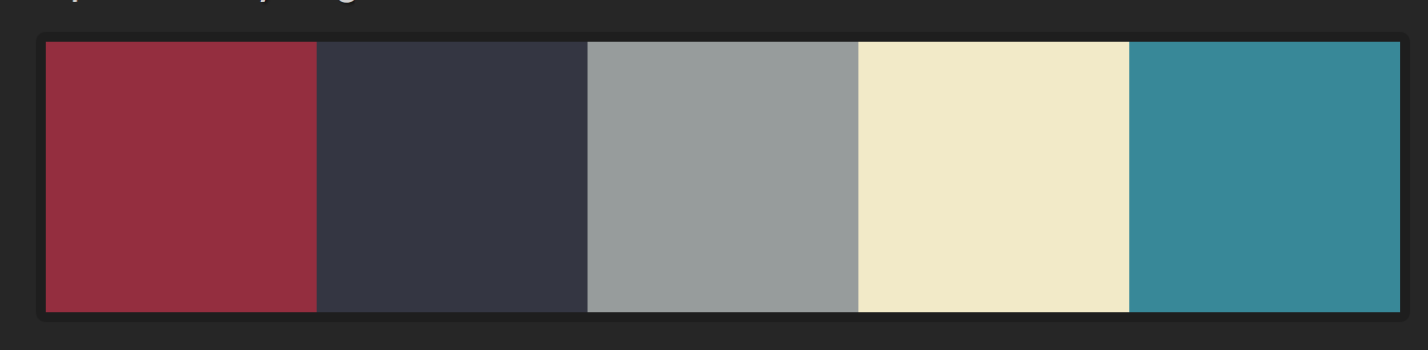

Hex 348899

Hex F2EBC7

Hex 979C9C

Hex 343642

Hex 962D3E

Typography:

Google Fonts

Raleway (Sans Serif Font)

Noto Serif SC (Serif Font)

HTML code:

<link href="https://fonts.googleapis.com/css?family=**Noto+Serif+SC|Raleway**" rel="stylesheet">

CSS code:

font-family: 'Raleway', sans-serif;

font-family: 'Noto Serif SC', serif;